Was the road to Auschwitz a ‘straight road’ or a ‘twisted path’?

The term ‘Holocaust’ primarily refers to genocide, particularly the systematic extermination of Jews during the Second World War (Garber and Zuckerman, 1989). Raphael Lemkin devised the term ‘genocide’ to describe the systematic destruction of entire ethnic and racial groups during the Second World War, leading to its recognition as a crime under international law. Scholars continue to debate its definition and complexities (Feierstein, 2014, pp. 11-38; United Nations, 1948). The Holocaust, culminating in the extermination of six million Jews and millions of others deemed undesirable by the Nazi regime, is a dark chapter in history. Auschwitz, the most infamous of the Nazi concentration and extermination camps, played a crucial role in this atrocity (Friedlander, 1994; Browning, 1992, p. ix). Auschwitz represents the Holocaust and is essential to discussions about the Nazi genocide. However, using Auschwitz as a shorthand for the Holocaust can oversimplify its intricate history (Kucia, 2019; Pettitt, 2019).
Understanding the journey to Auschwitz is pivotal in the study of Holocaust history, reflecting the conflict between intentionalist and functionalist perspectives on the Final Solution's development and responsibility. Functionalists argued that the Holocaust evolved into a chaotic bureaucratic initiative starting after the 1941 Soviet invasion, viewing the Nazi leadership as competing interests rather than under Hitler’s absolute control. In contrast, Intentionalists believed the Holocaust was primarily driven by Hitler's long-standing intention and ideological commitment to eliminating Jews (Bartrop and Jacobs, 2011, pp. 56-57).
This essay examines the complexities surrounding the rise of Nazi antisemitism and nationalism. It explores the ideological roots of these beliefs, the evolving policies toward Jews, the impact of the Second World War, particularly the invasion of the Soviet Union, and the roles of key individuals and organisations in implementing the Final Solution. The essay argues that a comprehensive approach, rather than competing ideological perspectives, provides a clearer understanding of Nazi Germany and its atrocities. The journey to Auschwitz was shaped by a complex interplay of ideology, institutional forces, and individual decisions rather than by a single, premeditated plan.
In the early 1900s, the German elite adopted beliefs in human inequality, influenced by scholars advocating heredity linked to racist Volkisch ideology. This idealised the German people as racially pure and superior, promoting a political belief that viewed race as the nation's foundation (Friedlander, 1994). Anti-Semitism in the interwar period arose from economic competition and social tensions, with crises and authoritarianism deepening radical anti-Jewish sentiments (Hagen, 1996). National Socialism emerged and gained momentum in the 1920s, leading to exclusionary policies after 1933 when Hitler became Chancellor. While anti-Semitism was a key aspect, the regime also targeted other groups whom they deemed unworthy (Friedlander, 1994). Richard Weikart (2013) argues that a distorted understanding of Darwinian evolution and Social Darwinism influenced Nazi racial ideology. The Nazis used the idea of survival of the fittest to promote Aryan superiority and justify the extermination and enslavement of Jews, Slavs, and disabled individuals through notions of racial struggle and eugenics.
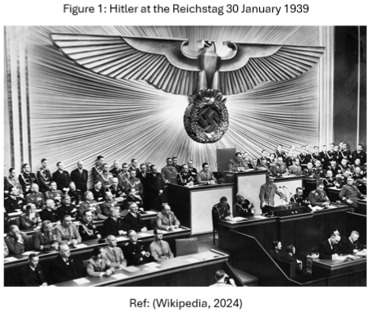
Intentionalists contend that the Holocaust was a direct result of Nazi racial ideologies and Hitler's deliberate actions, which they see as a purposeful plan for the extermination of the Jewish people. They evidence this perspective with Hitler's antisemitic beliefs in his book Mein Kampf and key verbal statements he made (Draper, 1999). The following presents early evidence of Hitler's anti-Jewish opinion. In a letter from 1919, he labelled Jews as a threat to Germany (Landau, 1998). In 1921, as chairman of the National Socialist German Workers' Party, he promoted anti-Semitic policies that denied Jews citizenship (Hatheway, 1994). Furthermore, in a 1922 interview, he stated that Jews would be ‘hanged indiscriminately’ to cleanse Germany (Fleming, 1984, p. 17). In Mein Kampf, Hitler asserted that German foreign policy should be for ‘protecting, advancing, and maintaining our nation for the future.’ Hitler believed in Aryan superiority and viewed Jews as a threat to German society, arguing that their elimination was essential for the survival of the German people (Dawidowicz, 1975, pp. 122-123). Hitler's 1938 memorandum defined Volksdeutsche (ethnic Germans) by blood and race, worsening anti-Semitism and persecution of Jews and others deemed impure through vague criteria based on physical traits and language (Bergen, 1994). During a conference in January 1939, Hitler said, ‘We are going to destroy the Jews’ (Krausnick et al., 1965, p. 44). Hitler reiterated this in his address to the Reichstag (See Figure 1). Intentionalist historians have pointed to the 1939 Reichstag address as key evidence of Hitler's plan to carry out the Final Solution, occurring just months before the beginning of the Second World War. Hitler stated, ‘If the global Jewish financiers, both within and outside Europe, should succeed in dragging the nations into another world war, then the outcome will not be the Bolshevisation of the earth, and consequently, the triumph of Jewry, but rather the extermination of the Jewish race in Europe!’ Hitler often cited this prophecy, and it was used by those committing genocide to justify their actions (Mommsen, 1997). Intentionalists also point to information derived from 'British intercepts of German radio communications' indicating that Nazi forces were murdering Jews shortly after the war began, with the highest rates of killings occurring in late 1941 (Draper, 1999). Lucy Dawidowicz links Hitler's intent for the Holocaust to Mein Kampf and possibly as early as 1918, after the Treaty of Versailles. She argued that the Holocaust was a primary objective of the Nazis, with military actions merely serving to advance this goal (Feingold, 1976; Mamlak, 1977; Milton, 1990). Dawidowicz acknowledges the obscurity of Hitler's language but argues that his audience understood his policies for the removal and extermination of Jews (Davis, 1999). Hitler shaped Nazi ideology with his rhetoric, but no evidence has yet been found that he directly commanded the Holocaust. He created an atmosphere of hatred and anti-Semitism that motivated committed Nazis to persecute Jews and others deemed inferior.
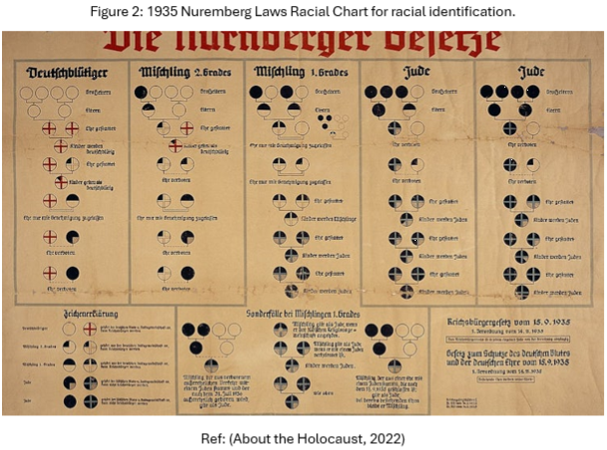
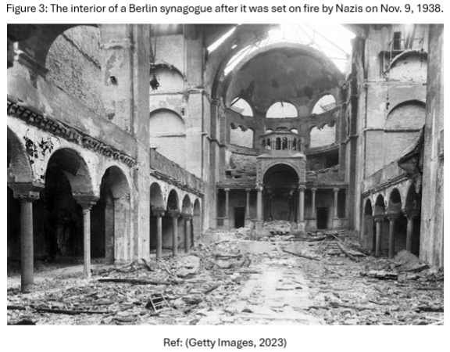
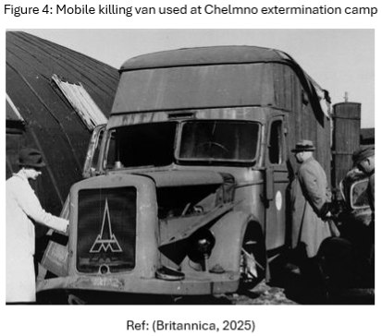
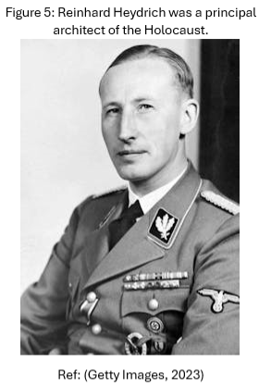
Proponents of intentionalism assert that the anti-Semitic policies enacted in the 1930s represent a deliberate strategy aimed at genocide. However, this view oversimplifies the situation as it overlooks the interplay of ideology, opportunism, and historical context. The Nazis employed various methods to eradicate the Jewish population in Germany, including promoting emigration, forced relocations, and evictions (Schulze, 2016). After Hitler became Chancellor, anti-Semitism increased, resulting in the marginalisation of Jewish people. Propaganda worsened conditions for individuals with disabilities, leading to forced sterilisations. The Law for the Prevention of Offspring with Hereditary Diseases, enacted in 1933, permitted the sterilisation of around 300,000 disabled individuals over the next decade (Friedlander, 1994). The Haavara Agreement of 1933 was the first organised effort to facilitate the migration of Jews to Palestine. While the Haavara initiative saved many lives, it also aligned with Nazi interests. Between 1933 and 1940, about 70,000 German Jews emigrated. However, the agreement does not imply that the Nazis supported Zionism. Instead, it highlights the complexity and evolution of Nazi policies toward Jews, characterised by deep-seated hatred and the belief that Jews caused Germany's problems (Polkehn, 1976; Schulze, 2016). The Nuremberg Laws, enacted in September 1935, legally defined Jews and other targeted groups in Germany, marking a significant step toward their dehumanisation (See Figure 2). They prohibited interracial marriage to ‘protect the honour of the race,’ defining a Jew as anyone with three or four Jewish grandparents or linked to a Jew. Marriages between Jews and Aryans were illegal, with severe penalties for violations, and interracial intercourse was termed racial defilement. These laws replaced earlier court rulings supporting mixed marriages and were part of a broader anti-Semitic campaign for racial purity (Loewenstein, 1936; Rosenhaft, 2011). The Nazi Madagascar Plan, proposed in 1940 after France fell to Germany, aimed to forcibly relocate millions of European Jews to Madagascar, then a French colony, creating a Jewish reservation managed by Heinrich Himmler’s Schutzstaffel (SS). Intentionalists argue that this reflects the Nazis' shift towards genocide, as figures like Adolf Eichmann and Himmler sought to eliminate Jews without confrontation. The plan intended to transport up to four million Jews, but it became impractical after Germany failed to defeat Britain in the Battle of Britain (1940); the Royal Navy retained control over key sea routes. This made it virtually impossible for Germany to transport millions of Jews across the seas to Madagascar safely (Kurlander, 2023). Jews were increasingly marginalised, losing their fundamental rights, being removed from jobs, and facing boycotts. Kristallnacht (or the Night of Broken Glass) occurred on 9th-10th November 1938, marking a significant escalation in Nazi anti-Semitic violence (See Figure 3). Triggered by the assassination of a German diplomat by a Jewish youth, this state-coordinated pogrom targeted Jewish communities, leading to approximately 100 deaths and the detention of around 30,000 Jews in concentration camps. Jewish businesses and synagogues were vandalised, and survivors were forced to pay for the damages. Kristallnacht marked a pivotal moment that signified a transition from discriminatory policies and anti-Semitic laws to open violence and persecution, demonstrating the Nazis' intention to annihilate Jewish communities (Rees, 2017, pp. 139-145). In late 1938, as war loomed, the Nazi regime escalated its policies towards groups deemed racially inferior or biologically unworthy, beginning with Hitler’s approval of killing infants with disabilities. By spring 1939, plans were underway to identify victims, recruit doctors, and set up lethal hospital wards. The T4 operation, initiated by Hitler in the summer of 1939, was later expanded to include disabled adults. Although the T4 killing centres closed in August 1941 due to opposition, new centres for Jews were being established. Chelmno opened in December 1941 using gas van technology for the murders (See Figure 4), followed by Belzec, Sobibor, and Treblinka in 1942. Gypsies faced persecution, deportation to ghettos, and were murdered alongside Jews and the disabled in the Holocaust. Disabled Jews were among the initial victims of the final solution, with many murdered in euthanasia centres in 1940 (Friedlander, 1994).
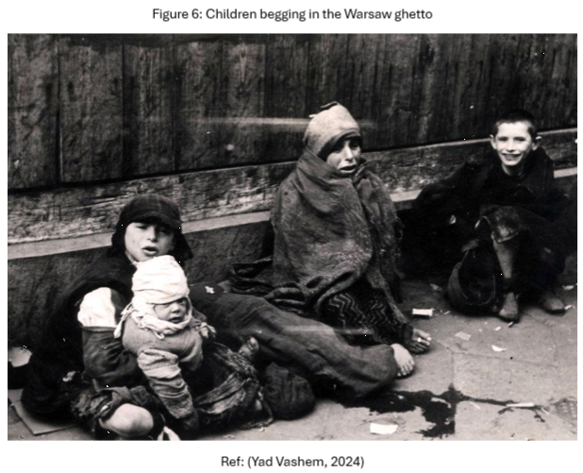
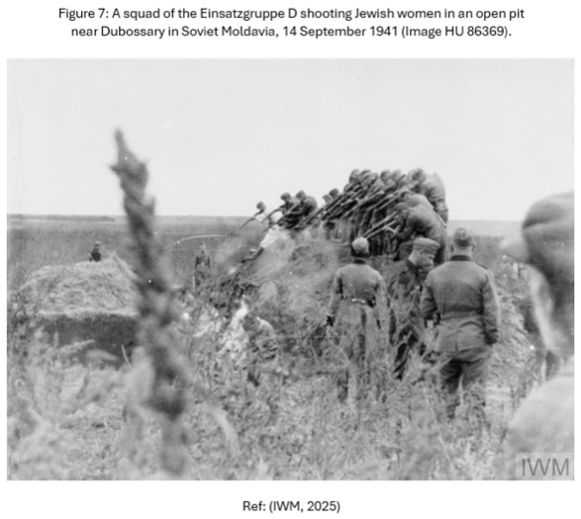
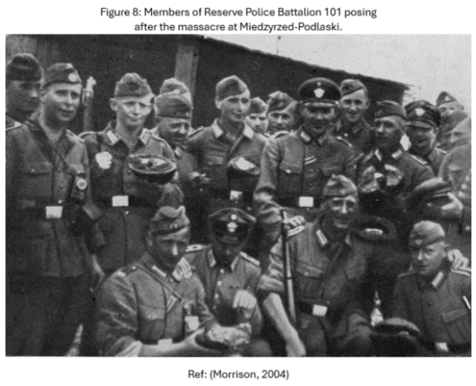
The invasion of Poland by Nazi Germany began on 1st September 1939, marking the start of the Second World War. Earlier that year, Hermann Goring had instructed Reinhard Heydrich (See Figure 5) to oversee the forced resettlement of Jews to achieve a Judenfrei (Jew-free) Germany (Browning, 2005, pp. 315-317). Consequently, the Nazi regime created ghettos to segregate and control Jewish communities in occupied areas, especially in Poland. The ghettos in Warsaw and Lodz were overcrowded and suffered from inadequate sanitation, resulting in high death rates (See Figure 6). Initially viewed as temporary, the ghettos sought to relocate Jews to the Lublin district by February 1940 but struggled with issues like starvation due to economic isolation (Browning, 1986). Intentionalists see ghettos as a calculated part of the Nazi genocide strategy, while functionalists view them as responses to situational pressures. Ghettoisation was not just a central authority action for extermination; it varied in execution and was primarily initiated by local authorities (Browning, 1992, pp. 28-30). On September 21, Heydrich gave instructions to the commanders of the Einsatzgruppen (mobile execution units), emphasising the need to eradicate Jews, intellectuals, and political figures in the areas of Poland under occupation (Landau, 1998, pp. 68-69). Intentionalist historians argue that the subsequent actions of the Einsatzgruppen (See Figure 7) and other organisations, such as Reserve Battalion 101 (See Figure 8), were part of a premeditated, top-down plan by Hitler and the Nazi leadership to implement the Final Solution and secure Lebensraum (living space) for the German people. According to this perspective, Hitler's long-standing antisemitism directly influenced the violent policies enacted in Poland (Rossino, 2001). Lebensraum was crucial for the Nazis, as it generated public support for Germany's expansion. The concept of Lebensraum emerged in the early twentieth century as Germany sought imperial expansion, notably in German South-West Africa, where indigenous groups were displaced and killed (Madley, 2005). It was later adopted by radical conservatives in the 1920s and influenced Hitler's 1941 invasion of Russia and resettlement plans in Eastern Europe (Smith, 1980). The Einsatzgruppen were vital in implementing the Nazis' racial and ideological policies, particularly in the early stages of the Holocaust. By systematically targeting Jews, the Einsatzgruppen facilitated the Nazis' broader goals of ethnic cleansing, territorial domination, and the establishment of German control in occupied Poland (Breitman, 1994). Christopher Browning’s 1992 book Ordinary Men explores how German police officers, particularly those in Reserve Police Battalion 101, became perpetrators of mass murder. The battalion, mainly composed of middle-aged working-class men from Hamburg and not predominantly Nazis, participated in the systematic killing of Jews in Poland. Over 16 months, they executed around 38,000 Jews and transported 45,000 to Treblinka through forced labour and escorting them to execution sites. Their actions can be analysed from two perspectives: intentionalism, which considers them part of a Nazi genocidal plan, and functionalism, which attributes their behaviour to social pressures and conformity (Pleasants, 2017). Fritzsche (2013) argues that both Nazi ideologies and social pressures played a key role, with a decentralised bureaucratic structure turning ordinary individuals into perpetrators. Likewise, Michael Mann (2000) found that many acted out of fear rather than ideology, revealing a mix of ordinary men and devoted Nazis. Understanding why ordinary people commit horrific acts is crucial. It is a misconception that such participation is driven solely by deep hatred or ideology. Individual actions shaped mindsets, fostering a psychologically favourable disposition towards deeds that, under different circumstances, would have been inconceivable and likely opposed (Cesarani, 1994, pp. 119-120). Situational pressures also play a significant role, including peer pressure, the desire to avoid social ostracism and desensitisation to violence.
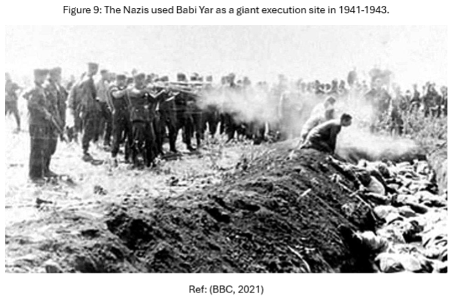
The concept of ‘working towards the Fuhrer,’ introduced by historian Ian Kershaw is vital to understanding the Holocaust as it sheds light on the dynamic between Hitler's overarching ideology and the actions of individuals within the Nazi regime. It describes how Nazi officials acted on their interpretation of Adolf Hitler's wishes without explicit orders. This approach suggests they autonomously escalated anti-Jewish measures, driven by ideological commitment and a desire for approval. It bridges two perspectives: the intentionalist view, which emphasises Hitler’s central role, and the functionalist perspective, focusing on the chaotic nature of Nazi governance. Therefore, the progression toward genocidal policies like the Final Solution resulted from both Hitler’s vision and the initiatives of his followers. Ambition and conformity among bureaucrats also played significant roles, as competition influenced policies like the Final Solution, illustrating a complex interplay of motivations and dynamics within the regime (Marrus, 1994).
On 22nd June 1941, Germany initiated Operation Barbarossa, invading the Soviet Union and subjecting millions of Jews in Eastern Europe to Nazi control. This invasion created logistical challenges that contributed to the radicalisation of anti-Jewish policies, and the Nazi approach to dealing with the Jewish population shifted fundamentally from expulsion to extermination. In the occupied regions, a systematic campaign began to eliminate Jews, highlighted by mass shootings such as the one at Babi Yar from 29th-30th September 1941 (See Figure 9), where 33,771 Jews were killed near Kyiv, Ukraine. The Einsatzgruppen carried out these executions with the help of local collaborators (Gerlach, 1998; United States Holocaust Memorial Museum, 2024). The Einsatzgruppen initially targeted Jewish male leadership and intelligentsia. However, by late July 1941, orders expanded to murder all nonworking Jews, including women and children, reflecting an evolving plan for the extermination of Soviet Jewry. Early logistical challenges delayed mass murders, but as German forces gained confidence, systematic extermination escalated (Browning, 1994). The Einsatzgruppen's mass executions were soon deemed impractical, leading to gas chambers and extermination camps as more efficient solutions, aligning with the functionalist view of wartime-driven policy evolution. The invasion of the Soviet Union created significant logistical challenges in managing millions of Jews, resulting in a crucial shift in how the Nazis addressed the issue. The Nazis had to find a more efficient solution on a larger scale.
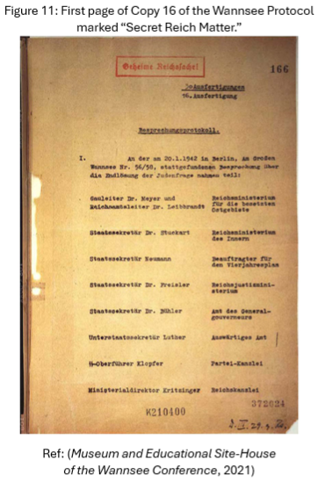
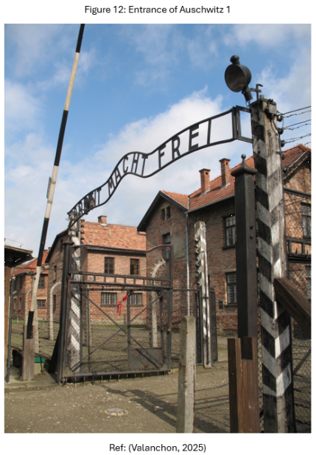
On July 31, 1941, Reinhard Heydrich was tasked with creating a final solution for the ‘Jewish question’. This was reinforced on 23rd October 1941 with the formal prohibition of Jewish emigration from Germany and the occupied territories, clearly showing the transition in Nazi policy from forced emigration to genocide. This led to the Wannsee Conference in January 1942, where officials formalised plans to eliminate eleven million Jews (See Figure 10). The minutes, recorded by Adolf Eichmann, detail this extermination plan (See Figure 11), including deportation and exemptions such as sterilisation for those of mixed Jewish ancestry and the temporary retention of Jewish workers in the military (Friedlander, 1994; Yad Vashem, 2025; Gerlach, 1998). The conference formalised genocidal policies, accelerated by the war in the East. By early 1942, Nazis were building extermination camps to industrialise murder. The Wannsee Conference coordinated efforts across Nazi-occupied territories, as the invasion of the Soviet Union demanded a continent-wide extermination program. It played a key role in implementing Hitler’s goals, reflecting the ideological zeal of the new elites within the Fuhrer state. This reflects a combination of intentionalist and functionalist viewpoints, as it illustrates the importance of Hitler's vision while recognising the bureaucratic and organisational facets of the regime's actions (Kershaw, 2004). The Wannsee Conference marked the official approval of the Final Solution, with Auschwitz identified as a key site for its implementation. Auschwitz became a notorious symbol of the Holocaust due to the scale of its systematic killings. Founded in June 1940 for Polish political prisoners, Auschwitz was divided into three sections: Auschwitz I (See Figure 12), Auschwitz II (Birkenau), and Auschwitz III. Birkenau, added in March 1942, became the main extermination centre, housing Europe’s largest gas chambers (Auschwitz Birkenau State Museum, 2024). From 1940 to its evacuation in January 1945, approximately 1.3 million people were brought to Auschwitz, with only about 200,000 surviving (Hayes, 2003).
Historian Hans Mommsen argues that while Hitler's approval was essential for the Holocaust, he did not directly order it. Instead, rival factions and committed Nazis wishing to progress their careers and impress Hitler developed the policies independently. In contrast, the intentionalist perspective suggests that Hitler verbally instructed Himmler and the SS to eliminate the Jews, intentionally avoiding written approval to evade direct implication. In his 1943 Posen speeches, Himmler described the extermination of the Jewish people as a directive from the highest leadership, implying it originated from Hitler (Friedlander, 1994). However, evidentially, no long-term premeditated plan or signed directive from Hitler explicitly ordering the Holocaust has ever been discovered. Historians generally agree that the decision-making process for the Final Solution was gradual and influenced by various entities within the Nazi regime. Functionalists believe it resulted from improvisation, while intentionalists connect it to Hitler’s ideological goals, linking it to the Soviet invasion and his pursuit of Lebensraum along with the annihilation of the Jews (Browning, 1992, pp. 3-4; Browning, 2003). Both perspectives are valid.
In conclusion, Hitler's antisemitic ideology was the foundation of early Nazi policies of discrimination and persecution toward Jews, such as the Haavara Agreement that forced many to flee Germany. The Nazis' mistreatment of Jews escalated from oppressive laws to violent actions. Significant events, such as Kristallnacht and the activities of the Einsatzgruppen in Poland, illustrate the increasing severity of these measures as the war progressed. The invasion of the Soviet Union marked a significant turning point; the logistical challenges of removing millions of Jews in pursuit of lebensraum raised the urgency of finding a solution. This culminated in the Wannsee Conference, where bureaucrats decided on plans for the systematic extermination of Jews and other targeted groups. The implementation of the Final Solution developed in a decentralised manner. Leaders and officials interpreted Hitler’s ideology and directives without receiving direct orders from him. The journey to Auschwitz did not follow a premeditated plan; instead, it involved changing policies and bureaucratic competition, all under a clear ideological goal: the eradication of Jews from society. This perspective highlights the coexistence of what can be described as the ‘straight road’ and the ‘twisted path’ of the Holocaust. Recognising the complexity of the Holocaust is vital to avoid oversimplification and to grasp its dual nature.

REFERENCES
About the Holocaust (2022) What were the Nuremberg Laws? Available at: https://aboutholocaust.org/en/facts/what-were-the-nuremberg-laws (Accessed: 7 January 2025).
Auschwitz Birkenau State Museum (2024) Basic Information on Auschwitz. Available at: https://www.auschwitz.org/en/press/basic-information-on-auschwitz/ (Accessed: 30 December 2024).
Bauer, Y. (1980) ‘Genocide: Was It the Nazis’ Original Plan?’, The Annals of the American Academy of Political and Social Science, 450, pp. 35–45. Available at: http://www.jstor.org/stable/1042557 (Accessed: 31 December 2024).
BBC (2021) Babi Yar: Synagogue opens at Nazi massacre site in Ukraine. Available at: https://www.bbc.co.uk/news/world-europe-57114197 (Accessed: 7 January 2025).
Bergen, D. L. (1994) ‘The Nazi Concept of “Volksdeutsche” and the Exacerbation of Anti-Semitism in Eastern Europe, 1939-45’, Journal of Contemporary History, 29(4), pp. 569–582. Available at: http://www.jstor.org/stable/260679 (Accessed: 1 January 2025).
Breitman, R. (1994) ‘Plans for the Final Solution in Early 1941’, German Studies Review, 17(3), pp. 483–493. Available at: https://doi.org/10.2307/1431895
Britannica (2025) Chelmno concentration camp, Poland. Available at: https://www.britannica.com/place/Chelmno-concentration-camp-Poland (Accessed: 7 January 2025).
Browning, C. R. (1994) ‘The Nazi Decision to Commit Mass Murder: Three Interpretations: The Euphoria of Victory and the Final Solution: Summer-Fall 1941’, German Studies Review, 17(3), pp. 473–481. Available at: https://doi.org/10.2307/1431894

Browning, C.R. (1986) ‘Nazi Ghettoization Policy in Poland: 1939–41’, Central European History, 19(4), pp. 343–368. Available at: https://doi.org/10.1017/S0008938900011158
Browning, C.R. (1992) Ordinary Men : Reserve Police Battalion 101 and the Final Solution in Poland. 1st edn. New York: HarperCollins Publishers.
Browning, C.R. (1992) The Path to Genocide : Essays on Launching the Final Solution. 2nd edn. Cambridge: Cambridge University Press.
Browning, C.R. (2003) Initiating the Final Solution: The fateful months of September-October 1941. Available at: https://www.ushmm.org/m/pdfs/20050728-browning.pdf (Accessed: 31 December 2024).
Browning, C.R. (2005) The Origins of the Final Solution: The Evolution of Nazi Jewish Policy, September 1939–March 1942. Lincoln: University of Nebraska Press. Available at: https://www.amazon.co.uk/Origins-Final-Solution-Evolution-1939-March/dp/0099454823/ref=sr_1_1?crid=2T5B6M7ZCRHYA&dib=eyJ2IjoiMSJ9.33X4JIgcKGvZ75OZ1dJsGQ1lELUA7LspZfTftyGZuHg.-K738V8Dvvn1-G1osVICpPMW3FF47W5AbzHWCetxNag&dib_tag=se&keywords=The+Origins+of+the+Final+Solution%3A+The+Evolution+of+Nazi+Jewish+Policy%2C+September+1939%E2%80%93March+1942.&nsdOptOutParam=true&qid=1735843814&sprefix=the+origins+of+the+final+solution+the+evolution+of+nazi+jewish+policy+september+1939+march+1942.%2Caps%2C72&sr=8-1 (Accessed: 2 January 2025).
Cesarani, D. (1994) The Final solution: origins and implementation. 1st edn. London: Routledge.
Davis, H. (1999) ‘What was the role of the Wannsee conference in the Final Solution’, European Judaism: A Journal for the New Europe, 32(2), pp. 26–36. Available at: http://www.jstor.org/stable/43740629 (Accessed: 31 December 2024).
Dawidowicz, L.S. (1975) The War against the Jews 1933-45. 4th edn. Harmondsworth: Penguin Books.
Draper, R. (1999) ‘Decoding the Holocaust’, The New Leader, p. 14. Available at: https://www.proquest.com/docview/225680580?accountid=130472&parentSessionId=UoK7IQ1o7ebKfXxw%2Fzqdj1GYxIS4vfu9PB3qHZA%2Fphs%3D&pq-origsite=primo&sourcetype=Magazines (Accessed: 31 December 2024).
Feather, D. (2024) ‘History repeating itself: the use of “third countries” to discourage immigration’, Round Table (London), 113(4), pp. 385–386. Available at: https://doi.org/10.1080/00358533.2024.2382564
Feierstein, D. (2014) Genocide as social practice : reorganising society under the Nazis and Argentina’s military juntas. 1st ed. New Brunswick: Rutgers University Press. Available at: https://doi.org/10.36019/9780813563190
Feingold, H. L. (1976) ‘Review of The War against the Jews 1933-1945, by L. Dawidowicz’, Jewish Social Studies, 38(1), pp. 82–85. Available at: http://www.jstor.org/stable/4466912 (Accessed: 31 December 2024).
Fleming, G. (1984) Hitler and the Final Solution. Available at: https://archive.org/details/hitlerfinalsolut0000flem/page/16/mode/2up (Accessed: 31 December 2024).
Friedlander, H. (1994) ‘Step by Step: The Expansion of Murder, 1939-1941’, German Studies Review, 17(3), pp. 495–507. Available at: https://doi.org/10.2307/1431896

Fritzsche, P. (2013) ‘Comment: Making Perpetrators’, Slavic Review, 72(1), pp. 28–31. Available at: https://doi.org/10.5612/slavicreview.72.1.0028

Garber, Z. and Zuckerman, B. (1989) ‘Why Do We Call the Holocaust “The Holocaust?” An Inquiry into the Psychology of Labels’, Modern Judaism, 9(2), pp. 197–211. Available at: https://doi.org/10.1093/mj/9.2.197

Gerlach, C. (1998) ‘The Wannsee Conference, the Fate of German Jews, and Hitler’s Decision in Principle to Exterminate All European Jews’, The Journal of Modern History, 70(4), pp. 759–812. Available at: https://doi.org/10.1086/235167
Getty Images (2023) Kristallnacht, 85 years ago, marks the point Hitler moved from an emotional antisemitism to a systematic antisemitism of laws and government violence. Available at: https://theconversation.com/kristallnacht-85-years-ago-marks-the-point-hitler-moved-from-an-emotional-antisemitism-to-a-systematic-antisemitism-of-laws-and-government-violence-213327 (Accessed: 7 January 2025).
Hagen, W.W. (1996) ‘Before the “Final Solution”: Toward a Comparative Analysis of Political Anti-Semitism in Interwar Germany and Poland’, The Journal of Modern History, 68(2), pp. 351–381. Available at: http://www.jstor.org/stable/2124667 (Accessed: 31 December 2024).
Hatheway, J. (1994) ‘The Pre-1920 Origins of the National Socialist German Workers’ Party’, Journal of Contemporary History, 29(3), pp. 443–462. Available at: https://doi.org/10.1177/002200949402900304

Hayes, P. (2003) ‘Auschwitz, Capital of the Holocaust’, Holocaust and Genocide Studies, 17(2), pp. 330–350. Available at: https://doi.org/10.1093/hgs/dcg005
Himmler, H. (1943) Extracts from speeches concerning the SS and the conduct of the war. Available at: https://nuremberg.law.harvard.edu/documents/2974-extracts-from-speeches-concerning?q=ps-1919 (Accessed: 4 January 2025).
IWM (2025) The Einsatzgruppen on the Eastern Front, 1941-1944. Available at: https://www.iwm.org.uk/collections/item/object/205081019 (Accessed: 7 January 2025).
Kershaw, I. (1993) ‘“Working Towards the Führer.” Reflections on the Nature of the Hitler Dictatorship’, Contemporary European History, 2(2), pp. 103–118. Available at: https://doi.org/10.1017/S0960777300000382
Kershaw, I. (2004) ‘Hitler and the Uniqueness of Nazism’, Journal of Contemporary History, 39(2), pp. 239–254. Available at: http://www.jstor.org/stable/3180723 (Accessed: 5 January 2025).
Krausnick, H. et al. (1965) Anatomy of the SS State. Available at: https://archive.org/details/anatomyofssstate0000helm/page/n7/mode/2up (Accessed: 31 December 2024).
Kucia, M. (2019) ‘The meanings of Auschwitz in Poland, 1945 to the present’, Holocaust Studies, 25(3), pp. 220–247. Available at: https://doi.org/10.1080/17504902.2019.1567658
Kurlander, E. (2023) ‘Prelude to Genocide or Late-Stage “Territorialism”? The Nazi “Madagascar Plan” in Comparative and Colonial Context, 1936–1940’, Journal of Genocide Research, pp. 1-26. Available at: https://doi.org/10.1080/14623528.2023.2283947
Landau, R.S. (1998) Studying the Holocaust : issues, readings and documents. 1st edn. London: Routledge.
Loewenstein, K. (1936) ‘Law in the Third Reich’, The Yale Law Journal, 45(5), pp. 779–815. Available at: https://doi.org/10.2307/792109
Madley, B. (2005) ‘From Africa to Auschwitz: How German South West Africa Incubated Ideas and Methods Adopted and Developed by the Nazis in Eastern Europe’, European History Quarterly, 35(3), pp. 429–464. Available at: https://doi.org/10.1177/0265691405054218
Mamlak, G. (1977) ‘The War against the Jews 1933-1945’, Tradition: A Journal of Orthodox Jewish Thought, 17(1), pp. 42–54. Available at: http://www.jstor.org/stable/23258750 (Accessed: 31 December 2024).
Mann, M. (2000) ‘Were the Perpetrators of Genocide “Ordinary Men” or “Real Nazis”? Results from Fifteen Hundred Biographies’, Holocaust and Genocide Studies, 14(3), pp. 331–366. Available at: https://doi.org/10.1093/hgs/14.3.331

Marrus, M. R. (1994) ‘Reflections on the Historiography of the Holocaust’, The Journal of Modern History, 66(1), pp. 92–116. Available at: http://www.jstor.org/stable/2124393 (Accessed: 5 January 2025).
Milton, S. (1990) ‘The Context of the Holocaust’, German Studies Review, 13(2), pp. 269–283. Available at: https://doi.org/10.2307/1430708
Mommsen, H. (1997) ‘Hitler’s Reichstag Speech of 30 January 1939’, History and Memory, 9(1/2), pp. 147–161. Available at: https://www.jstor.org/stable/25681003 (Accessed: 31 December 2024).
Morrison, W. (2004) ‘Reflections with Memories: Everyday Photography Capturing Genocide’, Theoretical Criminology, 8(3), pp. 341–358. Available at: https://doi.org/10.1177/1362480604044613
Museum and Educational Site-House of the Wannsee Conference (2021) Coordinating the Destruction of an Entire People: The Wannsee Conference. Available at: https://www.nationalww2museum.org/war/articles/wannsee-conference-1942
Parris, S. and Parris, I. (2021) Coordinating the Destruction of an Entire People: The Wannsee Conference. Available at: https://www.nationalww2museum.org/war/articles/wannsee-conference-1942
Paul R. and Jacobs, S.L. (2011) Fifty key thinkers on the Holocaust and Genocide. 1st edn. London: Routledge.
Pettitt, J. (2021) ‘Introduction: new perspectives on Auschwitz’, Holocaust Studies, 27(1), pp. 1–11. Available at: https://doi.org/10.1080/17504902.2019.1625110
Pleasants, N. (2017) ‘Ordinary Men: Genocide, Determinism, Agency, and Moral Culpability’, Philosophy of the Social Sciences, 48(1), pp. 3–32. Available at: https://doi.org/10.1177/0048393117739974

Polkehn, K. (1976) ‘The Secret Contacts: Zionism and Nazi Germany, 1933-1941’, Journal of Palestine Studies, 5(3/4), pp. 54–82. Available at: https://doi.org/10.2307/2536016
Rees, L. (2017) The Holocaust: A new history. 1st edn. Bungay: Penguin.

Rosenhaft, E. (2011) ‘Blacks and Gypsies in Nazi Germany: the Limits of the “Racial State”’, History Workshop Journal, 72, pp. 161–170. Available at: http://www.jstor.org/stable/41306842 (Accessed: 31 December 2024).
Rossino, A. B. (2001) ‘Nazi Anti-Jewish Policy during the Polish Campaign: The Case of the Einsatzgruppe von Woyrsch’, German Studies Review, 24(1), pp. 35–53. Available at: https://doi.org/10.2307/1433155
Schulze, R. (2016) Labour antisemitism row: there was nothing Zionist about Hitler’s plans for the Jews. Available at: https://theconversation.com/labour-antisemitism-row-there-was-nothing-zionist-about-hitlers-plans-for-the-jews-58656 (Accessed: 17 January 2025).
Smith, W. D. (1980) ‘Friedrich Ratzel and the Origins of Lebensraum’, German Studies Review, 3(1), pp. 51–68. Available at: https://doi.org/10.2307/1429483
United Nations (1948) Convention on the Prevention and Punishment of the Crime of Genocide. Available at: https://www.un.org/en/genocideprevention/documents/publications-and-resources/Genocide_Convention_75thAnniversary_2023.pdf (Accessed: 17 January 2025).

United States Holocaust Memorial Museum (2024) Mass shootings at Babyn Yar (Babi Yar). Available at: https://encyclopedia.ushmm.org/content/en/article/kiev-and-babi-yar (Accessed: 31 December 2024).
Valanchon, N. (2025) Entrance of Auschwitz. Available at: https://whc.unesco.org/en/documents/107824 (Accessed: 7 January 2025).
Weikart, R. (2013) ‘The Role of Darwinism in Nazi Racial Thought’, German Studies Review, 36(3), pp. 537–556. Available at: https://doi.org/10.1353/gsr.2013.0106
Wikipedia (2024) Hitler at the Reichstag 30 January 1939. Available at: https://en.wikipedia.org/wiki/30_January_1939_Reichstag_speech (Accessed: 7 January 2025).
Yad Vashem (2024) Warsaw Ghetto. Available at: https://www.yadvashem.org/holocaust/about/ghettos/warsaw.html (Accessed: 7 January 2025).
Yad Vashem (2025) Order banning the emigration of Jews from the Reich, October 1941. Available at: https://www.yadvashem.org/odot_pdf/Microsoft%20Word%20-%203264.pdf (Accessed: 18 January 2025).

