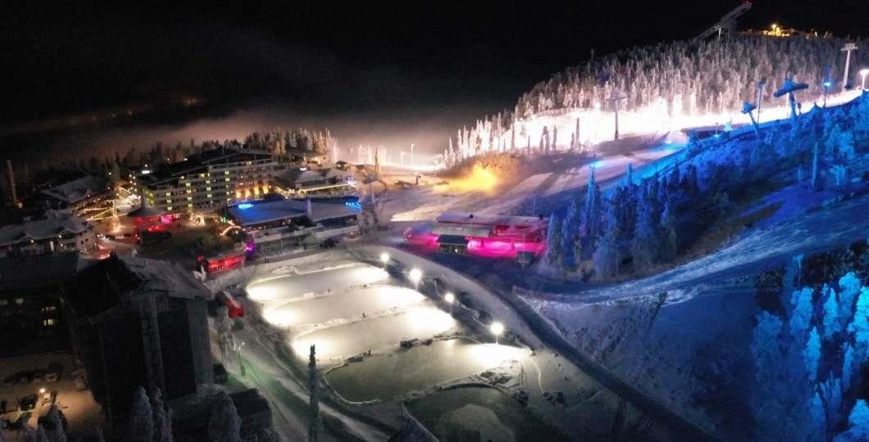
POLAR NIGHT FESTIVAL
Gabriela Zosllei
Student no: 2133167
Lecturer name: Kathryn Flynn
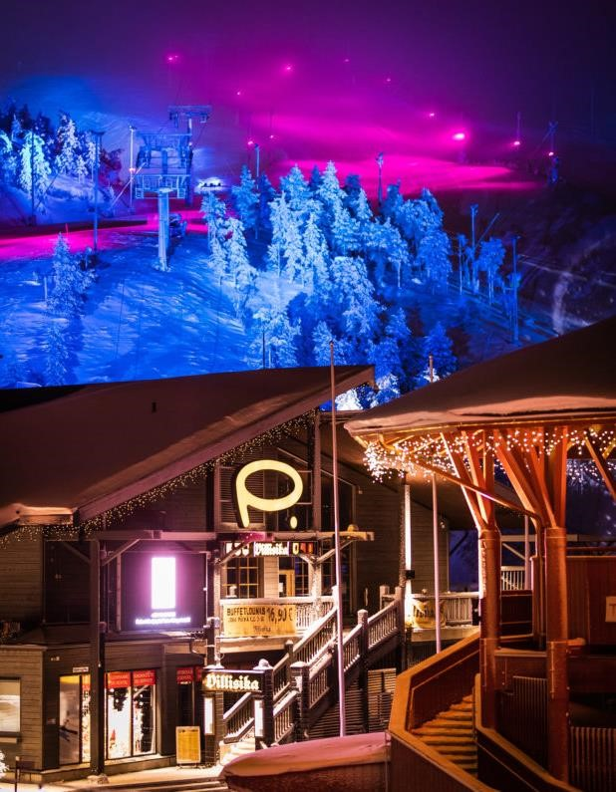
EVENT CONTENT AND
CONTEXT
Event Theme
:
An enthralling festival with a winter theme that showcases
the splendour of polar evenings, dazzling auroras, and intimate
stargazing encounters beneath the night sky (Xu
et al
., 2021)
Type & Nature
:
This is an immersive outdoor adventure that blends cosmic
phenomena with the wonders of nature, situated in an
attractive park.
Event Length
:
The festival lasts for three enchanted evenings, during which
time guests can go stargazing, take in light displays, and take in the
allure of winter (Akhundova, 2024).
Target Audience
:
Designed for those who enjoy the outdoors, families
looking for unusual circumstances, and those who are interested in
astronomy and the grandeur of the arctic regions.
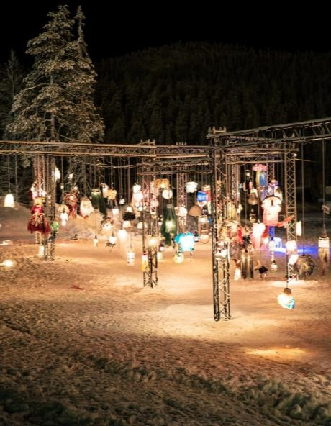
EVENT CONTENT AND CONTEXT
EVENT PURPOSE
:
My goal in this event is to
promote consciousness about arctic ecosystems
while celebrating the natural beauty of
winter nights.
•
Give guests a one
-
of
-
a
-
kind,
realistic arctic night and celestial
phenomenon adventure.
•
Involve guests with themed events
such as cultural narratives,
stargazing, and light displays
(
Arsalan,
Yirmibesoglu

and
Ozsoy
,
n.d
).
I WILL ARRANGE FOLLOWING ACTIVITIES FOR THIS EVENT:
Aurora Light Show: In term of creation of a mesmerizing
nighttime visual experience, installation of spectacular
lighting system will be made, and northern lights are set for
music.
Guided Stargazing Sessions: Guided trips to see the northern
sky where experts help you look at stars, planets, and other
things in space (
Bengesser
, Hansen and
Gemzee
, 2020).
Winter Folklore Storytelling: Enjoying fun story
-
telling times
by the warm bonfires, sharing tales about cold places, winter
legends, and stories about the sky.
Interactive Art Installations: Art displays that allow people to
explore the beauty of the Arctic and are inspired by winter
and space.
MARKET FACTORS
Target Market: Those interested in
astronomy, families, the outdoors, and
nature who want to immerse
themselves in immersive outdoor
experiences centered around celestial
phenomena will be drawn to the
event.
Potential Rivals: While there are some
winter festivals and light displays in
the area, none of them specifically
address polar themes or astronomy.
Demand analysis:
•
More people are enjoying nature events: in 2019, the worldwide wellness tourism
business was worth about $639 billion. By 2022, it is expected to be $919
billion. This market offers activities related to nature, like looking at stars and
going to eco
-
friendly festivals (Global Wellness,
n.d
).
•
Stargazing and light festival trends: more people are enjoying stargazing and
light festivals are becoming more popular. About 250,000 people went to the
UK’s luma light festival in 2020, which was 25% more than the year before
(
Eventbrite,
2021).
•
Interest in eco
-
friendly tourism: 83% of people traveling from other countries
believe it's important to travel in a way that's good for the environment.
Additionally, 61% say the pandemic has made them want to travel more in an
eco
-
friendly way. These numbers come from booking. Com's 2021 report on eco
-
friendly travel.
•
Astronomy enthusiasm: more and more people are interested in astronomy. Places
for stargazing, like dark sky parks, are seeing a 20% increase in visitors each
year. This shows that more travelers want to enjoy astronomy (Booking.com,
.
2021)
MARKETING FOR POLAR NIGHTS
FESTIVAL
Product:
•
Based on focus on nature
-
themed, stargazing, and polar lights activities, the Polar Nights Festival is
considered as one immersive experience.
•
A variety of interactive experiences tha are provided are included in the product offerings such as guided
stargazing sessions, storytelling, and light installations (Dalgoic and Birdir, 2020).
Price:
•
The use of a strategy that is called as tiered pricing will be focused which is based on including full
-
access
tickets, VIP stargazing experiences, family passes, and general admission.
•
The setting of prices will be done in a way that will help in catering segments of audiences and profitability
and affordability would be ensured
(
Cambrubi
,
Coromina

and
Guia
, 2023).
Place:
•
Cairngorm Mountain Resort, Scotland is the location where this event will take place and scenic winter
landscape and clear night skies are factors of its selection
•
An authentic and immersive experience of winter will allow by this venue (Darmawan and Grenier, 2021).
MARKETING FOR POLAR NIGHTS FESTIVAL
PROMOTION:
•
Social Media & Influencer Marketing: platforms that will be
leveraged by the event include Tik Tok and Instagram based on aim
of focusing on influencer collaboration ad targeted ads. Engaging
content will be created by influencers and behind the scenes footage
will be shared by them so that the increase in sales of tickers could
be achieved (Yasa
et al
., 2020).
•
Traditional Marketing: Posters, flyers, and brochures will be also
used in addition to efforts that will be made at digital level and
these would be distributed to nature reserves, eco
-
friendly stores,
and local tourist areas. Tourists and locals would be targeted by
these materials with a focus on immersive experience by this festival
(
Davies
et a
l., 2023).
•
Eco
-
Tourism Partnerships & Environmental Organizations: Credibility
and a broader reach will be also provided based on collaboration
with environmental organizations such as WWF and eco
-
tourism
agencies. The event will be promoted by these partners to audience
that is eco
-

conscious based on both use of printed materials and
digital channels.
People:
•
Experienced staff will play key role for the festival such as
volunteers, stargazing guides, and event coordinators so that
engaging and seamless experience could be ensured to be existed
for attendees (
Jechow
, 2024).
Process:
•
The experience of customers will be streamlined from purchase of
ticket to participation by customers based on on
-
site management
and online system of booking and in this way smooth transitions will
be ensured between different activities.
Physical Evidence:
•
the ambiance created by branded merchandise, themed
decorations, and light installations is involved and included in the
physical evidence based on which the overall experience will be
enhanced and it will serve as reminders.

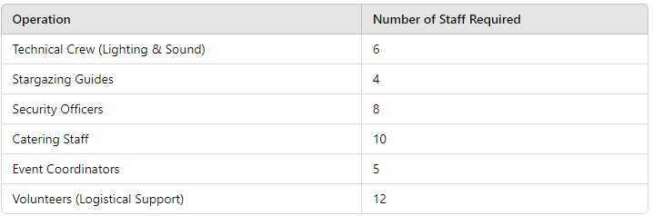
OPERATIONAL FACTORS
Staffing Requirements:
A technical staff to oversee light setups and
logistics, expert stargazing directs, security officers, and food teams
are needed for the event (Gold and Gold, 2020). For this event I will
arrange following staff members

OPERATIONAL FACTORS
Resource Allocation: To guarantee a flawless, pleasurable event, set aside enough money
for top
-
notch lighting, audio equipment, safety measures, and caterers (Yasa et al.,
. I will use the resources shows in the table below
2020)
:
8
Resource Required
How It Will Be Acquired
Lighting Installations
Team up with a local lighting company that focuses on organizing outdoor events. Hire experts to create pathway lights and li
ght

displays inspired by the aurora.
Audio Equipment
Rent high
-
quality outdoor sound systems from a trusted equipment rental provider. You can rent backup equipment for emergencies.
Security Personnel
Hire a well
-
known security company to provide trained staff for emergency plans and crowd management.
First Aid Stations
Team up with local health services to set up first aid stations. Hire trained first responders for the event (Finkel and Plat
t,
2020).
Heated Areas
Set up warm areas or tents and rent space heaters. To find temperature control solutions, contact a local equipment rental co
mpa
ny (Lohnas, Healey and Davachi,
2023).
Caterers
Proper connection should be made with caterers at local level who have specialization in winter
-
themed food. Vendors should be s
elected based on considering
past experiences with larger outdoor events.
Signage & Emergency Lighting
In install safety/emergency lights and clear directional signs at the venue it is important of working with provider of signa
ge
and emergency lighting.
Event Coordinators
Through a staffing agency, an experienced event planner could be hired. Logistics will manage by event coordinators and the s
moo
th running of event will be
ensured.
Volunteers
Volunteers should also need to be recruited from university programs and community groups at local level so that helps could
be
taken regarding logistical support
and welcoming guests.
FINANCIAL FACTORS
Revenue sources:
Sales of tickets: revenue received from guests who buy tickets to
take part in the event's exclusive polar
-
themed activities.
Food and merchandise sales: added income from food stalls and
event merchandise, like polar lights and stargazing themed
souvenirs.
Collaborations: creating alliances that help fund the event by
working with local companies, hotels, and travel agencies
Knottnerus, Johnson and Mason,
2022).
(
Expense Category
Cost (£)
Venue Rental
£15,000
Lighting Installations
£12,000
Event Staff
£10,000
Permits
£2,000
Catering
£8,000
Marketing
£5,000
Safety Measures
£3,000
Total Estimated Costs
£55,000
FINANCIAL FACTORS
Sponsorships
•
Tourism boards: To get sponsorship, I will contact to VisitBritain and VisitScotland. The organizers
want to get more attention and money by working with these tourism groups and using their existing
connections (
akhundova
, 2024).
•
Environmental organizations: To support the event's focus on being environmentally friendly, I will also
team up with national trusts and groups that protect the environment, like WWF UK. Their involvement
will add credibility and support, which will attract the festival's audience of nature lovers and fans
(
akhundova
, 2024).
•
Astronomy
-
related businesses: I will look for companies that focus on astronomy, like
Celestron

UK and
the Royal Observatory Greenwich, to support this event. These businesses will offer branded
merchandise and expert guides for stargazing, as well as financial help (
akhundova
, 2024).

Funding sources include retail sales, sales of tickets, sponsorships from ecological organisations, and possible financing from the local government to encourage natural and environmentally friendly events
(Yozukmaz, Bertan and Alkaya, 2020).
Estimated revenue: depending on projected participation and pricing approach, income will be made from the sale of tickets, meals, and goods.
FINANCIAL FACTORS

Break-even point: if the event receives sufficient finance and ticket sales, all operating expenses will be met, guaranteeing no loss of revenue (yozukmaz, bertan and alkaya, 2020) Potential for profitability: in order to break even, income can be attained via sponsorships, smart ticket prices, and meticulous cost control.

Akhundova, A., 2024. Role of Festivals in Stimulating the Development of Event Tourism. Theoretical And Practical Research In Economic Fields, 15(2), pp.277-287.
Arslan, A., Yirmibeşoğlu, S. and Özsoy, B., Popularizing Polar Sciences: Opinions on the Polar Festival. Uluslararası Türk Eğitim Bilimleri Dergisi, 12(1), pp.500-534.
Bengesser, C., Hansen, K.T. and Gemzøe, L.S., 2020. Location marketing and cultural tourism. Detect Deliverable, 4.
Booking.com (2021) Sustainable Travel Report. Available at: https://www.booking.com/articles/sustainable-travel-report.en-gb.html (Accessed: 2 October 2024).
Cambrubí, R., Coromina, L. and Guía, J., 2023. 6 Night and Light: Nocturnal Tourism. A TEMPORAL ANALYSIS, p.71.
REFERENCES
Dalgiç, A. and Birdir, K., 2020. Key success factors on loyalty of festival visitors: the mediating effect of festival experience and festival image. Tourism & Management Studies, 16(1), pp.28-38.
Darmawan, D. and Grenier, E., 2021. Competitive advantage and service marketing mix. Journal of Social Science Studies (JOS3), 1(2), pp.75-80.
Davies, K., Gouthro, M.B., Matthews, N. and Richards, V., 2023. Festival participation, inclusion and poverty: an exploratory study. Tourism and Hospitality, 4(1), pp.51-74. Eventbrite (2021) LUMA Light Festival Attendance Data. Available at: https://www.eventbrite.com/ (Accessed: 2 October 2024).Global Wellness Institute (2021)
Finkel, R. and Platt, L., 2020. Cultural festivals and the city. Geography Compass, 14(9), p.e12498.
Gold, J.R. and Gold, M.M., 2020. Festival cities: Culture, planning and urban life. Routledge.
International Dark-Sky Association (2020) Dark Sky Tourism Report. Available at: https://www.darksky.org (Accessed: 2 October 2024).
Jechow, A., 2024. Let there be Skyglow—light pollution from a large outdoor music festival (Lollapalooza Berlin 2016). Scientific Reports, 14(1), p.11725.
Knottnerus, J.D., Johnson, K. and Mason, J.D., 2022. Highly Successful Expeditions. In Polar Expeditions (pp. 115-162). Routledge.
Lohnas, L.J., Healey, M.K. and Davachi, L., 2023. Neural temporal context reinstatement of event structure during memory recall. Journal of Experimental Psychology: General, 152(7), p.1840.
REFERENCES
Global Wellness
Tourism Economy
. Available at: https://globalwellnessinstitute.org (Accessed: 2 October 2024).
Uí Dholáín, M. and Silvennoinen, D., 2023. Review Paper of Current Status and Strategies with regards to Dark Sky Tourism in the Northern Periphery and Arctic Regions.
Xu, J., Lei, Z., Wang, H., Niu, Z.Y., Wu, H. and Che, W., 2021, January. Enhancing dialog coherence with event graph grounded content planning. In Proceedings of the Twenty-Ninth International Conference on International Joint Conferences on Artificial Intelligence (pp. 3941-3947).
Yasa, N., Giantari, I.G.A.K., Setini, M. and Rahmayanti, P.J.M.S.L., 2020. The role of competitive advantage in mediating the effect of promotional strategy on marketing performance. Management Science Letters, 10(12), pp.2845-2848.
Yozukmaz, N., Bertan, S. and Alkaya, S., 2020. Festivals’ social impacts and emotional solidarity. International Journal of Event and Festival Management, 11(2), pp.239-253.

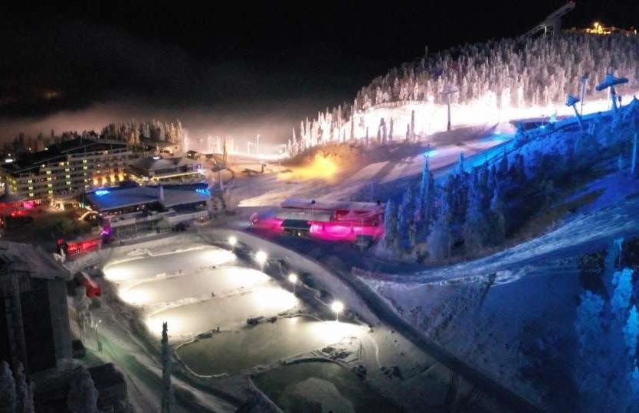
THANK YOU

