Module number ecey4001/c
Human development
2519650

I confirm that I have not used any AI tools In the research and creation of this assignment I confirm I have not presented any AI generated materials as my own work. I confirm I have copies of my drafts, notes, and other resources I used, which I may be asked to provide in evidence.

I acknowledge the use of Microsoft copilot Microsoft Copilot: Your AI companion on 29/11/2025 to create illustrations for my infographic. I used the prompts:
1 Generate an illustration of Maslow’s hierarchy of needs
2 Generate an illustration of an inclusive happy classroom
I confirm that I have not presented any AI generated text as my own work. I can confirm I have copies of my drafts, notes and other resources I used before, and after the use of AI tools which I may be asked to provide in evidence.

Infographic for module – explore Maslow’s model in depth
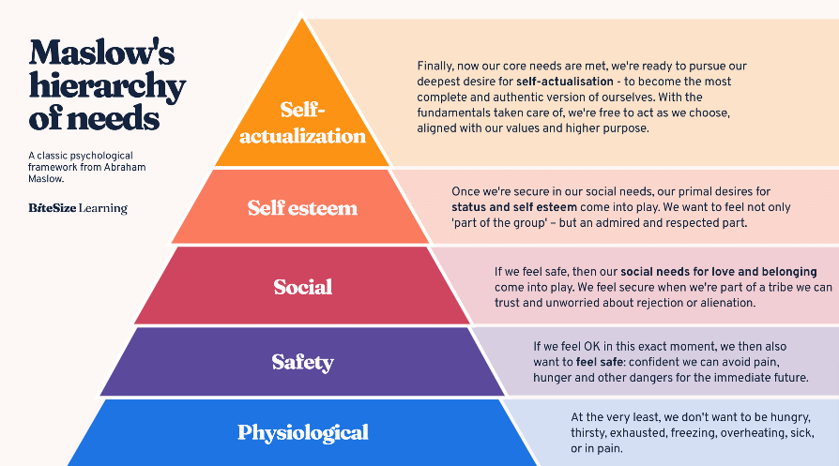
What is Maslow’s hierarchy of needs?

Bitesize learning

Maslow constructed his ‘hierarchy of needs’ to show that humans are driven by something deeper than just existence.
The five stages to the hierarchy are as followed.
- Physiological needs – fundamental needs for survival for example food, water, warmth and rest.
- Safety needs – physical safety, financial security, health and well-being.
- Love and belonging - the need for love and belonginess- friendships, intimacy and relationships.
- Self-esteem- the sense of accomplishment, recognition and desire for status.
- Self-actualization- the top of the hierarchy, the realisation of personal potential, self-fulfilment and personal growth.
Maslow (1943)
Maslow’s theory was that you had to fulfil the needs of the tier you were at before working up the hierarchy, for example you must first meet all needs in the physiological tier before attempting the safety tier.
‘Maslow attempted to explain human behaviour through the concept of human potential, Maslow proposed that all mentally healthy people share the same motivations, with self-actualization being the most virtuous.’ Stoianov, (2017) This statement is especially interesting as what are then the needs of someone who is not mentally healthy? What are the basic needs for those individuals? Is there an equivalent model for those who aren’t ‘mentally healthy’? Stoianov, (2017)

Criticism of Maslow’s hierarchy of need
Maslow’s hierarchy of needs has shaped many peoples outlook on the needs of people, King-Hill (2015) argues strengths and weaknesses to the ideology, ‘criticism of Maslow’s hierarchy has brought realisation that the hierarchy of needs is not a ‘one size fits all approach’ however King-Hill (2015) also states ‘ the hierarchy of needs has allowed for individualised learning pathways, resulting in a student centred approach, given consideration to environments both physiological and psychological.’
Schaller, et al. (2010) argue that ‘from an evolutionary perspective, the specific contents of the pyramid must be applicable to all people everywhere, but the specific prioritization of those contents (their actual position in the pyramid) is expected to vary in predictable ways across persons and situations.’
Dahhiam & Ghaleb (2024) propose that ‘the model is based on individuals’ subjective allocation of weights in their different needs. This highlights potential bias and raises questions about the reliability and validity of the weight allocation process. Human needs can be arbitrary, with the weight on certain needs changing over time’.
A criticism lies within the hierarchy itself being theoretical and not empirical, it’s a theory therefore not backed up by numerical data, a reason for this may be that testing the theory itself may be considered unethical, considering the first stage is basic needs for example, water, food, warmth, it would be against ethics to take this away from someone to see how they would perform. Dr Chavda (2024, p.97) supports this, stating that ‘Maslow’s hierarchy of needs is qualitive and subjective in nature. He did not use any scientific approach in this theory to define the nature of self-actualisation needs; therefore, it is not regarded as a realistic approach’.

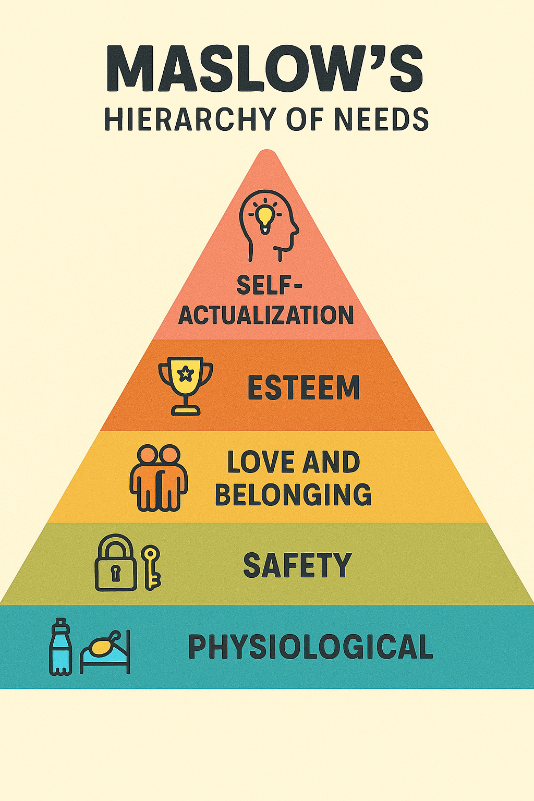



Impact of Maslow’s hierarchy

Maslows hierarchy of needs has shaped many practices, not just within education but within employment, within social sectors also, it has been fundamental for considering the whole persons needs. ‘maslows views have received much hectirorical attention and have been widely incorporated in social service practice’ Noltemeyer, A, et al. (2021).
An example of the impact maslows theories had would be to look at the success program which was established in 2005. Noltemeyer, A et al. (2021) explains it is a school-based system, but it is to be utilised by both children and their families. The program was designed based on the belief that taking away barriers, would then ensure impoverished students would be able to focus their time to academic tasks also taking away the anxiety surrounding if their basic needs were going to be met.
Within the early years practice, Maslow’s theory of human motivation has been valuable baseline to refer to when considering a holistic pedagogy. Naaz,H & Khalid,S (2023) explain how important it is to consider Maslow’s hierarchy and to use it in an individualised way, ‘educators and researchers should recognise that each student is unique and may have varying needs.’ Taking Maslow’s theory and applying it, the right support and environment can make a magnificent impact on a child’s experience and therefore their sense of belonging within a classroom.
Maslow’s theory of human motivation is a monumental theory that transformed the early years sector. It is practiced and implemented to this day. It is used in settings vast and wide, as a tool for the successful development of children.

References
Dahiam,B. Ghaleb,S.(2024) towards a dynamic model od human needs: a critical anaylyis of maslows hierarchy. International journal of multidisciplinary approach research and science. Vol 2, issue 3, pg 1031 Available at: (PDF) Towards A Dynamic Model of Human Needs: A Critical Analysis of Maslow's Hierarchy
Dr Chavda, AJ. (2024) Maslow’s hierarchy of needs: a critical evaluation. International journal of social impact. Vol 0, issue 3, pg 97. Available at: 18.02.012.20240903.pdf
King-Hill, S. (2015) Critical analysis of Maslow’s hierarchy of need vol 2(4) pages 54- 57. Available at: KingHill_CriticalAnalysisOfMaslows.pdf
Naaz, H. Khalid,S (2023) relevance of maslows hierarchy of needs in the education. International journal of physical and social sciences. Vol 13. Available at: IJPSS3July23_22806.pdf
Noltemeyer, A. James, AG. Bush,K. Bergen,D. Barrios,V. Patton,J. (2021) the relationship between deficiency needs and growth needs: the continuing investigation of Maslow’s theory. Vol 42, no 1. Available at: The Relationship between Deficiency Needs and Growth Needs: The Continuing Investigation of Maslow's Theory. (Article in Child & Youth Services). - Child Welfare Information Gateway
Oved, O. (2017). ‘Rethinking the Place of Love Needs in Maslow’s Hierarchy of Needs: III. Young Perspectives’. Society (New Brunswick), 54(6), 537–538. Available at: https://doi.org/10.1007/s12115-017-0186-x
Schaller.M, Steven.L, Neuberg, Vladas Griskevicius, Douglas T. Kendrick. (2010) Pyramid power: a reply to commentaries. Sage publications: perspectives on psychological science. Vol 5 (3) p335-337. Available at: Pyramid Power: A Reply to Commentaries on JSTOR
Stoi͡anov, S. (2017). An analysis of Abraham Maslow’s A theory of human motivation. Routledge.

Component 2
Explore in depth the concept of holistic child development with links to Maslow’s model

Holistic child development is an approach to childhood that nurtures a child’s growth as a whole person, rather than just focussing on academics as explored by Bronfenbrenners (1977) ecological theory, ‘a child’s environment has a major influence on their development.’ ‘Holistic development is the overall development of child, that means social, emotional, physical, mental and intellectual growth of the person’ (Dr, Sonali, et al., 2020) ensuring children work through Maslow’s model, for a child to achieve the ‘esteem and accomplishment needs’ they first must achieve ‘physiological and social/security needs’ intertwining the hierarchy of needs into the holistic development of children. ‘Enabling environments foster holistic approaches to early development and learning, recognising that different aspects are constantly connected in a child’s experience’ (Early education 2021).
When talking about holistic child development, it is crucial we acknowledge that childhood wasn’t always seen as it is today, up until the nineteenth century children were made to work in mines and factories at around age 7. Neglecting the early years in childhood, no education nor emphasis on the importance of these crucial years of life. It wasn’t until 1970 – 1980 that the attitude towards childhood changed (Conkbayir, M. Pascal,C, 2021). This change was impacted by theorists of the likes of Vygotsky suggesting that ‘a child’s development, thinking, social relationships are dependent on social and cultural concepts.’ (Norozi,SA, Moen,T, 2016) supported this by stating ‘Frobel’s values helped to create a much-needed change in how children were viewed and treated, particularly concerning education’ (Conkbayir,M. Pascal,C, 2021).
Holistic child development within education settings is utilised in a matter of ways, ‘a holistic summary will give attention not just of knowledge and skills, but also to the child’s emotional wellbeing, connections, and development of attitudes and dispositions for learning’ (Early education 2021). Recognising Maslow’s hierarchy of needs within the early years sector is crucial to a child’s success, meeting those basic needs for food and water and also needs for love and belonging will only aid in the child’s learning capabilities. Holistic child development means also going beyond academic results to consider all parts of a child’s life. This is supported by Rodiah et al., (2024) who further suggest that the cognitive, emotional and social developments being utilised simultaneously provide children with the opportunity to ‘develop optimally in various dimensions. This is particularly important when linking to Maslow’s theory as the act of satisfying a need, a basic need or a more complex growth need, will give a sense of accomplishment and well-being.
Within holistic child development, inside an educational setting, the practitioners would use an individualised approach, measuring the individual child’s needs, doing this they would use the right techniques and approaches to ensure the child’s potential could be nurtured. Using holistic child development would also encourage interconnectedness, understanding each area of development is linked. Within this approach there are the 4 C’s, these consist of communication, critical thinking, collaboration and creativity. (Dr, Sonali, et al., 2020) explains that ‘holistic development promotes self- confidence, self-awareness and increasing good sense of responsibility’ this aid in ‘developing strong critical thinking abilities and problem-solving attitude’ (Dr, Sonali, et al. 2020).
Holistic child development must practice a nurturing pedagogy with all practitioners understanding that when the main caregiver is absent, the practitioners must replace this absence with love, nurturing and belonging, in short, they must show the children love. This is supported by Grimmer,T p.6 (2021) who explains the ‘main benefit to adopting a loving pedagogy is that children will feel loved and have a sense of belonging’. This will in turn aid in a secure attachment between the child and the practitioner, this will have a positive knock-on effect on many aspects of the child’s development. The child will in turn feel more confident at the setting, which will lead to more exploration by the child, this will link into critical thinking by the child as they explore and learn new things within the setting. Linking Maslow’s theory to Bronfenbrenner’s ecological theory, you can analyse that ‘a child’s environment has a major influence on their development.’ Rodiah et al. (2024, p.3).

In conclusion, holistic child development is a powerful and important pedagogy within early years. It is pivotal to link Maslow’s theory of human motivation when deciding the approach to being a practitioner. Considering the whole child, taking all knowledge of several theories and implementing them into core values as a practitioner, to always ensure the child’s needs and met. Looking back in time to analyse how the theories have evolved and being critical when thinking is important, as to remain open to new theories and adaptions of previous ones, always putting the child first.

References
Conkbayir, M. Pascal, C (2021) early childhood theories and contemporary issues ; an introduction. Zed books. Available at : ProQuest Ebook Central - Reader accessed on: 26/11/25
Dr, sonali, Channawar, N. Gandhi, M. Chhattisgah, 2020 conceptual framework for holistic development. vol 82, no 24, pg 22, published at Dr harisingh Gour University. Available at; (PDF) Conceptual Framework for Holistic Development :NEP 2020
Early education (2021) Birth to 5 matters, non-statutory guidance for the early years foundation stage. Published on behalf of the early years coalition by Early Education. Available at: Birthto5Matters-download.pdf Accessed on: 25/11/25
Grimmer,T. (2021) developing a loving pedagogy in the early years. How love fits with professional practice. Routledge. Available at: Developing_a_Loving_Pedagogy_in_the_Early_Years_Ho.pdf
Norozi, SA. Moen, T. (2016) Childhood as a social construction. Department of education and lifelong learning. Norweigen university of science and technology Trondheim, Norway. Availble at: Childhood_as_a_Social_Construction.pdf Accessed on: 26/11/25
Rodiah,I, Zulaika, G, Sapurtra DG (2024) the importance of holistic education for early years childhood: integrating cognitive, emotional and social aspects. Vol 1 number 3. Available at: The_Importance_of_Holistic_Education_for_Early_Chi.pdf Accessed on:25/11/25
Schuelka, J, (2018) implementing inclusive education. University of Birmingham. Available at: 374_Implementing_Inclusive_Education.pdf Accessed on: 25/11/25

Component 3
Offer three examples from early years practice to highlight Maslow’s significance in understanding child development.
Example 1
Within this example I will discuss an experience where a child presents through behaviour how meeting basic needs is crucial to a child’s development. A child has come into the school setting, firstly I notice they are quiet and avoiding eye contact. Then I notice the child not focusing, quite emotional and reactive, generally quite challenging amongst peers within the classroom. I witness this and immediately ask myself why? I tackle this situation by replacing the child into a quiet calm area, finding out the child hadn’t eaten very well the last few days and was finding his clothes to be damp and uncomfortable.
Taking into account Maslow’s hierarchy of needs, straight away it is noticeable that this child hasn’t had his basic needs met, it would be unfair to expect this child to act appropriately in the classroom, understanding achieving milestones or the small tasks set throughout the day would not be a motivation of the child, when the child is still missing the building blocks that are his basic needs. Noltemeyer, A. et al. (2021) emphasise this by stating barriers posed by deficiency needs may limit aspects like cognitive, attentional, physiological needs, as well as opportunities to receive support with growth needs, in this case academic achievement. This idea is backed up by the research found by Conesa,PJ, et al (2022) who state that ‘psychological needs satisfaction is positively associated with motivation and engagement’.
To conclude, within early years practice it is pivotal to assess a child’s needs before their behaviour, behaviour is always telling something, often with children it is telling us of a need not met. This way using Maslow’s model it was identifiable that the child’s basic needs were in fact not met and had to be met for that child to engage and develop. Showing the child attention and compassion as well as then meeting the basic need that the child was lacking, impacted the child in a positive way.

Example 2
Within this example I will discuss a child who has autism showing difficulties within transitions and how this links in with a need for love, security and belonging. A child Is referred to play therapy for behavioural difficulties, one of his main struggles is transitions, this may be a large transition such as, starting a new school or going to a new setting. However, it could also be a minor transition, such as going from one activity to another within the same setting. Both extremes are equally as challenging for this child, the biggest concern is how we approach transitions to make them less anxiety producing for the child.
Within this example it is key to link the child’s anxieties surrounding transitions to Maslow’s theory, specifically love and belonging, with the lack of these feelings during transitions being the catalyst for these struggles within social situations. Research done by autism education trust found that ‘reasonable adjustments are positive steps to ensure learners with autism can fully participate in school life’ implementing this into the child’s day would ensure the child has their love and belonging needs met, nurturing this would hopefully give the child the opportunity to develop within the setting. The importance of a positive transition is imperative, supported by research from Snape et al, (2019) suggesting if transitions have a negative affect on the child, in turn the impact would be ‘in school misbehaviour, decline in feelings of school belonginess and connections’ furthering this argument Early education (2021) explains that recognising several aspects are connected in a child’s experience and fostering a holistic environment will ensure the best development for the child.
In conclusion, I would tackle this situation in a proactive way, over a reactive way. Ensuring this child’s additional needs were considered, as research shows that negative feelings surrounding transitions, have a deep and long-lasting impact on the child. Education on this topic would be essential to ensure the right techniques were used by the early year’s practitioners for this child, tailoring it to said child to ensure the psychological needs of the child were met, ensuring the idea that belongingness and emotional security are pivotal for a child’s success within early years.
Example 3
Within this example I will discuss a toddler who is of pre-school age, experiencing a flu type illness. The toddler Is appearing to show sings of a temperature, lethargic and with a disposition not usual for the child. A temperature is then followed by sickness. The child is tired and is needing a lot of attention and affection. Refusing food and water, only appearing to need comforting and affection.
Due to the child having a secure attachment with his primary care giver, the child clings on to practitioners for love and comfort. Bowlby’s research shows one overwhelming fact ‘attachment is a biological necessity’ Porter,LL (2003) this evidence suggests similarities to Maslow’s hierarchy theory, the child’s need for comfort and affection is as significant as meeting basic needs. Grimmer,T (2021) explains how ‘the main benefit to adopting a loving pedagogy is that children will feel loved, and have a sense of belonging’ this explains why a loving pedagogy is essential within the early years sector, referring back to Maslow it makes perfect sense to use this pedagogy to nurture a child’s social skills, sense of belonging and confidence.
In conclusion, nothing can prevent illness within the early years sector as it is quite a common occurrence, however we as early years practitioners can control how we react, and how we act to the child with the illness. I think it is important to always remember when s child is in the early years setting, we as practitioners are the care giver replacing the primary caregiver, the affection and care we show to the child has maintain the levels set by the primary care giver.

References
Autism education trust: supporting learners with autism during transitions. Available at: Supporting learners with autism during transition.pdf
Conesa, PJ. Onandia-Hinchado, I. Dunabeitia, JA. Moreno,MA (2022) Basic psychological needs in the classroom: a literature review in elementary and middle school students. Learning and motivation, vol 79. Available at: Basic psychological needs in the classroom: A literature review in elementary and middle school students
Grimmer,T. (2021) developing a loving pedagogy in the early years. How love fits with professional practice. Routledge. Available at: Developing_a_Loving_Pedagogy_in_the_Early_Years_Ho.pdf
Noltemeyer, A. James, AG. Bush,K. Bergen,D. Barrios,V. Patton,J. (2021) the relationship between deficiency needs and growth needs: the continuing investigation of Maslow’s theory. Vol 42, no 1. Available at: The Relationship between Deficiency Needs and Growth Needs: The Continuing Investigation of Maslow's Theory. (Article in Child & Youth Services). - Child Welfare Information Gateway
Snape, DJ. Cantali,D. Macgillvary,S. Hannah,E. (2019) Primary- secondary transitions: a systematic literature review. Transformative change: educational and life transitions research centre. University of Dundee. Available at: Supporting documents - Primary to secondary school transitions: systematic literature review - gov.scot

