ECIE5004

Elisa Parry - Student Number: 2115500

Celebrating Language and Culture
Belonging to Wales

Portfolio

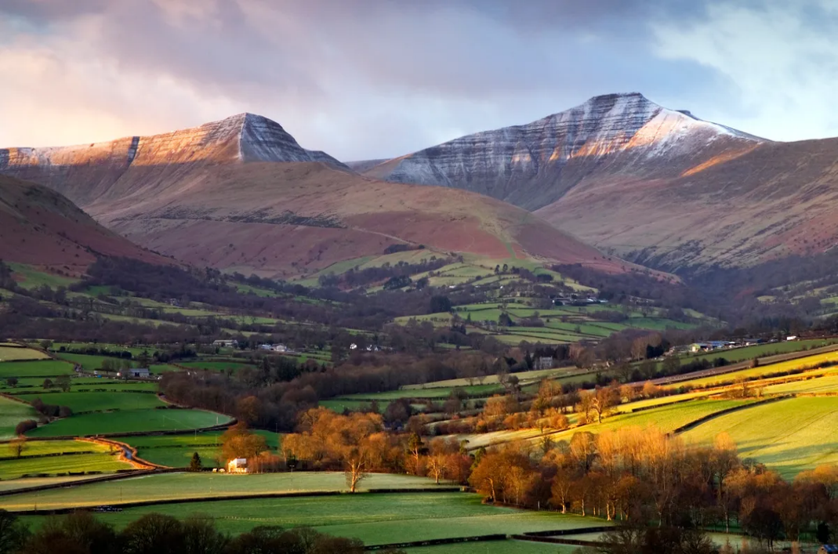

Brecon Beacons

Contents

Rationale 3-4

Overview of Activities 4-6

Evaluation 6-7

Appendices 7-9

References 10-11

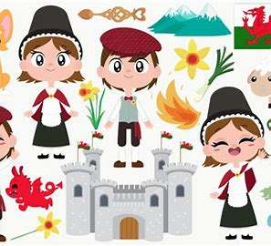

Welsh lady

This portfolio will look into activities used that promote the welsh language within the setting I work. It will also look into the history of the welsh language and how it has been extremely difficult for Wales to have its own identity with its own language over the years. It will describe the activities that I use within my own setting that promotes the Welsh language to demonstrate that the language is kept alive. The school in which I work is an English medium school and follows its own bilingual policy (Appendix 1). It states that the school aims to promote bilingualism across the curriculum at a level appropriate to the child’s age and ability. This demonstrates that English medium schools are active in promoting the Welsh as a second language as mush as possible.
Living in Wales, I feel it is important to be able to understand, converse or be fluent in our mother language and be passionate about it. There has been a decline in the number of welsh speakers within wales since the last census in 2001. Even more concerning is that every 10 years since the census began and information was obtained in 1901, the percentage of welsh speakers has declined up until the present day (Welsh Assembly Government, 2003). The 2021 census took place during the covid pandemic. Children were home learning and many places were shut for long periods of time and it is not known how the pandemic would have affected the figures and the ability to speak the language (Owen, 2022).
Residing in Brecon, the welsh language is not very strong in the area and therefore the language is slowly fading away. Jeremy Miles MS, The Minister for Education and Welsh Language has published a 10 year strategic plan which will set out plans to increase the number of welsh speakers within our education workforce. This will ensure that every learner in Wales has the chance to speak the language and to use this in an everyday life situation (Miles, 2022). There are clusters of areas within Wales that speak varying amounts of Welsh on a daily basis. Carmarthenshire, Ceredigion, Gwynedd, Conwy, Denbighshire and the Isle of Anglesey have the most Welsh spoken and some in the county of Pembrokeshire and Neath Port Talbot. Surprisingly, the largest County in Wales has the least amount of people that speak Welsh in comparison with all the other counties. Possibly because of the size of the county but almost definitely counties in North Wales converse in Welsh a great deal more than in the south.
In 1870, three quarters of the population were able to speak 1st language welsh and for some this was their only language they could converse in. The Education Act was formed at that time and was not designed for Wales, only for England as Wales and the Welsh language was seen as less important. It was classed as the language of the working class and did not rate very highly with the wealthy and the elite. In 1870 many of the teachers only spoke English and forbid the children to speak Welsh within the classrooms as they were trying to teach and instil English in all the children. If the children were caught speaking Welsh, they were given what is called the ‘Welsh not’ (Appendix 2) which was a wooden sign that would hang around the neck of the child. It would be passed onto any child that spoke welsh and the child wearing it at the end of the day would be punished (Jones et al, 2023).
Furthermore, the Welsh Language Act came into force in 1993 and it was stated that both the Welsh and English languages should be treated equally and not less favourably as it was in previous years (Welsh Government, 2021). This was a breakthrough for Wales and the Welsh language in general. The Welsh Language (Wales) Measure 2011 replaced the Welsh Language Act on 7th December 2010 to have official status in Wales (Welsh Language Commissioner, 2024).
The Welsh Assembly Government’s aim is to reach 1 million individuals being able to speak Welsh by the year 2050, called Cymraeg 50 - a million Welsh speakers. This is an excellent campaign, and they are encouraging everyone to take part. The Welsh language belongs to us all and we all have a part to play in ensuring that Cymraeg 50 happens and a part to play in its future to. This could be as simple as reading Welsh books, watching and listening to S4c, chatting to friends and colleagues to improve our Welsh skills. Children and staff within the school should feel proud of their Welsh heritage, their Welsh identity and the ability to speak a language which will benefit them in years to come. There are courses available in the local area for individuals wanting to learn Welsh and be inspired by learning a new language whatever your age. The Welsh Language Charter Programme supports the Cymraeg 50 by aiming to inspire children and young people to speak Welsh within all various social situations. It also supports the Curriculum for Wales in following the Four purposes (Welsh Goverment, 2023). (Appendix 3)
Within our school and in particularly in the Foundation Phase we give the children opportunities to develop their skills in enabling them to communicate in Welsh with confidence, by stimulating pupil’s interests and motivating them by;
- Singing songs and nursery rhymes
- Listening to welsh stories
- Hearing the welsh language being spoken on a daily basis
- Using incidental welsh (simple words and phrases being spoken all the time)
- Welsh Assemblies

Activity 1

Ardal Gymraeg

Language and Communication is a life skill, not just in English but in any language. Communication is vital within any social situation and will connect us to places and people (Welsh Government, 2022). Being bi-lingual is a skill that enhances your ability to learn other languages, so within our reception class we have a continuous provision Welsh corner (Ardal Gymraeg). This area demonstrates the culture of the welsh language with dragons, daffodils, key phrases and phrases of the week. The area has the added benefit of role play bringing in the historical element like the welsh lady costume. The children enjoy dressing up and are encouraged to use their welsh in that area and then continue the language into the classroom thereafter (School Policy, 2021). The welsh lady costume is the national dress of Wales (Appendix 4) and is based on working women and the clothing they wore during the nineteenth century in rural areas of the Country (Wales.com, 2023). Staff encourage children to use welsh throughout the day in any area of the classroom, with phrases like ‘Ga i help, os gwelwch yn dda’ or ‘ble mae Sophie?’ and ‘Lewis dim yma’ and believe it is all part of the learning process that they may make mistakes like Piaget (1896-1980) has stated. He believed that children should be able to “learn from their mistakes” and that they will be at different stages with their language development depending on their individual cognitive development (Bates, 2019). Chomsky also believes that we are born with a tendency and innate capacity to learn a language and in children, it comes naturally with not much effort and is “another genetically programmed inevitability of human development” (Bates, 2019, p. 210).
Activity 2
Criw Cymraeg
Living in Wales and being an English medium school, it is imperative that the Welsh language is a big part of the school day as much as is possible. Criw cymraeg is a group of pupils that have been chosen by the remaining children within the class after putting themselves forward to represent and promote the Welsh language within the school. Once they have been chosen, they will receive a badge (Appendix 5) so all children within the school are aware who the representatives are. The group will meet on a regular basis to discuss everything ‘Welsh’ and how they can promote it. John Dewey (1859-1952) believes that if children come together and discuss a topic then each child in that group will take on the ideas, suggestions and experiences of all the other children in the group. It suggests that every student has something to bring to the table, which is of benefit to all (Nickerson, 2023). Part of what the Criw Cymraeg have arranged is the Seren yr Wythnos (Appendix 6). This is the Welsh award of the week and a child from each class will be awarded this if the staff believe they are worthy of the award. Perhaps they know their colours in Welsh or been doing some great counting in Welsh. In our reception class, they will then take Dilwyn the dragon home in a bag, along with games, QR codes to link with songs and some welsh colouring sheets. For a child to receive that award they will be aware that if they show good behaviour and good knowledge of a subject, at some point they will receive the award too. B.F.Skinner (1904-1990) was a 20th century psychologist who believed that behaviour from the outcomes of punishment and reinforcement can be altered/changed. So, basically in terms of an award, if they see their friends getting the award because they have been speaking welsh, then that child will start speaking welsh, in the hope that they will receive the award next time (Structural Learning, 2023).
Activity 3
St Davids Day
This is celebrated every March 1st of every year to celebrate the life of St David who was the Patron Saint of Wales who was born in the year 500 and died on 1st March 589. St David was a well-known and highly respected preacher who founded settlements and churches in Wales (Welsh Government, 2024). This is a celebration throughout the whole of Wales, where children, young people and even adults dress in traditional Welsh costume or rugby shirts. Schools also have a St David’s Day Eisteddfod (which is different to the Urdd Eisteddfod) to celebrate the children’s achievements in Welsh where the children participate in singing, recitation, dancing, and instrumental performances. It’s a fun filled day and the judges decide from each category who becomes 1st (Cyntaf) 2nd (Ail) or 3rd (Trydyyd). There would also be a handwriting section (in Welsh) which would have been undertaken a few weeks previously and judged on that morning. Enabling the children to perform on the stage is excellent for their self-esteem and confidence. Some children feel too overwhelmed to stand on a stage and perform in front of a big audience but with encouragement and support the child will feel more inclined to have a go. Albert Bandura (1901-1994) believes that using the self-efficacy theory, it is possible. Positivity is key and if you think to yourself that its not possible, then you will convince and talk yourself out of doing something and give up. Ideas that Bandura thinks making it possible are: Practicing, observing others and how they are conducting themselves, listening to words of encouragement and being positive helps improve performance (Adeline et al, 2016). I tend to agree with Bandura in the fact that thinking positive will make a difference on how you perform but also will benefit your mental health.
Activity 4
Everyday activities
It is extremely beneficial when learning a language to hear it being spoken around you all the time. We are lucky enough within our area of Wales to live in the geographical area near the Brecon Beacons and to see the mountains from our school. Art projects are undertaken focusing on the mountains, sharing photos and linking shapes in welsh to the mountains also – bach, mawr, triongl.
When learning about 2d shapes, we also use the Welsh vocabulary – cylch, sqwar etc. The children continue to look for ‘cylch’s’ and ‘sqwar’s’ and objects that are bach and mawr in their outdoor learning as this is just an extension of the classroom and so crucial to their childhood (Froebel Trust, 2023). Welsh is being used within our school on a daily basis as much as is possible as it is so beneficial to have some knowledge of a language, as it puts the child in good stead as they continue onto high school.
Other activities we take part in are:
- Helpwr Heddiw – (Helper today/today’s helper) 2 children are tasked with doing jobs, washing up, turning lights out, giving out playdough, leading the other children into the hall, run errands etc
- Shw Mae Day - a day to celebrate the Welsh language starting every conversation with Shw Mae?
- Santes Dwynwen – 25th January. This is the Welsh version of Valentines Day. Saint Dwynwen was the Welsh patron saint of love.

People are constantly moving into the area from outside of Wales which is significantly diluting the Welsh language. Maybe this is the case for Powys/Mid Wales/Brecon Beacons and Pembrokeshire as these areas are not flourishing with Welsh speakers or Welsh learners. Possibly some properties within these areas are being purchased as holiday homes which is not great for the Welsh language and Cymraeg 50. I learnt Welsh when I was 30 years old and therefore feel very proud and passionate about the language and very saddened at the possibility that the language is in decline. There are many courses available for one to learn the language, but you must keep it up otherwise you will lose it. “Use it, don’t lose it”.
Our history and culture are our identity, and we cannot lose what has been there before us for hundreds of years. Wales is very aware of our role in respect of our culture and continues to thrive in making it a reality. Implementing the Welsh language in Wales to achieve Cymraeg 50 is falling short and more needs to be done as public bodies are not being creative in setting goals to achieve what is deemed to be ambitious, but achievable (Future Generations, 2020).
I continue to give lots of praise and encouragement to any child who speaks Welsh or predominately just has a go, as these children in our schools now are our future and will represent part of our Cymraeg 50 – a million Welsh speakers by 2050!

Appendices
Appendix 1
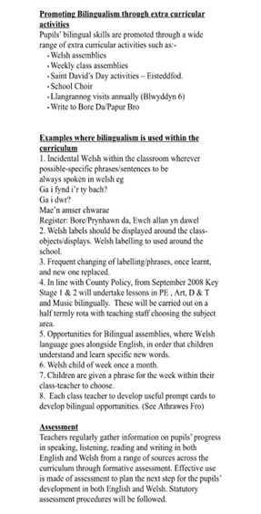
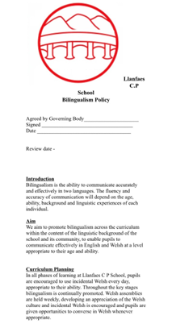
School Bilingualism Policy

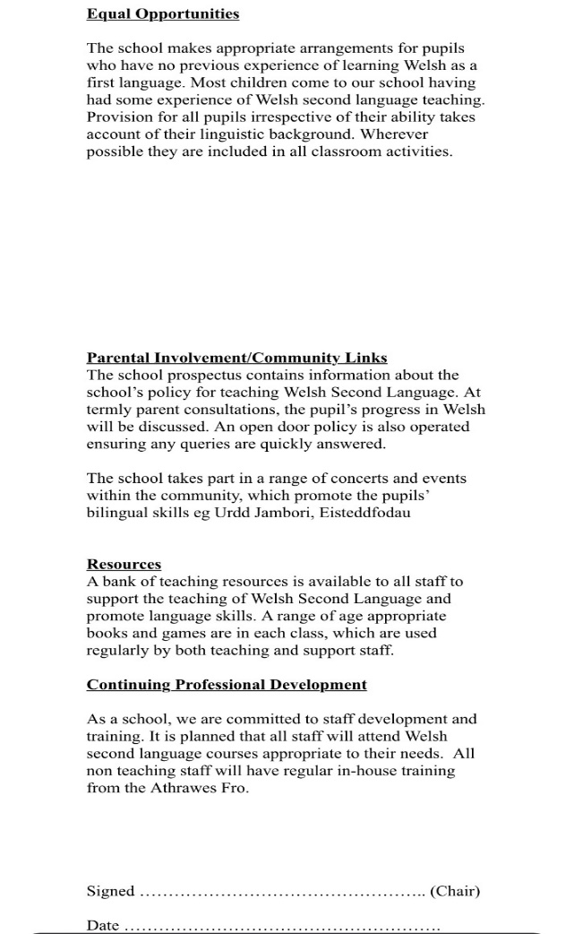

*Hyperlink to policy on school website if not clear*

http://d6vsczyu1rky0.cloudfront.net/30289_b/wp-content/uploads/2016/09/Policy_bilingualism.doc

Appendix 2 Appendix 3
Welsh Not The Four Purposes
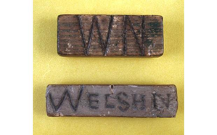
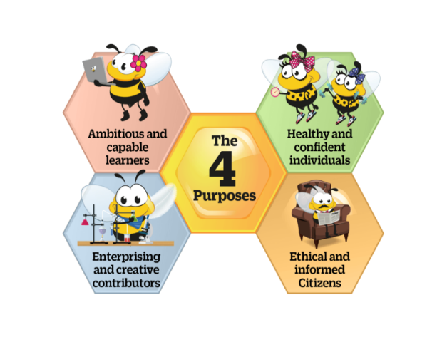
Bbc.co.uk/a history of the world

St-josephs-catholic-primary-school
bbc.co.uk

Appendix 4
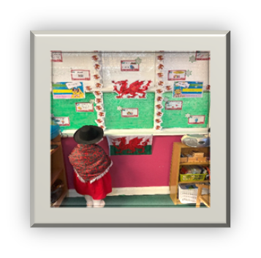

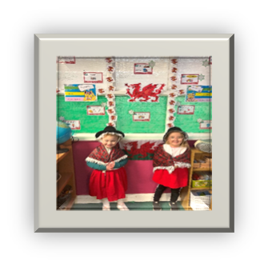
Welsh lady costume/role play
Ardal Gymraeg
The National Dress of Wales

Appendix 5 Appendix 6
Badge Certificate
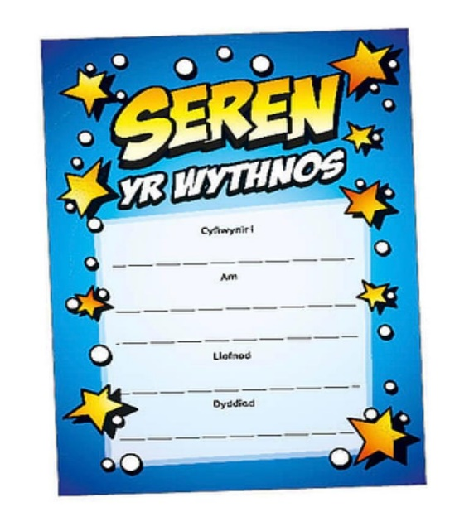
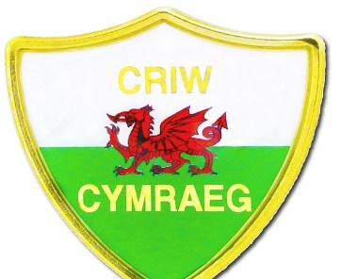

Criw Cymraeg badge

Certificate Welsh award

References
Adeline et al, Bandura’s Self-Efficacy Theory, 2016
Available at: http://www.youtube.com@wlt4939
(Accessed: 4 January 2024).

Bates, B., 2019. Learning Theories Simplified. 4 ed. London: James Clark.
Froebel Trust, 2023. Training and Resorces - Children and Nature.
Available at: http:/www.froebel.org.uk
(Accessed: 2 January 2024).
Future Generations, 2020. The Future Generations Report 2020 - At a Glance, Cardiff: Commisioner for Wales.
Jones, G.E. and Roderick, G.W. (2003) A History of Education in Wales. Cardiff: University of Wales. Available at: https://search-ebscohost-com.ezproxy.uwtsd.ac.uk/login.aspx?direct=true&db=nlebk&AN=117706&site=ehost-live
(Accessed: 27 December 2023).
Miles, J., 2022. Welsh in Education Workforce Plan, Cardiff: Welsh Government.
Nickerson, C., 2023. John Dewey on Education : Impact and Theory.
Available at: http://www.simplypsychology.org
(Accessed: 4 January 2024).
Owen, L., 2022. Welsh Language in Wales (Census 2021).
Available at: http://www.gov.wales
(Accessed: 1 January 2024).
Pedagogy 4 Change, n.d. Great Pedagogical Thinkers.
Available at: http://www.pedagogy4change.org
(Accessed: 4 January 2024).
Powtoon, 2016. Bandura's Self-Efficacy Theory, s.l.: Powtoon.
School Policy, 2021. Welsh Second Language Policy. Brecon: s.n.
Structural Learning, 2023. Skinner's Theories.
Available at: http://www.structural-learning.com
(Accessed: 2 January 2024).
The Four Purposes, nd
Available at: st-josephs-catholic-primary-school16.j2bloggy.com/new-curriculum/
(Accessed: 3 January 2024).

Wales.com, 2023. Black hats, petticoats and bedgowns - exploring traditional outfits in Wales.
Available at: http://www.wales.com
(Accessed: 27 December 2023).
Wanderlust, 2001. Brecon Beacons,
Available at: http://www.wanderlust.co.uk
(Accessed: 5 January 2024).

Welsh Assembly Government, 2003. A National Action PLan for a Bilingual Wales.
Available at: http://www.valeofglamorgan.gov.uk
(Accessed: 3 January 2024).
Welsh Goverment, 2023. Siarter Iaith.
Available at: http://www.hwb.gov.wales
(Accessed: 2 January 2024).
Welsh Government, 2021. Law Wales.
Available at: http://www.law.gov.wales
(Accessed: 1 January 2024).
Welsh Government, 2022. Languages, Literacy and Communication.
Available at: http://www.hwb.gov.wales
(Accessed: 3 January 2024).
Welsh Government, 2024. Five Facts about Saint David.
Available at: http://www.visitwales.com
(Accessed: 4 January 2024).
Welsh Lady, 2019 The Hungryjpeg
Avaiilable at: http://www.thehungryjpeg.com
(Accessed:6 January 2024).

Welsh Language Commissioner, 2024. The Welsh Language Measure.
Available at: http://www.welshlanguagecommissioner.wales
(Accessed: 2 January 2024).
Welsh not, 2014
Available at: www.bbc.co.uk/ahistoryoftheworld/objects/j35VCjYcS0CC3RGzvkLb-Q
(Accessed: 4 January 2024).

