DS 1 Template

My Screenshots/Photos
- Please add 4–6 screenshots or photos of your digital life.
- You can use your phone or laptop.
- For each screenshot, write one or two sentences explaining what it shows.

Screenshot/Photo 1
[Insert Photo/Screenshot below]
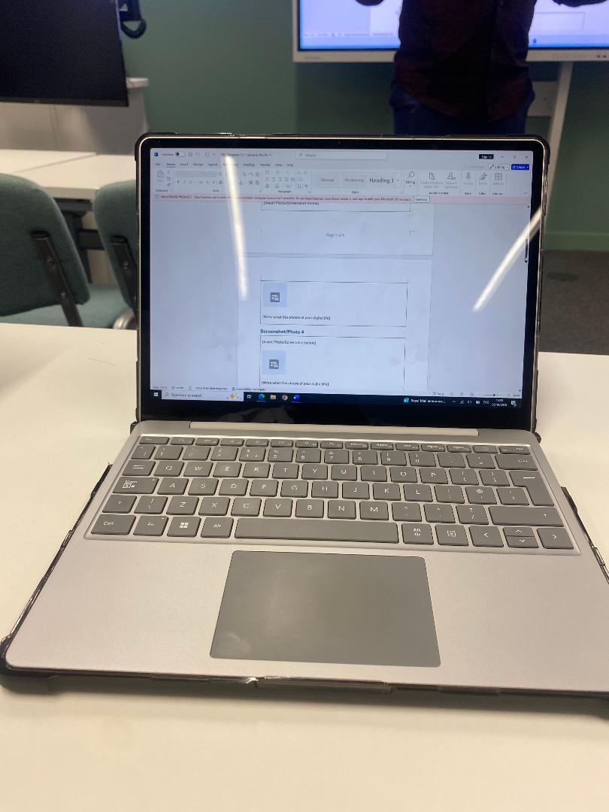Laptop
Streaming, Media & Video-standard definition built in speakers with web browsing
Document Processing-Supports writing documents, office work data sheetsc
Portable-Light weight for easy carry

Screenshot/Photo 2
[Insert Photo/Screenshot below]
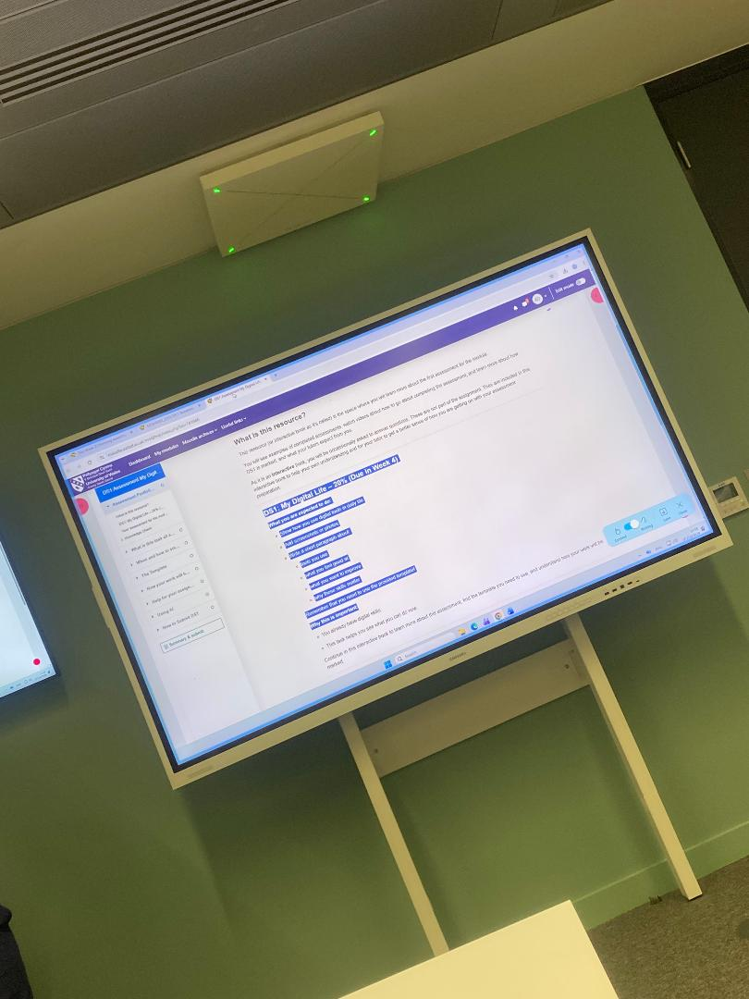Smart Board Screen
Media Browsing-Connecting internet, live websites, educational/business apps
Video Conversations-built in cameras, microphones and speakers allowing conference with nationwide users.
Motion Direct-Allowing user to display content on screen/physically via Ai

Screenshot/Photo 3
[Insert Photo/Screenshot below]
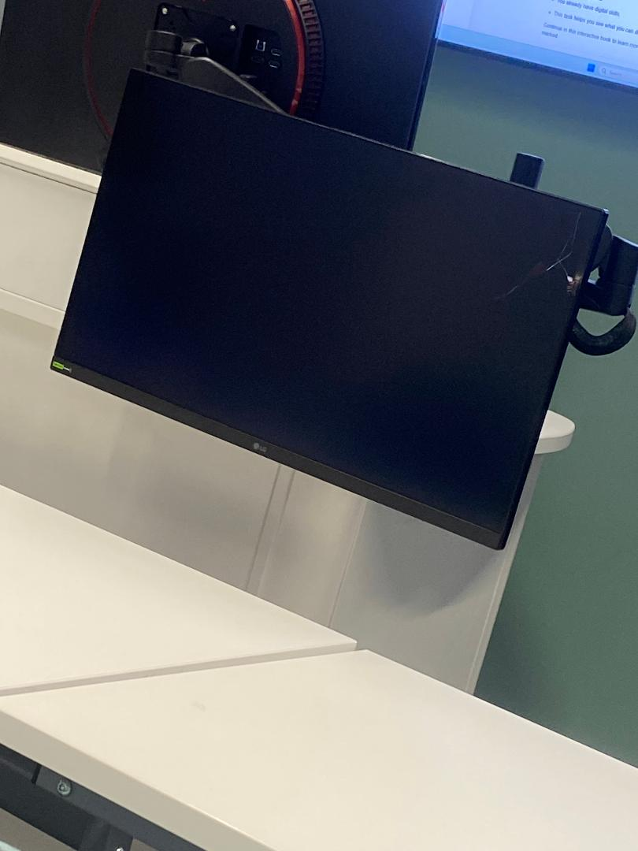 Computer screen
Display information visually-operating systems apps, documents , websites etc
Digital signals-Data streams such as stocks, display ports and USB converts to pixals via million

Screenshot/Photo 4
[Insert Photo/Screenshot below]
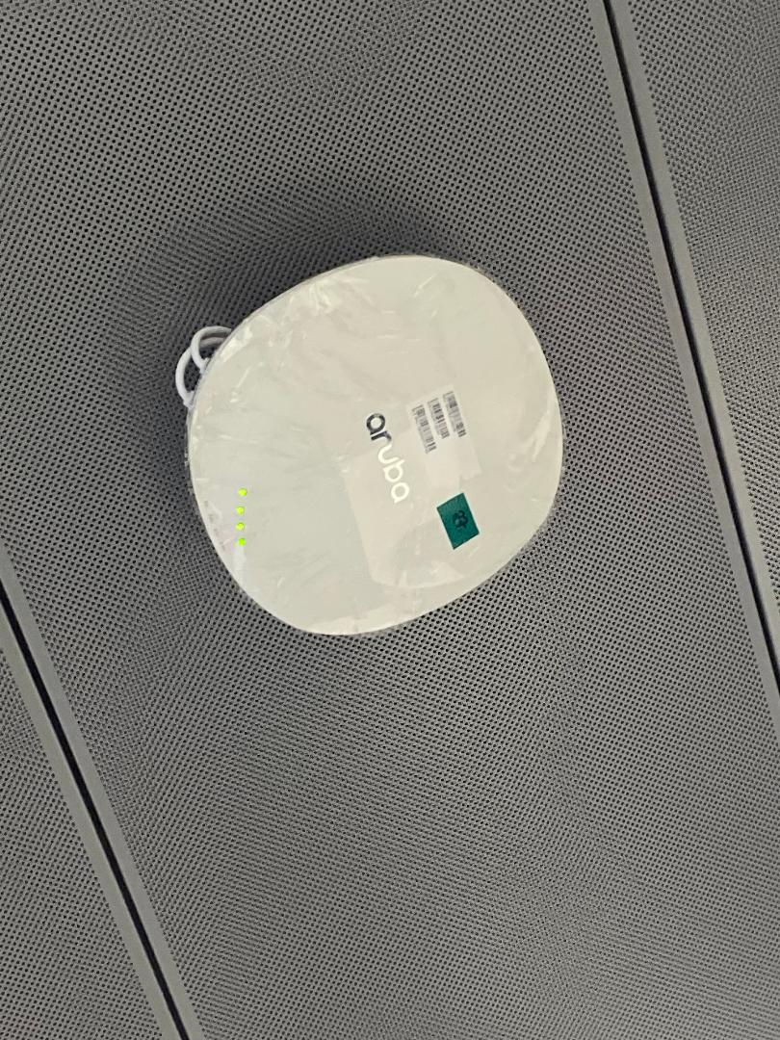Projector
Training-Videos, Lesson, Seminars, Lectures via classroom use
Advertisement-Displays via public/venues
Entertainment-Movies, Shows, Video Games and Theatre

Screenshot/Photo 5
[Insert Photo/Screenshot below]
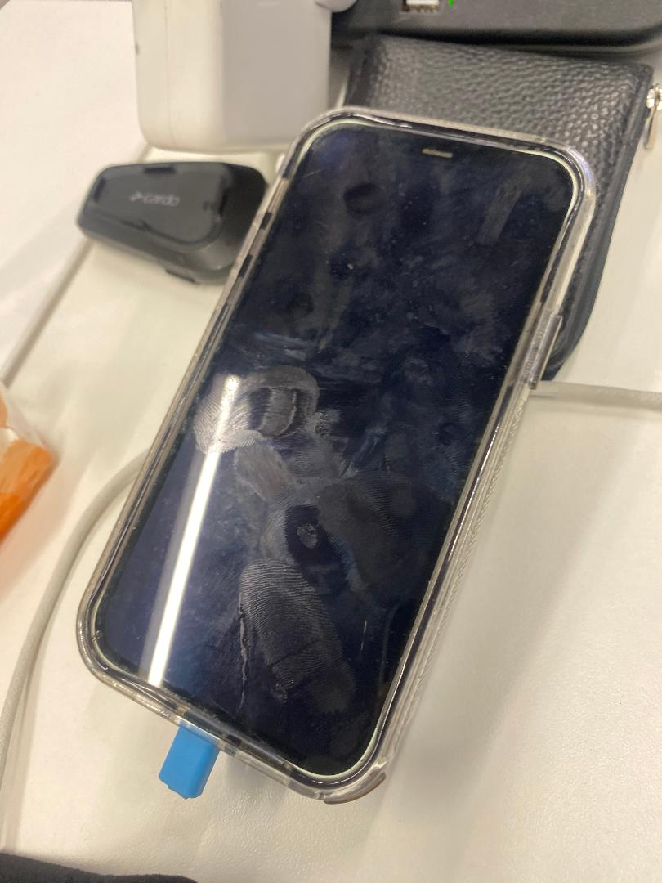 Iphone
Communication-Send text, Talk physically via mobile phone
Apps and Internet-Web usage,Emails, Downloading apps

Screenshot/Photo 6
[Insert Photo/Screenshot below]
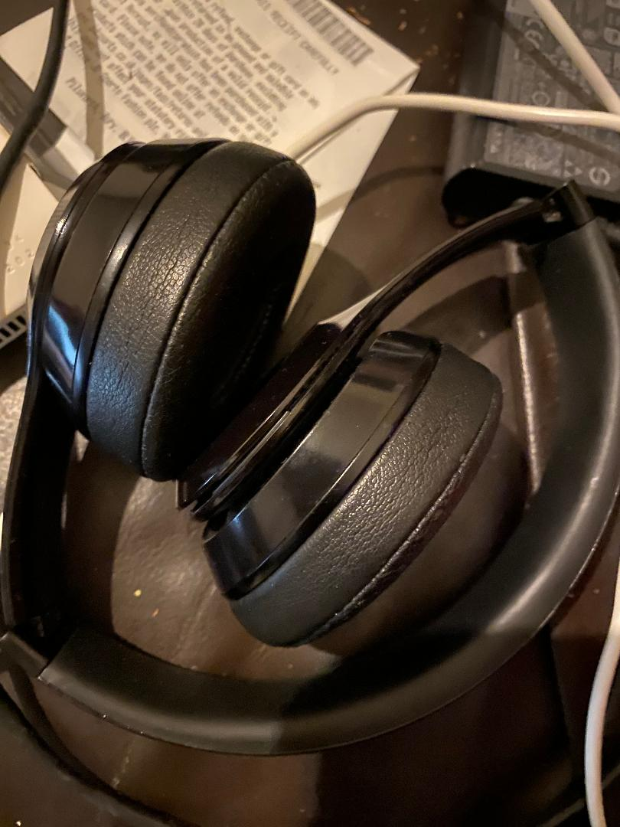 Beats HeadPhones
Private listening-Directly to your ears
Two way communication-Allowing access to use as a speaking device connected to your phone/smart watch

My Short Reflection
- Write 5–8 simple sentences about your digital life.
- You can use the sentence starters below if helpful.
Digital life is the empowerment of further education, reaching the masses and having a platform built by you, for you to interact Worldwide.
Enabling to connect with all works of life, government officials coding, apps, media and every digital platform available.
Years ago we as humans could only dream of the heights we could possibly reach, but since technology has taken over the world, the digital error is impossible to ignore

Sentence starters
- I use digital tools to …
- I feel confident when I …
- I want to improve …
- I often use these tools: …
- I sometimes feel nervous about …
- I hope this module will help me …
- Digital skills are important for me because …
You can write more if you want.

Submission Checklist
Before you submit, please check:
​​​ ☐ I added 4–6 screenshots
☐ I wrote short sentences for each screenshot
☐ I wrote my short reflection
☐ My work is my own
☐ My file opens correctly
​​☐ My file opens correctly

