University of Wales Trinity Saint David

Ryan Owen
2015048
ACMA 6013

Investigation into the root causes of product released under concession at LSN Diffusion



Declaration/Statements page

I declare this dissertation is the product of my own independent research and effort. It represents original work that has not been previously submitted for any academic qualification at any educational institution. I have complied with the research standards and requirements set out by the University of Wales Trinity Saint David.

Acknowledgements

I would like to acknowledge and personally thank the staff and lecturers at University of Wales Trinity Saint David for their support and patience in helping me complete my engineering materials degree. I am very grateful for their support and understanding throughout my time studying at the university.

Thank you to my colleagues at LSN Diffusion who have supported me in my studies and provided me with invaluable advice and support.

A special mention to my fiancé Amy, for her moral support and understanding without which, I would not have been able to achieve the academic outcome I have now.

Abstract
This dissertation investigates the root causes behind the high rate of product concessions at LSN Diffusion. In 2023, data revealed that 76% of certified powder batches were released under concession, significantly impacting the company’s financial performance and reputation. The project focuses on identifying and addressing the primary contributors to these concessions, with particular emphasis on Particle Size Distribution (PSD) discrepancies.
A data capture and analysis process were implemented, revealing that PSD and chemistry deviations accounted for 95% of all concessions. Further investigation showed that PSD related issues stemmed largely from inconsistencies between the screening department and laboratory test results. These inconsistencies were traced back to differences in sampling methods, equipment conditions, and sieve calibration.
To address these issues, several corrective actions were introduced. A standardized sampling method using a sample thief was adopted across departments, adhering to ISO 3954:2007 standards. A dedicated sampling area and new work instructions were established to ensure consistency in sampling. Equipment inspections led to the repair and calibration of Ro-Tap sieve machines, and a new procedure for sieve calibration was introduced using a specially prepared hybrid atomized nickel powder.
The impact of these improvements was significant. In the first three months of 2024, the number of PSD related concessions dropped from 212 to 124, and the overall concession rate decreased from 487 to 365. The straight pass rate improved greatly, demonstrating the effectiveness of the implemented changes.
This project highlights the importance of standardized procedures, cross-departmental collaboration, and data-driven decision-making in improving product quality. The findings and improvements serve as a model for ongoing quality assurance efforts at LSN Diffusion.

Contents
Declaration/Statements page 2
Acknowledgements 3
Abstract 4
List of Figures 6
List of tables 7
Company Overview LSN Diffusion 8
Introduction 10
Data Capture 11
Quantitative Data 11
New Data Capture 11
Data Monitoring 13
Data Analysis 15
Particle Size Distribution Overview 16
PSD Measurement Methods 17
Brainstorm for Difference in PSD Results 18
Powder Sampling 20
Overview of ISO 3954:2007 21
Key Concepts of ISO 3954:2007 21
Powder Sampling Work Instruction 22
Operator Errors 25
Equipment Failure 27
Sieve Accuracy 29
Data Monitoring After Changes 31
Conclusion 33
References 34

List of Figures
Figure 1 Graph showing breakdown of batches booked out of lab 10
Figure 2 Graph showing percentage of straight pass against concession 10
Figure 3 Straight pass versus concession data 11
Figure 4 Test report showing a chemistry concession 12
Figure 5 Example showing first entry onto new concession log 12
Figure 6 Graph showing percentage of straight pass against concession June 2023 to September 2023 13
Figure 7 Graph showing percentage of concession types June 2023 to September 2023 14
Figure 8 Brainstorm of "Reason for variation in PSD results" 18
Figure 9 Burkle PowderProof Sample Thief 20
Figure 10 Work Instruction Sample Collection 23
Figure 11 New dedicated sampling area 24
Figure 12 Comparison of Results Laboratory VS Screening 25
Figure 13 Work instruction for setup and checks of Ro-Tap RX-29 28
Figure 14 Keyence VHX Digital Microscope 29
Figure 15 Graph showing straight pass to concession for beginning of 2024 31
Figure 16 Graph showing concession type January 2024 to March 2024 32

List of tables
Table 1 Table showing concessions types for June 2023 to September 2023 14
Table 2 PSD Test Results 25
Table 3 Actuator bar height 27
Table 4 Sieve measurements 30
Table 5 Concession types January 2024 to March 2024 32

Company Overview LSN Diffusion
LSN Diffusion limited specialises in the manufacture of nickel, cobalt, and iron based powders via an atomizing process. It is a medium sized company with approximately 90 employees based in Ammanford, south Wales. The finished powders are sold globally for numerous applications including, spray welding, fuse welding, plasma transferable arc, high velocity oxygen fuel, hipping, brazing, and additive layer manufacture. Three atomizing methods are utilized to produce the powder (LSN Diffusion, 2025).
Dry gas atomization is the costliest of the three methods. This involves directing high pressure nitrogen gas through nozzles to hit a stream of molten metal. The metal is rapidly cooled, forming small droplets which are collected in an atomizing pan. There is no liquid present in the pan which allows the collected powder to fully cool in an atmosphere of nitrogen. This method is commonly used when tight control of the oxygen content of the finished powder is required, such as for stainless steel 316 (Metal 3DP, 2025).
Water atomization pumps high pressure water through nozzles to hit the stream of molten metal. The powder particles are collected in the atomizing pan, however unlike the dry gas method the powder is wet. This necessitates an additional drying step. This generally increases the oxygen content of the powder compared to if it was atomized by dry gas. This method is a lot more cost effective as the nitrogen gas is replaced by water. This atomizing method is commonly utilized for spray welding and fuse welding powders (Metal 3DP, 2025).
Hybrid atomization merges the previous two methods by using nitrogen gas to create the metal droplets, which are then collected in water and go through the drying process. This approach is a compromise between dry gas and water. The oxygen content is higher than powder produced by dry gas, but lower than water. It is more cost effective than dry gas atomizing as it does not require the additional nitrogen gas to purge during cooling. Hybrid atomization is commonly used for brazing alloys where oxygen content is restricted but will still fall within the alloy specification (Metal 3DP, 2025).
After the powder is atomized, it will go through a sieving process to alter the particle size distribution (hereafter referred to as PSD). As atomized powder is passed over a series of screens, the size of which depending on whether a fine or coarse powder is required. Common screen aperture sizes can range between 10µm and 500µm. Each batch of powder produced must meet designated PSD specifications based on customer order requirements. The screening department is responsible for the sieving process and ensures compliance with the specifications. PSD specifications fall into two categories: internal specifications, which are limits determined by LSN Diffusion to ensure the powder is suitable for its end use, and customer specifications, where the customer provides their own limits of each PSD band.
The final process for the screening department to complete is blending. During this, a batch of sieved powder is transferred into a large blender in order to recombine into a uniform distribution. This process is necessary as the powder will separate into layers during the sieving process. A sample is acquired using a Buerkle Powder Proof sampling gun. The sample is used by the screening department to test the PSD using the specified sieves on a Ro-Tap machine, the results of which are then compared against the specification. If the tests meet specification, the batch is sent to the laboratory for approval and release.

The laboratory undertakes several tests on these samples, including:
- ICP-OES chemical analysis
- Combustion method Carbon, Sulphur, Oxygen, and Nitrogen analysis
- Sieve testing
- Laser sizing – Laser diffraction and dynamic image analysis
- Weld quality testing
- Rockwell C hardness testing
- Apparent density
- Hall cup flow
- Digital microscope inspection
- Visual inspection
When all of the laboratory testing is completed, each batch of powder is reviewed by the laboratory manager. If the batch of powder fully meets the specification, then it is released from the laboratory to the packing department and a customer certificate is raised. Any tests which do not meet the specification are retested by laboratory staff to ensure the validity of the results. If the retest is still outside of specification, then it will either be rejected to be remade or reprocessed, or a concession will be considered. Customers who accept concessions will often be reimbursed a percentage of the costs of the product. Concessions of internal specifications can usually be made without customers approval, and these are assessed by LSN management to ensure they will not affect the end user’s application.

Introduction
Management at LSN Diffusion often focus on the reject rate of batches as this is extremely costly due to rework and remake costs and time. As can be seen in figure 1, the reject rate for 2023 was 11% of total batches. However, a new issue which has been recognised at LSN Diffusion is that a large proportion of batches are requiring concessions before release by the laboratory due to them not fully adhering to the specifications. This is causing a large financial impact on the business as the average discount given to customers for these concessions is 5%. As well as this, the company’s reputation is tarnished and may cause customers to question whether LSN Diffusion can reliably produce good quality powder (Bizmasters, 2024). Data captured throughout 2023 revealed that 76% of product released by LSN Diffusion left under concession as seen in figure 2.

Figure 1 Graph showing breakdown of batches booked out of lab

Figure 2 Graph showing percentage of straight pass against concession

Data Capture
In order to properly assess how much of an issue the concessions are at LSN Diffusion, the type and amount of data captured about them had to be improved greatly. The only data captured throughout the beginning of 2023 was whether the batch was passed as a straight pass or a concession. If the batch was marked as a concession, then no further details regarding the concession were logged. An example of the poor way in which this data was captured is shown in figure 3 below, comparing a straight pass to an internal concession.
Figure 3 Straight pass versus concession data

Quantitative Data
According to (Mertens, 2017), using quantitative data offers numerous advantages including:
- Less subjective than qualitative data as it is based on numerical values which aids in making unbiased decisions
- Enables analysts to identify trends, correlations, and patterns which may not be otherwise apparent
- Clear metrics making it easier to measure outcomes against defined benchmarks
- Ability to generalize findings of large sample sizes
- Allows easy comparison between different groups so evaluation of changes or impacts can be monitored
- Heavily used for forecasting due to its precise estimates
- Complex data can be made more accessible displaying the data using graphs or charts

New Data Capture
To capture the appropriate data required to assess the severity of the concessions a new spreadsheet containing the appropriate data points had to be determined. To do this, test reports for the previous thirty batches of powder which left under concession were gathered and a list was made of all the ways in which they were out of specification, Figure 4 below shows a typical test report of a product with a chemistry concession. The full list was as follows:
- Particle size distribution
- Chemistry
- Rockwell C Hardness
- Weld quality
- Appearance
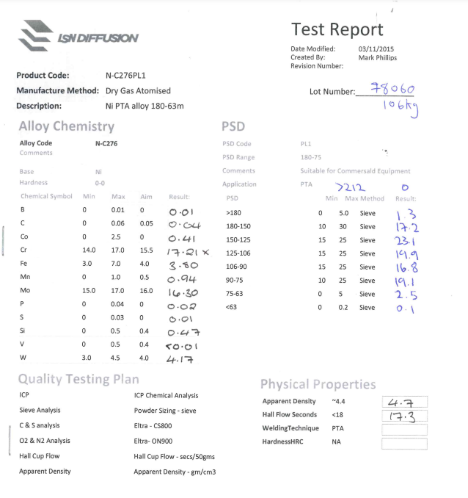
Figure 4 Test report showing a chemistry concession

When examining the previous test reports it was apparent that PSD and chemistry were the most common concession types. The deviation from the specification also varied greatly so it was decided that these categories would be further broken down into minor, moderate, and major concessions. As well as this, an option for “other” concession was added as something may not have been seen by looking at only thirty test reports. There were additional fields added for comments to describe the exact concession results as well as possible causes to save time in searching through old test reports in the future. As can be seen in figure 5 below, the spreadsheet is laid out simply and is easy to interpret. The type of concession is marked with a red X which can be filtered using Microsoft Excel for simple data interpretation (Leonelli, 2014).
Figure 5 Example showing first entry onto new concession log

Data Monitoring
The new spreadsheet was populated over the course of approximately three months, starting at the end of June 2023 and finishing at the end of September 2023. The ratio of straight passes versus concessions was monitored during this time and the results are displayed in figure 6 below:

Figure 6 Graph showing percentage of straight pass against concession June 2023 to September 2023
The percentage of straight passes versus concessions throughout this period is at 26% to 74%. Compared to the beginning of the year which was at 24% to 76% respectively. it is clear that before making any process changes the concession rate is stable and will continue to follow this high rate without intervention. The total number of batches certified between June 2023 and September 2023 was 459. Of these, 119 were straight passes and 340 were certified under concession.

Since data for this time period was now being captured using the new spreadsheet, it was possible to break the information down further into categories to gain a better understanding of why the batches needed concession.

Table 1 Table showing concession types for June 2023 to September 2023
Concession Type: |  | Total:
PSD | Minor | 106
PSD | Moderate | 102
PSD | Major | 4
Chemistry | Minor | 115
Chemistry | Moderate | 127
Chemistry | Major | 5
HRC |  | 22
Weld |  | 1
Appearance |  | 3
Other |  | 2
Total: |  | 487

As can be seen in Table 1 above, there were a total of 487 concessions made for the 340 batches. This equates to each batch of powder having an average of 1.4 concession types applied. To break this data down into a simper format a pie chart showing the relative percentages was created as shown in figure 7 below.

Figure 7 Graph showing percentage of concession types June 2023 to September 2023

Data Analysis

As can be clearly seen in figure 7 above, the primary two concession types were identified as PSD and chemistry. Totalling 95% of all concessions made. Chemistry concessions were slightly more prevalent at 51% of all concessions made, and they also cost the business the most financially as chemistry concessions typically resulted in higher discounts given to customers.

Despite chemistry concessions being the obvious choice to begin to reduce at LSN Diffusion, other departments were already working at reducing chemistry failures, and therefore it was agreed with management that this project would begin to focus primarily on the PSD aspect.

It can be seen in table 1 above that there was a total of 212 PSD concessions when combining minor, moderate, and major. Thanks to the new format to capture data, the "possible cause if known" column could be broken down to provide a clearer picture of what was going on. After studying this column, it was found that 68 of the concessions were due to the screening department submitting the material to the laboratory outside of specification. The remaining 144 batches were submitted within specification by the screening department; however, the laboratory achieved different results which led to the concessions being made.

These findings made it clear that this project would be split in two directions. Firstly, the technical aspect of why the PSD results were different between the laboratory and the screening department. And secondly, why did the screening department find it acceptable to submit product outside of specification.

Particle Size Distribution Overview

Particle size distribution can be described as the proportion of different sized particles within a given sample. Many industries (including mining, pharmaceutical, metalwork, cosmetics, and food) rely upon this characterization due to its influence on performance, behaviour, and processability of particulate materials such as powders, granules, and aggregates (Kroetsch, 2008).

A sample of particulate material will rarely have the same size. They form a varying distribution which can be displayed statistically. The ways in which PSD can be displayed include by surface area, volume, and number. Volume (by mass) distributions are commonly used across industrial fields as this measurement directly relates to material proprieties such as density and flowability (Yu, 1990).

There are a number of key terms which can be used to describe PSD which include:
- Mean Size - The average size of all the particles within a given sample
- d90, d50, and d90 - These percentiles represent the diameters of the particles of which 90%, 50%, and 10% of the cumulative volume is smaller than the stated size. For example, it can be stated that a sample with a d50 of 25µ has 50% of its particles smaller than 25µ.The d50 is also referred to as the median particle size
- Span - A calculation of the width of the distribution of particles. the formula (d90-d10) / d50 is used to calculate span. A broader range of particle sizes would be shown by a larger span value (Finlay, 2020).
It is common to display PSD data as cumulative curves (for displaying the cumulative percentage of particles under a given size) or as histograms (for displaying the frequency of particles within a size range) (Finlay, 2020).

PSD Measurement Methods

There are several methods which can be used to determine PSD. Each method is suited to a different particle size range and particle material type. Below are the five most common methods to determine PSD measurements (Bowen, 2002):
- Sieve Analysis - Particles are passed through a range of sieves which have progressively smaller apertures. Typically used for powders, granules and aggregates above 38µ in diameter.
- Laser Diffraction - Fires a laser beam at a sample of moving particles and measures the intensity and angle of light scattered by the particles. Commonly used for powders and slurries from 0.1µ to 3000µ
- Image Analysis - Captures static images of individual particles to measure size, and shape. This form of analysis provides detailed information on visual properties and works well with irregular particles
- Coulter Counter - Passes particles through a small orifice submerged in a conductive fluid. Electrical sensors count and size the particles as they pass through.
- Dynamic Light Scattering (DLS) - Measures particle size based on how they scatter light using Brownian motion. This method is only suitable for nanoparticles and can measure up to a maximum of 1µ (Bowen, 2002)
Three of these measurement types are used at LSN Diffusion. Sieve analysis, laser diffraction, and image analysis. Sieve analysis is the most common test performed due to the particle size of most of the powders produced at LSN. Laser diffraction is then used commonly for powders where fines content is critical, such as measuring the <20µ value or d90, d50, d10. Dynamic image analysis is not used commonly due to its time consuming nature of testing and interpreting the data. Dynamic image analysis is reserved for the most specialist alloys LSN produce.

Brainstorm for Difference in PSD Results

Representatives from the laboratory, screening, and quality departments met to brainstorm why we may be seeing the difference in PSD results between the laboratory and screening tests. The following brainstorm diagram was produced (Miro, 2025) (Figure 8 below):
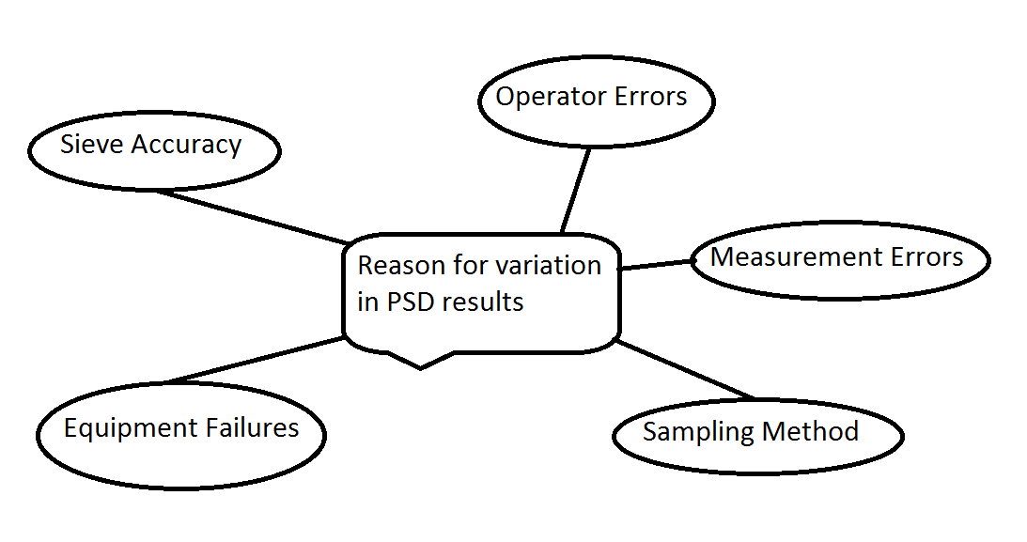
Figure 8 Brainstorm of "Reason for variation in PSD results"

The following discussion points took place regarding each point raised

Operator Errors:
- Are all the operators conducting PSD tests trained to the same level?
- Is there a difference in ability between operators?
- Is it possible for the operators to be interpreting the results differently?
Measurement Errors:
- Are the weighing scales calibrated?
- Are the operators weighing the correct amount for each test?
- Is any powder not being counted for at the end of the test?
Sampling Method:
- Do the laboratory and screening department use the same sampling method?
- What is the best sampling method to use for powders?

Equipment Failures:
- Is there any maintenance required for the Ro-Tap sieve analysis machines?
- Are all the settings correct?
- Do they all run for the same amount of time?
Sieve Accuracy:
- Are the sieves calibrated?
- Are any of the sieves damaged?
- How do the four sets of sieves compare to each other?

Powder Sampling

Powder sampling was the first thing to be investigated due to its criticality. Sampling was the first step in the PSD measurement process so if this was not done correctly, everything after this point would also be wrong (Agno, 2025).
It was quickly established that the laboratory and screening departments were using two different methods for taking powder samples.
The screening department were taking samples by holding an empty sample pot into the flowing stream of powder as the powder was being emptied from the blender. Despite being a valid method of sampling under ISO 3954:2007, there were a number of issues with the way it was performed at LSN Diffusion. The sample from the flowing powder needed to be taken at three intervals, the beginning, middle, and end of the emptying of the blender. Unfortunately, the screening department had no way to tell how much material was left in the blender, so the end sample was often taken too early, or missed all together.
The laboratory would take their own fresh sample for analysis. They were unable to use the same method as the screening department as the powder was already out of the blender and was now in a large hopper ready for packing. The laboratory used a sample thief (Burkle PowderProof shown in figure 9 below) to take their sample. This was also an acceptable method under ISO 3954:2007 (ISO, 2007).
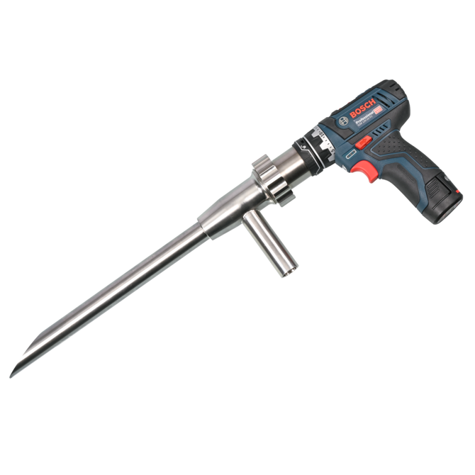
Figure 9 Burkle PowderProof Sample Thief

Overview of ISO 3954:2007

The purpose of ISO 3954:2007 is to define sampling techniques for metal powders. The main purpose for doing this is so that:
- The sample taken accurately displays the same characteristics as the balance of the material sampled. This includes PSD, composition, density, and flow ability.
- It is ensured that analysis results are comparable and consistent between different laboratories (ISO, 2007)

This ISO standard applies to alloys, virgin metals, and metallic powders, which include:
- Atomized powders
- Electrolytic powders
- Reduced powders
- Mechanically blended powders (ISO, 2007)

Key Concepts of ISO 3954:2007
- A sampling unit takes a portion from a single location
- These sampling units are then combined to form a gross sample
- The gross sample must be taken from different parts of a batch (such as top, middle, and bottom of a hopper)
- The gross sample must be large enough to divide up for analysis
- This sample needs to be reduced to a laboratory sample using a method such as, riffling, rotary splitting, or cone and quartering which allows homogeneity of the sample
- The laboratory samples must be kept in airtight, inert containers
- The samples should be clearly labelled with key information such as batch number and date (ISO, 2007)
The best practices for powder sampling in ISO 3954:2007 are laid out below:
- Use clean dry tools during sampling to avoid contamination
- Mix samples thoroughly before dividing into smaller samples to avoid segregation
- Take the sample immediately if moisture absorption or oxidation is likely
- Thoroughly document the sampling procedure to ensure repeatability and traceability (ISO, 2007)

Powder Sampling Work Instruction

It was concluded that the best way to sample the powder going forward would be for the screening department to take one master sample of the powder which would be tested by both screening and the laboratory. This ensured the greatest consistency and both departments would be testing the exact same sample. After reviewing ISO 3954:2007 it was decided that the most suitable sampling technique for LSN Diffusion would be using a sample thief. This would ensure that we could re-sample if required using the same technique each time. The riffling technique would also be used to split the sample into a smaller sample for testing (Muzzio, 1997).
From this research, a work instruction was derived which met all of the criteria of ISO 3954:2007 (ISO, 2007). Shown in figure 10 below:
As well as this, a new dedicated sampling area was set up within the screening department so they could easily adhere to the new sampling methods. Shown in figure 11 below:

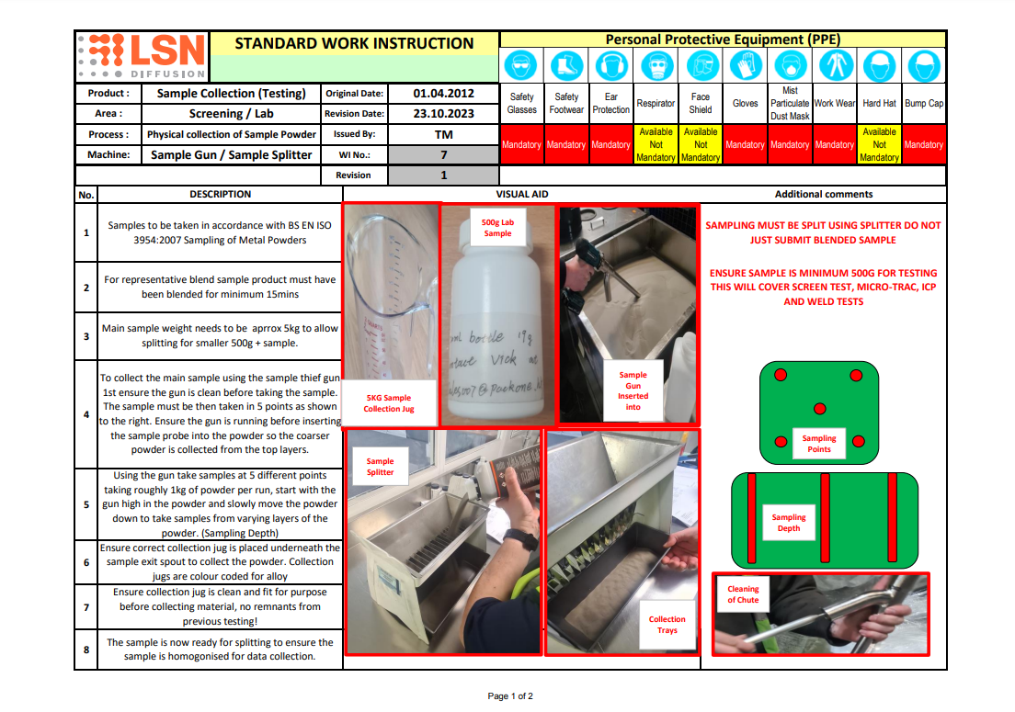
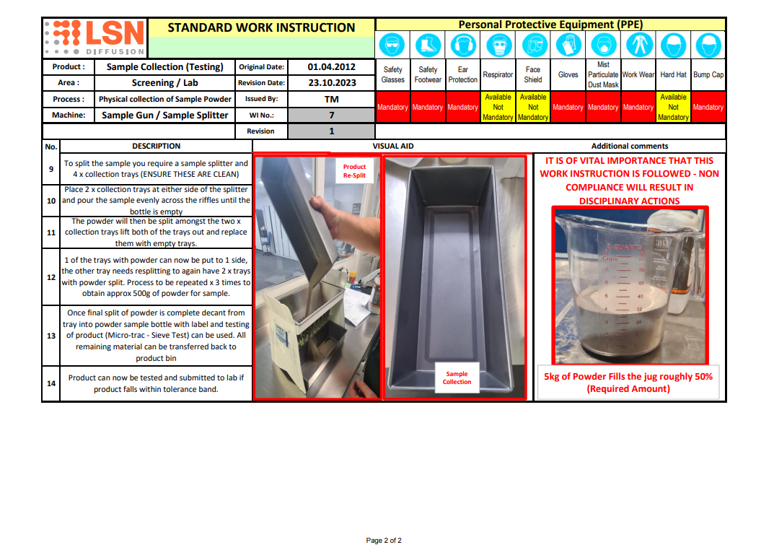
Figure 10 Work Instruction Sample Collection

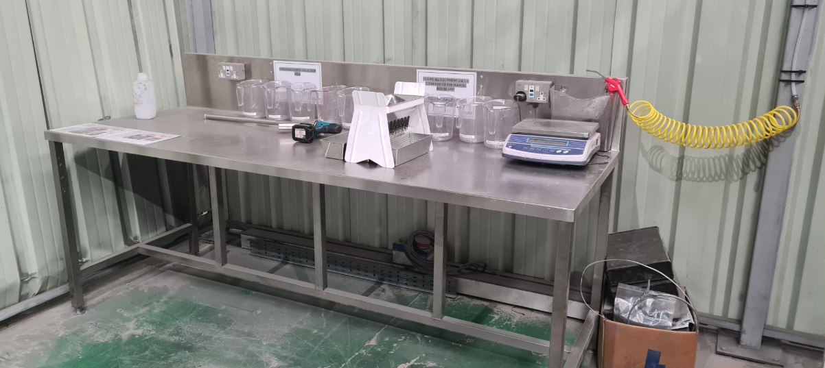
Figure 11 New dedicated sampling area

Operator Errors

To see if there was a difference in test results between operators a quick and simple test was conducted. Two laboratory technicians and two screening operators were asked to PSD test a sample of powder. They were each given the same sample and completed the test using the same Ro-Tap machine and test sieves. The results are in table 2 as follows:

Table 2 PSD Test Results
Sieve Size µ | Results (Weight %)
Sieve Size µ | Laboratory 1 | Laboratory 2 | Screening 1 | Screening 2
106-90 | 4.6 | 4.4 | 4.7 | 4.6
90-75 | 18.9 | 18.7 | 18.5 | 19
75-63 | 21.1 | 20.8 | 21 | 20.7
63-53 | 18.9 | 18.6 | 18.1 | 18.3
53-45 | 15.6 | 16.3 | 16.2 | 15.9
45-38 | 12.4 | 12.2 | 13.1 | 12.9
<38 | 8.5 | 9 | 8.4 | 8.6

Figure 12 Comparison of Results Laboratory VS Screening
As can be seen in figure 12 above, the comparison of results shows that they are all extremely close to one another. This is well within the expected normal range (ASTM Committee, 1985).
Despite this being a relatively small scale test. Management was confident in all the operator’s abilities to complete consistent screen test analysis. The decision was therefore made that it would not be viable to look any further into operator errors at this point in time as it was not the likely culprit for most of the PSD concessions.

Equipment Failure

At LSN Diffusion, sieve test analysis is carried out on one of four Ro-Tap RX29. Two of these are located in the laboratory area and two are within the screening department. A quick visual inspection was done on all four machines to get an idea of what condition they were in. All four machines were of similar age and condition; however, a few faults were noted. One of the screening departments machines had the cork replaced with a bottle top. Two handles were worn on the machines within the laboratory. These issues were quickly rectified with replacement parts.

There was no routine maintenance carried out on the Ro-Tap machines, so the maintenance department contacted Ro-Tap to see if there was anything that was required. They responded with four main checks which should be carried out (W.S Tyler, 2025).
- The actuator bar must be at the correct height to actuate the tap arm. When fully extended the bar should be between 31.8mm and 34.8mm. If the bar is outside of this range, it should be adjusted or replaced
- The cork within the top plate must extrude at least 5mm above the top plate to ensure full contact with the tap arm. If this is not prominent by at least 5mm then replace the cork
- For every screen test analysis, the top plate must sit flush with the frame of the Ro-Tap machine for the tap mechanism to work as intended
- The handle locking mechanism should be checked to ensure they are securely holding the sieves (W.S Tyler, 2025)
The actuator bar height was measured by the maintenance department and the results were as shown in table 3 below:
Table 3 Actuator bar height
 |  | Actuator bar height (mm):
Screening | Ro-Tap 1 | 34
Screening | Ro-Tap 2 | 29
Laboratory | Ro-Tap 3 | 32.5
Laboratory | Ro-Tap 4 | 33

One of the screening department Ro-Taps was out of manufacturers tolerance. This was adjusted within specification and the reading after adjustment went up to 33.8mm.

From this manufacturer’s guidance, a new work instruction was created for the operators to conduct daily checks on the equipment as shown in figure 13 below:

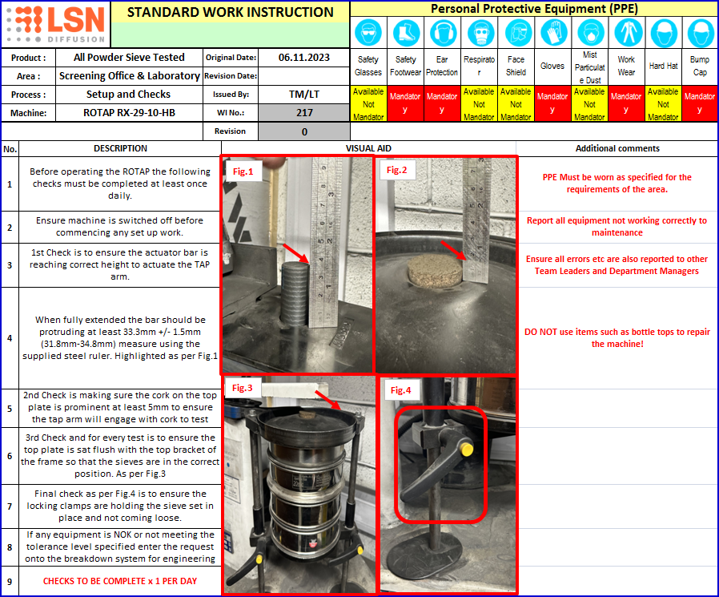
Figure 13 Work instruction for setup and checks of Ro-Tap RX-29

Sieve Accuracy
The accuracy of test sieves used for sieve test analysis can vary substantially depending on numerous factors. These include, quality of the sieve, proper handling and cleaning, calibration, and what international standards it complies with. Test sieves can provide repeatable reliable results, especially for spherical particles between 38µ and 180µ. All new sieves purchased come with a calibration certification. The certificate is valid for two years (Haver & Boecker, 2025).

All of the sieves at LSN Diffusion were catalogued and visually inspected. It was found that most of the sieves were well outside of the two year calibration certificate. To quickly check the size of the apertures of the sieves, a Keyence VHX digital microscope (as shown in figure 14 below) was used to take measurements. Five random locations on each of the sieves (Robomat, 2023). The measurement results were added to a table shown in table 4 below:
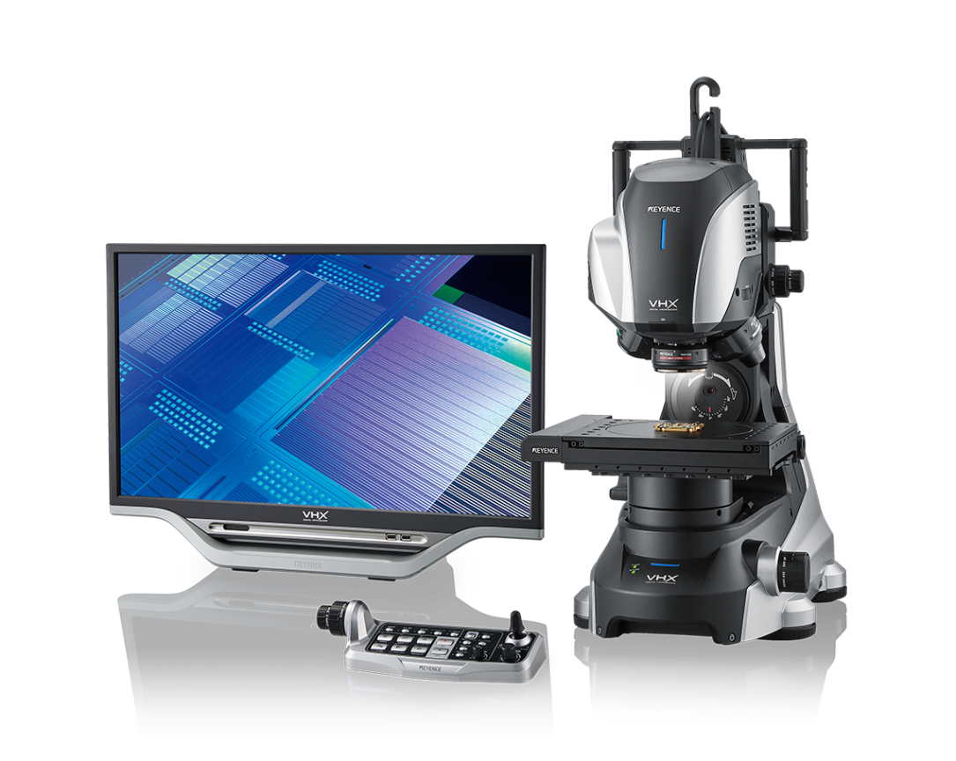
Figure 14 Keyence VHX Digital Microscope

Table 4 Sieve measurements
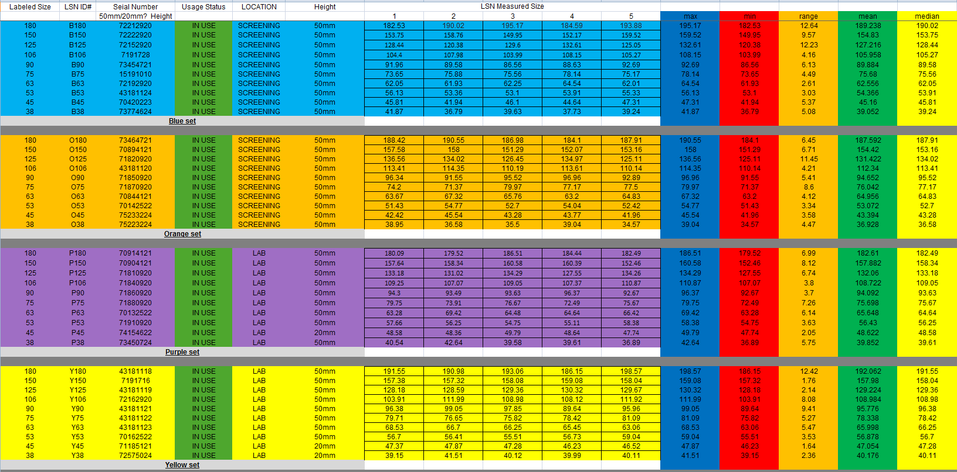

All of the sieves with a range of greater than 9µ were replaced as it was concluded that these sieves had worn in certain areas more than others (Rideal, 2000).
A procedure was created for future calibration of the test sieves. A calibration powder was to be created from hybrid atomized nickel powder. This was selected as it was the most spherical type of powder which should increase consistency of the test results. Dry gas atomized powder often has satellites which can break off during testing and be measured as fines. Water atomized powder has a more irregular shape which can get caught in the apertures of the sieves causing them to blind. The calibration powder was to have an approximately equal distribution between each PSD band, for example 9% <38µ, 9% 38µ-45µ, 9% 45µ-53µ, and so on (Lum, 1996).
This powder would be run through each of the four sieve sets once per week and the results logged. Any sieves which got damaged or wore out would be immediately noticed as their results would no longer line up with the other three sets. 50kg of the calibration powder would be produced which would be enough to last approximately 3 years.

Data Monitoring After Changes

All the improvements in the above project were completed throughout the end of 2023. The data below looks at the first three months of 2024, January, February, and March. This has given all of the improvements some time to take effect.

Figure 15 Graph showing straight pass to concession for beginning of 2024

As can be seen in figure 15 above, an enormous improvement has been made to reduce the number of concessions. Throughout the beginning of 2024, a total of 485 batches were certified, 210 of which were straight passes. Table 5 below shows a breakdown of the concession types for this time period:

Table 5 Concession types January 2024 to March 2024
Concession Type: |  | Total:
PSD | Minor | 77
PSD | Moderate | 46
PSD | Major | 1
Chemistry | Minor | 104
Chemistry | Moderate | 112
Chemistry | Major | 3
HRC |  | 19
Weld |  | 2
Appearance |  | 1
Other |  | 0
Total: |  | 365

As can be seen in table 5 above, the total number of concessions has been reduced from 487 towards the end of 2023 to 365. The total number of PSD concessions has reduced to 124, down from 212.

Figure 16 Graph showing concession type January 2024 to March 2024
A graph was created, shown in figure 16 above to clearly visualise the distribution of the concessions. The PSD concessions have dropped to 34% of total concessions, down from 44% at the end of 2023.

Conclusion
This investigation into the root causes of product concessions at LSN Diffusion has revealed critical insights into the operational challenges affecting product quality, particularly in relation to PSD. The project began by identifying a significant issue: a high proportion of powder batches, approximately 76% in early 2023 were being released under concession, often requiring customer discounts and risking the company’s reputation for quality. Through a structured approach involving data capture, analysis, and process evaluation, the project has successfully pinpointed key areas for improvement and implemented effective corrective actions.
The primary focus of the dissertation was on PSD related concessions, which, alongside chemistry deviations, accounted for 95% of all concessions. A detailed analysis of the data revealed that discrepancies in PSD results between the screening department and the laboratory were a major contributor. This inconsistency was traced back to differences in sampling methods, equipment conditions, and sieve calibration practices.
One of the most impactful changes was the standardization of the powder sampling process. By introducing a unified sampling method using a sample thief and adhering to ISO 3954:2007 standards, both departments began testing from the same master sample. This eliminated a major source of variability and improved the reliability of PSD measurements. Additionally, the creation of a dedicated sampling area and the implementation of a clear work instruction ensured consistency and repeatability in the sampling process.
Operator error was investigated and ruled out through controlled testing, which demonstrated consistent results across both laboratory and screening personnel. Equipment-related issues, however, were identified and addressed. Maintenance checks revealed that one of the Ro-Tap machines was operating outside of manufacturer specifications. Adjustments were made, and a new daily check procedure was introduced to ensure ongoing equipment reliability.
Sieve accuracy was another critical factor. Many sieves were found to be beyond their calibration date, and some showed significant wear. These were replaced, and a new calibration procedure was introduced using a specially prepared hybrid atomized nickel powder sample. This powder, with a balanced PSD, now serves as a weekly benchmark to detect any deviations in sieve performance.
The impact of these interventions was significant. In the first quarter of 2024, the number of PSD related concessions dropped from 212 to 124, and the overall concession rate fell from 487 to 365. The straight pass rate improved greatly, demonstrating the effectiveness of the changes implemented.
In conclusion, this project has not only identified the root causes of PSD related concessions but has also delivered measurable improvements in product quality and process reliability. The structured approach to problem solving helped by data analysis, cross-departmental collaboration, and adherence to international standard has laid a strong foundation for continued quality improvement at LSN Diffusion. Moving forward, it is recommended that LSN Diffusion maintains its focus on equipment maintenance, operator training, and data monitoring to sustain and build upon these gains.

References
Agno, 2025. Sampling of Powders. [Online]
Available at: https://agnopharma.com/technical-briefs/sampling-of-powders/
ASTM Committee, 1985. E-29 on Particle Size Measurement. Manual on test sieving methods.
Bizmasters, 2024. What is a Concession in Quality?. [Online]
Available at: https://bizmasterz.com/what-is-a-consession-in-quality
Bowen, P., 2002. Particle size distribution measurement from millimeters to nanometers and from rods to platelets. Journal of dispersion science and technology, pp. 631-662.
Finlay, W. a. D. C., 2020. Particle size distributions. Journal of aerosol medicine and pulmonary drug delivery, pp. 178-180.
Haver & Boecker, 2025. Your partner for perfect processes. [Online]
Available at: https://www.haverboecker.com/en/
ISO, 2007. ISO 3954:2007. Powders for powder metallurgical purposes — Sampling, Volume 2, pp. 1-8.
Kroetsch, D., 2008. Particle size distribution. Soil sampling and methods of analysis, pp. 713-725.
Leonelli, S., 2014. Data interpretation in the digital age. Perspectives on Science, pp. 397-417.
LSN Diffusion, 2025. [Online]
Available at: www.lsndiffusion.com
[Accessed 2025].
Lum, L., 1996. Standard reference materials for particle size analysis of ceramic powders by gravity sedimentation. Powder technology, pp. 233-238.
Mertens, W., 2017. Quantitative data analysis. A companion, pp. 1-8.
Metal 3DP, 2025. Atomized Metal powder – A Comprehensive Guide in 2025. [Online]
Available at: https://met3dp.com/atomized-metal-a-comprehensive-guide/
Miro, 2025. What is brainstorming?. [Online]
Available at: https://miro.com/brainstorming/what-is-brainstorming/
Muzzio, F., 1997. Sampling practices in powder blending. International journal of pharmaceutics, pp. 153-178.
Rideal, G., 2000. Sieve Calibration–a New Simple but High Precision Approach. Particle & Particle Systems Characterization: Measurement and Description of Particle Properties and Behavior in Powders and Other Disperse Systems, pp. 77-82.
Robomat, 2023. Sieve, filter fabric, Screen printing mesh, wire mesh lattice grid. [Online]
Available at: https://www.robomat.eu/check-filter-screen-wire-mesh?lang=en
W.S Tyler, 2025. RO-TAP® Sieve Shaker. [Online]
Available at: https://hub.wstyler.com/rotap
Yu, A. a. S. N., 1990. A study of particle size distributions. Powder Technology, pp. 101-118.

