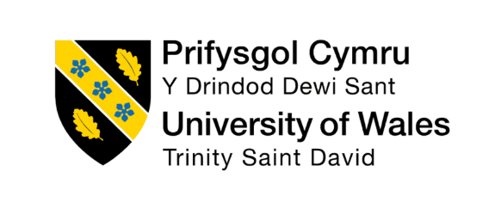

Module Name: Effective Team Working and Communication

Module Code: BMSW4009

Student Name: Natalie Brown

Student Number: 2524431

Lecturer: Melanie Squire

Deadline: 26.06.2026

AI Statement
I confirm that I have not presented any AI-generated text as my own work. I confirm that I have retained copies of drafts, notes, and resources used before and after the use of AI tools.

Effective Teamworking and Communication: Reflective Report
Contents
Introduction .................................................................1
Findings and Application of Learning .............................2
Conclusion ..................................................................3
References ..................................................................4
Appendices .................................................................5

1. Introduction
Effective teamworking and communication are essential skills in both academic and professional environments. Working effectively within a team requires individuals to communicate clearly, listen to others, understand different perspectives and contribute towards a shared objective.
During this module, I have developed a greater understanding of how individual behaviour can influence team performance. The theories and activities explored during the module have encouraged me to reflect on my own communication style, my response to conflict and the way I contribute to group activities. Tuckman’s stages of team development, Belbin's Team Roles and the Thomas-Kilmann Conflict have helped me understand why teams experience disagreements and how these can be managed constructively.
Belbin, M. (2010) Team Roles at Work. Thomas-Kilmann Conflict Mode
The purpose of this report is to evaluate what I have learned about effective teamworking and communication and consider how I have applied this learning so far.
2. Findings
accommodating scores could mean that I sometimes do not express my own preferences strongly enough, particularly when I do not want to create disagreement. For example, when working in a group, I chose to allow the leader to decide which position or responsibility would be most suitable for me. This showed that I was willing to trust the leader's judgement and accept a role based on where they believed I could contribute most effectively. This can be positive because it allows the group One of the most useful theories from the module was Tuckman’s model of team development. Tuckman identified the stages of forming, storming, norming and performing, describing how teams develop as relationships and working practices become established. The forming stage Belbin and Tuckman: Enhancing Team Development
involves team members getting to know one another and understanding the purpose of the group. During storming, disagreements and differences in opinions may become more noticeable. Norming involves developing agreed ways of working, while performing is associated with an effective and more independent team.
This theory has helped me understand that disagreement within a team is not necessarily negative. the module has shown me that constructive disagreement can allow different ideas to be considered and can improve decision-making. I have applied this learning by trying to listen to different opinions.
Belbin's Team Role theory was another important area of learning. Belbin identified nine behavioural Team Roles, including Team worker, Co-ordinator, Plant, Monitor Evaluator, Implementer and Completer Finisher. The theory recognises that effective teams benefit from different strengths and behaviours rather than everyone working in exactly the same way. This has helped me recognise that people can contribute to a team in different ways.

I have applied this learning during group work by becoming more aware of the strengths of other team members. Instead of expecting everyone to communicate and work in the same way, I have tried to adapt my approach. Open communication and ensuring that different views are heard are important features of effective team development.

My Thomas-Kilmann questionnaire results showed a score of 2 for competing and 7 for collaborating, compromising, avoiding and accommodating. This indicates that I have a relatively low preference for competing, while I am comfortable using several different approaches when dealing with conflict. As four styles received the same score, I cannot identify one single dominant conflict style. Instead, my results suggest that I may adapt my response depending on the situation and the people involved.
One strength of my results is that I appear to value cooperation and maintaining positive relationships within a team. My high collaborating score suggests that I am willing to listen to other people's ideas and work towards a solution that benefits the group. My high compromising score also suggests that I can be willing to find a middle ground when team Reflection on the Results
However, these approaches can also have weaknesses. My high avoiding and to organise responsibilities according to individual strengths. However, reflecting on this experience, I recognise that I should also communicate my own strengths, interests and preferences rather than simply waiting for someone else to decide for me.
Overall, the results have helped me understand that effective conflict management involves being flexible rather than relying on one approach all the time. I believe my willingness to cooperate, compromise and support other team members is a strength, but I also need to develop greater confidence in expressing my own views. This will help me become a more balanced and effective team member.

3.conculsion
To continue developing my skills, I have identified three specific actions:
- Improve active listening. I will make a conscious effort to listen without interrupting, ask questions when I am unsure and summarise important information to confirm my understanding. I will use this approach during future group discussions and review whether it improves communication.
- Become more flexible when managing conflict. I will use my Thomas-Kilmann results to recognise when I am relying too heavily on my preferred conflict style. Before responding to disagreement, I will consider whether collaborating, compromising, accommodating, competing or avoiding is most appropriate for the situation.
- Encourage equal participation within teams. In future group activities, I will actively invite quieter members to contribute and make sure decisions are not made by only the most confident individuals. I will do this by asking for everyone's views during discussions and agreeing clear responsibilities for team members.
These actions will allow me to transfer the learning from the module into future academic and professional situations. By continuing to reflect on my communication, conflict management and teamwork, I aim to become a more adaptable and effective team member.

4. References
- Belbin, M. (2010) Team Roles at Work. 2nd edn. Oxford: Butterworth-Heinemann.
- Belbin (2026) Belbin Team Roles. Available at: Belbin Team Roles (Accessed: 26 August 2026).
- Belbin (2026) Belbin and Tuckman: Enhancing Team Development. Available at: Belbin and Tuckman (Accessed: 26 August 2026).
- Belbin (2026) Team Role Communication Styles. Available at: Belbin Communication Styles (Accessed: 26 August 2026).
- Thomas, K.W. and Kilmann, R.H. (1974) Thomas-Kilmann Conflict Mode Instrument. TKI Profile and Interpretive Report.
- Tuckman, B.W. (1965) ‘Developmental sequence in small groups’, Psychological Bulletin, 63(6), pp. 384–399.
- Tuckman, B.W. and Jensen, M.A.C. (1977) ‘Stages of small-group development revisited’, Group & Organization Studies, 2(4), pp. 419–427.
- Open University (2026) Group Development. Available at: OpenLearn – Group Development (Accessed: 26 August 2026).
- NHS England (2023) Improving Patient Safety Culture: A Practical Guide. London: NHS England.
- Salas, E., Sims, D.E. and Burke, C.S. (2005) ‘Is there a “Big Five” in teamwork?’, Small Group Research, 36(5), pp. 555–599.

5.Appendices.
Appendix 1- Thomas -kilmann questionnaire findings
Conflict style score
Competing 2
Collaborating 7
Compromising 7
Avoiding 7
Accommodating 7

My highest conflict style is Collaborating, Compromising, avoiding, Accommodating and my lowest score for competing. These results show that I would prefer to maintain a positive relationship within a team instead of trying to control a situation, its shows that I am more likely to consider other people’s views then to create any tension between the team.
I see my low score of two as a small strength I am willing to improve on its show that I am not forceful when dealing with conflict, as a strength I am willing to listen to other team members and I do not feel I am always right. Its also shows a big weakness as to work in team I have to be able to clearly express my opinions particularly if have concern or believe something could be improved. In team everybody’s ideas and perspective should be heard including my own. I will need to become more confident in teamwork.
My accommodating score of 7 also suggests that I can be willing to put other people's needs before my own. This can demonstrate flexibility, empathy and consideration for other team members. However, I need to ensure that accommodating others does not mean that I regularly ignore my own needs or opinions simply to keep the peace.
Overall, my results have increased my awareness of how I respond to conflict. I recognise that my preference for cooperation can be a positive quality in teamwork, but I also need to develop greater assertiveness. In future group situations, I will aim to balance collaboration and compromise with being willing to express my own views and address problems directly. This should help me become a more confident, balanced and effective team member.

Appendix 2 – Evidence of teamworking and communication
This photograph shows our team wearing matching T-shirts, which helped create a sense of team identity and belonging. Although wearing matching T-shirts was a simple activity, it helped us feel connected as a group and presented us as a united team.
The experience also helped me understand Belbin's Team Role theory, which explains that effective teams benefit from individuals contributing different strengths and roles. Rather than everyone trying to perform the same role, each member of our team was able to contribute according to their own strengths and choices. This helped us work together effectively and complete the activity successfully.

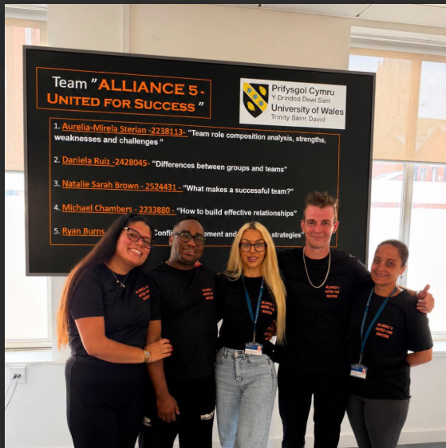
Photo 2 – Team Notes Photograph of the notes produced by the team.
This photograph shows the notes we created while planning and developing our group work. The notes provide evidence of how we organised our ideas, communicated with one another and agreed on our individual responsibilities. Each team member was able to choose their own role, and the group supported these decisions.
Our team did not experience any significant disagreements because everyone respected each other's choices and agreed on the roles they wanted to undertake. This demonstrated the importance of communication, respect and cooperation in creating a successful team.

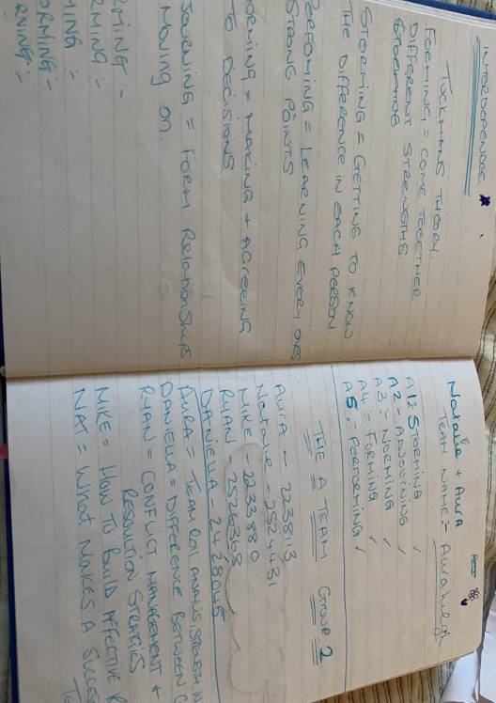
Appendix 3 – Personal Action Plan

Development area | Action | How I will do it | Evidence of progress
Active listening | Listen without interrupting | Ask questions and summarise key points during group discussions | Feedback from team members
Conflict management | Use different TKI approaches | Pause before responding to disagreement and select the most appropriate approach | Reflection after group activities
Team participation | Encourage everyone's contribution | Ask quieter members for their views and clarify responsibilities | Peer feedback and meeting notes

