Programme: Public Service Portfolio

Module: Learning in the Digital Era

Module code: BMPS4009 & BMPL4007

STUDENT NAME:Bogdan CALINOIU
Student ID:2224514
DATE OF SUBMISSION:10.03.2023

Table of Contents
Task 1-Written Summary 2
Task 2-Mind Map 3
Task 3-Presentation 3
Task 4-Reflection 4
Conclusion 5
Reference List 7

Task 1-Written Summary
Preparing for higher education entails a set of actions that can aid students in making knowledgeable choices regarding their academic and professional pathways. The initial stage, according to Miller and Light (2019), is to investigate various academic specialisations and employment opportunities that fit their interests, aptitudes, and values. This can entail investigating several majors, speaking with academic advisers or career counsellors, going to career fairs, and participating in networking activities.
After deciding on their academic and professional objectives, students can start preparing for college by enrolling in challenging high school courses. The information and abilities needed to thrive in college and stand out throughout the college admissions process can be acquired through these courses (College Board, 2021).
Creating a strong study routine and learning time management techniques is another crucial component of getting ready for higher education (Horvath et al., 2019). This may entail making a study timetable, remaining organised, and allotting specific time each day to study and finish tasks (Grossman, 2019). Students should prioritise their physical and mental health as well by getting adequate rest, exercising, and eating wholesome foods (American College Health Association, 2020).
Students should begin investigating suitable colleges before applying, taking location, size, cost, and academic offerings into consideration (National Association for College Admission Counselling, 2021). Also, they should practise for college admission exams and seek advice from instructors or tutors (The College Board, 2021).
The main goal for students should be to create a compelling application that shows their academic prowess, extracurricular involvement, and personal assets (Benioff, 2009). This may entail producing an effective personal statement, obtaining credible letters of recommendation, and engaging in significant extracurricular activities that exhibit leadership, community service, and a love for their chosen subject (American Association of Colleges and Universities, 2021).


Task 2-Mind Map

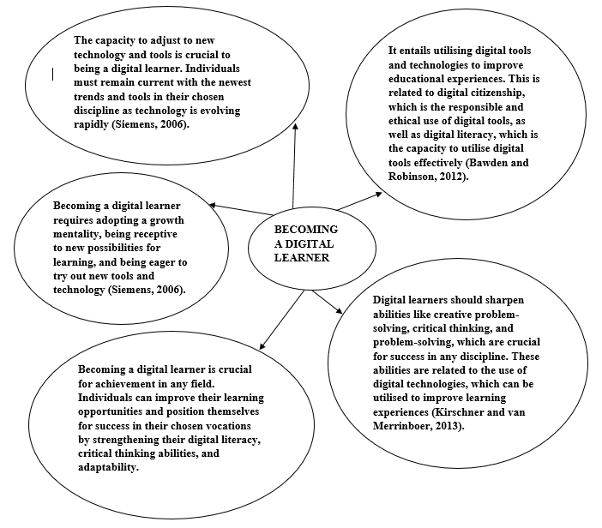

Task 3-Presentation
Personal identity is the set of qualities and attributes that make us who we are as people. It consists of our feeling of place, our values, and our beliefs, all of which are crucial in forming our identity (Moloney and Walker, 2003).
Sense of place
The several places I have lived and the experiences I have had in each of them have impacted my sense of place. I learned the value of relationships and the significance of community from my upbringing in a small town, for instance. This sense of community has shaped my personal identity and improved my empathy and understanding of other people.
Values
Values are the basic principles or beliefs that direct our actions and choices. My family, culture, and life events have influenced my values. For instance, my family taught me the importance of perseverance and hard effort. These ideals have shaped my own identity and helped me become a determined and ambitious person.
Beliefs
What we believe to be true as beliefs are our ideas or convictions. My upbringing and experiences have impacted the values I hold now. As an illustration, my encounters with prejudice and inequality have influenced my views on equality and fairness (Katz and Taylor, 2018). These convictions have had an impact on my sense of self, enhancing my capacity for empathy and understanding.
Being a good team player
Being a good team player has been influenced by my sense of place, values, and beliefs. For instance, I have learned the value of cooperation and striving for a common goal due to my sense of community. As a result, I have grown more receptive to collaboration and teamwork. I am a dependable and dedicated team player who is eager to put in the work to succeed because I value hard work and dedication. I am more open-minded and attentive to different ideas now because I believe in equality and justice, which are crucial for productive teamwork.

Task 4-Reflection
Borton’s reflective model stimulates others to consider how they might grow from their experiences and to reflect on their own (Skinner and Mitchell, 2016). I will use this framework to reflect on my first-year university experiences, my understanding of online learning and resources, and the writing of my first assignments.
What?
It was both exhilarating and intimidating for me to start university. I had to adjust to a new atmosphere and manner of studying as a first-year university student. It was particularly difficult to make the switch to online education. I had to learn how to use a variety of internet technologies, such as communication tools, virtual learning settings, and online libraries.
So What?
I had a high learning curve as I adjusted to online study and used numerous online tools. I realised that I was spending a lot of time learning how to use various platforms and technologies. Yet I quickly understood that these sites were excellent assets that might improve my learning process.
The process of composing my first assignments was also gratifying and demanding. I had a hard time getting used to the academic writing style and the demanding standard of critical analysis. I also discovered that the writing and research processes assisted in the development of my comprehension of the subject and enabled me to better organise my thoughts.
Next, what?
I have discovered from my experiences that beginning university is an adventure and discovery journey. It necessitates a readiness to pick up new skills and adapt to different surroundings and learning styles. I have learned that online resources can be beneficial tools for studying and can improve the learning process.
Moving forward
I will keep reflecting on my encounters and utilising them to guide my future education. To improve my learning experience, I will also look for chances to improve my academic writing abilities and ways to interact with my peers and lecturers.

Conclusion
Many students find it difficult to adjust to online learning, start university, and write their first assignments. People can, however, obtain important insights and benefit from their experiences by employing reflective tools like Borton's model. This insight has helped me to better comprehend my experience as a university student. I am aware of how important academic writing skills development is and how valuable online resources can be in aiding the learning process. In addition, I have realised that success in a new setting requires being adaptive and eager to learn.
I will keep reflecting on my experiences as I advance in my studies and use them to guide my learning and growth. To further strengthen my academic writing abilities and engage with my peers and instructors, I will look for opportunities to do so. I now have a better knowledge of my experiences and what I may take away from them overall thanks to this contemplation. I am hoping that by sharing my reflection, other students will be motivated to reflect on their own experiences and use them to guide their future study. We can all thrive and achieve in our academic endeavours with the correct attitude and resources.

Reference List
American Association of Colleges and Universities. (2021). High-impact practices. https://www.aacu.org/resources/high-impact-practices
American College Health Association. (2020). Healthy campus 2020 objectives. https://www.acha.org/healthy_campus/healthy_campus_2020_objectives
Bawden, D., & Robinson, L. (2012). Information behaviour. In Introduction to Information Science (pp. 187-206). Facet Publishing.
Benioff, M. (2009). Compassionate capitalism: How corporations can make doing good an integral part of doing well. ReadHowYouWant. Com.
College Board. (2021). Advanced placement. https://apstudents.collegeboard.org/courses
Grossman, S. (2019). The best study habits for successful college students. Top Universities. https://www.topuniversities.com/student-info/health-and-support/10-best-study-habits-successful-college-students
Horvath, D., Stirling, E., Bevacqua, J., Coldrey, M., Buultjens, P., Buultjens, M., & Larsen, A. (2019). Plan, prepare and connect: How investing in understanding and tracking the evolving needs of online students informs the development of targeted programs for transition and success. Journal of University Teaching & Learning Practice, 16(1), 4.
Katz, I., & Taylor, D. A. (2018). Eliminating racism and discrimination in higher education: What needs to be done?. Journal of Higher Education Policy and Management, 40(2), 167-182.
Kirschner, P. A., & van Merriënboer, J. J. (2013). Do learners really know best? Urban legends in education. Educational Psychologist, 48(3), 169-183.
Miller, M. & Light, G. (2019). The ultimate guide to college and career readiness. Corwin.
Moloney, G., & Walker, I. (2003). You are where you have lived: An examination of the relationship between place of residence and place identity. Journal of environmental psychology, 23
National Association for College Admission Counseling. (2021). College search process. https://www.nacacnet.org/college-search-process/
Siemens, G. (2006). Knowing knowledge. Lulu. com.
Skinner, M., & Mitchell, D. (2016). “What? So What? Now What?”: Applying Borton and Rolfe’s Models of Reflexive Practice in Healthcare Contexts. Health and Social Care Chaplaincy, 4(1), 10-19.

