
S&CD Report – PHP AND DATABASE
Connor Stock - 1801401

February 28, 2020
Smart and Connected Devices
Gaynor Thomas

Contents
1. Introduction: 1
2. SQL Database: 1
3. Website/PHP Code: 2
3.1. Conninfo Page: 2
3.2. Home/Landing Page and Checklogin Page: 3
3.3. Main Page: 5
3.4. Graphs Page/Make Graph Page/phpMyGraph5.0 page: 7
3.5. Search Page: 8
4. Conclusion: 9

Introduction:
The author of this report is required to create a website using HTML, CSS and PHP along with an SQL database created using phpmyadmin, with the goal of linking the two and creating a web interface that could be used to filter and interpret provided data. This data consists of rainfall readings taken from three separately located sensors, with each sensor providing rainfall per hour measured in millimeters along with the date and time the reading was gathered.
The SQL database should store the rainfall and date and time readings, which should be implemented into the database using PHP. The website should then have features such as a search feature to allow users to filter the data from the database, along with graphs and other ways of interpreting the rainfall readings. Additionally, security measures should be added such as a login system. This report will detail the implementation of the PHP Code, the website plus features, and the database with screenshots included to illustrate each point.

SQL Database:
Firstly, the database was created. It was named ‘rainfallassignment’ and four tables were created inside of the database. These tables were named ‘rainfall1’, ‘rainfall2’, ‘rainfall3’, and ‘webusers’. The three ‘rainfall’ tables would each store one of the three text files containing the rainfall readings, while the ‘webusers’ table would store login details for users. The following screenshots shows the structure of the database along with the structures for the ‘webusers’ table and the matching structure used for all three ‘rainfall’ tables:

Database Structure:
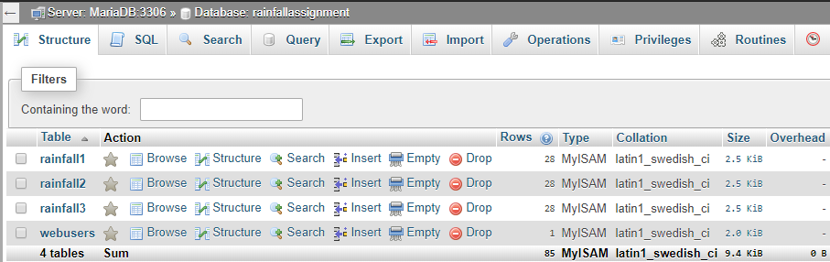

Webusers table structure:
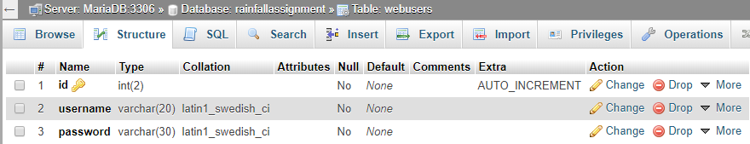

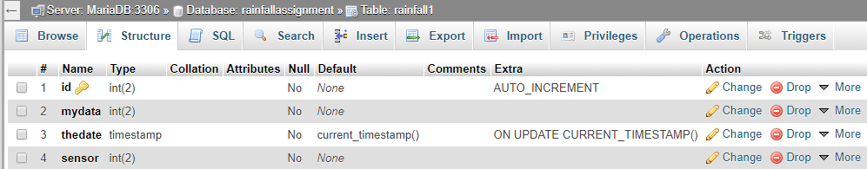
‘Rainfall’ tables structure:

As can be seen, each row of data has been given an appropriate data type and value, along with the ‘id’ being set to AUTO_INCREMENT on every table. This will make the id automatically go up by one every time new data is entered into the table.

Website/PHP Code:
This section will cover the website created and the PHP code used to create the web-interface, connect it to the above database and add features.

Conninfo Page:
The first page created is the ‘Connection Info Page’ (conninfo.php). This page is required to allow your PHP code to connect to a database. In this page, you enter your server name, server username, server password and the name of the database you want to connect to. The following annotated code is the code used to create the Conninfo.php page:
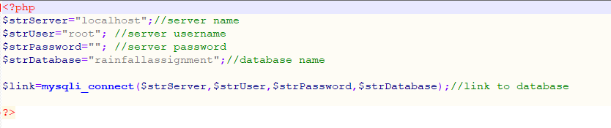

Home/Landing Page and Checklogin Page:
The first page of the website is the home/landing page. This page simply contains a header with a title, a footer, an article explaining the website, and a login form. Using PHP code, the login form was connected to the database, which allowed users to be able to login if their username and password are stored in the database.
Home Page:
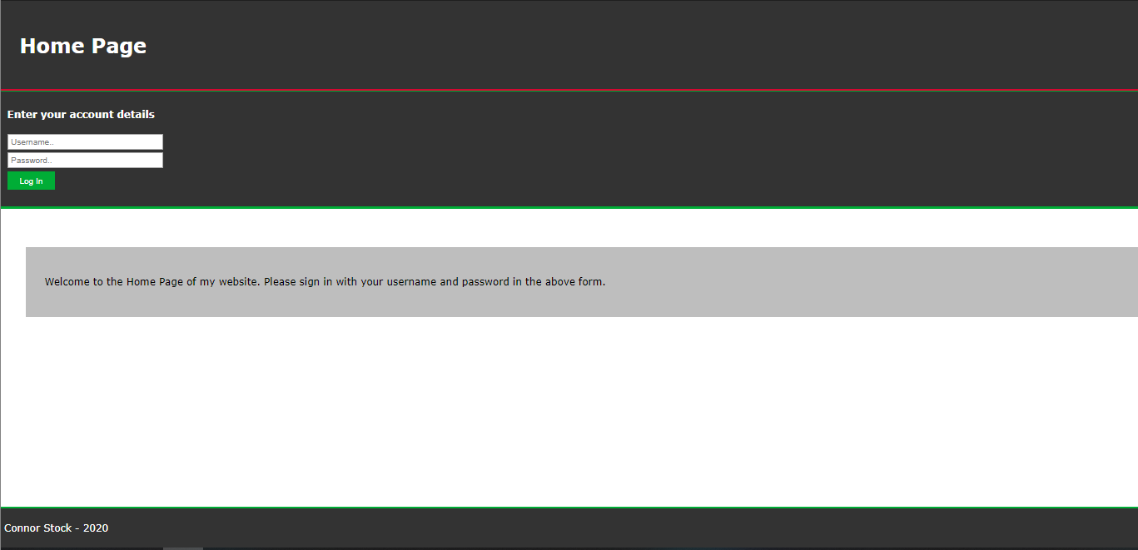

Home Page Code:
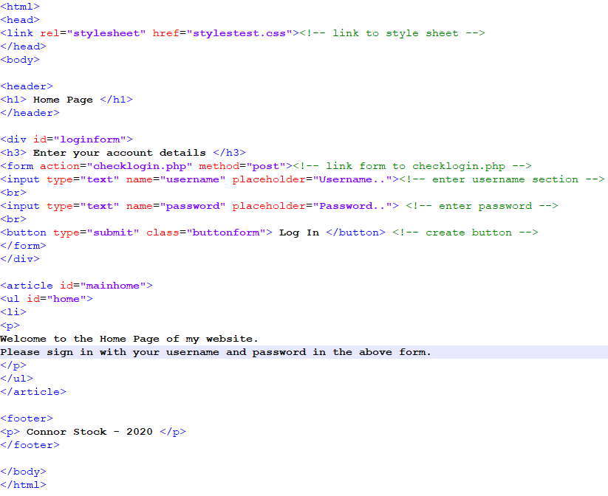

For the login form to work, another file needs to be created containing PHP code which will connect to the database and check if the username and password entered exist. This code should allow users to login if their credentials exist within the database and deny access if they do not.
CheckLogin (Successful Login):
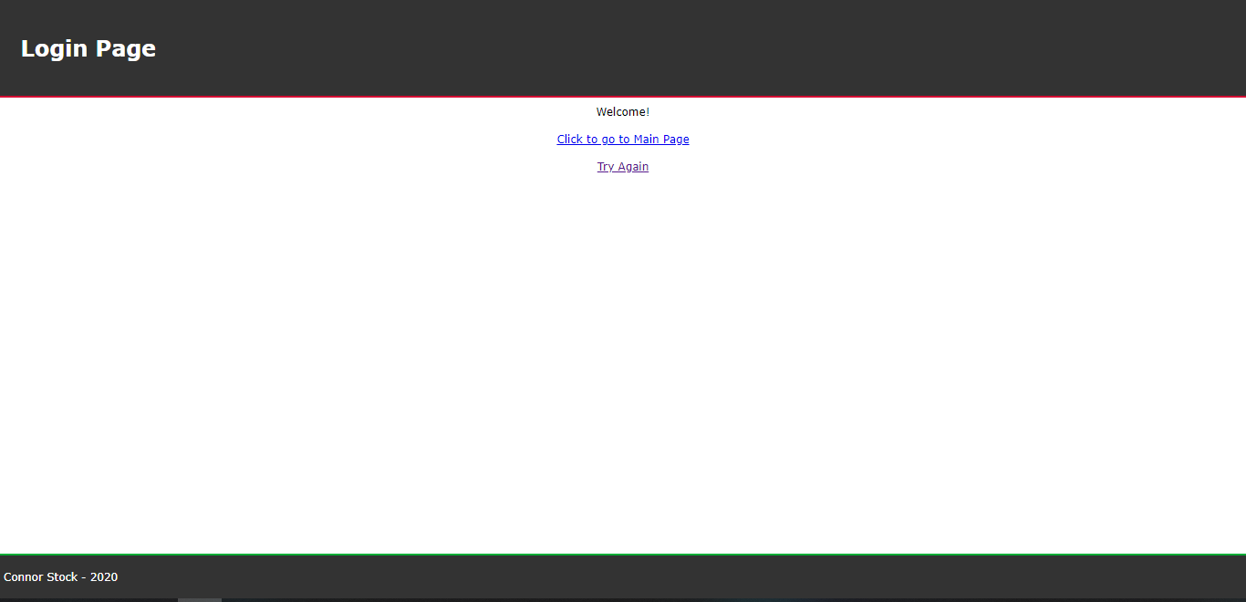

CheckLogin (Unsuccessful Login):
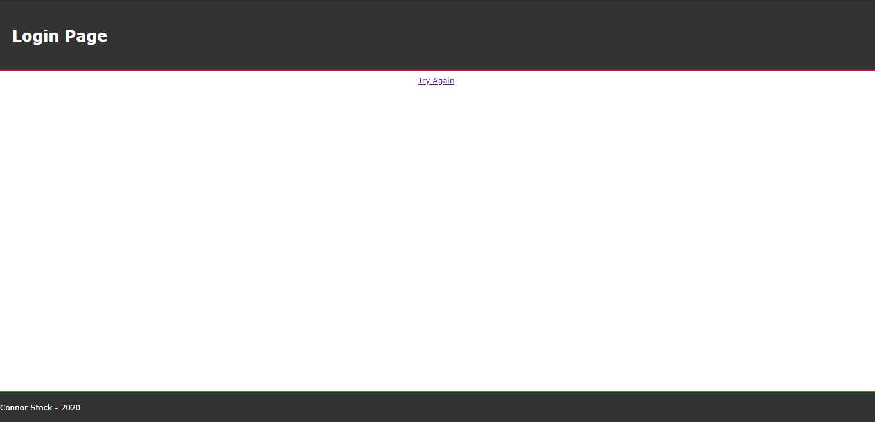

As you can see, if the user successfully logs in, they are given a link to access the main page. If they are not successful, they are given a link to go back to the home page and try again.

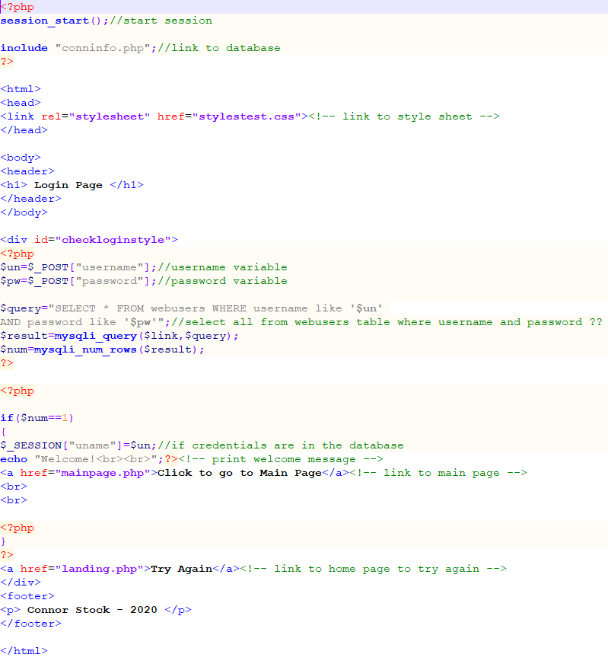
CheckLogin Code:

Main Page:
The next page is the main page of the website, which is where users are taken after logging in. This page contains navigation links to other pages, which contain features that allow users to filter and interpret the rainfall readings.

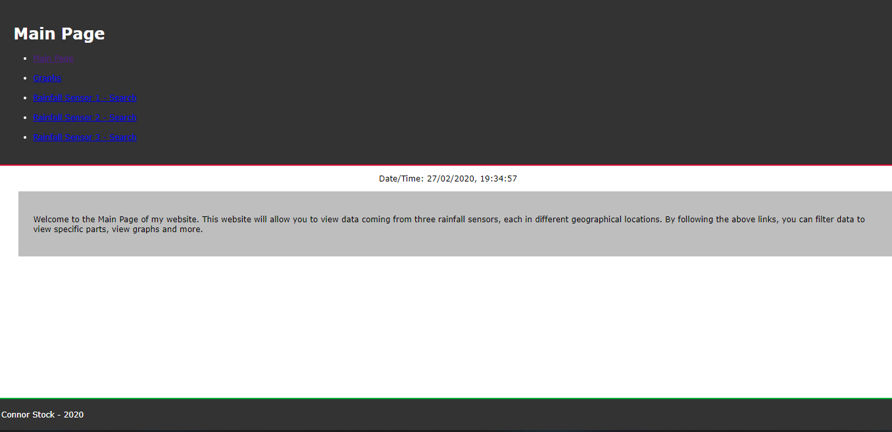
Main Page:

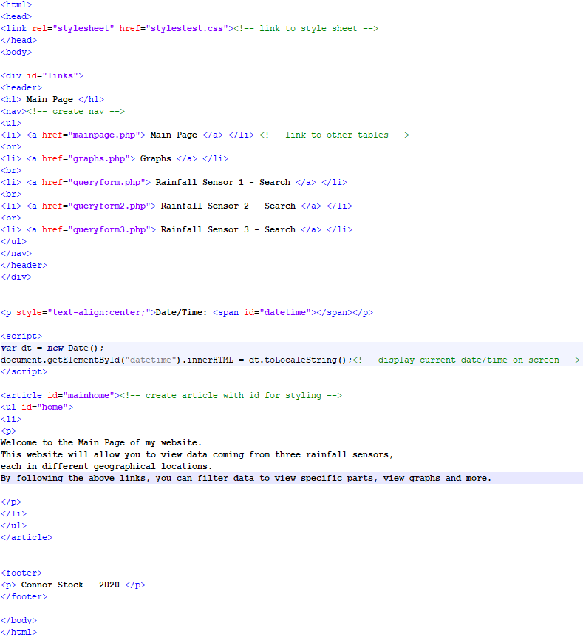
Main Page Code:

Graphs Page/Make Graph Page/phpMyGraph5.0 page:
The graphs page (graphs.php) allows the user a visual method of interpreting the rainfall readings. This page can be accessed using the navigation bar on the main page, and once opened contains three graphs. The graphs each show rainfall in millimetres over 48 hours, with each graph corresponding to a different sensor.
Graphs Page:
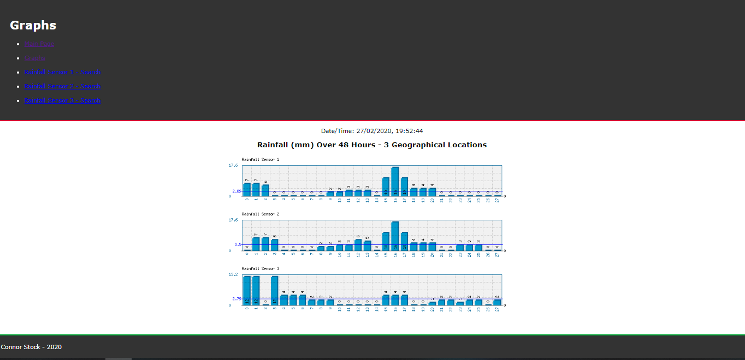

Graphs Page Code:
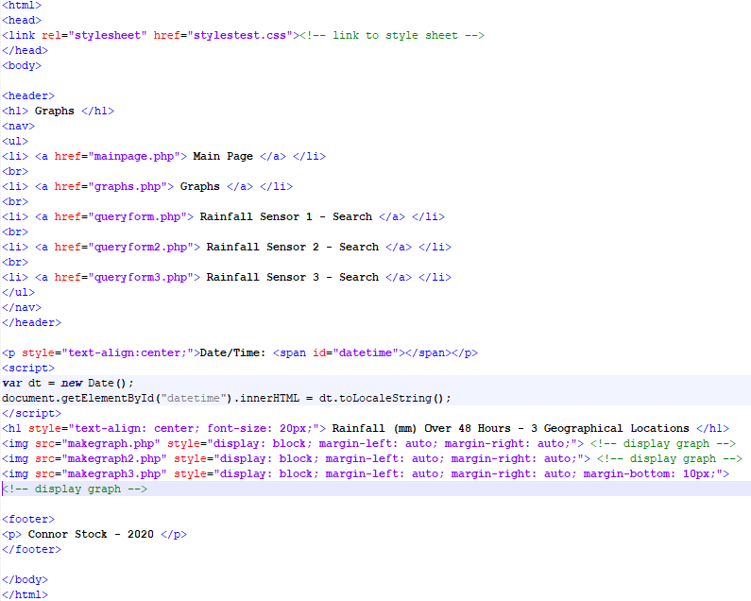

The make graph pages (makegraph.php) create the graphs seen in the above screenshots. There are three make graph pages, one for each graph, with the only difference in the code being the database name typed in.
Make Graph Code:
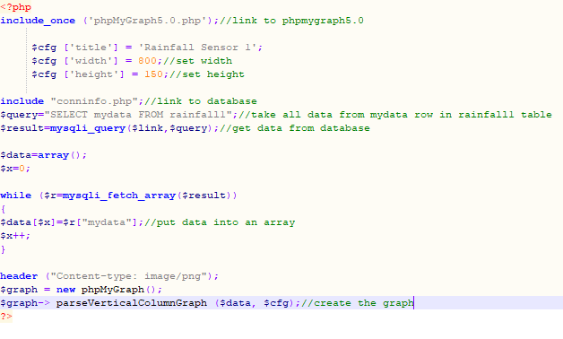
The final graph page is phpMyGraph5.0. This page is the library used to create the graphs. Without this page, making the graphs would not be possible. In the above code, you can see code creating a link to this page.

Search Page:
The final pages are the ‘search’ pages. There are three search pages, one for each rainfall sensor. Each is connected to it’s corresponding table, allowing users to search for and filter data from each sensor. This will allow users to access the information they require using the web-interface. These pages consist of an area where users can enter information, a drop-down list to choose a specific filter, and a search button. The three pages are practically identical in their code, other than code which chooses the table it links to.
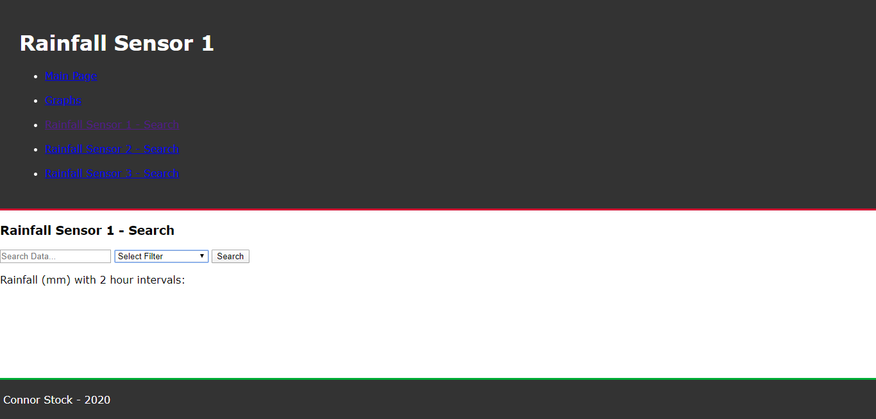
Search Page (queryform.php):

Search Page Code:
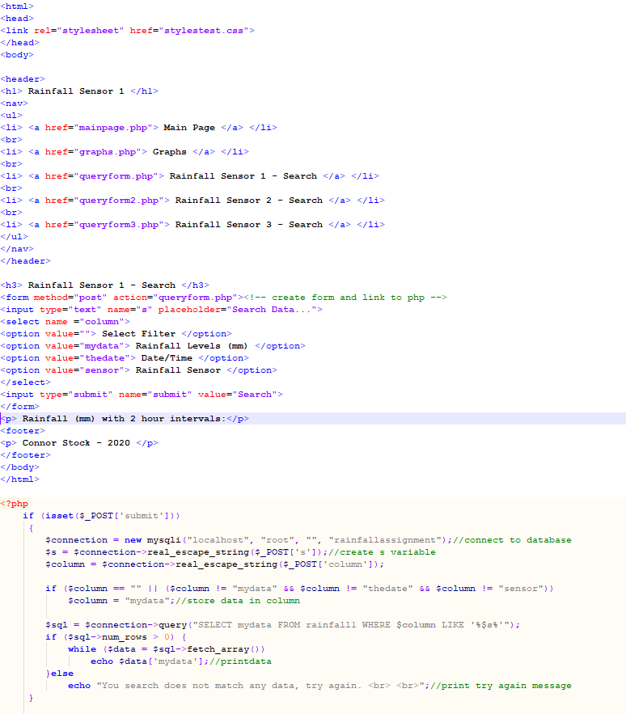

Conclusion:
To conclude, an SQL database was created using phpmyadmin, where data that was collected from three rainfall sensors along with user credential information was stored. This database was then linked to a website using PHP, where features such as logging in, viewing graphs relating to the rainfall readings and searching for and filtering the readings were added. These features allowed the user to enter the website securely, and then use the additional features to better understand and interpret the rainfall readings, while also being able to search for and filter specific information that they may wish to access.
The implementation of the database, the PHP code and the website was covered, with screenshots of the webpages and the PHP code being provided to allow further understanding of the intricacies of the implementation.

