Module: Networks and Cyber Security Essentials
Module code: ACCA4024
Student name: Mohammad Hasan Tohin
Student ID: 2514325
Main text word count: approximately 2,000 words
Table of Contents
Governing the Trusted Path 1
Abstract 3
1. Introduction and extended scenario 3
1.1 Smart-manufacturing context 3
1.2 SteelForm problem and assumptions 3
1.3 Aim, question and argument 3
2. Conceptual and analytical framework 4
2.1 Confidentiality, integrity, availability, safety and recoverability 4
2.2 Framework synthesis 4
2.3 Risk method and limitations 4
3. Prioritised threat and risk analysis 4
3.1 Assets, trust boundaries and broad threat scan 4
3.2 Three end-to-end attack scenarios 5
3.3 Prioritisation and case evidence 5
4. Integrated security and data-governance policy architecture 7
4.1 Governance and accountability 7
4.2 Integrated policy package 7
4.3 Standards, law and alternatives 8
5. Mitigation design and implementation roadmap 8
5.1 Target information technology-operational technology architecture 8
5.2 Control implementation 9
5.3 Phased roadmap and validation 10
6. Monitoring, incident response and recovery 11
6.1 Monitoring model 11
6.2 Incident-response process 12
6.3 Recovery measures 12
7. Role-based training and security culture 12
7.1 Behavioural foundation 12
7.2 Role-specific programme 13
7.3 Metrics and governance 14
8. Strategic implications and conclusion 14
8.1 Strategic and future implications 14
8.2 Recommendation, limitations and conclusion 15
References 16
Appendix A. Board presentation 18

Abstract
SteelForm Manufacturing Ltd faces a path from supplier account theft to production stoppage because persistent remote access joins corporate systems, engineering workstations and factory assets. The proposed response combines the National Institute of Standards and Technology Cybersecurity Framework 2.0 with industrial security and information governance standards [1], [2]. A consequence-weighted assessment ranks supplier-enabled ransomware above industrial espionage and production-data manipulation, although the latter could damage product quality. SteelForm should broker every external session through time-limited approval, network separation, recorded administration and tested recovery. Governance must bind procurement, engineering, security and management to the same evidence.

1. Introduction and extended scenario

1.1 Smart-manufacturing context
Connected manufacturing gives managers production data and lets equipment vendors diagnose faults remotely. The same links create inherited trust. A stolen supplier account can cross an organisational boundary, enter engineering systems and reach machinery designed for stable plant traffic, not hostile internet activity. Castillo-Villar et al. [3] connect cyber risk with resilience and supply-chain design, while ENISA [4] records ransomware and availability attacks among threats. Connectivity brings value. It also widens the route to failure.

1.2 SteelForm problem and assumptions
SteelForm Manufacturing Ltd produces components for automotive and aerospace customers. Its Internet of Things sensors, machinery and cloud platform sit beside malware, procurement phishing and attempted production-network access. The analysis assumes Virtual Private Network (VPN) accounts for vendors, slow patch cycles on Human-Machine Interfaces, and backups reachable from shared identity administration. Engineering designs, machine programmes, inspection thresholds and traceability records form assets. Interruption may delay deliveries and force manual work, as Norsk Hydro and The Clorox Company disclosed [5], [6].

1.3 Aim, question and argument
SteelForm must govern third-party access without blocking necessary maintenance. Governed connectivity offers the sounder choice: verified identity, narrow routes, observable sessions, safe isolation and proven restoration should replace standing trust.

2. Conceptual and analytical framework

2.1 Confidentiality, integrity, availability, safety and recoverability
Confidentiality limits disclosure, integrity protects accuracy, and availability keeps services usable. Operational Technology (OT) changes weighting. A stolen drawing harms secrecy, but a calibration error can corrupt a component while machines run. Stouffer et al. [7] state that OT decisions must respect safety, reliability and process continuity. SteelForm should assess the triad beside safety, business harm and recoverability. The extension corrects a blind spot when office-system assumptions govern factory risk.

2.2 Framework synthesis
National Institute of Standards and Technology Cybersecurity Framework 2.0 (NIST CSF 2.0) groups work under Govern, Identify, Protect, Detect, Respond and Recover [1]. International Organization for Standardization and International Electrotechnical Commission 27001:2022 (ISO/IEC 27001) sets management requirements; ISO/IEC 27002:2022 lists controls [8], [9]. International Electrotechnical Commission 62443-2-1:2024 governs industrial asset owners [2]. Together they connect board accountability, policy and controls. Compliance does not prove safety.

2.3 Risk method and limitations
Threat j receives Rj = Lj(0.15Cj + 0.30Ij + 0.25Aj + 0.20Sj + 0.10Bj). L means likelihood; C, I, A, S and B represent impact dimensions. Martinez-Medina et al. [10] support scoring, but values are judgements rather than probabilities.

3. Prioritised threat and risk analysis

3.1 Assets, trust boundaries and broad threat scan
SteelForm's trust boundaries separate suppliers from the VPN, Information Technology (IT) from engineering, engineering from OT, sensors from cloud services, and the plant from recovery copies. Internal hazards include excess privilege, service accounts, removable media and unsafe configuration. External hazards include credential theft, cloud takeover, software-supply compromise and ransomware. Boyens et al. [11] treat supplier risk as a life-cycle concern, not a procurement check. Figure 1 maps the main route, while Table 1 records other hazards beside three selected risks.
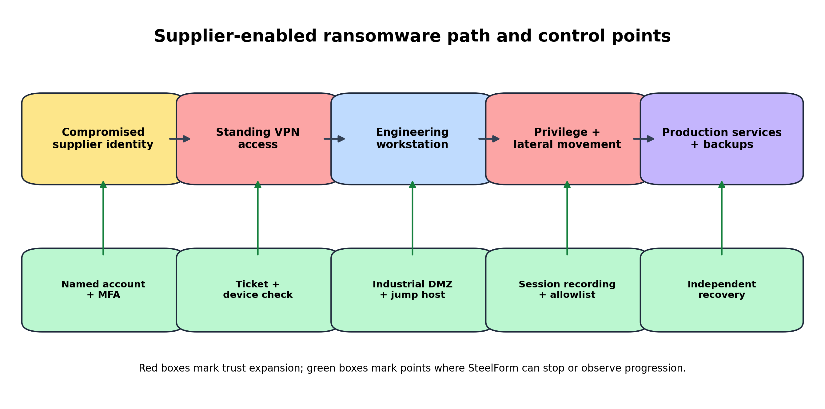
Figure 1. Supplier-enabled ransomware path and control points
Source: Synthesised from [11], [12] and [7].

3.2 Three end-to-end attack scenarios
Supplier-enabled ransomware starts when an attacker steals a vendor identity, enters through a channel, reaches an engineering host and seeks administrator rights. Weak separation permits movement towards production servers and reachable backups. Unusual login time, a device, an unapproved destination or rapid encryption may expose the attack, yet valid credentials can make traffic look ordinary.
Industrial espionage follows a quieter route. A compromised procurement or engineering account can locate customer specifications, Computer-Aided Design files and production volumes, then remove them through cloud or supplier services. Availability alarms may remain silent, so data classification, unusual-download detection and short sessions matter more than malware signatures.
Production-data manipulation targets integrity. An intruder changes inspection thresholds, machine parameters or sensor values so defective parts appear compliant. Low-volume tampering may evade alerts. The National Cyber Security Centre recommends controlled OT connectivity, monitored flows and safe isolation because office-style containment can cause physical disruption [12].

3.3 Prioritisation and case evidence
Ransomware scores 16.60, production-data manipulation 8.60 and industrial espionage 8.55. Table 1 records assumptions. Norsk Hydro used isolation and manual work after a March 2019 attack; Clorox reported reduced capacity after an August 2023 incident [5], [6]. Cases inform consequences, not probability.
Table 1. Consequence-weighted SteelForm risk register
Threat | Asset | Weakness | L | C-I-A-S-B | R | Treatment | Owner
Supplier-enabled ransomware | Vendor identity; engineering host; backups | Persistent access; weak separation | 4 | 4-4-5-3-5 | 16.60 | Time-limited access; independent recovery | IT Security / OT
Production-data manipulation | Inspection thresholds; machine parameters | Weak change detection; broad routes | 2 | 2-5-4-5-5 | 8.60 | Restricted path; configuration monitoring | OT Manager
Industrial espionage | CAD files; customer specifications | Excess privilege; approved cloud channels | 3 | 5-3-2-1-5 | 8.55 | Data classification; download monitoring | Engineering / Security
Procurement phishing | Supplier payments and contacts | Weak verification workflow | 3 | 3-2-1-1-3 | 5.40 | Independent supplier-detail verification | Procurement
Infected removable media | Engineering workstation; HMI | Uncontrolled media | 2 | 2-3-3-2-3 | 5.30 | Approved media; scanning station | OT / IT Operations
Cloud account takeover | Manufacturing execution and reports | Weak MFA; token theft | 2 | 3-2-3-1-3 | 4.60 | Phishing-resistant MFA; conditional access | Cloud Service Owner

Source: Scenario scoring based on Section 2.3. Impact order: confidentiality, integrity, availability, safety and business harm; values are ordinal judgements.

4. Integrated security and data-governance policy architecture

4.1 Governance and accountability
Board directors should approve risk appetite and receive evidence on production exposure. The IT Security Manager should own the security management system; the OT Manager should own plant-risk treatment and operating limits. Procurement should bind supplier access to contract terms, staff and notification duties. Asset owners should accept residual risk after security and engineering review. ISO/IEC 27001 links policy, risk ownership, control selection and periodic review [8].

4.2 Integrated policy package
Identity policy should require named accounts, phishing-resistant Multifactor Authentication (MFA), least privilege and recertification. Privileged work must use separate administrator identities. Third-party policy should forbid standing access: a maintenance ticket, owner, target asset, service and expiry time must define each session. The gateway should record activity and close dormant connections.
Network policy should separate corporate, engineering, OT, sensor, guest, recovery and vendor zones. Firewall rules should deny unapproved routes, while an industrial demilitarised zone should broker IT-OT exchanges. Asset policy should record owner, firmware, dependency, support status and recovery method. Patch policy should use risk-based windows; where vendors cannot patch safely, SteelForm should restrict routes, disable unused services and monitor passively.
Data policy should classify design files, machine logic, quality records and personal data, then set storage, transfer, retention and disposal rules. Supplier policy should require breach notice, device control, account removal and test evidence. Backup policy should keep independent copies, block administrators from deleting them and require restoration trials. Logging policy should retain identity, gateway, firewall, cloud, endpoint and OT events. ISO/IEC 27002 supplies control guidance, while Boyens et al. [11] connect those rules to supplier governance [9]. Table 2 links policy to ownership and evidence.
Table 2. Policy, control evidence and ownership matrix
Policy domain | Mandatory rule | Evidence | Owner
Identity and privilege | Named accounts, phishing-resistant MFA, separate admin identities | Identity logs; quarterly access review | IT Security Manager
Third-party access | Ticket-bound, approved, recorded and time-limited sessions | Gateway logs; supplier account register | Procurement and OT asset owner
IT/OT separation | Deny unapproved routes; broker traffic through industrial DMZ | Firewall tests; flow inventory | Network and OT managers
Asset and patch control | Record owner, firmware, support state and recovery method | Asset register; exception record | OT Manager
Data governance | Classify design, production, quality and personal data | Access reports; retention checks | Data owners
Backup and recovery | Keep independent copies and test restoration | Restore results; recovery evidence | Infrastructure Manager
Logging and response | Retain relevant events and report incidents promptly | Coverage dashboard; exercise record | IT Security Manager

Source: Synthesised from [8], [9], [2] and [11].

4.3 Standards, law and alternatives
IEC 62443 assigns industrial security duties to asset owners, so SteelForm cannot transfer accountability to vendors [2]. UK data rules require technical and organisational measures for personal data [13], [14]; the Data (Use and Access) Act 2025 changed that regime [15]. Air-gapping would obstruct cloud production and remote maintenance, while unrestricted supplier VPN access creates excessive trust. Brokered access preserves service but limits reach.

5. Mitigation design and implementation roadmap

5.1 Target information technology-operational technology architecture
Figure 2 separates corporate IT, engineering, OT, Industrial Internet of Things (IIoT), guest, vendor and recovery zones. External technicians should authenticate at a managed gateway, enter a jump host in the industrial demilitarised zone and reach only the named asset through an approved protocol. Corporate users should read production reports through brokered services, not direct plant routes. Sensors should reach a telemetry broker but not finance or identity servers. NCSC guidance supports this design, while IEC 62443 provides its industrial basis [12], [2].
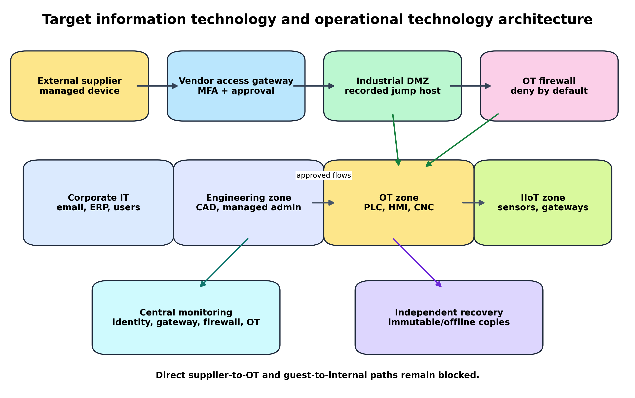
Figure 2. Target information technology and operational technology architecture
Source: Synthesised from NCSC [12], IEC (2024) and Stouffer et al. [7].

5.2 Control implementation
Security staff should issue supplier identities and require phishing-resistant MFA plus a certificate. Procurement and the asset owner should approve a maintenance ticket before the gateway grants an access window. The jump host should record sessions, restrict destinations and block file transfer unless the ticket permits it. Network engineers should apply deny-by-default rules and test allowed paths. OT engineers should tune monitoring so inspection does not inject unsafe traffic.
Infrastructure staff should keep immutable or offline recovery copies outside domain administration. Monthly restore trials should rebuild an engineering workstation, its configuration and a production-support service. Where old machinery cannot accept patches, SteelForm should remove unused services, restrict source hosts, monitor configuration changes and record residual exposure. Stouffer et al. [7] support controls that respect plant reliability; Boyens et al. [11] require discipline for supplier dependencies.

5.3 Phased roadmap and validation
Days 0 to 30 should remove accounts, require MFA, verify backups and stop vendor routes. Months 2 to 3 should produce the asset register, dependency map and flows. Months 4 to 6 should install the gateway, jump host, rules and logs. Months 7 to 9 should migrate suppliers and test restoration. Months 10 to 12 should review risk and exercise response. Table 3 records ownership and evidence. Packet Tracer can test reachability, but it cannot prove latency, protocol safety or recovery. Attack-graph methods may guide investment [10].

Table 3. Twelve-month implementation roadmap
Period | Action | Owner | Evidence
0-30 days | Remove dormant accounts; require MFA; verify backups; stop direct vendor routes | IT Security Manager | Account and route review signed off
Months 2-3 | Build IT/OT asset register, dependencies and approved data flows | OT Manager | Asset coverage and owner confirmation
Months 4-6 | Install gateway, jump host, network rules and central logging | Network Manager | Connectivity tests match policy
Months 7-9 | Migrate suppliers; run restore and incident exercises | Procurement / Infrastructure | Supplier completion and recovery results
Months 10-12 | Review residual risk, policy evidence and capital plan | Board Risk Committee | Approved treatment plan and budget

Source: SteelForm implementation sequence derived from the proposed control dependencies.

6. Monitoring, incident response and recovery

6.1 Monitoring model
SteelForm should collect events from identity, email, the vendor gateway, jump hosts, firewalls, endpoints, cloud systems, backups, physical access and passive OT sensors. Rules should flag supplier access outside windows, new devices, failed MFA, direct OT attempts, unexpected routes, machine-parameter changes and rapid encryption. Security analysts should confirm evidence with OT engineers before isolating plant equipment. Nelson et al. [16] place incident response inside risk management, and NCSC [12] links monitoring to OT connectivity. Figure 3 shows the decision path.
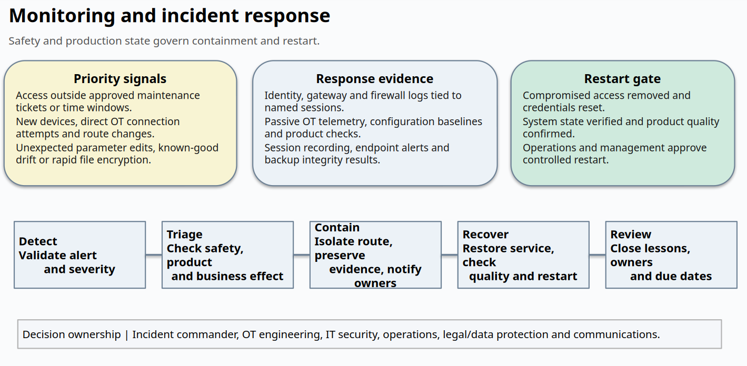
Figure 3. Monitoring and incident response with operational safety decisions
Source: Synthesised from [16], [12] and [7].

6.2 Incident-response process
An analyst should validate the alert, classify severity and call the incident commander. OT engineering should assess safety and decide whether isolation can occur without harming people, equipment or material. Security staff should preserve logs, disable exposed identities and block the route. Legal and data-protection staff should assess reporting duties; procurement should contact the supplier; communications staff should control messages. Recovery should start only after a clean identity path, known-good configuration and backup are confirmed. Norsk Hydro and Clorox used manual work during recovery, so SteelForm must define fallback processes before an incident [5], [6].

6.3 Recovery measures
Mean Time to Detect, Mean Time to Contain and Mean Time to Recover should track speed. Recovery Time Objective and Recovery Point Objective should follow business-impact analysis. Restoration rate should show whether tested copies return services [16].

7. Role-based training and security culture

7.1 Behavioural foundation
Annual awareness alone rarely changes conduct. Alshaikh [17] treats security culture as practice shaped by management, communication and routines. Sutton and Tompson [18] connect culture to observable behaviour, while Uchendu et al. [19] find uneven practice and measurement in programmes. SteelForm should design safer work, reward early reporting and remove incentives to share accounts or bypass approval. People make mistakes. The system should catch them before production pays the price.

7.2 Role-specific programme
All new staff should complete induction on reporting, data handling, MFA and removable media, followed by annual renewal. Procurement staff should face quarterly supplier-impersonation exercises requiring independent payment and bank-detail checks. Production operators should practise reporting Human-Machine Interface messages and isolating removable media without stopping equipment unsafely. Administrators should rehearse privileged-access review, log preservation and restoration. Senior managers should join an annual ransomware exercise that forces decisions on shutdown, customer notice and recovery priority. Contractors should complete an access briefing before projects and acknowledge monitoring. Merritt et al. [20] recommend learning programmes tied to roles and outcomes. Table 4 converts that principle into a schedule.

Table 4. Role-based training and assurance scorecard
Audience | Objective | Frequency | Measure
All staff | Report suspicious activity and handle data safely | Induction plus annual renewal | Completion, test score, reporting speed
Procurement | Detect supplier impersonation and payment fraud | Quarterly scenario exercise | Reporting rate; verification accuracy
Production operators | Report HMI anomalies and control removable media | Six-month practical drill | Correct response; safe escalation time
Administrators | Use privileged access and preserve evidence | Quarterly technical exercise | Access-review errors; log quality
Senior managers | Decide shutdown, notice and recovery priority | Annual ransomware tabletop | Decision time; lesson closure
Contractors | Follow access and data-handling rules | Before each project | Acknowledgement; access exceptions

Source: Synthesised from [17]-[20].

7.3 Metrics and governance
Completion rate measures attendance, not conduct. SteelForm should record reporting rate, speed, unsafe actions, supplier compliance, exercise decisions and lesson closure. Managers should compare departments because exposure differs. A falling click rate with reporting may mean silence rather than learning. The security committee should review trends and revise training when incidents expose a workflow weakness.

8. Strategic implications and conclusion

8.1 Strategic and future implications
Cloud-managed machinery, software-defined production and remote service contracts will deepen supplier dependence. Castillo-Villar et al. [3] place cyber resilience in manufacturing and supply-chain design, not only IT operations. SteelForm should make identity, network architecture and recovery evidence part of future equipment purchases. A cheaper machine may create a costly constraint when it lacks supported authentication, logging or safe restoration. Cyber risk should enter capital planning, vendor selection and production-change approval.

8.2 Recommendation, limitations and conclusion
SteelForm should approve four decisions: assign joint IT and OT ownership, mandate brokered supplier access, fund network separation and independent recovery, and measure staff and supplier behaviour. Exact loss reduction cannot be claimed because the case lacks telemetry, verified asset data and recovery times. Standing trust remains hard to defend. Time-limited identity, narrow communication paths, recorded work and proven restoration provide a proportionate route between unsafe openness and impractical isolation.

References
[1] C. Pascoe, S. Quinn, and K. Scarfone, The NIST Cybersecurity Framework (CSF) 2.0, NIST Cybersecurity White Paper 29. Gaithersburg, MD, USA: National Institute of Standards and Technology, 2024. doi: 10.6028/NIST.CSWP.29.
[2] International Electrotechnical Commission, IEC 62443-2-1:2024 Security for Industrial Automation and Control Systems - Part 2-1: Security Program Requirements for IACS Asset Owners, 2nd ed. Geneva, Switzerland: IEC, 2024.
[3] K. K. Castillo-Villar, H. Dai, G. Martinez Medina, and H. Mehrzadi, "Cybersecurity for smart and resilient manufacturing and supply chains: A systematic review of the evolving knowledge base," Computers & Industrial Engineering, Art. 112244, 2026. doi: 10.1016/j.cie.2026.112244.
[4] European Union Agency for Cybersecurity, ENISA Threat Landscape 2025, version 1.2. Heraklion, Greece: ENISA, 2025, revised Jan. 2026. [Online]. Available: https://www.enisa.europa.eu/publications/enisa-threat-landscape-2025
[5] Norsk Hydro ASA, "Update: Hydro subject to cyber attack," Mar. 19, 2019. [Online]. Available: https://www.hydro.com/en/global/media/news/2019/update-hydro-subject-to-cyber-attack/
[6] The Clorox Company, Form 8-K Current Report. Washington, DC, USA: U.S. Securities and Exchange Commission, filed Sep. 18, 2023. [Online]. Available: https://www.sec.gov/Archives/edgar/data/21076/000120677423001133/clx4242401-8k.htm
[7] K. Stouffer, M. Pease, C. Tang, T. Zimmerman, V. Pillitteri, S. Lightman, A. Hahn, S. Saravia, A. Sherule, and M. Thompson, Guide to Operational Technology (OT) Security, NIST Special Publication 800-82 Rev. 3. Gaithersburg, MD, USA: National Institute of Standards and Technology, 2023. doi: 10.6028/NIST.SP.800-82r3.
[8] International Organization for Standardization and International Electrotechnical Commission, ISO/IEC 27001:2022 Information Security, Cybersecurity and Privacy Protection - Information Security Management Systems - Requirements, 3rd ed. Geneva, Switzerland: ISO, 2022.
[9] International Organization for Standardization and International Electrotechnical Commission, ISO/IEC 27002:2022 Information Security, Cybersecurity and Privacy Protection - Information Security Controls, 3rd ed. Geneva, Switzerland: ISO, 2022.
[10] G. Martinez-Medina, K. K. Castillo-Villar, and T. Hossain Bhuiyan, "Integrating IT and OT for cybersecurity: A stochastic optimization approach via attack graphs," IEEE Access, vol. 13, pp. 140578-140599, 2025. doi: 10.1109/ACCESS.2025.3596837.
[11] J. Boyens, A. Smith, N. Bartol, K. Winkler, A. Holbrook, and M. Fallon, Cybersecurity Supply Chain Risk Management Practices for Systems and Organizations, NIST Special Publication 800-161 Rev. 1 Update 1. Gaithersburg, MD, USA: National Institute of Standards and Technology, 2024. doi: 10.6028/NIST.SP.800-161r1-upd1.
[12] National Cyber Security Centre, Secure Connectivity Principles for Operational Technology (OT), version 1.0. London, UK: NCSC, Jan. 14, 2026. [Online]. Available: https://www.ncsc.gov.uk/collection/operational-technology/secure-connectivity
[13] Information Commissioner's Office, A Guide to Data Security. Wilmslow, UK: ICO, updated May 19, 2023. [Online]. Available: https://ico.org.uk/for-organisations/uk-gdpr-guidance-and-resources/security/a-guide-to-data-security/
[14] UK Parliament, Data Protection Act 2018, 2018 c. 12. [Online]. Available: https://www.legislation.gov.uk/ukpga/2018/12
[15] UK Parliament, Data (Use and Access) Act 2025, 2025 c. 18. [Online]. Available: https://www.legislation.gov.uk/ukpga/2025/18
[16] A. Nelson, S. Rekhi, K. Scarfone, and M. Souppaya, Incident Response Recommendations and Considerations for Cybersecurity Risk Management: A CSF 2.0 Community Profile, NIST Special Publication 800-61 Rev. 3. Gaithersburg, MD, USA: National Institute of Standards and Technology, 2025. doi: 10.6028/NIST.SP.800-61r3.
[17] M. Alshaikh, "Developing cybersecurity culture to influence employee behavior: A practice perspective," Computers & Security, vol. 98, Art. 102003, 2020. doi: 10.1016/j.cose.2020.102003.
[18] A. Sutton and L. Tompson, "Towards a cybersecurity culture-behaviour framework: A rapid evidence review," Computers & Security, vol. 148, Art. 104110, 2025. doi: 10.1016/j.cose.2024.104110.
[19] B. Uchendu, J. R. C. Nurse, M. Bada, and S. Furnell, "Developing a cyber security culture: Current practices and future needs," Computers & Security, vol. 109, Art. 102387, 2021. doi: 10.1016/j.cose.2021.102387.
[20] M. Merritt, S. Hansche, B. Ellis, J. N. Snyder, K. Sanchez-Cherry, and D. Walden, Building a Cybersecurity and Privacy Learning Program, NIST Special Publication 800-50 Rev. 1. Gaithersburg, MD, USA: National Institute of Standards and Technology, 2024. doi: 10.6028/NIST.SP.800-50r1.

Appendix A. Board presentation
Slide 1. Title slide
The title slide frames the board discussion as a decision about replacing standing supplier trust with short, approved and recorded access.
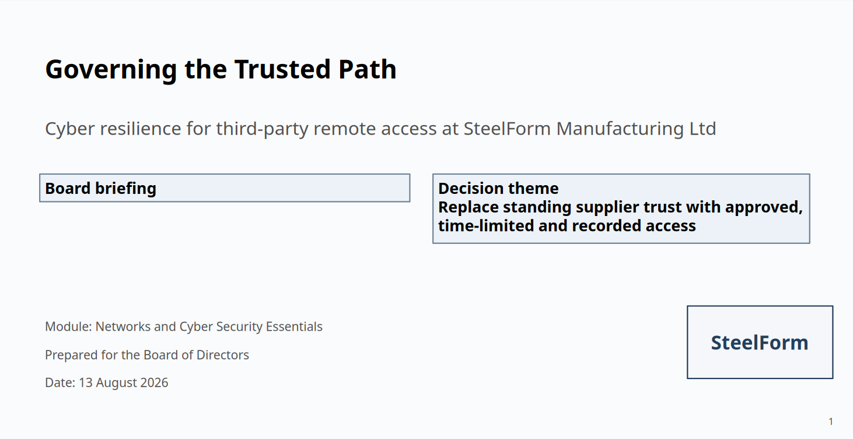

Slide 2. SteelForm scenario
The scenario connects production value to the trust inherited from suppliers, cloud services and shared administration.
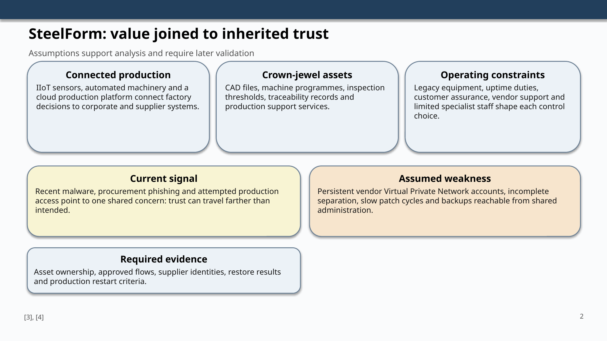

Slide 3. Supplier attack path
The attack path shows where identity, route control and recovery evidence can stop progression before production disruption.
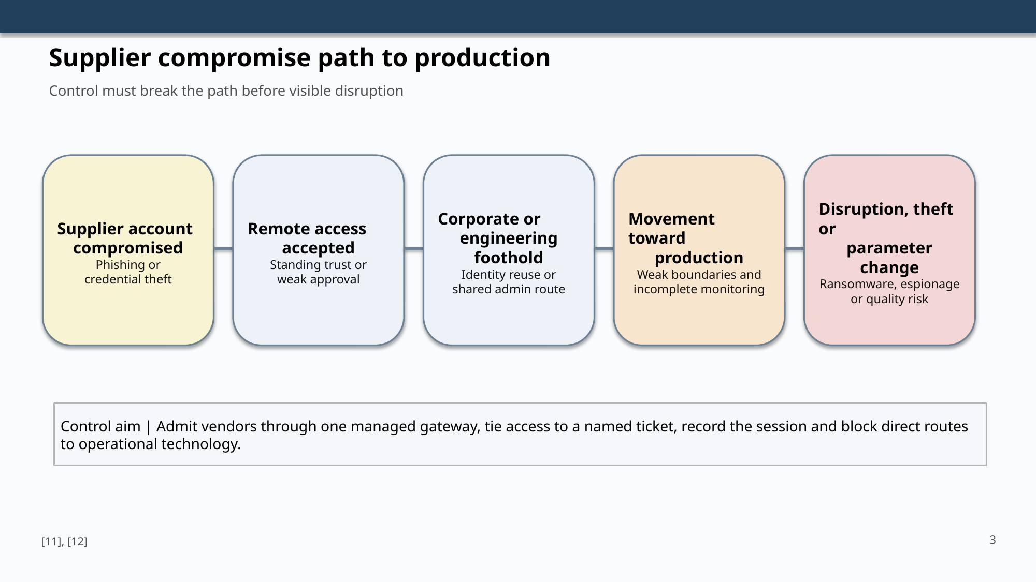

Slide 4. Risk priority
Risk scores make assumptions open to challenge, while the case evidence shows the operational cost of isolation and manual work.
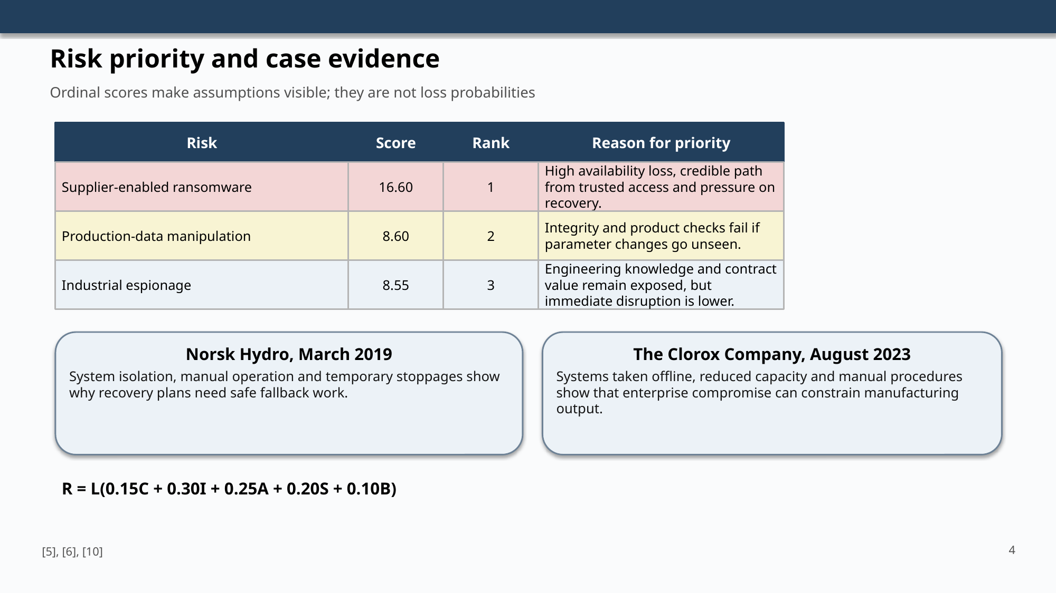

Slide 5. Target architecture
The target architecture gives suppliers one managed route and keeps direct production access blocked.
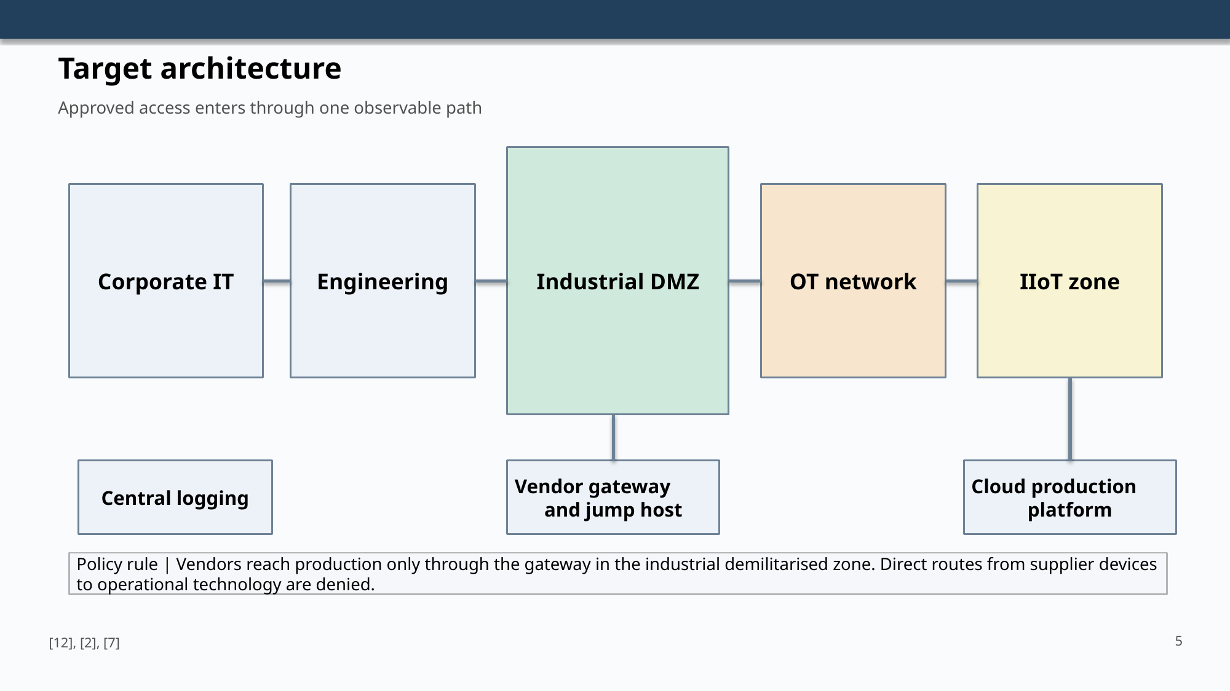

Slide 6. Policy package
Policy ownership joins information security, engineering, procurement, data ownership and infrastructure evidence.
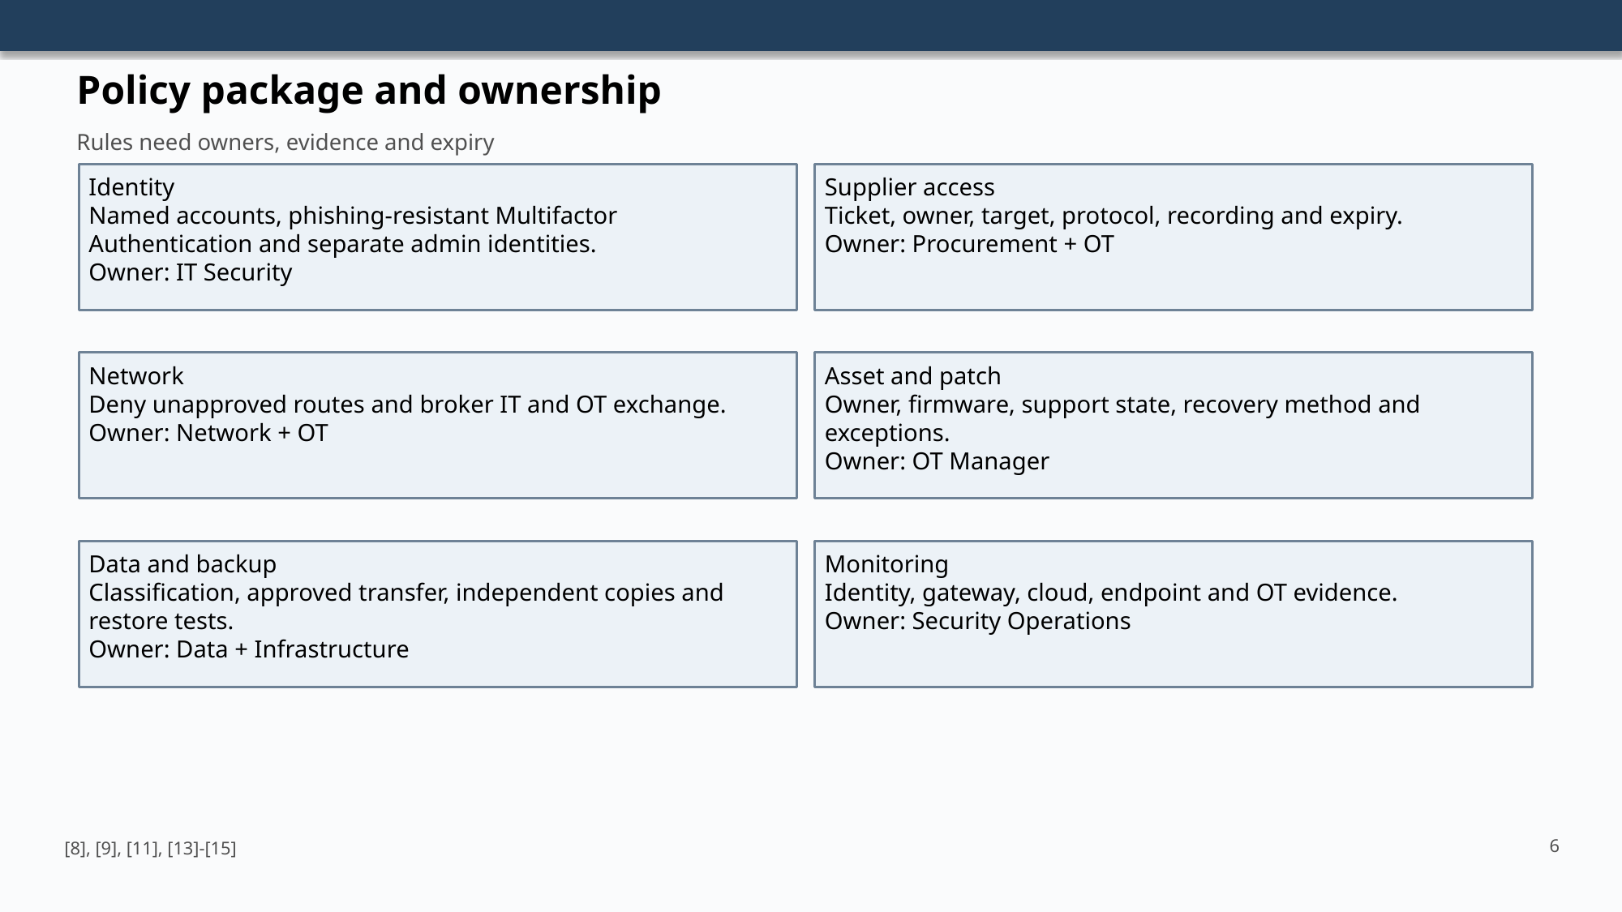

Slide 7. Implementation roadmap
The phased plan reduces urgent exposure before larger architectural work and supplier migration.
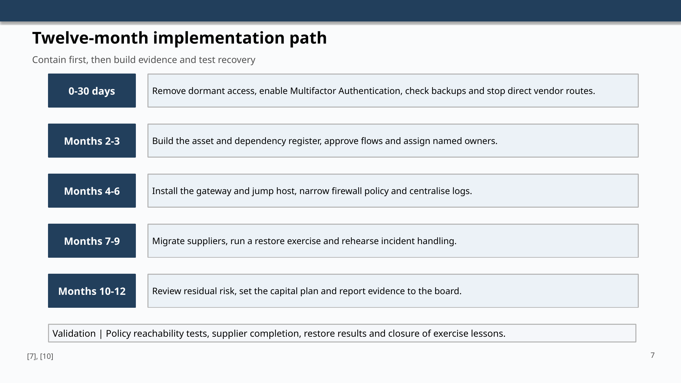

Slide 8. Monitoring and incident response
The improved response slide places detection, evidence, restart criteria and decision ownership in one readable sequence.

Slide 9. Training programme
Training measures reporting and decisions, not only attendance.
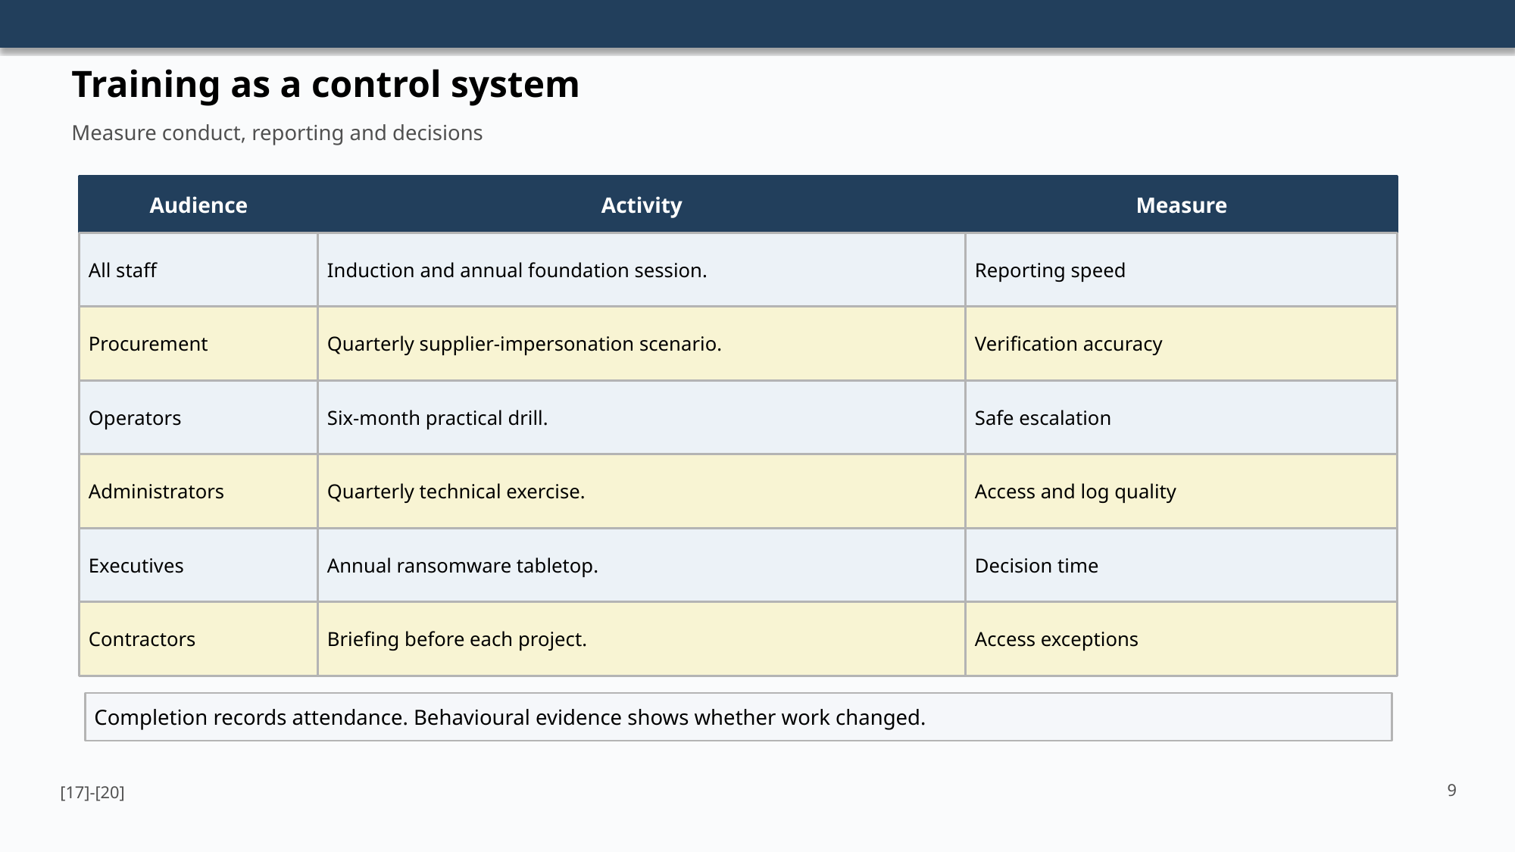

Slide 10. Board decisions
The decision slide records ownership, brokered access, funding and assurance requirements.
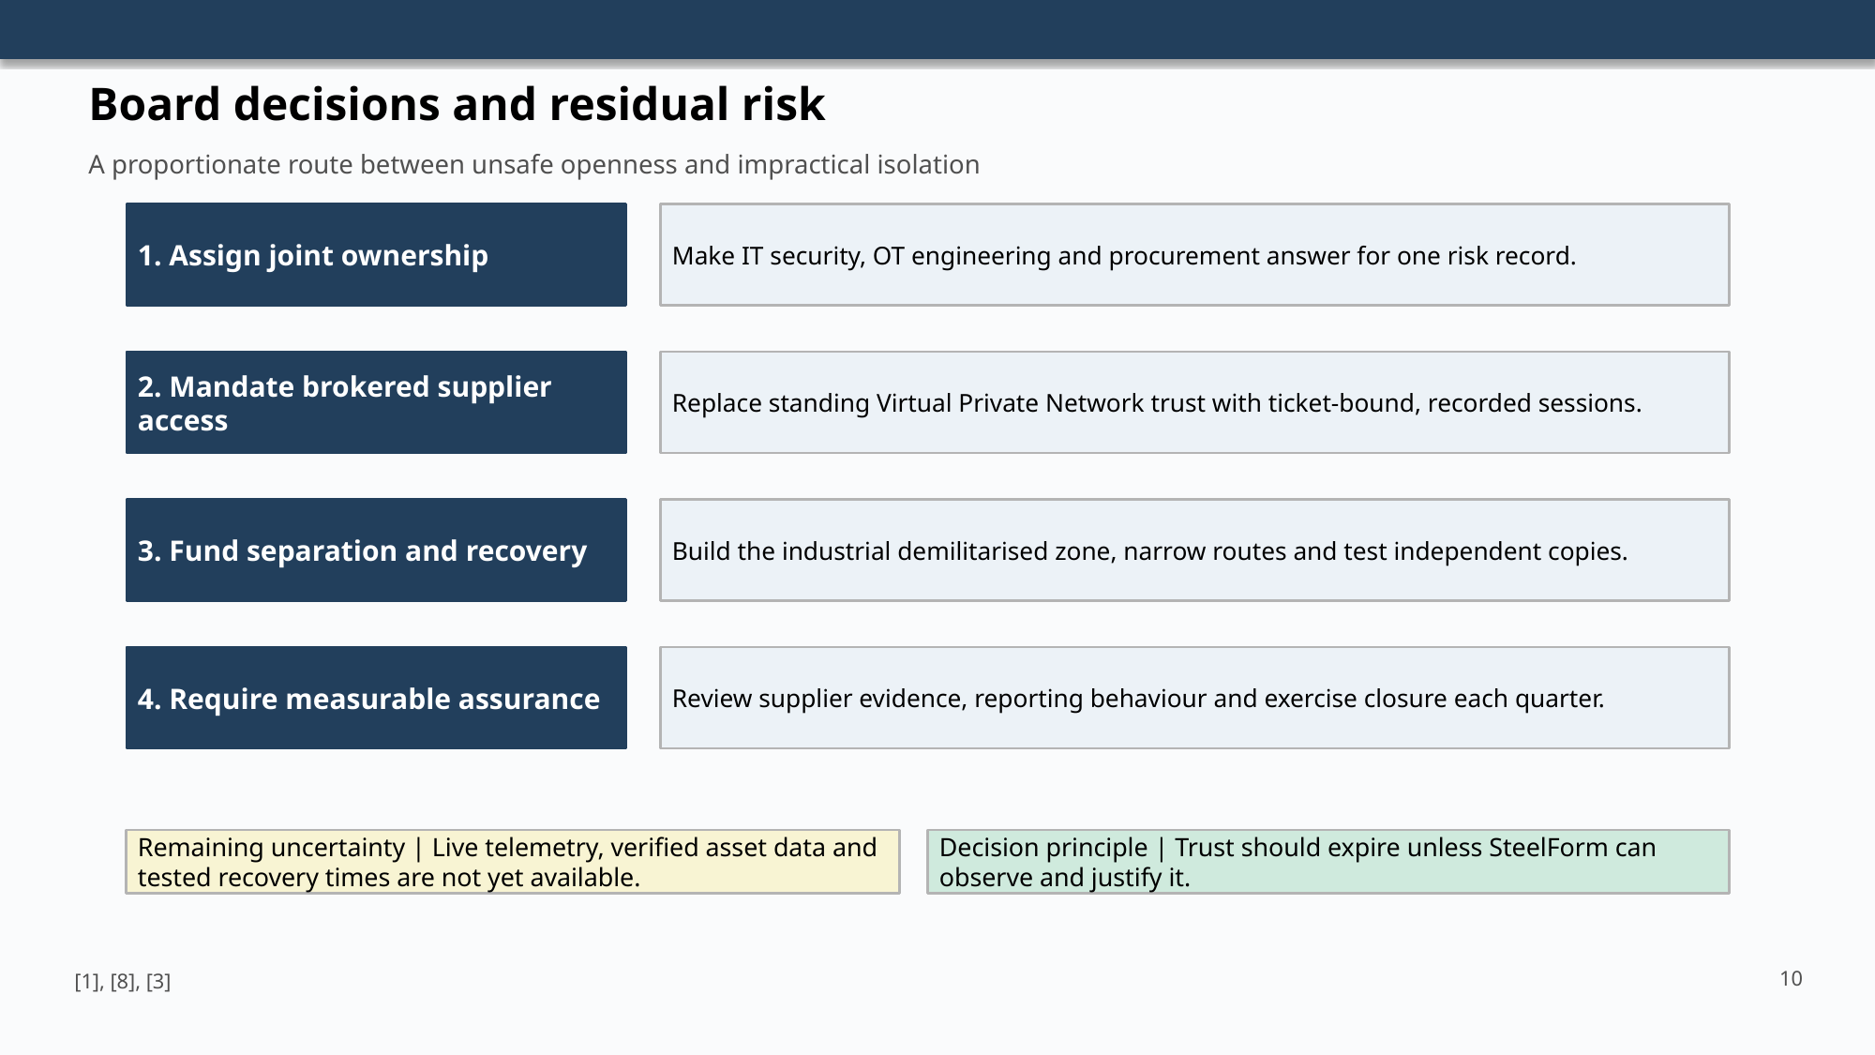

Slide 11. References
The final slide lists all sources cited in the presentation in IEEE numeric style.


