Undergraduate Dissertation

Student Name: Evan Rogers
Student ID Number: 2320243

Research Topic question: How do the advantages and disadvantages of police taser use effect its ethical justification in the role of being a police officer?

Chapter 4 - Analysis of results

4.0 - Introduction
In the last chapter of the dissertation, I discussed the different methodology for the research project using the model created by Boulton (2014). During this chapter of the dissertation it will provide and analyse the finding of the research project through the collection of primary research data.
A Blank copy of the Survey can be found in Appendix A. This copy presents the questions within survey. This Survey was emailed to twenty different police officer individuals within the policing organisation. With all these participants working as a response police officers covering different areas within the policing organisation area.
Due to limitations on word count throughout the research project, only four topics can be analysed during this chapter.

4.1 - Data Analysis
The Data analysis used during this chapter ensures that the research explored throughout: “How do the advantages and disadvantages of police taser use effect its ethical justification in the role of being a police officer?”. The term data analysis in simple terms involves the organising and extracting of information from large amounts of data to identify patterns and themes that relate to the research question.

4.2 - Analysis Method
As the data was collected via a survey, all answers were collated from participants and complied into a document. Each individual participant gives a Participant number, to assist in analysis when going through data. The data collected is qualitative and it was vital to find a method to analyse the answers and identify themes.

4.3 - Analysis of the Data Gathered from Surveys
To assist with the analysis of the data collected through the use of a survey, I used the online tool Google Forms. This tool allowed me identify themes easily and gather an overall view of the data collected from participants.

4.4 - Theme One – Ethical justification of taser use as a less lethal weapon in the role of being a police officer
At the start of the survey participants were asked to state whether they strongly agree, Agree, Neutral, Disagree or Strongly Disagree to the question “Do you agree that it is ethical to use taser as a less lethal weapon within Policing?. Adam and Jennison (2007) discussed that there were inconsistencies regarding people ethical justification on the use of taser. A display of these answers from the survey can be seen in Figure 4.4 Below.

Do you agree that it is ethical to use taser as a less lethal weapon within Policing?
Strongly Agree | 16
Agree | 4
Neutral | 0
Disagree | 0
Strongly Disagree | 0

Figure 4.4.1 – Do you agree that it is ethical to use taser as a less lethal weapon within Policing?

Subsequent to assembling all the answers, a clear consensus and theme emerges from the participants answers. Based on the answers from the participants 80% of them strongly agree that it is ethical to use taser within policing as a less lethal option. This data contradicts the findings in chapter 2 by Adam and Jennison (2007), whereby they stated that there were inconsistencies regarding this as a topic.

Although, one of the following questions in the survey asked the participants the following question “What disadvantages of taser use effect its ethical justification in the role of being a police officer?”. Please see Figure 4.1.2 below.
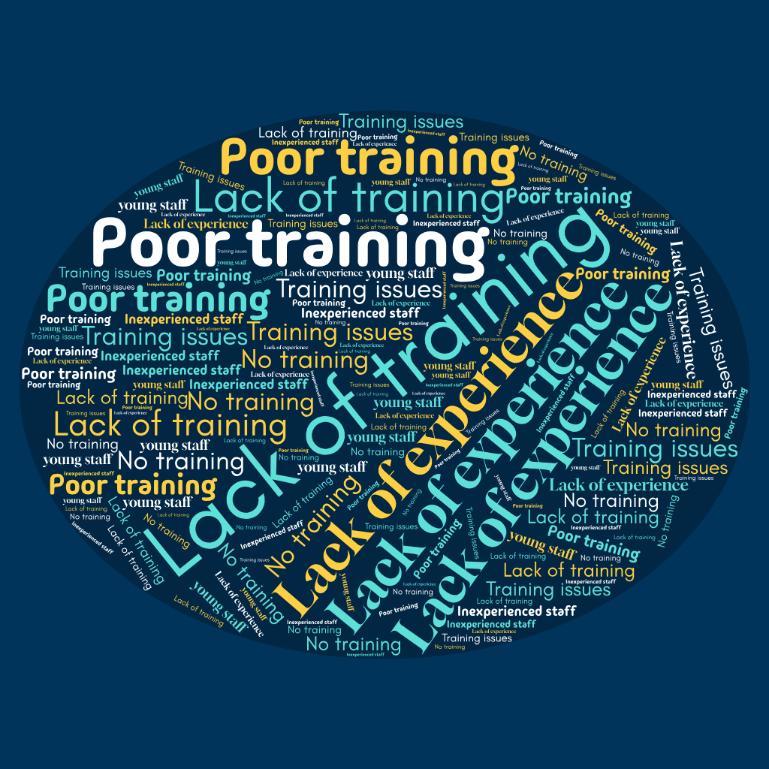

Figure 4.4.2 - What disadvantages of taser use effect its ethical justification in the role of being a police officer?
These findings support the theories of Adam and Jenison (2007) in Chapter two where one of the key issues and disadvantages highlighted surrounding the ethical justification of taser use within policing being lack of or poor training.

4.5 Theme two – The benefits of taser use within policing

During the survey participants were asked to state what they believed to be the benefits of police taser use within policing. This was an open question whereby all 20 participants could have answered openly. Although, all data collected fell within three categories – a display of these answers can be seen in Figure 4.5 below.

Figure 4.5 – What are the benefits of using taser within policing?

Following the analysis of the answers given, a clear consensus emerges. Based on the answers given officer safety has been identified as a vital benefit of using taser by police officers. This agrees with Roberts (2024) discussed in chapter two. Whereby, it was discussed that a key benefit identified was to mitigate the risk to officers on duty.

4.6 Theme Three – Media coverage and the impact of Taser use on public confidence
With regards to the impact media coverage and public confidence has on the ethical justification of taser within policing, participants did not agree with the analysis presented by Donoghue (2018) in Chapter 2. This can be seen in Figure 4.6 below.

Figure 4.6 - Do you agree or disagree with Donoghue (2018) where he states that the media majorly impacts in the ethical justification in taser being used by officers?

Following a compilation of the answer from the survey 75% of the participants disagree with Donoghue (2018). Therefore, more of the police officer participants do not believe that media and public confidence impact them when using taser.

4.7 Theme Four – Officers justification and ethical decision making when using taser
Figure 4.7 is a collection of the most used words by the participants during their answers within the survey when asked the following question, “What impact factors do officers consider when using their taser within day-to-day policing?”.

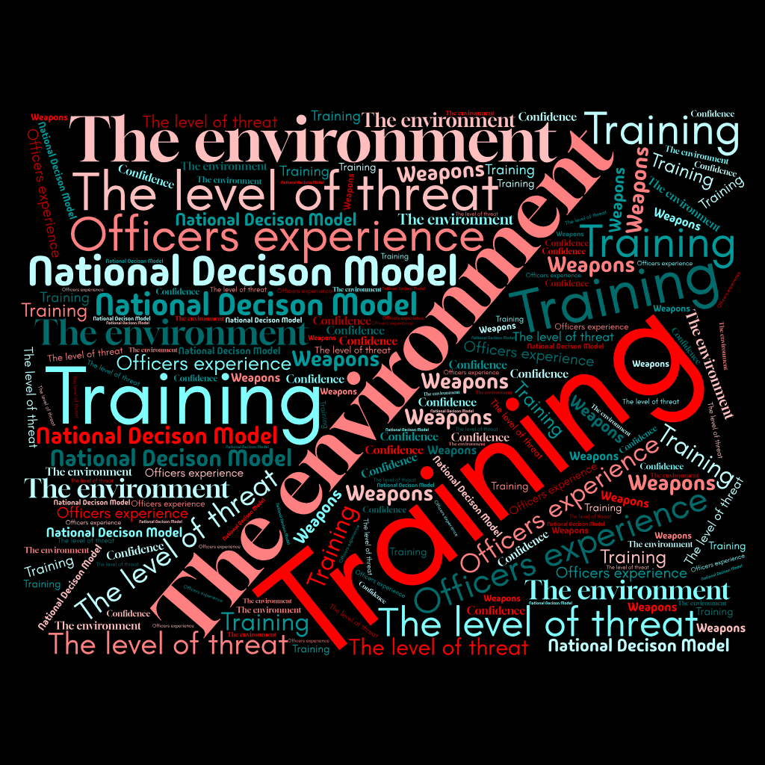

Figure 4.7 - What impact factors do officers consider when using their taser within day-to-day policing?

The most frequently used factors mentioned by the participants were Training, The environment, The National Decision Model and the level of threat. These words were included in the majority of participants surveys and these also shared views with Dymond (2019) in chapter two of the dissertation.

4.8 Conclusion
Through analysing the data collected through the use of qualitative surveys similarities and differences have been discovered in regards to the research discussed in Chapter two.
This chapter has presented the analysis of the data collected through the use of qualitative surveys. This chapter has also continued to complete the objectives set out for this research project.

Word Count = 1030

