Case study report with drawings

Written by:
S. Williams

Prepared for:
R. Thomas

Date Completed:
08/05/2026

Table of Contents
1.0 Introduction 3
2.0 Importance of Scan to BIM in the Built Environment 3
2.0.1 Benefits of Scan to BIM for Retrofitting and Renovating Existing Buildings 3
2.0.2 Benefits of Scan to BIM for Facility Management and Maintenance 4
2.0.3 Mitigating Risk Through BIM 5
2.0.4 Scan to BIM Case Study – Notre-Dame de Paris 6
2.1 Benefits of Smart Buildings 6
2.1.1 Disadvantages of Smart Buildings 7
2.1.2 Smart Building Case Study – The Burj Khalifa 7
2.2 Benefits of QR Codes in Facility Management 8
2.2.1 Benefits of Augmented Reality (AR) in Facility Management 9
3.0 Conclusion 10
4.0 References 11

1.0 Introduction
The Dylan Thomas Centre based in Swansea has gained an interest on how different modernised technologies could be incorporated into the building for greatly improving user needs, optimising energy efficiency and streamlining facility management. The report primarily focuses on assessing the advantages of each technology discussed in order to determine whether they would be beneficial for future use. Secondly, relevant case studies pertaining to the outcomes of these technologies being integrated with other builds around the world will also be provided.

2.0 Importance of Scan to BIM in the Built Environment
A high-precision 3D laser scanner can now be deployed on an existing building site where it will have the ability to accurately capture measurements as a point cloud and convert them to create a digital replica of it. By generating a digital twin of the building, it provides an opportunity to enhance collaboration as information can easily be accessible and shared between all parties involved in a project. In addition to this, a detailed visualisation of the building can also encourage better decision making in the design process and helps identify issues before they can materialise during the construction phase (Multivista, 2025).

2.0.1 Benefits of Scan to BIM for Retrofitting and Renovating Existing Buildings
Design Flexibility: When the structural elements and features of the building’s interior have been accurately generated within the digital model, it allows flexibility for architects to explore different design options before determining the most desirable solution. Design proposals that incorporate or repurpose existing building elements can potentially minimise factors such as demolition, material waste and extra work. Additionally, creating a detailed model of an existing interior can enable architects to simulate the buildings energy performance with the purpose of improving its overall energy use (Multivista, 2025).
Accurate Engineering: Structural engineers can use analysis software with the digital twin to inspect the original building conditions such as load paths, design reinforcements and alignment of key structural components. It will also have the ability to detect the misalignment of structural elements and areas that are affected by degradation. An accurate visualisation of the digital twin can be greatly beneficial to MEP engineers when mapping out new building services alongside the existing ones as it will help prevent clash detection and costly change orders which further could result in additional material waste and rework (Multivista, 2025).
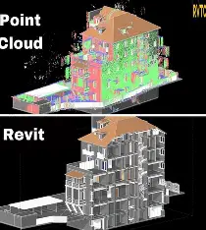
Figure 1: Shows scanners capturing point cloud data which is then used to create the model in BIM (Medium 2024).
Enhancing project management: When working with a highly detailed replica of the existing building, it allows project managers to plan more effectively and maintain stronger quality control throughout the project. This would generally result in more accurate quantity take-offs, sequencing of works and improved logistic coordination Additionally, it can make effective use of project programming, on site equipment usage and materials which will inevitably save time and reduce the carbon footprint (Multivista, 2025).
Preserving architectural design: If the Dylan Thomas Centre for example were to suffer from events such as structural collapse or fire damage in future, the exact copy of the existing building created from scan to BIM can enable a complete reconstruction of the buildings original architectural design and fabric (Designing Buildings, 2026).

2.0.2 Benefits of Scan to BIM for Facility Management and Maintenance
Improving Energy Efficiency & Sustainability: By having access to a fully accurate digital twin, facility managers can test different energy saving methods and select the one that will maximise the buildings overall energy efficiency. Furthermore, this would also improve sustainability which will have a positive impact on the environment (Mars, 2024).
Better Asset Management: When building assets are up-to-date, scanning will provide an accurate digital twin that will be capable of monitoring their performance, condition and maintenance history. This can further extend the lifespan of building systems while supporting predictive maintenance (Mars, 2024).
Maximising building space: A detailed 3D model can allow facility managers to visualise and explore alternative approaches into optimising available floor space for each room within the building. By achieving this, it will potentially improve the comfort for all building users (Mars, 2024).
Efficient Maintenance & Repairs: An accurate and detailed digital twin enables facility managers to plan and carry out maintenance jobs more efficiently by allowing them to pinpoint the exact location of issues affecting building services or elements with ease. As a result, this shortens task duration while ensuring accurate repairs are made (Mars, 2024).
Reliable Building Records: For the purpose of performing tasks on maintenance and repair, highly detailed documents relating to the various structural elements, components and services in the building can be created with the assistance of scan to BIM. These accurate documents will guide facility managers with the information to execute tasks efficiently (Mars, 2024).

2.0.3 Mitigating Risk Through BIM
Greater Visualisation & Planning: BIM software offers multidimensional visualisation which can help consultant teams review the model more effectively by identifying risks early, planning out construction tasks efficiently and overall having a better understanding of the project before work commences (United BIM, 2026).
Reliable resource & cost management: Quantities, their associated costs, and project programming can be incorporated into 5D BIM thus allowing for accurate material take-offs, effective labour planning and reliable cost prediction. Any variations towards the design can be simulated, enabling the project team to evaluate its impact on the budget and schedule (United BIM 2026).
Adhering to Building and Safety Standards: As projects can be affected by delays and legal complications when not complying with current industry standards, BIM can greatly reduce these risks as it allows consultants to implement compliance checks into the design to ensure all elements adhere to the building regulations (United BIM, 2026).
Clash detection: BIM software is equipped with automated clash detection that identifies where building components in the model interfere with one another. This tool encourages teams to collaborate on resolving these issues early and eliminates further problems from arising during construction (United BIM, 2026).
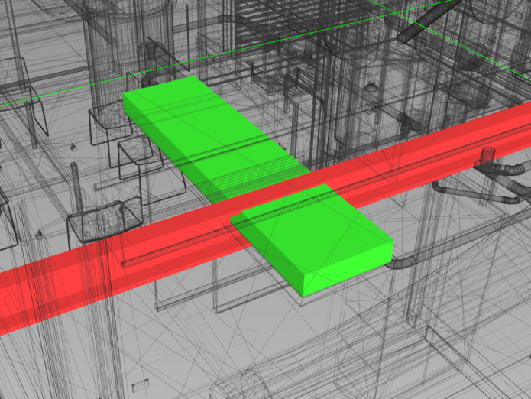
Figure 2: Shows detection of two structural components clashing in the BIM model (TheBIMCenter, 2016).
Safer Planning & Logistics: Project managers can greatly benefit from utilising BIM as work activities, equipment use and movement of materials can be simulated. This will enable them to recognise potential risks early and promote safer work activities for everyone on site (United BIM, 2026).

2.0.4 Scan to BIM Case Study – Notre-Dame de Paris
In 2019, the Notre-Dame cathedral located in Paris had suffered a devastating fire which had caused extensive damage to the historic monument. Following this unfortunate event, a restoration project had begun which aimed at recreating a fully detailed replica of the cathedral in order to preserve its historical authenticity. Over the course of a year, a point cloud containing billions of data points were captured by 3D laser scanners which was then used to create an accurate model that preserved the buildings original architectural design and detail (ArchDaily, 2025).
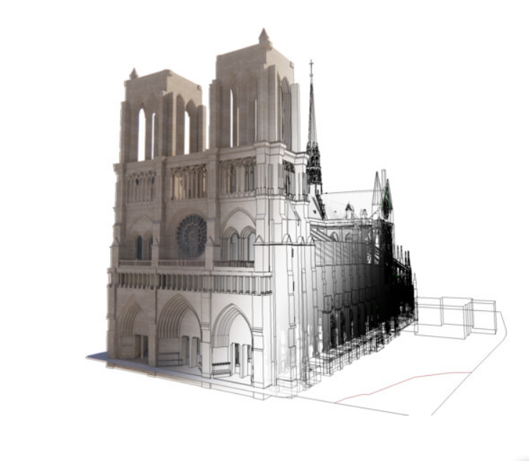
Figure 3: Displayed above is the Notre-Dame cathedral model that was generated in BIM from the combination of digital technologies that were used to preserve it to its existing architectural state (ArchDaily, 2025).

2.1 Benefits of Smart Buildings
AI Assistance: AI can be integrated into smart buildings, allowing it to be paired with IoT sensors, building systems and devices. This will enable it to monitor and make accurate predictions overtime on improving energy use, maintenance, user comfort and security (smartspaces, 2024)
Improving energy efficiency: Smart building technologies such as automated HVAC, lighting and occupancy sensors have the ability to control energy use of spaces depending on how they are being used. For example, rooms that are left unoccupied after building users have left can be adjusted automatically to reduce energy consumption. This ensures efficient use of heating, ventilation and lighting systems thus improving the buildings overall energy performance (IBM, 2026).
Increasing User Comfort: The variety of heating, cooling and ventilation systems used within all spaces of a smart building are capable of being customised to create a more comfortable working environment which can have a positive impact on the users productivity and mood (IBM, 2026).
Smart Maintenance: With the smart building systems ability to monitor and process real-time data, predictive maintenance is being carried out on a continuous basis. This will greatly assist facility managers as system issues can be rectified early before they begin showing problems or breakdown completely resulting in costly repairs (IBM, 2026).
Cost reduction: As the systems in a smart building collect and analyse data over time, it can provide facility managers with an opportunity to look for improvements into optimising energy efficiency in the future which could potentially reduce costs (IBM, 2026).
Improving Sustainability: As it was discussed previously that smart buildings can closely monitor and analyse data collected from systems such as IoT devices and automated services, this can also help stakeholders on making important decisions as to whether the building would require further retrofitting and renovation to improve its overall energy efficiency (IBM, 2026).

2.1.1 Disadvantages of Smart Buildings
Increased Security risk: One of the major disadvantages concerning smart technology is its vulnerability to cyber-attacks as hackers can gain control of building systems and devices throughout a building. However, the solution to mitigate breaches into the network lies investing in higher quality products and implementing stronger security measures (European Property, 2022).
For example, in 2021, an office complex based in Frankfurt suffered the consequences of poor cybersecurity when hackers had hijacked and shutdown a HVAC system. This resulted in extreme financial loss due to lost productivity and system repairs (Industrial Build News, 2025).
Connectivity Issues: Systems and devices in smart buildings depend on a fast and reliable internet connection to operate efficiently. Without this, smart systems will not be able to share data between them (European Property, 2022).

2.1.2 Smart Building Case Study – The Burj Khalifa
Located in Dubai, a combination of smart technologies was incorporated with the Burj Khalifa which had resulted in delivering remarkable energy efficiency. It includes high quality IoT sensors for effective performance, a HVAC system that automatically adjusts depending on user occupancy and a predictive maintenance system that can identify potential issues in advance. In addition to this, the building has achieved a substantial drop in waste and energy consumption while greatly increasing asset availability to reduce unplanned maintenance (Matterport, 2025).

Figure 4: The Burj Khalifa in Dubai. An exceptional example on integrating smart technology for optimising energy performance (Matterport, 2025).

2.2 Benefits of QR Codes in Facility Management
Raising Requests & Work Activities: QR codes can be assigned to different rooms or open areas within the building and are able to help facilitate workflow for facility managers while on site. When scanned, the code provides a detailed account of existing issues or concerns raised by the building user. By using this method as opposed to manual data input, it can improve efficiency and accuracy (Trackplan, 2026).
Viewing Asset Information: Facility managers will also have the ability to scan QR codes for accessing assets and their details relating to maintenance history or warranty. In addition to this, a job can be distributed to several assets at once which improves maintenance efficiency (Trackplan, 2026).
Quicker Inspections: QR codes related to specific building items can promote more detailed and accurate inspections as facility managers are provided with appropriate checklists. Each item can then be digitally marked, ensuring that a comprehensive inspection has been carried out and they meet compliance standards (Trackplan, 2026).
Recording contractor activity: QR codes have the ability to actively monitor and record the progression of contractor works while on site. Scanning the code will provide live updates on the times they have clocked in or out (Trackplan, 2026).
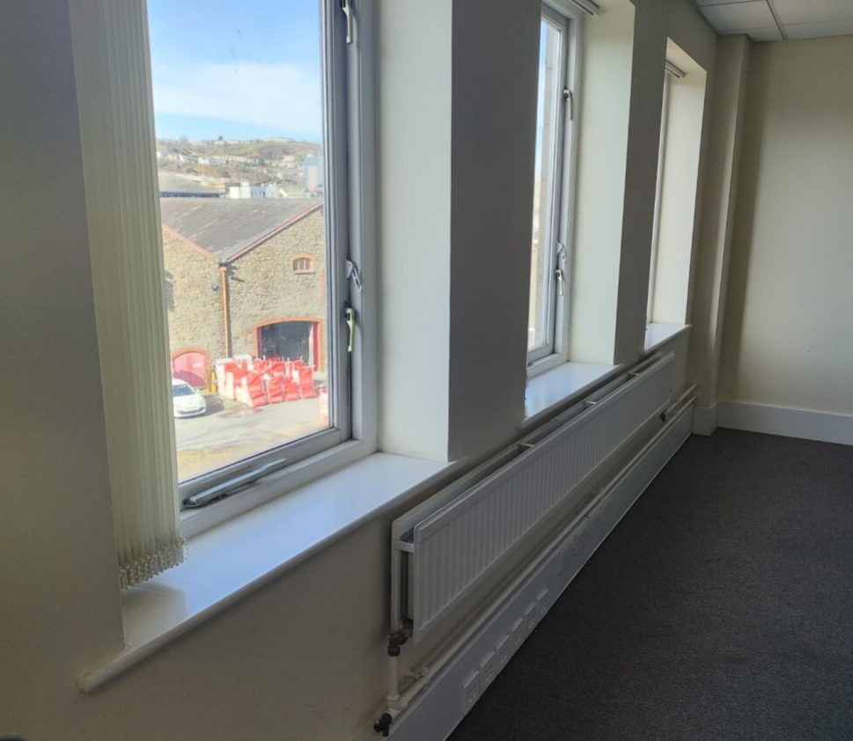
Figure 5: Displayed above is a photograph taken within one of the rooms in the Dylan Thomas Centre. For example, if an occupant faced difficulty closing a window, they could scan a QR code assigned to this room and report the issue on the system.

2.2.1 Benefits of Augmented Reality (AR) in Facility Management
- Investing in AR technology will further improve predictive maintenance of building systems due to its ability to be paired with IoT sensors. Facility managers will be able to scan these systems via a smart device or AR headset where it can provide an overlay of real time data. As a result, emerging issues can be highlighted at the present time which mitigates the risk of failures occurring and will extend asset lifespan (AUGmentecture, 2025).
- AR can help facility managers to visualise the buildings energy consumption through its fabric and systems in real time. For example, a digital overlay of an existing wall could reveal immense heat loss or artificial lighting in certain areas are deemed inefficient. This feedback will help make improvements to enhance user comfort and energy efficiency (AUGmentecture, 2025).
- AR technology also serves to enhance the users experience by providing a smart phone app to make it easier when navigating a building. A digital overlay can be used in front of the user via the app and will help them find available workspaces or meeting rooms (AUGmentecture, 2025).
- When new building staff have been employed, AR can assist their training by providing a digital overlay equipped with step-by-step instructions on systems for completing difficult tasks (AUGmentecture, 2025).
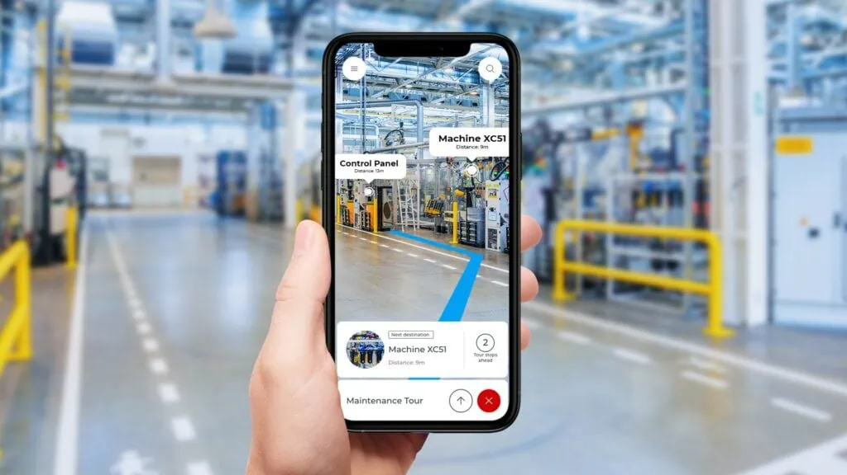
Figure 6: Shows AR technology accessed through a smartphone where a digital overlay provides a navigation route for the building user (SPIE, 2026).

3.0 Conclusion
Overall, the technologies reviewed within this report for potentially retrofitting and renovating the Dylan Thomas Centre in future would have a positive impact into improving the energy efficiency and comfort of users in the existing building. Scan to BIM allows for the creation of a detailed and accurate digital twin which helps consultants effectively manage maintenance, identify alternative design solutions while mitigating risks in advance.
Although smart building systems can be paired with technologies such as IoT or AI to improve their operational efficiency, facility managers must implement strong security measures to mitigate the risk of cybercriminals gaining unauthorised access to building systems which would in most circumstances result in costly restoration repairs. The combination of QR codes and AR devices will greatly increase predictive maintenance where the likelihood of breakdowns or complete system failures would be reduced significantly.

4.0 References
ArchDaily (2025) How Did BIM Help Notre-Dame Rise from the Ashes. Available at: https://www.archdaily.com/1025809/how-did-bim-help-notre-dame-rise-from-the-ashes (Accessed: 27/04/2026).
AUGmentecture (2025) AR in Facility Management: Streamlining Maintenance and Operations. Available at: https://www.augmentecture.com/blog/ar-in-facility-management-streamlining-maintenance-and-operations/ (Accessed: 08/05/2026).
Designing Buildings (2026) Top Benefits of Scan to BIM for Heritage & Renovation Projects. Available at: https://www.designingbuildings.co.uk/wiki/Top_Benefits_of_Scan_to_BIM_for_Heritage_%26_Renovation_Projects (Accessed: 23/04/2026).
European Property (2022) The Pros And Cons Of Smart Buildings Of The Future. Available at: https://europeanproperty.com/the-pros-and-cons-of-smart-buildings-of-the-future/ (Accessed: 05/05/2026).
IBM (2026) What are smart buildings? Available at: https://www.ibm.com/think/topics/smart-buildings (Accessed: 02/05/2026).
Industrial Building News (2025) Smart Building Security Breaches Are Rising. Here’s How to Protect Your Assets. Available at: https://www.build-news.com/technology-and-digital-innovation/smart-building-and-information-modeling/smart-building-security-breaches-are-rising-heres-how-to-protect-your-assets/#:~:text=Recent%20security%20breaches%20in%20smart%20buildings%20have%20demonstrated,hackers%20exploited%20vulnerabilities%20in%20its%20building%20management%20system. (Accessed: 06/05/2026).
Mars (2024) How Scan to BIM Enhances Facility Management and Maintenance. Available at: https://www.marsbim.com/how-scan-to-bim-enhances-facility-management-and-maintenance/ (Accessed: 25/04/2026).
Matterport (2025) 8 Smart Building Examples: Amazing Ways Technology is Redefining Modern Spaces. Available at: https://matterport.com/blog/smart-building-examples (Accessed: 07/05/2026).
Medium (2024) Transforming Point Cloud Data into As-Built Drawings. Available at: https://medium.com/@scantobim/transforming-point-cloud-data-into-as-built-drawings-3a81eedb4234 (Accessed: 28/04/2026).
Multivista (2025) The Benefits of Scan to BIM for Renovations, Retrofits, and Beyond. Available at: https://www.multivista.com/blog/the-benefits-of-scan-to-bim-for-renovations-retrofits-and-beyond/ (Accessed: 21/04/2026).
smartspaces (2024) Ai: Driving the Future of Smart Buildings. Available at: https://www.smartspaces.app/blog/ai-driving-the-future-of-smart-buildings/ (Accessed: 01/05/2026).
SPIE (2026) Augmented Reality in Action – The Revolution in Industrial Maintenance. Available at: https://www.spie-rodias.de/en/news/augmented-reality-in-action-revolution-in-industrial-maintenance/ (Accessed: 08/05/2026).
TheBIMCentre (2016) What is Clash Detection? How Does BIM Help. Available at: https://www.thebimcenter.com/2016/03/what-is-clash-detection-how-does-bim-help.html (Accessed: 01/05/2026).
Trackplan (2026) The Six Best Ways to Utilise a QR Code in Facility Management. Available at: https://www.trackplanfm.com/the-6-best-ways-to-utilise-qr-codes-in-facility-management/ (Accessed: 08/05/2026).
United BIM (2026) 7 Ways BIM Helps in Construction Risk Management. Available at: https://www.united-bim.com/bim-and-construction-risk-management/ (Accessed: 25/04/2026).

