University of Wales Trinity Saint David (UWTSD)

Name: Lisa Partridge
Student Number: 1708297

Course Name: BSc (Hons) Business Information Technology & Applied Computing
Module: Managing People and Change
Module Code: M6X01102

Lecturer: James Williams
Submission Date: 11/01/2019

Contents

Introduction 2
Change Management - Internal & External Change Drivers 5
Resistance to Change 7
Change management models 9
Recommended model for introducing GDPR 10
Leadership/ Management Styles 11
Changing the culture at Jaguar case study 12
Conclusions & Recommendations 12
References 14

Figure 1 Public Health Wales - Our Priorities 2018 - 2030 6
Figure 2 Force Field Analysis for implementing GDPR into Public Health Wales 8

Introduction

Change management is a structured approach to moving an organisation from the current state to the desired future state.
Resistance to change is natural, so managing change using a structured controlled approach is essential to implement a successful change management programme within an organisation and it is important to get people involved early on in the change [1].
For this assignment the organisation of choice to review change management is Public Health Wales NHS Trust.
Public Health Wales (PHW) was established as an NHS Trust on 1 October 2009 by the Minister for Health and Social Services. It has four statutory functions which includes;
- Proving a range of public health, health protection, healthcare improvement, health advisory, child protection, microbiology laboratory services and surveillance, prevention and control of communicable diseases
- develop and maintain arrangements for making information about matters related to the protection and improvement of health in Wales that is available to the public; to undertake and commission research into such matters and to contribute to the provision and development of training in such matters
- To undertake the systematic collection, analysis and dissemination of information about the health of the people of Wales; including cancer incidence, mortality and survival; and prevalence of congenital anomalies
- To provide, manage, evaluate and conduct research into screening of health conditions and screening of health related matters [2].

A recent change that the organisation had to introduce was the new General Data Protection Regulations (GDPR).
The GDPR and updated Data Protection Act 2018 came into force on the 25th May 2018. The purpose of the new regulations was to provide a standardised approach to data protection and to introduce the right to be forgotten. With Information Technology rapidly growing the old Act wasn’t fit for purpose. One of the changes was for people to understand how their data is being used and how to have data rectified if incorrect or to be removed known as the right to be forgotten.
The European Union began talking about GDPR in 2012 which was an update to the Data Protection Act 1998. It required all business to start to think about their business processes and what they needed to do to ensure they would be compliant on the 25th May 2018. Businesses could not start to make changes at this point as it was unclear at that point of what changes would be required. It wasn’t until around 2017 that information started to become more available.
The changes included;
- New data breach notification of 72 hours, which means that if you don’t report to the Information Commissioner within 72 hours business could face being fined.
- Individuals should be able to withdraw consent and consent should be freely given. If individuals cannot withdraw consent it is not freely given and therefore would be a breach of the GDPR. Explicit consent is required for data that is of a sensitive nature.
- Parental consent requirement for children under 13 years.
- Increased fines for data breaches could be in the region of 4% of the business's annual turnover or 4 million euros, whichever is higher.
- Business also need to be clear and transparent and provide fair processing notices. Clear and transparent privacy notices must be easily accessible telling individuals what is being done with their data and what their rights are.
- Privacy by design, businesses need to build in Data Protection Impact Assessments (DPIA) for any new or changes to processes which involve personal data. Policies and procedures need to be available to support departments to ensure that they carry out DPIAs for all new projects and changes to existing processes.
- Changes to data processors and data controllers. This means that were a business is a data controller they must ensure that if they use data processors for any work which involves processing personal data need to ensure that they have data processing contracts in place with the data processors. This is to ensure the data security is in line with GDPR and that the processors operate within the agreed terms. This links back to transparency where individuals must be told if their data is being processed by a 3rd party processor.
To ensure that all the GDPR requirements would be met required a big change in the way that PHW managed its staff and service user’s personal data and ensure their information technology systems build in GDPR into its business processes. This would be called a privacy by design approach, where DPIAs would be embedded into the procedures for all new projects that involved personal data [3].

Change Management - Internal & External Change Drivers
Public Health Wales has set out a long term strategy for the next 10-12 years, within the strategy it brings together seven strategic priorities. Driving this strategy is the need for Public Health Wales to achieve a healthier future for Wales.
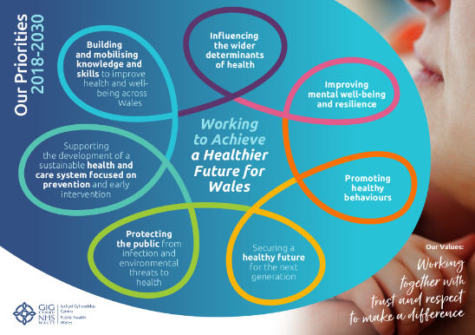

Figure 1 Public Health Wales - Our Priorities 2018 - 2030
The plan was developed following a report produced by the Public Health Wales Observatory Department. This was the internal change driver that led the organisation to look to develop the long term strategy. They carried out a PESTLE Analysis to help understand the environment that Public Health Wales would be operating in over the coming years and identified the challenges that they would need to combat to achieve the purpose – a healthier Wales.
Based on the theory of the Kondratiev wave, the 6th Kondratiev wave also plays a part in the priorities that Public Health Wales has set out to achieve in the long term strategy. The 6th Kondratiev wave theory is related to improving society and reducing the obstacles to stimulate growth to support innovations. Innovations alone will not improve society, improving health and making people healthier will help to reduce barriers to growth and the economy [4].
PHW aims to reduce the burden on the NHS within its long term strategy. This is an external change driver for PHW. The internal driver is having the resources and systems to enable the organisation to achieve the long term strategy.
A PEST or SLEPT analysis is a management tool that can be used to look at the Political & Legal, Environment, Social and Technological to achieve alignment to the business objectives [5].
To enable PHW to achieve its strategic priorities within the long term plan, there is a need to ensure that the use of information and information technology systems are available and used safely and efficiently.
To do this the organisation needs to ensure that it meets all the GDPR requirements and updates is policies and procedures to incorporate the changes.
PEST Analysis for GDPR implementation
•P: Political & Legal analysis
Update to the Data Protection Act 1998. All businesses to review their business processes and ensure compliance to the GDPR by 25th May 2018.
•E: Economic & Competition / Market analysis
Higher financial penalties if not compliant with GDPR.
•S: Social & Customer analysis
Patient, staff and other service user's personal data to be handled safely.
•T: Technological analysis
Information systems including data held in the cloud systems to be compliant with GDPR.
All information assets to be documented with data flows showing how data comes in and out of Public Health Wales.

Resistance to Change

People often resist change for a number of reasons, some of these may be because the change was a surprise, and they may feel that the change was unnecessary or they had no involvement in the change. These are classed as barriers against implementing a successful change. To overcome these barriers Kotter suggests that by being open and honest, communicating supporting staff and by involving staff to produce ideas and be party to the change can overcome resistance to change [6].
To implement GDPR staff may resist because they feel that the organisation lacks the necessary resources to implement the changes required. They also may feel that they have no involvement in the decisions because they are based on legislation requirements and are forced upon staff rather than them being involved in the decision making.
Lewin’s Force Field Analysis is a framework to look at forces for and against change [7].
The Force Field Analysis Framework works by using 8 steps, the aim is to create an environment where people are willing to embrace change. It is important for people to embrace the change to ensure the change is successful. The first three steps work by defining the change, listing the driving forces for and against the change and assessing each of the forces out of 10. By identifying and assessing the forces for and against change the organisation can then document strategies to overcome the barriers to change.

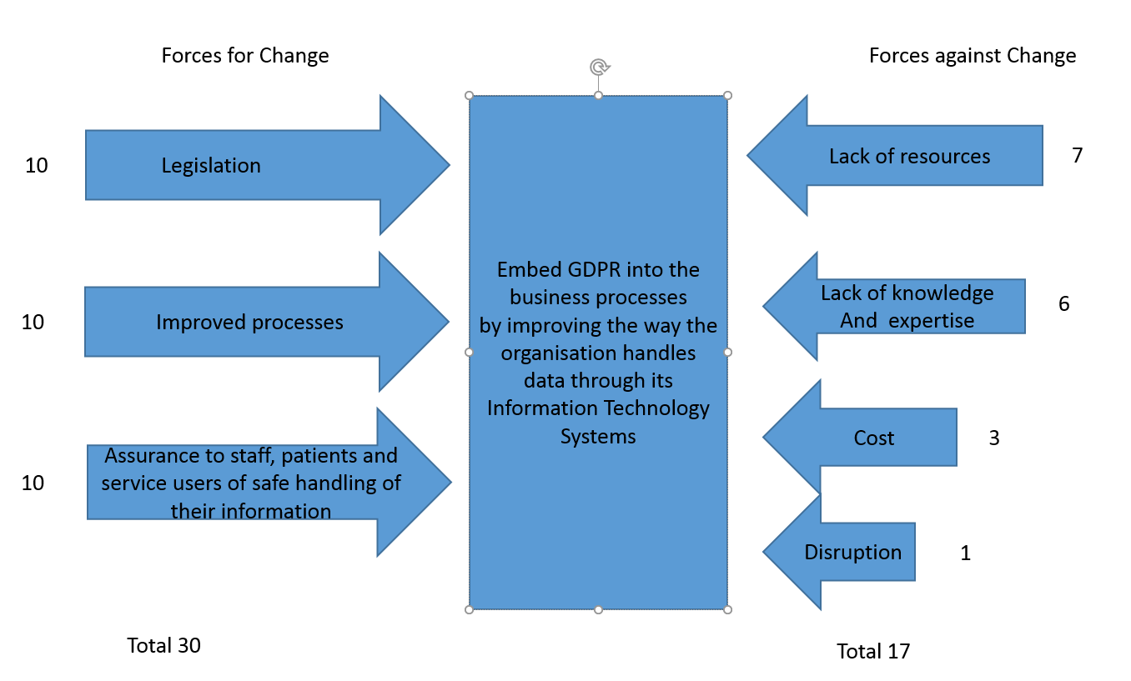
Figure 2Force Field Analysis for implementing GDPR into Public Health Wales

By using Lewin’s Force Field analysis framework, it highlights areas for and against change. With GDPR being a legislative requirement the forces for change are scored as a 10, as has improved processes and being able to assure staff, patients and other servicer user’s that their data will be managed safely using robust IT systems. The forces against are issues such as a lack of resources, knowledge and cost and disruption. The force field analysis helps to identify the barriers that can prevent the change from being implemented successfully.
To address the forces against change the organisation needs to explain why the change was necessary. With it being a legislative requirement, by explaining the potential heavy fines and reputational damage for breaching data protection and to ensure the safety of staff, patients and other service user's data. Involving people in the planning stages and by increasing engagement by setting up focus groups.

Change management models

Kotter's change management model uses an 8 step process, it starts with getting buy in by identifying threats and examining the opportunities that the change may bring. The aim of the initial steps are to get the key people on side and form powerful coalitions. It sets a clear vison and strategy that can be communicated and works towards removing any barriers that may prevent the change from being successful. The aim of this model is to create short term targets in incremental stages, with rewards for staff who meet the targets. The final step is to build on the change and embed into the corporate culture. The new processes such as data protection impact assessments and the privacy be design approach needs to be embedded into PHW [8].
Lewin’s freeze phase model is similar to Kotter's 8 stage model, it looks at the change in stages [9]. It has 3 stages and within each stage there are a number of steps.
Stage 1) Unfreeze - determine what needs to change, ensuring there is strong support from senior management.
Within the unfreeze stage you create the need for change, explaining why change is required. Communication is vital in explaining the vision and why change has to occur and to manage doubts and concerns.
Stage 2) Change – keep communicating throughout the change to keep up momentum and avoid rumours, empowering action and keep individuals involved.
Stage 3) Refreeze – anchor the changes into the organisations culture, developing ways to sustain the change, support and training is key to keep everyone informed and supported.

The Prosci ADKAR change model is founded on 2 basic ideas and that it’s the people that change not the organisation [10]. The organisation continues to do what it needs to do and that is to improve public health. For the change to be successful individual people need to move in stages. Similar to Kotter and Lewin it follows a step process and the aim is to get the change embedded into the corporate culture.

The Kubler Ross Model brings in the emotional element to the change strategy [11]. Based on the grief cycle and how people are affected by grief and bad news it uses stages;
- Shock stage – initial paralysis at hearing bad news
- Denial stage – trying to avoid the inevitable
- Anger stage – frustration
- Bargaining stage – seeking for a way out
- Depression stage – final realisation of the inevitable
- Testing stage – seeking realistic solutions
- Acceptance stage - finally finding the way forward.

The Longaker 4 stages of major change model is very similar to the Kubler Ross model, the model is based on experiences of grief cycles. From shock and disbelief, resistance and finally acceptance [12].

The Change Roller Coaster model has similarities to Kubler Ross and the Longaker model, it involves the emotional element and looks at anger and denial in stages through to acceptance by using rewards and senior management as role models [13].

Recommended model for introducing GDPR

Lewin’s 3 phase model would be the most appropriate change management model to use to introduce GDPR into Public Health Wales.
Stage 1) Unfreeze
Determine what needs to change, ensuring there is strong support from senior management. PHW is a hierarchical organisation and for any change to be successful there will be a need to be support at a senior level.
Within the unfreeze stage you create the need for change, explaining why change is required. With this being a legislation requirement, this would need to be the vision of the change and how it links into the 7 strategic priorities. Within the priorities there are business objectives and IT systems need to be robust and safe to enable PHW to meet these objectives.
Communication is vital in explaining the vision and why change is necessary and to manage doubts and concerns as to why the change is necessary.
Stage 2) Change
Keep communicating throughout the change to keep up momentum and avoid rumours, empowering action and keep individuals involved. It is essential to regularly provide guidance and support throughout the change.
Stage 3) Refreeze
Anchor the changes into the organisations culture, developing ways to sustain the change, support and training is key to keep everyone informed and supported. Provide regular briefing notes prior to the change and ensure support is available for staff while GDPR is being embedded into the organisation.

Leadership/ Management Styles

Leaders set the vision and the direction that the organisation needs to follow. Leadership and management go hand in hand. The management plans, organises and coordinates, whereas the leader’s role is to inspire and motivate. Manager’s focus on outcomes, the leaders role is to co-ordinate the outcomes, interests and emotions of the people to direct and organise them [14].
There are different leadership and management styles that support the workforce and depending on the type of organisation there will be a style that suits it. Some organisations require a strategic leadership role, particularly where strategic thinking is required to support multiple types of employees at once.
The transformational leadership style is where the leader works with its employees to continuously improve upon the company by motivating its employees. Kotter's 8 stage change model works together with the transformational leadership style. The model and the transformational leadership work together by engaging and enabling the organisation. One of the barriers to a successful change is where the management don’t allow the workforce to be innovative and use an autocratic micromanagement style. A transformational leader should ensure this management style is not used and a visionary or democratic management is a better management style which results in successful change management and prevents change failures.

Changing the culture at Jaguar case study

The Jaguar car manufacturer introduced a change programme by using a transformational leadership style [15]. Jaguar changed by introducing a different culture and encouraging the workforce to not be afraid to take risks. With the car industry becoming more competitive they had to move away from the standardised products and processes and had to be a more flexible and versatile manufacturer. The organisation changed both its strategy and culture together, this was because if the culture doesn’t change and only the strategy, this often results in change failure. Employees were now allowed to make decisions where in the past they were previously told what to do.
Jaguar made the change happen by carrying out a needs and assessment measurement to identify current strengths and any barriers to change that they may face. They then held a series of workshops to build commitment to the change in all areas. They carried out training with staff and involved everyone in the culture change programme establishing a clear vision which resulted in the employees being motivated and wanted the change to succeed.

Conclusions & Recommendations
The aim of this assignment was to research the changing nature of PHW, looking at its 7 strategic priorities and its 10 to 12 year plan. To identify its internal and external change drivers.
To support the 7 priorities Public Health Wales needs to ensure that it has innovative IT systems to enable the organisation to meet its strategic 10 to 12 year plan. To support these IT systems, the organisation needs to have good governance arrangements in place to make sure it keeps the data of its staff, patients and service users safe and available. The threat of Cyber crime is one of the major issues that the NHS faces where there is such a heavy reliance on IT systems.
GDPR and Data Protection Act 2018 was updated because information technology is rapidly changing and the old regulations and Act was out of date and didn’t provide adequate protection for IT systems and processes which involves collecting and sharing personal data.
On review of a selection of the change management models; from Kotter’s 8 step model, the ADKAR and also the Kubler Ross and Longaker style using the grief type cycle. It really depends on the change you are implementing and the organisation on which model would be most appropriate in the circumstances.
For this particular change Lewin’s 3 phase model seemed to flow better compared to the other models, although the Kotter model came a close second. However, Kotter was far more complex to use for the GDPR change and the Lewin model was a much simpler model to use.
The leadership style that would complement the Lewin model is the transformational style. It would work towards boosting morale, particularly working towards the forces against change around lack of resources, knowledge and expertise [16]. This style could provide inspiration and motivation to staff who may feel negative towards the success of the change. The leadership style that would least suit would be an authoritarian, this leadership style would not compliment the Lewin or the Kotter model as these models both involve getting people on side. It would be difficult to get people onside and motivated by using the authoritarian style.
Based on evaluation of each of the models it is recommended that Lewin’s freeze phase model is the most suitable model of change for the organisation and implementing GDPR. It suits the requirements and works through each stage by determining what needs to change, to get support from senior management, communicating with staff and working with them to implement the processes required to meet the GDPR by updating the policies and procedures to embed the change into the culture.

References
[1] apm association for project management - Change management. [Online] Available at https://www.apm.org.uk/body-of-knowledge/delivery/scope-management/change-management/. [Accessed 07/01/2019]
[2] Public Health Wales. Statute and History. [Online] Available at http://www.wales.nhs.uk/sitesplus/888/page/70470. [Accessed 07/01/2019]
[3] Privacy Trust GDPR – The General Data Protection Regulation. [Online] Available at https://www.privacytrust.com/gdpr/index.html. [Accessed 07/01/2019]
[4] Nefiodow, Leo and Nefiodow, Simon 2016: The Sixth Kondratieff The New Long Wave in the Global Economy. [Online] Available at https://www.kondratieff.net/the-sixth-kondratieff. [Accessed 07/01/2019]
[5] MindTools PEST Analysis [Online] Available at https://www.mindtools.com/pages/article/newTMC_09.htm. [Accessed 07/01/2019]
[6] Kotter, J.P. Leading Change. Boston: Harvard Business School Press, 1996
[7] MindTools Forcefield Analysis [Online] Available at https://www.mindtools.com/pages/article/newTED_06.htm. [Accessed 07/01/2019]
[8] Kotter’s 8 step Model of Change [Online] Available at https://www.managementstudyguide.com/kotters-8-step-model-of-change.htm. [Accessed 07/01/2019]
[9] Lewin’s Change Management Model Understanding the Three Stages of Change [Online] Available at https://www.mindtools.com/pages/article/newPPM_94.htm. [Accessed 07/01/2019]
[10] Prosci People. Change. Results. The Prosci ADKAR Model. Focusing on the people side of change. [Online] Available at https://www.prosci.com/adkar. [Accessed 07/01/2019]
[11] The Five Stages of Grief An Examination of the Kubler-Ross Model. [Online] Available at https://www.psycom.net/depression.central.grief.html. [Accessed 07/01/2019]
[12] Christine Longaker The 4 stages of major change An existential perspective.[Online] Available at http://www.strategies-for-managing-change.com/christine-longaker.html. [Accessed 07/01/2018]
[13] The Roller Coaster of Change. [Online] Available at https://www.businesspsychology.com/the-rollercoaster-of-change/. [Accessed 07/01/2018]
[14] Cameron, E & Green, M. Making Sense of Change Management: A Complete Guide to the Models Tools and Techniques of Organisational Change. Kogan Page Publishers, 3 March 2015
[15] Changing the culture at Jaguar. [Online] Available at https://businesscasestudies.co.uk/jaguar/changing-the-culture-at-jaguar/. [Accessed 07/01/2019]
[16] The resourceful managers guide to leadership. [Online] Available at https://moodle.uwtsd.ac.uk/pluginfile.php/26918/mod_resource/content/1/Guide%20to%20Leadership.pdf [Accessed 09/01/2019]

