Student Name: Nizar Kasamali Charania
Student ID: 2132189
Supervisor: Rexon Nting
Course: Proposal for Dissertation

INVESTIGATION OF THE RELATIONSHIP BETWEEN BRAND IMAGE AND BRAND LOYALTY: A CASE STUDY OF NESTLE IN UK

Table of Contents
Introduction 4
Aim 4
Objective 5
Methodology 5
Literature review 6
Factors affecting brand image 6
The existing relationship between “brand image” and “brand loyalty” 6
Theories 7
Research gap 8
Limitations 9
Ethical considerations 9
Timeframe 9
Conclusion 10
References 11

Introduction
A brand is everything a company is about, starting from the mission, vision, aim, culture, performance, market capture and others. A brand image helps the customers to understand the business aspects and is related to the establishment and consistency of the brand in the market (Bernartoet al. 2020). As opined by Marliawati and Cahyaningdyah (2020), a well-developed image of a brand helps a business to be consumer-focused, and reliable. This consistency of the brand and effort for establishment eventually encourages a consumer to connect with the customers and engagement with the customer base. This way, brand loyalty comes in the context and is considered to be the reason for consumers to choose a product or service, use it, recommend it to others and come back for the next time (Semadi and Ariyanti, 2018). It has been found that there is nearly a 41.8% possibility of repurchasing if a brand has successfully established a positive brand image in the market (Bernartoet al. 2020). With the increasing globalisation and digitalisation, the market competition is increasing along with the market volatility. This has created a problematic situation for the pre-existing brands to improve the brand image for retaining customers in United Kingdom.
As the brand image is all about customer perceived value for a brand, customer opinion is a major factor affecting the brand image. Besides that, the brand image can also be influenced by the quality of the product or services offered, which eventually impacts the opinion and perspective of the customer and impacts the level of loyalty of the particular customerin United Kingdom(Marliawati and Cahyaningdyah, 2020). Therefore, brand image is necessary to develop any brand as it has many advantages like improving brand loyalty, developing strong brand equity and others. As opined by Foroudiet al. (2018), a brand is shaped by the view of existing and potential customers. According to the views of Dam and Dam (2021), a positive brand image in association with customer satisfaction can help to grow customer loyalty by an additional 21.1%. The dissertation is all about finding the relationship between these two crucial aspects: brand image and brand loyalty for a brand leading to profitability and sustainability. There are several studies using secondary data reflecting on previous findings but there is no primary research on the brand perspective especially in the case of Nestle has been found. Thus, primary research on the relationship between brand loyalty and the image is needed in terms of growing market capture and profitability of Nestle.

Aim
The primary aim of the research will be to investigate the existing relationship between brand image and loyalty in regard to Nestle in on United Kingdom.

Objective
- To Determine the factors affecting brand image for companies like Nestle.
- To examine the degree of brand loyalty from the existing customer base of Nestle.
- To evaluate the existing relationship between brand image and brand loyalty.
- To Determine the strategic ways to improve brand loyalty by improving the brand image of Nestle.

Methodology
Gathering general knowledge on methodological options in light of the methodologies to be used for the research is presented in this section. However, to study the primary components that are accountable for "brand loyalty and brand image," this portion also assists in the collecting of various procedural strategies used throughout the stages that supported the accomplishment of the complete research. In order to determine the effects and relevance of this research, it will be done utilising a "primary research technique with quantitative," which will rely on first-hand data and perspectives. Yet, the positivism philosophy will be taken into account while the study is conducted. The positivist concept enables researchers to convey the information they have obtained in a condensed, transparent, and deliberate manner (Wan, 2022). Since this may be done, excessive descriptiveness will not be employed, nor will interpretivism, realism, or pragmatism. Yet with the use of the "deductive approach", the researcher will be capable of obtaining knowledge that is very beneficial for forming the research's premise. Also, by employing this method, the significance of the data acquired will be understood (Skinner, 2020). The research will be followquantitative analysis.
A "primary research" technique will be used in the data collection procedure. This method is useful for gathering current and pertinent information about the link between "brand image and brand loyalty," particularly in the context of Nestle. The research design in this case will be a "mono method" with a quantitative approach. Nevertheless, a “survey” employing specially created “self-sufficient and closed-ended questionnaires” would be used to collect the data. “Probability sampling” will be used in the sample selection processes together with the “random sampling technique” (Bhardwaj, 2019). The Nestle consumer base will be the study's target group and 80 people will be urged to participate in the survey, which will be conducted online via email. The information received from data collection will be analysed by "Statistical Package for the Social Sciences (SPSS)" software.

Literature review

Factors affecting brand image
Brand image is part of brand management and plays a crucial role in marketing and promotion. According to the views of Bilgin (2018), the brand image of any company plays a central role, which defines the point of survival and success in the market. As argued by Romdonny and Rosmadi (2019), a brand image is the perception of consumers and is highly affected by the attribute of products or services, prices, benefits, after-sale services, recall management and others. This opinion has led me to believe the brand is the direct experience and distinct value provided by the brand along with considering the pre-existing brand knowledge among the consumers. Yet, the visual identity of a brand is superficial but nearly 89% of consumers absorbed the visual identity of a brand, which affects the brand image of the related company in United Kingdom(Allen et al. 2018; Hughes et al. 2019).
Brand image is crucial for any company as it provides a positive reputation and competitive advantage along with reflecting the overall perception of brand management. As opined by Foroudiet al. (2018), some essential factors that affect the brand image of an organisation include “brand awareness”, “brand equity”, “perceived quality”, “brand association” and “brand loyalty”. However, research (Allen et al. 2018; Fujita et al. 2018) has shown that about 81% of buying decisions by consumers are based on trust factors of the consumer. This means consumer trust is also a crucial factor that affects a brand image. As opined by Romdonny and Rosmadi (2019), a positive brand image is a by-product of a strong brand, which has crucial benefits like increased brand recognition, improved consumer loyalty, and increased revenue due to the improved saleability of the products.

The existing relationship between “brand image” and “brand loyalty”
Brand loyalty is something when a consumer continues to shop with a specific brand (Leong et al. 2022). When it comes to a specific brand, brand image is a concerning factor and this way the loyalty points and imagery points of a brand are related to each other (Kataria and Saini, 2020). However, as argued by Özkanet al. (2020), there is nearly 35% dependency on brand image in terms of customer loyalty to a brand. Therefore a positive correlation between "brand image" and "brand loyalty" is evident. However, there are as many as 41.8% possibilities of repurchasing and recommending the brand to others if a brand has a positive brand image (Bernartoet al. 2020).
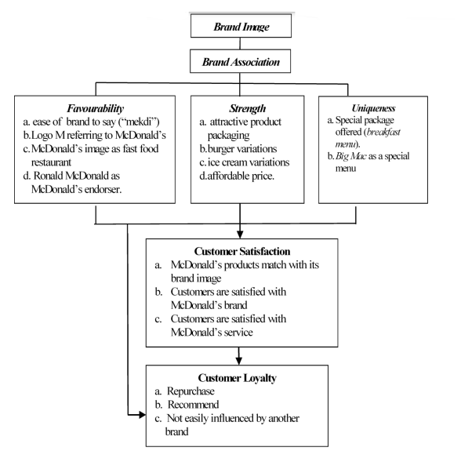
Figure 1: The “relationship between brand image and customer loyalty”
(Source: Romdonny and Rosmadi, 2019)
As per the perception of Romdonny and Rosmadi (2019), the brand image first encounters the brand association for a company, which then incorporates uniqueness, favorability and brand strength. However, these aspects encompass the customer satisfaction level, which eventually impacts the loyalty of the consumer. This shows, as argued by Hughes et al. (2019), a cohesive relationship between the loyalty and image of a brand. This means, without a sustainable base for a brand image, there might be lacking areas of brand loyalty. Thus, any company required to improve brand loyalty and profitability in this way needs to focus on improving brand image first (Bernartoet al. 2020; Dam and Dam, 2021).

Theories
Brand identity theory
As per this theory, a consumer is more likely to accept the brands recognised by them depending on the perceived value (Fujita et al. 2018). However, the brand identity regarding this depends on the visible elements of the brand like logo, colour, specific products and others. Therefore, consistent marketing techniques and messaging the brand's perceived value continuously to the consumer might help to improve the brand image and thereby consistent sales (Liao et al. 2021).
“Customer-Based Brand Equity (CBBE)” Model
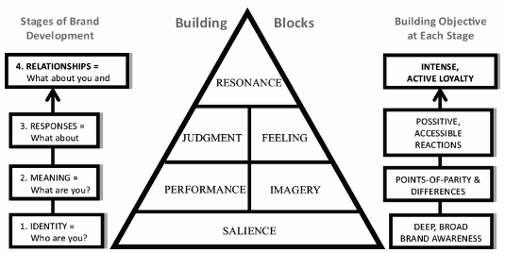
Figure 2: CBBE model
(Source: Stukalina and Pavlyuk, 2021)
The CBBE model is a marketing tool that helps a company to develop a branding strategy and capture the market while improving brand loyalty (Chekalinaet al. 2018). This model has four distinct phases that ultimately help a company in the aspects of brand improvement. The first phase is identity, which helps to introduce the band's salience. The performance and imagery of the brand provide brand meaning for the customers (Kataria and Saini, 2020). The third phase is called brand response and is derived from the feelings and judgements of the brand. Lastly, the relationship between the brand and the customer shows brand resonance (Stukalina and Pavlyuk, 2021).

Research gap
There are not many studies on the "relationship between brand image and consumer loyalty". From a business perspective, brand awareness and brand image have always proven resilient to consumer loyalty (Allen et al. 2018; Özkanet al. 2020). This includes the connection to the current economic situation and the morphing dynamics of consumer demand and loyalty (Fujita et al. 2018). We are not taking information before 2014 research papers. Because from those papers we can receive some old data which can be improve after their research.
Due to the limited intervention on the impact of brand image on brand loyalty, the related literature reviews are disregarded even though they show the significance of the essential step in any further study on this issue.

Limitations
The research will have certain limitations because it uses just one approach and only primary data. The process of gathering data for a “quantitative model” is highly unstructured, which might be proved challenging for the researcher as well (Asalet al. 2018). In addition, there is a chance for some bias from the end of the researcher as the questionnaire will be created in a closed-ended way to simplify the study process as well as make data processing easier. The research implications will also be constrained because the study's focus is just on the food and beverage sector, particularly as it relates to Nestle.

Ethical considerations
In order to incorporate the preservation of the rights and dignity of every research subject, the study will adhere to some ethical standards. The researcher shall guarantee informed permission, confidentiality, voluntary involvement, and anonymity. Password protection will be utilised to access the data collected throughout the process, which will only be used for the sake of research with a larger value for the food and beverage sector in the companies like Nestle. In dealing with the confidentiality and data security of the gathered data, the researcher will also adhere to the "Data protection act 2017" (Wachter and Mittelstadt, 2019).

Timeframe
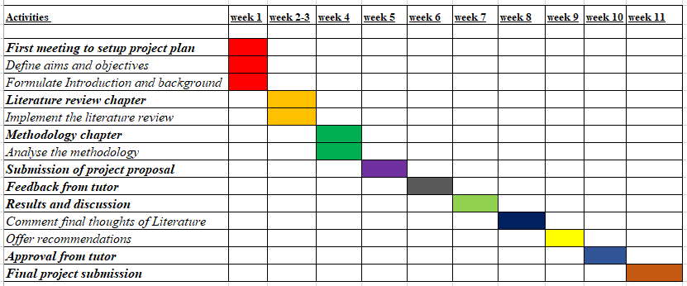
Figure 3: Time frame
(Source: Self-developed)

Conclusion
The establishment and constancy of the brand in the market are both tied to its brand image, which aids clients in understanding the business's many facets. If a firm has succeeded in building a favourable brand image in the market, there is almost a 41.8% chance that customers will return. Customer loyalty to a brand is dependent on a brand image by around 35%. The research's relevance rests in the possibility that regions of brand loyalty will be absent in the absence of a stable foundation for a brand image. The research will be done by a “primary and quantitative study” to exert the relationship between brand image and loyalty for Nestle. The potential outcome of the study is likely to benefit Nestle Company and other companies in a similar industry.

References
- Allen, C.T., Fournier, S. and Miller, F., 2018. Brands and their meaning makers. In Handbook of consumer psychology (pp. 773-814). Routledge.
- Asal, V., Fahrenkopf, N., Jadoon, A. and Hwang, I., 2018. prisoners at midnight: illustrating the advantages and disadvantages of quantitative analysis through a simulation exercise. European Political Science, 17, pp.621-633.
- Bernarto, I., Berlianto, M.P., Meilani, Y.F.C.P., Masman, R.R. and Suryawan, I.N., 2020. The influence of brand awareness, brand image, and brand trust on brand loyalty. JurnalManajemen, 24(3), pp.412-426.
- Bhardwaj, P., 2019. Types of sampling in research. Journal of the Practice of Cardiovascular Sciences, 5(3), p.157.
- Bilgin, Y., 2018. The effect of social media marketing activities on brand awareness, brand image and brand loyalty. Business & management studies: an international journal, 6(1), pp.128-148.
- Chekalina, T., Fuchs, M. and Lexhagen, M., 2018. Destination brand promise: The core of customer-based brand equity modeling. Tourism Analysis, 23(1), pp.93-107.
- Dam, S.M. and Dam, T.C., 2021. Relationships between service quality, brand image, customer satisfaction, and customer loyalty. The Journal of Asian Finance, Economics and Business, 8(3), pp.585-593.
- Foroudi, P., Jin, Z., Gupta, S., Foroudi, M.M. and Kitchen, P.J., 2018. Perceptional components of brand equity: Configuring the Symmetrical and Asymmetrical Paths to brand loyalty and brand purchase intention. Journal of Business Research, 89, pp.462-474.
- Fujita, M., Harrigan, P. and Soutar, G.N., 2018. Capturing and co-creating student experiences in social media: A social identity theory perspective. Journal of Marketing Theory and Practice, 26(1-2), pp.55-71.
- Hughes, D.E., Richards, K.A., Calantone, R., Baldus, B. and Spreng, R.A., 2019. Driving in-role and extra-role brand performance among retail frontline salespeople: antecedents and the moderating role of customer orientation. Journal of Retailing, 95(2), pp.130-143.
- Kataria, S. and Saini, V., 2020. The mediating impact of customer satisfaction in relation of brand equity and brand loyalty: An empirical synthesis and re-examination. South Asian Journal of Business Studies, 9(1), pp.62-87.
- Leong, V.S., HjAhady, D.M. and Muhamad, N., 2022. Corporate image as an enabler of customer retention. International Journal of Quality and Service Sciences, 14(3), pp.486-503.
- Liao, J., Dong, X., Luo, Z. and Guo, R., 2021. Oppositional loyalty as a brand identity-driven outcome: a conceptual framework and empirical evidence. Journal of Product & Brand Management, 30(8), pp.1134-1147.
- Marliawati, A. and Cahyaningdyah, D., 2020. Impacts the brand of experience and brand image on brand loyalty: Mediators brand of trust. Management Analysis Journal, 9(2), pp.140-151.
- Özkan, P., Süer, S., Keser, İ.K. and Kocakoç, İ.D., 2020. The effect of service quality and customer satisfaction on customer loyalty: The mediation of perceived value of services, corporate image, and corporate reputation. International Journal of Bank Marketing, 38(2), pp.384-405.
- Romdonny, J. and Rosmadi, M.L.N., 2019. Factors affecting customer loyalty in products. Budapest International Research and Critics Institute-Journal (BIRCI-Journal) Volume, 2, pp.337-343.
- Semadi, I.P. and Ariyanti, M., 2018. The influence of brand experience, brand image, and brand trust on brand loyalty of ABC-Cash. Asian Journal of Management Sciences & Education, 7(3), pp.12-23.
- Skinner, C., 2020. Quantitative research. In Handbook for research students in the social sciences (pp. 215-224). Routledge.
- Stukalina, Y. and Pavlyuk, D., 2021. Using customer-based brand equity model in the higher education context: simulating the current university’s brand. Business, Management and Economics Engineering, 19(2), pp.272-288.
- Wachter, S. and Mittelstadt, B., 2019. A right to reasonable inferences: re-thinking data protection law in the age of big data and AI. Colum. Bus. L. Rev., p.494.
- Wan, M., 2022. Research methods. In CSR Image Discursive Construction of Banks and the Effects on Capital Markets: Comparative Study of China and US (pp. 69-86). Singapore: Springer Nature Singapore.

