
78%
APPENDIX GA36b

LEVEL 5 ASSESSMENT SPECIFICATION

Student name: | Ricardo Hughes | Student ID number: | HUG12808147
Programme: | HND LEVEL 5
Module: | MECHANICAL PRINCIPLES
Module code: | M5X00926 | Contribution to Overall Module Assessment (%): | 50%
Lecturer: | EMILY NYATHI | Internal Verifier: | EDWARD HORNAGOLD
Assignment Title: | Power Transmission Systems | Word count (or equivalent): | (Nominal 2500)
Submission deadline: | 1/05/2020 | Return date of provisional marks & written feedback: | 8/05/2020
Submission method: | All written assessments, where practical and possible, must be submitted via Turnitin unless otherwise instructed by the Lecturer. (Please DO NOT put this assessment specification into Turnitin or it will match many similarities with other students’ submissions.)  Alternative submission method (if applicable):  Late submission of the assessment will result in a late penalty mark. Penalties for late submission: Up to one-week late, maximum mark of 40%. Over one week late, 0%. Only the Extenuating Circumstances Panel may approve a change to submission dates.
Academic honesty / referencing: | Academic honesty is required. In the main body of your submission you must give credit to authors on whose research and ideas your work is based. Append to your submission a reference list that indicates the books, articles, etc. that you have used, cited or quoted in order to complete this assessment.

Module Learning Outcomes
(From module syllabus)
LO2. Determine the dynamic parameters of power transmission and rotating system elements.

Student FEEDBACK FORM

This section details the extent to which you demonstrate the assessment criteria, which in turn determines your mark. The marks available for each category of skill are shown. Lecturers will use the space provided to comment on the achievement of the task(s), including those areas in which you have performed well and areas that would benefit from development/improvement.

Generic Assessment Criteria | Marks available | Marks  awarded
1. Engagement with Literature Skills
.
You have researched well on the subject and you have also with a variety of literature relevant to the subject. Keep it up. |  | 19
 | 25 | 19
2. Knowledge and Understanding Skills

Very good application of governing equations. Excellent, detailed knowledge and highly critical understanding of the well-established concepts and principles of the subject and the main methods of enquiry. |  | 24
 | 30 | 24
3. Cognitive and Intellectual Skills

Excellent critical evaluation and analysis of concepts and principles leading to logical, evidence-based, reasoned arguments and judgements. |  | 19
 | 25 | 19
4. Practical Application Skills

You have identified practical applications of pulleys and gear drives and suggested very good possible solutions to problems relating to both power transmission systems. |  | 12
 | 15 | 12
5. Transferable Skills for Life and Professional Practice

Very good research and organisational skills shown. You have demonstrated excellent skills for employment requiring the exercise of personal responsibility and decision-making and an appetite for further development. | 5 | 4

Assessment Mark (Assessment marks are subject to ratification at the Exam Board. These comments and marks are to give feedback on module work and are for guidance only until they are confirmed. ) | Late Submission Penalties (tick if appropriate) |  | 78 %
 | Up to 1 week late (40% Max) |  | 78 %
 | Over 1 week late (0%) |  | 78 %

Mechanical Principles
Power Transmission Systems

Ricardo Hughes
Course: HND Year 2 Mechanical Principles

Lecture: Emily Nyathi

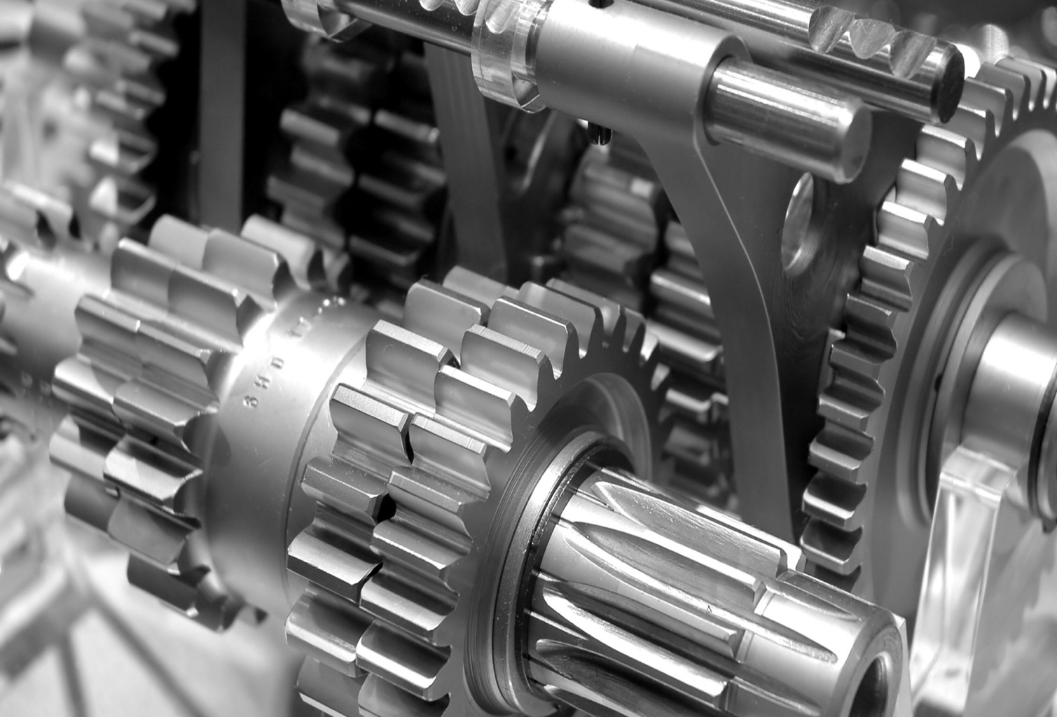

Contents Page
Introduction............................................................................................................................................3
Task 1 ..............................................................................................................................................4 – 21
Task 2 ............................................................................................................................................22 – 39
Bibliography .................................................................................................................................40 – 41

Introduction

The assignment set is to carry out 2 tasks, which will involve both theory based research and accompanied with mathematical calculations to help support this. Task 1 will involve the research into belt drive friction, exploring the different mathematical elements associated with belt driven assembly’s along with research into the different types of belts drives and their purpose.
Task 2 will look into gear trains, carrying out research on simple, compound, reverted and epicyclic gear trains uses and applications, and a problem solving element which will look into theoretical gear calculations such as the finding the output speed of meshed gears.

Task 1: Belt drive friction

Introduction:

The task set out is to carry out research into belt drive systems, and a practical experiment looking into belt drive friction with the intention to satisfy the key objectives which are listed below.

Key objectives:

- To show that a constant angle of lap $θ$ has a constant tension ratio of $\frac{T_{1}}{T_{2}}$
- To verify the relationship of $\frac{T_{1}}{T_{2}}= e^{μθ}$
- To determine the friction $μ$ between the CI pulley and the belt.

Research:
Pulley drive systems depend on friction to enable the belt to grip the wheel and pull it around with it. To enable this, the belt must be tensioned, even when the wheels are stationary. This is unlike positive chain drive systems where teeth mesh with the chain and slip is not possible so no initial tension is required. Pulley drives are most often used to produce speed reduction between a motor and the machine being driven (e.g. a motor driving a roll on a rolling mill). Many other applications exist from small rubber band drives in video recorders to large multi belt systems on heavy industrial equipment. On many modern systems, toothed belts are used (e.g. timing belt on a car engine) to prevent the belt slipping. (D.J.Dunn, 2016)
There are two main types of belt systems, these being the flat and V belt systems, although there is circular and toothed belts as mentioned above, research conducted will focus on flat and V drive systems.

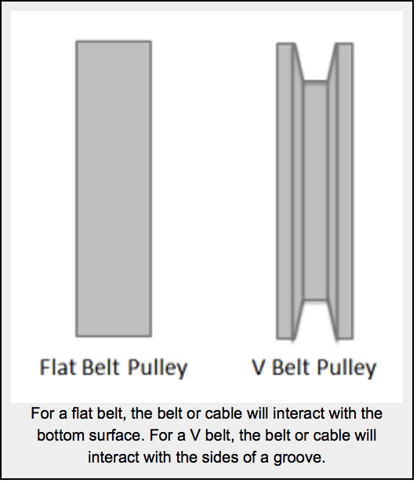

(Hussein, 2016)
Selection of belt drives:
Following are the various important factors upon which the selection of a belt drive depends:
- Speed of the driving and driven shafts
- Speed reduction ratio
- Power to be transmitted
- Centre distance between the shafts
- Positive drive requirements
- Shafts layout
- Space available
- Service conditions
(Hussein, 2016)

Types of belt drives:
- Light drives, these are used to transmit small powers at belt speeds up to about 10m sec as in agricultural machines and small machines tools.
- Medium drives, these are used to transmit medium powers at belt speeds over 10m sec up to 22m sec as in machine tools.
- Heavy drives, these are used to transmit large powers at belt speeds above 22m sec as in compressors and generators.
(Hussein, 2016)
Materials used for belts:
The Martials used for belts and ropes must be strong, flexible, and durable. It must have high coefficient of friction, the following would be considered the most common types used:
- Leather belts
- Cotton belts
- Rubber belts
- Balata belts
(Hussein, 2016)
It is important to note that each belt material has their own specific advantages and disadvantages, therefore it is crucial that the correct material is selected for its intended application. This meaning the type of environment needs to be considered, climate, operating temperature, contamination of chemicals etc. For example ‘balata becomes sticky’ (Udayana University, 2013), almost gum like at high temperatures.

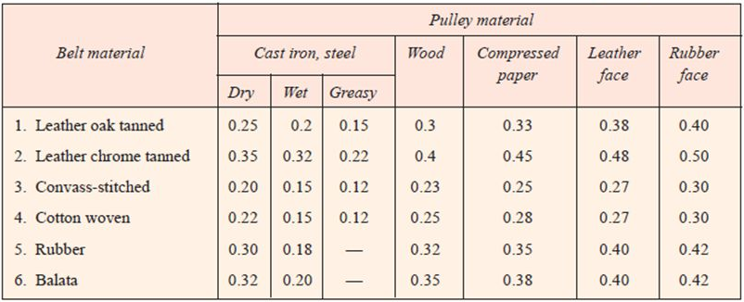
- The following table shows the values of coefficient of friction for various materials of belt and pully.
(Udayana University, 2013)
Flat belt
In its simplest form a drive of this type consists of an endless belt fitted tightly over two pulleys (driving and driven) transmitting motion from the driving to the receiving pulley by frictional resistance between belt and pulleys. The flexibility of the belt makes it possible to arrange the shafts of the driving and driven pulleys in any manner and to use as many pulleys as necessary (Hussein, 2016).
Friction in flat belts
A flat belt is any system where the pulley or surface only interacts with the bottom surface of the belt or cable. If the belt or cable instead fits into a groove, then it is considered a V belt.
When analysing systems with belts, we are usually interested in the range of values for the tension forces where the belt will not slip relative to the surface. Starting with the smaller tension force on one side (T1) we can increase the second tension force (T2) to some maximum value before slipping. For a flat belt, the maximum value for T2 will depend on the value of T1, the static coefficient of friction between the belt and the surface, and the contact angle between the belt and the surface (Beta) given in radians, as described in the equation show in the image below (Moore, 2018).
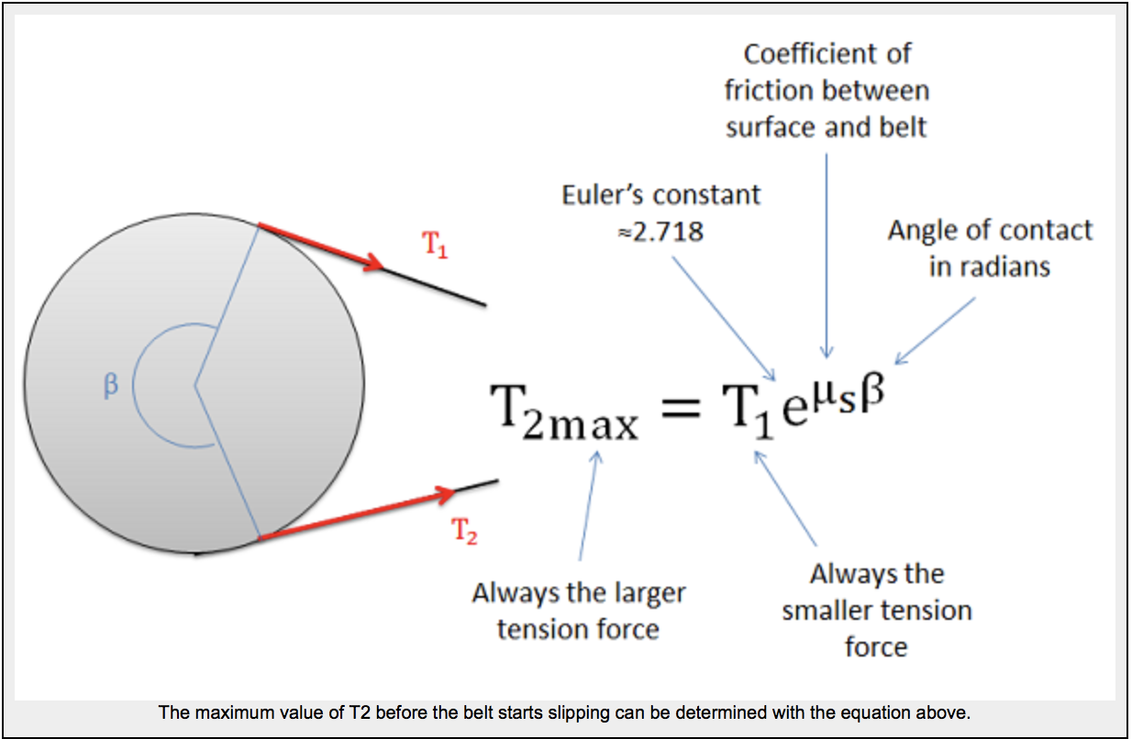
(Moore, 2018)

V belt
The V-belt is mostly used in factories and workshops where a great amount of power is to be transmitted from one pulley to another when the two pulleys are very near to each other. The V-belts are made of fabric and cords moulded in rubber and covered with fabric and cover as shown in image below (Hussein, 2016).
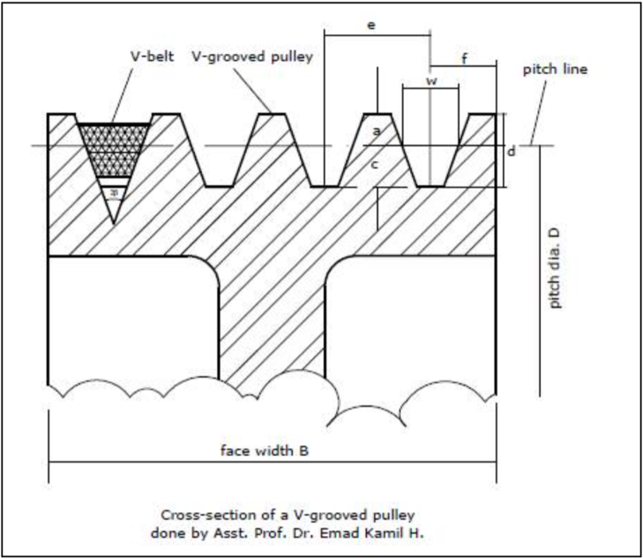
These belts are moulded to a trapezoidal shape and are made endless. The included angle for the V-belt is usually from 30° to 40°. The power is transmitted by the wedging action between the belt and the V-grooved in the pulley or sheave (Hussein, 2016).
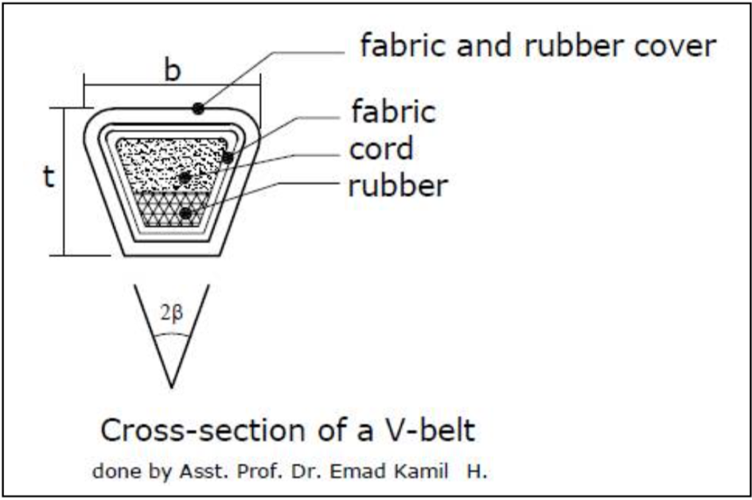
(Hussein, 2016)
In order to increase the power output several V-belts may be operated side by side. It may be noted that in multiple V-belt drive all the belts should stretch at the same rate so that the load is equally divided between them. When one of the set of belts breaks the entire set should be replaced at the same time (Hussein, 2016). If only one belt is replaced then the new one unworn and un-stretched belt will be more tightly stretched and will be move with different velocity.

Friction in V belts
A V belt is any belt that fits into a groove on a pulley or surface. For the V belt to be effective, the belt or cable will need to be in contact with the sides of the groove, but not the base of the groove as shown in the diagram below. With the normal forces on each side, the vertical components must add up the same as what the flat belt would have, but the added horizontal components of the normal forces, which cancel each other out, increase the potential for friction forces (Moore, 2018).
The equation for the maximum difference in tensions in V belt systems is similar to the equation in flat belt systems, except we use an "enhanced" coefficient of friction that takes into account the increased normal and friction forces possible because of the groove (Moore, 2018).

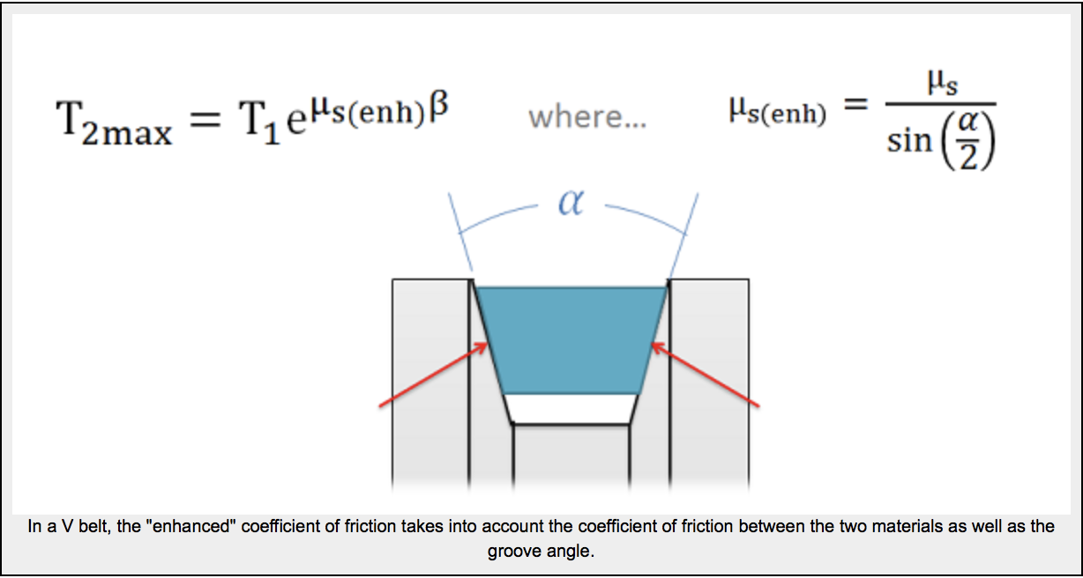

(Moore, 2018)

As we can see from the equation above, steeper sides to the groove (which would result in a smaller angle alpha) result in an increased potential difference in the tension forces. The trade-off with steeper sides however is that the belt becomes wedged in the groove and will require force to un-wedge itself from the groove as it leaves the pulley. This will cause losses that decrease the efficiency of the belt driven system. If very high tension differences are required, chain driven systems offer an alternative that is usually more efficient (Moore, 2018).

Key equations of belt drive systems

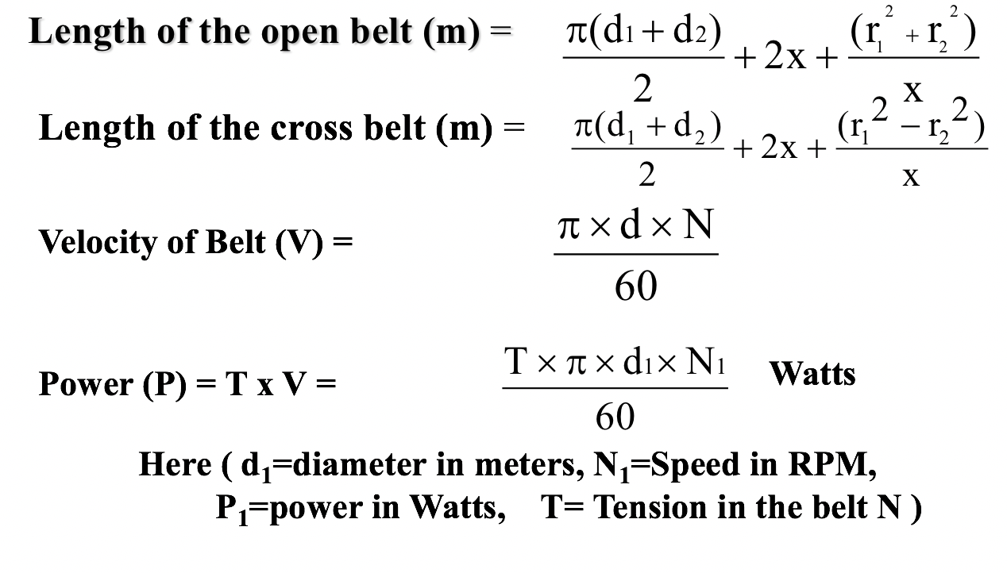

(Chandramouli, 2019)

Advantages and disadvantages of belt drive systems

Advantages

- They are simple and economical.
- Noise and vibration are damped out.
- Machinery life is prolonged because load fluctuations are cushioned (shock-absorbed).
- They are lubrication-free. They require only low maintenance.
- They are highly efficient (90–98%, usually 95%).
(Chandramouli, 2019)

Disadvantages

- The angular-velocity ratio is not necessarily constant or equal to the ratio of pulley diameters, because of belt slip and stretch.
- Heat buildup occurs. Speed is limited to usually 7000 feet per minute (35 meters per second). Power transmission is limited to 370 kilowatts (500 horsepower).
- Operating temperatures are usually restricted to –31 to 185°F (–35 to 85°C).
(Chandramouli, 2019)

Experiment
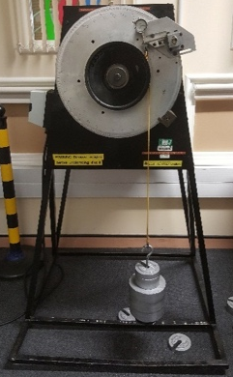
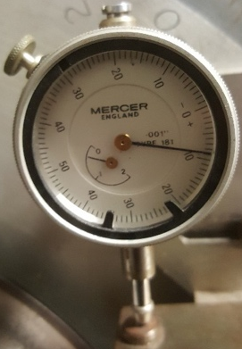
Equipment used

- Belt friction rig
- Dial test indicator
- Weight carrier
- 2 – 25 kg weights

Procedure

Cantilever calibration

- Turn angle of lap protractor to 0
- Hang belt and weight carrier on the cantilever
- Set the dial test indicator to 0
- Measure the deflection of the cantilever for masses from 0 – 24kg in steps of 3kg.
- Plot T₂ against deflection for the cantilever
- Use the plot as a calibration curve to determine T₂ on the slack side against deflection

Constant angle of lap

- Set lap θ to 90⁰, attach the belt and set the dial indicator to 0
- Switch the pulley motor on
- Measure the deflection for masses 0-20kg
- Using the calibration curve compute T₂ and plot T₁ against T₂.
- Calculate µ using first method in theory section

Variable angle of lap

- Attach belt and set the test indicator to 0
- Attach 20kg to the belt
- Switch pulley motor on
- Measure deflection for angle of lap θ from 240⁰ to 10⁰
- Determine T₂ for each angle with aid of the calibration curve
- Plot $ln\frac{T1}{T2}$ against θ, rad
- Record µ from the slope of the curve

Safety considerations

No eating or drinking in the lab.
Be careful while handling heavy equipment.
Do not perform unauthorized experiment by yourself.
Never leave experiment that is in progress unattended.
No Laboratory Work should be carried out in the absence of
instructor.
Shoes should not be slippery in order to avoid any slippage of student
on lab floor.

No eating or drinking in the lab.
Be careful while handling heavy equipment.
Do not perform unauthorized experiment by yourself.
Never leave experiment that is in progress unattended.
No Laboratory Work should be carried out in the absence of
instructor.
Shoes should not be slippery in order to avoid any slippage of student
on lab floor.

No eating or drinking in the lab.
Be careful while handling heavy equipment.
Do not perform unauthorized experiment by yourself.
Never leave experiment that is in progress unattended.
No Laboratory Work should be carried out in the absence of
instructor.
Shoes should not be slippery in order to avoid any slippage of student
on lab floor.
- Handling of heavy equipment - correct lifting procedures used and PPE worn, (I.e. safety boots)
- Slips trips and falls – work area clean and free of any obstructions before experiment commences.
- Eyes – eye protection should always be available and worn in a workshop environment.
- Food/drink – no food or drink should be consumed In the workshop environment, due to the risk of contamination.

Results

Cantilever calibration results

m (kg) | 0 | 3 | 6 | 9 | 12 | 15 | 18 | 21 | 24
𝛿 | 0 | 15 | 30.5 | 45 | 60 | 75 | 90 | 104 | 118
T₂ = mg (N) | 0 | 29.43 | 58.86 | 88.29 | 117.72 | 147.15 | 176.58 | 206.01 | 235.44
Graph showing the slack side against deflection, where T2 is in newtons and deflection represented by delta.

Calculations carried out (g = force of gravity):
$$T_{2}=m × g$$
For 3kg:
$$T_{2}=3× 9.81$$
$$T_{2}=29.4$$

Constant angle of lap results

m (kg) | 0 | 2 | 4 | 6 | 8 | 10 | 12 | 14 | 16 | 18 | 20
𝛿 | 0 | 5 | 11 | 18 | 23 | 29 | 34 | 40 | 45 | 51 | 58
T₁ = mg (N) | 0 | 19.62 | 39.24 | 58.86 | 78.48 | 98.1 | 117.72 | 137.34 | 156.96 | 176.58 | 196.2
T₂ = k x δ | 0 | 9.94 | 21.868 | 35.784 | 45.724 | 57.652 | 67.592 | 79.52 | 89.46 | 101.388 | 115.304

Graph of T₁ against T2

Calculations carried out:
$$T_{2}=k × δ$$
$$T_{2 }=1.988 ×5$$
$$T_{2 }=9.94N$$
Using equation given in hand out:

$$\frac{T_{1}}{T_{2}}=e^{μθ}=k$$

$∴$
$$k=\frac{19.62}{9.94}$$

$$=1.988$$

$$θ= \frac{π}{2}$$

$e^{μ(\frac{π}{2})}$ = 1.988

$$μ×\left(\frac{π}{2}\right)=\ln\left(1.988\right)$$

$ln⁡(1.988)$ = 0.687

$$μ= \frac{π}{2} × 0.687$$

$$μ=0.437$$

Variable angle of lap results

Θ  deg | 240 | 220 | 200 | 180 | 160 | 140 | 120 | 100 | 80 | 60 | 40 | 20 | 10
δ | 25 | 26 | 29 | 33 | 37 | 41 | 47 | 53 | 60 | 67 | 76 | 86 | 92
T_{2,} N | 49.7 | 51.69 | 57.65 | 65.60 | 73.56 | 81.51 | 93.44 | 105.36 | 119.28 | 133.2 | 151.09 | 170.97 | 182.9
Θ, rad | 4.19 | 3.84 | 3.49 | 3.14 | 2.79 | 2.44 | 2.09 | 1.75 | 1.4 | 1.05 | 0.7 | 0.35 | 0.17
$$\frac{T_{1}}{T_{2}}$$ | 3.95 | 3.80 | 3.40 | 2.99 | 2.67 | 2.40 | 2.10 | 1.86 | 1.64 | 1.47 | 1.30 | 1.15 | 1.07
$$ln\frac{T_{1}}{T_{2}}$$ | 1.37 | 1.34 | 1.22 | 1.10 | 0.98 | 0.88 | 0.74 | 0.62 | 0.49 | 0.39 | 0.26 | 0.14 | 0.068
Graph of T1/T2 against the angle of lap

Graph of LnT1/T2 against the angle of lap

Calculations:
$T_{1}=m × g$ $T_{2}=m × g$
$T_{1}=20kg × 9.81$ $T_{2}=1.988 × 25$
$T_{1}=196.2$ $T_{2}=49.7$

$$μ= \frac{1.37}{4.19}$$
$$μ=0.327$$

Findings

First objective: To show that a constant angle of lap $θ$ has a constant tension ratio of $\frac{T_{1}}{T_{2}}$
- From carrying out the experiment it is conclusive that the tension ratio for a given angle is constant. The results in experiment 2 show that the value for $μ$ stayed rather consent with each of the different masses applied.
Looking at the second graph t1 and t2 gives a gradient of 1.719 with a fairly linear line. Furthermore the looking at experiment 3 when t1/t2 begins to decrease as the angle of lap decreases this shows when the angle is changed the tension ratio remains fairly constant.

Second objective: To verify the relationship of $\frac{T_{1}}{T_{2}}= e^{μθ}$

- From the experiment carried out it is shown that there is a particularly strong correlation between t1/t2 and $e^{μθ}$ as the values gained are relatively similar. For example in table 3 at 220 degrees, rad = 3.84 t1/t2 = 3.80.
Therefore, $e^{μθ}=e^{0.327×3.84}$ = 3.51.

Third objective: To determine the friction $μ$ between the CI pulley and the belt.
- From carrying out the experiments the friction $μ$ values were found:

- Experiment 1 $μ$ = 0.437
- Experiment 2 $μ$ = 0.327

Conclusion

From carrying out the set task each of the objectives have been satisfied. Furthermore it is apparent that there has been some discrepancies in the results for example the values found for $μ$ should be the same but there appears to be a 25.2% error (0.437 – 0.327 = 0.11, (0.11$÷$0.437 ) $× 100=25.17$) this suggest that a number of errors could have occurred during the experiment.
Firstly human error could have played a part not correctly taking the readings given by the dial test indicator or misreading the (DTI). Additionally the equipment supplied could be out of calibration, test equipment is regularly used by different groups of people and general wear and tear takes place and/or damage occurred and not reported.

To help rectify potential errors, the experiment could be carried out multiple times taking an average, in addition using multiple people to take readings of each test would also allow for a comparison. Also implementing better equipment such as (DTI) with digital readout will eliminate human error when reading the analogue dial. Although these will help rectify and reduce error, during an experiment of this nature there is always possibilities for potential error, and complete accuracy to theoretical results would be rather improbable.

Task 2: Gear Trains

Introduction:
When two or more gears mesh with each other they transmit power from one shaft to another. ‘This is known as a gear train or train of toothed wheels’ (Mahesh, 2017). The nature of the train used depends upon the velocity ratio required and the relative position of the axes of shafts. A gear train may consist of spur, bevel or spiral gears. Gear trains are widely used in industry and are a vital part in everyday life such as being a crucial part of a vehicles power train, they transmit the engine torque to the wheels and provides various transmission ratios to enable different driving speeds to adapt for different driving conditions. Research will be carried out into various types of gear trains along with theoretical calculations to help support this.

Research:

Simple gear train

A gear train is any collection of two or more meshing gears. A simple gear train is one in which each shaft carries only one gear, the most basic (Rider, 2015). When the distance between the two shafts is small, the two gears 1 and 2 are made to mesh with each other to transmit motion from one shaft to the other, as shown in the image below. Since the gear 1 drives the gear 2, therefore gear 1 is called the driver and the gear 2 is called the driven or follower. It may be noted that the motion of the driven gear is opposite to the motion of driving gear (Mahesh, 2017).
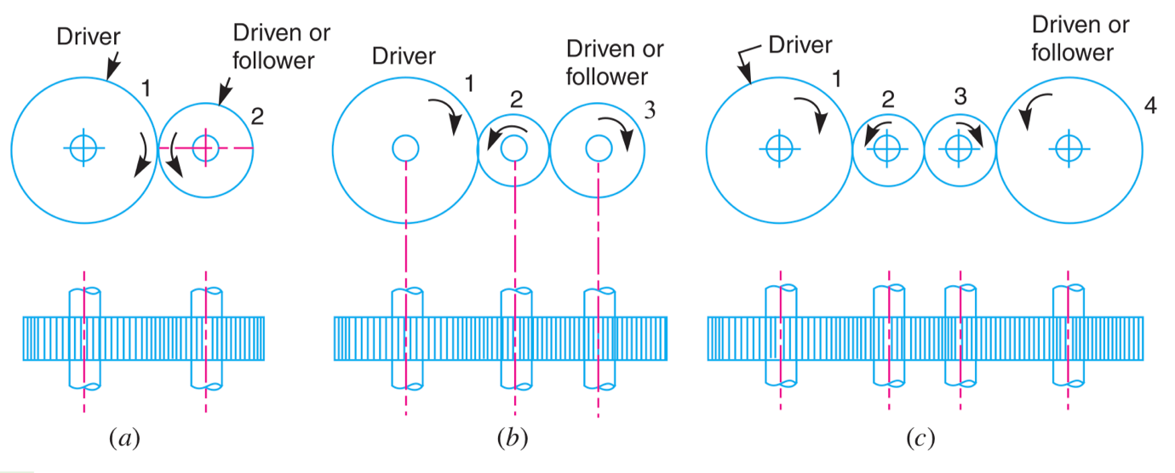
(Mahesh, 2017)
Since the speed ratio (or velocity ratio) of gear train is the ratio of the speed of the driver to the speed of the driven or follower and ratio of speeds of any pair of gears in mesh is the inverse of their number of teeth, therefore (Mahesh, 2017).
$$speed ratio= \frac{N_{1}}{N_{2}}=\frac{T_{2}}{T_{1}}$$
It may be noted that ratio of the speed of the driven or follower to the speed of the driver is known as train value of the gear train. Mathematically,
$$Train value= \frac{N_{2}}{N_{1}}=\frac{T_{1}}{T_{2}}$$
From above, we see that the train value is the reciprocal of speed ratio. Sometimes, the distance between the two gears is large. The motion from one gear to another, in such a case, may be transmitted by either of the following two methods :
1. By providing the large sized gear
2. By providing one or more intermediate gears
A little consideration will show that the former method (i.e. providing large sized gears) is very inconvenient and uneconomical method ; whereas the latter method (i.e. providing one or more intermediate gear) is very convenient and economical.
Furthermore when the number of intermediate gears are odd the motion of gears are clockwise, but if the number of intermediate gears are even, the motion of the driven or follower will be anticlockwise (Mahesh, 2017).

Common applications

Common applications of simple gear trains would be a variety of different applications, such as in heavy industry with gearboxes driven by electrical motors. Also lathe gears would have a combination of different gear set ups including a simple gears trains and heavy duty press machines. In its simplest form a simple gear train could be found in a manual wind up clock or mechanical wrist watch.
The following image represent a gearbox found in heavy industry, such as the steel industry.

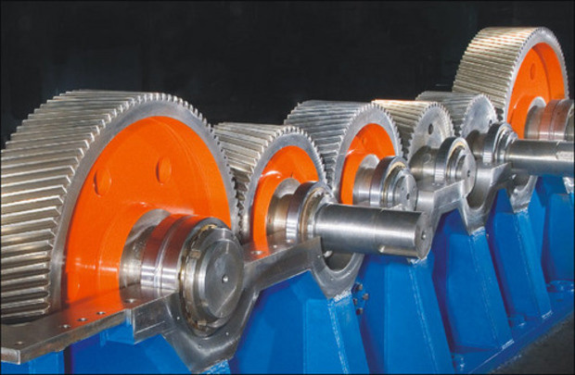

(Egypt , 2017)

Compound gear train

To get a train ratio of greater that about 10:1 with a spur, helical or bevel gears (or a combination thereof) it is necessary to compound the train. A compound train is one in which at least one shaft carried more than one gear. This will be a parallel or series or parallel arrangement, rather than the pure series connections of the simple gear train (Rider, 2015).
It is shown that idle gears, in a simple train of gears do not affect the speed ratio of the system. But these gears are useful in bridging over the space between the driver and the driven.
Whenever the distance between the driver and the driven or follower has to be bridged over by intermediate gears and at the same time a great ( or much less ) speed ratio is required, then the advantage of intermediate gears is intensified by providing compound gears on intermediate shafts. In this case, each intermediate shaft has two gears rigidly fixed to it so that they may have the same speed. One of these two gears meshes with the driver and the other with the driven or follower attached to the next shaft as shown in the image below (Mahesh, 2017).
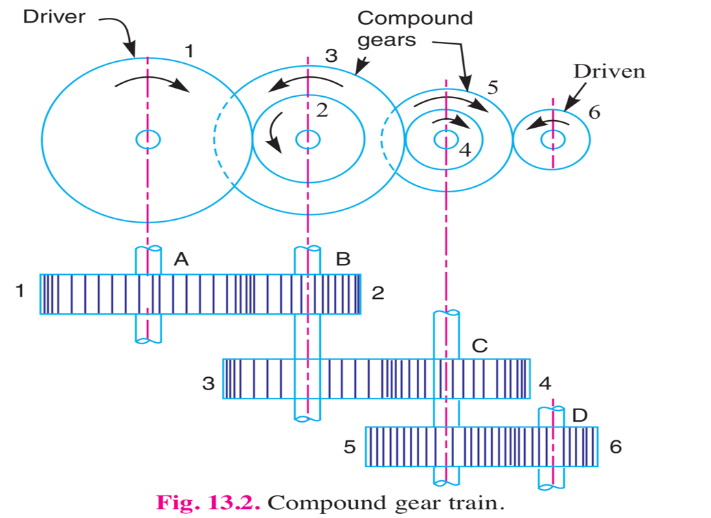

(Mahesh, 2017)
In a compound train of gears, as shown in the image above, the gear 1 is the driving gear mounted on shaft A, gears 2 and 3 are compound gears which are mounted on shaft B. The gears 4 and 5 are also compound gears which are mounted on shaft C and the gear 6 is the driven gear mounted on shaft D (Mahesh, 2017).

Since gear 1 is in mesh with gear 2, therefore its speed ratio is: $\frac{N1}{N2}=\frac{T2}{T1}$
Similarly, for gears 3 and 4, speed ratio is: $\frac{N3}{N4}=\frac{T4}{T3}$
and for gears 5 and 6, speed ratio is: $\frac{N5}{N6}=\frac{T6}{T5}$
The speed ratio of compound gear train is obtained by multiplying the equation
$$\frac{N1}{N2}×\frac{T3}{N4}×\frac{N5}{N6}=\frac{T2}{T1}×\frac{T4}{T3}×\frac{T6}{T5}$$
(Mahesh, 2017)

Common applications
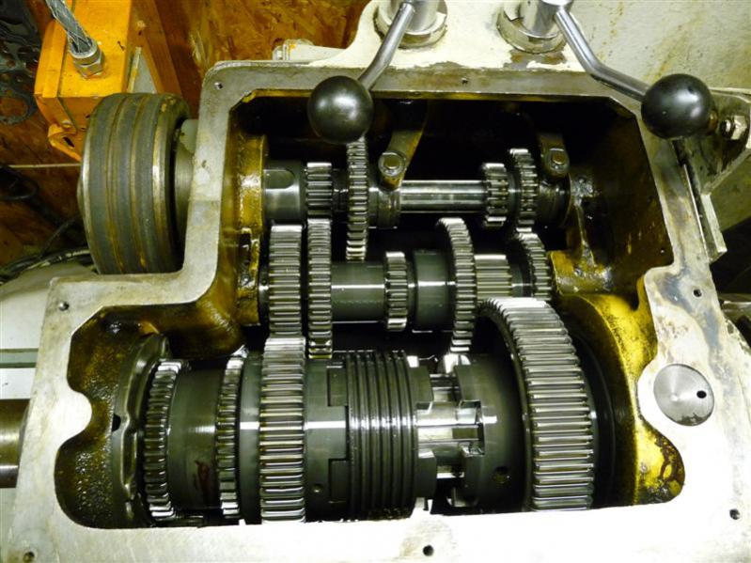
There are many applications consisting of compound gear trains again similarly to simple gears trains many variations of sets up consists within equipment. Lathe machines would commonly have a compound gear train, as would heavy industry gear boxes and very common would be a manual car gear box. The following images represent a manual car gear box and a lathe headstock gears.
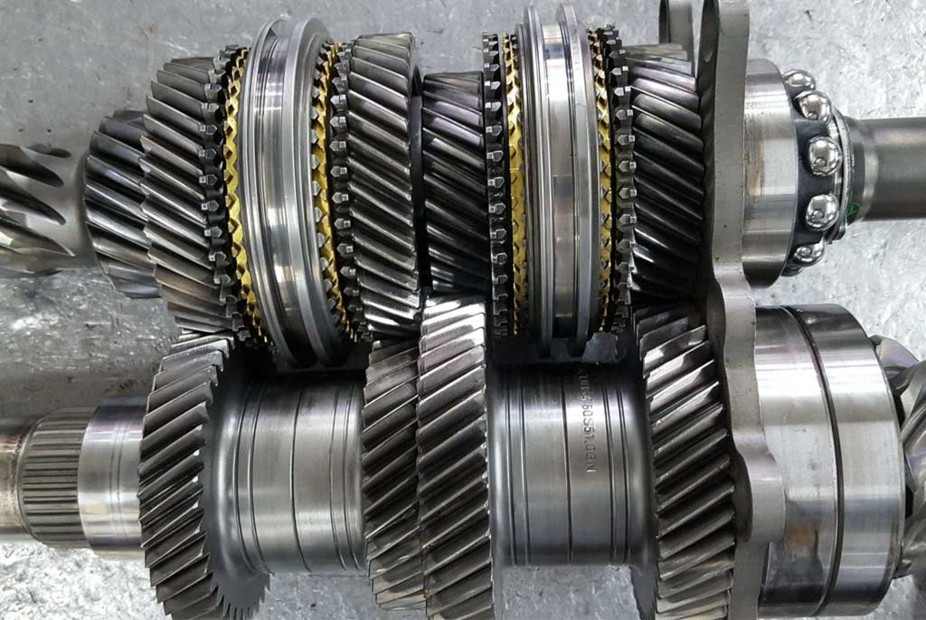

(Hardy Engineering, n.d) (Lathes, n.d)
Reverted gear train

When the axes of the first gear this being the first driver and the last gear, the last driven or follower are co-axial, then the gear train is known as reverted gear train as shown in the image below.
We see that gear 1, drives the gear 2 in the opposite direction. Since the gears 2 and 3 are mounted on the same shaft, therefore they form a compound gear and the gear 3 will rotate in the same direction as that of gear 2. The gear 3 (which is now the second driver) drives the gear 4 this being the last driven or follower in the same direction as that of gear 1 (Mahesh, 2017).
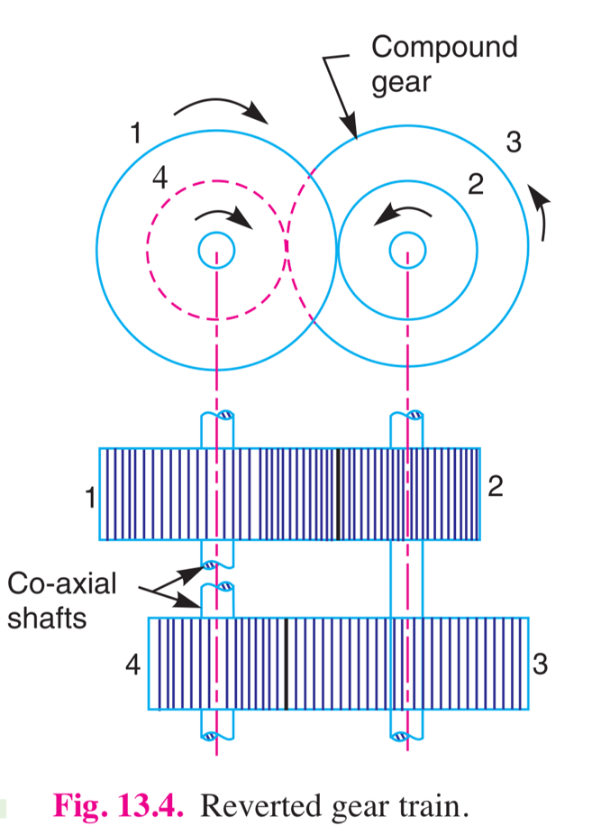

(Mahesh, 2017)

Let T1 = number of teeth on gear 1, R1 = pitch circle radius of gear 1 and N1= speed of gear 1 in rpm.
Similarly T2, T3, T4= number of teeth on respective gears. R2, R3, R4 = pitch circle radii of respective gears and n2,n3,n4 = speed of respective gears in rpm.

Since the distance between the centres of the shafts of gears 1 and 2 as well as gears 3 and 4 is same, therefore:
R1 + R2 = R3 + R4
Also, the circular pitch or module of all the gears is assumed to be same, therefore number of teeth on each gear is directly proportional to its circumference or radius, therefore T1 + T2 = T3 + T4
And
$$speed radio= \frac{product of number of teeth on drivens }{product of number of teeth on drivers}$$
(Mahesh, 2017)

Common applications

The reverted gear trains are used in a number of different applications, they are commonly found in vehicle and heavy industry gear boxes, lathe back gears and industrial speed reducers and clocks. The image represents an industrial gearbox.
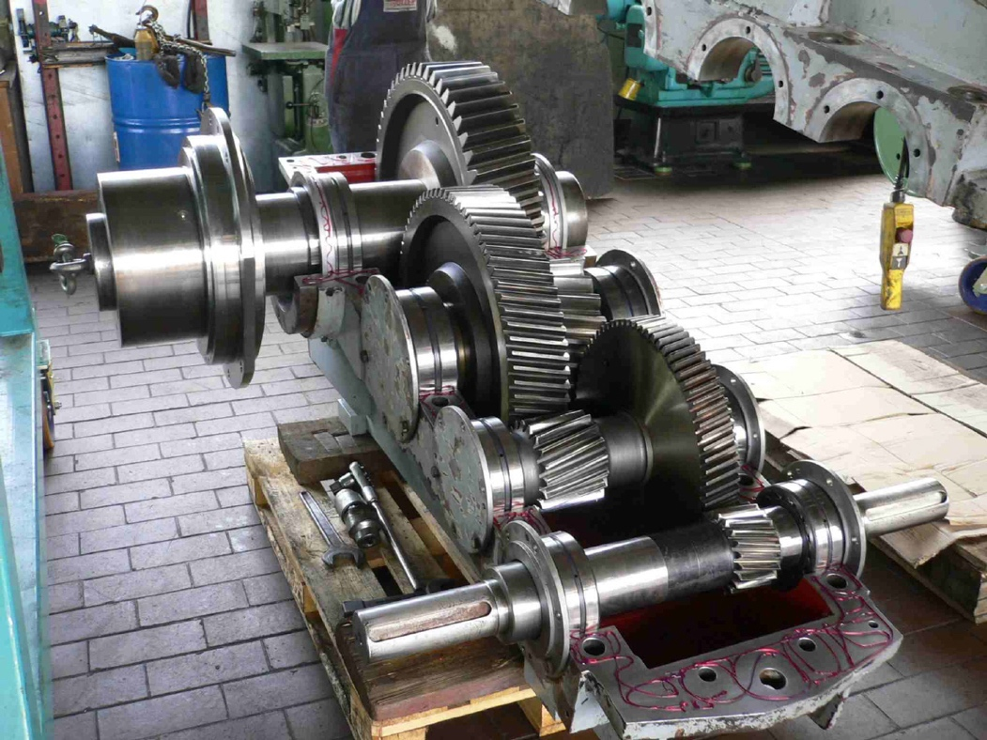

(Mueller-Wanna, n.d)
Epicyclic gear train
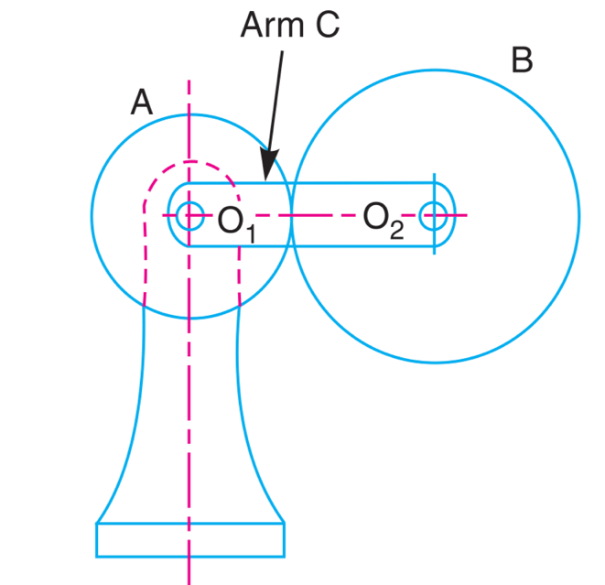
The conventional gear trains described in the previous sections are all one-degree-of-freedom (DOF) devices. Another class of gear train has wide application, the epicyclic or planetary train. This is a two-DOF device. Two inputs are needed to obtain a predict- able output. In some cases, such as the automotive differential, one input is provided (the driveshaft) and two frictionally coupled outputs are obtained (the two driving wheels). In other applications such as automatic transmissions, aircraft engine to propeller reductions, and in-hub bicycle transmissions, two inputs are provided (one usually being a zero velocity, i.e., a fixed gear), and one controlled output results (Rider, 2015).
In the image shown, where a gear A and the arm C have a common axis at O about which they can rotate. The 1 gear B meshes with gear A and has its axis on the arm at O , about which the gear B can rotate. If the arm is fixed, the gear train is simple and gear A can drive gear B or vice- versa, but if gear A is fixed and the arm is rotated about the axis of gear A (i.e. O ), then the gear B is forced to rotate 1 upon and around gear A . Such a motion is called epicyclic and the gear trains arranged in such a manner that one or more of their members move upon and around another member are known as epicyclic gear trains (epi. means upon and cyclic means around). The epicyclic gear trains may be simple or com- pound (Mahesh, 2017).
- we know the speed ratio: $\frac{speed of first driver}{speed of last driven }= \frac{Na}{Nd}=12$

- also $\frac{Na}{Nd}=\frac{na}{nb}×\frac{nc}{nd}$

- for, $\frac{Na}{Nb } and \frac{nc}{nd}$ to be the same, each speed ratio should be $√12$ so that:

- $\frac{Na}{Nd}=\frac{na}{nb}×\frac{nc}{nd}= \sqrt{12} × \sqrt{12}=12$
(Mahesh, 2017)
Common applications
The epicyclic gear trains are useful for transmitting high velocity ratios with gears of moderate size in a comparatively lesser space. The epicyclic gear trains are used in the back gear of lathes, differential gears of the automobiles, hoists, pulley blocks, wrist watches etc. one of the most common applications for this type of system is on an automatic gear box of automobiles as shown below.
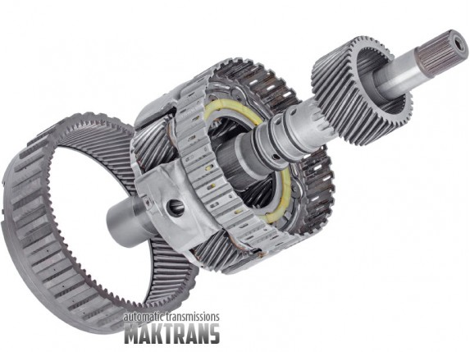

(Maktrans, n.d)

Problem solving

- The gearing of a machine tool is shown in Figure 1 below. The motor shaft is connected to gear A and rotates at 1000r.p.m The gear wheels B,C,D and E are fixed to parallel shafs rotating together. The final gear F is fixed on the output shaft. What is the speed of gear F?
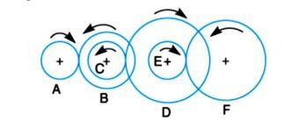

The numbers of of teeth are given on each gear are shown in the table below.
Gear | A | B | C | D | E | F20
No. Of teeth | 20 | 50 | 25 | 85 | 28 | 65

From the example given it is clear that:

A | Drivers | B | Driven
C | Drivers | D | Driven
E | Drivers | F | Driven

From looking at the diagram above it is apparent that gear A rotates in the clockwise direction, thus gears B,C which is a compound gear rotates in the anticlockwise direction. This is the same for gears D,E which is a compound gear and rotates clockwise. Finally this leaves gear F which rotates in the anticlockwise direction.

$N_{A}$= 1000 Rpm | $T_{A}$= 20 | $T_{D}$= 85
 | $T_{B}$= 50 | $T_{E}$= 28
 | $T_{C}$= 25 | $T_{F}$= 65
Therefore: let

Let $N_{f}$ = the speed of gear f

We know: $\frac{speed of first driver}{speed of last driven }= \frac{product of no. teeth on drivens}{product of no. teeth on drivers}$

$\frac{N_{A}}{N_{F}}$ = $\frac{T_{B ×}{ T}_{D × }T_{F}}{T_{A ×}{ T}_{C × }T_{E}}$

$\frac{N_{A}}{N_{F}}$ = $\frac{50×85×65}{20×25×28}$= 19.73

$N_{F}= \frac{N_{A}}{19.73}$ = $\frac{1000}{19.73}$

= 50.68 rpm

$∴Speed of gear F$ = 51 rpm

- i. What type of gears are the best for applications that require speed reduction and torque multiplication?

There are different variaty of gear types which all have thier immediate advantages and disadvantages, it is imporant to note that the actual application of this set up is not stated, such as producing continous rotatioal motion, converting rotational motion into liniar motion or if the input /output is perpendicular.
Having considered this the best set up for speed reduction and torque multiplication would be the worm gear.

Worm gears are constructed of a worm and a gear (sometimes referred to as a worm wheel), with non-parallel, non-intersecting shafts oriented 90 degrees to each other. The worm is analogous to a screw with a V-type thread, and the gear is analogous to a spur gear. The worm is typically the driving component, with the worm’s thread advancing the teeth of the gear. the worm in a worm gear may have a single start or multiple starts – meaning that there are multiple threads, on the worm. For a single-start worm, each full turn (360 degrees) of the worm advances the gear by one tooth. So a gear with 24 teeth will provide a gear reduction of 24:1. For a multi-start worm, the gear reduction equals the number of teeth on the gear, divided by the number of starts on the worm (Collins, 2017).

Although the sliding contact reduces efficiency, it provides very quiet operation. (The use of dissimilar metals for the worm and gear also contributes to quiet operation.) This makes worm gears suitable for use where noise should be minimised, such as in elevators. In addition, the use of a softer material for the gear means that it can absorb shock loads, like those experienced in heavy equipment (Collins, 2017).

The primary benefit of worm gears is their ability to provide high reduction ratios and correspondingly high torque multiplication. They can also be used as speed reducers in low- to medium-speed applications. And, because their reduction ratio is based on the number of gear teeth alone, they are more compact than other types of gears. Like fine-pitch lead screws, worm gears are typically self-locking, which makes them ideal for hoisting and lifting applications (Collins, 2017).
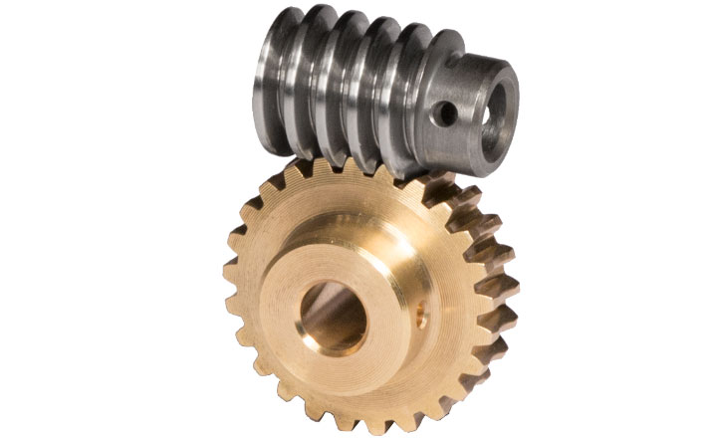

(Framo Morat, n.d)

ii. Two parallel shafts, about 800mm apart are to be connected by spur gears. One shaft is required to run at 360r.p.m amd the other at 140r.p.m. Design the gears, given that the pitch is to be 25mm.

Let:
- x = Distance between the centres of two shafts | - $N_{1}$ =Speed of the driver
- $T_{1}$ =Number of teeth on the driver | - $d_{1}$ = Pitch circle diameter of the driver,
- N2 , T2 and d2 = Corresponding values for the driven or follower | - $P_{C}$ = Circular pitch.

$x$= 800mm | $N_{1}$= 360 rpm | $d_{1}$= Pitch circle of first gear
$P_{C}$= 25 | $N_{2}$= 140 rpm | $d_{2}$= pitch circle of second gear
Given:

We know the speed ratio, using:

$\frac{N_{1}}{N_{2}}= \frac{d_{2}}{d_{1}}$ = $\frac{T_{2}}{T_{1}}$

$\frac{N_{1}}{N_{2}}= \frac{d_{2}}{d_{1}}$ = $\frac{360}{140}$

= 2.57

The centre distance between the shafts $(x)$ using:

$x$= $\frac{d_{1+ }d_{2}}{2}$

800 = $\frac{1}{2}(d_{1}+d_{2})$

$∴$
$D_{1}$ = 400mm
$D_{2}$ = 1028mm

Using :
$$T_{1}=\frac{πd_{2}}{P_{c}}$$
Number of teeth on first gear:

$$\frac{π × 400}{25}$$

= 50.27 teeth

Number of teeth on second gear:$$\frac{π × 1028}{25}$$

= 129.18 teeth

As the number of teeth on each of the gears are incomplete number the number have been rounded to the nearest whole number:

- Gear 1 = 50 teeth
- Gear 2 = 129 teeth

Pitch circle diameter for the first gear, using:

$$d_{1}= \frac{T_{1} × P_{C}}{π}$$

$$d_{1}= \frac{50 × 25}{π}$$

= 397.89 mm

Pitch circle diameter for the second gear:

$$d_{1}= \frac{129 × 25}{π}$$

= 1026.55 mm

$∴$ exact number between shaft using:

$x$ = $\frac{d_{1} + d_{2}}{2}$

$$\frac{397.89 + 1026.55}{2}$$

= 712.22 mm

- A riverted gear train is to be designed such that its speed ratio is 12, as shown in Figure 2.The module pitch of gears A and B is 3.13mm and of geras C and D is 2.5mm. What are the suitable numbers of teeth for the gears? No gear should have less than 24 teeth.

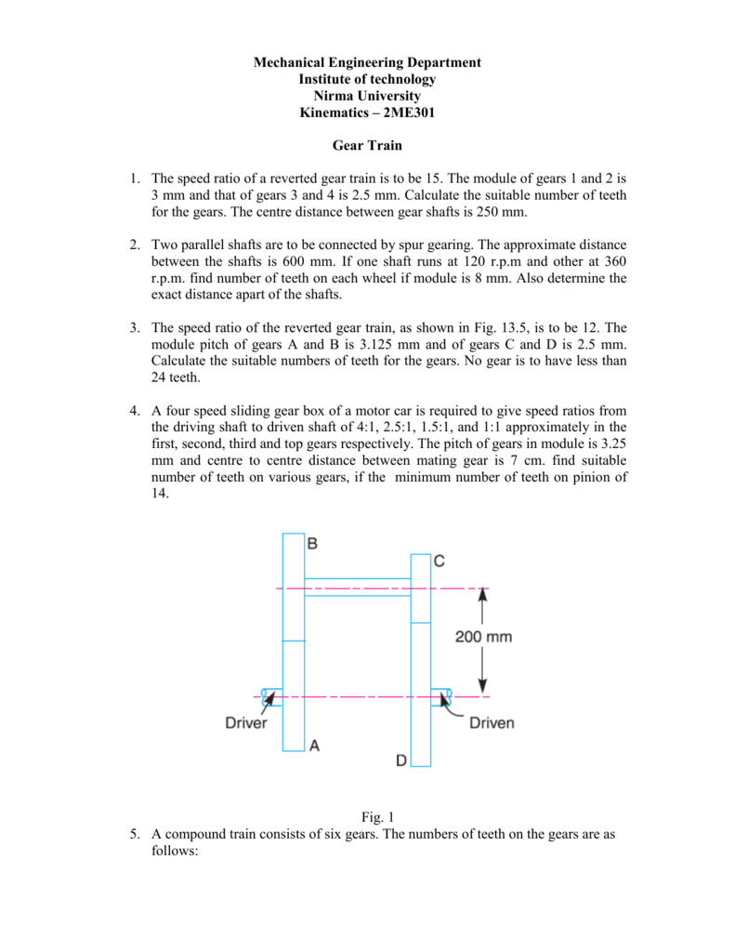

Let:

- $N_{A}=$Speed of gear A | - $N_{B},N_{C,}N_{D}$ = speed of respective gears
- $T_{A}$= Number of teeth on gear A | - $T_{B,}T_{C,}T_{D}$ = Number of teeth on respective gears
- $r_{A}$= Pitch circle radius of gear A , | - $r_{B}{, r}_{C}, r_{D}$ = Pitch circle radii of respective gears

Given:

$N_{A}=$12 | $m_{B}=$ $3.13 mm$
$N_{D}=$ 12 | $$m_{C}=2.5 mm$$
$$m_{A}= 3.13 mm$$ | $$m_{D}=2.5 mm$$

We know circular pitch,

$$P_{c}=\frac{2πr}{T}=πm$$

$$∴$$
$r_{1}=\frac{m × T_{1}}{2}$ $r_{2}=\frac{m ×{ T}_{2}}{2}$ $r_{3}=\frac{m ×{ T}_{3}}{2}$ ${ r}_{4}=\frac{m × T_{4}}{2}$

Now:
$\frac{m × T_{1}}{2}$ + $\frac{m × T_{2}}{2}$ = $\frac{m × T_{3}}{2}$ + $\frac{m × T_{4}}{2}$

$T_{1}$ + $T_{2}= T_{3}$ + $T_{4}$

Since the speed ratio between the gears A and B and between the gears C and D are to be same, therefore
$$\frac{N_{A}}{N_{B}}=\frac{N_{A}}{N_{B}}= \sqrt{12}=3.464$$

Also the speed ratio of any pair of gears in mesh is the inverse of their number of teeth, therefore
$$\frac{T_{B}}{T_{A}}=\frac{T_{D}}{T_{C}}=3.464$$

We know that the distance between the shafts:
$$x= r_{A}+r_{B}=r_{C}+r_{D}=200mm$$

$$∴$$
3.13 $(T_{A}+T_{A})$ = 2.5$(T_{C}+T_{D})$ = 200

$T_{A}+T_{A}$ = 400$÷$3.13 = 127.80

$T_{C}+T_{D}$ = 400$÷$2.5 = 160

From first equation:

$$T_{A}=3.464T_{A}=127.80 T_{A}=127.80÷4.464=28.63$$

$T_{B}=127.80-$28.63 = 99.17

Again using first equation:

$$T_{D}=3.464T_{C}=160 T_{A}=160÷4.464=35.84$$

$T_{B}=160-$35.84 = 124.16

$∴$ suitable number of teeth rounded up:

$T_{A}=$28 | $T_{B}=$100 | $T_{C}=$36 | $T_{D}=$124

Conclusion

From carrying out task 2 it has allowed for an in depth understanding of gears types and different gear train systems. Each of the different systems researched showed the benefits and limitations of each system, thus highlighting what application each system is suited to. Furthermore it is clear that some gear box configurations might use a combination of gear train types. Additionally the use of gears and gear trains is a very important and crucial to enable many process to function, there main aim to reduce speed and increase torque or visa vice versa if required. Not only industry benefits, everyday life involves the use of gears and gear trains, for example:
- Automobiles ( differential, gearbox, steering rack)
- Bicycles
- Can openers
- Manual clocks
- Drills
- Elevators
Ultimately in mechanical engineering using, understanding gears/gear trains is paramount as their use is vast and vital.

Bibliography
Chandramouli, H., 2019. Power Transmission - Belt Drives. [Online]
Available at: https://www.scribd.com/presentation/406373157/Belt-drives-ppt
[Accessed 16 04 2020].
Collins, D., 2017. Worm gears: What are they and where are they used?. [Online]
Available at: https://www.motioncontroltips.com/worm-gears-what-are-they-and-where-are-they-used/
[Accessed 10 04 2020].
D.J.Dunn, 2016. Solid Mechanics Dynamics. [Online]
Available at: Pulley drive systems depend on friction to enable the belt to grip the wheel and pull it around with it. To enable this, the belt must be tensioned, even when the wheels are stationary. This is unlike positive chain drive systems where teeth mesh with the
[Accessed 15 04 2020].
Egypt , 2017. Global Helical Gearbox Industry Analysis and Revenue Forecast. [Online]
Available at: https://www.egypt-business.com/ticker/details/1741-global-helical-gearbox-industry-analysis-and-revenue-forecast-2017/167411
[Accessed 08 04 2020].
Framo Morat, n.d. Worm Gear Sets. [Online]
Available at: https://www.google.com/url?sa=i&url=https%3A%2F%2Fframo-morat.com%2Fproducts%2Fworm-gear-sets%2Fworm-gear-sets-a17%2F&psig=AOvVaw25z_bqcuVG9mFtuAXXa3Lc&ust=1588603300429000&source=images&cd=vfe&ved=0CAIQjRxqFwoTCKDik9H2l-kCFQAAAAAdAAAAABAD
[Accessed 10 04 2020].
Hardy Engineering, n.d. [Online]
Available at: https://www.google.com/search?q=car+gearbox&tbm=isch&ved=2ahUKEwiNluXhpZHpAhXp3eAKHY1lDToQ2-cCegQIABAA&oq=car+&gs_lcp=CgNpbWcQARgAMgQIABBDMgQIABBDMgQIABBDMgQIABBDMgQIABBDMgQIABBDMgQIABBDMgQIABBDMgQIABBDMgQIABBDOgIIADoFCAAQgwFQgaEDWIalA2DcsQNoAHAAeACAAUq
[Accessed 08 04 2020].
Hussein, E. K., 2016. BELTS SYSTEMS, TYPES OF BELTS SYSTEMS. [Online]
Available at: https://www.researchgate.net/publication/307431645_BELTS_SYSTEMS_TYPES_OF_BELTS_SYSTEMS_FLAT_BELT_DRIVES
[Accessed 15 04 2020].
Lathes, n.d. Colchester Student & Master lathes. [Online]
Available at: http://www.lathes.co.uk/colchester/page7.html
[Accessed 08 04 2020].
Mahesh, K. S., 2017. Kinematics of Machines. [Online]
Available at: https://www.slideshare.net/taruian/module-4-gear-trains
[Accessed 18 04 2020].
Maktrans, n.d. Front planetary gearset. [Online]
Available at: https://maktrans.net/perednyaya-planetarnaya-peredatcha-obschaya%20vysota-300mm-4-satellita-v-sbore-s-koltsevoy-82%20zuba-i-solnetchnoy-shesterney-38%20zubov-43-shlitsa-AKPP-0C8-TR-80SD-B-U
[Accessed 08 04 2020].
Moore, J., 2018. Belt Friction. [Online]
Available at: http://adaptivemap.ma.psu.edu/websites/6_friction/belt_friction/beltfriction.html
[Accessed 16 04 2020].
Mueller-Wanna, n.d. BILDER UND REFERENZEN. [Online]
Available at: https://www.google.com/url?sa=i&url=http%3A%2F%2Fwww.mueller-wanna.de%2Fservice%2Fgetriebe-reparaturen%2Findex.html&psig=AOvVaw3FzXijlZacpvJwLyhPFNwB&ust=1588416055962000&source=images&cd=vfe&ved=0CAIQjRxqFwoTCODx3429kukCFQAAAAAdAAAAABAb
[Accessed 08 04 2020].
Rider, M. J., 2015. Design and Analysis of Mechanisms: A Planar Approach. 1st ed. Ohio : Wiley-Blackwell.
Udayana University, 2013. Belt Drives. [Online]
Available at: https://www.scribd.com/presentation/147664947/Elmes2-Belt-Drive
[Accessed 16 04 2020].

