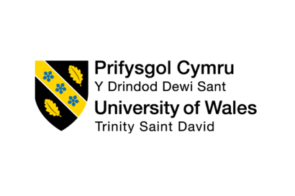

Academic and Employability Skills (BMSW_4001)

Manuel Vasile Obreja
Student ID – 1816174



Lecturers
Mr. Peter Allen
Mrs. Sylvia Hoffmann
Table of Contents

Task 1
Introduction 3
Personal and Professional Development: An introduction 4
Time management 5
Paraphrasing 6
Referencing 7
Report Writing 8
Summarizing 9
Conclusion 10
Reference 11
Appendix 12

Task 2
Introduction 15

Public speaking skills 16

Analytical and critical thinking 17

CV writing 18

Conclusion 20

References 21

Task 1

Introduction

The academic and employability skills relate attributes that people are attempting to bring to their academic learnings from lifetime experiences, these achievements are provided from many sources, evidently from a specialized course, as well from textbook and sources from the course that are applied at the workplace. However depending on the devotion of learning to main a tasks is reflected on the ability of succeeding , this is where employability reflects on succeeding , an important factor is that employability skills are valuable to employers of different organizations , other than from academic skills , while it is not possible for every candidate to have every academic and employability skill , the hirer of organizations prefer the skills that makes the individual suitable for the job, this is where a degree or a qualification are considerate important , skills are developed through academic skills as well as personal attributes. The desire to raise academic standards and, at the same time, to provide opportunities for students to acquire other competencies creates substantial challenges for educators.

This is the reason it is essential to understand about academic and employability skills, which means employability skills are ¨a set of achievements, understandings and personal attributes that make the individuals more likely to gain employment and to be successful in their chosen occupation¨ Knight ,P. & Yorke, M.(2003).This report is my own analysis on the academic and employability skills for the workplace, that I’ve been able to develop from all lectures, in class exercises from this module which I would be able to present in order of seeking better employability opportunities in my career.

Personal and Professional Development: An introduction

In the beginning of this module we were introduced to a comprehension of personal and professional development, about building academic and employability skills, students can pass through their achievements personally and professional development as they augment their acquaintance through learning and building new skills. There are tools that can identify skills like SWOT analysis, Personal Development plan (PDP), Identifying skills, for the beginning it allows us to identify our own strengths, weakness, opportunities and treats which can refer to their personal and professional development.
- During the introduction course about the variation of types that can be adapted on categorized skills:
- Adaptive skills – Our own interpersonal interactions determine how we manage ourselves in personal life
- Academic skills - Develop and reflect our historic achievements and experiences on a professional level
- Transferable skills – Skills that can be moved between different situation in personal and professional situations
- Job related skills – Are the most accurate to a specific professional situation (Maund.,2017)
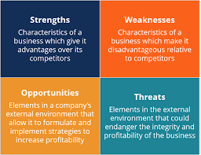

Time management

Time management techniques typically involve setting goals, establishing priorities, budgeting the amount of time allocated to the respective activity, planning and scheduling the experience needed to achieve goals. Basically, time management refers to development of processes and tools that increase efficiency and productivity. When we think about time managing, we tend to think of personal time management, loosely defined as managing our time to waste less time on doing the things we have to do so we have more time to do the things that we want to do.

Here are some tips helping time managing more efficient and productive:

- Organize your work - this is a common advice , if you are able to jot down your tasks for the day you will spend no lost time in performing your responsibilities , you may need to keep a calendar or a notepad where you can make a list of your tasks .

- Recognize what are the causes why you are unable to manage your time properly. A custom statement that some workers spend more time surfing the internet than doing their tasks in a computer is true. Try to cut down on the time you spend at work on non-work-related activities.

- Setting a goal will help give a worker better direction in their work activities. As cited out in a time management, a goal-oriented person knows what they aim to achieve and work out to attain their objective.

Paraphrasing

In week 5 we were introduced to the aspect of academic writing; paraphrasing means writing the ideas of someone in your own words, when paraphrasing you need use your own words but keep the meaning of the idea the same.
Techniques used to present the same meaning differently:
- Using synonyms
- Changing words class
- Changing word order
- Acknowledge sources
- Change order of ideas
- Making abstract ideas more concrete

The examples in the appendix show the ability of the writers to explain the same meaning of an original writing but using words that are completely different from the original author. The principal thing is trying to understand how to do so that the meaning remains the same as the original source in order to present the understanding of the writer from that original source.
Effective paraphrasing is a vital academic skill because it avoids the risk of plagiarism.

Referencing

From my progress throughout the university year, I have come to the understanding of the term of referencing which indicates the use of materials that have been used in citing a piece of writing. This reflects that referencing and bibliography are not the same thing. I achieved from the class the ability to make the difference between referencing and bibliography content which is composed of a list of materials that have been consulted during the writing; not the list of sources that have been used in citation.

Referencing is crucial to carry on successful research, and to show who the research has been done. It is a key component of a good academic practice that enhances the presentation of the work. If knowledge is informed in an appropriated academic reading it shows that the writing has a solid base.

Report writing

Writing reports is often seen as a time consuming and pointless exercise. However, by sharing information, reports can help develop common purposes and aims, spread successful innovations, build on successes, and avoid reinventing wheels and duplicating mistakes (Lowcay, 2003).

The principal idea of report writing is to bring information while explaining your own opinion of a background. It has to be close to the actual meaning from the data that has been shown in the original report and then coming up with recommendations based on the background in order to take necessary actions. This has to reflect summarized tons of data from researching in order to communicate the findings by presenting the analysis and explaining it to the readers. The material could be explained properly, and advice can be given.

A report is a structured written presentation developed as a response to a specific purpose, aim or request. The purpose of a report is to give an account of something, to offer a solution to a problem, or to answer a question.

A report writing begins with a title page that summarizes and explains the purpose of the report along with the name of the author and the date when this report was published. Thanks, are written before and after the title page where there is the acknowledgement where the consumer is mentioned along with the plan of the material and methods that have been used to prepare the material in a single paragraph. After the table of content is presented to the list of arguments covered in the report with the page number. The report starts with a brief that summarizes the entire content of the report without going in extensive details. This is the aim of the summary and its findings are detailed explained and afterwards the report should be written. The next category of the report is the presentation where the context of report and its role is mentioned as well as the tasks and the limits. It also contains a brief background to the argument and brief information on the methods that have been used for research.

Effective reports have to appropriate to the purpose so that the conclusion or recommendations can be relevant. Also, they have to be appropriate to the audience, by emphasizing the type of background detail influenced by the readers knowledge placed on a certain issue of interest. For high quality reports it is essential that the writing needs to be accurate and complete, but most important logical so that it be easily understood.

Summarizing

Summarizing is a skill that is part of a writing assignment, it is a metacognitive strategy that leads to effective using of mental skills and increases remembering and understanding. Sometimes in a personal or professional situation you are specifically assigned to write a summary of a report, a situation or something else. However, you will need to summarize your readings, experiences in most assignments whether you are asked to or not. A summary can be a few words or many pages long. One of the main reasons for summarizing is to give a reader your brief understanding of something.

“For writing good summaries, students must interrelate these new ideas with old ones, and put forward authentic ideas.” (Friend, 2001:320).
For a good summary you must first set main and secondary ideas from the background, keeping the most important ones.

Summarizing is one of the essential strategies for reading comprehension and transferring information to long term memory significantly but also the hardest for students to grasp and fully learn, because, in general, even though we may say that students are successful in stating the main idea, they project their own ideas and thoughts into the summaries. Students must develop thinking process by increasing the use of summary strategies.

Conclusion

In conclusion, students must be able to apply academic knowledge to authentic situations they may face in their careers, since most of the career opportunities for today’s students will require some form of validation of skills and knowledge that will allow them to be career ready without further waiting. Additional knowledge and specialization in one or more areas is often required either immediately after graduation or after a certain time in the company, depending on someone’s career choice.

Employers expect graduates to have the academic and employability skills from their degrees but require, to demonstrate a range of broader skills.

However, regardless to a person’s career choice, it takes all of the above skill sets to be ready for a career. The twenty-first century society should focus on providing all students a strong foundation across all these areas so they are prepared for whatever their lives may bring.

Reference

Knight, P. & Yorke, M (2003) Assessment, Learning, and Employability. Open University Press

Maund A., Schriek M., Tinkler P., (2017). Certificate in Higher education: Skills for the Workplace Student Yearbook. Sage Publications

Lowcay, B., Kalucy L. (2003). Sharing the Know-How, PHC RIS. From: http://www.phcris.org.au/publications/pdfs/SharingKnowhow_full.pdf

Friend, R. (2001) Teaching summarization as a content area reading strategy. Journal of Adolescent and Adult Literacy. December 2000/ January 2001. 44,4, 320.

Bailey, S. (2011) Academic writing for international business students. London: Routledge

UEfAP (2019). ‘Academic Writing: Reporting – paraphrase, summary & synthesis’. Online http://www.uefap.net/writing/writing-reporting-paraphrase

Britton, B.K. and Tesser, A. (1991) ‘Effects of time management practices of college grades’, Journal of Educational Psyhology, 83, 405-10.

Appendix
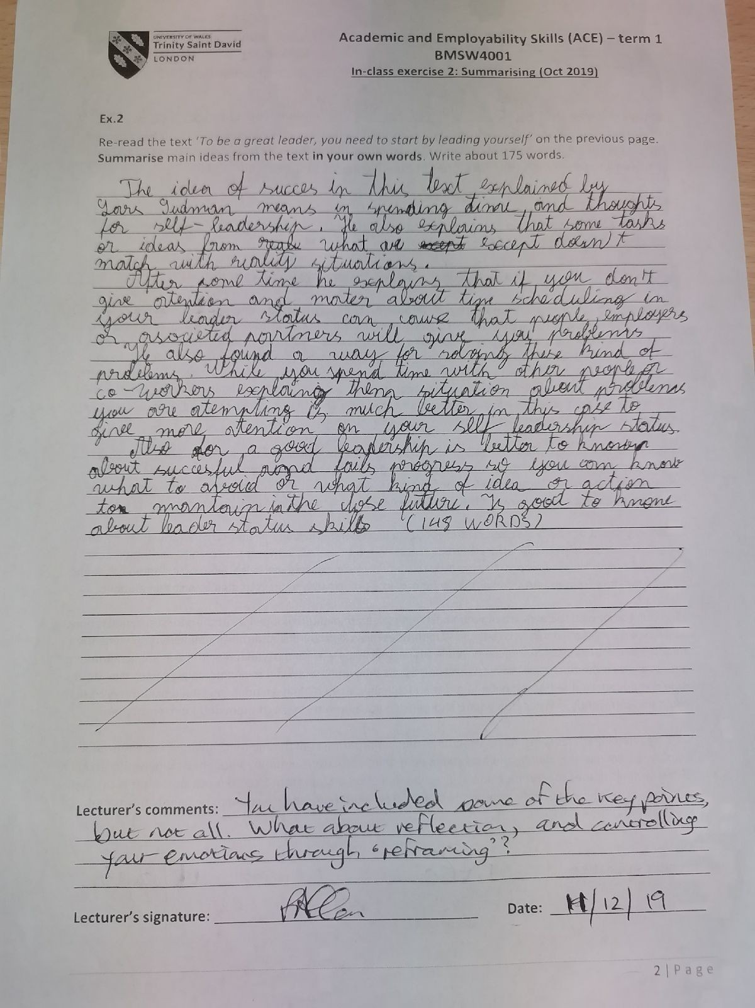
Contains the list of exercises presented in the class

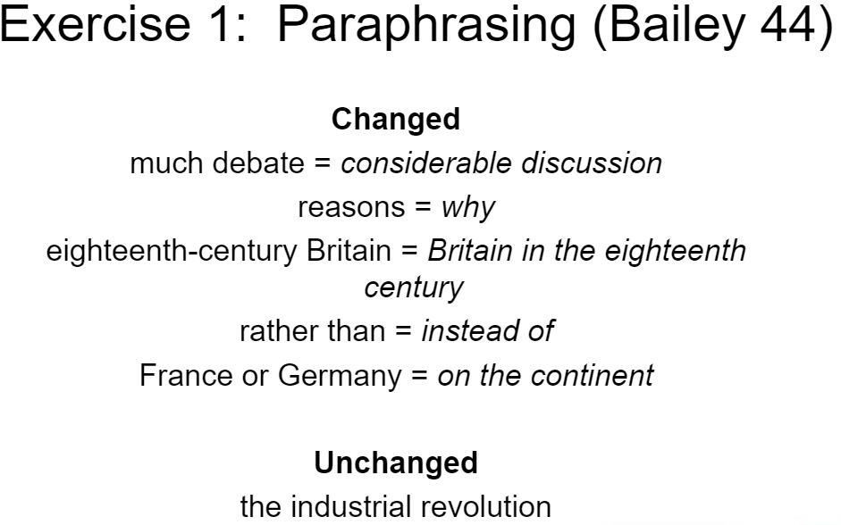
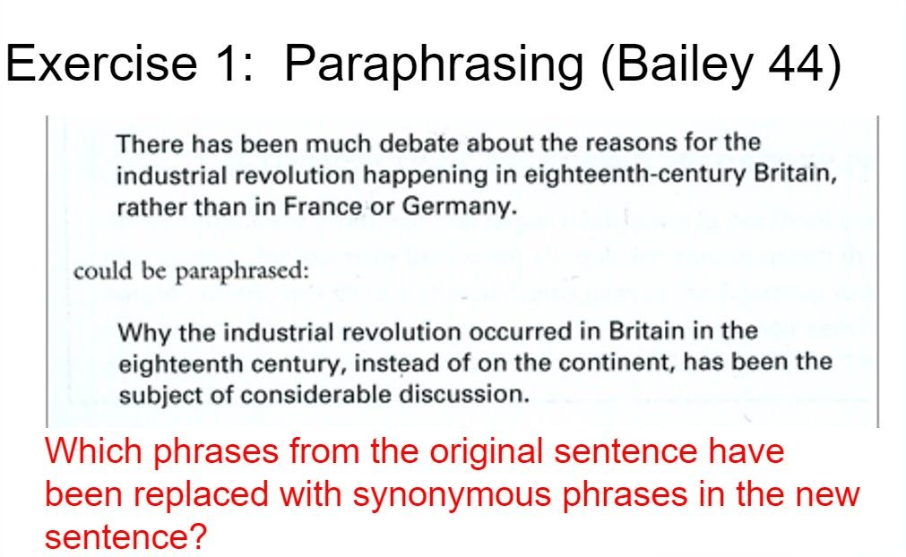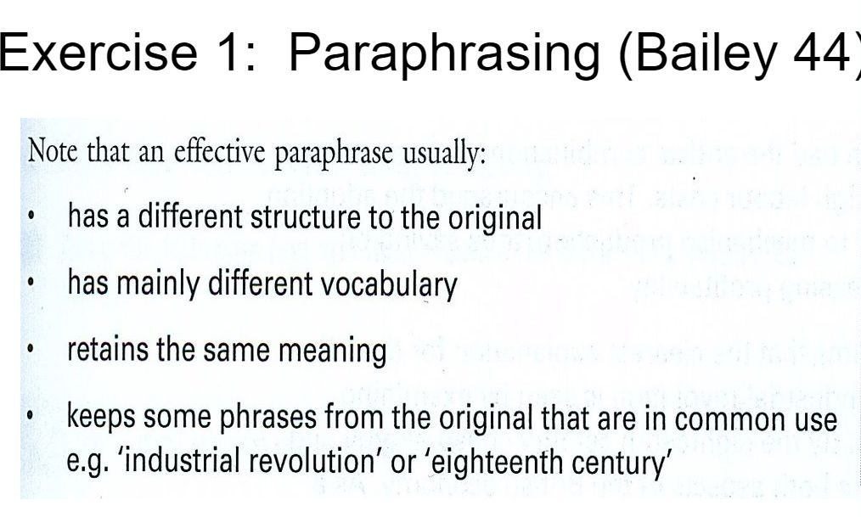

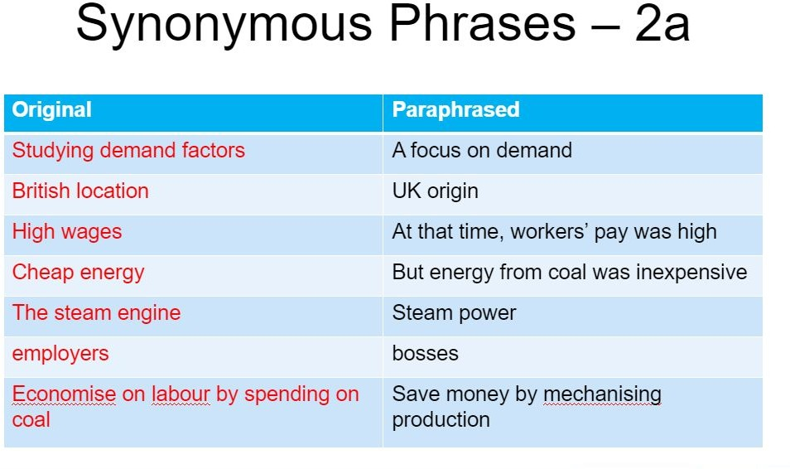
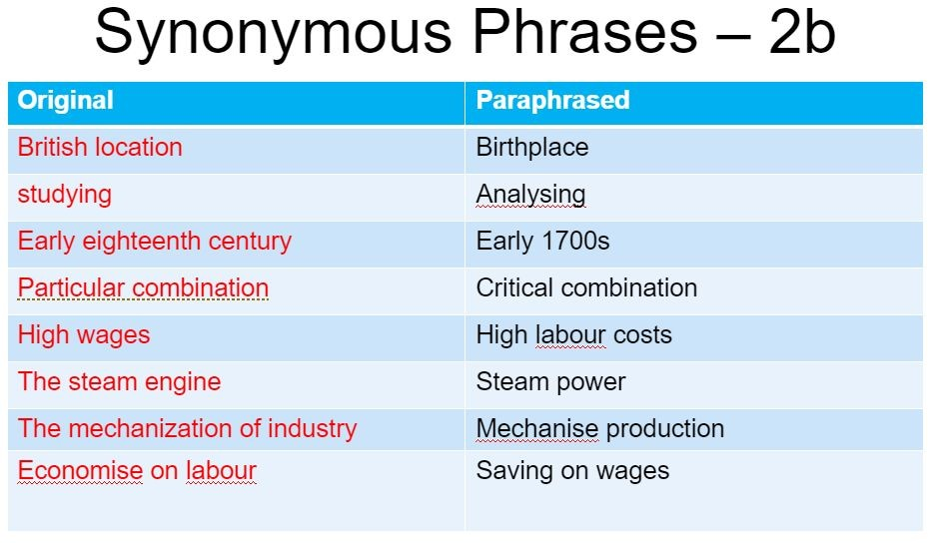
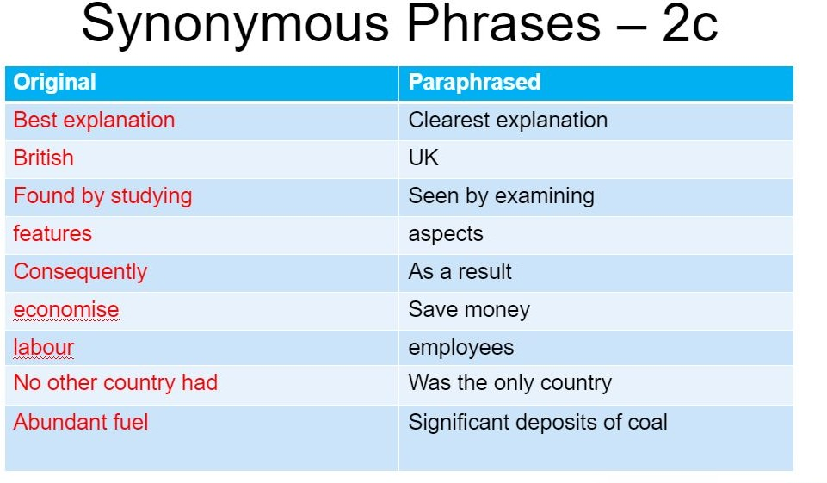
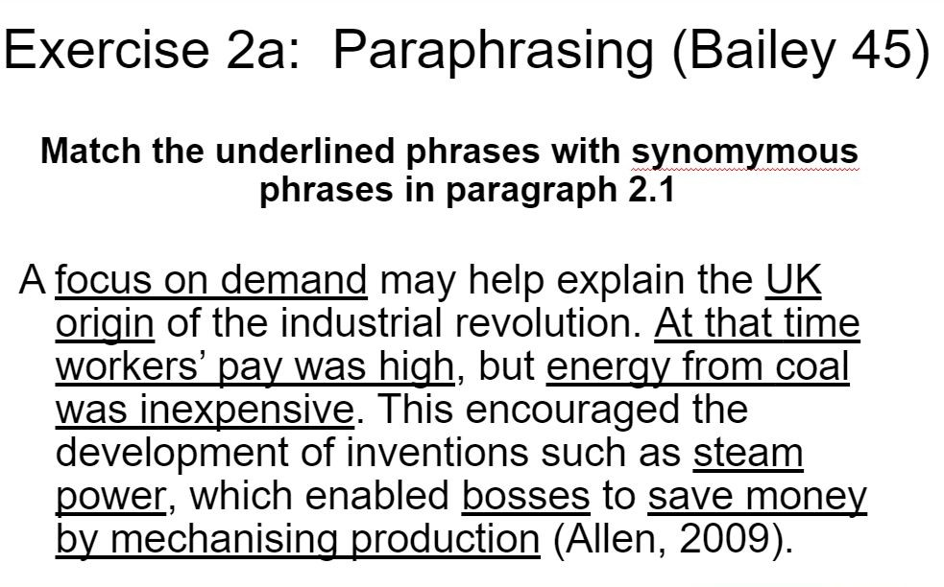

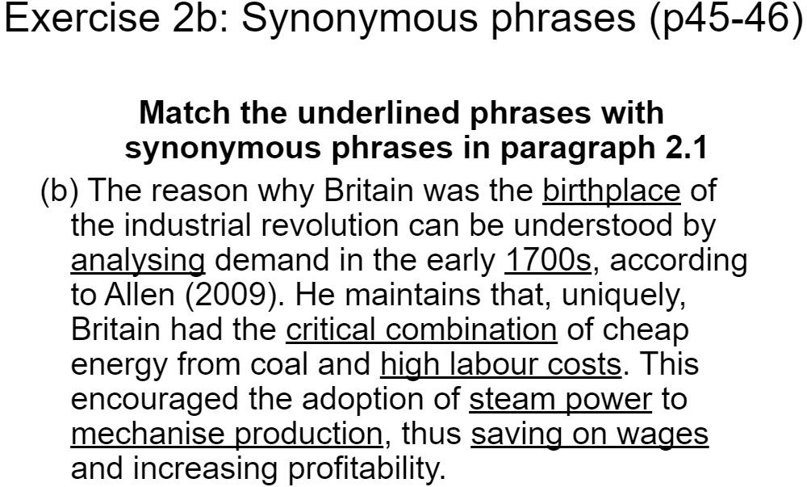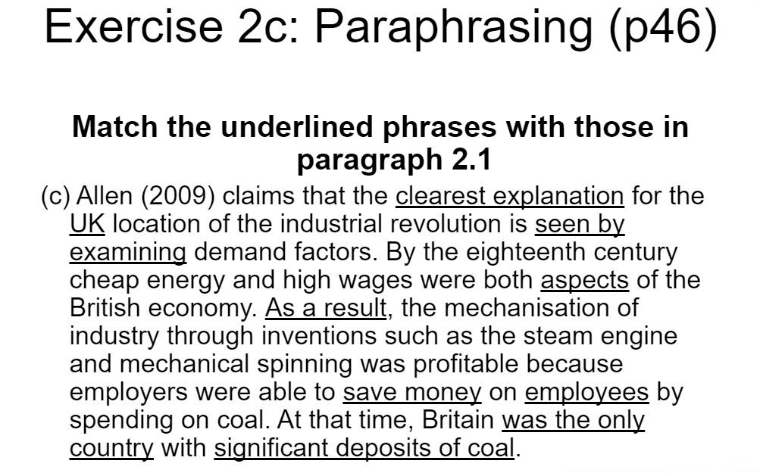

Task 2

Introduction

In this part of the assignment reflective tools are useful in academic and employability skills such as a CV, a cover letter, reflective writing. These are important capacities on identifying employee ability skills such as job expertise and attributes. The following parts will reflect my achievements with Public Speaking Skills, Analytical and Critical Thinking and CV Writing in the workplace.
To develop professionally and personally it is necessary to improve essential skills in reflective writing and practicing, skills that should be developed across previous experiences and accumulate personal development in the same time.

I worked at McDonald’s over a period of two and a half months last summer. I wanted to work at McDonald’s because I wanted to understand, partially of course, how this American company had attracted the whole European population, and what is the organization of a quasi-monopoly company, while also trying to practice my newly learned academic and employability skills. Of course, at first glance, you might think that the simple position of a polyvalent team member is not the best position to understand all the facets of this American "monster", nor to practice what I have learned in the course. But being at the very heart of the world's first "fast food", in front of the customer, allows you to understand a lot about public speaking, analytical and critical thinking, but also how writing a good CV can put you ahead of others in the run up for a job.

Professional experiences are what help us grow even on a personal level. That is why it is important to understand what you like, what you’re good at and most importantly what you want to do and figure out how to get there.

15

Public speaking skills

In the first part I will reflect on an experience that enhanced my public speaking skills.
I enjoyed my experience work at McDonald’s as a counter manager, this experience brought me a lot human interactions. I must say that I have worked a lot on my way of being with the other team members. I thought a lot about how to talk to them, to give them orders, to show them the example, etc ... And for that, I relied a lot on my experience, and the way (generally) managers (or counter managers) used to speak to me, and to speak to other team members. Of course, I did not reproduce these ways identically. I was indeed very lucky to work with an agreeable team, I learned to meet and then discover people, almost all from different backgrounds. This encouraged my public speaking skills. I always agreed that a good manager must be both authoritarian and patient. A manager who isn’t patient is an unorganized manager, but the problem with this is often a source of conflict because it is a source of disagreement. I had the chance myself to work under the orders of patient managers, as well as under the orders of stressed managers, I can say that I was much more productive with the first ... We only harvest what we sow ... On the other hand, we must show a lot of authority to avoid confusion.
As a team member, I think that you have to be patient first, because it sometimes happens that after a few hours of work (a job which is quite repetitive moreover) a team member is at the end of his nerves … You have to know how to accept orders without necessarily understanding them. Relational qualities as well as a team spirit are rigorous. Hygiene, speed, efficiency, memory, vigilance and organization are essential to perform these functions in optimal conditions. I think that a good manager must be attentive to his staff, to avoid disagreement as well as to reap the maximum of suggestions, which are generally very constructive.

Finally, when the first customer arrives, you have to know how to welcome them with a smile!
This is one of the only times to take initiative, because there is no one to tell you what to do. Everyone knows what to do and how to be polite and efficient with the clients and giving them the best possible customer experience.

Analytical and critical thinking

The content of this part shows a situation regarding an experience from an analytical and critical thinking situation.

First, I would say that these two months taught me to have a critical sense of a whole management system. I have both seen the qualities and the flaws of an original management style. Managing a business (and more specifically employees) is something that was completely foreign to me then, in practice at least. Having already been trained, therefore, allowed me to focus on the type of management implemented at McDonald's, rather than on my work itself.

I have also learned to manage a whole team myself, from the responsibilities that I have been given, and I think I have lived up to the expectations of my superiors. Leading a team is not easy, especially when you have exactly the same job as the team you have to lead. Indeed, this originally supposes fewer authorities than one might think. It’s very easy to understand it’s normal to take orders from someone with the same professional status less seriously than orders from a superior. So that forced me to be more judicious about my directives, and especially about the ways of giving them.

In quieter periods, the counter manager organizes and assigns each team member a specific task. There should never be a team member who doesn't know what to do, and you should always have in mind what has already been done, what each team member is doing and where he is. It is very important to know where each team member is, because if ever a large number of customers enter the restaurant, the counter manager must be able to gather all the team members in a very short time.

This mission has been entrusted to me through my experience, but also because I have acquired a certain speed, a certain ease and a certain reliability in my teamwork. These are the three main qualities that every team member must have in order to become a counter manager.

CV writing

A CV is a document especially created to attract an employer by identifying abilities, qualifications, previous experiences, digital skills or even perform better skills with actual knowledge reveled on you CV.

In a previous job application at McDonald’s company my CV was clearly summarized with all my illustrated attributes as language qualifications, degree and previous job experiences. So, it is good to figure out your personal attaining, personal details commonly are involved at the top of the first page, as for referees generally appear at the bottom of the page.
On the CV could be noted the following attributes

- Profile: Administrative support, office management skills such as Microsoft Office programs
- Education: Relevant courses, previous educational history, professional development
- Key Skills: Technological skills, personal skills, office skills, public speaking skills and so on.

This is the CV I have sent to McDonald’s when I was looking for a job.

Conclusion

In conclusion, the best way in finding a job is by developing the academic and employability skills by learning and trying to practice them in real situations till they become cognitive. By doing so you will be able to climb the corporate ladder and become the person that you want to be.

In my professional experience at McDonald’s I have understood the importance of the counter manager who must be very efficient on his teamwork, but he must also know how to manage a whole team of teammates who are under his command. For that, it is of course necessary to show reflection but also vigilance.

Indeed, certain times require the presence of all team members (during peak periods: lunch and dinner hours), and in these cases, the counter manager is important in times of crisis (when there is a shortage dry stocks; in the event of an indoor accident: a spilled coke, a need for help for a young mother ...; in the event of a lack of trays). In these cases, you have to know how to take the time to ask a team member to take care of the problem and learning how to speak publicly. That is why the counter manager is also essential to motivate team members, encourage them, but also take them back when they do their job badly, or even help new employees who are having difficulties with a client.

Most importantly is to understand how you are and what your personal qualities and employability skills are so you can summarize them in one page that reflects your life work. By doing so, the employers can understand if you are made for the job or not. That’s why you have to think a lot and put everything you can on the CV.

References

Morgan, P (2017). The Business Student’s Guide to Employability.
London: Sage
Maund, A., Schriek, M., and Tinkler, P. (2017) Certificate in Higher Education: Skills for the Workplace Student Yearbook. London: Sage.
Hampton, M. (2010) Reflective Writing. A basic introduction
Schon, D. A. (1983) The reflective practitioner: how professionals think in action. New York: Basic Books

