NAME: Muhammed shah
STUDENT NUMBER: 2131204
MODULE: LCMB7000
LECTURER: Dr Gladius David Kulothungan
COURSE: MBA General management
SUBMISSION DATE:14/09/2022
TITLE: HRM Assignment 2

Table of Contents

INTRODUCTION 3
ABOUT THE COMPANY 3
CHANGE MANAGEMENT 3
Kotter’s Theory 4
Significance of the Theory 6
STAFF RETENTION 6
Theory of Organisational Equilibrium 6
Social Exchange Theory 7
Zingers model 7
Adams Equity Theory 8
Significance of the Theories 8
LEADERSHIP DEVELOPMENT 9
Transformational Leadership Theory 9
Blake and Mouton’s Managerial Grid 11
Significance of the Theory 12
RECOMMENDATIONS 13
CONCLUSION 13
REFERENCES 14

INTRODUCTION
The active involvement of manpower is necessary for the production of goods and services. The most important resource in an organisation is its human capital (Szierbowski-Seibel and Kabst, 2018). Skilled labours are necessary for the effective achievement of the goals of a company. Intellectsoft is a renowned software company in the UK(Intellectsoft Client Reviews | Clutch. co, no date). The report gives a detailed outline regarding the strategies to be adopted for the better management of the human capital of the company and better achievement of the organisational objectives. The role of various human resource management theories is significant in this context.
ABOUT THE COMPANY
Modern engineering solutions are offered by Intellectsoft, a digital transformation company, to large international enterprises. Our multi-award-winning organisation assists businesses in orchestrating continuing innovation, unravelling complicated problems, and speeding up the adoption of emerging technologies(Intellectsoft LLC - Company Profile Report | IBISWorld, no date). The engineering centres for Intellectsoft, which was founded in 2007, are located in the united states, the united kingdom and eastern Europe(Accounting Software Development Basics — Intellectsoft Blog, no date). The report contains the strategies to be adopted by the head of the human resource department in Intellectsoft.
CHANGE MANAGEMENT
Change is inevitable for the success of every organisation. The adoption of innovative ideas and strategies ensures the growth of a company(Errida and Lotfi, 2021). Being the human resource head of Intellectsoft I would be ready to incorporate changes in the organisation. The examples of the greatest leader like Knudstrop in the lego group, and the strategies adopted by Jeff Bezos on amazon are to be considered(Isa and Liem, 2021). Imparting changes may bring out organisational efficiency, better management of the workforce and effective achievement of the goals of the company.
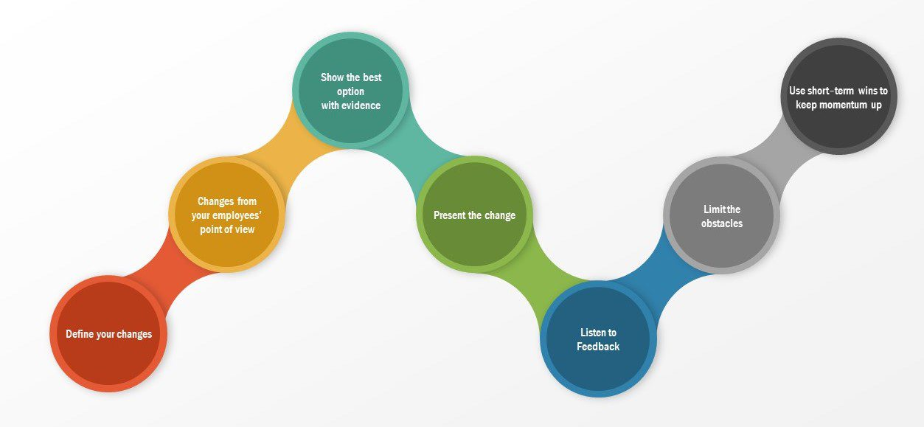
Source:(10 Proven Change Management Models (2022), no date)
To influence employees toward the desired change, nudge theory depends on subtly worded, informal recommendations that are supported by data. Siemens adopted this theory to adapt to changes in employees and the policy was a great success(Study, 1847). Resistance is less likely since the nudge theory enables employees to recognise the necessity of changing themselves and control how it is made(Kosters and Van der Heijden, 2015). The theory states the need for the involvement of workers in the decision-making process (Wang et al., 2020).
Kotter’s Theory
The theory suggests the steps involved in the process of bringing changes to the organisation. Kotter saw a great number of executives and companies as they attempted to implement or modify their strategies(Henry et al., 2017). He determined the common success characteristics, isolated them, and listed them as the 8 steps for leading change.
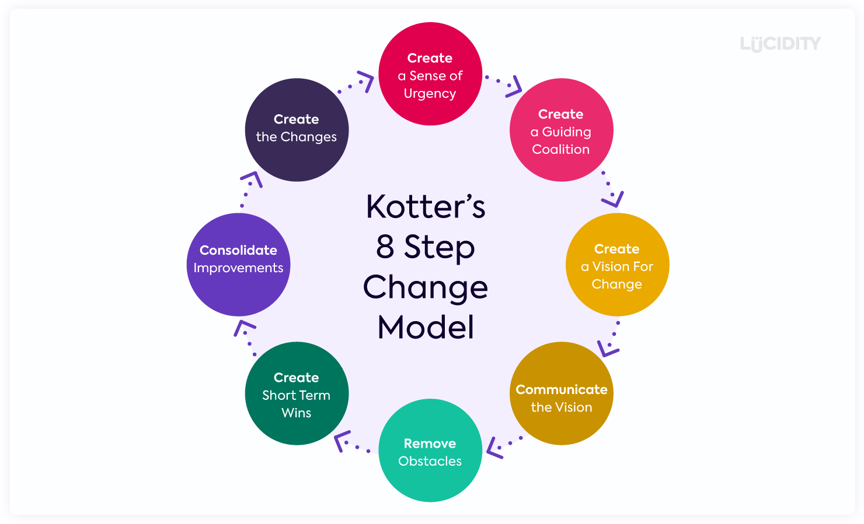
Source:(John Kotter Model of Change | Kotter’s 8 Step Change Model Template, no date)
Kotter’s model adopted by Erickson is a great success in imparting changes in the company(Shurrab and Zec, 2013). The steps involved in the model are,
To create urgency, all parties involved must have a sense of the need for transformation and think that change is necessary for organisational growth to create enduring transformation(Laig and Abocejo, 2021).
Coalition and creating a strong team with team spirit are necessary for bringing change (Henry et al., 2017).
Develop a vision, develop a clear strategy for the company's endeavour and work with the team to make sure it is achieved. It enables the greatest enthusiasm for workers (Laig and Abocejo, 2021).
Communication, a crucial step in ensuring support throughout the organisation is to communicate the vision to the employees and engage in open communication(Henry et al., 2017).
Remove obstacles, there might be various hindrances regard to employees' attitudes and the organisation structure. Such obstacles should be removed to bring change (Henry et al., 2017).
Short-term goals, showcasing the team's progress about the change plan is a tremendously powerful method to inspire and engage them. Examining short-term wins is the simplest approach to accomplish this(Laig and Abocejo, 2021).
Consolidation, the various efforts of the workers need to be consolidated for the achievement of the vision (Szadkowski and Cercone, 2016).
Sustain change, the anchoring of the change is an essential phase for hopefully obvious reasons. Once you've made significant progress and achieved a lot, you need to make certain that the new ideas are integrated into the business(Purnell et al., 2020).
Significance of the Theory
The adoption of Kotter's model for imparting change is necessary in the case of Intellectsoft as the company has to keep the momentum by adopting innovative practices. The redesigning of the composition and policies in the management may create flexibility in the working environment(Laig and Abocejo, 2021). The team-building process might ensure a good synergy among the team members and helps to develop an effective resourcing strategy for the organisation(Henry et al., 2017). The employee growth and revenue growth of the company are very low in the present scenario. The company has global operations and has to face competition from various companies all over the world. A proper change is necessary to boost the capabilities of its human capital and to expand the area of operations. Kotter’s eight-step model gives a detailed outline regarding how to incorporate change in the organisation in the current situation.
STAFF RETENTION
One of the best ways to guarantee the presence of dedicated and deserving employees is through employee retention. It is also outstanding at preserving a company's productivity. It prevents staff morale from declining and saves the organisation a lot of money in employee turnover fees(Butt, Lodhi and Shahzad, 2020).
Theory of Organisational Equilibrium
The theory proposed by Barnard-Simon states that the contribution by employees and contribution given by employees to companies should be balanced (Gamber, Kruft and Kock, 2020). Due to a variety of human limits, when a person attempts to meet his needs or motives, he frequently finds that he is unable to obtain sufficient satisfaction(Zaza, Brooks and Armstrong, 2020). The person creates cooperative mechanisms to get around these constraints, particularly the typical physiological constraints. Fayol’s theory also argues that there should be a proper balance or equilibrium between authority and responsibility.
Social Exchange Theory
The theory states that social ties are essential for sustaining employees (Southall, 2021). The social relationship between the staff is necessary for maintaining a suitable work environment (Cropanzano and Mitchell, 2005). Social exchange and building community in the organisation is necessary for the retention of the existing employees. A proper social exchange may also attract prospective employees to the company. Lower job performance results from the employer's violation of a collection of negotiated standards of conduct(Chernyak-Hai and Rabenu, 2018). This staff retention theory also emphasises how a company's strong social relationships encourage individuals to stay longer and result in more contented workers.
Zingers model
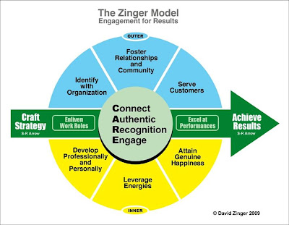
Source:(Zinger Employee Engagement Model, no date)
The zinger argues that employee engagement is crucial in retaining them. (Zinger Employee Engagement Model, no date). Recognition and reward are important for retaining the workforce. The active participation of employees is the crux of generating satisfying human capital.
Adams Equity Theory
According to adam's equity theory, people continue to treat others fairly when it comes to the relationship between performance and incentives. In other words, if an employee's inputs exceed his outputs, the both job and the company will demotivate him(Tseng and Kuo, 2014). The amount of motivation among people in the workplace is shown through adam's equity hypothesis. If a person feels that they are being treated fairly, that person is considered to be highly motivated. A person may experience demotivation if they believe they are being unfairly treated in the workplace(Young, 2018).
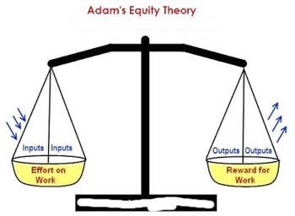
Source:(Adam's Equity Theory | Human Resource Management)
Significance of the Theories
The applications of the theories and obtaining insights from the theories are essential in the case of Intellectsoft. The retention of employees is an important concern for every organisation. The theory of organisational equilibrium suggests that to retain employees, a proper strategy is necessary to ensure perfect coordination among employees and they have to operate within their limits(Butt, Lodhi and Shahzad, 2020). The cooperative mechanism in the organisation should be built stronger to maintain the workforce. Encouraging positive and effective team dynamics outside of the office is another smart move. The zingers model also has application in the company as, the employee should be in line with the organisation to increase the organization's reputation, and there shouldn't be any division between the two(Hunt and Wasserman, 2014). The approach states that workers should experience professional and personal growth through their employment, including taking courses and discovering their skills. The Adams equity theory also guides employee retention to ensure a fair return of output for the inputs provided by employees is essential for maintaining the workforce(Young, 2018). The employee turnover in it sector is comparatively higher due to the stress and work environment. A proper policy to ensure flexible working environments will help in the retention of employees.
LEADERSHIP DEVELOPMENT
The way businesses usually engage in internal growth and prepare high-potential individuals to assume senior roles in the firm shortly is through leadership development programmes(McCauley and Palus, 2021). But the traits and abilities we identify with effective leadership have changed. Leadership training for a wider variety of managers has also grown increasingly crucial as businesses know how critical agility is.
Transformational Leadership Theory
A true transformational leader ought to be able to inspire others, establish clear objectives, set high-performance expectations and preconceptions, be honest and fair in his dealings with others, show appreciation for his team's efforts, encourage staff members to consider the company's overall success rather than just their interests, and challenge individuals to reach their full potential(Kjellström, Stålne and Törnblom, 2020).
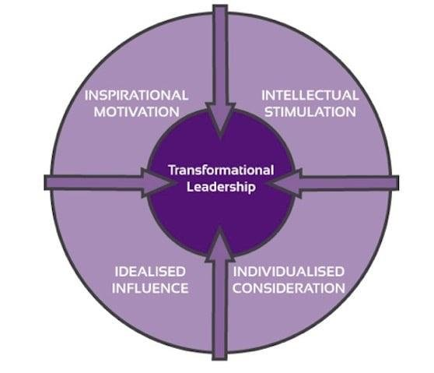
Source:(Transformational Leadership explained with leaders examples, no date)
The components of the theory are,
With intellectual stimulation, stimulating the intellectual capacity of employees is necessary for bringing changes. (YAMMARINO and DUBINSKY, 1994). The transformational leader can avoid factors contributing to dissatisfaction. The development of critical thinking and problem-solving skills ensures a creative solution to organisational problems (Moradi Korejan and Shahbazi, 2016).
Influence, the leader should have the capability to influence his followers. The managers should have a charismatic attitude to influence the behaviour of the workforce (Moradi Korejan and Shahbazi, 2016). Motivation brings changes in the attitude of employees toward work. The behaviour of leaders should have characteristics that can influence the performance of employees.
Inspiration, the ability to inspire the workforce towards work is essential in every organisation. The leader's ability to inspire followers is important in the organisational scenario. The decision and feelings of leaders should inspire followers to work. Transformational leaders can influence their workers to the effective achievement of organisational goals. (Mbindyo, O’connor and Nandedkar, 2021). The strategies adopted by transformational leaders might become role models for the employees (Siangchokyoo, Klinger and Campion, 2020). Steve Jobs in Apple Inc. is the greatest example of a transformational leader with the ability to inspire his workers. The worker's productivity and efficiency were improved with idealised influence(Delaney and Spoelstra, 2015).
Individual consideration, the ability to communicate to the employees and an empathetic attitude are necessary to capture the minds of customers (Mbindyo, O’connor and Nandedkar, 2021). A better relationship with employees creates open line communication. The consideration given to employees may spark the mind of employees. The consideration given by transformational leaders can influence the performance of employees (Price and Weiss, 2013).
Blake and Mouton’s Managerial Grid
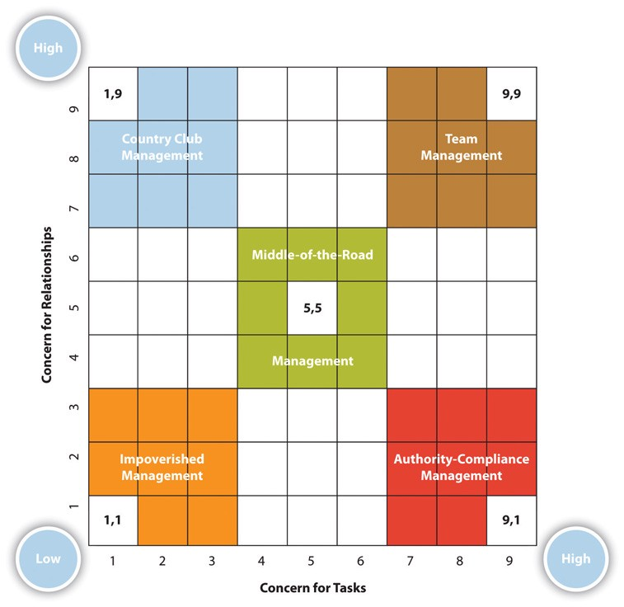
Source:(Blake-Mouton’s Managerial Grid Theory | by SANDHYA PRABHAKARAN | The Shadow | Medium, no date)
Country club management is a leader in which the manager is more focused on and disposed toward the social needs of his group's members than the task(Price and Weiss, 2013).
Authority-compliance management is a management approach where the leader prioritises productivity over the emotions of the followers.
In impoverished leadership, the leader shows no care for either the workers or productivity. Their major goal is to avoid conflict, even if it arises, and let the other members manage everything(Ladkin and Patrick, 2022). Because of their responsibilities and pressure, workers well under a leader become disorganised.
Middle of the road, with relation to both the workforce and productivity, the leader is not overly ambitious. Such leaders strike an equilibrium between the demands of the workforce and organisational goals(Cho, Yi and Choi, 2018). However, because such a leader cannot meet everyone's requirements, confrontations frequently occur.
Team management is a kind of management in which the leader places a high value on both the needs of the workforce and production. This is a great management style that fosters employee satisfaction and high production as needed by the business(Koc, Kiliclar and Yazicioglu, 2013).
Significance of the Theory
In the case of Intellectsoft, leaders should have the capability to influence the workforce by way of transformational leadership. The leadership development plans have a long-term perspective. If they can influence their followers then innovations can be introduced with the help of collaborative operations(Kjellström, Stålne and Törnblom, 2020). The intellectual stimulation brings problem-solving skills to the mind of employees. As the company is facing intense competition, innovative ideas are required to sustain itself in the competitive world. The adoption of transformational leadership practices brings out changes in the organisation. The commitment level of employees can also be improved with the help of these practices. The example of the Lego Group can be considered in this case, the company was in heavy loss during 2010-2013. When the transformational leader took charge of the company their profit went up with the adoption of innovative practices. Another important problem that the company may face in future will be employee turnover. The turnover ratio in its companies is comparatively higher than in any other sector. This may be due to job stress and the working environment. The Blake and Mouton model suggest that leaders should be task-oriented and employee-oriented(Todăriţă, 2021). Equal consideration should be given to both aspects. The leaders who provide good consideration to employees can influence them and which will lead to job satisfaction. The concern for task ensures the fair achievement of organisational goals with effective utilisation of the available resources.
RECOMMENDATIONS
The Changes should be implemented with due consideration to the feelings of employees. The strategies adopted by Intellectsoft should ensure a proper balance between the various internal and external factors. The policies of the company should have equal consideration for the organisation and its workforce. A problem-solving and critical thinking attitude should be developed in the organisation to find innovative solutions. Community building activities should be developed to ensure adequate cooperation between the workforce. Participatory leadership styles should be followed to attract the ideas of employees. The adoption of these practices ensures Intellectsoft becomes a leading software company in Europe by maintaining the manpower and attracting customers through innovative solutions.
CONCLUSION
Intellectsoft is a leading company in the UK, long-term plans are necessary to stand ahead of the competitors. Change management welcomes innovation in the company. Alternative ways to solve the problems can be developed with the help of incorporating change. Proper motivation and management practices must ensure committed workers. This will lead to job satisfaction and retention of employees(Lopez-Cabrales and Valle-Cabrera, 2020). Leadership development is necessary for every organisation to bring out transformation(McCauley and Palus, 2021). The active participation of employees may help find innovative solutions to business problems.

REFERENCES
10 Proven Change Management Models (2022) (no date). Available at: https://whatfix.com/blog/10-change-management-models/ (Accessed: 5 September 2022).
Accounting Software Development Basics — Intellectsoft Blog (no date). Available at: https://www.intellectsoft.net/blog/financial-accounting-software-development/ (Accessed: 6 September 2022).
Blake-Mouton’s Managerial Grid Theory | by SANDHYA PRABHAKARAN | The Shadow | Medium (no date). Available at: https://medium.com/the-shadow/blake-moutons-managerial-grid-theory-aa0842e771a (Accessed: 6 September 2022).
Butt, A., Lodhi, R.N. and Shahzad, M.K. (2020) ‘Staff retention: a factor of sustainable competitive advantage in the higher education sector of Pakistan’, Studies in Higher Education, 45(8). Available at: https://doi.org/10.1080/03075079.2019.1711038.
Chernyak-Hai, L. and Rabenu, E. (2018) ‘The New Era Workplace Relationships: Is Social Exchange Theory Still Relevant?’, Industrial and Organizational Psychology. Available at: https://doi.org/10.1017/iop.2018.5.
Cho, K.W., Yi, S.H. and Choi, S.O. (2018) ‘Does Blake and Mouton’s managerial grid work?: the relationship between leadership type and organization performance in South Korea’, International Review of Public Administration, 23(2). Available at: https://doi.org/10.1080/12294659.2018.1471029.
Cropanzano, R. and Mitchell, M.S. (2005) ‘Social exchange theory: An Interdisciplinary review’, Journal of Management. Available at: https://doi.org/10.1177/0149206305279602.
Delaney, H. and Spoelstra, S. (2015) ‘Case study : Steve Jobs as a transformational leader’, Transformational leadership, pp. 81–83.
Errida, A. and Lotfi, B. (2021) ‘The determinants of organizational change management success: Literature review and case study’, International Journal of Engineering Business Management, 13. Available at: https://doi.org/10.1177/18479790211016273.
Gamber, M., Kruft, T. and Kock, A. (2020) ‘Balanced give and take-an empirical study on the survival of corporate incubators’, International Journal of Innovation Management, 24(8). Available at: https://doi.org/10.1142/S1363919620400058.
Henry, L.S. et al. (2017) ‘Application of Kotter’s Theory of Change to Achieve Baby-Friendly Designation’, Nursing for Women’s Health, 21(5). Available at: https://doi.org/10.1016/j.nwh.2017.07.007.
Hunt, R.W. and Wasserman, W.W. (2014) ‘Non-targeted transcription factors motifs are a systemic component of ChIP-seq datasets’, Genome Biology, 15(7). Available at: https://doi.org/10.1186/s13059-014-0412-4.
Intellectsoft Client Reviews | Clutch.co (no date). Available at: https://clutch.co/profile/intellectsoft (Accessed: 6 September 2022).
Intellectsoft LLC - Company Profile Report | IBISWorld (no date). Available at: https://www.ibisworld.com/us/company/intellectsoft-llc/428663/ (Accessed: 6 September 2022).
Isa, S.S. and Liem, A. (2021) ‘Exploring the role of physical prototypes during co-creation activities at LEGO company using case study validation’, CoDesign, 17(3). Available at: https://doi.org/10.1080/15710882.2020.1715443.
John Kotter Model of Change | Kotter’s 8 Step Change Model Template (no date). Available at: https://online.visual-paradigm.com/diagrams/templates/kotters-8-step-change-model/john-kotter-model-of-change/ (Accessed: 5 September 2022).
Kjellström, S., Stålne, K. and Törnblom, O. (2020) ‘Six ways of understanding leadership development: An exploration of increasing complexity’, Leadership, 16(4). Available at: https://doi.org/10.1177/1742715020926731.
Koc, H., Kiliclar, A. and Yazicioglu, I. (2013) ‘The Analyzing Leadership Styles of Turkish Managers in the Scope of the Blake and Mouton’s Managerial Grid’, International Journal of Business and Social Science, 4(11).
Kosters, M. and Van der Heijden, J. (2015) ‘From mechanism to virtue: Evaluating Nudge theory’, Evaluation, 21(3). Available at: https://doi.org/10.1177/1356389015590218.
Ladkin, D. and Patrick, C.B. (2022) ‘Whiteness in leadership theorizing: A critical analysis of race in Bass’ transformational leadership theory’, Leadership, 18(2). Available at: https://doi.org/10.1177/17427150211066442.
Laig, R.B.D. and Abocejo, F.T. (2021) ‘Change Management Process in a Mining Company: Kotter’s 8-Step Change Model’, Journal of Management, Economics, and Industrial Organization [Preprint]. Available at: https://doi.org/10.31039/jomeino.2021.5.3.3.
Lopez-Cabrales, A. and Valle-Cabrera, R. (2020) ‘Sustainable HRM strategies and employment relationships as drivers of the triple bottom line’, Human Resource Management Review, 30(3). Available at: https://doi.org/10.1016/j.hrmr.2019.100689.
Mbindyo, M., O’connor, R.J. and Nandedkar, A. (2021) ‘Linking transformational leadership theory to the practice of academic advising-a conceptual paper’, Journal of Higher Education Theory and Practice, 21(12). Available at: https://doi.org/10.33423/jhetp.v21i12.4710.
McCauley, C.D. and Palus, C.J. (2021) ‘Developing the theory and practice of leadership development: A relational view’, Leadership Quarterly, 32(5). Available at: https://doi.org/10.1016/j.leaqua.2020.101456.
Moradi Korejan, M. and Shahbazi, H. (2016) ‘An analysis of the transformational leadership theory’, Journal of Fundamental and Applied Sciences, 8(3). Available at: https://doi.org/10.4314/jfas.v8i3s.192.
Price, M.S. and Weiss, M.R. (2013) ‘Relationships among coach leadership, peer leadership, and adolescent athletes’ psychosocial and team outcomes: A test of transformational leadership theory’, Journal of Applied Sport Psychology, 25(2). Available at: https://doi.org/10.1080/10413200.2012.725703.
Purnell, S.M. et al. (2020) ‘Utilizing Change Management Theory to Optimize Resources and Reduce Supply Chain Costs’, The American Surgeon [Preprint]. Available at: https://doi.org/10.1177/0003134820952830.
Shurrab, H. and Zec, M. (2013) ‘The Eight-Step Change Model in Practice: A Case Study on Ericsson’, (September 2014). Available at: https://doi.org/10.13140/2.1.2139.7762.
Siangchokyoo, N., Klinger, R.L. and Campion, E.D. (2020) ‘Follower transformation as the linchpin of transformational leadership theory: A systematic review and future research agenda’, Leadership Quarterly, 31(1). Available at: https://doi.org/10.1016/j.leaqua.2019.101341.
Southall, R.M. (2021) ‘Institutional logics’, in Encyclopedia of Sport Management. Available at: https://doi.org/10.4337/9781800883284.institutional.logics.
Study, C. (1847) ‘How Siemens used nudge to transform pension’.
Szadkowski, A. and Cercone, M. (2016) ‘From Pilot to Policy: Implementation of a Pediatric Rapid Response Team Using Kotter’s Change Theory’, Academic Pediatrics, 16(6). Available at: https://doi.org/10.1016/j.acap.2016.05.038.
Szierbowski-Seibel, K. and Kabst, R. (2018) ‘The impact of HR outsourcing and strategic HR integration on the HR-to-employee ratio: An empirical evaluation of the HR function over the last decade’, International Journal of Manpower, 39(2). Available at: https://doi.org/10.1108/IJM-06-2016-0129.
Todăriţă, E.-T. (2021) ‘Leadership Style Determination according to Robert Blake and Jane Mouton’s Managerial Grid’, International conference KNOWLEDGE-BASED ORGANIZATION, 27(1). Available at: https://doi.org/10.2478/kbo-2021-0037.
Transformational Leadership explained with leaders examples (no date). Available at: https://www.marketing91.com/transformational-leadership/ (Accessed: 6 September 2022).
Tseng, L.M. and Kuo, C.L. (2014) ‘Customers’ attitudes toward insurance frauds: An application of Adams’ equity theory’, International Journal of Social Economics. Available at: https://doi.org/10.1108/IJSE-08-2012-0142.
Wang, H. et al. (2020) ‘Blockchain-based data privacy management with Nudge theory in open banking’, Future Generation Computer Systems, 110. Available at: https://doi.org/10.1016/j.future.2019.09.010.
YAMMARINO, F.J. and DUBINSKY, A.J. (1994) ‘TRANSFORMATIONAL LEADERSHIP THEORY: USING LEVELS OF ANALYSIS TO DETERMINE BOUNDARY CONDITIONS’, Personnel Psychology, 47(4). Available at: https://doi.org/10.1111/j.1744-6570.1994.tb01576.x.
Young, J. (2018) ‘Adams’ Equity Theory - How Fairness Affects Employee Motivation’, Peakon [Preprint].
Zaza, S., Brooks, S. and Armstrong, K. (2020) ‘Developing an IT Career Anchor Fit Construct: An Organizational Equilibrium Theory Approach’, in SIGMIS-CPR 2020 - Proceedings of the 2020 Computers and People Research Conference. Available at: https://doi.org/10.1145/3378539.3393837.
Zinger Employee Engagement Model (no date). Available at: http://www.davidzinger.com/zinger-employee-engagement-model-4011/ (Accessed: 5 September 2022).

