Logistics and Chain Supply Management- M7X01376
Critical Evaluation of Supply Chain Vulnerability and Resilience
Author: - Adrian Devonald
Product / Service of Choice: - Altrad (Mechanical Services)

Critically evaluate the potential risk that exists in your chosen international supply chain which could potentially threaten the supply of this product service

Abstract
The objective within this paper is to evaluate Altrads supply of process piping to various petrochemical, nuclear and alike sites around the world and the contribution of internal and external factors in which play a massive part into how the outcome is achieved. Predominantly for this paper, relate my research and findings to the mechanical fabrication facility in Pembroke, into which fabricate process piping for clients all over the world. I plan to observe the potential risks within the company and examine factors from third party suppliers/ consumers, locally and internationally which could present Altrad with potential downfalls when manufacturing required goods.
Introduction-Altrad Group Today
Altrad are a leading group in the delivery of industrial services to a number of oil and gas, power generation, process, environment and construction sectors, renewable sites on and offshore. Our multidisciplinary services range from engineering and technical services to maintenance, access solutions and specialised services for industry leaders. The Group, headquartered in France, employs around 42,000 people and owns established international brands including Cape, Hertel and Prezioso Linjebygg. (Altrad.com, 2018)

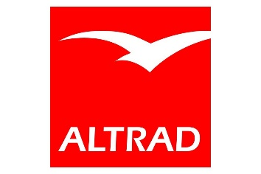
(Altrad.com, 2018)

Within the Pembroke’s division, the main objective is to produce and supply several the world’s largest oil and gas companies with a professional, efficient and reliable service throughout. The aim is to achieve customer satisfaction to the highest nature.
I plan to explore and evaluate factors within Altrads manufacturing supply chain (internal and external) which could have an impact on how items are manufactured from concept to final site installation.
Throughout the engineering manufacturing process, there are many factors in which need to be addressed when supplying products to clients. From internal matters which are distributed in-house, to having to rely on third parties, external factors in which provide a service to support achieving the end goal, providing a client with an efficient, reliable product or service to achieve customer satisfaction.
Supply Chain-Mechanical Engineering
The mechanical engineering sector can be a very competitive industry, so standing out from other competitors is key. Locally, Altrad have three major competitors: - Jenkins and Davies, Ledwoods and Rhyal, all mechanical fabrication companies based in Pembrokeshire. They are constantly tendering against each other for projects and alike on all local refinery. Altrad have a flexible product platform which may increase the client’s decision to use the facility in Pembroke.
As well as being competitive commercially, supplying a quality service and product for clients is key to obtain maximum capacity within the organisation. Making sure the company manufactures and produce product the best of the ability is key throughout. There are many factors within the organisation which could affect the supply to customers, as well as external factors that need to be examined to maintain quality of production.
Companies are increasingly expected to act responsibly throughout their supply chains ([69] Walker and Brammer, 2009; [31] Klassen and Vereecke, 2012), and failure to do so can have significant consequences for their reputation and financial performance ([50] Phillips and Caldwell, 2005). (Roehrich, Grosvold and Hoejmose, 2013)
Internal Factors-Potential Risks
There are many factors to address in which could be present internally when manufacturing items for clients which could result in issues/delays in producing goods in the most effective and sufficient ways. From commercial issues, to production issues.
Due to the nature of our work at the Pembroke facility, we have to first of all be accredited to fabricate pressure piping to the American ASME B31.3. As per our yearly audits from the TWI, this allows clients to have confidence in our ability to produce the required goods to the industry standard. Failure to obtain this accreditation would restrict what projects Altrad could bid for, resulting in less fabrication at the Pembroke facility.
ASME V, B31.3.
B31.3 is a construction code for the manufacturing and testing of new pipework. It has been defining piping safety since 1922. ASME B31.3 contains requirements for piping typically found in petroleum refineries; chemical, pharmaceutical, textile, paper, semiconductor, and cryogenic plants; and related processing plants and terminals. It covers materials and components, design, fabrication, assembly, erection, examination, inspection, and testing of piping. (Asme.org, 2018)
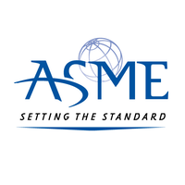
(Asme.org, 2018)
As per the detail below, there are many factors which play a part into how a company can review and control a sufficient supply chain.
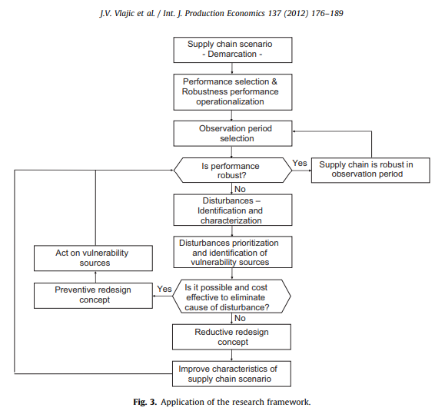
(Vlajic, van der Vorst and Haijema, 2012)

Altrad must evaluate each stage which could include commercial issues in which may arise, right through to the labour required in the workshop to carry out the given task. For example, due to the nature of the contracting environment, if workers are not classed as a “regular” within their organisation, then additional labour is employed on a temporary basis if the work load extends past the normal day to day running of the facility. Work pools are not readily available due to other projects ongoing around the country and consuming a lot of the man power required, so would need to be addressed at the planning stage, making sure the right labour/trades are available to achieve the required outcome specified by the client.
Refineries around the United Kingdom are in regular contact to make each other aware of scheduled shutdowns, making sure each organisations do not overlap, preventing tradesmen not to be all consumed on one site, when other projects are available. They schedule shutdowns, so they do not overlap, which allows the required work forces are available at the required times.
The UK Mechanical Engineering industry (UKME) employs some 210,000 people, 6.7% of the total employees in the EU Mechanical Engineering Industry (EUME). “Although overall employment is declining, there is still a need for the sector to recruit – particularly managers, skilled craftspeople and operatives. A lack of technical and practical engineering skills is the major cause of skill-related problems. (Industryforum.co.uk, 2018)
As above, the employment within the engineering sector is on the decline, therefore good reliable tradesmen to carry out the given tasks are few and far between. Altrad have a pool of tradesmen in which they employ on a regular basis due to the productivity and quality of the workmanship. Due to the decline of reliable, quality tradespersons available in the engineering sector could have an impact within Altrads organisation and the supply of services in which the provide.

External Factors-Potential Risks
There are many external factors that must be examined when it come to the fabrication and supply to clients. When Altrad required services or alike form third party companies they are committed to seeking suppliers and contractors who add value to the company and to the customers we serve. We are committed and focused on developing a long term, mutually beneficial relationship into which will benefit clients worldwide.
Client Information/Factors
When Altrad are initially awarded a contract, it is here in which drawings issued for construction are received from the client, where they can be reviewed, and comments highlighted regarding any underlying matters that may arise during fabrication. During the review, and a material take off would be produced into which we source to accommodate the requirements as per the specified specification. The piping specification would be stated on the drawings in which are issued for construction. Here the client’s designers would use their piping specifications to highlight the requirements into which materials, components are to be used for the piping systems standard. Below, I have taken Valero as an example of a client in which we produce pipework on a continuous basis.
Client: -Valero, Pembroke Refinery
Prior to Altrad taking over Cape (Redhall Engineering), we have been working on Valero for many of years, building up a good sustainable relationship throughout. We have held the off-plot maintenance contract on there for the past 10 years as well as being awarded numerous project works throughout the refinery. An integrity contract for the general maintenance of all mechanical works on Valero was previously held by Mainport Engineering, but in 2016 the company went into liquidation. Here, Valero had to react fast and required a company to supply labour and fabricate required spools for all ongoing maintenance works. Due to several factors, Altrad where awarded the remaining contract to assist in all integrity works. I believe this was down to the overall relationship in which Altrad hold with Valero, and the workman ship on and off site.
Valero Integrity
The integrity maintenance contract involves being on direct standby to Valero, carrying out any immediate repairs to any issues in which may arise on site at any time. We must react quick and supply pipework similar to a “just in time” scenario. In manufacturing, speed to market and costs of production can make or break a company. Just in time (JIT) manufacturing is a workflow methodology aimed at reducing flow times within production systems, as well as response times from suppliers and to customers. (LeanKit, 2018). We will not know the extent of the issues off site, but will be instructed by the client to fabricate, paint and deliver pipework to site by a required date. We must react quick to achieve the given task and to meet the set deadline as all maintenance works are carried out on live running plan, so are priority when issued to the workshop. If delays in fabrication occur, this will have a knock-on effect with other trades, operations etc as all site activities must be planned accordingly to suit running plant. If we don’t achieve the given deadline, as with all other works, there would be a penalty charge which would be deducted from the original agreed price for non-fulfilment of agreed items on dates stated by the client. Not only this, the reputation of the Altrad offsite fabrication shop and personnel on site would be damaged, along with the confidence from the client to issue future works to Altrad.

Valero Projects
With regards to Valero projects, this is organized and managed in a different way. We have fabricated many projects on Valero in the past which tend to be new pipelines which are installed to update refinery process systems. This is predominately carried out aside from the running plant.
Drawings are issued by Valero weeks in advance for review/comment by Altrad. Here all materials listed and ordered as per client’s specification. Below are two example of information that is supplied to Altrad to make sure all the specify design requirements are adhered to. It is critical at this state all pipe and fittings are ordered are per client’s instruction to prevent any downfalls during the fabrication process.
PJ164 Carbon Steel-Valero RTW Ethanol Project Drawings-Issued for construction
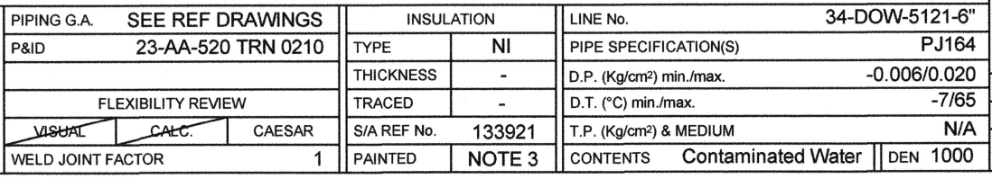

PJ164-Valero Piping Specification
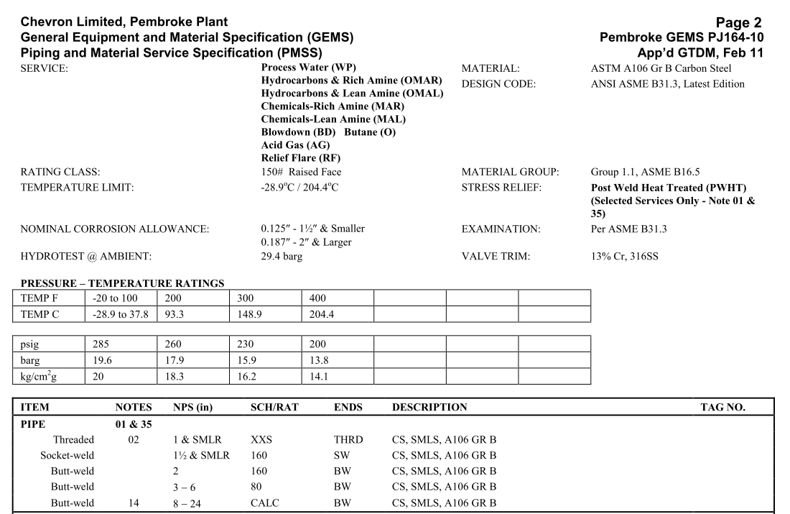

Designers may not always state the above details, I which would be picked up on the review stage, therefore result in correspondence being sent to the client to confirm specific details prior to being ordered and issued to the shop for construction.
Once the materials have been identified, Altrad source the materials from one of their approved suppliers. As an organization Altrad have an approved suppliers list, in which all businesses have been audited by an Altrad representative to make sure they and their product meet Altrads and industry standards throughout.
Approved Material supplier-MRC Global
One of our main suppliers of pipe and fittings in which we use to fabricate all pipework spools come from MRC Global. MRC are one of the divisions main suppliers of pipe and fittings in to which are used to fabricated to the given specifications. They are one of the largest distributors of pipe and valves and alike to the energy and industrial markets. They maintain one of the largest pipe and tubular inventories in North America.

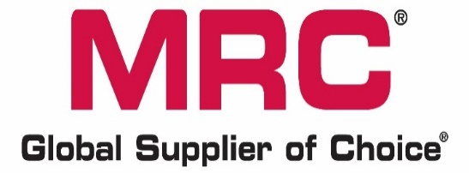
(Mrcglobal.com, 2018)

MRC Global serves the oil and gas industry upstream, midstream and downstream as well as chemical and gas distribution markets.
They are an accredited supply to Altrad after various audits on their facility and procedures. Having built up a positive relationship due to the amount of work we issue to them. The demand for items at short notice is key for the Integrity works on Valero, as mentioned above, the short notice given by Valero where maintenance spools would be required for quick turnaround off site.
Further to the materials being confirmed and ordered accordingly, further third parties will need to be contacted regarding specialist works. Non-destructive Testing as specified by the client would be required, along with any further specialist services, e.g. heat treatment on pipe. Again, this would be specified at tender stage, so the appropriate resources can be arranged. Painting of all spools will need to be planned, again to the clients site speciation
Outsourcing
Outsourcing involves a loss of direct control found in hierarchical relationships within the firm, requiring companies to find alternative mechanisms for asserting control over production processes. (Robinson and Rainbird, 2013).
There are a number of products (mechanical fabrications) in which we supply to customers in which we outsource the work due to the nature of its work. We use a local machine shop in which we have used for a number of years due to the available resources in their workshop. They have been used for several years, which has led to a good, strong relationships between groups, which have an impact on the cost and turnaround of specific products when required. If a Valero work pack
Additional Outsourcing / External Risks
Further to the external factors mentioned above, there are a number of additional factors which need to be examined and assessed to keep supply and productivity at is fullest capacity. I have gone into further detail on each subject below and stated examples of how it can affect productivity.
Transport
There are many ways in which Altrads goods are received and delivered all over the world, from air, sea and land.
Predominately, as all materials are delivered by road, we do receive lead times on when items are to be received. There may be instances where further equipment i.e. cranage is required due to the size/load, but again that is sourced accordingly. Again, additional planning would be required as further companies would need to be involved and booked accordingly to suit the job in hand. Again, Altrad have built up good relationships with the local haulage/craneage companies to which are readily available in short notice to accommodate our needs.
Within Altrad, they have an internal transport fleet of vans, lorry and arctic lorries to try and accommodate all needed.
But due to the location of some branches and the workloads throughout the country, Altrads own fleet are not always available, so we have to outsource to a local company. Altrad have a number of approved transportation companies but tend to use the same one due to the reliability and quality of service provided.
Language
Due to the amount of countries in which Altrad are involved with the transportation of goods, languages barriers may have an effect into the way in which goods are processed and transported. Within the Pembroke facility, we currently have contracts running in the Ascension Islands and Falkland’s, where shipping companies and clients may have issues understanding our needs. There have even been instances where interpreters have been sourced to try and get across each other’s information accordingly regarding critical items.
Weather
Weather factors are something into which we cannot control. There are aspects into which we can control, for example summer seasons, predominantly better weather and longer periods of light in which may help transportation of products. But natural disasters can have a massive effect into the way in which produces are shipped all over the world.
In today's business environment, harsher and more frequent natural and man-made disasters make supply chains more vulnerable. Supply chain disruptions now seem to occur more frequently and with more serious consequences. During and after supply chain disruptions, companies may lose revenue and incur high recovery costs. If supply chain managers were more capable of measuring and managing supply chain vulnerability, they could reduce the number of disruptions and their impact. (Wagner and Neshat, 2010)
With reference to the above, we have had many instances where our pipework in which has been exported to the Ascension islands has been delayed due to weather which has affected shipping by sea and air. Due to the restricted number of flights into the island, if not as scheduled, this would have a massive impact on site install as planned transport onto the island are schedule twice every six weeks. Therefore, the project plan would have a massive effect, and all other parties effected. We have third party inspection companies in which have to wait until all pipe is installed then carry out the required testing as would the painting contractors one all NDT and pressure testing compete. This would mean paying the men stand down money for the time on the island, and work with the client to set a new completion date.
When Iceland’s volcano, Eyjafjallajökull, erupted in April 2010, the cessation of air travel in Europe for nearly seven days caused an estimated cost of US$5 billion globally. Not only were approximately seven million passengers severely affected when they were stranded at airports, but companies also missed important shipments. For example, BMW and Nissan were forced to slow down or stop production (BBC, 2010; Oxford Economics, 2010). (König and Spinler, 2016)
Given the example above is that of massive cost, this can be related back to the nature of Altrads works. We cannot predict natural disasters in which can delay scheduled works, but it’s how the company as a whole react when these disasters hit.
Logistics
As stated, Altrad have their own fleet of vehicles within the company in which we are advise to use where reasonably placatable. Due to our location in South West Wales, the main dept for all vehicles is Middlesbrough which is 325 miles away, we tend to use local companies. We have three approved but mainly use one, D & A Saunders Haulage, as over the years have built up a good relationship with their commercial employees and work force out in the field. This has grown over the years due to the service in which they provide. They are readily available to our needs, local, and are very competitive on price compared to other parties. There are cheaper options available, but we find that their service is much better from that of others. If D & A Saunders have not got the resources available at the time we need transport, we will use other parties but as a last resort due to service observed during previous contracts.
The role of logistics has become increasingly important for companies due to longer and increasingly complex supply chains (Chopra and Meindl, 2009; Christopher, 2011). At the same time, as companies are focussing on their core competencies, logistics is one of the key areas being outsourced to logistics service providers (LSPs) (Lambert et al., 1999; O’Marah and Afghan, 2011). (König and Spinler, 2016)
Not only are our main logistics company efficient and readily available to react to our needs, once items have left out workshop, feedback from clients have detail on how helpful and professional the haulage company had been whilst on site. Feedback like this is welcomed from out clients as will be placed on record when reviewing their record in the yearly audits.

Altrads Supply Chain
All the above factors are key to making sure Altrad have a robust supply chain to meet all client’s needs through the industry. From making sure we have the right accreditation to allow us to fabricate pipework to the industry standard, right through to the from concept to site install, making sure suitably trained and qualified personnel are employed to carry out given tasks.
Failure to have built up such strong relationships with third party companies predominantly would reduce the productivity and quality of service Altrad provide to clients, not only locally in the Pembroke facility, but world-wide throughout the company.
There are sectors internally and externally in which are continuously monitored and reviewed at schedule intervals but overall, achieving a solid frame work within any organisations to control the supply of quality goods is key to be able to respond to all clients needs.

References
Roehrich, J., Grosvold, J. and Hoejmose, S. (2013). Reputational Risk & Responsible Supply Chain Management: Decision Making under Bounded Rationality. Academy of Management Proceedings, 2013(1), p.15308.
Vlajic, J., van der Vorst, J. and Haijema, R. (2012). A framework for designing robust food supply chains. International Journal of Production Economics, 137(1), pp.176-189.
Industryforum.co.uk. (2018). The competitiveness of the European Mechanical Engineering Industry - Industry Forum. [online] Available at: https://www.industryforum.co.uk/resources/articles/the-competitiveness-of-european-mechanical-engineering-industry/ [Accessed 3 Dec. 2018].
LeanKit. (2018). What is Just-In-Time Manufacturing (JIT)? | LeanKit | LeanKit. [online] Available at: https://leankit.com/learn/lean/what-is-just-in-time-manufacturing/ [Accessed 3 Dec. 2018].
Asme.org. (2018). ASME - STANDARDS - Process Piping. [online] Available at: https://www.asme.org/products/codes-standards/b313-2016-process-piping [Accessed 5 Nov. 2018].
Wagner, S. and Neshat, N. (2010). Assessing the vulnerability of supply chains using graph theory. International Journal of Production Economics, 126(1), pp.121-129.
König, A. and Spinler, S. (2016). The effect of logistics outsourcing on the supply chain vulnerability of shippers. The International Journal of Logistics Management, 27(1), pp.122-141.
Mrcglobal.com. (2018). United Kingdom - Pipe, Valve and Fitting Products - MRC Global. [online] Available at: https://www.mrcglobal.com/Europe/uk [Accessed 13 Nov. 2018].
Van Belle, J., Germain, B., Valckenaers, P., Van Brussel, H., Bahtiar, R. and Cattrysse, D. (2011). Intelligent Products in the Supply Chain Are Merging Logistic and Manufacturing Operations. IFAC Proceedings Volumes, 44(1), pp.1596-1601.
Robinson, P. and Rainbird, H. (2013). International Supply Chains and the Labour Process. Competition & Change, 17(1), pp.91-107.

