

UWTSD
Module: Data Centre Virtualization
A research report on Data
Centre Virtualization
By: Marin Zaharidov 1814694
ACUA 6001

Lecturer: Koushik Modak

TABLE OF CONTENT

- Virtualized DATA Centre
- Hypervisor 1
- SAN – infrastructure and security
- Design and benefits
- What is AWS?
- Benefits, DATA Protection and Disaster recovery

Scenario 1 (50%):
UWTSD have decided to virtualise its central IT operation and to build a virtualised Data Centre to
Centralise UWTSD’s servers and services. As an expert you are tasked to produce a proposal of how
the services will be structured. You need to produce a case for whether it is better for the university
to create its own data centre or to use an outsourced solution such as AWS (Amazon Web Services).

What is virtualised Data centre?
A virtual data centre is a collection or pool of cloud computing services designed specifically for enterprise business needs. Processor (CPU), memory (RAM), storage (disc space), and networking are the most essential tools (bandwidth). It's a virtual replica of a physical data centre, complete with servers, storage clusters, and a variety of networking components, both of which are hosted in virtual space by one or more physical data centres.

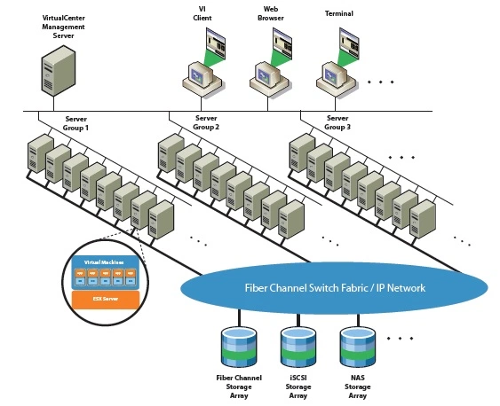[1]

The Infrastructure as a Service (IaaS) cloud computing delivery model produces a virtual data centre. It can provide on-demand computing, storage, networking, and software, all of which can be easily incorporated into an organization's current IT infrastructure.[1]

The virtual data centre solution's premise is to offer businesses the option of increasing capacity or implementing new IT technology without having to buy or instal expensive hardware, which requires more manpower, space, and electricity. The data centre infrastructure as a whole is delivered through the cloud.
One of the most significant advantages of cloud computing is that it allows relatively small businesses to access IT infrastructure in the form of a virtual data centre without having to invest millions of dollars in resources to construct a physical data centre. They just have to pay for what they use, which gives them a lot of versatility and scalability.[1]

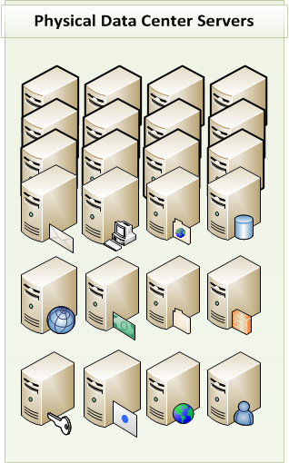[2]

Conceptual Foundations
To grasp what data centre virtualization entails, we must first define virtualization from an IT standpoint. We're going to use a variant of the term "virtuality" because it conveys the idea of virtualization far better than the word's original meaning.
It also aids in comprehending the distinction between hardware and software. Any physical IT equipment is referred to as hardware. A computer tower, monitor, and keyboard, for example, are all hardware. Servers, firewalls, and network equipment are examples of data centre hardware.2 Software is a type of code used to develop a program.[2]

In our scenario we need to offer on UWTSD an option to build a data centre by using own resources or to use from already existing one like AWS.
Main question is why companies and big business need data centre virtualization?
Existing data architecture, particularly when it comes to big data, does not match current business needs. Fortunately, data virtualization has developed to assist in the resolution of complex data centre performance, cost, and access issues.

Data centre virtualization, which was once only used to build and test server environments, now allows IT to deliver diverse, vast volumes of data to the right users at the right time.

Virtualization is no longer a niche IT tool, it's becoming commonplace. By 2022, the server virtualization market is expected to have grown from $1.2 billion in 2016.[3]
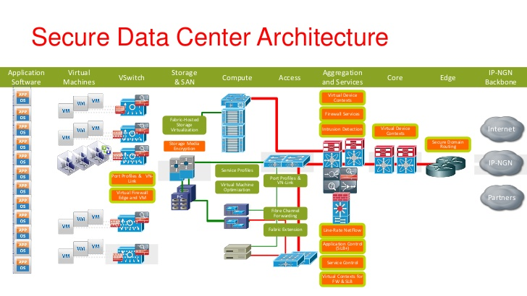[3]

According to the Forrester Wave: Enterprise Data Virtualization survey, 56 percent of respondents were using data virtualization in Q4 2017, with another 20% planning to do so in the next 12 months. Although the figures are impressive, they don't show how virtualization can help companies boost their data centre hardware and software efficiency.[3]

Why business should virtualize their data center?

1. Lower The Operating Costs
Hardware is one of the most costly assets, and IT budgets are spread in several directions.
Applications and utilities are separated from the underlying hardware using data virtualization. Businesses will reduce capital costs by replacing outdated physical servers with virtualized servers.
Data centre virtualization also helps control maintenance and operational costs by extending the life of existing equipment and providing more flexibility within a limited technology budget.

2. Enhance the performance of the application
Application efficiency, agility, and responsiveness can all be improved by virtualizing data centres.
Managing success standards is a difficult task. IT workloads are frequently reallocated as technological and business requirements change, and application efficiency is frequently impacted by factors outside the IT department's control, such as the network of a service provider.
3. Cut down on or eliminate downtime
Downtime is costly. According to a 2017 Rand report, 98 percent of businesses estimate that downtime costs them at least $100,000 per hour.

A business continuity plan to ensure minimal disruptions and a comprehensive disaster recovery strategy to recover from data loss are the two keys to avoiding downtime.

Continuity of Operations
The aim of business continuity is to have as few business interruptions as possible.
One of the most common causes of business disruption is server hardware failure. IT teams can conduct server maintenance and updates without planned downtime by virtualizing data centres.
They can also transfer overburdened virtual machines through several servers to better handle workloads and minimise downtime.
Economic sustainability is enhanced by disaster recovery.

A company can be crippled if data is lost due to fires, floods, employee errors, viruses, or server failures. A disaster recovery plan is designed to restore operations with minimal data loss and downtime in the event of a disaster.
Virtualization facilitates disaster recovery when properly handled. It's easier to back up virtualized data centres than it is to back up disparate hardware servers. You can easily restore your data centre by using modified snapshots of your virtual machines.

Finally, traditional data centres may take a long time to recover, especially if a physical server is destroyed.
Virtualization facilitates disaster recovery when properly handled. It's easier to back up virtualized data centres than it is to back up disparate hardware servers. You can easily restore your data centre by using modified snapshots of your virtual machines.
4. Reduce the amount of heat that accumulates
Servers produce heat. Overheated servers can cause equipment failures and shutdowns. Using less physical hardware generates less heat and improves the security of your files. [3]

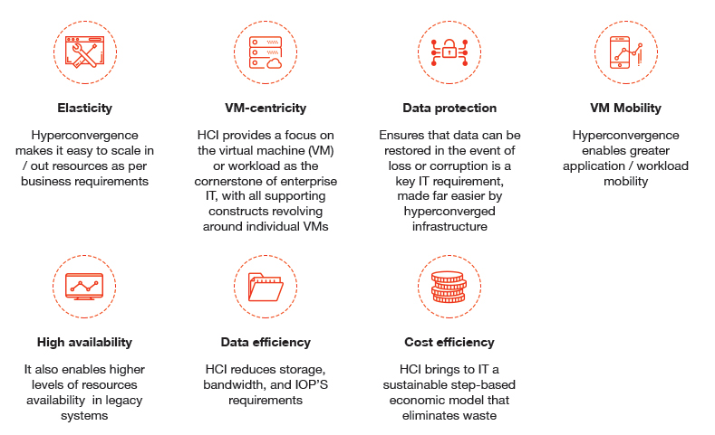[3]

HOW to build the DATA Centre?
First we need to know where to build the Data Centre? In our case we can use university campus on site or renting.

A brand new building helps you to design it specifically for the data center's needs, which means you'll be able to achieve better energy parameters and certification standards. The position should allow for potential expansion and be in a seismically stable region that is not prone to flooding.
It is usually preferable to choose a location that has high-quality electrical and internet connectivity. Ideally, two separate optical fibre tracks should already be in place. When there is only one fibre link open, laying a second one would put a significant strain on your budget and construction schedule. Obtaining land or the rights to use it, for example, is typically a lengthy process when building a fibre link.
Retrofitting normally comes with the added benefit of reduced prices. On the other hand, it imposes constraints imposed by the current structure and its state. The structural strength of the floors, as well as their load-bearing capability, should be tested.[4]
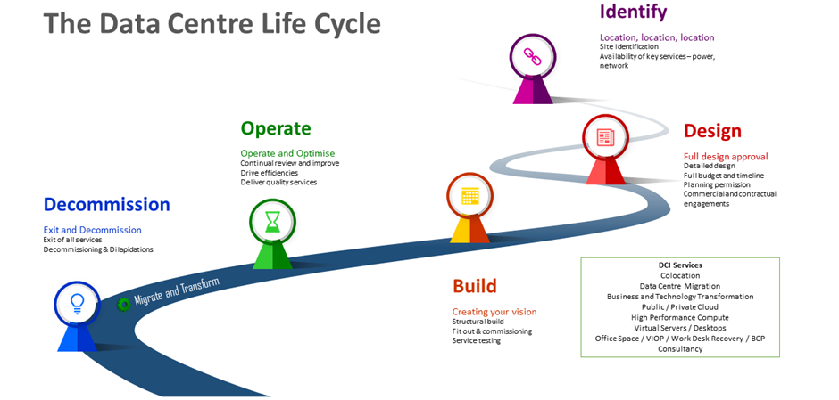[4]

The importance of power cannot be overstated.
That is why data centres are constructed, and why they should preferably be operated by two separate energy sources, each with its own transformers. The energy passes via a substation through an automatic transfer switch (APS) – which is connected to a diesel generator – and into UPS units with their own generators and batteries. Smaller businesses can get by with only one substation, but any computer should be dual-powered via two separate paths. In the meantime, larger data centres that plan to use more than 2 megawatts will opt for specific battery-free power solutions, such as the so-called dynamic or rotary UPS, rather than a UPS with batteries. In one box, you get a transformer, a UPS, and a motor generator. UPS units should always be held in a different location because they require a lower operating temperature. Furthermore, the value of purchasing a high-quality UPS unit should not be overlooked. Some of the less expensive models have short-life batteries that have cost some businesses a lot in maintenance fees.[4]
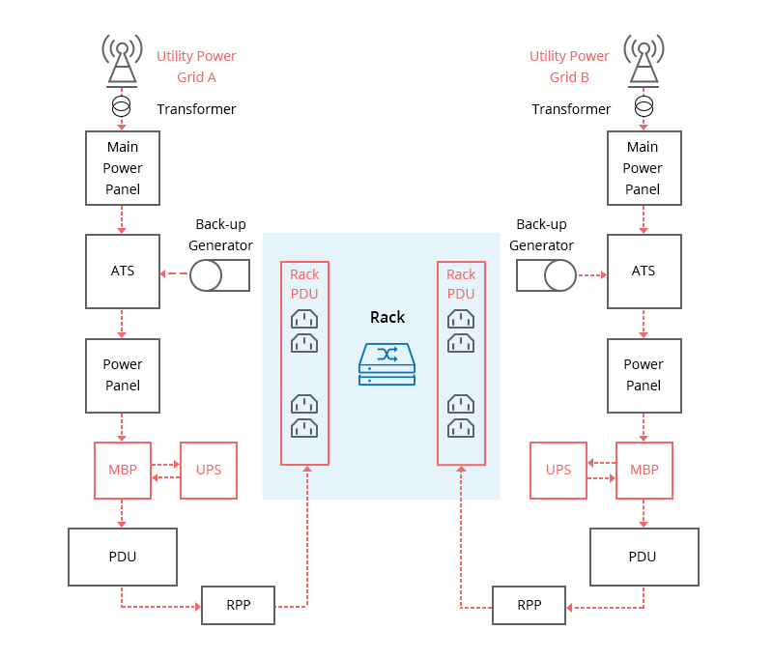[5]

The data center's power system failure can take the form of a system halt, data loss, transformer heating, damage shutdown, or something else. These occurrences have the potential to set off a series of unprecedented incidents, resulting in the data center's complete destruction. So, how does a power supply and distribution system experience a power outage?
- Overestimating capacity could result in unused capacity, implying that the data centre will be used for the duration of its existence to support the equipment's excessive installation and maintenance costs.
- The above-mentioned estimation factor is linked to poor power equipment selection. Many data centres are installing more and more high-density servers to keep up with the increasing market, pushing the power distribution system to its limit.
- Unreasonable power system design and development have their own set of pitfalls that can lead to the emergence of a hidden hazard. If multiple power equipment is connected to a single point in the power line, the excessive load can cause power failure.[5

How Do Data Centers Avoid Power System Failure?
- Understanding the power requirements of IT equipment, cooling systems, lighting, and critical power loads is the first step in evaluating current power capability. The average power consumption is increasing as more high-power devices are adopted.
- After correctly determining the data center's power capacity requirements, the process of equipping the data centre with suitable equipment begins. The right power system would reduce the chances of a power outage. To support redundancy, dual power modules, such as a double PDU, are recommended.
- Physical inspection of power and IT equipment is required on a daily basis to ensure that all systems are in good working order.

It's all about the cold and hot aisles when it comes to cooling.
Cooling is an essential component of every data centre. A double flooring scheme of cold and hot aisles has become a de facto norm. To avoid the combination of hot and cold air, the cold aisles should be roofed over. The server racks must be positioned in such a way that they "inhale" cold air from their front sides and "exhale" hot air from their backs (the so-called front-to-back system).
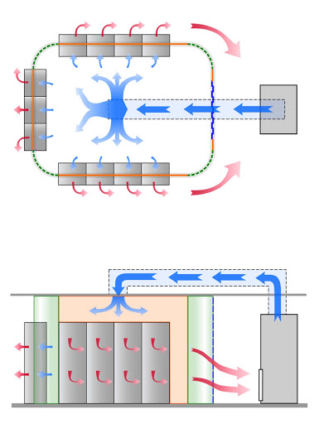[5]
The described double flooring allows cold air to be directed to the proper location while also concealing metallic cables. Optical fibres should most likely be led up through special plastic troughs over the racks. The so-called free cooling system is now the preferred cooling method. It enables data centres to use cold outside air, saving electricity that would otherwise be used to cool the air. This method works best when it's cold outside, but it can save money on cooling even when the temperature difference between inside and outside is just a few degrees.[4]
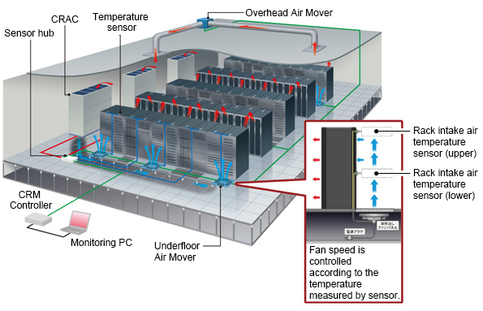[5]
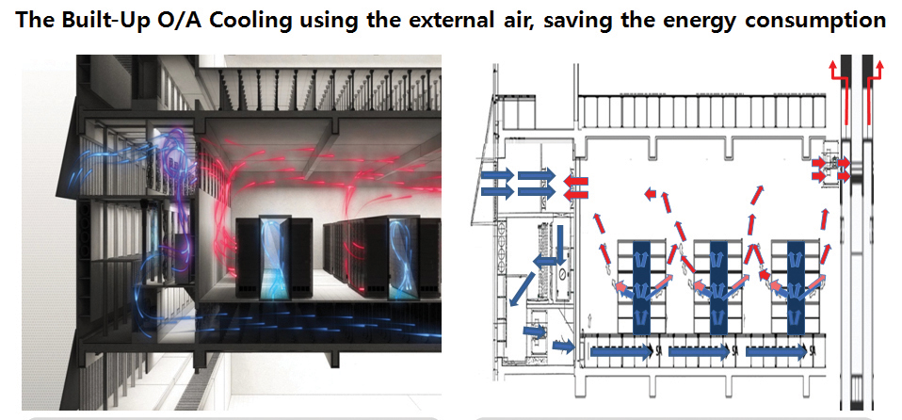[6]
A glycol-based circuit with an outside radiator that removes heat from the data centre can help with this.A smaller business on a tight budget, on the other hand, would have to make do with standard direct expansion (DX) air conditioning. The DX units are less costly to purchase, but they are more expensive in the long run. They're best for reducing the amount of heat in a room. The majority of today's data centres are constructed as so-called high-temperature data centres. In certain extreme situations, the latest computer technology can withstand temperatures as high as 35 degrees Celsius. Even a small rise in the operating temperature will save a significant amount of money in energy costs - for example, by increasing the temperature of their data centres by one degree Celsius, Google saves 4% of its total energy costs, and Intel saves 7% of its total energy costs by doing the same. And, if the conditions are correct – as they are in the Czech Republic – free cooling can be used all year, saving even more money.[5]

The data must also be protected from fire and burning.
Not only should the servers be secure from power outages, but also from fire and unauthorised access. Even the tiniest server rooms should have a fire alarm and electric appliance fire extinguishers. Automatic fire and heat detection systems are often used in medium-sized data centres, and fires are put out using inert gases, such as the ecological FM200, which is safe for both the servers and the atmosphere. There are, of course, less expensive alternatives, such as demineralized water or sodium. Surveillance cameras, coded doors, and security personnel are all needed for physical security. Don't forget to keep an eye on all of the parts. To analyse and avoid unnecessary losses, you can calculate the energy consumption of each rack. It's just as critical to keep an eye on the temperatures and cooling. When devices are required to operate outside of their optimal operating range, their energy consumption usually skyrockets. Since you want to stop this, it's normally better to use programmes and software to keep track of all of these variables. There are several commercially available options, or you can simply code your own.[5]

In the scenario we need to consider that using AWS is an option. So I am going to review what is the possibility and advantages of using AWS.

Public cloud providers make their services appear to be much less expensive than on-premises data centres. Hardware manufacturers advocate for the opposite viewpoint. Furthermore, internal politics within organisations tends to inevitably affect the outcomes of any effort to generate credible calculations.
Clients often struggle to measure the cost savings and new business opportunities that the cloud model can provide. As a result, clients often calculate cloud costs using the same purchasing habits as they do in their data centres, losing out on the cost savings that public cloud resources can provide. Clients, on the other hand, are struggling to calculate the requisite investments to skill up and operationalize cloud in order to fully utilise the technology.

“Cloud services will initially be more costly than operating on-premises data centres,” according to the report. It also demonstrates that, over time, cloud resources can become more cost-effective if companies learn to use and run them more efficiently.”[6]

What is Amazon WEB Services?
AWS (Amazon Web Services) is Amazon's robust cloud computing platform, which includes infrastructure as a service (IaaS), platform as a service (PaaS), and bundled software as a service (SaaS) offerings. AWS services may provide a company with resources including computing capacity, database storage, and content delivery. Amazon Web Services (AWS) was established in 2006 as an extension of Amazon.com's internal infrastructure for handling its online retail operations. AWS was one of the first organisations to provide a pay-as-you-go cloud computing model, which scales to meet users' needs for compute, storage, and throughput. AWS provides a variety of tools and technologies for businesses and software developers that can be found in data centres around the globe. AWS programmes are available to government departments, educational institutions, nonprofits, and private organisations. AWS is divided into different services, each of which can be configured differently depending on the needs of the user. For an AWS service, users should be able to see configuration options and individual server charts.[12]

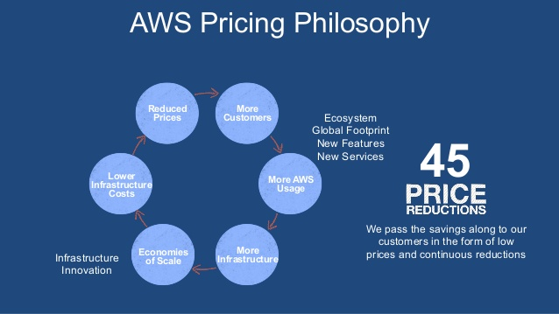
[11]

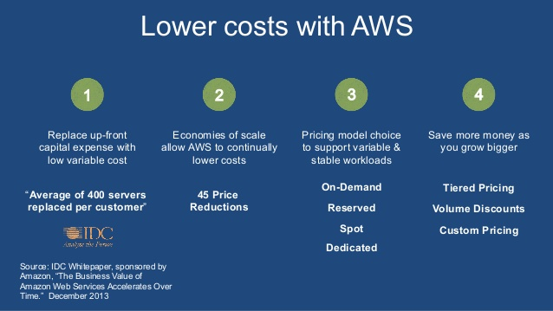[11]

There is some of the services in AWS:
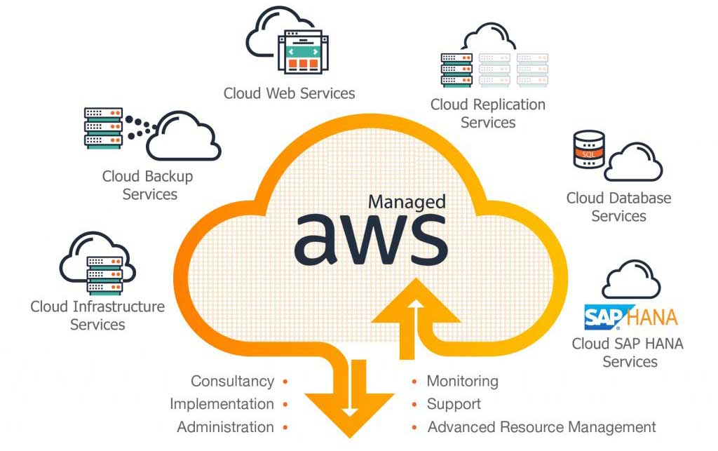[11]
Storage Area network is taking very important part in the data center.
A SAN is made up of hosts, switches, and storage devices that are all linked together. A variety of protocols can be used to connect the components. The original transport protocol of choice was Fibre Channel. Another option is Fibre Channel over Ethernet (FCoE), which allows organisations to move Fibre Channel traffic across existing high-speed Ethernet networks, thereby bringing storage and IP protocols together on a single infrastructure. SAN is divided into two levels: The first level, the storage-plumbing level, connects network nodes and transports device-oriented commands and status. This network must have at least one storage node connected to it. The second level, known as the software level, employs software to provide value-added services to the first tier.
Storage vendors are constantly adding new features to improve scalability, manageability, and efficiency. Flash storage is having an impact on enterprise SAN performance. Hybrid arrays, which combine spinning discs and flash drives, as well as all-flash SANs, are available from vendors. [7]
We define two types of hypervisors: type 1 and type 2. In this article, we'll look at both, specifically what distinguishes them. Before we get there, let's take a look at what hypervisors are and what they can do for you. A hypervisor effectively separates a computer's operating system and applications from the underlying physical hardware. This is how it enables virtualization by allowing the physical host machine to run multiple virtual machines on the same system. The presence of multiple VMs as guests aids in the optimization of computing resources such as memory, network bandwidth, and so on.
The Type 1 hypervisor is also known as a "bare-metal" hypervisor. This means that it runs directly on the physical hardware of the host machine, without the need to first load an underlying Operating System. Because Type 1 hypervisors have direct access to the underlying hardware (and no other Operating Systems or device drivers to contend with), they are thought to be the best performing and most efficient for enterprise computing.[8]
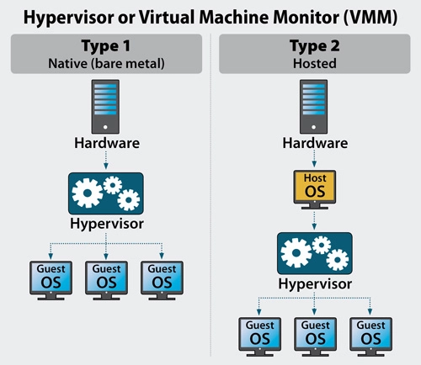
[8]

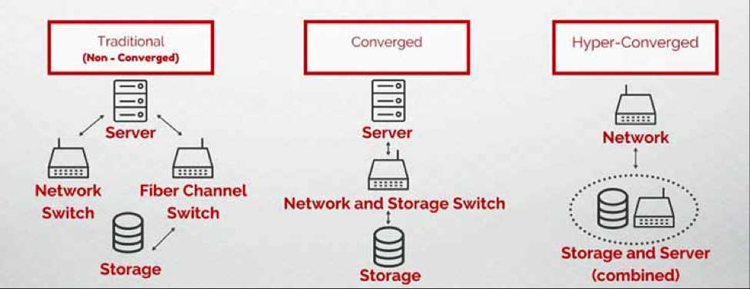

SCENARIO 2 :

The Cloud and the virtualization.
While sharing the resources of a single physical computer, different virtual machines (VMs) can run different operating systems and multiple applications. Furthermore, because each virtual machine is isolated from the other virtualized machines, if one virtual machine crashes, the other virtual machines are unaffected. Virtualization is only possible because of hypervisor software.
In addition to partitioning a single machine into several virtual machines, virtualization solutions can be used to combine multiple physical resources into a single virtual resource. Storage virtualization is a good example of this solution.
Other types of virtualization you may have heard of include the following: network virtualization that divides a network's available bandwidth into independent channels - can be assigned to specific servers or devices, application virtualization - isolates applications from the hardware and operating system, placing them in a container that can be relocated without interfering with other applications system and desktop virtualization - allows a centralised server to remotely deliver and manage individualised desktops.[8]

Generic SAN.
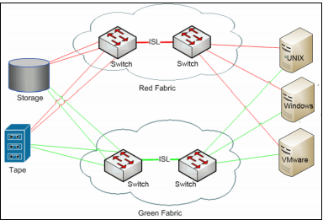[8]
BENEFITS and What happens when physical servers are transformed into virtual machines?
You gain portability — Virtual machines can be moved around. Because the hypervisor separates the operating system from the underlying hardware, a VM can be moved from one machine to another with no impact. There are numerous advantages to doing so, whether you are scaling up, scaling out, or planning for redundancy and disaster recovery.
Scaling your deployment becomes simpler — As discussed in Scalability 101: Up And Out, scaling up can be difficult if your application is unable to fully utilise the additional CPU and memory resources. In a virtualized environment, you can use idle resources to deploy additional clones of a virtual machine on the same physical hardware.
Reduced costs — When scaling out, the abstraction from hardware allows you to deploy servers from any vendor without having to worry about fine-tuning your application to different adapters, configurations, and underlying storage. Consolidation of older, inefficient hardware is possible.
You gain versatility — Furthermore, where appropriate, virtualized servers can have multiple identities. A development environment, for example, can be turned off while a QA and integration environment is activated—all on the same hardware. This can be extremely useful in situations where the environment is short-lived, temporary, or mutually exclusive.
You become ready to scale into off-site virtual machines, also known as the cloud — We've already discussed how virtualization improves efficiency, flexibility, and portability. This can be useful when scaling your environment, but once virtualized and abstracted, there's no reason it has to stay on premise. This is where the Cloud enters the picture.[9]
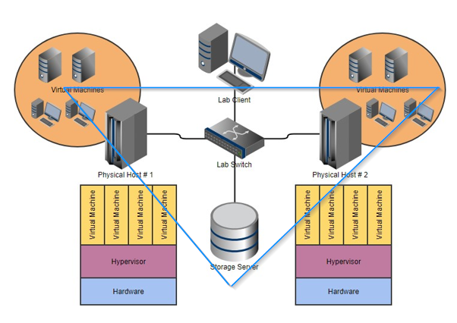[8]

Cloud computing's scalability opens up a world of possibilities.
You can design highly scalable environments that scale from a small initial rollout to thousands or millions of users with proper planning and application architecture.[9]
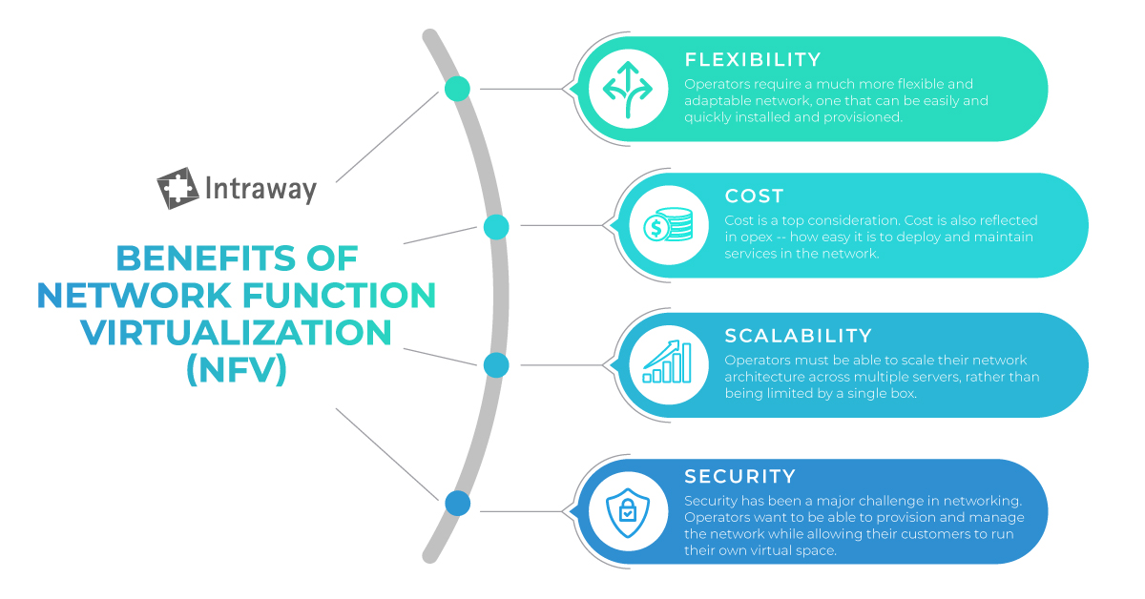[9]
Energy supply and costs.
One of the fundamental requirements of a modern economy is a reliable energy supply. The goal is to provide a cost-effective and dependable energy supply to residential, commercial, and industrial customers. A modern energy system should reduce greenhouse gas emissions while also being appealing to energyintensive companies in international competition through its price structure.
The existing energy storage systems are adequate for the current energy system structure. Strategic oil and gas stockpiling can compensate for temporary bottlenecks in transportation, power plants, and heat supply. Pumpedstorage hydroelectric power stations, in conjunction with flexible power plant operation, can respond adequately to fluctuations in electricity consumption. As a result, energy storage can be classified as a significant but not urgent issue. Nonetheless, research and development are already required to prepare for the time when large-scale energy storage is required.[10]

SECURITY

Security is always a top priority for network administrators and users. Even for specialised networked infrastructures, such as a storage area network (SAN), special precautions must be taken to ensure that information is not corrupted, either accidentally or intentionally, or falls into the wrong hands.
Keep in mind that the most likely attack vector in a SAN is through the hosts that are linked to it. There are thousands of security concerns specific to hosts, applications, and operating systems that are beyond the scope of this chapter but should be addressed as your system and server administrators properly configure their owned devices.
Storage architects and administrators must understand that in a SAN environment, which frequently includes a mix of different operating systems and vendor storage devices, a mix of technologies is required. This combination ensures that the SAN is safe from unauthorised system and user access, whether accidental or intentional.[8]
SECURITY Principles
Authentication and authorization techniques can be used to control access:

- Verification The secure system must challenge the user (typically with a password) in order to identify this user.

- Authentication After identifying a user, the system knows what this user is permitted to access and what they are not permitted to access.

An audit trail must be kept for auditing and troubleshooting purposes, particularly when creating a root cause analysis (RCA) after an incident occurs. Logs should be inspected and archived on a regular basis.
Data safety
Whether we're talking about data at rest or data in flight, data security is comprised of data confidentiality and integrity:
- The confidentiality of data The system must ensure that unauthorised people cannot access the information, that it remains confidential, and that it is only accessible to authorised personnel. Data encryption is commonly used to maintain confidentiality.
- The integrity of data The system must ensure that the data is stored or processed within its boundaries without being altered or tampered with in any way.

DATA Protection Principles
The major principles of data safety are to protect and make data available in all circumstances. The term data protection refers to both operational data backup and business continuity/disaster recovery (BCDR). Data security strategies are evolving in two directions: data availability and data management.
Data security strategies are evolving in two directions: data availability and data management.
Data availability ensures that users have access to the information they require to conduct business, even if the data is damaged or lost.
In data protection, two key areas of data management are used: data lifecycle management and information lifecycle management. The process of automating the movement of critical data to online and offline storage is known as data lifecycle management. Information lifecycle management (ILM) is a comprehensive strategy for valuing, collating, and safeguarding information assets against application and user errors.
Malware and virus attacks, machine failure, and facility outages and disruptions are all possibilities.
Data management has recently evolved to include the discovery of methods to extract business value from otherwise dormant copies of data for reporting, test/dev enablement, analytics, and other purposes.
Data portability – the ability to move data between different application programmes, computing environments, or cloud services – introduces a new set of challenges and solutions for data protection. On the one hand, cloud computing enables customers to migrate data and applications between or among cloud service providers. It does, however, necessitate safeguards against data duplication.
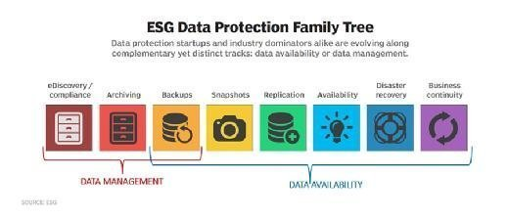

The integration of disaster recovery and backup
Snapshots and replication have made it possible to recover from a disaster much more quickly than in the past. When a server fails, data from a backup array is used instead of primary storage – but only if an organisation takes precautions to prevent the backup from being modified.
These steps entail using a snapshot of the data from the backup array to create a differencing disc right away. The backup array's original data is then used for read operations, while write operations are directed to the differencing disc. The original backup data is not affected by this method.[14]
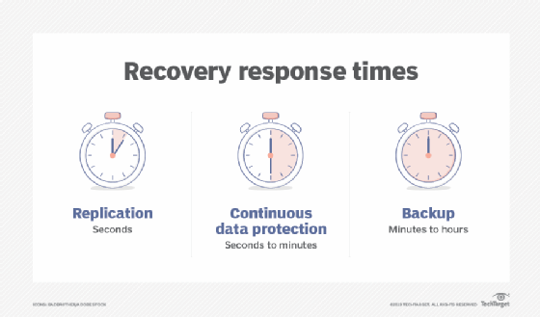

Failure of the media. The goal is to keep data accessible even if a storage device fails. One approach is synchronous mirroring, which writes data to both a local disc and a remote site at the same time. The write is not considered complete until the remote site sends a confirmation, ensuring that the two sites are always identical. Mirroring necessitates a total capacity overhead of one hundred percent. Erasure coding is a popular alternative to advanced RAID in scale-out storage environments. Erasure coding, like RAID, employs parity-based data protection systems, writing both data and parity across a cluster of storage nodes.[14]

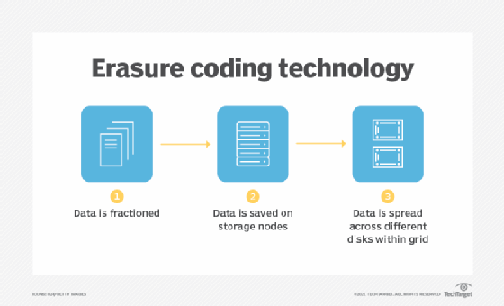
Corruption of data. Snapshots can be used to restore data that has been corrupted or accidentally deleted. Most storage systems today can track hundreds of snapshots without affecting performance significantly.
Storage systems that use snapshots can collaborate with key applications like Oracle and Microsoft SQL Server to capture a clean copy of data while the snapshot is taking place.
Failure of the storage system. Data centres rely on replication technology built on snapshots to protect against multiple drive failures or other major events.
Only changed blocks of data are copied from the primary storage system to an off-site secondary storage system with snapshot replication.
Complete data centre failure. A comprehensive disaster recovery plan is required to protect against the loss of a data centre. There are several options, as with the other failure scenarios. One option is snapshot replication, in which data is replicated to a secondary site. The cost of running a secondary site, on the other hand, can be prohibitively expensive.[14]
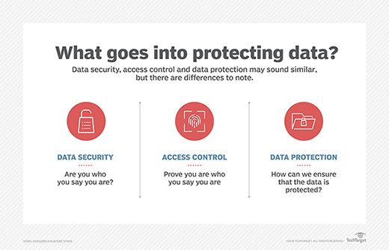

Data protection and privacy laws and regulations differ from country to country, and even from state to state – and new ones are constantly being enacted. China's data privacy law became effective on June 1, 2017. The General Data Protection Regulation (GDPR) of the European Union went into effect in 2018.[14]
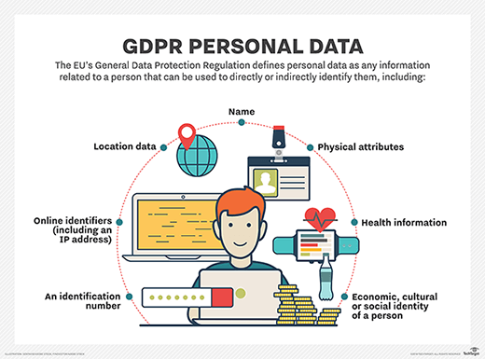[14]

Benefits of AWS will helps to make the right choice:
AWS Customer Benefits and Usage:
- Pay as you go
- Reduce the time to market
- Server launching speed
- Service integration agility
- Storage solutions that are simple and inexpensive
- Application development agility
- Services that are completely managed
[12]
When you make a long-term commitment to AWS, you will notice that every improvement or new feature you want to add to your application, website, or blog becomes easier to implement as AWS grows and provides you with better tools.
Also, keep in mind that you will be charged based on usage, so the more you use, the more they will likely charge you. As a result, you must always keep AWS service costs (hourly rate) in mind.
Many organisations are migrating to the cloud because it simplifies IT resource management, increases availability and scalability, improves development agility, and lowers costs.[13]
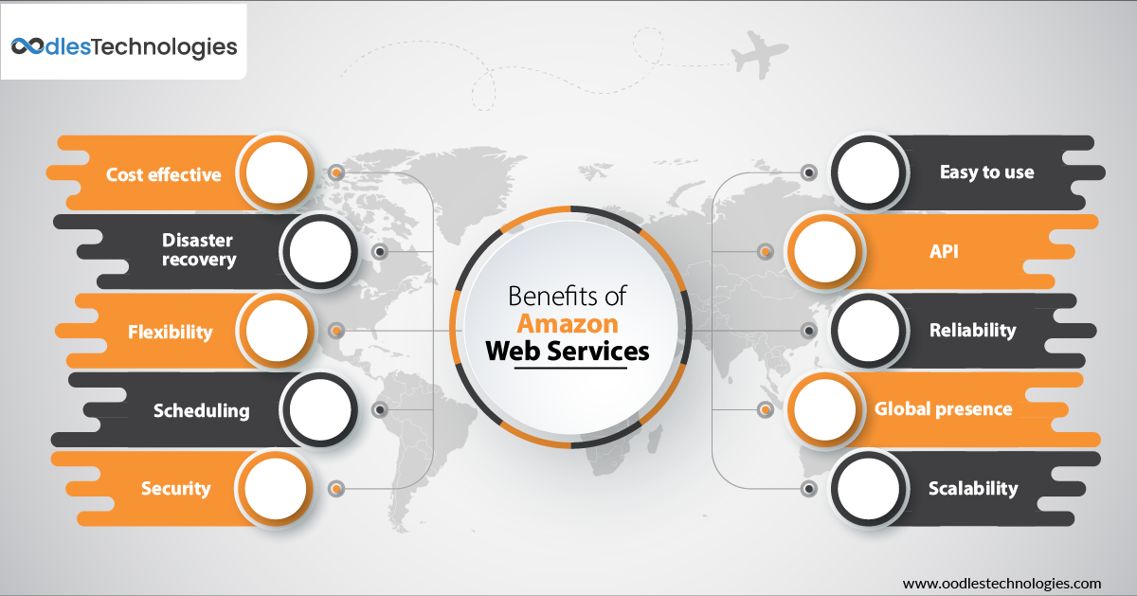[13]

CONCLUSION

In my research I suggest that using AWS is better choice if the company main goal is to safe money.
In this days Cloud storage is typically more dependable, scalable, and secure than on-premises storage systems. AWS provides a comprehensive set of cloud storage services to meet application and archival compliance requirements. This whitepaper will help you understand the various storage services and features available in the AWS Cloud because these cloud storage services' usage patterns, performance, durability and availability, scalability and elasticity, security, interface, and cost models are outlined and described.
By incorporating the AWS Framework into your architecture, you will be able to create more stable and efficient systems, allowing you to focus on your functional requirements.[13]

References
[1] M. Prague and M. Brno, "How to Build a Company Data Center? Part One - Blog MasterDC.com", Master Internet, 2020. [Online]. Available: https://www.masterdc.com/blog/how-to-build-a-company-data-center-physical-security-guide-tutorial-part-one/. [Accessed: 29- Apr- 2021].
[2] C. Wu and R. Buyya, Cloud data centers and cost modeling. Waltham, MA: Morgan Kaufmann, 2015.
[3] S. Khan and A. Zomaya, Handbook on Data Centers, 1st ed. 2015.
[4] W. Heller, "Why companies need data center virtualization right now", New Horizons Worldwide, 2020. [Online]. Available: https://www.newhorizons.com/article/why-companies-need-data-center-virtualization-right-now. [Accessed: 29- Apr- 2021].
[5] D. Janssen and C. Janssen, "Techopedia: Educating IT Professionals To Make Smarter Decisions", Techopedia.com, 2019. [Online]. Available: https://www.techopedia.com/. [Accessed: 29- Apr- 2021].
[6] C. DeCusatis, Handbook of fiber optic data communication, 3rd ed. 2014.
[7] S. Solutions, "Storage Area Network Market Research Report: Market size, Industry outlook, Market Forecast, Demand Analysis,Market Share, Market Report 2018-2023", Industryarc.com, 2021. [Online]. Available: https://www.industryarc.com/Report/15450/storage-area-network-san-market.html. [Accessed: 11- Apr- 2021].
[8] Ochs, J., 2014. Scalability in cloud computing: using virtualization to save money | ServerCentral Turing Group. [online] ServerCentral Turing Group. Available at: <https://www.servercentral.com/blog/scalability-in-cloud-computing/> [Accessed 3 May 2021].
[9] Tate, J., Beck, P., Ibarra, H., Kumaravel, S. and Miklas, L., 2017. Introduction to Storage Area Networks. 2nd ed. USA: IBM.
[10] M. Howard, "FS Community", Blog, 2020. [Online]. Available: https://community.fs.com/. [Accessed: 29- Apr- 2021].
[11] M. Wittig, A. Wittig and B. Whaley, Amazon Web Services in action. Shelter Island, NY: Manning, 2019.
[12] B. Golden, Amazon web services for dummies, 2nd ed. 2017.
[13] C. Mellor, "Vetted Technology | AWS Solutions Library", Amazon Web Services, Inc., 2021. [Online]. Available: https://aws.amazon.com/solutions/. [Accessed: 29- Apr- 2021].
[14] Crocketi, P., Peterson, S. and Heffner, K., 2021. What is Data Protection and Why is it Important? Definition from WhatIs.com. [online] SearchDataBackup. Available at: <https://searchdatabackup.techtarget.com/definition/data-protection> [Accessed 3 May 2021].

