Morgan Sprint
Josh Davies - 2404886
Jay Hodson - 2404496
Keira Phillips - 2321194
Nia Jenkins – 2519702
Niall Hindmarch - 2316600
Table of Contents
Tables 2
Figures 2
1 Introduction to the Project 3
2 Project organisation 4
2.1 Allocation of roles and tasks 4
3 Overview of completed work 5
3.1 Chassis twist and development 5
3.2 Intake Design by Keira Phillips and Jay Hodson 11
3.2.1 Combined Introduction 11
3.2.2 Keira Phillips 11
3.2.3 Jay Hodson 20
3.3 Vi-Grade Car Simulation (Nia) 22
3.3.1 Introduction to the role 22
3.3.2 Research and data collection 22
3.3.3 Simulation Model Development 23
3.3.4 Experiments and Test Scenarios 23
3.3.5 Simulation Results and Limitations 24
3.4 Static Kinematic Suspension Analysis (Nia) 25
3.4.1 Purpose of the Kinematic Analysis 25
3.4.2 Hardpoints and Model Setup 25
3.4.3 Results: Plus 4 and Plus 6 Suspensions 25
3.4.4 Kinematic Outputs Analysed 26
3.4.5 Interpretation and Implications for the Hybrid Model 27
3.4.6 Limitations of the Kinematic Analysis 28
3.4.7 Conclusion 28
4 Progress and achievements against the initial plan 29
4.1 Chassis 29
4.2 Intake System 29
4.2.1 Keira Phillips 29
4.2.2 Jay Hodson 30
4.3 Vi-Grade and Kinematic Simulation Analysis 30
5 Review of project outcomes and challenges 32
5.1 Chassis 32
5.2 Intake system 32
5.2.1 Keira Phillips’ Project Review 32
5.2.2 Jay Hodson’s Project Review 32
5.3 Vi-Grade and Kinematic Suspension Analysis 32
6 Bibliography 35
6.1 References 35

Tables
Table 1 - Table of Roles and Tasks 4

Figures
Figure 1 – Graph of Twist Angle 6
Figure 2 – Graph of Section Stiffness 7
Figure 3 – Bracket Concept Design 1 8
Figure 4 – Bracket Concept Design 2 8
Figure 5 - Bracket Concept Design 3 9
Figure 6 - Ram air design 14
Figure 7 - Cold air design 15
Figure 8 - Cold air design (Front view) 15
Figure 9 - Optimal Air Design 16
Figure 10 - 3D Scan of Group Morgan 17
Figure 11 - 3D Scanning process of Group Morgan 18
Figure 12 - 3D Scan of Second Morgan 18
Figure 13 - Llandow Circuit data 2023 20
Figure 14 - Photograph of weighing tyre taken by the author 22
Figure 15: Plus 6 axle image generated by SuspensionGen 25
Figure 16: Plus 4 axle image generated by SuspensionGen 25
Figure 17: combined axle setup of plus 4 and plus 6 showing: -60mm, 0mm, and +60mm jounce positions, taken by the author 25
Figure 18: Graph generated by SuspensionGen using data created by the author 26
Figure 19: Graph generated by SuspensionGen using data created by the author 26
Figure 20: Graph generated by SuspensionGen using data created by the author 27
Figure 21: Graph generated by SuspensionGen using data created by the author 27
Figure 22 - Combined 3D Scans in SolidWorks 29
Figure 23: Screenshot of Excel spreadsheet containing Gantt chart for Vi-Grade simulation 30
Figure 24: Screenshot of Excel spreadsheet containing Gantt chart for static kinematic suspension analysis 30

Introduction to the Project
The aim of our project is to evaluate the current performance of the Morgan Plus 4, and carry out targeted modifications to improve its capability for competitive racing. This involves understanding the category of racing that the vehicle is used for and identifying key systems to focus on, such as the chassis, suspension and the intake system, to ensure the vehicle performs as effectively and reliably when taken onto the track. The long-term goal is to prepare the Morgan for future university-level motorsport events and ensure it is safe, responsive, and reliable without sacrificing one for another, all whilst abiding by the rules and regulations we have been provided to follow.
This report brings together the findings from all members of the project team. Each member was responsible for a specific subsystem or area of analysis, allowing the group to assess the vehicle comprehensively and implement improvements based on both practical work and engineering evaluation. Together, these contributions form a complete overview of the modifications carried out and the progress made toward developing a competitive racing vehicle.

Project organisation

Allocation of roles and tasks
Table 1 - Table of Roles and Tasks
Group Member | Role | Task Description
Joshua Davies | Chassis Investigation. | To investigate, research and improve the current chassis system.
Niall Hindmarch
Jay Hodson | Air-Box Investigation. | To investigate and improve the current air box system.
Keira Phillips | Air-Box Investigation. | To investigate and improve the current air box system.
Nia Jenkins | VI Grade Development and Static Kinematic Suspension Analysis. | To simulate and analyse the current vehicle models and the Morgan Plus 4 and Plus 6 suspension system.

Overview of completed work

Chassis twist and development

Introduction:
As a leading part to any motorsport vehicles build a strong, durable but overall flexible to different tracks run plans and strategies. It must also be noted that this part of the car is responsible for not only the performance side but also the safety aspect for the driver. By choosing to do this section of the project brings forward more opportunities to learn new skills and improve on past ones. The aim of this investigation is to learn and calculate and improve the current chassis found on the Morgan 4/4 when its under a load to simulate torsion that a racetracks force would do on a race day. The idea of this is to have visual data on where the chassis weak points are and be able to come up with a sensible solution to how this can be improved. To conduct this investigation the usage of the universities Twist rig will be important as a load of our choice can be added via a jack found at the bottom (more on the investigation can be found below). This leads to the role assignment to me, its simply to use the twist rig to show where the weak points of the ladder chassis are, and to present ideas on how this can be eliminated to help the overall performance of the car.

Research:
Doing research for this topic is very limited due to the fact that most information will mainly be collected through the investigation with limited research required until after it has been completed. Once done the research can be done. This research includes the varies different types of solutions to chassis torsion to the costs of buying or producing these parts. Its also good to note down why the chassis does its movement as is it normal for what its needed for. However just because the investigation hasn’t been completed or is underway doesn’t mean we can’t eliminate any ideas or problems. The first thing that would be researched is different methods that can be used to eliminate the vehicles twist. After doing this research two main ideas came to light. A suspension bracket and Anti roll bars. Both are used in the world of motorsport and at a very high level so taking these ideas and putting them with the Morgan should work. It’s important to note the shape of the chassis too, this is a make or break part of the cars design as working around a ladder chassis is very difficult due to its shape. So when both ideas was presented the design and shape. As previously stated anti roll bars was presented as they are a quick and suitable way to eliminate roll when turning and adding stability to the vehicle when in motion specially to the vehicles chassis. The roll of these bars are simple. Counter any roll that is produced when turning and when the vehicle has a load when on the track as well as helps improve overall stability in the cars handling. When speaking to one of the other race team the MCR team they suggested the use of anti roll bars as they too have them on the race cars. By using these the team has different run plans and found out that the car was a lot more stable on faster circuits so by using the information they provided and by taking part in test days running anti roll bars might be the best solution for the Morgan

Chassis Test:
The chassis test itself is very easy to explain and overall easy to work with. The twist rig can be found in the workshop of the university with a morgan body and chassis already on it. It is important to note that the morgan found on the rig does not have an engine or cockpit interior, its simply just the bodywork and the chassis. How the investigation is done is by putting 8 DTI gauges on a magnetic beam around the frame of the car. 2 at the front and rear and 4 in the middle, so there should be 4 on each side. A jack will be placed on top of a scale and placed underneath the jacking point found on the front left side of the car. This is used to add the load to the rig and twist it. To twist the jack a medium socket extension is used. When the scale reads the wanted load for example 100kg the rig would have moved this can be seen by the fact the DTI gauges have now got a reading if they have been zeroed properly at the start of the experiment. Once ready record what each gauge is saying and repeat the process for each gauge and load. In this case the load went up by 100kg each time till the maximum value of 400kg was reached. Of course, all safety features must be followed for example steel toe capped boots and goggles if required.

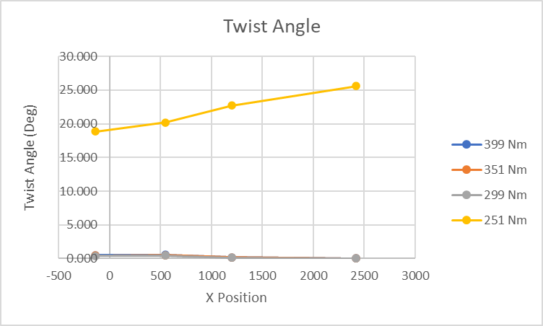
Figure 1 – Graph of Twist Angle

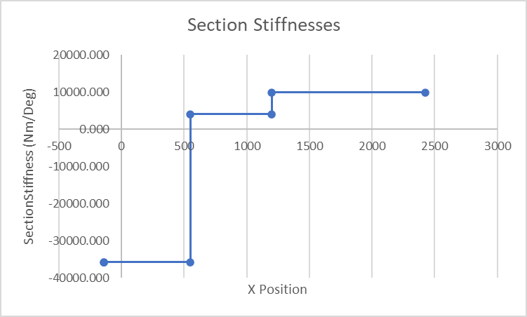
Figure 2 – Graph of Section Stiffness
What the two graphs above show is the twist angle and the sectional stiffness of the Morgan vehicle. What they say is that as the x angle increases the twist angle follows the same correlation. However you can see the front and rear of the vehicle and how each section reacts to a load being added to it. The second graph shows the different sections stiffness of the Morgan. However there are clear issues with this so taking the data from it may not be accurate enough to justify any actions taken. To help solidify any answers that may have been created from this graph is to simply to repeat the investigation again but this time only looking at the sectional stiffness therefore you can generate better answers and overall work out the best ways to deal with the problems provided at the beginning of this group project I should also be noted that the there is a possibility that some graphs may have followed in the same diverse problems as this graph has so it must be taken into consideration when analysing all data that has been gathered and it might be worthwhile reviewing and re assessing the experiment. If it’s found that the data might not be working correctly to answer the questions it might be best to re do the experiment as a whole therefore the data can be regathered reanalysed and compared to make sure that the readings are true before making any massive leaps or changes to any components that have or will be designed.
Ideas on Improvement:
When looking at the data recorded its easy to see that towards the engine mount and behind the dash is where the most of the twist is recorded this is also backed up by the test done last year. So the next steps would be how do we improve it. The main idea that many teams follow is putting brackets at the bottom to produce a higher level of stiffness while also reducing the recorded level of twist. This is due to the ladder frame basically being welded together to add an extra cross section this spreads the load around the frame equally which helps to displace the twist. Another idea that was discussed previously was the addition of anti roll bars. These are used all throughout different levels of motorsport and provide extra versatility to the vehicles suspension. These have the ability to be changed to match different set up and run plans so by having this on the morgan would allow the team to make different strategies for different tracks.
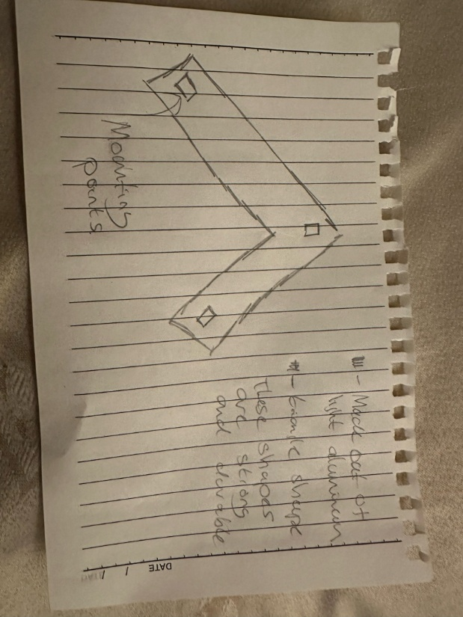
Figure 3 – Bracket Concept Design 1
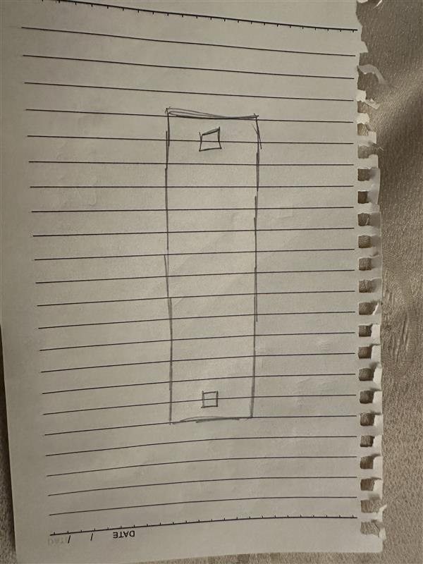
Figure 4 – Bracket Concept Design 2

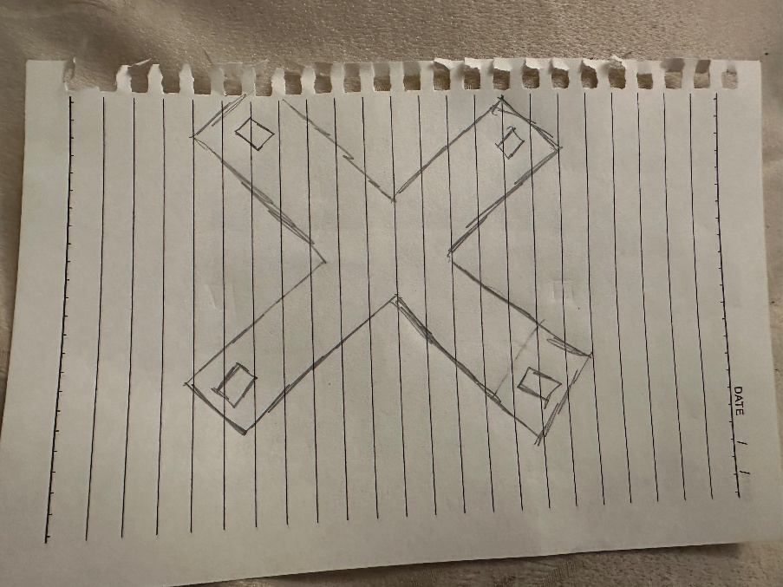
Figure 5 - Bracket Concept Design 3

Above is the first design that was made for the bracket. The idea of it being triangle follows the same idea that buildings use to help make them stronger and durable. The triangle shape equality distributes the stress created by the load and due to the fact that it would be made out of light steel would hep keep the overall weight of this design to a minimum but have a maximum effect on the chassis. With the load no longer being transferred to a singular point now over an area it means the that the Morgans performance would be greatly improved. This design also takes the straightforward design of modern day brackets and changes its shape to match the design of the ladder chassis found underneath the Morgan 4/4 this and its pointed edge means a small amount of aerodynamic stability can also be created this means not only if the Morgan’s overall handling can be improved but also its aerodynamic strength will too. The design also features a 3 plate mounting point to allow it to be seated closer to engine mount and connect to the cross section area found underneath to make sure it’s securely connected to the chassis.
There is also two more designs that can be found one is a straight beam that mounts onto the main frame of the chassis. Although limited in design aspects it does provide that extra level lot load transfer. It’s also good to note that since the design is also a basic shape means that it would be easy to produce in numbers and also keep the costs down due to the idea of bulk production and manufacturing this part. The third design is a more complex which was drawn up from the idea of producing two cross sectional bars and making an x shaped bracket this would be the strongest design to date but due to the complexity of the mainframe of the Morgan

Evaluation and achievements:
Overall, the investigation was interesting to do and the results was intriguing to see. What they show is what was stated last year that the front of the vehicle does in fact have more twist motion that the centre of rear of the vehicle. Most likely due to the fact that most of the vehicles main components being found there. With this data its clear to see how the vehicle twist so what we need to do to limit this becomes apparent. The Idea of a forward bracket would work well. This is due to the fact we can make the part to be placed in the main area which is being affected the most. However there would be a higher cost of production rather than simply being and anti roll bar. This leads on to the second idea of an anti roll bar. Another very simple way to improve stiffness but will also have a cost to it. Not as much as designing a bracket but the cost of purchasing and the wait of arrival could cost the team more than just money but also time too. Overall the investigation was completed on my part, which did allow for data to be collected analysed and presented in both this report and the presentation, however there was still makes made during it. The workshop was still very active when this was being done so the chances of someone walking by and accidentally hitting the DTIs which caused them to move could have happened and made the data inaccurate. Does this mean that investigation can’t be repeated. No this investigation can be done as many times as possible due to the fact it’s always accessible in the University and since the data is easy to gather all of that combined means that yes the investigation is very repeatable. Of course there was things that went both well and wrong for example the data was collected and analysed which helped to write this report. Also personal skills on how to use the test rig was increased which means that when using the rig personal confidence has improved significantly. However there was of course errors too. When transferring the data from paper to excel there was errors which delayed this report in being completed. Those errors were quickly corrected so that the data can be presented better and more efficiently than before. If this was to be done again it would have made the task a lot more easier if the car was on track. Comparing data from actual track information to data that we estimated from the workshop might make the data unreliable and misleading due to the car being stationary it’s not reacting in a natural way like if it was on a track. Therefore the data doesn’t reflect official chassis movement.

Intake Design by Keira Phillips and Jay Hodson

Combined Introduction
This section of the project focuses on the redesign of the intake system for one of the University’s Morgan vehicles, with the aim of improving airflow efficiency, reducing intake air temperature, and overall simplifying the existing system. The original intake configuration routes air from an inlet positioned behind the engine near the windscreen, through a relatively long pathway to the airbox located behind the wheel arch, before going through another pipe behind the wheel to finally reach the turbocharger. This extended and complex route introduces unnecessary flow restrictions, increases heat exposure, and reduces the overall efficiency of the system. (Keira Phillips)
Intake system design is very important for engine performance because the air entering the engine affects how well it can produce power. The temperature, pressure, and flow of the air all play a role in how efficiently the engine runs. In motorsport and high-performance vehicles, even small improvements in airflow can make a noticeable difference in performance and reliability. This project applies key engineering principles such as airflow behaviour and heat transfer in a practical way. As this was a group project, good communication and teamwork were also important to make sure all parts of the design worked together and led to a final, effective solution.(Jay Hodson)
My role within the project was primarily focused on the first few stages of the intake design, including concept generation, aerodynamic considerations, airflow optimisation, and the investigation of potential temperature effects within the system. Additionally, I contributed to the physical understanding of the vehicle’s geometry through 3D scanning, enabling more accurate design positioning and packaging. (Keira Phillips)
The objective of my section is to present the research, design development, and evaluation of a simplified intake system. The proposed design relocates the air intake to the front of the vehicle, above the radiator, allowing for a shorter and more direct airflow path into the turbo. This approach aims to improve engine performance through enhanced airflow, reduced pressure losses, and lower intake temperatures. (Keira Phillips)
My role within the project was mostly focused on the middle and final stages of the resign of the intake system. This includes contributing to the development, simulation, and refinement of the proposed intake design. A key responsibility with this phase was to turn one of our concepts into a fully defined model using SolidWorks software. This allowed for the transformation of the initial design ideas into an accurate 3D model which we would then analyse. Then we would use Computational Fluid Dynamics (CFD) software to analyse the airflow characteristics within both the original and redesigned intake systems were analysed, providing a comparative understanding of performance in terms of airflow behaviour, velocity, and efficiency. (Jay Hodson)
The objective of this section is therefore to present the development process of the intake system, detail the simulation methods used to evaluate performance, and analyse the resulting data to determine whether the redesigned intake provides measurable improvements over the original system. (Jay Hodson)

Keira Phillips

Research
- Current Intake System Issues
The existing intake system design involves a long and indirect airflow path, beginning near the windscreen and routes air through multiple bends before reaching the turbo. This configuration introduces several inefficiencies. Firstly, the extended pipe length increases frictional losses, reducing the velocity and pressure of the air reaching the engine. Secondly, the routing of the intake behind the wheel arch exposes it to turbulent airflow and heat from surrounding components, including the engine bay and braking system.
Additionally, the positioning of the intake’s inlet near the windscreen is not optimal from an aerodynamic perspective, and although this location may provide relatively clean airflow at higher speeds, it does not take full advantage of stagnation pressure available at the front of the vehicle. As a result, the system does not take maximise potential ram-air effects that could help improve engine performance.

- Aerodynamics of Intake Placement
Aerodynamics plays a significant role in the performance of any intake system, so we can use research to predict, analyse and evaluate the characteristics of the airflow over the Morgan.
At the front of the vehicle, particularly above the radiator, behind the front grille, a region of high pressure is created due to airflow stagnation, providing an ideal location for an intake, as it would allow air of increased density and pressure into the system. By relocating the system to this zone of high pressure, we would reap the benefits of a natural ram-air effect, which would increase the mass flow rate of air entering the engine, theoretically improving combustion efficiency and power output.
In contrast, the original positioning of the intake inlet near the windscreen significantly affects the aerodynamic behaviour of the incoming airflow. This is because as airflow travels over the bonnet and approaches the base of the windscreen, it encounters a sudden change in geometry, causing the flow to decelerate and quickly become turbulent at higher speeds, resulting in a region of stagnation and recirculation, where airflow direction becomes inconsistent and local pressures fluctuate. Although a stagnation region can increase static pressure, which we can take advantage of in some circumstances, the airflow in this particular area is typically unsteady and disrupted, reducing the efficiency of air entering the current intake system.
Additionally, the curvature of the windscreen forces airflow upwards, creating separation and vortices near the base of the screen, which results in less direct and less uniform airflow entering the intake, particularly at lower speeds where the airflow energy is reduced. Consequently, the intake system receives air with lower velocity and increased turbulence, leading to reduced mass flow rate and less efficient engine breathing, reinforcing the limitations of the original intake design, and supporting the relocation of the system to the front of the vehicle.
Finally, having an enclosed casing around the filter would help control airflow direction and prevent any drag that may be created by air flow hitting and/or passing over the engine and also preventing any turbulence under the bonnet.

- Airflow & Pressure
Airflow efficiency within intake systems is strongly influenced by pipe length, diameter, and geometry, with longer paths increasing frictional resistance which results in pressure losses that reduce the amount of air reaching the engine at a given time. Additionally, each bend in the system further contributes to these losses by disrupting airflow and creating regions of turbulence.
Our proposed redesign of the intake system significantly shortens the airflow path by positioning the airbox at the front of the Morgan and directly connecting it to the turbocharger. This decision is to reduce both frictional and dynamic losses, allowing us to achieve a higher volumetric flow rate, and promote laminar flow.
Furthermore, the use of a cone filter within an enclosed airbox helps maintain a consistent airflow profile, along with providing a larger surface area in comparison to the current panel filters used, allowing for improved airflow while maintaining filtration efficiency.

- Temperature Effects
Intake air temperature is another key factor in engine performance, and was another source of concern for us within the current system, as the intake air travels through areas exposed to engine, and braking heat, leading to higher air temperatures before reaching the turbo.
The redesigned system prioritises drawing cooler, denser air, which contains more oxygen per unit volume from the front of the vehicle where air temperatures are lower due to direct exposure to ambient flow, which would result in improved combustion efficiency. On the other hand, unfortunately, positioning the airbox above the radiator may introduce some other thermal considerations, however, with appropriate shielding, material selection, and airflow management, the intake can still benefit from significantly cooler air compared to the original routing.
In addition, successfully reducing the intake air temperature not only improves engine performance but it also enhances reliability by reducing the likelihood of heart related issues.

- Materials Overview
When considering what materials to utilise for our new system we must consider what it retires to balance weight, strength, thermal properties, and manufacturability whilst also being mindful of cost.
Firstly, lightweight materials such as aluminium and carbon fibre are commonly used due to their desirable strength-to-weight ratios. Aluminium offers good thermal conductivity which can help dissipate heat, while carbon fibre provides excellent stiffness and, depending on the type of resin used to bind it, good heat resistance, making it a smart choice for performance applications, however it can prove to be costly.
Secondly, polymers in 3D printing offer flexibility in design and rapid prototyping capabilities, all whilst being cost-effective. These filaments allow for complex geometries to be produced with relative ease, making them ideal for iterative design processes. However, their thermal resistance and structural properties must be carefully considered, particularly in high temperature environments around the engine.
Lastly, to route the airbox to the turbocharger, silicone hoses are typically used due to their flexibility and resistance to both heat and pressure, ensuring reliable operation under varying conditions.

Concept Designs
- Concept Design One
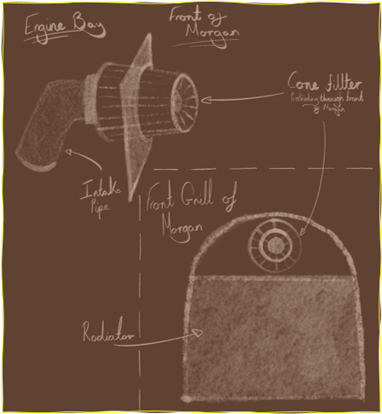
Figure 6 - Ram air design

The Concept Design shown in figure 6, focuses on a direct, front-facing intake positioned above the radiator at the grille area. This design aims to capture the high-pressure airflow entering the front of the vehicle and channel it directly into the intake system. The aerodynamic advantage of this configuration lies in its exposure to relatively undisturbed airflow, allowing for efficient air capture.
However, this design introduces potential challenges related to packaging as the positioning may require careful sealing, further filtration to prevent contaminants from entering the engine, and protection from exposure to debris on the track.

- Concept Design Two
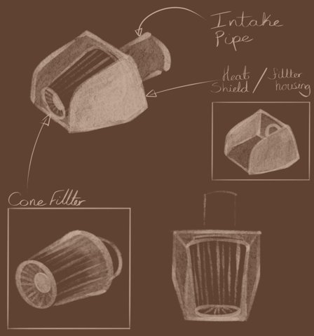
Figure 7 - Cold air design

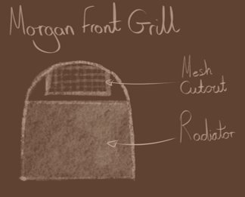
Figure 8 - Cold air design (Front view)

Our second Concept Design displayed above in figure 7, introduces a more enclosed airbox with a defined intake duct, heat shield, and a mesh cutout to protect the opening at the front of the morgan to protect the system from debris, shown in figure 8. This configuration improves thermal management by isolating the intake air from the heat of the engine bay, and incorporates some control over airflow direction, which reduces turbulence and ensures a more consistent air supply throughout the system.

- Concept Design Three
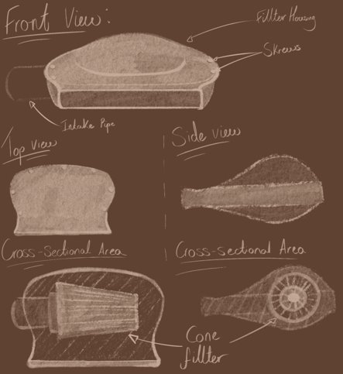
Figure 9 - Optimal Air Design

Lastly, as seen in figure 9, our third Concept Design represents a refined approach, combining aerodynamic efficiency with improved thermal management. The intake is positioned above the radiator utilising the high-pressure zone while maintaining a controlled and enclosed airflow path, as well as featuring a similar mesh cutout to prevent debris entering the housing as shown in figure 8.
The shape of the airbox creates smooth internal geometry which minimises energy losses by reducing both frictional and dynamic losses, whilst also improving pressure recovery. Moreover, the smoothness also promotes more stable airflow characteristics by reducing turbulence and promoting laminar flow which improves airflow efficiency. Additionally, it would provide a shorter route to the turbo which minimises pressure losses and enhances system responsiveness.
Finally, this design also integrates considerations for the manufacturability and installation side of our objectives, making it the most viable solution among the concepts, with the aim of the airbox to be 3D printed.

3D Scanning
Utilising the University’s 3D scanner and Peel.OS software I was able to accurately capture the geometry of the engine bay and surrounding components in our area of focus. This involved combining the scans of two separate Morgan vehicles as the one we are aiming to improve was unable to be taken apart for easier access with the scanner at the time, meaning I had to combine the two scans utilising a second software before it could be converted to a SolidWorks file, with the different scans being visible in figures 10, 11, and 12 below. However, although I was unable to get a complete scan of components attached to the engine due to the lack of space, the scan still allowed for a more precise understanding of spatial constraints and allowed us to ensure that our proposed intake design can be effectively integrated within the available space.
The purpose of 3D scanning was to improve design accuracy by reducing the reliance on manual measurements, which could introduce errors, potentially wasting time, materials, and money. Additionally, it was also to enable better alignment between digital models and physical components, particularly when developing Computer Aided Design (CAD) models for manufacturing.
Overall, the process was valuable, particularly in allowing us to determine the optimal positioning of the airbox and intake duct, ensuring adequate clearance from surrounding components.
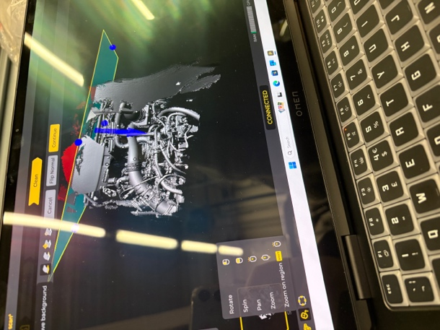
Figure 10 - 3D Scan of Group Morgan

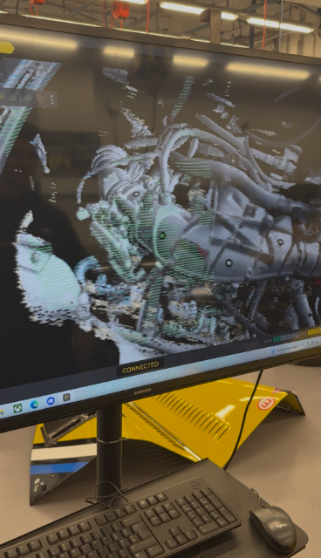
Figure 11 - 3D Scanning process of Group Morgan

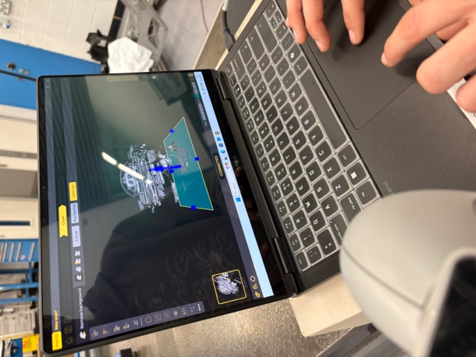
Figure 12 - 3D Scan of Second Morgan

Personal Conclusion
To conclude, the intake redesign focused on improving airflow efficiency, reducing intake air temperature, and simplifying the system layout. Through research and concept development, we were able to identify that relocating the intake to the front of the engine bay provides significant aerodynamic advantages, including increased air pressure and improved airflow consistency. Furthermore, the final design concept offers a more direct airflow path, reducing pressure losses within the system and enhancing engine performance potential. Additionally, the considerations put into thermal management and material selection contribute to the practicality and effectiveness of the design.
Despite time constraints resulting in the lack of live data testing and collection, the proposed design demonstrates a clear level of improvement over the existing system and provides a strong foundation for further development, especially once live, accurate data is able to be gathered and compared.

Jay Hodson

Software Research
SolidWorks (CAD)
SolidWorks is a popular CAD and CAE software program used by engineers worldwide. It enables the replication of various materials behaviour and the creation of highly accurate 3D models. This software was chosen because we have been trained how to use it during our university studies and have easy access to it on university computers. This removed the need for personal installation and avoids potential hardware limitations or technical issues. Additionally it provides a wide range of tools that support the intake design process making it much easier. SolidWorks modelling, assembly capabilities and compatibility with simulation software make it well suited for developing and refining the intake system design.

Ansys R2 2024 (CFD)
Ansys is a simulation software used for analysing and predicting the behaviour of complex physical systems. It is a general purpose finite element analysis (FAE) tool that can simulate various engineering problems (PcHardwarePro, 2024). We used this software to study the important factors of the intake system including fluid dynamics, and heat transfer. Learning and using this software benefits us by showing how the intake reacts when there is an airflow going through it. Starting to learn about this now will benefit us further in our final year at university when we will be taught more about it.

Development

Following on from the design phase of the intake system, the development stage involved evaluating the proposed designs to determine their potential to improve key performance areas. These areas included intake air temperature, mass airflow rate, and airflow behaviour within the intake system. The analysis process began with the use of SolidWorks Computer-Aided Design (CAD) software to create detailed 3D models based on the initial sketches. Once the models were completed, they were imported into Computational Fluid Dynamics (CFD) software to simulate and analyse airflow characteristics within the intake. The results of these simulations provided insight into how each design performed, allowing for an informed comparison and selection of the most effective design for manufacture. Computational Fluid Dynamics (CFD) was used as a cost-effective method to test and compare the intake designs before physical manufacturing. It allowed for a clearer understanding of airflow behaviour within the system and supported the decision-making process when selecting the final design.

Build and Simulation test
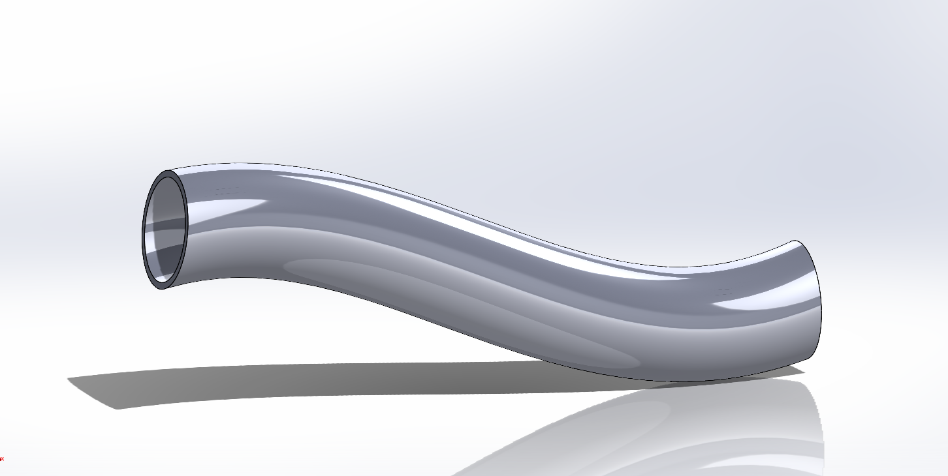
Figure 13 - CAD Design
In the figure above shows the idea of what the intake pipe should look like. This is a simple design as the beginning of the intake pipe and the beginning of the turbo is direct. This design was developed using SolidWorks software allowing for an accurate detailed model. This design features a smooth, continuous curvature with it being the length from the metal plate to the entry to the turbocharger. This design was used because we wanted to minimize airflow resistance and turbulence inside of the intake pipe. Also, its smooth curves are implemented to ensure there is a steady air flow and to prevent unnecessary pressure losses. The outer surface was modelled to ensure there are no leaks when air flows through the pipe and to give it a strengthened structure. However, during the design process there were areas that should have been considered, such as the head of the intake which we should have designed into the model to show how this new intake would fit into the Morgan. The other feature that should have been taken into consideration is a slot for the Mass Air Flow (MAF) sensor. This feature would have shown where the MAF sensor would be positioned which would have been near the end closest to the turbocharger because this would have allowed us to see what the airflow is like before it goes into the turbocharger.

Analysis of Results
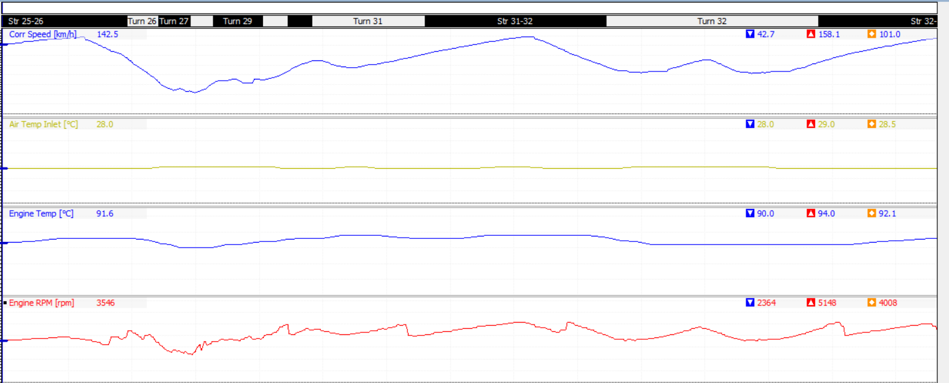
Figure 14 - Llandow Circuit data 2023
The figure above shows data that was collected on circuit in 2023 when the Morgan went to Llandow Circuit for some test laps. At this time the Morgan was running with the manufacturer’s intake system. From the data collected we can see that with the old intake its air temperature has an average of 28.5 degrees Celsius around a single lap of the circuit. Also, from the other channels of data they are showing the speed the Morgan is reaching and by looking at the two channels at peak speed is not affecting the air temperature in the inlet. Also, from the other channels like the engine temperature the average the engine in the Morgan is hitting is 92.1 degrees Celsius. So, overall from the data gathered from a previous test run, our ideal goal was being below for inlet temperature and engine temperature in this set of data.
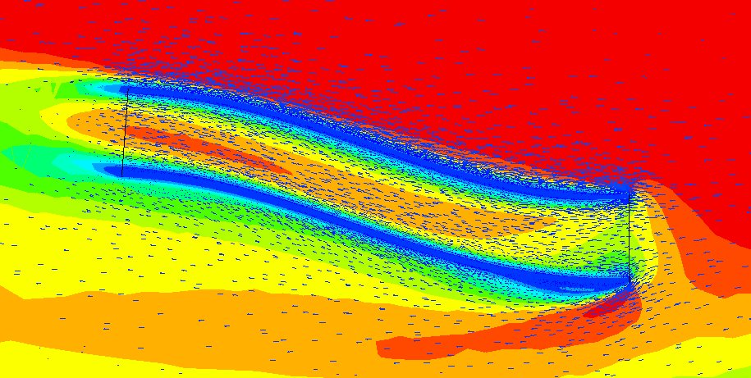
Figure 15 - CFD Simulation
In our final stages of our group project of the Morgan Sprint, due to certain circumstances we were unable to take the Morgan for a live test with a new intake system. So, an alternative method was running a Computational Fluid Dynamics (CFD) simulation. We used this to evaluate the intakes performance against the original design. From the simulation results in the figure above shows both the velocity and the pressure changes when the air makes contact with the intake pipe. The high velocity areas are indicated with warm colour (red and orange), while the slightly lower velocity areas are shown with cooler colours (green). The results from the figure above show that when the airflow is entering the intake pipe the air flow is hitting against the edges of the intake pipe causing high pressure and turbulence causing the entering airflow to slow down. Then as the air flows further through the intake the velocity begins to increase back up to speed. Also, the vector arrows indicate that there is higher pressure along the intake pipe walls and there is not as high pressure in the centre line of the pipe. This suggests that the redesigned geometry reduces flow separation and promotes more efficient air delivery. Overall, the flow is more stable which is an improvement compared to the manufacturers design with a sharper and more restrictive design. When compared to the original intake system, the redesigned intake shows a more consistent airflow path with reduced turbulence. This indicates that the new design is more efficient at delivering air to the turbocharger.

Evaluation
Overall, the redesign of the intake system successfully demonstrated improvements in airflow behaviour through simulation. The development process involved creating a 3D CAD model in SolidWorks and analysing its performance using CFD software. The results indicated smooth airflow and a reduction in turbulence, suggesting on improvement in overall efficiency. However, several limitations were identified during the project. The CFD simulation, while useful, it provided only an approximation of real-world conditions and may not fully account for factors such as temperature variation or intake location. Additionally, some experiments were not taken into account when they should have been such as using the flow blenching to test the airflow, or fitting the new intake and putting the Morgan onto the dynamometer and collect the data from Motec to see what the intake does. Also, there could have been improvement when creating the model in CAD such as creating the mouth of the intake pipe where the air begins to enter. Also, there could have been improvements in the simulation such as improving the details in the simulation so it shows the air flowing through the pipe itself and not air flowing around the whole thing. Additionally, the simulation does not fully account for real-world conditions such as heat transfer, vibration, and varying driving conditions, which may affect the actual performance of the intake system. For future work, the intake system could be physically manufactured and tested using a dynamometer to validate the simulation results and provide more accurate performance data.

Vi-Grade Car Simulation (Nia)

Introduction to the role
My role in this project was to analyse how different combinations of engines and suspension systems affected the performance of the Morgan Plus 4 and Plus 6, with the aim of identifying a suitable configuration for a race-focused vehicle. The intended race car is expected to use the Plus 6 suspension with a modified Plus 4 engine, so understanding how this hybrid setup behaves dynamically is central to my contribution.
To investigate this, I created three vehicle models in Vi-Grade Car Real-Time: a standard Plus 4, a standard Plus 6, and a hybrid model combining the Plus 6 suspension with the Plus 4 engine. These allowed direct comparison of how changes in powertrain output and chassis configuration influenced handling and overall behaviour.
I took over this part of the project from a previous group member, who had collected the initial suspension measurements but had not begun the modelling or analysis. After reviewing the data, I completed the remaining Plus 4 measurements, checked the accuracy of the existing values, and then carried out all of the VI-Grade model development, simulation work, and kinematic analysis required for this section.
During the modelling process, I identified that the suspension geometry used in the existing Vi-Grade models did not match the real Morgan layouts. Because suspension geometry strongly affects wheel alignment and stability, this mismatch limited the reliability of the simulation results and prompted the need for additional kinematic analysis.

Research and data collection
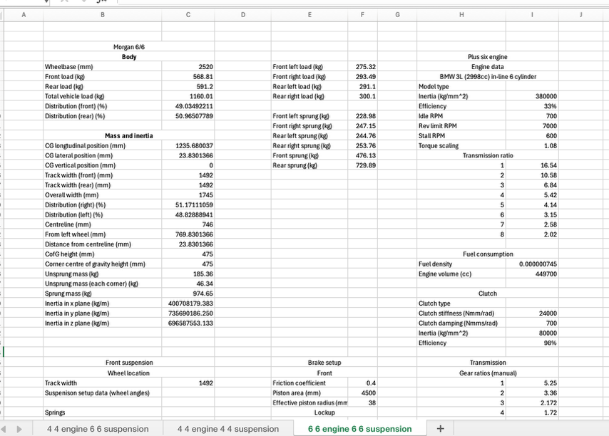
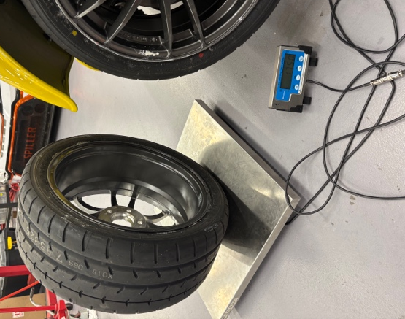
To ensure the simulation models were as accurate as possible, I gathered the real-world measurements required for both the Morgan Plus 4 and Plus 6. The Plus 6 data had already been collected by a previous group member, so my responsibility was to complete the remaining measurements for the Plus 4 and confirm that all parameters required for Vi-Grade were available. This included suspension geometry, chassis dimensions, and powertrain inputs.
Figure 13: screenshot of excel spreadsheet containing data collected and complied by the author
Figure 16 - Photograph of weighing tyre taken by the author
Engine data was taken from the official vehicle handbooks¹ ², providing key specifications such as power output and fuel information. Where exact values were unavailable, I generated reasonable engineering estimates to maintain realistic behaviour. Suspension information, including spring and damper characteristics, was taken from previous student work to improve consistency across the models³.
Collecting and validating this data ensured that the simulation inputs were reliable and provided a solid foundation for building the Vi-Grade models.

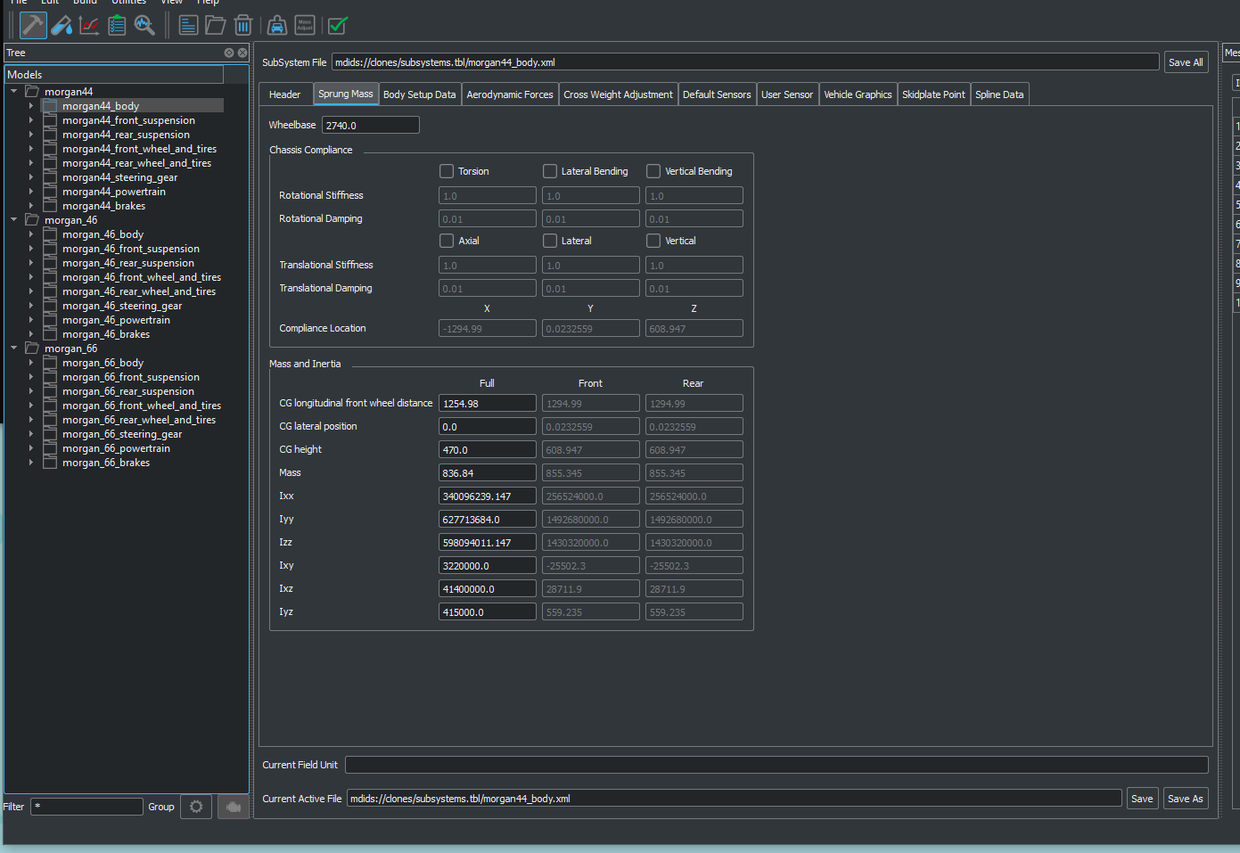
Simulation Model Development
To develop the simulation models, I began with the generic sports-car template in Vi-Grade and duplicated it to create three versions representing the Plus 4, Plus 6, and hybrid configurations. Each model was customised using the parameters gathered during the research stage, including chassis dimensions, suspension settings, and powertrain characteristics. For the hybrid model, the Plus 6 suspension was combined with the estimated Plus 4 engine data to reflect the intended race setup.
Where exact values were unavailable, I applied engineering judgement and reference data from similar vehicles to produce consistent estimates. Each model was validated by running basic test scenarios to check for unrealistic behaviour or parameters errors. Any issues identified were corrected to ensure that all three models were stable and ready for performance analysis.
Figure 14: Screenshot of Vi-Grade input tables taken by the author.

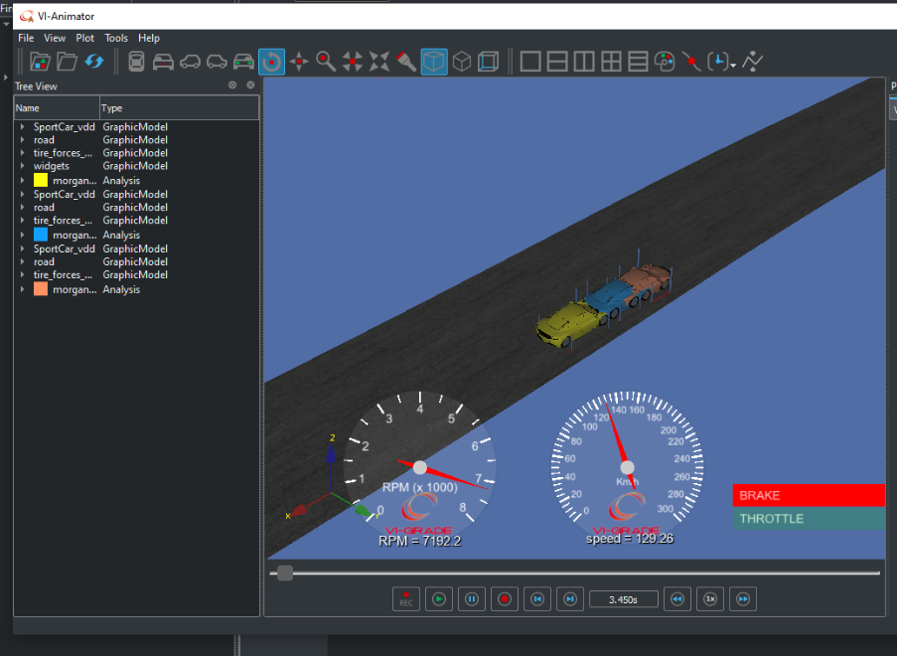
Experiments and Test Scenarios
To compare the performance of the three configurations, I simulated each model driving a previously recorded lap of the Llandow circuit. Using the same driver-input profile ensured that the results were directly comparable, allowing consistent evaluation of speed, braking behaviour, and cornering performance.
From the simulation outputs, I analysed key indicators such as speed traces, braking points, acceleration behaviour, and overall chassis balance. These results provided an initial indication of how the Plus 4, Plus 6, and hybrid configuration behave dynamically.
Figure 13: Screenshot of Vi-Grade animation taken by the author
However, because the suspension geometry in the models did not accurately represent the real vehicles, the simulated behaviour could not be fully trusted. This limitation led to the need for a more detailed investigation of the real suspension systems through static kinematic analysis.

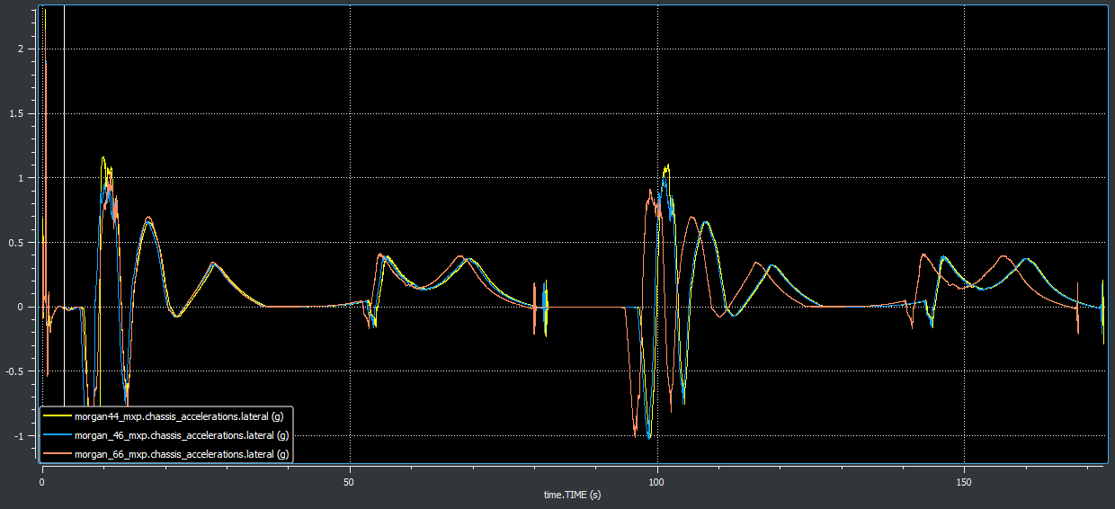
Simulation Results and Limitations
The simulation focused on longitudinal and lateral acceleration to compare how the different engine and suspension combinations influenced acceleration, braking, and cornering. Using the same driver inputs allowed direct comparison between the three models.
However, because the suspension geometry in the simulation did not match the real Morgan layouts, deeper analysis would not have been meaningful. Once the correct geometry is implemented, a more detailed and reliable performance assessment will be possible.
Figure 16: Graph generated by Vi-Grade using data created by the author.

Static Kinematic Suspension Analysis (Nia)

Purpose of the Kinematic Analysis
To support the simulation work, I expanded the project to include a static kinematic suspension analysis using Vi-Grade SuspensionGen. This allowed me to examine the actual Plus 4 and Plus 6 suspension geometries and compare how their wheel-alignment characteristics change throughout jounce and steer motion. These results will be used to update the Vi-Grade models in future work so that the dynamic simulations reflect the true behaviour of the vehicles.

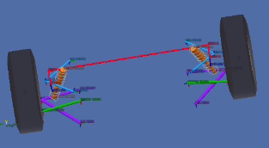
Hardpoints and Model Setup
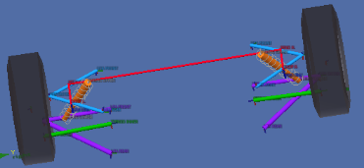
SuspensionGen provides detailed outputs such as camber, toe, and track width, making it well-suited for examining how the suspension behaves through bump and rebound. To build the models, I used the real suspension pickup points measured from the physical Morgan Plus 4 and Plus 6. These coordinates were originally collected by a previous student and imported directly into the software⁴. I then applied the same tyre values used earlier in the vehicle simulations to maintain consistency.
Figure 17: Plus 6 axle image generated by SuspensionGen
Figure 18: Plus 4 axle image generated by SuspensionGen

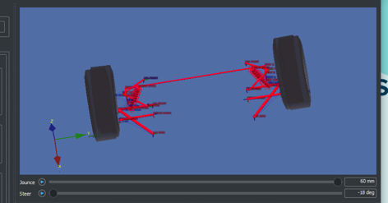
Results: Plus 4 and Plus 6 Suspensions

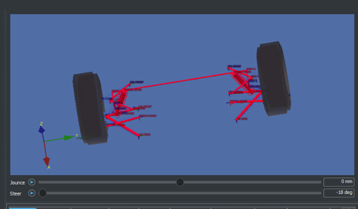
The Plus 4 and Plus 6 share a double-wishbone layout, but their geometries differ significantly. The Plus 4 uses a shorter upper wishbone, a more inclined upright, and a narrower track, giving it a more compact and reactive setup. The Plus 6 has longer arms, a more upright kingpin axis, and a wider track, producing a more stable baseline geometry. These differences are visible in both jounce and steer motions.
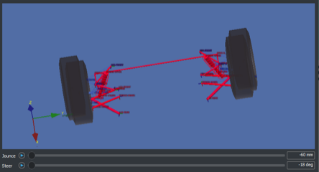
Through vertical travel, the Plus 4 gains negative camber quicker and shows greater track width variation, while the Plus 6 produces smoother, more gradual changes. In steering, both axles generate similar toe-gain due to their comparable steering-arm layout, but the Plus 4 produces stronger camber gain because of its steeper steering-axis inclination.
Figure 19: combined axle setup of plus 4 and plus 6 showing: -60mm, 0mm, and +60mm jounce positions, taken by the author
These behaviours translate into distinct handling characteristics, the Plus 4 feels more agile and reactive, while the Plus 6 feels more stable and predictable.

Kinematic Outputs Analysed
Below are the key behaviours observed from the jounce based kinematic outputs for the Morgan Plus 4 and Plus 6 front suspension systems.

Camber Angle v Jounce
In Figure 18, the graph shows how the front wheel camber angle changes as the suspension moves through bump, positive jounce, and rebound, negative jounce. This behaviour is important because it affects tyre contact during cornering, which influences front-end grip.
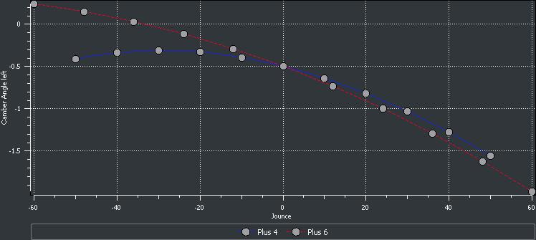
The Plus 6 starts with slight positive camber at full rebound, and transitions gradually into negative camber as it compresses. The Plus 4 follows the same general trend but begins closer to neutral and gains negative camber quicker. This indicates that the Plus 4 produces stronger initial camber gain, which typically supports sharper turn-in, while the Plus 6 has a smoother, more progressive camber curve.
Figure 20: Graph generated by SuspensionGen using data created by the author
Overall, both suspensions generate negative camber in bump, but at different rates. These differences help explain why the Plus 4 feels more responsive on initial steering input, whereas the Plus 6 offers a more stable and predictable front-end.

Wheel Track v Jounce
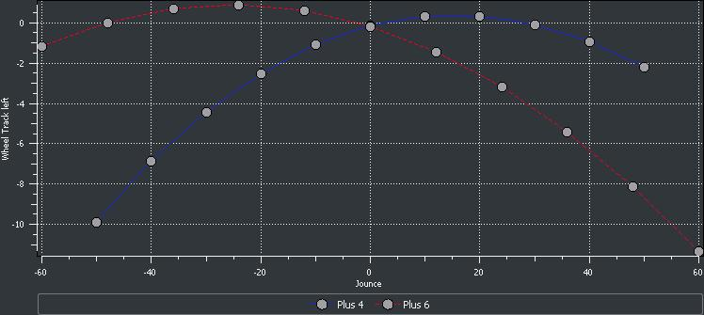
In Figure 19, the graph shows how the lateral distance between the front wheels changes through bump and rebound. Stable track behaviour is important because large variations can affect lateral load transfer and reduce handling consistency. Ideally, any change in track with jounce should be minimal and smooth to support predictable cornering behaviour.
Figure 21: Graph generated by SuspensionGen using data created by the author
Both the Plus 4 and Plus 6 follow smooth, gradual curves, but in opposite directions. The Plus 4 begins with a small negative track change at full rebound, moves toward zero at ride height, and increases slightly in bump. The Plus 6 begins just below zero, rises in positive track change, and then tapers back toward negative as jounce increases. Despite the mirrored shapes, neither suspension shows abrupt or unstable movement.
Overall, both designs maintain controlled and predictable track width variation throughout vertical travel. This supports stable cornering behaviour and balanced load transfer, and the smoothness of both curves indicates well managed lateral geometry.

Below are the key behaviours observed from the steer based kinematic outputs for the Morgan Plus 4 and Plus 6 front suspension systems.

Toe Angle v Steer
In Figure 20, the graph shows how the front wheels change orientation as they are steered left or right. Small variations in toe during steering influence how responsive or stable the vehicle feels.
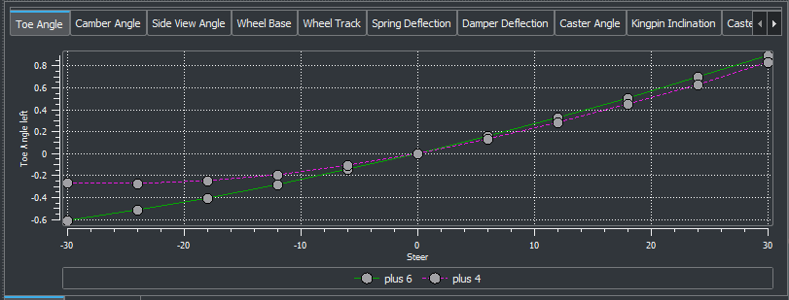
Both the Plus 4 and Plus 6 follow almost identical patterns. They begin with slight toe-out at large left-steer angles and move smoothly toward toe-in as the steering angle increases to the right. The transition is linear and consistent for both vehicles, indicating predictable toe-gain with no abrupt changes that would cause inconsistent steering behaviour.
Figure 22: Graph generated by SuspensionGen using data created by the author
Overall, the results show that both suspensions generate controlled and stable toe characteristics during steering. The similarity in curve shape suggests broadly comparable steering responses, with any small differences in toe-gain contributing to subtle variations in turn-in feel between the two designs.

Camber Angle v Steer
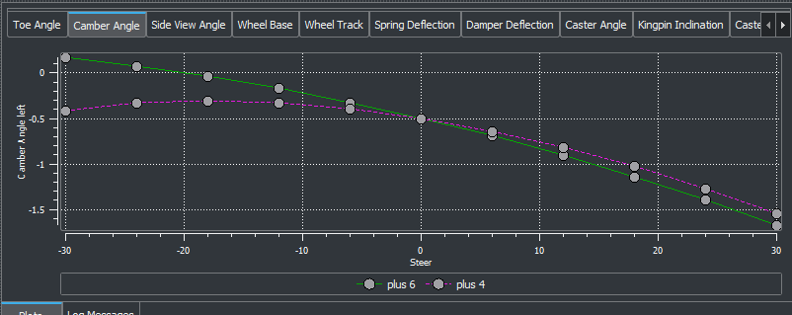
In Figure 21, the graph shows how the tyre leans as the wheel is turned left or right. This camber gain is important because it helps the outer tyre maintain grip during cornering.
Figure 23: Graph generated by SuspensionGen using data created by the author
Both the Plus 4 and Plus 6 show increasing negative camber with steering angle, meaning the tyre leans further into the corner as steering input increases. The Plus 4 generates this camber gain slightly faster, which typically supports a sharper, more responsive turn-in. The Plus 6 follows a more gradual curve, indicating a smoother and more stable steering feel. In both cases, the curves are consistent and well-controlled, with no abrupt changes.
Overall, both suspensions produce useful negative camber during steering, supporting strong cornering performance. The difference in camber-gain rate helps to explain why the Plus 4 feels more immediate on initial steering input, while the Plus 6 delivers a more progressive and composed response.

Interpretation and Implications for the Hybrid Model
Although the hybrid suspension was not modelled directly in SuspensionGen, the comparison between the Plus 4 and Plus 6 geometries allows a reasonable prediction of how the hybrid is likely to behave once the correct geometry is implemented in Vi-Grade. Because the hybrid uses the Plus 6 suspension but carries the lighter Plus 4 engine, it would operate at different points on the Plus 6’s camber, toe, and track width curves.
Based on the kinematic trends, the hybrid would be expected to gain camber more gradually in bump than a full Plus 6, but to feel more reactive in steer because the lighter front end allows the wheel to tilt more readily. This would place the hybrid between the two existing vehicles, more responsive than the Plus 6, but more stable and progressive than the Plus 4.
These predictions provide a useful indication of likely behaviour, but the final characteristics can only be confirmed once the corrected suspension geometry is implemented in the Vi-Grade model and tested dynamically.

Limitations of the Kinematic Analysis
Kinematic analysis assumed rigid components and does not account for compliance in bushings, tyres, or chassis structures, meaning real-world deflection is not represented. It also excludes dynamic effects such as weight transfer, transient steering inputs, braking forces, and road irregularities. Tyre behaviour is simplified, and the analysis evaluates geometry only at fixed jounce and steer positions. As a result, the outputs provide a strong geometric baseline but must be combined with dynamic simulation or physical testing to fully predict on-road handling.

Conclusion
Combining the Vi-Grade simulation with the static kinematic analysis provided a clear understanding of how the Plus 4 and Plus 6 suspension systems behave in vertical travel and steering. The kinematic study established how camber, toe, and track width evolve with jounce and steer, highlighting the reactive geometry of the Plus 4 and the smoother, more stable characteristics of the Plus 6.
These geometric findings were then used to predict how the hybrid configuration is likely to behave once the correct suspension geometry is implemented in Vi-Grade. Although the hybrid was not analysed directly in SuspensionGen, the comparison suggests that it will combine the responsiveness of the Plus 4 with the composure of the Plus 6.
Overall, the work met the project objectives by identifying key suspension behaviours, comparing the two axles, and establishing a clear expectation of how the hybrid configuration should perform when fully modelled.

Progress and achievements against the initial plan

Chassis

Intake System

Keira Phillips
The initial objective of this project was to redesign the intake system to improve airflow efficiency, reduce intake air temperature, and create a more direct routing between the intake and turbocharger. My contribution focused on concept development, aerodynamic analysis, and supporting the physical integration of the system through 3D scanning.
In terms of progress, a significant portion of the conceptual and research work was successfully completed with multiple intake concepts developed, each considering airflow direction, pressure zones, thermal exposure, and packaging constraints within the engine bay. These concepts evolved from a simple front facing intake to a more refined enclosed airbox design, demonstrating a clear progression in design thinking and engineering consideration.
Additionally, my research phase achieved its intended goals by identifying key performance factors affecting intake systems, including aerodynamic placement, airflow losses, and temperature effects. This research directly informed the design decisions made in the later stages, particularly the relocation of the intake to the higher-pressure region at the front of the Morgan.
A key achievement within my role was the successful use of the 3D scanning technology to capture the geometry of the engine bay. Despite limitations in accessing a single complete vehicle, combining scans from multiple Morgans and successfully producing a SolidWorks file pictured below in figure 22, allowed for a sufficiently accurate representation of the available space. This contributed to increased confidence in the feasibility of our proposed design and ensured that spatial constraints could be properly considered.

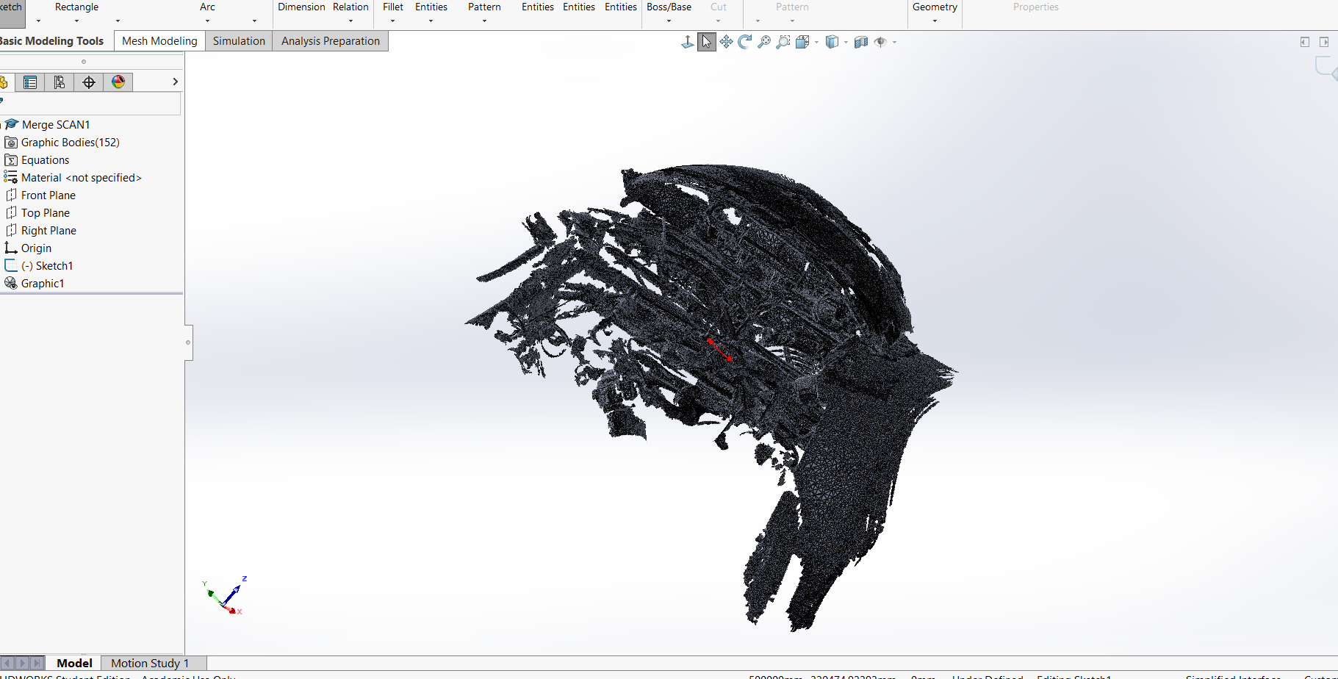
Figure 24 - Combined 3D Scans in SolidWorks

However, progress was limited in the later stages of the project, particularly in relation to live testing, meaning that validation of the design is based on engineering principles rather than experimental data. Despite this, the work completed still provides a strong conceptual and analytical foundation, aligning well with the original objectives of the project.

Jay Hodson
The initial objective of this project was to redesign the intake system to improve airflow efficiency, reduce intake air temperature, and optimise the routing between the intake and turbocharger. My contribution focused on the development, simulation, and refinement stages of the intake design, as well as supporting the physical validation of the final concept. During this stage, a number of design ideas were sketched out and compared with images of existing intake systems found online for inspiration. This helped guide the selection process and allowed us to choose a design that best suited the project requirements.
In terms of progress, the development phase was successfully carried out by transforming the selected design into a detailed 3D model using SolidWorks. This allowed for accurate visualisation and refinement of the intake geometry, ensuring that airflow pathways were smooth and suitable for further analysis. We reviewed our sketches and discussed which geometry would be most suitable for both simulation and manufacturing, based on performance and practicality. Then the use of Computational Fluid Dynamics (CFD) software enabled the performance of the redesigned intake to be evaluated, providing a clear comparison between the original and proposed designs. The combination of CAD modelling and CFD analysis allowed for a more accurate evaluation of the design, linking theoretical design with simulated performance results. This stage met its intended objective by identifying improvements in airflow behaviour and highlighting areas for further optimisation.
A key achievement within this role was the successful integration of simulation and physical testing. This process also required close collaboration with other team members to ensure that the developed design aligned with the overall project objectives and constraints. Overall, the planned objectives for development, testing, and analysis were partially achieved, contributing to a well-supported and validated redesign of the intake system. Although further testing would be required to fully validate the design, the work completed provides a strong foundation for future group project development and improvement.

Vi-Grade and Kinematic Simulation Analysis
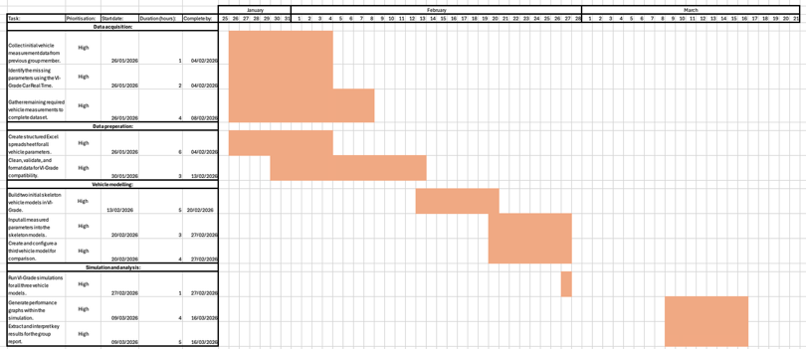
My initial plan was to build complete Vi-Grade models for the Plus 4, Plus 6, and the hybrid configuration, run the dynamic simulation, and analyse their performance. This part of the project progressed as expected, and I was able to create the models and complete the planned tests within the original timeframe.
Figure 25: Screenshot of Excel spreadsheet containing Gantt chart for Vi-Grade simulation
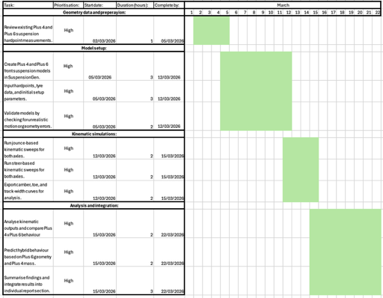
During the process, however, I identified that the suspension data used in the existing models were incorrect. This meant the simulation results could not be fully relied upon, so I expanded my work to include a detailed kinematic analysis using SuspensionGen. Although this was not part of the original plan, generating the jounce and steer curves and comparing the Plus 4 and Plus 6 geometries was essential for understanding the true suspension behaviour.
Figure 26: Screenshot of Excel spreadsheet containing Gantt chart for static kinematic suspension analysis
This additional work strengthened the overall project by ensuring that future Vi-Grade simulations will be based on accurate suspension geometry. The next step will be to implement the corrected hardpoints into the vehicle models so that the dynamic results reflect the real system.

Review of project outcomes and challenges

Chassis

Intake system

Keira Phillips’ Project Review

Overall, the project successfully achieved its primary aim of developing an improved intake system design based on engineering principles. The final concept demonstrates clear advantages over the original system, including a shorter, more direct airflow path, utilisation of high-pressure airflow regions, and better thermal management through strategic positioning and enclosure of the air filter. I also achieved a successful SolidWorks model of the area of fucus in the engine bay which help strengthen and simplify the later development stages.
Despite these positive outcomes, several challenges were also encountered throughout my section of the project. One main challenge being related to data acquisition, time constraints, and physical access to the vehicle, such as the inability to fully disassemble or scan a single complete system required for the combined scans which left gaps in the final model, which could potentially lead to inaccuracies. Additionally, working within a group environment sometimes meant that progress was dependant on the availability of other team members which impacted the overall pace of development.
Furthermore, the positioning of the intake above the radiator introduced a trade-off between aerodynamic efficiency and potential heat expose. Although this was addressed conceptually through shielding and airflow management, it highlights an area that would require further testing and refinement in future work.
In reflection, despite the challenges the outcome provides a well-developed design concept supported by research and analysis, with clear opportunities for further development through prototyping and testing.

Jay Hodson’s Project Review

My contribution to the intake system section of this group project focused on the development, simulation, and evaluation stages of the design. The main aim of my work was to take a selected concept and turn it into a CAD model, which was then analysed using CFD software to assess its performance. This then allowed us to move from initial ideas into a more practical and testable design.
An achievement of my role was successfully creating a 3D model using SolidWorks that represented the initial idea of the chosen intake design. This model was developed to ensure smooth airflow through the intake, with careful attention given to the geometry of the pipe to reduce turbulence and pressure losses. The model provided a strong base for further analysis and allowed us to visualise how the intake would function within the engine bay.
The use of CFD software was also an important part of my contribution. It allowed us to analyse airflow behaviour within the intake system and see how that reacts to airflow compared to the data gathered on circuit. From the results, it was clear that the new design had minimal turbulence, which would theoretically suggest an increase in overall efficiency. This supported the decision to move forward with the redesigned intake concept.
However, there were several limitations within my section of the project. The main limitation was the lack of physical testing, meaning that the results were based on simulation rather than real-world data. Additionally, some features such as the intake entry and MAF placement were not included in the final CAD model, which could affect the accuracy of the results. The CFD simulation also had limitations, as it did not fully represent real operating conditions such as temperature changes and airflow from vehicle movement.
In reflection, my contribution provided a strong development and analysis stage within the project, helping to confirm the proposed design through simulation. For future work, the intake system could be physically manufactured and tested to compare real performance data with the simulation results, allowing for further refinement and improvement.

Vi-Grade and Kinematic Suspension Analysis
The project achieved several key successes, particularly in developing and analysing the Vi-Grade vehicle models. I completed all core simulation tasks as planned, including building the Plus 4, Plus 6, and hybrid models and running the required dynamic tests. These simulations provided clear comparative insights into how engine output and suspension configuration influence vehicle behaviour. A major success was expanding the project to include a kinematic analysis once the suspension-geometry issue was identified. Using SuspensionGen allowed me to independently verify the true behaviour of each axle and strengthened the technical foundation of the overall study.
The project also faced challenges. Early progress was slowed by difficulty accessing previous data, delaying the start of the simulation work. The discovery that the VI-Grade suspension geometry was inaccurate meant that some initial results could not be used and required a change of direction. Although the kinematic analysis resolved this issue, the corrected geometry could not be fully implemented back into the VI-Grade models within the timeframe, limiting the number of dynamic scenarios I could run.
Despite these setbacks, the project delivered meaningful results. The combination of VI-Grade simulation and kinematic analysis provided a deeper understanding of the Plus 4, Plus 6, and predicted hybrid behaviour. The main shortcoming was the inability to update the VI-Grade model with the corrected geometry, but this now provides a clear direction for future work.

Bibliography

References

Nia’s References
- Morgan Motors (2022). Plus 6 Handbook. [Online]. Available at: https://morgan-motor.com/wp-content/uploads/Plus-Six-Owners-Handbook-Digital.pdf (Accessed: 28th February 2026).
- Morgan Motors (2022). Plus 4 Handbook. [Online]. Available at: https://morgan-motor.com/wp-content/uploads/Plus-Four-Owners-Handbook-Digital.pdf (Accessed: 28th February 2026).
- (Claydon, n.d.)
- (Anonymous, n.d.)
Jay’s References
PcHardwarePro (2024) What is Ansys and what is it used for?, PcHardwarePro. Available at: https://www.pchardwarepro.com/en/What-is-ansys-and-what-is-it-for/ (Accessed: 29 March 2026).
Technologies, S. (no date) Top 7 Benefits of Learning SOLIDWORKS: Is it Worth It?, SeaCAD. Available at: https://seacadtech.com/blog/benefits-of-learning-solidworks/ (Accessed: 29 March 2026).

