Artefact task 3 and task 4
Module name: Changemakers: Creativity and Value Creation
Module code: BMHP5014_BIRM
Lecturer name: DR. Azora Hurd
Student name and code: Mihaela Cristina Duca (2026748)

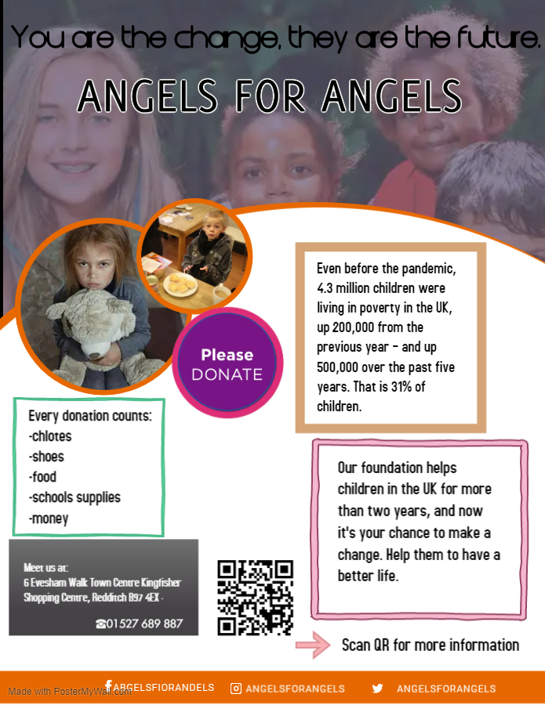

Artefact task 4- Flyer
According to the National education union, the United Kingdom has one of the world's greatest economies, yet 4.3 million kids are growing up impoverished. It indicates that 30% of kids, or 9 students in every group of 30, are technically impoverished. Inequality holds back so many kids, restricting their opportunities in life and posing impediments to development. (NEU, 2021)
The emotional consequences of the COVID-19 lockdown on families and children in the United Kingdom is big enough for them to have long lasting problems. The government's implementation of COVID-19 prevention methods in several nations (e.g., school closures and social separation) has impacted millions of children and their families worldwide. Unfortunately, the influence of all these strategies on children's wellbeing is uncertain. (Morgul, Kallitsoglou and Essau, 2020)
According to Weinger, poor housing typically limits children's ability to follow a meaningful future career. This descriptive research investigates if underprivileged kids are conscious that the odds of survival of their richer friends may be larger than their own. (Weinger, 1998)
In my flyer, I used a white background because according to Jennifer Bourn, white could indeed resemble a prosperous start. White in inscriptions represents belief and purification. As the direct opposite, animated films, publications, newspapers, tv and movies the good guy is dressed in white and the villain in black. (Bourn, 2010)
I associated the white colour with faith, hope, light, and sincerity.
I used an orange outline because according to Nikiya Palombi, many healthy foods have an orange hue in origins. As a result, it's no mystery that orange has become associated with health, vitality, and energy. (Palombi, 2022)
I associated the orange colour with energy, happiness, and optimism.
Our name, Angels for Angels, represents the purity of a child, and the need to have someone to watch over them.
With our motto “You are the change, they are the future”, I wanted to describe the need of help for the future generation.
I have used pictures of children, to make the flyer more credible. The bigger picture in my flyer represents the happiness of a group of children, which is showing as how every child should be, comparing with the other two pictures, where you can see two kids in need, kids that are living in poverty, fact that is stopping them from smiling in the same way as the other do.
I wanted my flyer to contain enough information about the problem that we are trying to fix, about the problem that the children in UK needs to face every day. I added a QR code which can be accessed on every smartphone, and it will send you directly to our website where you can find more useful information about the fundraising and where you can donate as much as you want.
The flyer also contains our Facebook page, Instagram, and Twitter page, where you can see the families that we worked with and more information about the volunteers.

Artefact Task 3- Elevated pitch
Hello,
My name is Mihaela Cristina Duca, I am a full-time student at university of Wales Trinity Saint David and a full-time employee in a production factory. I am studying Health and social care, and today I want to talk with you about child poverty in UK, which I believe that is the biggest issue these days, an issue that people try to avoid, and the government try to hide.
The statistics from 2020/2021 shows that in UK more than 3.9 million kids are living in poverty, which is more than 27%, in schools, more than eight children in a group of a minimum of 30 are living in poverty.
Growing up, my parents worked 6 out of 7 to provide for me and my sisters the resources for a normal life, but even like that we still couldn't afford to spend more than necessary. I grew up seeing kids that their parents couldn’t afford school supplies or even a lunch, and that made me think that I had more than enough.
The Covid issue has shed attention to the difficulties that this entails children suffering from hunger and parents dependent on donations and existing week after week. The pressures on raising children are great, and the influence on child behaviour and lifestyle choices is obvious.
Because of the poverty there are a lot of sick children, children with parents that cannot afford treatment or healthy food, children that are living in an unhealthy environment, that struggling with cold and hunger and end up dying, because no one helped them.
Our foundation is trying to stop, or at least to help as much as possible the children in UK to live without the experiences of poverty. The economic, material, and social deprivation is affecting their future, and they will continue living an unhealthy and unsafe life. Every child needs to attend a good school, to have enough support from their families and from us, they need safe houses and safe neighbourhoods, and you can make this happen.
Our goal is to offer them the chance to grow into good and responsible adults, to offer them a happy and safe childhood, the chance to choose what they want to do in the future, because they are our future. They are the next generation of adults, adults that will have children of their own, children that they will need to educate and take care of.
I invite you to join us every Sunday at Emmanul Church in Redditch from 09:00 to 11:00, to talk about these problems, about the help that we can give them and about the support that they all need.
Every donation count, you can donate money, food, clothing items, shoes, school supplies, household items, or to participate alongside the church canteen preparing hot meals for the ones in need.
Thank you for listening to my speech, we will wait for you to make the change. Two hours of your time can change a life.

References
- Morgül, E., Kallitsoglou, A. and Essau, C.A.E., 2020. Psychological effects of the COVID-19 lockdown on children and families in the UK. Revista de Psicología Clínica con Niños y Adolescentes, 7(3), pp.42-48.
- Weinger, S., 1998. Children living in poverty: Their perception of career opportunities. Families in Society, 79(3), pp.320-330.
- N. Palmobi, (2022). 10 Color meanings: the psychology of using different colors. [Online]
Available at: 10 color meanings: the psychology of using different colors (webflow.com)
[Accessed: 10 July 2022]
- J. Bourn, (2010). Colour Meaning: Meaning of The Colour White. [Online]
Available at: Meaning of The Color White | (bourncreative.com)
[Accessed:10 July 2022]
- Child Poverty Action Group (2021). Child poverty facts and figures. [online] CPAG.
Available at: https://cpag.org.uk/child-poverty/child-poverty-facts-and-figures.
[Accessed: 10 July 2022]
- Bing.com. (2022). [online]
Available at: https://www.bing.com/images/blob?bcid=RLglH13fPWkEy
[Accessed 10 July 2022].
- ‌Bing.com. (2022). [online]
Available at: https://www.bing.com/images/blob?bcid=RF.SEiPulWkE2g
[Accessed 15 July 2022].
- Bing.com. (2022). [online]
Available at: https://www.bing.com/images/blob?bcid=RBL9Kwg6YGkENA [Accessed 15 July 2022].

