Reflection and why is it important to reflect on your work

Introduction:
According to John Dewey, "truly educative" encounters produce intrigue, are inherently advantageous, introduce issues that stir new interest and make an interest for new data, and set aside adequate opportunity to cultivate improvement. Well known in endowed projects, similar to business, nursing, crime scene investigation and instruction, reflection is an imperative piece of making associations amongst hypothesis and practice.
Definition:
Reflection is a process designed to promote the examination and interpretation of experience and the promotion of cognitive learning by which learners think and act vitally concerning their skill-sets.’ It is the way toward thinking back on the ramifications of moves made great and figuring out what has been increased, lost, or accomplished and interfacing these conclusions to future activities and bigger societal settings.
Through reflection understudies/representatives investigate ideas, assess encounters, and hypothesize hypothesis. Basic reflection gives understudies/representatives with the chance to look at and question their convictions, feelings, and qualities. It includes perception, making inquiries, and putting realities, thoughts, and encounters together to determine new importance.
Advantages of Reflection work in personal and private of an individual’s such as:
- Reflection improves basic professional skills
- Reflection promotes a deeper understanding of course subject matter and its relations to the non-academic or professional world
- Reflection improves higher level thinking and crisis solving and an individual’s ability to learn from practical exposure.
- Promotes individual progress by enhancing students’/professionals self-awareness, and their intellect of their own competence.
‘Kolb’ model of reflection and the benefits of using the model.
“Learning is the process whereby knowledge is created through the transformation of experience” (Kolb, 1984, p. 38).
Kolb's ELT works on 2 levels & 4 stage cycle of learning and four unique learning styles. To a large extent of Kolb’s theory, it is fretful with the professional/ student learner’s internal cognitive processes and the impetus for the development of advanced model is presented by innovative experiences.

The Experiential Learning Cycle
ELT (experiential learning theory) defines learning as “a process whereby knowledge is created through the transformation of experience. Knowledge results from the combination of grasping and transforming experience” (Kolb 1984: 41).

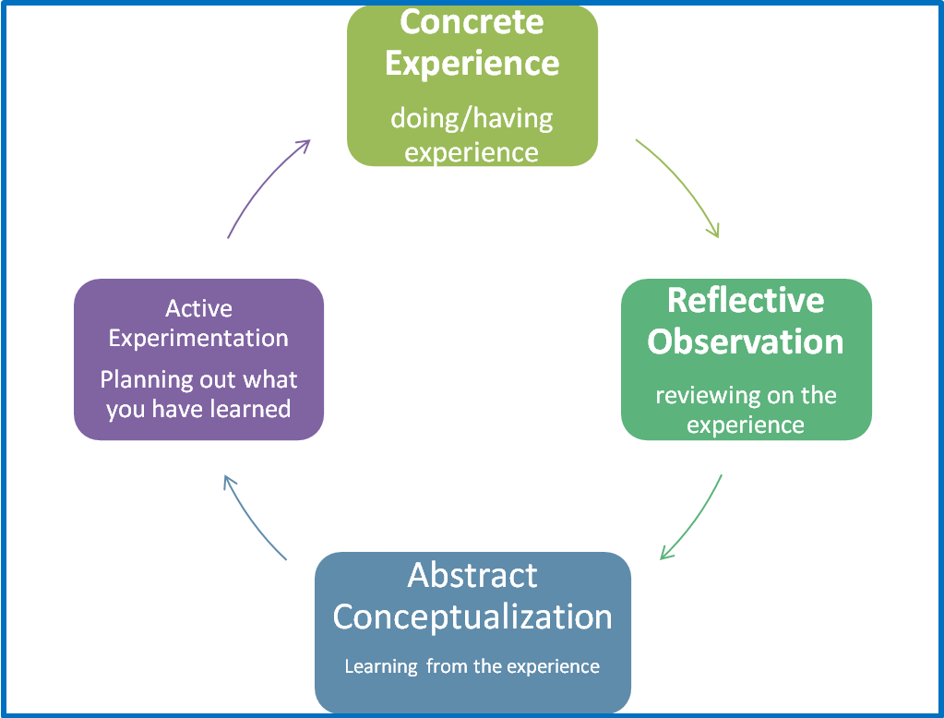
Figure 1. The Knob’s experiential learning cycle
The ELT model portrays two dialectically related modes of grasping Experience-Concrete Experience (CE) and Abstract Conceptualization (AC) - and two dialectically related modes of conversion understanding- Reflective Observation (RO) and Active Experimentation (AE).
Experiential learning is a procedure of building information that includes an imaginative pressure among the four learning modes that is receptive to logical requests. This procedure is depicted as a romanticized learning cycle or winding where the student "touches every one of the bases"— encountering, reflecting, considering, and acting-in a recursive procedure that is receptive to the learning circumstance and what is being realized. Prompt or solid encounters are the reason for perceptions and reflections. These reflections are acclimatized and refined into dynamic ideas from which new ramifications for activity can be drawn. These suggestions can be effectively tried and fill in as aides in making new encounters. ELT suggests this glorified learning cycle will fluctuate by people's learning style and learning setting.
Kolb's experiential learning style hypothesis is commonly spoken to by a four phase learning cycle in which the student 'touches every one of the bases':

1. Concrete Experience - (an additional experience of circumstance is practised).
2. Reflective Observation (of the new experience/ specific significance are any irregularities amongst experience and comprehension).
3. Abstract Conceptualization (Reflection offers ascend to another thought, or an adjustment of a current dynamic idea).
4. Active Experimentation :( Any student/ professional may apply them to their general surroundings to perceive what comes about).
Viable learning is seen when a man advances through a cycle of four phases: of
(1) Having a solid ordeal took after by
(2) Perception of and reflection on that experience which prompts
(3) The development of dynamic ideas (investigation) and speculations (conclusions) which are at that point
(4) Used to test speculation in 1/4 future circumstances, bringing about new encounters.

Kolb (1974) sees learning as an incorporated procedure with each stage being commonly steady of and nourishing into the following. It is conceivable to enter the cycle at any stage and complete it its intelligent succession.
In any case, successful adapting just happens when a student can execute each of the four phases of the model. In this way, nobody phase of the cycle is a powerful as a learning strategy all alone.

Kolb’s Learning Styles:
Kolb's learning hypothesis (1974) sets out four unmistakable learning styles, which depend on a four-organize learning cycle (see above).
In general, Kolb clarifies that various persons (students/professionals) normally favour a specific different distinctive learning style. Different elements impact a man's favoured style. For instance, social condition, instructive encounters, or the fundamental psychological structure of the person.

Kolb trusted that we can't perform the two factors on a solitary hub in the meantime (e.g. think and feel). Our learning style is a result of these two decision choices.
It's frequently simpler to see the development of Kolb's learning styles as far as a two-by-two framework. Each learning style speaks to a blend of two favoured styles. The outline additionally features Kolb's phrasing for the four learning styles; veering, acclimatizing, and focalizing, obliging:

 | Doing  (Active Experimentation - AE) | Watching  (Reflective Observation - RO)
Feeling  (Concrete Experience - CE) | Accommodating (CE/AE) | Diverging (CE/RO)
Thinking  (Abstract Conceptualization- AC) | Converging (AC/AE) | Assimilating (AC/RO)

Learning Styles Descriptions
Knowing a man's (and your own) learning style empowers figuring out how to be orientated by the favoured strategy. All things considered, everybody reacts to and needs the boost of a wide range of learning styles to some degree - it's a matter of utilizing accentuation that fits best with the given circumstance and a man's learning style inclinations.

Brief depictions of the four Kolb learning styles:
Diverging (feeling and watching - CE/RO): These individuals can take a gander at things from alternate points of view. They are touchy. They like to observe as opposed to do, tending to accumulate data and utilize creative energy to take care of issues. They are best at survey solid circumstances at a few unique perspectives. Kolb called this style 'separating' in light of the fact that these individuals perform better in circumstances that require thoughts age, for instance, conceptualizing. Individuals with a wandering learning style have wide social premiums and get a kick out of the chance to accumulate data. They are occupied with individuals, have a tendency to be inventive and passionate, and have a tendency to be solid in expressions of the human experience. Individuals with the separating style like to work in gatherings, to tune in with a receptive outlook and to get individual criticism.

Assimilating (watching and thinking - AC/RO): The Assimilating learning inclination is for a compact, consistent approach. Thoughts and ideas are more imperative than individuals. These individuals require great clear clarification as opposed to common sense opportunity. They exceed expectations at seeing boundless data and sorting out it in a reasonable intelligent configuration. Individuals with an acclimatizing learning style are less cantered around individuals and more keen on thoughts and dynamic ideas. Individuals with this style are more pulled in to consistently stable speculations than approaches in view of useful esteem. This learning style is critical for viability in data and science professions. In formal learning circumstances, individuals with this style incline toward readings, addresses, investigating expository models, and having sufficient energy to think things through.

Converging (doing and thinking - AC/AE): People with a focalizing learning style can take care of issues and will utilize their figuring out how to discover answers for common sense issues. They lean toward specialized assignments, and are less worried about individuals and relational perspectives. Individuals with a focalizing learning style are best at finding down to earth utilizes for thoughts and hypotheses. They can take care of issues and settle on choices by discovering answers for inquiries and issues. Individuals with a joining learning style are more pulled in to specialized errands and issues than social or relational issues. A joining learning style empowers master and innovation capacities. Individuals with a focalizing style get a kick out of the chance to explore different avenues regarding new thoughts, to reproduce, and to work with functional applications.

Accommodating (doing and feeling - CE/AE): The Accommodating learning style is an 'hands-on', and depends on natural feeling instead of underlying principle. These individuals utilize other individuals' examination, and want to take a viable, experiential approach. They are pulled in to new difficulties and encounters, and to doing plans. They usually follow up on 'gut' sense as opposed to intelligent examination. Individuals with an obliging learning style will have a tendency to depend on others for data than do their own investigation. This learning style is pervasive inside the overall public.

Educational Implications
Both Kolb's (1984) learning stages and cycle could be utilized by instructors to basically assess the learning arrangement commonly accessible to understudies, and to grow more suitable learning openings. Instructors ought to guarantee that exercises are composed and completed in ways that offer every student the opportunity to participate in the way that suits them best. Similarly, people can benefit from outside assistance to take in more adequately by the unique proof of their slighter preferred learning styles and the fortifying of these through the deployment of the ELT, experiential learning cycle. Preferably, exercises and material ought to be created in ways that draw on capacities from each phase of the experiential learning cycle and take the understudies through the entire procedure in grouping.

Case 1: Soccer Sports
Concrete Experience—player participates in a preparation coordinate, endeavouring to score objectives
Reflective Observation—player thinks about his/her execution, particularly her/his scoring endeavours.
Abstract Conceptualization—player converses with coach who gives understanding concerning scoring methods
Arranging Active Experimentation—player utilizes bits of knowledge from the mentor and also encounter from the primary match to get ready for the following match The littler boxes allude to the four learning styles that include all students in light of a person's favoured purpose of entering the learning cycle

Diverging /Reflectors—Like to consider the action/idea and watch other people groups' goes up against the issue
Assimilating /Theorists—Relate the job needing to be done to different encounters or ideas
Converging /Pragmatists—Like to consider how to apply hypothesis by and by
Accommodating /Activists—Like to hop in to attempting the action.

Case 2: Software Employee
How might you first approach figuring out how to utilize another product program?
Extremist—instantly start utilizing the product, trying different things with its devices and capacities
Reflector—Think about your involvement with comparable programming or counsel somebody who has utilized this program
Scholar—Read the manual to get a reasonable handle on the activities of the program
Realist—Start the product and swing to the assistance highlight to get master tips

Knob’s Model Advantages and Implementation:
At last, the yield procedure incorporates surveying the achievement of the understudy in accomplishing wanted learning targets following the experience, including comprehensive appraisal of all learning modes and full of feeling, discerning, psychological, and behavioural characteristics. This procedure frequently includes rehashing the info appraisal to distinguish changes through the span of the learning knowledge.

Advantages:
- Knob's model is adaptable and liberal
- Happy to be presented to new or unusual conditions
- Excellent in tuning in and watching the core of the subject.
- Exceptional in offering conversation starters to moderator in scholastics or corporate.
- Precise in discovering straight to the point
- Purely strategy situated

Conclusion
Active learning, research & inquiry have an important role to play in enhancing the prominence of student learning methodology. Recognising that students have diverse preferred learning styles needs to be built in to the design of learning activities and evaluation. The Kolb’s ELT cycle provides a constructive framework for the designing effectual and vigorous learning in real time experience.
In this assignment I proposed different ways of engaging students/ professionals in active learning, research and inquiry so that their learning is enhanced is challenging.
We conclude ‘Learning is considered as a continual process by incorporating coaches’ reflections on previous experiences in sport and encouraging ongoing reflection in the future. Through the use of interactive activities coaches gain hands on experience.
• Best options for intervention and practicing some of the skills required to intervene in potential cases of maltreatment. Through group and individual activities, presentations, and follow-up exercises, coaches.
• Have the opportunity to experience, reflect, theorize, and apply the course content, thus using all four modes of Kolb’s learning cycle (concrete experience, reflective observation, abstract conceptualization, and active experimentation). Attending to the holistic nature of the learning process, the coaches’ feelings, and perceptions.
• Thoughts and actual behaviours are strategically focused on throughout the coach education module.
• Opportunities are provided for coaches to develop individualized action plans recognizing
• The individualized nature of learning and knowledge production

References:
- Lane Perry, “More Than a Vacation: Short-Term Study Abroad as a Critically Reflective, Transformative Learning Experience”. Creative Education 2012. Vol.3, No.5, 679-683
- Kolb, D. A. (1984). Experiential learning: Experience as the source of learning and development (Vol. 1). Englewood Cliffs, NJ: Prentice-Hall.
- R. J. Sternberg and L. F. Zhang (Eds.), Perspectives on cognitive, learning, and thinking styles. NJ: Lawrence Erlbaum.
- Soccer/Software example retrieved frottp://www.simplypsychology.org/learning-kolb.html Software example retrieved 1/9/08 from http://nwlink.com/~donclark/hrd/ styles.html
- Ashley E.Stirling, Applying Kolb’s Theory of Experiential Learning to Coach Education. University of Toronto, Toronto, Canada. Volume 6, Issue 2, Fall 2013

