Patrick O'Brien (P139647)

Major Project Proposal
Research Methods UWTSD SWANSEA
2018

Contents

1. Contents 1
2. Table of Figures 2
3 . Introduction to the Project and Aims 3
4. Background and rationale 4
5. Objectives 6
6. Methodology 7
6.1.1. DMAIC Six Sigma 8
6.1.1. PDCA – Plan, Do, Check, Act 9
6.1.1. Bottleneck Analysis 10
7. Main activities involved in the Project 11
8. Resource requirements 12
9. Constraints 13
10. Potential Problems 14
11. Literature Review 15
11.1. Software Package research 17
11.1.1. Sage 50 Accounts 17
11.1.2. SAP 18
11.1.3. Arma Plus 18
12. Recommendations 19
13. Bibliography 20

Table of Figures

Figure 1: QRC Template 15

Figure 2: Express Reinforcement Shape Code 16

Introduction to the Project and Aims

Paper traceability is not the most practical way to record information, especially in a fast-paced production environment such as Express Reinforcements. In order to make the company's manufacturing-to-delivery sequence much more efficient, this traceability needs to be improved which explains why it is being changed to paperless.
(Brand, 2014) States that,”accurate real time manufacturing data is crucial to maximising production efficiency, improving shop floor management and manufacturing cost reduction”. It will be a 100% improvement within the manufacturing process as the items produced can be logged as the machine is manufacturing them.
(Brand, 2014) Then continues to identify that, “without accurate information about what is happening day to day on the manufacturing shop floor, many companies function without any real control. They may be producing good quality product yet not know the true potential of production capacity or product quality that is achievable. Used as part of a continuous improvement program a manufacturing data system will pay for itself many times over in improved throughput, quality and efficiency gains”.
To improve traceability in the Neath Depot there must be a way to gain information from the manufacturing machines and transfer them across to the office and management team to give greater clarity as to what exactly is being produced and what types of product are needed to be delivered and when. The quality department will also benefit from these improvements as they will gain the ability to check products and items before they are sent out for delivery, (in-case there are mistakes made or items missing), which will in turn prevent any customer complaints.

Background and rationale

Express Reinforcements LTD is Britain’s leading reinforcement steel specialist. Providing good quality and cost-effective steel to the construction industry and major build projects nationwide. Express drives for continuous improvement (Davies, 2015) states that “Express Reinforcements’ drive for continual improvement in the way steel reinforcement is detailed, fabricated, assembled and placed on site through collaboration has been borne out by it being involved in some of the most demanding and complex construction projects in the UK”.
The product development continues to evolve in a competitive market which results in Express staying ahead by offering customers a choice of product groups which can be used for all appropriate applications and also contribute to specified projects.
These product groups are:
- Buildability.
- Carpet reinforcement solutions.
- Concrete/rebar modelling/detailing.
- Factory Assembled prefabricated units.
- Flat pack reinforcement for easy on-site assembly.
The construction industry in Britain is requiring less on-site assembly or fabrication and this is why Express Reinforcements offers a range of different product selections for the company to keep up with recent growth and industry requests.
Express Reinforcements, Neath has a total of two Shear Lines, seven Automatic Link Benders, (ALB), two Decoil Lines, three Griptec Threading machines and six saws for offcuts. Express, Neath has a production capacity to have an output of 200 Tonnes - whilst this is a significant figure to produce on a daily basis, there is a traceability problem.
With a high demand from current customers and new customers, the only traceability is to record how many bars have been produced, the bar diameter, the length and the grade of steel is recorded manually on paper. (Costa, 2010) Describes that, “for discrete manufacturers, track and trace each component that comprises your product – from suppliers and manufacturers through assembly and final delivery to customers”.

Objectives

The main objective of this project is to achieve 100% paperless traceability; it will enable the company to receipt goods and upload onto a system or server and then give them the ability to trace the part throughout the production process.
The Quality Department being able to produce a Quality Release Certificate (QRC) once the material has gone through the production department is also another key objective. Every shift requires Quality Personnel to reference and check the QRC against production paperwork, which is time-consuming and unproductive. (Dunkley, 2015) States that, “using a paperless office platform allows easy access to all documents by all employees. They can search the company database without opening multiple applications, or digging through messy, complex paper files”.
There will be documents stored on a network with no need to worry about looking for documents as they will have unique numbers and dates, which will make both customer and company audits run smoother whenever they occur. (Seth, 2014) States that, “with a digital document management system, there are no limits to the amount of documents you can store and every document will have a unique number –automatically generating an audit trail”.

Methodology

In order to carry out this research proposal there will be relevant methodology used to do so. Methodology describes various tools and techniques, which can help to structure reports and solve equations or problems because it provides a person or a team a structure to follow within the particular process. Methodology is a technique also used by scientists to observe the quality of a research programme or project, used to discern areas, which have previously been, covered which may require improvement or to detect if anything was missed. (Piller, 2018) States, “the methodology employed in an experiment is essential to its success and bad methodology has spoiled thousands of research projects. So whenever a piece of research is published in a scientific or medical journal, the researchers always carefully describe their methodology”.

DMAIC Six Sigma

One of the methodologies that will be used is the DMAIC Six Sigma approach. DMAIC Six Sigma is more than a process improvement tool - it requires sophisticated uses of data and makes the person or persons using it emphasise the statistical analysis of findings and experiments. (Krivokapić2, 2009) States, “Six Sigma is an organisation-wide approach used to specify exactly how organisation managers set up and achieve objectives. It demonstrates how breakthrough improvements tied to significant bottom-line results can be achieved”.
The DMAIC methodology consists of:
- Define
- Measure
- Analyse
- Improve
- Control
This is the route that would be taken on completing the full project, for this proposal only the defined process of this methodology will be undertaken to help justify and understand with research the need for a new system, which is paperless. (Prasath, 2018) State “The Define Phase is the first phase of the Lean Six Sigma improvement process. In this phase, the leaders of the project create a Project Charter, create a high-level view of the process, and begin to understand the needs of the customers of the process. This is a critical phase of Lean Six Sigma in which your teams define the outline of their efforts for themselves and the leadership (executives) of your organization”.

PDCA – Plan, Do, Check, Act

The Plan, Do, Check, Act cycle (PDSA cycle), also known as the Deming cycle is a tool or a wheel that drives continuous improvement. The use and outcomes of the PDCA cycle has been found to be more effective in small businesses and manufacturing companies than other techniques. (Pratik M Patel, 2017) States, “the implementation of the PDCA cycle has been found more effective than other techniques and any small-scale industry, school or hospital can implement PDCA methodology”.

The PDCA cycle consists of:

- Plan – Plan what is needed throughout and to carry out the project.3
- Do – Implement the plans and carry out the project.
- Check – revise what has been implemented and make sure everything is in order.
- Act – To see if the performance needs to be improved or correct faults.

A PDCA cycle carried out in Express would be the plan for the project, which will be improving traceability and going paperless. The ‘do’ would actually be the company moving to a paperless base production factory. The ‘checks’ would be tracing the system and seeing that everything was implemented correctly. ‘Act’ would be looking at what works and what need improving going forward.

Bottleneck Analysis

In every process, there is a Bottleneck. This describes the part of the process that limits the rest due to it being most time-consuming. Bottleneck analysis is identifying which bit on the manufacturing production line or process limits the overall throughput or output. (Qing Chang, 2009) States, “vvariability is a key characteristic for evaluating the performance of a process. Small variability for a bottleneck machine can generate high production variability. Short-term production analysis and bottleneck identification are imperative for enabling optimal response to dynamic changes within the system”.
Within the process at express the bottleneck is clearly, the paper traceability so there will be research carried out into what is the best system to look at to improve throughput. The production department are producing all required items but the quality department are struggling to produce the QRC on time for delivery clearly outlining a bottleneck, but it is not clearly defined what part of the process is the bottleneck for the paper traceability.
To improve on this there will be research carried out on what system will be best to use for the traceability and help limit the bottleneck of the operation and when the bottleneck is defined more clearly, the system can work and help reduce the bottleneck further.

Main activities involved in the Project

To define the essential data to be involved in this project proposal the company has stated the issue it is currently undergoing. The ways to improve it must be found by undertaking research, the different types of research are qualitative and quantitative. (Charles, 1998) States, “Qualitative research is a type of scientific research. In general terms, scientific research consists of an investigation that:
• Seeks answers to a question
• Systematically uses a predefined set of procedures to answer the question
• Collects evidence
• Produces findings that were not determined in advance
• Produces findings that are applicable beyond the immediate boundaries of the study”.

(Leedy, 1993) Also says “Quantitative research methods are research methods dealing with numbers and anything that is measurable in a systematic way of investigation of phenomena and their relationships. It is used to answer questions on relationships within measurable variables with an intention to explain, predict and control phenomena”. With paper traceability it is difficult to keep track of everything being produced within the production department, then for the quality department to produce a QRC research of different solutions must be conducted to try to improve this system.

This system must be able to keep track of every bar that is being produced and what has been put into production, it also need to see that everything that is being manufactured is within specification of the customer and also adhering to the British Standard regulations. The regulations are (BS4449), (BES6001) in the current regulations and the laws are abided by within the company. The new system will also have to be able to check when the product is due for delivery and trace it onto the lorry so that the company can be sure where the steel is. After these processes it is critical that the Quality department can then cross reference production planned and production carried out bar by bar to then produce the QRC for the customer. With paper traceability, these tasks are very difficult to carry out within the company, as paper is very easy to misplace or lose.

Resource requirements

The resources required to carry out this project would be both qualitative research and quantitative research, there will be both, as it would require a person or persons to be out on the factory floor collecting data. It will then need to be logged and calculated how much raw material will be received a day. Then the product will be either in a shape of coils ranged from 8mm – 16mm of it will be in 15m lengths with a diameter of 40mm or 50mm.
The raw material is then either taken to the shear lines, which deals with the bigger diameter bars, or it is taken to the ALB machines to cut and bend, these will need to be logged as to which area each bundle goes to and which machine is using them. The material can also go to the threading bay to be threaded and coupled before bending then the material will need to be logged into threading before the ALB area.
Once the material is logged and data is captured in each area it is then transported to the loading area to be placed onto Lorries for distribution to customers. The traceability system will need to log all of these sequences in order to achieve full traceability of the material for a QRC to be generated. Also for the production team to be able to keep updated as to which machines are meeting requirements and which ones will require maintenance work or overhauling parts, this way the research will be carried out over time to ensure the best possible outcome.

Constraints

The theory of constraints (TOC) is a tool or technique that can be sourced or used to develop different areas or concepts of a manufacturing process. (Steyn, 2002) States, “The application of the Theory of Constraints (TOC) is an approach that can be used to develop a variety of management techniques. As a result of the multi-disciplinary nature of project management a variety of different applications within project management are possible”.
To use this technique in the current process and help improve it and schedule the project correctly, it will help keep the project on track for time and resources. For example, if the project team needed x amount of time on researching new systems for the plant and then y amount of time to set up and install, the constraints will be calculated and time will be allocated to suit those processes.

Potential Problems

Risk management plans are often carried out by the project manager, the plan will contain diagrams and tables to see where the potential problems or failures will be. The project manager will try to foresee the problems and then try and identify the solutions for them in the event they happen.
At Express, the management use the SCRA technique where the layout of a diagram and highlight risks and potential problems then survey for solutions and try and keep hold ups to a minimum.

Literature Review

Express Reinforcements are currently running paper traceability; the depot is using valuable time in creating a QRC to send to customers as per requirement.

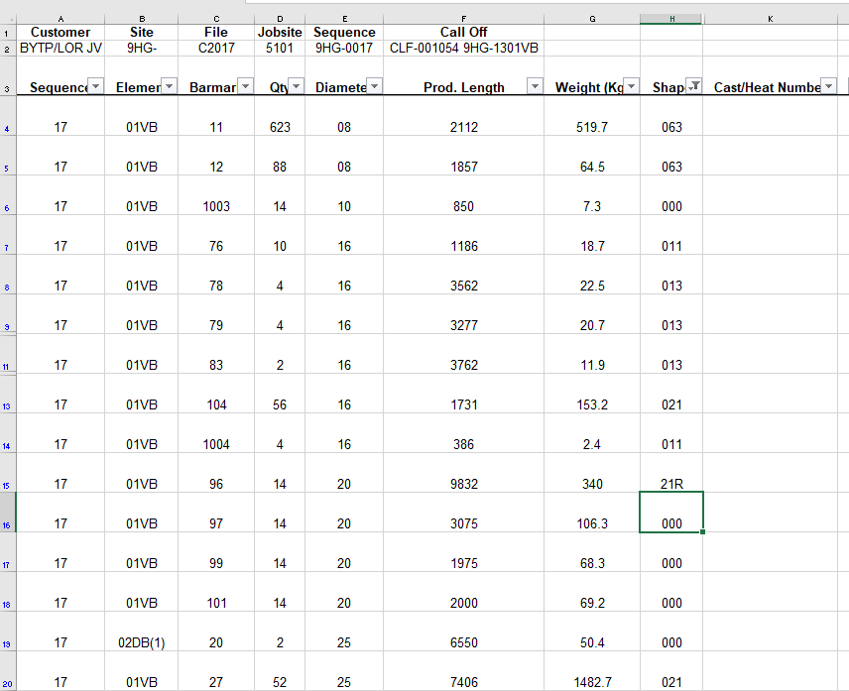
Figure 1: QRC Template

These are bars and call offs by customers requiring the certain bars and material for whatever project they are involved in. the shape are numbers in reference to what Express Reinforcements offers as a company.
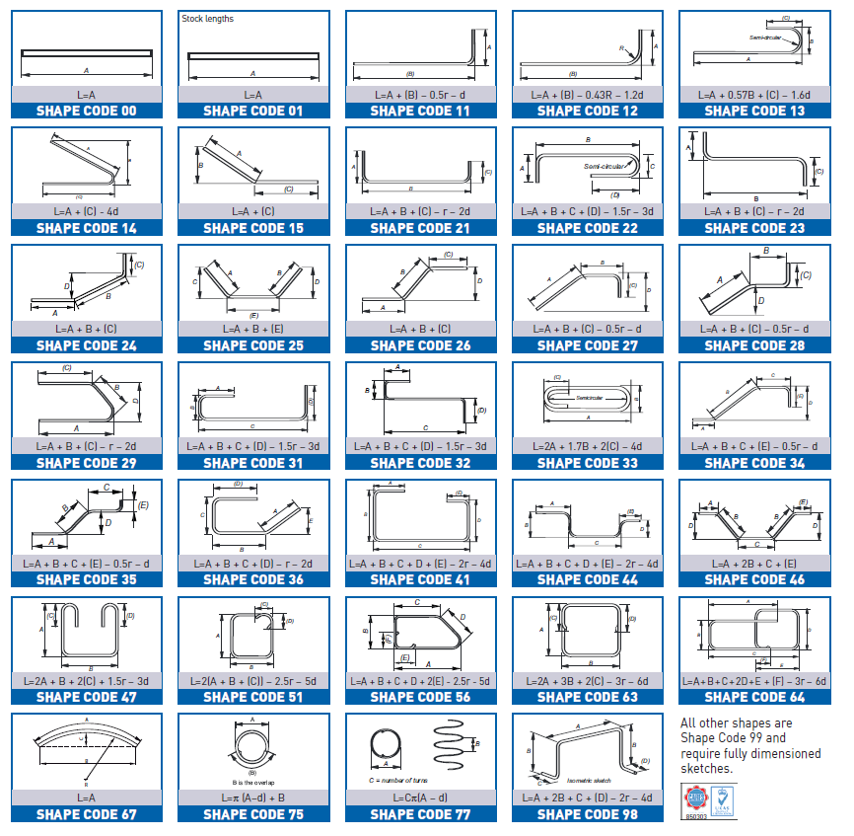
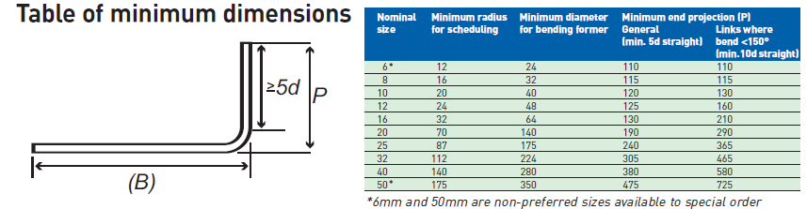
Figure 2: Express Reinforcement Shape Code

With all of these options and the quantity ranging from 1 bar at 15 kg to 15000 bars to 1.5 tonne in weight this is where the traceability becomes harder and harder to keep up with to create a QRC.
The company needs to find a suitable solution to access all of this information electronically, the full electronic traceability of production at the Neath Depot.
Figure 1. Shows a bottleneck and a constraint as there are many different codes and bar marks to be put into a single sheet. These sheets are generated by transferring data from paper into Microsoft excel and this is providing the sheets are completed and promptly handed in to the quality department by the production machine operators. This is currently how the QRC is being generated at Express; it is taking a lot of time for the Quality technicians to gather all relevant information and details to put these certificates together. Research of different software packages will now take place for a better understanding of the current market.

Software Package research

To improve the system and stay competitive for the customers that express have it appears there must be more time spent on production and less time spent on QRC’s. A paperless system will mean more throughput with less chance there is a delay.

Sage 50 Accounts
Sage 50 Accounts is a company software programme, which helps manage all-important documentation and information. It manages accounts mainly but this is something that would be ideal in the manufacturing industry. (Chalzik, 2018) States “Sage 50 Accounts accounting package with paperless Document Management software. Being much more than a simple document management solution, Paperless software allows companies to improve productivity levels and increase invoice processing speeds through the automation of the entire document management process.
This type of software package allows companies and businesses to keep track of all transactions previously made, currently and future and allows storage of documentation, which is exactly what Express reinforcements, is in need of from its production department to the quality department.

SAP
SAP is another software package, which is used in companies across the globe, it is used to transfer information between companies and within companies, it handles data storage deliver to customers, accounts and production information. (Jacob, 2017) States” the software is Easy to manage, which includes your SAP and non-SAP applications with all the processes, tools, and services you need to support your IT landscape now and in the future”.
(McDermott, 2018) Also states, “At SAP, information security is a priority. That is why we focus significant research and resources protecting of our customers’ businesses. This can clearly be seen as a secure and trustworthy network to consider.

Arma Plus
ARMA plus solutions is a manufacturing software, which carries data from one part of a process to another. It helps link all data within the software so industries can rely on entering data and safely transferring it. Arma uses Touch Box scanners on production lines where they can scan barcodes and cast labels to transfer into software and later us them to record. (Coulson, 2016) States, “The Touch Box is a major equipment in the A+ Software processes. It is the link between the factory and the technical and administrative database. The implementation of our services helps improve your profitability, optimizing your return on investment and your cost-effectiveness. Our solutions are scalable, following the progression of your activities”.
This software is thought to help industrial companies with data management and transfer and also integrated into the production process, this system is very efficient.

Recommendations

It is clear there is much more research and work to be done when considering improving this process within express reinforcements. There are constraints in this proposal as the project is not underway it is all research and there are many different companies and processes to study and consider. The actual project will be more in depth and will be able to define, measure, analyze, improve and control the whole process.

Bibliography

Brand, D. R., 2014. Manufacturing Data System - Go Paperless. [Online]
Available at: https://plantrun.co.uk/manufacturing-data-system.html?gclid=EAIaIQobChMIr9eX_o-Y3gIVU-d3Ch2DeA3LEAAYASAAEgLpXvD_BwEE
Chalzik, S., 2018. Sage. [Online]
Available at: https://paperlesseurope.com/paperless-software-document-management-for-sage-50-and-200/?gclid=EAIaIQobChMI-unWxOzW3gIVTbftCh0uMw2bEAAYAyAAEgLf0_D_BwE
[Accessed 09 11 2018].
Charles, T. A. &. T., 1998. Combining Qualitative and Quantitative Approaches. Mixed Methodology, p. 6.
Costa, J., 2010. What is Traceability?. Best Practices for Traceability in Manufacturing, p. 1.
Coulson, M., 2016. A+ SOLUTIONS: A comprehensive response to universal expectations. [Online]
Available at: https://www.armaplus.com/solutions-comprehensive-response-to-universal-expectations/
[Accessed 13 11 2018].
Davies, J., 2015. The market leaders in steel reinforcement, buildability, innovation.. [Online]
Available at: https://www.expressreinforcements.co.uk/about/
Dunkley, R., 2015. Saving time. Paperless document management saves time, money and the environment, p. 4.
Jacob, M., 2017. Industry Solutions Direct. [Online]
Available at: https://www.sap.com/industries.html
[Accessed 12 11 2018].
Krivokapić2, M. S. &. J. J. &. Z., 2009. 7QC TOOLS IN SIX SIGMA. Basic Quality Tools in Continuous Improvement Process, p. 4.
Leedy, P. D., 1993. Practical research: planning and design.. New Jersey: Prentice-Hall.
McDermott, B., 2018. A Discussion on Digital Transformation and the Future. [Online]
Available at: https://www.sap.com/corporate/en/company.integrated-report.html#integrated-report
[Accessed 12 11 2018].
Piller, C., 2018. Methodology and its uses. [Online]
Available at: https://www.merriam-webster.com/dictionary/methodology
[Accessed 01 11 2018].
Prasath, R. K. B. &. K. A., 2018. SIX SIGMA METHODOLOGY. SIX SIGMA CONCEPT AND DMAIC IMPLEMENTATION, p. 113.
Pratik M Patel, V. A. D., 2017. PROBLEM IDENTIFICATION. Application Of Plan-Do-Check-Act Cycle For Quality And Productivity Improvement - A Review, Volume 5(ISSN: 2321-9653), p. 197.
Qing Chang, J. N. &. S. B., 2009. Real time production improvement through bottleneck control, 47(Issue 21 ), p. 9.
Seth, U. S. &. R., 2014. Reasons to Go Paperless. Paperless Office: A New Name to Technology, p. 2.
Steyn, h., 2002. Project management applications of the theory of constraints beyond critical chain scheduling. International Journal of Project Management, 20(1), pp. 75-80.

