Adekoyejo Sobola (1601748)
University of Wales Trinity Saint David

Amazon Human Resource Management

Table of Content
Introduction ………………………………………………………………………… 1
Effect of Internal External Environment of Human Capital Development …............ 3
Staffing/ Recruitment Selection ……………………………………………………. 4
Policy Setting ……………………………………………………………………. 7
Compensation and Benefit………………………………………………………….. 9
Retention, Engagement, and Motivation ………………………………………….. 10
Training and Development ……………………………………………………….. 11
Monitoring & Performance Management ……………………………………….. 11
Employment Law...….…………………………………………………………….. 13
Conclusion ………………………………………………………………………… 14
References…………………………………………………………………………. 15
BIBLIOGRAPHY…………………………………………………………………. 23
Appendix ………………………………………………………………………….. 25

Introduction

This paper seeks to evaluate the Human Resource Management in a large organisation, and the internal and external environmental factors that influence Human Resource Strategy. The processes of engaging employees for high performance in the workplace, commitment to equality of opportunity; managing diversity. Strategies the organisations utilise to develop key talent to create sustainable competitive advantage through workforce and how the organisations attract, select, developing and retain staff and what skills drives and influences organisation performance. This paper will employ the S.W.O.T and P.E.S.T.E.L Analysis. Appendix 1 defines S.W.O.T and P.E.S.T.E.L Analysis
Amazon, Inc. the E-commerce giant is the case study. Amazon.com, Inc. has 541,900 employees and a revenue of US$M 135,987 billion (2016). (Marketline.com, 2017) (Day, 2017a). Amazon is actively seeking to automate, and this poses a huge challenge for the Human resource management (HRM).

HRM is the management of people and the function of HRM includes, designing organisation structures, designing types of contract for employees, recruiting, selecting and developing the people for roles. HRM function contains finding the right people, with the right skills for the services needed (Hall, et al., 2017).

Fig 1
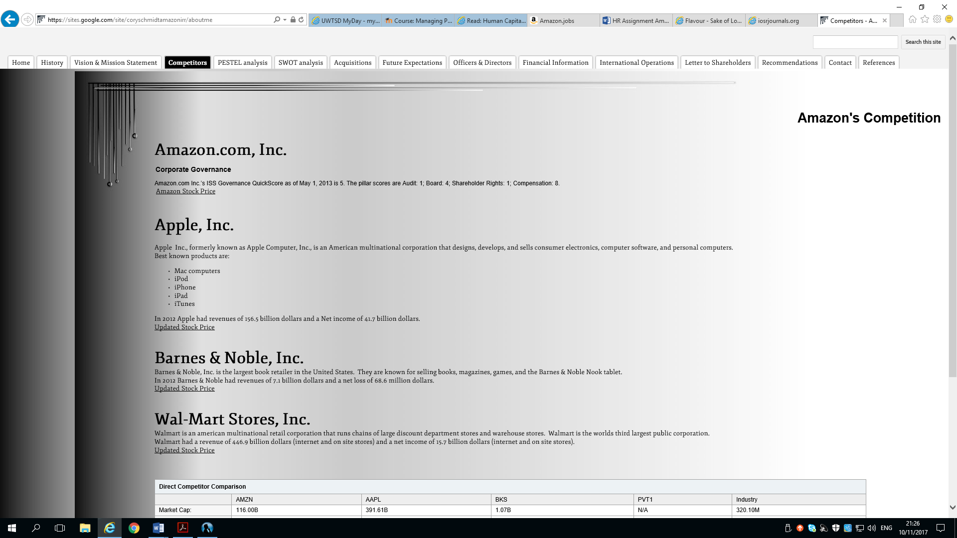
(Google.com, 2013a)
Storey, (2001) Suggested that HRM is a distinctive approach to managing Human Resources (HR), and it can give a competitive edge to organisations through strategic placement of committed, loyal and capable workforce by using different arrays personnel techniques.

Jeff Bezos the founder of Amazon found an opportunity to launch an e-commerce company. (Barringer & Ireland, 2016, p. 65) Said, “An entrepreneur recognises a problem or an opportunity gap and creates a business to address the problem or fill the identified gap”, and now, Amazon is dominant in so many markets (Ruddick, 2013). Amazon.com has become a global company revolutionizing and disrupting multiple industries (New York Times, 2017) (Anthony, 2008).

Effect of Internal External Environment of Human Capital Development

(Johnson, et al., 2014) suggested that strategy is ‘the long-term direction of an organisation’ therefore the Amazon’s HRM has huge challenge as the company is a growing and launching products at different locations across the world. Consequently, Amazon HRM must recruit and train staff to achieve company goals. Hence, the HRM strategist must have a good understand of the competitive environment and constantly must appraise the talent they already possess (Grant, 2013). See Appendix 2 on Swot Analysis.

Accordingly, the HRM must assess the internal and external environment, however, the HRM at Amazon, has a strong executive leadership that support HR strategic development, but one major weakness for the HRM is maintaining employee morale and reducing staff turnover.

The growth opportunities for the company’s workforce is increasing due to demand for products, the ability of humans and robot working side by side without loss of jobs and the ability to attract better calibre of staff with innovative ideas.

The PESTEL analysis in Appendix 3, analysed the external factors affecting the HRM function at Amazon as the HRM must deal with external negative public perceptions and bad publications including Facebook, see fig 2 below.

Fig 2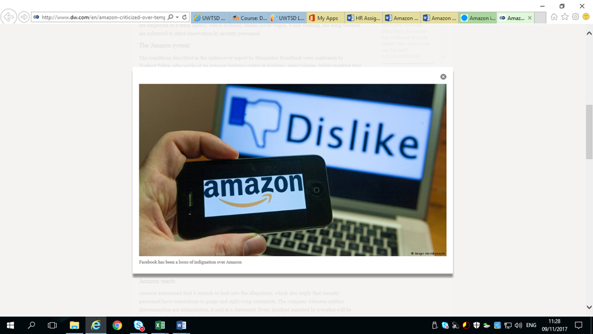
(Fraczek, 2013)

Staffing/ Recruitment Selection

The HRM in undertaking the recruitment and selection of staff must ensure that the employed the right people with the right skills. Therefore, HRM must be aware of the business environment, be aware of employment, the economic climate, skills shortages and the future corporate objectives (Martin, et al., 2010).

Amazon advertised jobs through their own dedicated Job website, See Fig 3 & Fig 4 (Amazon.com Inc, 2017a); they also advertise jobs on T.V, radio, and other professional Websites. Amazon is an organisation that is creating new jobs because of rapid growth (Reuters, 2017). In 2018, Amazon will employ 150,000 work-force and in 2016, thousands of holiday positions were permanently employed (Baron, 2017), therefore Amazon needs to recruit the right human capital.

Schultz, (1961) described Human Capital as ‘all human abilities to be either innate or acquired’. The Amazon’s 14 leadership style clearly states the instructions for the employee and these rules are part of their daily language and used in hiring (Kantor & Streitfeld, 2015). Amazon’s recruiters identify thousands of job prospects, by providing extra screening, they raise the bar because their mission is hiring the best.

Besides, Staff performances are linked to the success of their assigned projects or they are let go (New York Times, 2015).

Fig 3
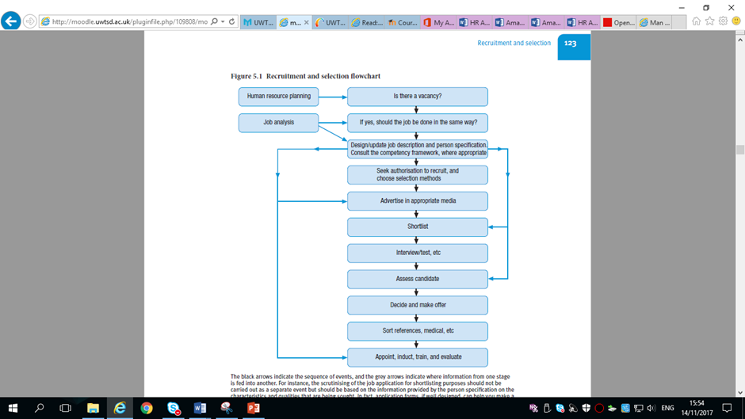

(Martin, et al., 2010)

Amazon has been successful in the process called “Purposeful Darwinism,” The HRM believes they will never have accomplished their success without Amazon’s cycle of constantly hiring employees, driving them and cutting them but at what cost? (Swartz, 2017).

Amazon is innovative organisation and do things that are not easy and the nature of the work is challenging, thus, not many people could work in the environment (Kantor & Streitfeld, 2015).

Working in Amazon requires a different capability (Mayo, 2000). (Prahalad & Hamel, 1990) Argued that ‘people are the only source of continuing competitive advantage’ but Amazon achieve competitive advantage in the Synergies between Marketplace, Amazon Web Services, and Amazon Prime and being consumer centric (Amazon.com Inc, 1997-2017b).

The purchase of Whole Foods Market will give Amazon more physical presence, and this will improve business synergies (González, 2017).

Fig 4

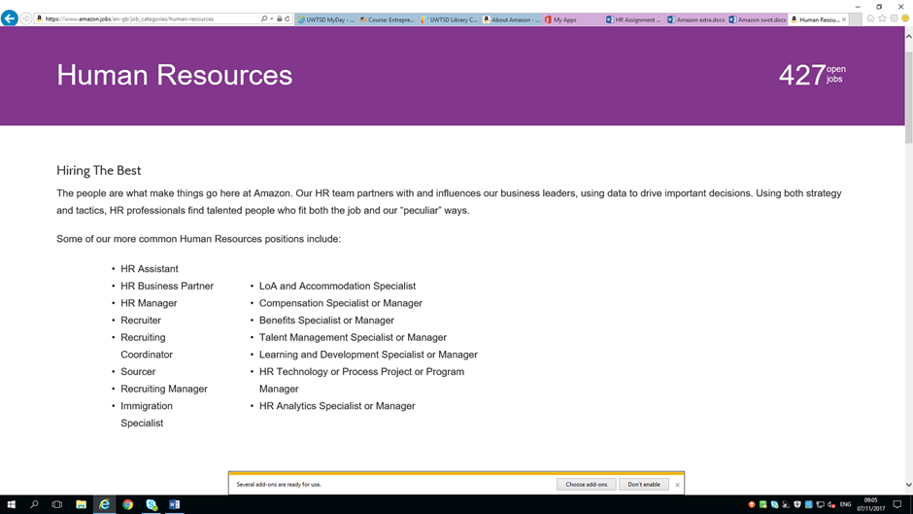

(Amazon.com Inc, 2017j)

More so, there is a diverse workforce at Amazon (see Fig 5) in terms of gender, age and ethnicity. Amazon pride itself as a diverse organisation and men and women earn 99.7 cent to dollar and says there is pay equality, but there is neither a woman or black or ethnic minority in the top tier of the organisation’s leadership team compared to Facebook, Google or Walmart (Google.com, 2013b). See Fig 6

Fig 5
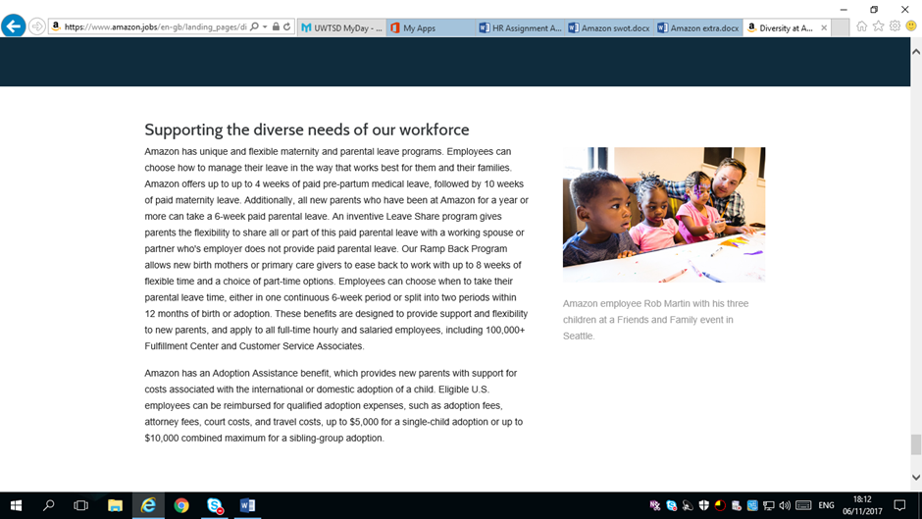
(Amazon.com Inc, 2016i)

Fig 6
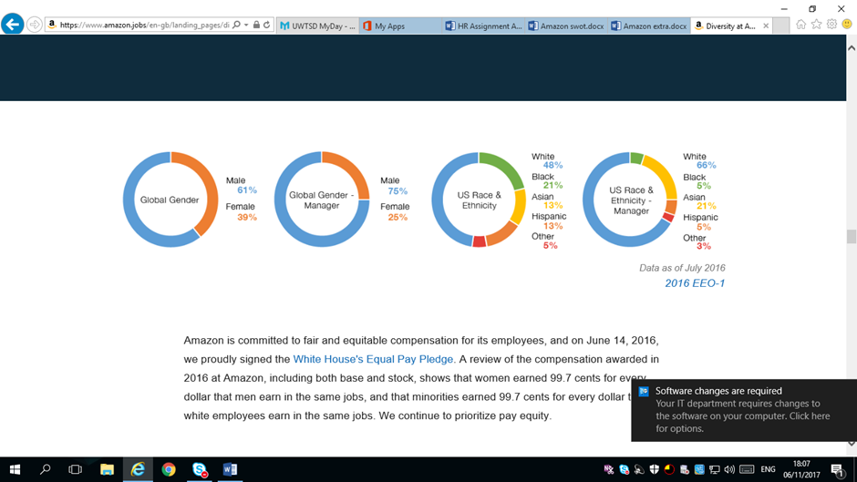
(Amazon.com Inc, 2016i)

Amazon needs to answer the question whether it has a job for the disable since their mantra is simply to employ the best, where is Amazon’s CSR.

Policy Setting

Amazon seeks to be a cost leader (Porter, 1998) and this is another competitive advantage. They have disrupted the book market, the big data market and the brick and mortar shops.

Furthermore, Amazon uses open book management, and trains employees to become more business literate and Staff are encouraged to own their jobs (Barton, et al., 1999), consequently there is no job for non-entrepreneurial Staff.

Again, Amazon believes in small teams versus bureaucratic control, internal competition. The rivalries at Amazon, where people challenge each other, and ideas must compete to win, this, can be very exhausting and uncomfortable for some especially women. Amazon encouraged staff to embraced risk, and every idea is critically tested, and any staff can contribute ideas. Nonetheless, Amazon believes that robust and tensed debate leads to right decisions according to Amazon Vice President for human resources (Kantor & Streitfeld, 2015).

Conversely, the former HRM (Rossman, 2016) said, “It’s the greatest place I hate to work”.
Some staff embraced the challenge but still they do not stay long (The Economist, 2014).

They believe that new employees always create new value and new ideas for compensation and that regenerates the company, but how are the staff invigorated? (Streitfeld, 2014).

Amazon embraced Taylorism by “Roboticing” of work processes (Winslow, 2005), they reinforced FW Taylor’s believed in technical structuring of each process and that there is a machine for each job and this is the idea behind “Amazon Robotics Challenge,” the contest to build robots that can do human warehouse work.

On the other hand, Schumpeter’s blueprint is behind the Digital Taylorism, a modern version of “scientific management” threatening to dehumanise the workplace (Schumpeter, 1952), (The Economist, 2015). See Fig 7 of Amabot.

Fig 7



(Rosenblatt, 2015)

Amazon’s is utilising thousands of robots at their centres under the pretence that the robots will shorten the pickers’ journey (The Economist, 2014). The implication of the policy in the end is more robots, less human jobs (Baron, 2017).

Amazon Go has already taken over the checkout jobs at Amazon (Zaleski & Soper, 2017) (Kumar, 2016). But, for now, Robots and Humans are still working together at many job areas in Amazon (Chainon & Mullin, 2017). See Fig 8

Fig 8
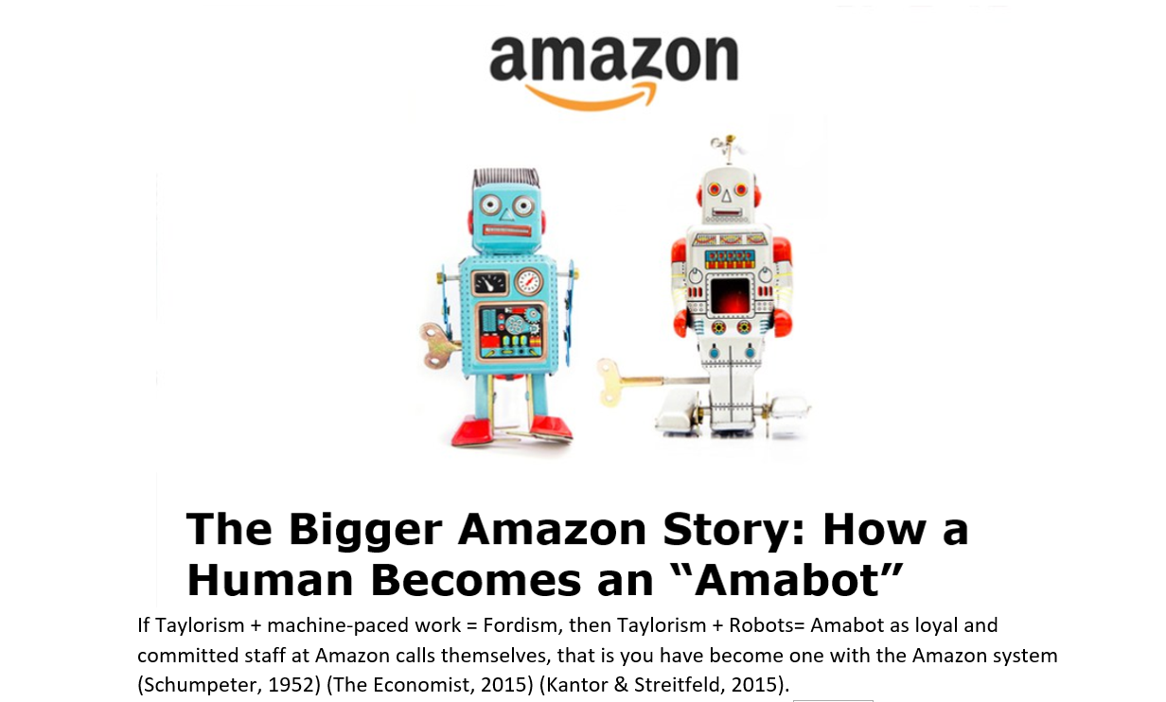
(Rosenblatt, 2015)

Compensation and Benefit

Reward management is a key HRM function as it deals with how employees are remunerated and motivated to improve performance and productivity (Marchington, et al., 2016). At Amazon, the SVP, International Consumer Business is the highest paid employee $175,000 this is less compared to others in tech industry (Google.com, 2013b). Similarly, Amazon considers its compensation as competitive because successful managers collect bonus of stock at the end of the year. Nonetheless, the values of stock are subject to fluctuations. Time will tell how many millionaires Amazon will create compared to Microsoft, Google, and Facebook.

Besides, Amazon’s parental leave policy was less desirable unlike other top high-tech companies like Twitter and Facebook. Consequently, due to bad press and internal pressure, Amazon HR has now reviewed the parental policy.

The HRM has now design flexible maternity and parental leave programs that worked for all employees (Umoh, 2017), or they will struggle to retain hard to find technical talent. (Kantor & Streitfeld, 2015). See Fig 9 for Amazons benefit system.

Retention, Engagement, and Motivation
A 2013 survey by PayScale a salary analysis firm, concluded that Amazon has high attrition, and revealed a one-year tenure for an average staff. Amazon insisted tenure was low because hiring was so robust, adding that 15 percent of employees had been at the company for more than five years. Rossman the former HRM at Amazon said, “We hire a lot of great people, but we don’t always get it right.” Obviously, Amazon cannot find a way to reduce staff turnover (Rossman, 2016).

Fig 9
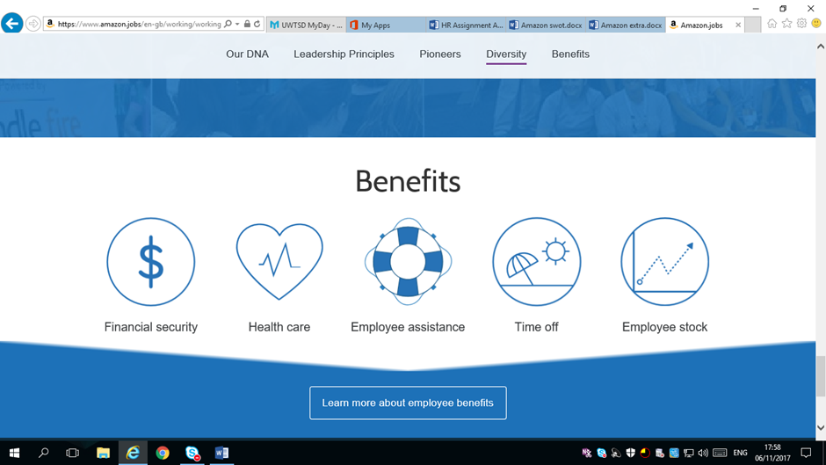

(Amazon.com Inc, 2017i)

Many of Amazon’s staff are defecting to Facebook; one of them is Nimrod Hoofien, now a director of engineering at Facebook (Kantor & Streitfeld, 2015). The staff turnover at Amazon is not only due to pay, as it is hard for any company to hire and retain top employees especially when other companies are offering more attractive benefits with competitive salary.

There is an underlying job dissatisfaction behind the high turnover. (Herzberg , 1968) Opined the Hygiene factor, where better pay does not necessarily motivate but the extrinsic rewards. See Fig 10. Staff at Amazon worked excruciating hours, with little work-life balance.

Landauer, (1997) Proposed that companies that engage in work-life balance of their staff experienced increased productivity. Google and Facebook motivate employees with gyms, meals and benefits, financial compensation for new parents (Stone & D'Onfro, 2015). Amazon needs to evaluate and improve Staff’s well-being (Adams, 2007). Nonetheless, there are few employees that enjoyed being pushed hard because they are giving the power to own their work and the possible promotion, this satisfy the expectancy theory for these group of staff (Vroom, 1964).

Fig 10

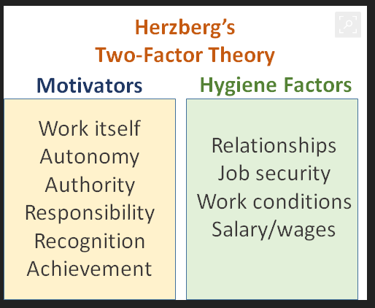
(Oshatrain, 2017)

Training and Development

The HRM ensure that Staff can be the best Amazonians they can be, by guiding them to follow the 14 leadership principles, which is the core of the Amazon culture.
On Staff development, Amazon claimed to have 25 classrooms out of over 180 fulfilment centres to help associates pursue their passions. Certainly, the ratio of classroom to fulfilment centres is poor thus, few staff could benefit from the opportunity, and Amazon helps staff with school fees, besides, Amazon always recruit their former staff that returned from studying MBA (Amazonnews, 2017).

Monitoring & Performance Management

It is expedient to say that the Amazon’s HRM uses the ‘Matching’ model’ as employee resources because workforce is managed and measured like Robots (Devanna, et al., 1981). See fig 11

Fig 11

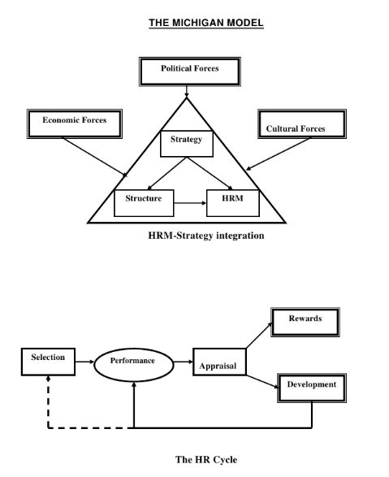

(Slideshare.net)

At Amazon the Key HR areas includes selection, performance, appraisal and monitoring, rewards for performance, skill development etc. Data allows for continuous measurement of workforce performance at Amazon warehouses (Streitfeld, 2015). The Amazon HR team collaborates with and influences the company’s business leaders by using data to drive important decisions. Using both strategy and tactics, the HR professionals find talented people who fit both the job and Amazon’s peculiar ways, but it’s not yet a success for all recruit (Amazon, 2017).

The welfare of the workforse was of little concern because Amazon uses a set of management, data and psychological tools to push its employees to do more. The performance improvement algorithm on staff is relentless (Kantor & Streitfeld, 2015). The Feedback Tool, is also used by employees to praise or criticise colleagues (Atwater & Waldman, 2008) described the importance of feedback and open communication processes, unfortunately, the system was used by staff as a scheming tool, Some good staff are sabotaged by negative comments from colleagues, and there were suggestions that Staff were not fairly evaluated (Kantor & Streitfeld, 2015).

Employment Law

Amazon must abide by legislations at all its operating regions and countries of the world which includes but not limited to Fig 12 below.

Fig 12

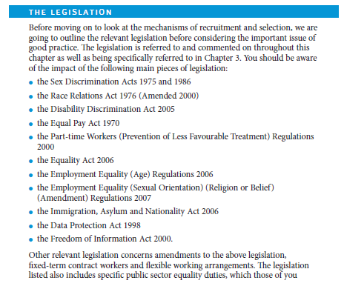
(Martin, et al., 2010)

Conclusion

Amazon is a very innovative company; it has produced disruptive innovations (Anthony, 2008) and is disturbing itself by the Scale of the costly Staff turnover and the staff turnover certainly needs reviewing.
Since Amazon, is customer centric, less thought was given to staff wellbeing? The introduction of robots will only result in loss of jobs, human still has jobs because they have not yet figure out how robots could do jobs done by human. This paper discovered how Amazon used data to measure staff’s performance, however, staff’s feedback system is a big part of the organisation, these tools are crucial to HRM functions. Again, the organisation operates an uncompetitive wage structure compared to competitors and Staff motivation is low and Staff wellbeing is poor, these leads to attrition

Recommendation

- The HR team need to come up with a better solution of how to retain staff, the current system is counter-productive, as the constant cutting of workforce will continue to lead to top talent loss. Intense pressure and scrutiny is not for everyone.
- The HRM must find ways to improve the staff motivation and the internal and public perception of the company’s staff attrition.
- Amazon will also do better if they put staff’s wellbeing at the centre of the operational policy, not everyone likes competition and rivalries as it can be uncomfortable or else Amazon will continue to lose talented workers.
- The constant monitoring of staff movements and performance of employees is dehumanising and needs reviewing.
- Amazon must improve the staff feedback system to eliminate the deliberate sabotage by co-workers this will further help in staff retention.
- Amazon can stop the lip service to equality, Amazon must create equal opportunity environment whereby all staff can attain top positions.
- Talented disabled people must be given employment opportunity.

REFERENCES
Adams, J., 2007. Managing People in Organisation Contemporary theory and Practice. Basingstoke: Palgrave Macmillan.
Amazon.com Inc, 1996-2017c. Leadership Principles. [Online]
Available at: https://www.amazon.jobs/principles
[Accessed 14 11 2017].
Amazon.com Inc, 1997-2017a. Amazon.com Inc. [Online]
Available at: https://www.amazon.com/p/feature/xqkh4k2t3q8s3yv
[Accessed 6 11 2017].
Amazon.com Inc, 1997-2017b. Corporate Governance. [Online]
Available at: http://phx.corporate-ir.net/phoenix.zhtml?c=97664&p=irol-govhighlights
[Accessed 28 10 2017].
Amazon.com Inc, 2016i. hamazon.jobs/diversity. [Online]
Available at: https://www.amazon.jobs/en-gb/landing_pages/diversity
[Accessed 6 11 2017].
Amazon.com Inc, 2017a. Amazon.com Grow Your Business in the Cloud. [Online]
Available at: https://www.amazon.com/p/feature/46j9rr5chvnu3x2
[Accessed 29 10 2017].
Amazon.com Inc, 2017b. Amazon.com Inc Amazon Launchpad. [Online]
Available at: https://www.amazon.com/p/feature/kzwyhyjs7ore8d6
[Accessed 29 10 2017].
Amazon.com Inc, 2017c. Amazon.com Inc Parental Leave Policy. [Online]
Available at: https://www.amazon.com/p/feature/6t6qwashg35v883
[Accessed 29 10 2017].
Amazon.com Inc, 2017d. amazon.jobs. [Online]
Available at: https://www.amazon.jobs/en-gb/working/working-amazon
[Accessed 6 11 2017].
Amazon.com Inc, 2017h. Find jobs by location. [Online]
Available at: https://www.amazon.jobs/en-gb/locations/?&continent=all&cache
[Accessed 14 11 2017].
Amazon.com Inc, 2017j. Human Resources. [Online]
Available at: https://www.amazon.jobs/en-gb/job_categories/human-resources
[Accessed 6 11 2017].
Amazon.com Inc, 2017k. Amazon.jobs. [Online]
Available at: https://www.amazon.jobs/?ref_=aa_navt_2&pf_rd_r=7JDR2H8QTA2JRM5D4652&pf_rd_p=e1b3a2f9-b58d-495d-83e7-7811f89dce51
[Accessed 29 10 2017].
Amazon.com Inc, 2017l. US Benefits and Stock. [Online]
Available at: https://www.amazon.jobs/en-gb/benefits
[Accessed 6 11 2017].
Amazon, 2017e. Amazon.jobs. [Online]
Available at: https://www.amazon.jobs/en-gb/job_categories/human-resources
[Accessed 6 11 2017].
Amazon, 2017g. Diversity at Amazon. [Online]
Available at: https://www.amazon.jobs/en-gb/landing_pages/diversity
[Accessed 6 11 2017].
Amazonnews, 2017. Amazonnews. [Online]
Available at: https://twitter.com/amazonnews
[Accessed 9 11 2017].
Anthony, S. D., 2008. The innovator's guide to growth: putting disruptive innovation to work. Boston: Harvard Business School Press.
Atwater, L. E. & Waldman, D. A., 2008. Leadership, Feedback and the Open Communication Gap. New York: Taylor & Francis Group,LLC.
Baron, E., 2017. siliconbeat. [Online]
Available at: http://www.siliconbeat.com/2017/11/01/amazon-hiring-800-workers-in-bay-area-job-fairs-start-nov-2/
[Accessed 5 11 2017].
Barringer, B. R. & Ireland, R. D., 2016. Entrepreneurship: successfully launching new ventures. 5 ed. Harlow: Pearson.
Barton, B. L., Shenkir, W. G. & Tyson, T. N., 1999. Open-Book Management. CPA Journal, 69(Issue 3), p. p36. 6p. 1.
Blodget, H., 2014. No Profits, The Book Controversies, The Phone Flop — And He Showed Why Amazon Is Such A Huge Success [Interview] (13 12 2014).
CNBC, 2016. cbsnews.com. [Online]
Available at: https://www.cbsnews.com/news/should-low-wage-workers-have-to-sign-non-compete-agreements/
[Accessed 28 10 2017].
CNBC, 2017. CNBC.com. [Online]
Available at: https://www.cnbc.com/2017/03/24/the-holiday-is-over-amazon-will-collect-sales-taxes-nationwide-on-april-1.html
[Accessed 28 10 2017].
Day, M., 2017a. Seattletimes.com Amazon’s breakneck growth pushes head count past a half-million. [Online]
Available at: https://www.seattletimes.com/business/amazon/amazon-exceeds-earnings-expectations-as-head-count-tops-a-half-million/
[Accessed 29 10 2017].
Day, M., 2017b. Seattletimes.com Amazon unveils newer, smaller Echo — with newer, smaller price. [Online]
Available at: https://www.seattletimes.com/business/amazon/amazon-extends-its-bid-for-smart-home-and-entertainment-devices
[Accessed 29 110 2017].
Echdar, H. S., 2013. Effect of Internal and External Environment of Human Capital Development (Empirical Study on Manufacturing Company Gopublik in Indonesia). IOSR Journal of Business and Management, Volume 11(Issue 3), pp. PP 39-56.
Flint, J., 2017. The Wall Street Journal Roy Price Resigns as Head of Amazon Studios. [Online]
Available at: https://www.wsj.com/articles/roy-price-resigns-as-head-of-amazon-studios-1508275459
[Accessed 7 11 2017].
Fraczek, J., 2013. Amazon criticized over temp workers in Germany. [Online]
Available at: http://www.dw.com/en/amazon-criticized-over-temp-workers-in-germany/a-16604526
[Accessed 9 11 2017].
González, Á., 2017. Amazon to buy Whole Foods for $13.7 billion in bid to become major grocer. [Online]
Available at: https://www.seattletimes.com/business/amazon/amazoncom-buys-whole-foods-for-137-billion/
[Accessed 14 11 2017].
Google.com, 2013a. Amazon's Competition. [Online]
Available at: https://sites.google.com/site/coryschmidtamazonirr/aboutme
[Accessed 9 11 2017].
Google.com, 2013b. 2012 Summary Compensation Table For top Officers/Directors. [Online]
Available at: https://sites.google.com/site/coryschmidtamazonirr/board-of-directors/compensation-table
[Accessed 9 11 2017].
Google, 2017c. PESTEL. [Online]
Available at: https://sites.google.com/site/coryschmidtamazonirr/pestel-analysis
[Accessed 9 11 2017].
Grant, R. M., 2013. Contemporary Strategy Analysis. 8 ed. Oxford: Blackwell Publishing.
Hall, T. L., Atkinson, C. & Taylor, S., 2017. Human Resource Management. 1 online resource ed. Harlow: Pearson Education.
Herreria, C., 2017. huffingtonpost.co.uk. [Online]
Available at: http://www.huffingtonpost.co.uk/entry/roy-price-resigns-sexual-harassment_us_59e672ede4b08f9f9edb6572
[Accessed 7 11 2017].
Herzberg, F., 1968. One more time: How do you motivate your employee? Harvard Business Review, Issue January-March, p. 56.
Johnson, G. et al., 2014. Exploring Strategy. 10 ed. Harlow: Pearson Education Limited.
Jurevicius, O., 2017. strategicmanagementinsight.com. [Online]
Available at: https://www.strategicmanagementinsight.com/swot-analyses/amazon-swot-analysis.html
[Accessed 5 11 2017].
Kantor, J. & Streitfeld, D., 2015. Inside Amazon: Wrestling Big Ideas in a Bruising Workplace. [Online]
Available at: https://www.nytimes.com/2015/08/16/technology/inside-amazon-wrestling-big-ideas-in-a-bruising-workplace.html
[Accessed 2 11 2017].
Kitroeff, N., 2017. Seattle Times.com E-commerce warehouses bring new life to defunct manufacturing hubs. [Online]
Available at: https://www.seattletimes.com/business/retail/e-commerce-warehouses-bring-new-life-to-defunct-manufacturing-hubs/
[Accessed 29 10 2017].
Kumar, N., 2016. Amazon Go, London: Marketline.com,
Landauer, J., 1997. Bottom-Line Benefits of Work/Life Programs. Benefits Quarterly, 13(4), p. 96.
Lerman, R., 2015. seattletimes.com. [Online]
Available at: https://www.seattletimes.com/business/technology/amazon-increases-paid-leave-for-new-parents/
[Accessed 29 10 2017].
Manjoo, F., 2014. bits.blogs.nytimes.com. [Online]
Available at: https://bits.blogs.nytimes.com/2014/10/20/amazons-new-high-end-kindle-beats-hardcovers/?action=click&contentCollection=Technology&module=RelatedCoverage&region=Marginalia&pgtype=article
[Accessed 2 11 2017].
Marchington, M., Wilkinson, A., Donnelly, R. & Kynighou, A., 2016. Human Recourse Management at Work. 6 ed. London: CIPD.
Marketline.com, 2017. Amazon.com, Inc. Company Profile. [Online]
Available at: http://advantage.marketline.com.ezproxy.uwtsd.ac.uk/Product?pid=2B52E1D8-E964-4D7F-8B1B-C48DBC97815F&view=SWOTAnalysis
[Accessed 5 11 2017].
Martin, M., Whiting, F. & Jackson, T., 2010. Human Resource Practice. 5 ed. s.l.:CIPD.
Mayo, A., 2000. The role of employee development in the growth of intellectual capital. Personal Review, 29(4).
MSN, 2017. Jeff Bezos is now the richest man in the world with $90 billion. [Online]
Available at: https://www.msn.com/en-gb/money/news/jeff-bezos-is-now-the-richest-man-in-the-world-with-dollar90-billion/ar-AAu89x2?li=AAmiR2Z&ocid=spartanntp
New York Times, 2016. nytimes.com. [Online]
Available at: https://www.nytimes.com/2015/01/13/business/media/award-for-transparent-vindicates-amazons-tv-executives.html?action=click&contentCollection=Business%20Day&module=RelatedCoverage&region=Marginalia&pgtype=article
[Accessed 28 10 2017].
New York Times, 2017a. Jeff Bezos and Amazon Employees Join Debate Over Its Culture. [Online]
Available at: https://www.nytimes.com/2015/08/18/technology/amazon-bezos-workplace-management-practices.html?action=click&contentCollection=Business%20Day&module=RelatedCoverage&region=Marginalia&pgtype=article
[Accessed 28 10 2017].
New York Times, 2017b. Robots and Humans Team Up at Amazon. [Online]
Available at: https://www.nytimes.com/video/technology/100000005396963/robots-humans-team-up-amazon-warehouses.html?action=click&contentCollection=business&region=supplemental&module=undefined&contentPlacement=7&pgtype=collection
[Accessed 7 11 2017].
Nytimes.com, 2014. Nytimes.com. [Online]
Available at: https://www.nytimes.com/2014/12/02/technology/to-gain-the-upper-hand-amazon-disrupts-itself.html
[Accessed 27 10 2017].
Oshatrain, 2017. Herzberg’s Two-Factor Theory. [Online]
Available at: https://www.bing.com/images/search?view=detailV2&ccid=4GX2BC3e&id=F37E0CD404B879C9A759D03B3E4199FFABF0A515&thid=OIP.4GX2BC3epPt0Co1JWcK6IQEVDg&mediaurl=http%3a%2f%2fwww.oshatrain.org%2fcourses%2fimages%2fherzberg.gif&exph=403&expw=498&q=representation+of+
[Accessed 14 11 2017].
Osterwalder, A., 2017a. blog.strategyzer.com Can (Lean) Innovation Ever Conquer The Board Room?. [Online]
Available at: http://blog.strategyzer.com/posts/2017/11/8/can-lean-innovation-ever-conquer-the-board-room?utm_source=Master+Email+List&utm_campaign=8c812b40b4-EMAIL_CAMPAIGN_2017_11_02&utm_medium=email&utm_term=0_fd75a09316-8c812b40b4-338690073&mc_cid=8c812b40b4&mc_eid
[Accessed 10 11 2017].
Osterwalder, A., 2017b. blog.strategyzer.com Thought Provoker: Amazon Inno Culture + Business Model Portfolio = Great Valuation. [Online]
Available at: http://blog.strategyzer.com/posts/2017/1/23/thought-provoker-amazon-inno-culture-business-model-portfolio-great-valuation
[Accessed 9 11 2017].
Porter, M. E., 1998. Competitive advantage. Michael E. Porter: Free.
Prahalad, C. K. & Hamel, G., 1990. The Core Competence of the Corporation. Harvard Business Review, 68(3), pp. 79-91.
Reuters, 2017. reuters.com. [Online]
Available at: https://www.reuters.com/article/idUSFWN1FU0T6
[Accessed 4 11 2017].
Rockoff, J. D. & Stevens, L., 2017. WSJ.com. [Online]
Available at: https://www.wsj.com/articles/amazons-push-into-pharmacy-business-is-full-of-promise-and-pitfalls-1509188400
[Accessed 29 10 2017].
Rossman, J., 2016. The Amazon Way: 14 Leadership Principles behind the World's Most Disruptive Company. 2 ed. New York: PR Newswire Association LLC.
Ruddick, G., 2013. Amazon is Britain's most influential retailer - and it doesn’t even make a profit. [Online]
Available at: http://www.telegraph.co.uk/finance/newsbysector/retailandconsumer/10245630/Amazon-is-Britains-most-influential-retailer-and-it-doesnt-even-make-a-profit.html
[Accessed 7 11 2017].
Schultz, T. W., 1961. Investment in human capital. American Economic Review, Volume 51, p. 1–17.
Schumpeter, J. A., 1952. Capitalism, socialism and democracy. 5 ed. London: George Allen & Unwin.
Sledge, M., 2012. huffingtonpost.co.uk. [Online]
Available at: http://www.huffingtonpost.co.uk/entry/amazon-career-choice-pr-stunt_n_1699810
[Accessed 9 11 2017].
Slideshare.net, n.d. The Michigan Model. [Online]
Available at: https://www.bing.com/images/search?view=detailV2&ccid=oMhRjlLD&id=2B1E2FD0BFC217F9AC3AD1BAD59009964C73B153&thid=OIP.oMhRjlLDEmDs0dVFSl_P7gDbEc&mediaurl=https%3a%2f%2fimage.slidesharecdn.com%2fshrm-unit1-120623130636-phpapp01%2f95%2fshrm-unit-1-11-728.jpg%
[Accessed 14 11 2017].
Sobola, A., 2017a. Amazon SWOT Analysis. Carmarthenshire: UWTSD.
Sobola, A., 2017b. Amazon's PESTEL Analysis. Carmarthenshire: UWTSD.
Stone, M. & D'Onfro, J., 2015. Businessinsider.comEmployees confess the worst parts about working for Amazon. [Online]
Available at: http://uk.businessinsider.com/the-worst-parts-about-working-at-amazon-according-to-employees-2015-8
[Accessed 7 11 2017].
Storey, J., 2001. Human resource management: a critical text. 2 ed. London: Thomson Learning.
Streitfeld, D., 2014a. New York Times To Gain the Upper Hand, Amazon Disrupts Itself. [Online]
Available at: https://www.nytimes.com/2014/12/02/technology/to-gain-the-upper-hand-amazon-disrupts-itself.html
[Accessed 4 11 2017].
Streitfeld, D., 2014. bits.blogs.nytimes.com [Interview] (26 9 2014).
Streitfeld, D., 2015b. Nytimes.com. [Online]
Available at: https://www.nytimes.com/2015/08/18/technology/data-crunching-is-coming-to-help-your-boss-manage-your-time.html?action=click&contentCollection=Business%20Day&module=RelatedCoverage&region=Marginalia&pgtype=article
[Accessed 02 11 2017].
Swartz, J., 2017. USA TODAY Amazon is creating 100,000 U.S. jobs, but at what cost?. [Online]
Available at: https://www.usatoday.com/story/tech/columnist/2017/01/13/amazons-jobs-creation-plan-comes-amid-labor-pains/96488166/
[Accessed 28 10 2017].
The Economist, 2014. economist.com. [Online]
Available at: http://www.economist.com/node/21604559#print
[Accessed 6 11 2017].
The Economist, 2015. Schumpeter Digital Taylorism. [Online]
Available at: https://www.economist.com/news/business/21664190-modern-version-scientific-management-threatens-dehumanise-workplace-digital
[Accessed 16 11 2017].
The New York Times, 2015a. Inside Amazon: Wrestling Big Ideas in a Bruising Workplace. [Online]
Available at: https://www.nytimes.com/2015/08/16/technology/inside-amazon-wrestling-big-ideas-in-a-bruising-workplace.html
[Accessed 27 10 2017].
Umoh, R., 2017. cnbc.com. [Online]
Available at: https://www.cnbc.com/2017/10/05/amazon-takes-paid-parental-leave-so-seriously-even-spouses-get-it.html
[Accessed 29 10 2017].
Winslow, T. F., 2005. Scientific management. A to Z of Management Concepts & Models, Volume 3, pp. 366-369.
www.amazon.jobs, 1996-2017f. amazon.jobs/principles. [Online]
Available at: https://www.amazon.jobs/principles
[Accessed 28 10 2017].
Zaleski, O. & Soper, S., 2017. Amazon’s Cashierless Store Is Almost Ready for Prime Time. [Online]
Available at: https://www.bloomberg.com/news/articles/2017-11-15/amazon-s-cashierless-store-is-almost-ready-for-prime-time
[Accessed 16 11 2017].

BIBLIOGRAPHY
Available at: https://www.seattletimes.com/business/amazon/amazon-extends-its-bid-for-smart-home-and-entertainment-devices
[Accessed 29 110 2017].
Amazon.com Inc, 2017. Amazon.com Grow Your Business in the Cloud. [Online]
Available at: https://www.amazon.com/p/feature/46j9rr5chvnu3x2
[Accessed 29 10 2017].
Amazon’s Cashierless Store Is Almost Ready for Prime Time (Zaleski & Soper, 2017)
Amazon launches two furniture lines as private-label ambitions grow (Day, 2017)
Amazon.com Inc, 2017. Amazon.com Inc Amazon Launchpad. [Online]
Available at: https://www.amazon.com/p/feature/kzwyhyjs7ore8d6
[Accessed 29 10 2017].
(Amazon.com Inc, 1997-2017) In the community
Day, M., 2017. Seattletimes.com Amazon unveils newer, smaller Echo — with newer, smaller price. [Online]
Health Human Capital and Economic Development, Journal of African Economies, Volume 19, Issue suppl_3, 1 November 2010, Pages iii12–iii80, (Schultz, 2010)
O’Reilly III, C. A. & Tushman, M. L., 2004. The Ambidextrous Organization. Harvard Business Review, Issue April.
Strategic management of human resources (Echdar, 2013)

Appendices

Appendix 1
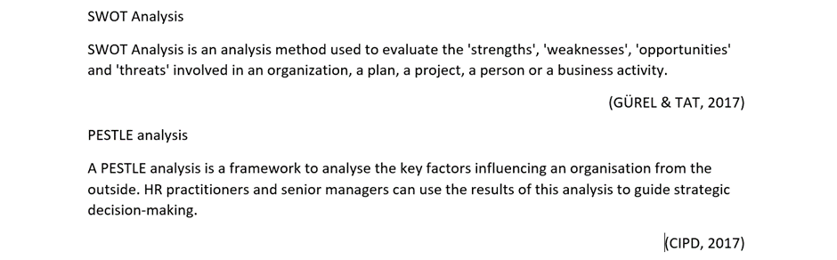

Appendix 2
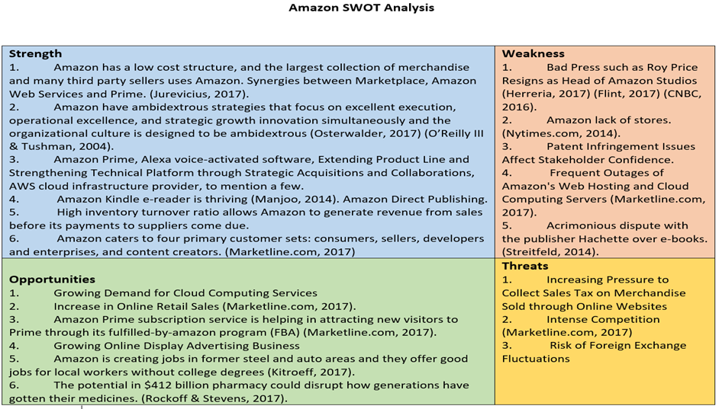
(Sobola, 2017)

Appendix 3
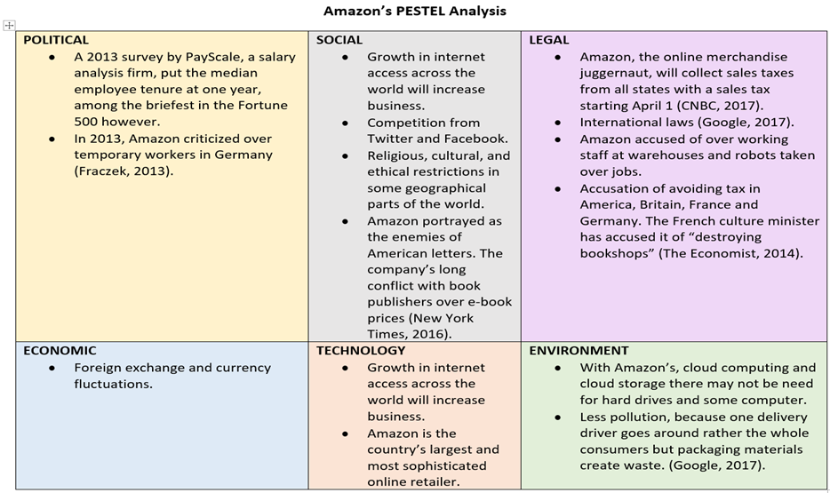
(Sobola, 2017)

Appendix 4

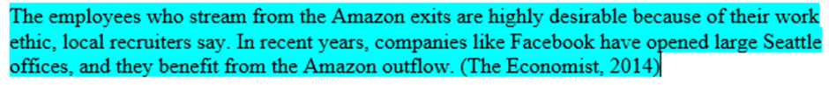

Appendix 5

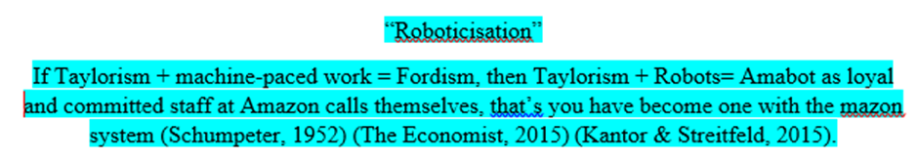

Appendix 6

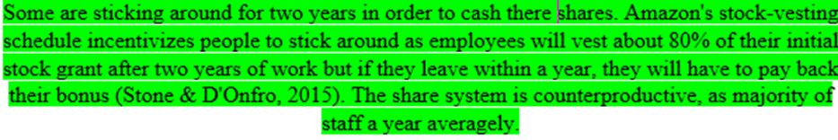

Appendix 7
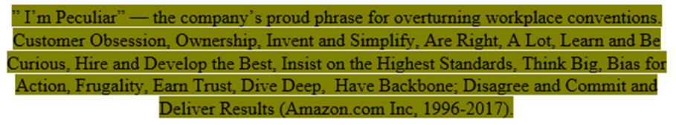

Appendix 8


