Business Plan for

Bean Travel Garden

Produced By:

Elijah Thomas

Dated: 04.07.25

Student Number: 2313487
Module Name: Entrepreneurship
Module Code : BMIH5012

CONTENTS

 |  |  | PAGE
1. | Executive Summary |  | 1
2. | The Business Idea |  | 2 - 3
3. | The Team |  | 4 - 5
4. | Market Research |  | 6 - 7
5. | Marketing Plan |  | 8 - 9
6. | Key Resources |  | 9 - 10
7. | Finances & Start-Up Support |  | 11 - 12
APPENDICES:
Appendix A |  |  | SWOT Analysis
Appendix B |  |  | PEST Analysis
Appendix C |  |  | Copy of Pitch Supporting Material

1. EXECUTIVE SUMMARY

The business idea is Bean Travel Garden, Located in Central Swansea. The business is a hybrid Travel Agency and multi world brew coffee bar which aims to sit consumers down, talk specific destinations and try coffees from that country to give them an idea of what the destination is like. The marketing opportunity behind this is that there are few businesses that allow a fully immersive destination experience when booking holidays. This experiential coffee sipping business appeals to bring back interpersonal and immersive experiences in travel and tourism. This business offers the opportunity to tap into trends such as becoming social hubs people look for outside of work and home, as well as authentic new experiences when drinking out and having coffee. Overall, in the short term this business aims to sell over 400 holidays’ within becoming a business to local people on Swansea, as well as sell of 2000 cups of coffee to become a leading destination for Travel and Tourism in Wales.
2. THE BUSINESS IDEA

2.1 The Product/Service

Bean Travel Garden Limited will be in Swansea’s city centre; The business will be operating in the travel and hospitality industry. The business operates a travel agency service that promotes and advises global destinations and organises holidays for customers, however as a secondary service it also serve’s a variety of barista blend coffee’s that promotes different holidays. The service offered is an informal travel agency and coffee bar where people can enjoy global coffee and stay for the holiday options. The benefit of this business is that it offers a unique experience to the community unseen before, it offers features such as a relaxed tourism hub. The benefits of this service are experienced based allowing consumers to have a memorable experience and feel of global destinations, additional business benefits offered are the business being multi revenue streamed

Our value proposition is “At the Bean Travel Garden we provide world class variety, unlike a traditional travel agency we aim to get to know you over a cup of coffee. Providing different blends, we will make you a cup of coffee and find the holiday for you.”

2.2 SWOT Analysis Summary

From the conducted SWOT analysis highlighted in (Appendix A), The key strengths of Bean Travel Garden are that the concept of combining a coffee service and travel agency is unique and has never been done by any notable business before, using them together to upsell one another feeding into the goal of selling as product as possible. Being unique provides a competitive advantage with the service offering a new innovative face to face experience. Locating in Swansea city centre is also a great strength as Swansea is home to many different demographic’s who seek travel and higher end experiences such as families, older couples and students. Swansea is open to high ends of foot traffic and tourism with the expansion of the city centre and people working there allowing for walk in experiences and interest from locals (SwanseaGov.uk, 2025)

However, weaknesses to consider are that the business model may be unique and successful it isn’t an easy concept to manage, Management of two different concepts within one business can prove strenuous in overseeing operations, causing occasional oversights which can damage business (Jones, 2025). Another weakness that comes along with this business idea is the difficulty of recruitment finding qualified staff and retaining staff. The business upon opening may not have a high reputation and struggle to create interest for people to apply., Consumers may be unfamiliar with how the concept works.

Key opportunities that will allow for growth would be undertaking research and developing an understanding of niche markets and travel trends, Adapting to trends within both industries, such as eco-friendly trends. To maximise potential of the business researching travel trends through recognised travel sites and articles such as Forbes and ABTA trends (ABTA Trends, 2025), These providing the fastest and most accurate travel trends. Finally maximising potential for the business through hosting local events and creating partnerships with big brands, using these deals to host exclusive holiday offers and create relationships with larger brands, Partnership’s and limited offers creating a reputation for this business and increasing income opportunities

Key threats are firstly running into supply chain issues’, International Coffee imports are prone to shortages which can impact service, leading to running out of coffee during open times, This can limit revenue streams and put the business at risk. To minimise this risk having a clear communication plan can lessen the negative impact. Communicating shortages in a positive matter may not please consumers but humanizes the business and creates a positive relationship (Filbert, 2024).

3. THE TEAM

3.1 Key Personnel

Name and Company Position: Elijah Thomas General Manager and Owner
Skills and Experience:
Travel Trade Trained - This includes ABTA Training, Caribbean Elegant Hotels Training and Travel Trade Wales Training,
Bar And Waiting Team Member| St Austell Brewery Group – Work experience within hospitality in a high tourism destination in Cornwall
Student Volunteer | ATG Theatre Group | Swansea Arena – Work experience in event management

Skills
Collaborator • Attention to detail • Enthusiastic team worker • Time management skills • Multitasking • Professionalism •

Role and Responsibilities: Managing and overseeing both services, Dealing with any conflict and floating helping with the coffee bar service and travel service. Ensuring management responsibilities are seen too

3.2 Skills Gaps & Key Partners

3.2.1 Additional Staff Requirements (Roles and Responsibilities):
- The first additional role that would be recruited for is for Destination Barista’s, the role and responsibilities for the baristas and Bean Travel Garden would be to brew and deliver exceptional coffee experiences, Acting as ambassadors of our global travel brand. Key responsibilities would be coffee preparation and service, Customer engagement and storytelling advising different blends, this role is high importance for the service of this business because it fills the skill gaps of providing consistent coffee quality, Cultural immersivity and providing event and travel support
- The second additional role that would be recruited for is Barista Team Leaders, the role and responsibilities for this role would be identical to regular barista’s however also supervising over the coffee bar to ensure consistent quality, acting as the lead barista and acting as support for the assistant manager in management responsibilities. The importance of this role is high as it maintains operational consistency and fills gaps such as leadership control
- The third additional role that would be recruited would be Travel Agents, the roles and responsibilities for this role would be ensuring smooth selling of holidays, bookings and admin as well as meeting sales targets. The importance of this role is high as it fills skill gaps such as ability to carry out an authentic service, create promotions and events and monitor and increase revenue targets

3.2.2 Training and Development:

- Cross training will be provided by the business for staff wishing to progress. Cross training is an important aspect in hospitality as it creates team effectiveness and offers plenty of development and progression opportunities (Marks, 2002). This allowing staff pivoting to where they are needed during quietness. Both Barista’s and Travel agents should receive foundation skills that allow for the basics of the other role. Travel destination knowledge being provided by TravelBusinessAcademy.com through E-Learning (Business Academy, 2025), Webinars and tutorials,

3.2.3 Outsourced Support / Key Partners:
- The business will be outsourcing freelancers. This outsourcing would be used to help with marketing, branding and design. Digital agencies such as SEOSwansea.com, This being used for boosting discoverability and local engagement sourcing a local agency to start the local business (SeoSwansea, 2025)
- Another agency outsourced would be Barista Trainer Wales, Providing personalized guidance to Barista's by an expert who has been in the industry for 15 years making sure there are no discrepancies any consistency serving, this being used to improve the quality of products and reputation of the coffee being served (BaristaTrainer, 2024)

4. MARKET RESEARCH

4.1 Market Information, Trends and External Factors

Facts and figures show that over 2023-24 the UK's coffee market has reached 4.6 billion, overall receiving a 4.1% increase in sales over the previous year (Heath, 2025). Not only this 38% of UK travellers have booked their holidays through travel agencies, In the face of travel disruptions and uncertainties across destinations travellers are starting to value human support (Sugiura, 2024).

Trends show that consumers are increasingly seeking place's outside home where it’s possible for escape. To relax, socialise or work (Dmsretail, 2025). Another key trend is that consumers are looking for authentic experiences that carry weight when consuming coffee, Such as unique blends that offer a story (Kallivrousis, 2024)

From pest analysis (Appendix B) The importance of adhering business licensing is crucial. Business licensing has a significant impact on the business, resulting in fine's, legal closures and operational risk (Vestil, 2023), To adhere to business licensing registering with the UK government HMRC as a limited company. As well as apply for additional licensing such as Swansea food business licensing with Swansea Council and public liability insurance (SwanseaGov.uk)

One final consideration is rising costs, rising costs of supplies and bills prices are going to result in higher product costs and a lower profit margin, this will have a significant impact on the business as prices of holidays and drinks will increase and consumer attitudes are sure to change, Thinking its overpriced or undervalued. To lessen the impact is regular review pricing to quickly catch onto any changes and adjust prices (NewGen, 2024).

4.2 Customer Profiles

- Families – Families will be a targeted, Families have a lot of stress booking travel agents they may thinks they don’t exist anymore and they are too expensive (“Families Love Travel agents, “When the use them”)
Customer Profile: Age 35-45 couple, 2 or 3 Kids, Located in Wales, Annual 60k.

Families may use the business a means of a fun way to book a holiday, taking children to traditional travel agencies is formal and may be boring to younger children. Along with these parents don’t trust traditional travel agents due to hidden costs. 61% of gen X said, "paying more was their top concern" (Edensor, 2018)

- Older Generation – Older couples will be targeted as the coffee shop and travelling fits them, older couples will be looking for more relaxed holidays and the more interpersonal aspect.
Customer Profile: Age 55-75, Located in Wales, Annual 80k.

Older couples may use the business as a means of getting personalised service. Older couples usually value the interpersonal aspect of booking holidays and develop personal relationships with their agents (Luong et al., 2011). Order couples are more likely to become repeat customers once they develop a relationship where the other knows preferences, additional needs and any food and drink preferences. The venue offers the ability for older couples to have a social hub and book holiday's all in one appealing to their needs

- Students – We are also looking to target students with the coffee aspect and encourage the travel aspect. High number of students travel 1.4 million in volume from 2023 (Student Travel BUSINESS BAROMETER ANNUAL REPORT 2023)
Customer profile: Age 18-22, Located in Wales

Students may use the business as university students have a keen interest in adventure travel, gap years and may seek help planning first time experiences. This help can involve guidance on visa requirements, student exchange programmes and travel or health insurance (Sageeducation, 2020).

4.3 Competitor Profiles

- Tui – Tui is a large-scale travel agency that operates holiday packages and provides travel agencies.
Strength: Well, recognized brand with high quality products loyal customers
Weaknesses: Being a bigger company, they do not do as much
market research may be late to industry trends (“An Analysis of the Tui Group Tourism Essay”)

A key way to compete with tui is through personalization service and focusing on niche markets. The smaller size of the business makes personalization easier, With the sit-down hospitality experience customization for different demographics are available. As a pose to Tui’s fitting travel packages to fit one niche the businesses unique selling point will be offering a small local community personalized travel packages that fit their needs. This gives the business a competitive advantage as consumers feel in control, like they are known and valued for their business as a pose to tui’s mass market campaigns

- Starbucks – Starbucks is a large-scale coffee corporation that focuses on barista coffee.
Strengths: Unique customer twist, Focused on guest service and individualized touch
Weaknesses: Unaffordable prices out of budget (The Strategy Story)

A key way the business will compete with Starbucks is through local identity and being authentic, Starbucks is a chain located across all the country and are known for being pricey and corporate. The competitive edge that gives is offering locally sourced premium blends of world coffee, Giving more pf a humanised feel to consumers rather than a consistent chain product. Offering customers not only more choice but feel like they’re supporting local community

5. MARKETING PLAN

5.1 Price

When considering pricing for products and services pricing based off the value offered, covering costs and feels fair and flexible to customers is essential, for my pricing the following will be priced out as
- £4.50 per cup of one the 7 different world blend holidays’
- £100 Travel Agent fee for guaranteed holiday consultation

The price’s offered about my product and service’s are high, This tells consumers that what is being offered is premium service, meaning high consumer expectations with the blends of coffee and the guaranteed holiday also insinuates top tier holiday selling, The prices of my product’s compares to competitors differently, for example Starbucks offer a high end pricing range compared to this business, focusing on premium quality and brand experience average around £5-6 for better end drinks (Song, 2025). Whereas the global blends also focus on quality but for cheaper

5.2 Product

For the product unique branding will be used, for example Bean Travel Garden has a unique logo. All Coffee's served will have this unique logo on the cup, with a small text slogan "Where have you bean"

Not only this coffee menu's feature a unique design, Menu's offer visuals of all the country flags where you can talk to experts about holidays to. Sparking curiosity and encouraging consumers to think on what services they want to

(Refer Appendix D) For Designs

5.3 Placement

For placement products are going to be sold in house, Coffee will be served for drinking and taking away, When the business makes enough of a profit margin and becomes successful the business will be able to start coffee deliveries, Digital and face to face meet ups and upon high succession an online shop that sells merchandise

5.4 Promotion

Digital Forms of online marketing being used will be advertisements through websites, paying to sell advertisements online to customers, Appeal to the customer profile. Online advertising is effective in creating awareness (Saranya). Aswell as Social Media Marketing on all forms of social media making promotional videos and marketing holidays, which generates leads and incentives to book appointments and visit the coffee shop (“Social Media Marketing in 2023: The Ultimate Guide – Forbes Advisor”)

Traditional marketing being used will be on the street getting the public’s attention through street campaigns, hanging up posters and giving coffee samples, which build relationships and leave an impression (CROnuts.digital)

The business will create customer relationships through loyalty programmes, offering exceptional rewards for paying for service, for example after 10 coffees’ being offered a free one or after booking around 5 holidays’ getting a holiday service half price, Promoting these through social media and online

6. KEY RESOURCES

6.1 Premises

The ideal venue for this Business is an indoor are with a large bar space and seating areas provided with the travel agency stall’s and separately inside and outside to seat around 15 people indoors and 15 outdoors aiming for around 1500 square feet

A location for this could be is Princess Way Swansea, this property goes for £3600 PA and has enough space to host themed destination areas and a coffee bar (Zoopla)

6.2 Equipment

The key equipment needed for the business to run activities smoothly are listed below

Barista Machine's -£9,000
Fridge's - £442
Boiling Water Dispensers - £2,000
Measuring tools - £100
Coffee grinders - £1000
Mugs, saucers and glasses -£410
Technology costs - £3,600

6.3 Key Suppliers

Bulk Company Coffee UK Ingredients – Cost is 1 KG £9.73 or 6 KG for £55.38 of differing blends of premium coffee (BulkCoffee, 2025)

Lavazza - Provides professional barista machines (Noack, 2025)

Coffee Bay Crymu - Supplies espresso machines, beans and barista kits (CoffeeBayCymru, 2025)

7. FINANCES AND START-UP SUPPORT

EXPENDITURE | Year 1  £
Company Registration | 84
Rent/Rates | 3600
Staff Wages | 41040
Travel/Accommodation | 0
Telephone (mobile) | 1000
Broadband | 1000
Utilities | 5000
Marketing and materials | 3000
Insurance | 5000
Capital Expenditure/Equipment | 16294
Training & Development | 1500
Accounting/Legal | 1000
Outside Services | 1000
Stock/Materials Purchases | 2800
Technology Cost | 5000
Table’s Chairs and Bar | 20,000
Loans Repayments | 9370
Total Expenditure | £ 107,318
INCOME | Year 1  £
Coffee Sales | 135,000
Holidays | 504,000
Loans/Borrowing | 50,000
Total Income | £

YEAR ONE PROFIT/LOSS | £
Total Income
Total Expenditure
Profit/Loss | £

7.1 Financial Summary

These figures on the chart are based off the startup costs for the business to start, including all the equipment, marketing, legal costs that would include. The income is based off two primary sources of revenue being cups of coffee, this amount of income is how much would be made if 2500 or 30,000 a year coffees were sold per month at a rate of £4.50 and 420 holiday's a month or 5040 holidays a month were sold with an agent fee of £100 per session

The loan repayment is based of taking a £50,000 of Barclay’s bank for start-up costs to be covered, which is repaid by £9730 per operating year

APPENDICES

Appendix A – SWOT Analysis

Strength’s  Strategic Location – Swansea city centre is an accessible vibrant area; Swansea is home to two different university’s offering a large student demographic  Unique Concept – Combine’s two popular ideas into one unique concept, both idea’s feed into one goal using coffee to make profit and upsell holiday’s  Braud Customer Audience – Swansea is open to a lot of foot traffic, offers opportunities for walk ins from families, students and an older demographic  Local Community – Encourages socialising, conversations and connections over travelling, coffee and global cultures. Creating a positive reputation for the business | Weaknesses  Complex Operations – Combining a service industry with the concept of a travel agency may prove difficult, Making management challenging  Unfamiliar Concept – To the public the fusion of service industry and travel agency may be confusing, not knowing how it works may discourage consumers  Staff And Cross Training – This business requires well trained and knowledgeable staff for travel destinations and confident barista’s, retaining staff may be challenging and training will cost a lot of money and time
Opportunities’  Potential To Host Events – Potential to host local events to offer exclusive holidays deals, promote destinations and encourage community engagement. Creating a positive reputational impact  Partnerships With Tourism Boards + Big Chains – Potential to partner with larger chains after gaining recognition. Allowing for promotion opportunities and opportunities to expand service making it bigger  Ability To Focus on Niche Brands + Trends – Potential to analyse global travel trends and market them, Such as growing eco travel adapting packages and coffee to fit this brand and expand customer base | Threat’s  Supply Chain disruption – International coffee imports may have shortages or delays; these can lead to half of the businesses selling point and revenue being limited and struggle to stay open  Digital experience uprising – Trend of face-to-face travel agency has become less desired; people book online themselves or don’t look for interpersonal aspect which may limit business opportunity  Recognised Competition – Chain coffee business or travel agencies may offer cheaper fewer premium services which may appeal more to some, or other businesses may copy the idea and make it cheaper impacting consumer interest

Appendix B – PEST Analysis

Political  Travel Advice & Visa Policies – UK Government travel advice may impact consumer willingness to book certain trips. Travel restrictions may also slow booking cycles  Business Licensing – Business licensing for Travel hospitality businesses is an essential to operate, Incorrect business licensing can lead to legal, financial and operational risk  Local Policies – Operating in central Swansea local council laws will affect where it’s possible to operate, any outdoor seating policies and foot traffic’s use of public area’s | Social  Sustainability Ethical Concerns – Consumers especially Gen Z and Millennials expect businesses to act ethically and sustainably. Consumers care where products are sourced and align with fair trade and community standards  Cultural Awareness – The business represents multiple culture. Misrepresenting certain cultures can upset consumers and lead to backlash and negative reviews  Local Community – In a smaller city like Swansea local community opinions hold value, having a negative review can damage trust. Being inclusive and hosting events for the local community leaves a positive impression
Economic  Seasonal Sales – Sale’s will differ depending on the time of year, this will affect demands for certainly holidays and drinks. Aswell as footfall Swansea experiencing more in the summer months  Rising Costs – Rising costs of bills and goods may impact the price of drinks. This may result in lower profit margins unless drink and holiday prices are increased | Technological  Digital Uprise – Consumer expectations have changed; Consumers expect digital convenience and shy away from booking face to face  Data protection – As a business handling and protecting data is a legal requirement. Small breaches can expose data as a business installing data protection security, secure back up and cyber insurance is a must

Appendix C – Copy of Pitch Supporting Material

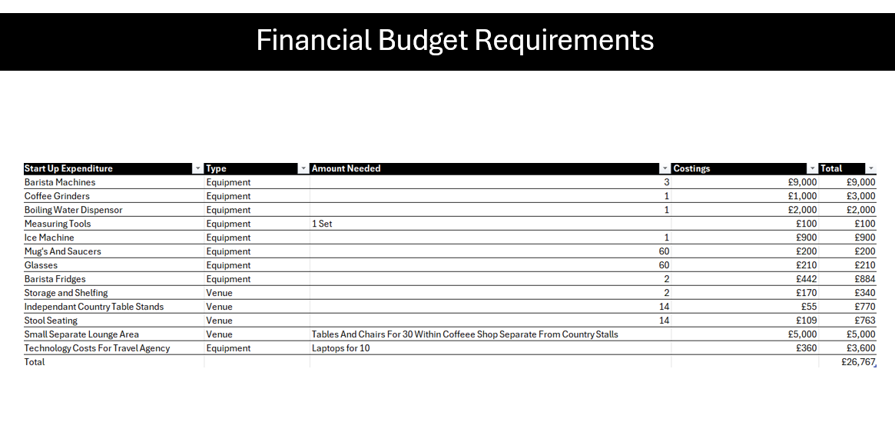
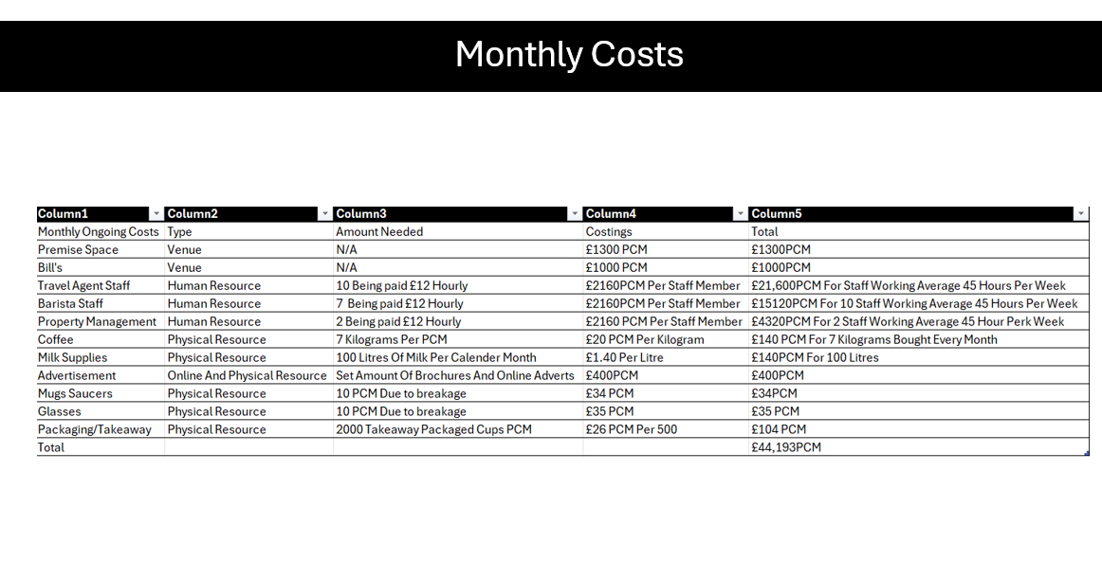
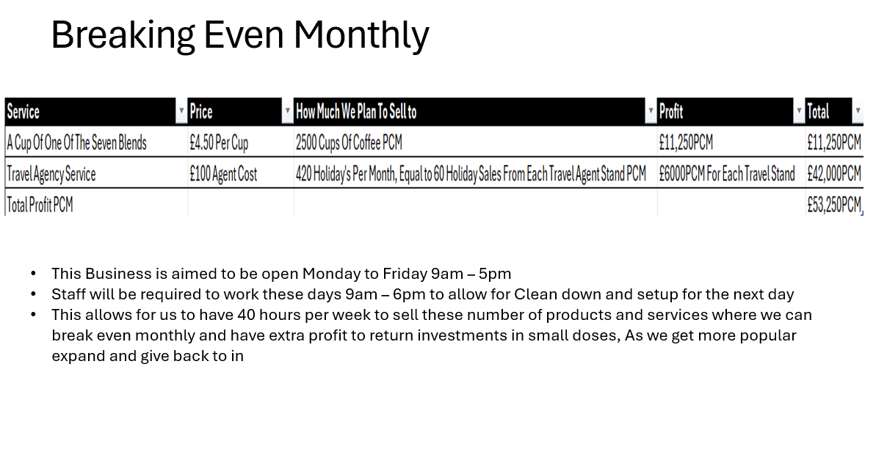

Appendix D – Product Designs

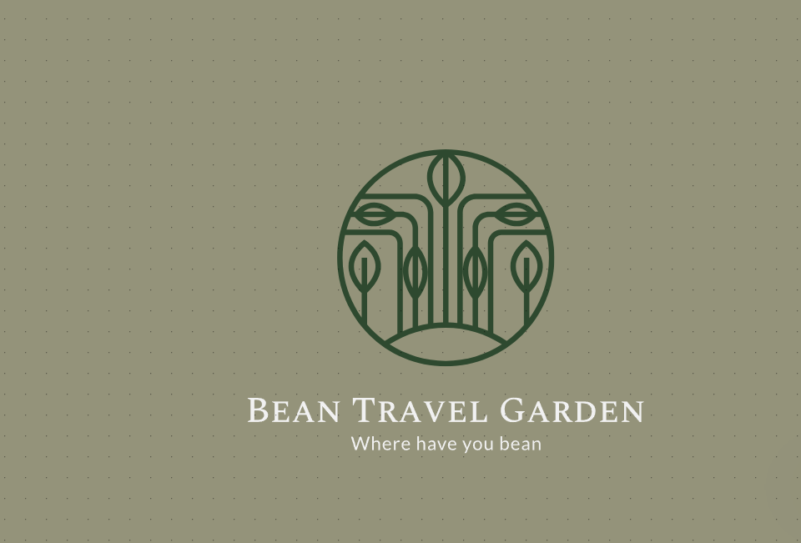

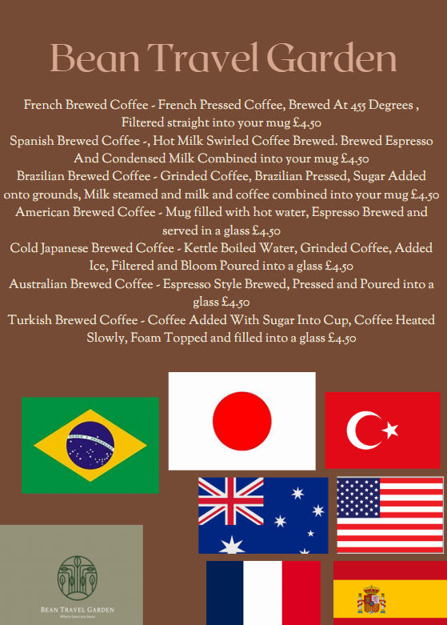

REFERENCE LIST:

(No date) Syta. Available at: https://syta.org/wp-content/uploads/2024/06/Student-Travel-Business-Barometer-2023-web.pdf (Accessed: 04 July 2025).
ABTA Trends (2025) ABTA trends reports, ABTA. Available at: https://www.abta.com/industry-zone/reports-and-publications/abta-travel-trends-reports (Accessed: 30 June 2025).
Admin (2024) Starbucks SWOT analysis - The strategy story, The Strategy Story - Simplifying Business Strategies. Available at: https://thestrategystory.com/blog/starbucks-swot-analysis/ (Accessed: 04 July 2025).
BaristaTrainer (2024) Barista trainer Wales, Barista Trainer Wales. Available at: https://barista-trainer.co.uk/ (Accessed: 03 July 2025).
BulkCoffee (2025) Wholesale hand roasted coffee beans, Bulk Coffee Company. Available at: https://bulkcoffee.co.uk/ (Accessed: 04 July 2025).
Business Academy, T. (2025) The Travel Business Academy: Start A travel business, The Travel Business. Available at: https://www.thetravelbusinessacademy.co.uk/ (Accessed: 02 July 2025).
Business loans: Business loan calculator (no date) Barclays. Available at: https://www.barclays.co.uk/business-banking/borrow/loans/?campaign=BusinessLending2024&chnnl=AFF&msrc=Nerdwallet&adid= (Accessed: 04 July 2025).
CoffeeBayCymru (2025) Coffee Bay Cymru | Beans, Machines & Training. Available at: https://coffeebaycymru.co.uk/ (Accessed: 03 July 2025).
Dmsretail (2025) Why third spaces are the retail trend to tap into in 2025, Retail News & More. Available at: https://dmsretail.com/RetailNews/why-third-spaces-are-the-retail-trend-to-tap-into-in-2025/#:~:text=If%202024%20was%20all%20about%20pop-ups%2C%20in%202025%2C,work%20and%20home%20where%20people%20gather%20and%20connect. (Accessed: 03 July 2025).
D’Ambrosio, R. (no date) Families Love Travel Agents, when they use them, Travel Market Report: The Voice of The Travel Advisor. Available at: https://www.travelmarketreport.com/articles/%20%20%20%20/retail-strategies/articles/families-love-travel-agents-when-they-use-them (Accessed: 04 July 2025).
Edensor, H. (2018) The real reasons people don’t use travel agents, Travel Weekly. Available at: https://travelweekly.com.au/the-real-reasons-people-dont-use-travel-agents/ (Accessed: 03 July 2025).
Filbert, F.& (2024) Problem solving in hospitality industry., Medium. Available at: https://medium.com/@fernanfilbert/problem-solving-in-hospitality-industry-12fa805d64d4 (Accessed: 04 July 2025).
Heath, H. (2025) UK independent coffee shops trading strongly on quality and authenticity, World Coffee Portal. Available at: https://www.worldcoffeeportal.com/news/uk-independent-coffee-shops-trading-strongly-on-quality-and-authenticity/ (Accessed: 03 July 2025).
Jones, A. (2025) The real pros and cons of running multiple businesses, Entrepreneur. Available at: https://www.entrepreneur.com/starting-a-business/the-real-pros-and-cons-of-running-multiple-businesses/492158 (Accessed: 04 July 2025).
Kallivrousis, K. (2024) Nostalgia and authenticity: The new drivers for Specialty Coffee’s growth?, Coffee Intelligence. Available at: https://intelligence.coffee/2024/11/nostalgia-authenticity-in-specialty/#:~:text=With%20romanticised%20depictions%20of%20%E2%80%9Cauthentic%E2%80%9D%20coffee%20origins%20and,and%20genuine%20craft%20%E2%80%93%20not%20just%20quality%20alone. (Accessed: 03 July 2025).
Luong, G., Charles, S.T. and Fingerman, K.L. (2011) Better with age: Social relationships across adulthood, Journal of social and personal relationships. Available at: https://pmc.ncbi.nlm.nih.gov/articles/PMC3291125/ (Accessed: 03 July 2025).
Marks, M.A. (2002) (PDF) the impact of cross-training on Team Effectiveness. Available at: https://www.researchgate.net/publication/11448831_The_Impact_of_Cross-Training_on_Team_Effectiveness (Accessed: 02 July 2025).
NewGen (2024) Navigating rising operational costs: A strategic guide for hoteliers - newgen advisory. Available at: https://newgenadv.com/2024/03/navigating-rising-operational-expenses-a-strategic-guide-for-hoteliers/ (Accessed: 04 July 2025).
Noack, R. (2025) Lavazza coffee in Swansea – enjoy authentic Italian flavour, Whipped Cream Gas. Available at: https://whippedcreamgas.co.uk/lavazza-coffee-in-swansea/ (Accessed: 04 July 2025).
Puig, A. (2023) How street marketing revolutionizes brand strategies, CRONUTS.DIGITAL. Available at: https://cronuts.digital/en/strategies-impacting-street-marketing/ (Accessed: 04 July 2025).
Sageeducation (2020) Why study abroad aspirants rely on education agents for assistance: SAGE, Sage Education. Available at: https://www.sageeducation.ae/blog/why-study-abroad-aspirants-rely-on-education-agents-for-assistance (Accessed: 03 July 2025).
SeoSwansea (2025) Seo Swansea | Bespoke Seo & Digital Marketing Agency. Available at: https://seoswansea.com (Accessed: 03 July 2025).
Social Media Marketing: The ultimate guide (2025) Forbes. Available at: https://www.forbes.com/advisor/business/social-media-marketing/#social_media_marketing_best_practices_section (Accessed: 04 July 2025).
Song, Y. (2025) (PDF) consumer satisfaction for Starbucks: Analysis and possible strategy. Available at: https://www.researchgate.net/publication/360495521_Consumer_Satisfaction_for_Starbucks_Analysis_and_Possible_Strategy (Accessed: 03 July 2025).
Sugiura, E. (2024) Hays Travel Hunts for deals to expand presence on UK high street, Subscribe to read. Available at: https://www.ft.com/content/a8756717-82fe-4d54-867d-08cf326387cb?utm (Accessed: 03 July 2025).
SwanseaGov.uk (2025) Schemes to combine for city centre footfall boost, Swansea. Available at: https://www.swansea.gov.uk/FootfallSchemes2025 (Accessed: 29 June 2025).
SwanseaGov.uk (no date) How to register your new food or drink business, Swansea. Available at: https://www.swansea.gov.uk/howtoregisterfoodbusiness#:~:text=For%20anyone%20starting%20a%20new%20food%20business%2C%20they,to%20date%20of%20any%20changes%20within%20the%20business. (Accessed: 04 July 2025).
Team, M.S. (no date) Jet2.com limited SWOT analysis - Key Strengths & Weaknesses, MBA Skool. Available at: https://www.mbaskool.com/swot-analysis/airlines/9377-jet2com-limited.html (Accessed: 04 July 2025).
Vestil, M. (2023) Why licensing compliance is important for your business, Mike Vestil. Available at: https://www.mikevestil.com/entrepreneurship/business-planning/business-plan/why-licensing-compliance-is-important-for-your-business/ (Accessed: 04 July 2025).
Wordpress (1BC) An analysis of the Tui Group Tourism Essay, UKEssays.com. Available at: https://www.ukessays.com/essays/tourism/an-analysis-of-the-tui-group-tourism-essay.php (Accessed: 04 July 2025).
Zoopla (no date) Houses & Flats to rent | properties to rent in the UK - zoopla. Available at: https://www.zoopla.co.uk/to-rent/ (Accessed: 03 July 2025).

