Assignment 1: Reflective Review of Learning Journey

Contents
Introduction page 1
S.W.O.T. Analysis page 2-3
Kolb`s Experieritical learning cycle (1984) page 4
Maslow theory of development page 5
Andy Gilbert page 6-9
Vark –Learning style Questionnaire page 9-11
MyerBiggs-learning style Questionnaire page 11
Personal development page 13
Conclusion page 13
Reference page

Introduction
To give a report of a reflective review of learning journey to demonstrate any understanding of the skills and knowledge which will contribute to the goals. This report will show two different methods of learning styles for employability. It will contain a S.W.O.T analysis which stands for strengths, weaknesses, opportunity and threats. It will show how we turn our threat to opportunity and our weaknesses into strengths. It will also establish our employability goals and develop a personal development plan. The end of the report will contain a conclusion of the findings and include a set of recommendations.
S.W.O.T Analysis (Humphreys, 2005)
Albert Humphrey developed the S.W.O.T analysis, which consists of strengths, weaknesses, opportunities and threats. This can be used to identify and analyse an individual’s main skills, and the areas in which they could improve. The analysis suggests that weaknesses could potentially become strengths, and threats could become opportunities.
Strengths
- G.N.V.Q intermediate certificate for speaking two languages (Bengali/English).
Shakerifar (2019) suggests in her article that having a bilingual teacher in a school setting can benefit both the children and parents, as it allows non-English speakers to communicate their opinions to a member of staff within the school.
- Good with children
- Strong communication skills
- Good at listening to others

Weaknesses
- Poor organisation skills
Being a disorganised individual in relation to a work place could lower self-confidence, as the individual may compare themselves to collogues and feel disheartened. Additionally, being a disorganised individual university student is likely to lower the individuals grades and overall academic performance.
It is important to take some action to change this behaviour in order to improve future performance. It could be possible to conduct a timetable to allocate specific times for assignments to be completed in.
- Low in confidence
Standing up in a presentation is challenging for a person with low confidence. An individual with low self-confidence may feel awkward while presenting in front of a large group of people. This could result in pauses during the speech, or forgetting the words of the script. To avoid this, it is necessary to practice the presentation as much as possible beforehand.
- Lack of I.T skills
This can be overcome by developing I.T skills in college or asking a family or friend for help.

These weaknesses have been turned into strengths to be used in work to help you to achieve the goal.
Opportunities
- Gain a new qualification (certificate of higher education skills for workplace)
Making a timetable so can I can see what needs to be done and when it needs to be done by.
- Developing I.T skills
By attending college, there is an opportunity to learn and develop I.T skills, which will be useful for future use.

Threats
- Payment – not that good with wages.
Try and promote yourself by learning and developing a wider range of skills.
It is necessary to learn new methods of teaching, which can be done by going for nursery nurse training.

Kolb’s Experiential Learning Cycle
Here, I will be using Kolb’s Experiential Learning cycle (1984).

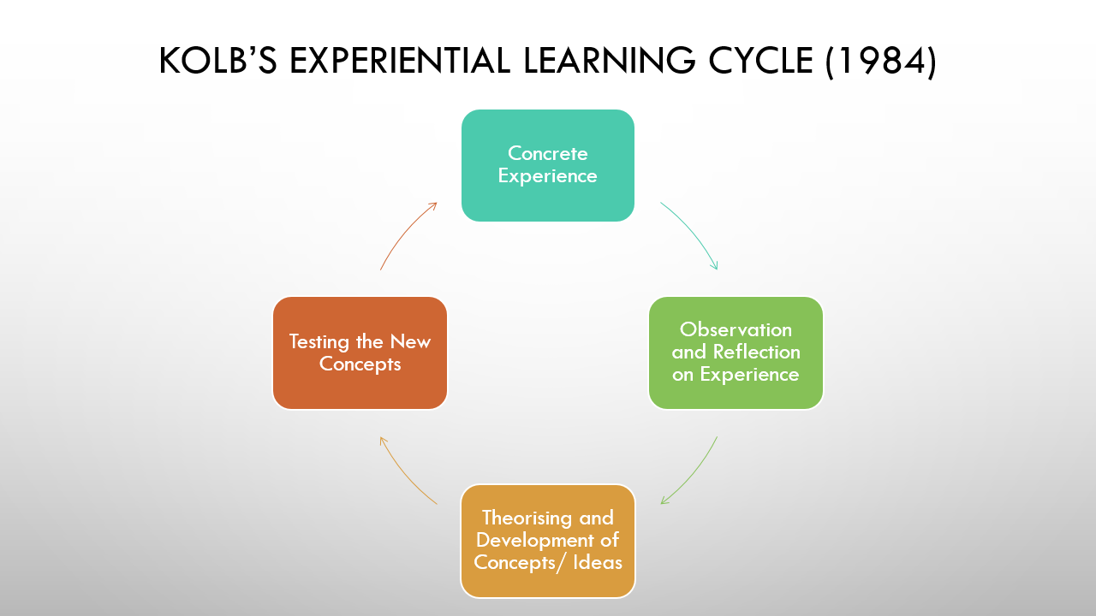

This is based on individuals having and thinking about their own experience rather than just absorbing the theory itself. Basically learning a new skill which can be demonstrated on the report.
Concrete Experience – Working in a school environment and teaching young children and meeting the curriculum targets on time.
Reflective Observation – How you would have to do things differently, also see if all the children have met the curriculum targets and also understood it.
Abstract Conceptualisation – If a child in school didn’t understand the work that you have set up for him/her because of the language barrier. You can speak to him/her in their language of choice and can also use pictures that will make it easier to understand the work.
Active Experiment – Putting him/her with another child who speaks in the same language, who does understand the work and see how he/she reacts to that.

Maslow’s Theory of Development

Maslow’s theory of development, motivation was originally published in 1943. Maslow’s theory stated that healthy human beings have a certain number of needs; these needs are:



Physiological needs – Is our basic need which includes; breathing, food, and water etc. Without these things, our bodies will not function well to carry out any duties or roles that you may have.
Safety needs – which can be our resources, our health, and our security. If you have a setback in your role of work, you can ensure yourself by exceeding and being comfortable in other roles of duties.
Belongingness and love needs – This section is all about our relationship with our friends and families, and also work teams in our workplace. Working with others in your workplace will show you your positive behaviour as well as negative. This can give you an idea of where you are in your workplace.
Esteem needs – In this section your workplace people will need to respect you and acknowledge your achievements.
Self-Actualization – In this section of hierarchy needs, you need to realise your potential and your creativity and shine out to people to achieve you goal. A desire “to become everything one is capable of becoming” (Maslow, 1987, P64).
Andy Gilbert started “Go M.A.D” methodology in 1997. He wanted to do something, and that was to help people to improve their lives in the workplace, as well as at home. “Go M.A.D” stands for Making a Difference.
Andy Gilbert’s company says “we believe that the quality of people’s thinking determines their actions, results, and wellbeing”.
There are 3 levels in the “Go M.A.D” framework, each contributing to your goal. There are seven habits that help you to achieve your goals. These habits are shown in the “Go M.A.D” framework.

Go M.A.D framework
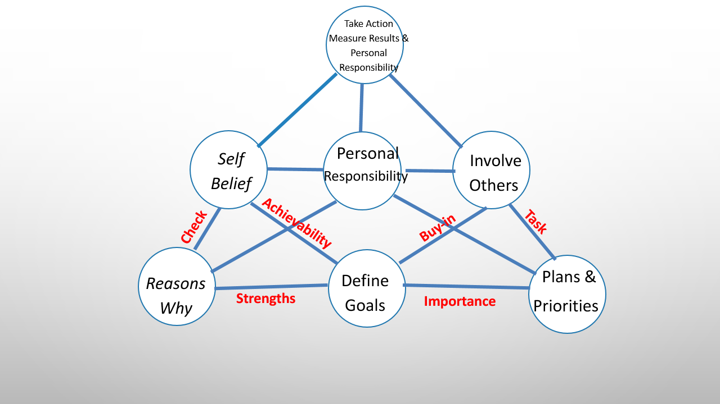

Then you have your internal triangle, which is your principle 1,2 and 4. Then you have your external triangle, which is your principle 2,3 and 5.
This internal and external triangle is your first level, and needs to be a strong a foundation. Here, you need to check your strengths and your achievability. In the external triangle, you need plan and sort out your priorities, and then define your goals. You will then need to involve others and then do the task.

MY “GO MAD” FRAMWORK
Define goal
To graduate and earn my certificate.
Get a job
Personal responsibility
Stay honest
Stay focus
Do researching

Reason why
To develop my knowledge
To support my family
Possibilities and priorities
To focus and achieve my goals in university.
To make my family proud.
Have 100% attendance

Involving others
My husband
My kids
My classmates
Lecturer

Take action and Measure Result
Going to class on time.
Doing my work on time.
Keep an eye on my grades
Self-believe
Have focus at my work
Built my confidence.

PRINCIPLE 1: Reason ‘why’ to make the difference
To develop supportive knowledge and confidence for family.
PRINCIPLE 2: Define goal
In one-years’ time, graduate and obtain a certificate in higher education skills for workplace.
Get a job as a nursery assistant in a school.
According to the research “Wales needs 50,000 more teaching staff over the next 7 years”
PRINCIPLE 4: Self belief
Focusing to become more organized in my work.
Build my confidence by speaking to others.
PRINCIPLE 3: Plan & priorities
Work in a school as a nursery nurse.
Obtain my university certificate of higher education skills for workplace in a year.
Go to university and attend the class
Get a good grade
Make sure assignments are handed in on time.
Be more organized with everything.
PRINCIPLE 5: Involve others
Husband, who will be looking after children.
Lecturers, who will be teaching at university and giving guidance with our work.
Classmates, who will be giving advice on things that are not understood.
PRINCIPLE 6: Personal responsibility
Stay focused on work and being more organized
Be honest when something is misunderstood and ask for help when it is needed.
PRINCIPLE 7: Take action, measure results and celebrate
Look at the feedback that has been given by lecturers on the work, and try and improve it.
Go on a holiday and enjoy yourself
Look back at the time when you didn’t have much confidence in yourself.
Do some research on what kind of things you might need to be a nursery assistance and how long it would take to do it.
Would a first aid qualification be required?
Would training by necessary to become a nursery assistant, and where can I get it from?
Do I pay for the training, and if so, how much?
There are postgraduate teacher training takes about one year.

Learning Styles
Here, we are showing VARK (Fleming and Mills, 1987). The style of learning. VARK stands for Visual learning, Aural learning, reading/writing and kinesthetic. The person who choses this style of learning questionnaire shows that they are more of a visual learner and then reading/writing.

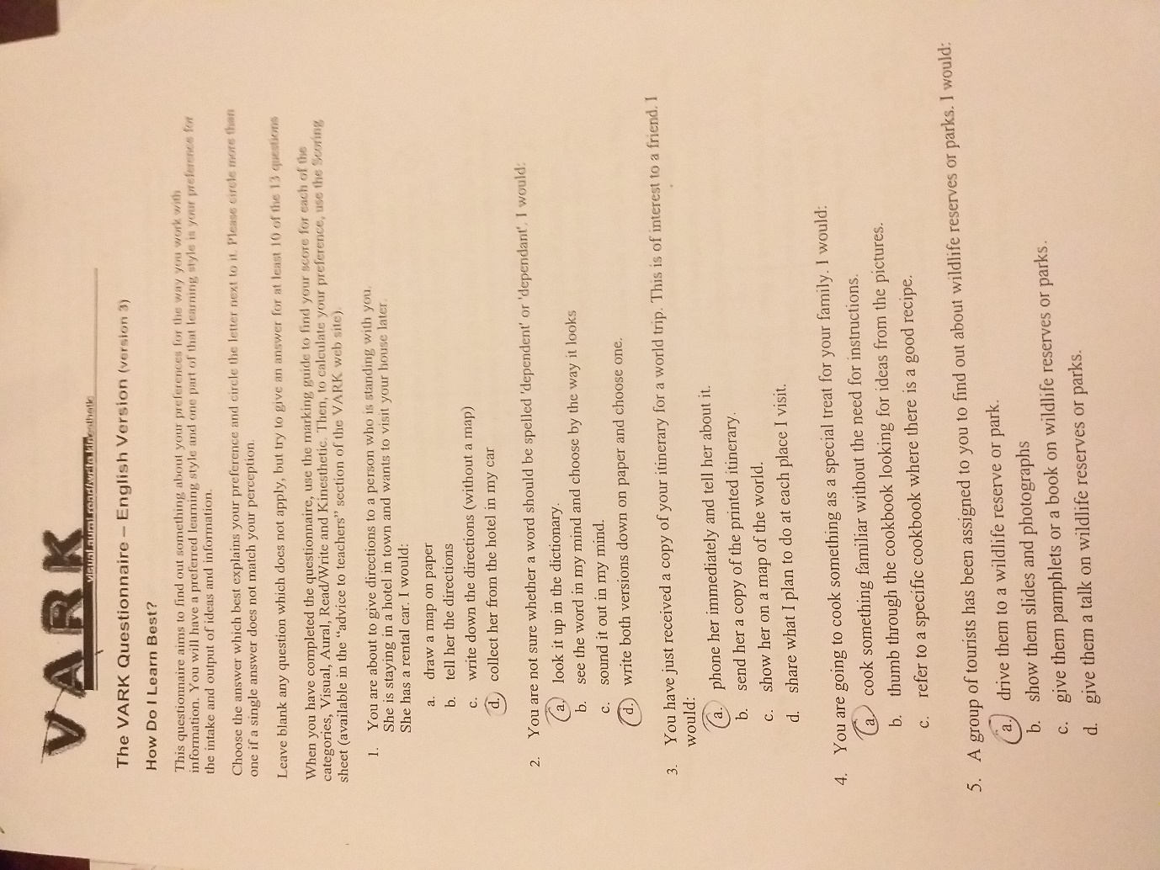

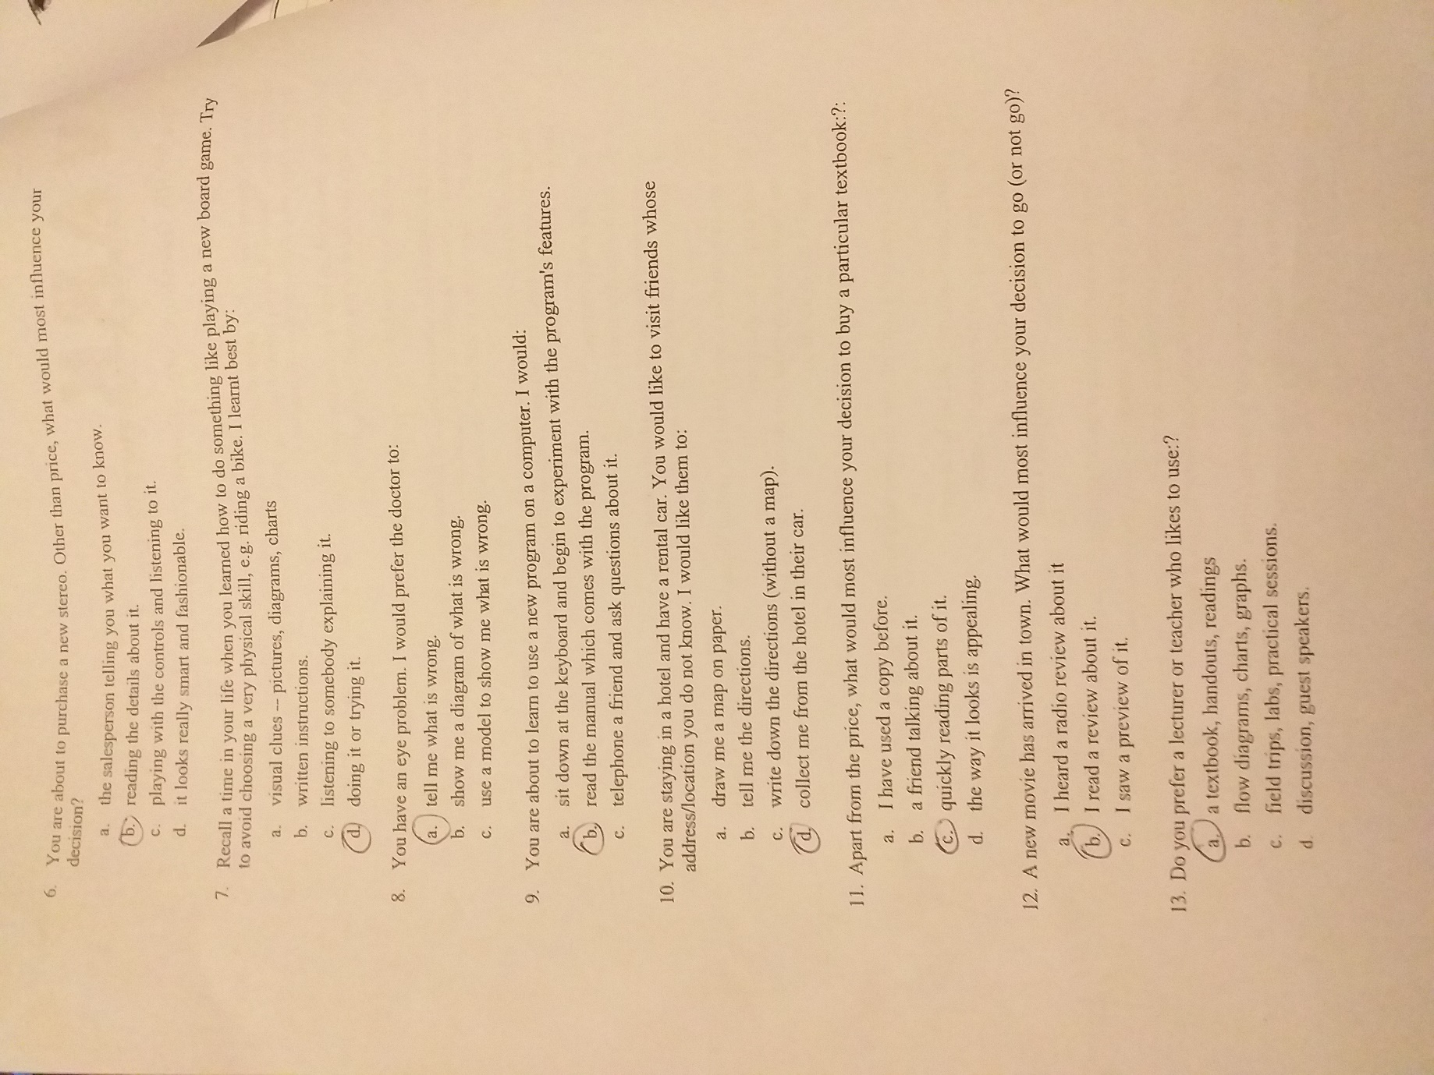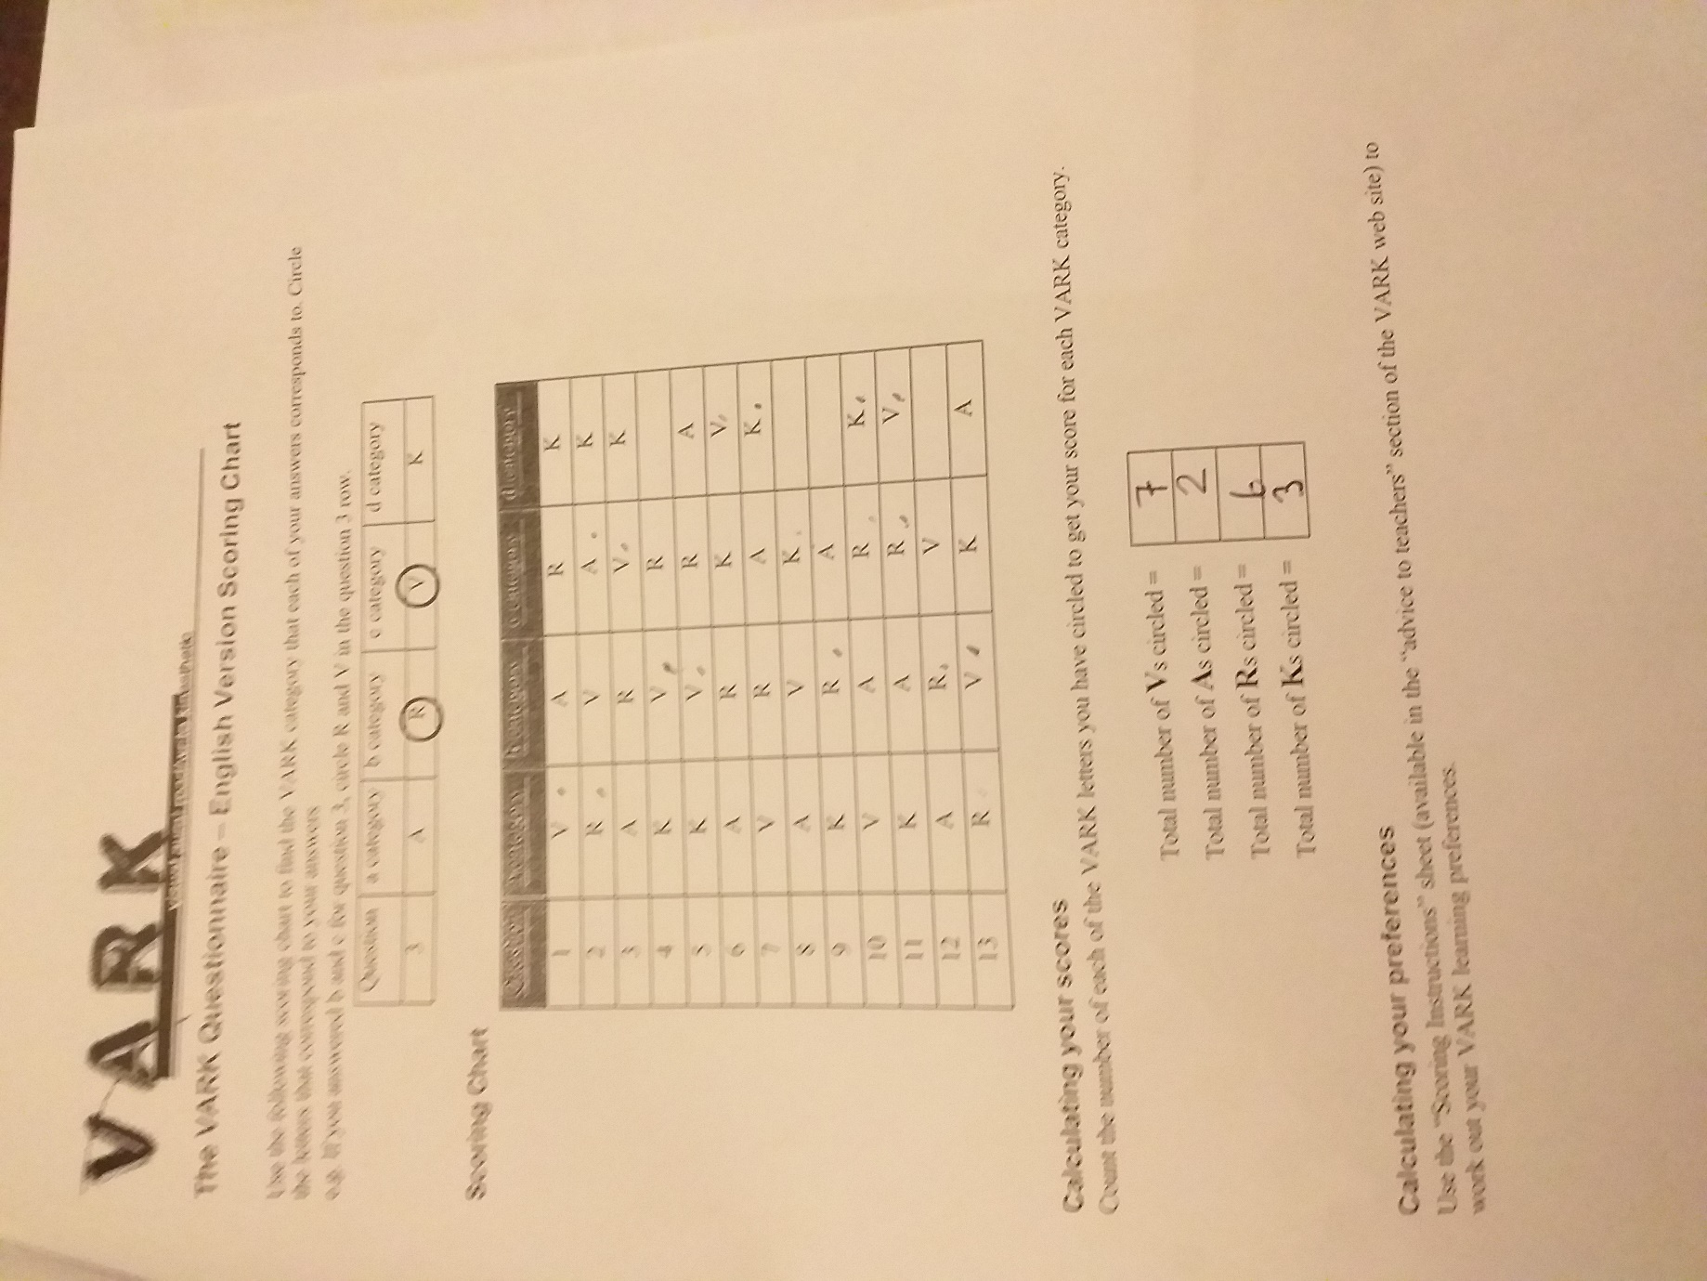

Myer Briggs Personality Profiling. This is the second type.
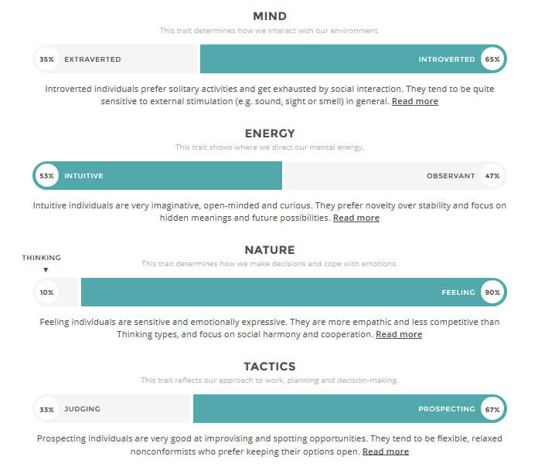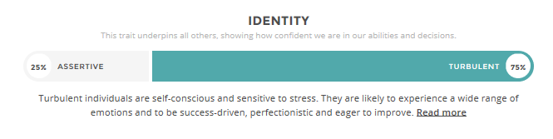
Myer biggs personality test shows that this person is more of Extraverted person (35%)
Also its shows here that the person is prospecting (65%)
Judging is (33%)
This person`s Assertive is 25% and Turbulent is 75%. As you can see that this person is sensitive to stress. They will experience wide range of emotion to get to their goal.
Intuitive is 53% and obeservation is 47% , so this show that the person is very open minded and curious about things around him/her.
Both personality result are in some why similar to one another for example Emational side are the same and then u got obsesrvation an then you got the judging bit as will.
Extraverted person gets exhausted very quickly in social activities, extraverted person is very quite around other people that they don’t know.

Personal Development Plan
Development Objective | Specific actions | Blockers and how they will be removed | Support required | How I will know when I have achieved the objective
Organisation skills | Constructing a time table | In conveniences may arise, so new times will have to be allocated for tasks. | Family, friends | Will be able to complete work on time and meet all deadlines with ease.
Team working abilities | Contributing ideas in a team.  Providing feedback | Lacking confidence can arise due to large group of people or giving a presentation. This will be overcome by practicing beforehand. | Classmates, teachers guidance. | Interacting with ease.  Sharing concerns with teachers and classmates.  Getting feedback from teachers.

Conclusion
Learnt about S.W.O.T which stands for strengths, weaknesses, opportunities and threats. How we can improve on our weaknesses and threats. I learnt that I am more of a visual learner rather than a kinesthetic learner. This has been a very interesting learning journey for me as I learnt to discover myself and improve on things that I am weak at. My strength is that I can speak two languages. I will try to become more confident throughout this course, and work on developing my I.T skills. This will help in the future to get a job. As I want to be a nursery teacher in a primary school. This will help my children with their school work to.

Reference
Mumpherys. A (2005),SWOT anaslysis for managenment consulting, united state:SRI International
Maslow, A. H (1987), Motivation and personality (3rd ed). Dehli, India: Pearson Education.
Maslow, A. H (1943), A theory in human motivation, Psychological-review, 50 (4),370-396
Kolb, D.A. (1984), Experiential learning: Experience as the source of learning and development, Englewood cliffs, NJ.: Prentice hall
Vark-learning. Com (2018), about;[online]. Available: https://vark-learn.com, [2018, Novermber,08 ]
Dunn ,c. w ( 2019) 10 things you can do to boots self-confidence
https://www. Enterperneure.com/article/281874 accessed 7/03/19
hhtps://www.daynurseries.co.uk/news/article. Cfm/id/1564647/bilingual-nurseries-come-make-children-more- creative-torlerant-and-better-at problem-solving. (accessed 5/03/10 time 12:00)
https://www.gomadthinking.com/about/our story. (accessed 5/03/19 time 11:00)
Wightwick .A. walesonline (News) https://www. Walesonline.co.uk (accessed 17/02/19 Time:9:30)
https://www.UCAS.com/postgraduate-teacher-training (accessed 17/2/19 time:10:00)
https://www.16personalities.com/free-person-test
published 2011-2019 accessed 7/3/19 time:2:00

