
Master of Business Administration

International Business pathway

Contemporary employability skills
Assessment 1: Individual report. Weight: 50%
Module Name: International Marketing: Principles and Practices
Module code: LCMB7026
Lecturer Name: Dr Amir Homayounfard

Student Name: Zeel Bharatbhai Talaviya
Student ID: 2434306

Word count: 5018
Submission Date: Thursday 13th August 2026

AI Use Acknowledgement
Note: One acknowledgement is needed for each used AI tool.
I acknowledge that the complete was solely done by me. I have not used any kind of generative Ai tools to complete the work. I used academic resources, reports, company information available on online resources. The sources through which I collected data have been put in reference section along with right citations throughout the report.
Table of Contents
1. Introduction 4
2. Comparative analysis 6
Comparative PESTEL Analysis 6
Critical Evaluation 8
Comparative Cultural Analysis Using Hofstede's Cultural Dimensions 8
Critical Evaluation 9
3. Comparative STP Analysis 11
Critical Evaluation 13
4. Comparative International Marketing Mix (7Ps) 14
Critical Evaluation 22
5. Market Entry Strategy in India 23
6. Ethical Issues in India's Marketing Mix 25
7. Recommendations 26
8. Conclusion 27
Reflective Account (Gibbs' Reflective Cycle) 29
Introduction to Gibbs' Reflective Cycle 29
References 33

Section 1

1. Introduction
This report aims to critically discuss Adidas International market entry strategy and Adidas international marketing strategies in Germany (home country) and India (host country). The report follows the assessment requirements by comparing the macro-environment of both countries using the PESTEL framework and cultural differences using Hofstede's Cultural Dimensions. This report further evaluates Adidas' Segmentation, Targeting and Positioning (STP) strategy and then compares its international marketing mix (7Ps) to assess the business environment. Then this report further analyses Adidas’s market entry strategy in India while assessing ethical issues related to its marketing mix and provides recommendations to strengthen its future international marketing performance. International marketing is the marketing planning and execution of marketing activities across country boundaries to meet the needs of the customers and to adjust to the various economic, political, legal and cultural environments. When organisations grow internationally, they need to adjust to local market conditions and retain their global brand identity (Loewe, 2023). This demands to have a clear grasp of both home and host market settings.

Figure 1: Adidas Brand Logo
(Source: Adidas, 2026)
Adidas is selected because it is one of the world's leading sportswear companies with a strong global presence and well-established operations in both Germany and India. In 2025, Adidas achieved record net sales of €24.8 billion, supported by double-digit growth across all markets through locally relevant products, marketing activities and sales channels (Adidas, 2026). Adidas' primary market continues to be Europe and emerging markets such as India offer rapid growth prospects. The report takes a comparative and evidence-based strategy to identify and analyse the issues that arise from the differences between Germany and India and how these impact Adidas' international marketing decision-making. The discussion aims to demonstrate how macro-environmental conditions, cultural characteristics and consumer behaviour shape the company's market strategies and contribute to its international competitiveness. Finally, the report identifies practical recommendations to support Adidas' sustainable growth and long-term success in international markets.

2. Comparative analysis

Comparative PESTEL Analysis
PESTEL analysis is a tool that helps assess the external macro-environment by analysing the political, economic, social, technological, environmental and legal factors that affect an organisation's performance and foreign marketing decisions (Karadzhov and Patarchanova, 2025). In the case of Adidas, the PESTEL framework allows them to compare Germany with India to understand the opportunities and challenges they will face in their foreign marketplace.
Political Factors
Adidas operates with a low risk factor in Germany due to a politically stable climate, good governance and strong legal and IP protection. By contrast, India has improved its investment climate with programs such as Make in India, resulting in resilient FDI inflows of about US$71 billion during 2023-24 (RBI, 2024). However, different state-level laws complicate things for business. Therefore, Adidas has a more stable business in Germany and flexible approaches to markets in India.
Economic Factors
The economy of Germany had a gross domestic product of about US$5.05 trillion and gross domestic product per capita of US$60,496 in 2025 (World Bank Group, 2026). This shows high purchasing power of consumers in Germany which gives way to high prices of Adidas’ products. On the other hand, India registered an impressive GDP growth rate of 6.5% in 2024 (PIB Delhi, 2025). The growing Middle Class in India offers great growth potential but consumers are more price-sensitive. Thus, the brand’s premium positioning is balanced with other product offerings and discounted prices to appeal to various income groups.
Social Factors
The population of Germany is 83,491,249 people, offering Adidas a vast consumer base for its high-quality sportswear products (World Bank, 2025). In contrast, India's population is about 1.45 billion people, thus being the most populated nation in the world and giving Adidas access to the largest consumer base in the world (Worldometer, 2026). The growing trend of fitness, athleisure and sports has led to higher demand for sportswear brands. Therefore, Adidas is more inclined towards digital interaction and social media promotion in India whereas German campaigns emphasise their performance and sustainability.
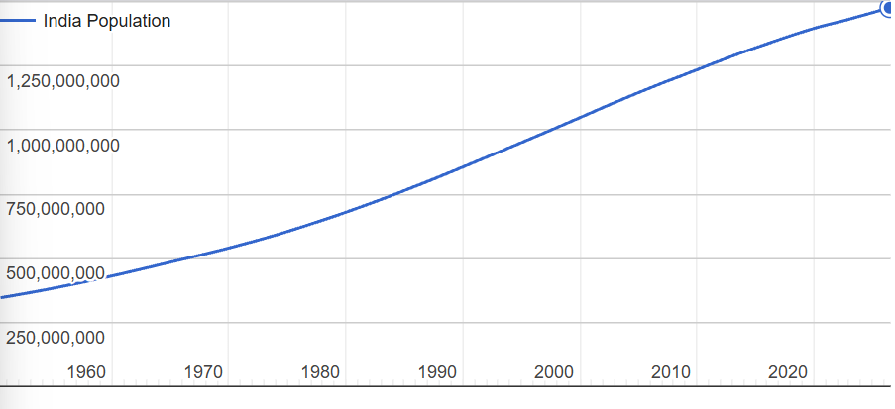
Figure 2: Indian Population (1950-2026)
(Source: Worldometer, 2026)
Technological Factors
Germany's cutting-edge manufacturing, combined with an efficient logistics framework, provides Adidas with the innovation and supply chain performance needed. India has seen tremendous growth in technology, with 950 million internet users in 2025 driving the booming growth of e-commerce and omnichannel retailing in the country (ET Brand Equity, 2026). Therefore, Adidas integrates its digital platforms with its retail stores to enhance access for customers in India.
Environmental and Legal Factors
Germany maintains stringent rules regarding the environment and customers now demand eco-friendly products. Despite India's efforts to improve its environmental policies, there is an inconsistency in their application in different regions of the country (ITA, 2026). To address this, Adidas has been increasing the usage of recycled and sustainable materials as well as improving its supply chain transparency (Adidas, 2026). Legally, Germany provides greater certainty of regulation while India's diverse state rules mandate constant compliance monitoring for Adidas and enforcement of its IP.

Critical Evaluation
Germany offers Adidas a stable and established business environment which is conducive to premium branding and long-term planning. In contrast, India's economic growth, favourable demographics and digital development provide more growth opportunities, although higher regulatory opacity and price sensitivity remain challenges. These differences give rise to the necessity of a more normalised approach in Germany and a more adaptive approach in India.

Comparative Cultural Analysis Using Hofstede's Cultural Dimensions
Culture is defined as the values, beliefs and behaviours held by consumers that influence their behaviours and attitudes. Hofstede identified the Cultural Dimensions, an extensively adopted framework used to analyse national cultures and evaluate how cultural values influence marketing strategies (Wale, 2020). For Adidas, recognising the cultural differences between Germany and India contributes to formulating culturally appropriate marketing techniques.
Comparative Cultural Analysis
Germany has a low Power Distance (35), whereas India has a high one (77) (The Culture Factor, 2026). German customers give importance to clear communication, quality of the product and product information whereas rich Indian consumers focus more on the prestige and status of the brand (Unlabel, 2022; Murugan, 2025). Therefore, Adidas use celebrity promotion and aspirational branding more in India than in Germany.
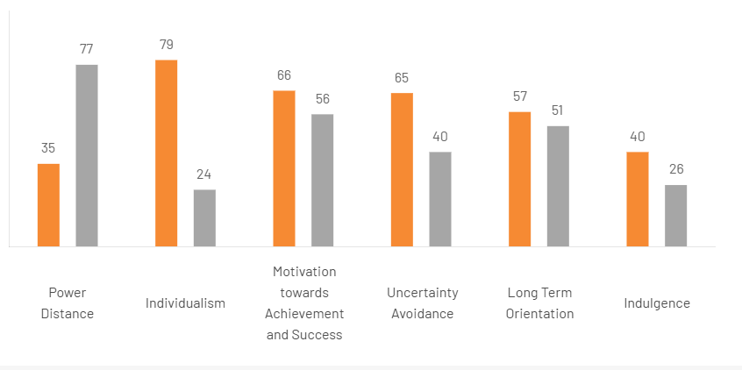
Figure 3: Comparison of Germany and India
(Source: The Culture Factor, 2026)
In the index of Individualism, Germany ranks 79, while India is 24 (The Culture Factor, 2026). However, consumers in Germany rely on the objective characteristics of the products while making buying decisions while Indian consumers are more influenced by family, reference groups and social rules (Unlabel, 2026; Kumar and Navaneeth, 2026). As a result, Adidas inspires individual sporting excellence in Germany and a community-centric and emotionally-driven approach in India.
Germany also has a higher score for Uncertainty Avoidance (65) than India (40) (The Culture Factor, 2026). Thus, there is a general behaviour of consumers in Germany to buy a well-established, reliable and favoured product. While in India, consumers are more open to innovative product launches or fashion-trendy products. In Germany, Adidas focus on its product technology and sustainability, while digital campaigns, lifestyle collections and initiating influencer marketing are implemented more aggressively in India.

Critical Evaluation
Differences in the cultural traits of Power Distance, Individualism and Uncertainty Avoidance are reasons why Adidas cannot apply a fully standardised international marketing strategy. Instead of this, the firm uses the combination of consistent branding across the globe along with localised efforts in the areas of communications and promotions to satisfy consumer needs.

3. Comparative STP Analysis
Segmentation, Targeting and Positioning (STP) is a strategic marketing framework that helps organisations identify suitable customer groups, select the most attractive market segments and create a distinctive brand position (Mogaji, 2025). In international marketing, STP enables firms to respond to differences in consumer behaviour, purchasing power and cultural preferences across countries (Schlegelmilch, 2022). For Adidas, the framework supports the development of market-specific strategies while maintaining a consistent global brand identity in Germany and India.

Figure 4: STP Analysis
(Source: By Author)
Segmentation
Adidas adopts both demographic and geographic segmentation in both countries, along with psychographic and behavioural segmentation depending on market conditions. The company focuses on consumers in Germany who have a higher purchasing power and are actively involved in sports activities like football, running or outdoor sports (Adidas, 2024). Sustainability-conscious consumers are also a significant group, as they care about product quality, innovation and the sustainability of production methods. Adidas is aiming at a younger and more diverse customer base in India (Adidas, 2025). The company targets urban millennials, Gen Z consumers, fitness enthusiasts and aspiring middle-class consumers who buy sportswear for sport and lifestyle. As a result, Adidas can have a wider range of products to cater to different income groups and customer tastes.
Targeting
Adidas uses a differentiated target strategy in both markets. In Germany, the company primarily targets high-quality consumers who are looking for technologically advanced sportswear with high performance and sustainability. Marketing activities focus on professional athletes, sports clubs and consumers who prioritise product quality. In contrast, Adidas has taken a more comprehensive approach to its target market in India, aiming at both high-end consumers and the burgeoning middle class (Marketing Monk, 2024). The company increases market reach through digital platforms, branded retail stores and collaborations with leading athletes, cricket players and social media influencers. This not only helps increase brand visibility but also contributes to market expansion in the burgeoning Indian sportswear sector.
Positioning
Adidas has a global brand position defined by innovation, quality, performance and sustainability (Adidas, 2023). But its positioning is based on local consumer expectations in every market. Adidas is a sportswear company that is perceived as a high-quality brand in Germany, known for technological innovations, performance and sustainable product development (Adidas, 2023). The company leverages this premium positioning in India through the power of celebrity endorsements, sports sponsorships and lifestyle marketing through digital campaigns which are more relevant to younger audiences. The strategy will allow Adidas to remain competitive and stand out as a global brand.

Figure 5: Brand Ambassador of Adidas (Cricket)
(Source: Sharma, 2026)

Critical Evaluation
The comparative STP analysis shows that the Adidas brand has managed to achieve a balance between global standardisation and local adaptation. The company's positioning is the same in both countries, but the segmentation and targeting strategies are adapted to the differences in demographics, purchasing power and consumer behaviour. Germany's mature market needs more focus on performance and sustainability, while India's growing youth population needs increased access, lifestyle branding and digital engagement. This agile STP approach allows Adidas to build customer relationships and maintain its competitive edge in both developed and developing global markets.

4. Comparative International Marketing Mix (7Ps)
The International Marketing Mix (7Ps) is a strategic framework that enables organisations to design marketing strategies that satisfy customer needs across different countries (Eze, et al., 2024). It consists of Product, Price, Place, Promotion, People, Process and Physical evidence, enabling companies to maintain global uniformity while tailoring their strategies to local markets. Since the preferences, purchasing power and market conditions in Germany are different from those in India, Adidas uses a combination of standardisation and adaptation in the use of its global brand and the execution of some marketing activities in the local market.

Figure 6: International Marketing Mix
(Source: By Author)
Product
Adidas has adopted a consistent product approach, providing high-quality footwear, clothing and sporting goods with a global brand identity (Quintero, 2026). The consumers in Germany prioritise innovation, sustainability and durability of the product, which is why the company has a strong focus on technologically advanced products and collections with a sustainability focus as well as on performance-oriented sports shoes Stahl, et al., 2021). Products designed for football, running and outdoor sports receive particular attention due to their popularity within the German market.
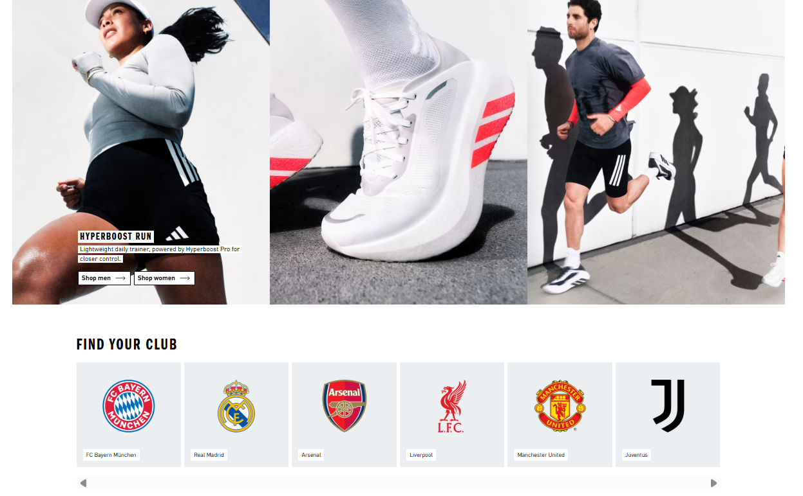
Figure 7: Adidas Football Marketing
(Source: Adidas, 2026)
In India, Adidas continues to build its range with top-performing products and lifestyle/athleisure options at an affordable price. The company also markets products inspired by cricket and sports fashion trends oriented towards fashion, reflecting the growing importance of casual sports fashion and local sporting interests. Product adaptation allows Adidas to meet the needs of various consumers while maintaining its high positioning in the global market.
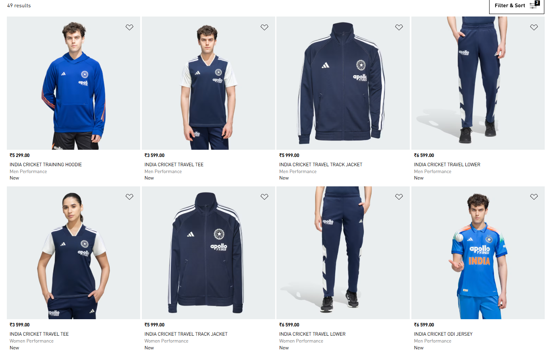
Figure 8: Adidas Cricket Clothing Line
(Source: Adidas, 2026)
Price
Adidas' pricing strategy is premium in both countries to boost the company's image of quality, innovation and performance. However, pricing is adjusted based on differences in purchasing power and consumer price sensitivity. However, Adidas can keep the prices at a premium level in Germany due to higher disposable income and the fact that consumers appreciate product quality, technological innovation and sustainability (Nation Master, 2026). On the other hand, Indian consumers are more price sensitive because of greater income inequality. To justify a high price, Adidas offers a variety of product types and festival discounts, as well as seasonal promotions that make the product more accessible without sacrificing its high-end brand perception. The flexible pricing model allows the company to remain competitive in the highly competitive Indian sportswear market.
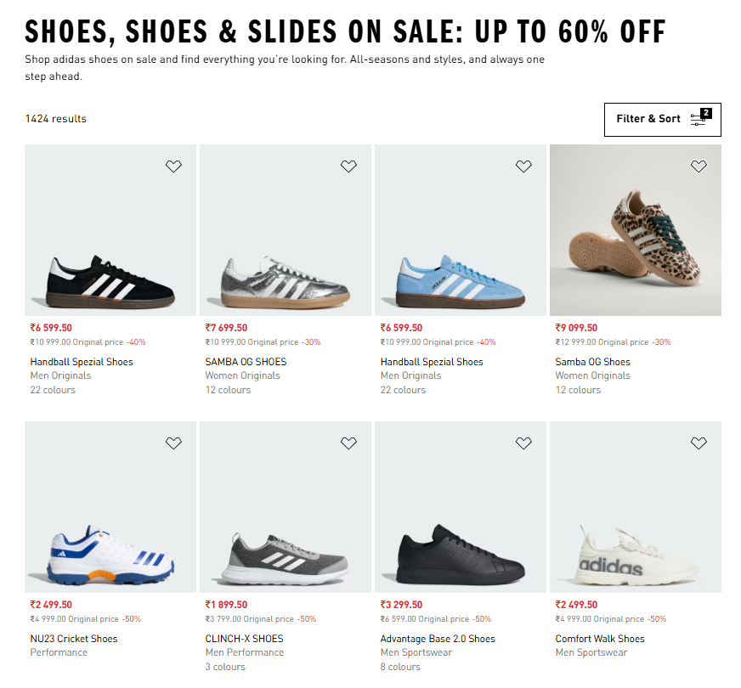
Figure 9: Discounted marketing of Adidas in India
(Source: Adidas, 2026)
Place
Adidas has developed a highly comprehensive omnichannel sales infrastructure across India and Germany, with the focus varying by market maturity. In Germany, Adidas products are being sold in flagship shops, specialist sports shops, department stores and the official website online, with the products reaching consumers quickly with efficient organisation (PR Newswire, 2023). In India, Adidas has partnered with unique brand stores, franchise stores, multi-brand stores and top e-commerce players to ensure easy access to its products throughout the country despite its geographic spread. Over the last few years, the company has been investing in digital retail to further expand its reach to younger consumers and growing urban populations.
Promotion
The most suited component of Adidas' marketing is promotion. In Germany, promotional activities emphasise product innovation, sporting performance and sustainability with the involvement of professional athletes, football clubs and international sport events (FIFA, 2026). Marketing communications focus on quality, technological progress and environmental responsibility. On the other hand, Adidas promotes products in India in a more lifestyle approach which involves association with cricket players, celebrities and digital influencers (Adidas, 2026). Campaigns are created during key sporting events and festive periods to enhance consumer engagement. Adidas successfully leverages the use of culturally relevant ambassadors, digital marketing and global brand messaging to enhance their brand's presence and reach while addressing the variations in consumer behavior between both markets.
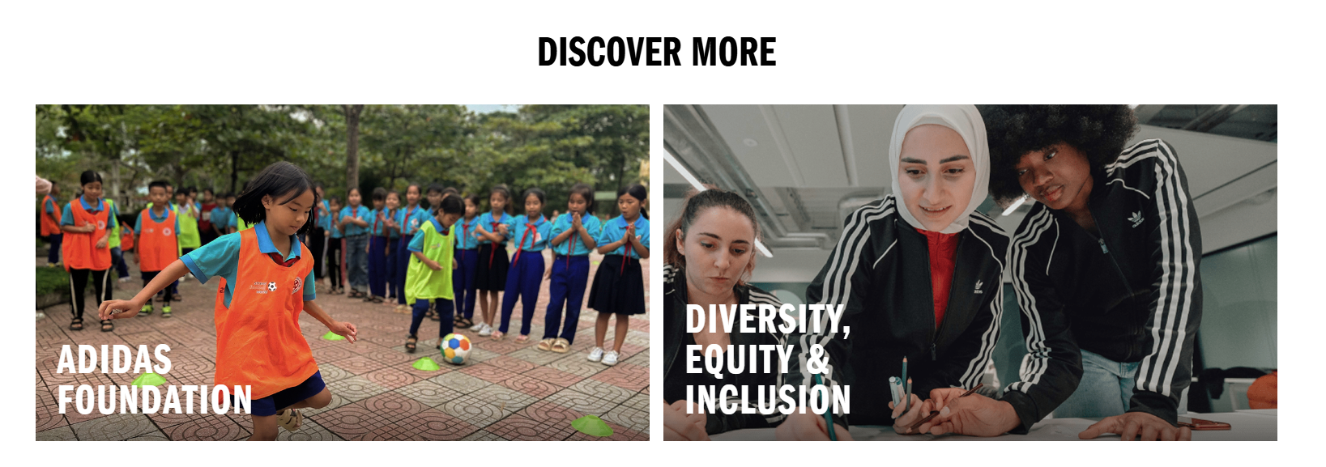
Figure 10: Adidas Campaigns
[Source: Adidas, 2026]
People
All employees who encounter customers and who affect customer experience are referred to as people (Gustafsson, et al., 2024). In international marketing, people working as employees are particularly important in creating customer satisfaction, trust and loyalty eventually. Adidas maintains consistent global service standards through comprehensive employee training, product knowledge development and customer service programmes (Adidas, 2024). However, the company's people strategy is adapted to reflect cultural differences and consumer expectations in Germany and India.
German customers are typically looking for efficient, knowledgeable and professional service (Unbabel, 2022). The salespeople receive training in footwear technology, sports performance and sustainability products so they can offer technical advice to help consumers make informed purchases. German consumers like to be efficient and knowledgeable about their products, so the interactions with customers tend to be more focused on information and direct (BCG, 2024).
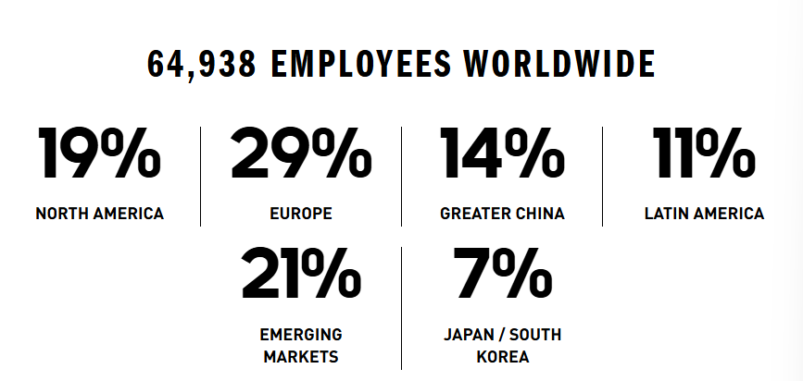
Figure 11: Adidas Employees
(Source: Adidas, 2025)
On the other hand, customer service in India is more relationship-based. People tend to expect personalised support all the way through the buying process, especially when comparing products and assessing prices. Thus, Adidas focuses more on the engagement of its customers, multilingual communication and personal support in-store. Staff are encouraged to develop better relationships with customers and provide high-value consumer experience (Ghlichlee and Bayat, 2021). These adaptations enhance customer satisfaction and strengthen brand loyalty in India's highly competitive retail market.
Process
Process is the methods and systems that facilitate the delivery of products and services to customers (Gaiardelli, et al., 2021). Adidas has standardised several fundamental business operations across countries such as inventory management, quality control, digital payments systems, and after-sales service. This uniformity guarantees product consistency and a smooth customer journey worldwide. However, the operational processes are adjusted according to the market needs. Germany is well-equipped in terms of transport infrastructure, logistics, and digital integration (GTAI, 2026). Consequently, Adidas offers swift delivery times, streamlined inventory management, and a smooth online and in-store shopping experience. Consumers also benefit from convenient product returns and click-and-collect facilities.
India has certain challenges to face in the operation because of the geographical diversity and the growth of the retail industry (ITA, 2026). Adidas works closely with major e-commerce partners, local logistics and franchise partners and continues to grow its own retail presence to make its products more accessible. The company also has multiple digital payment solutions and mobile shopping applications to cater to consumer buying habits (Adidas, 2017). These adaptations enable Adidas to improve operational efficiency while responding to the increasing demand for online and omnichannel retailing.
Physical Evidence
Physical evidence includes the actual factors that affect the perception of customers about a particular brand (Zhou, et al., 2024). They include the retail stores, packaging, store design, visual merchandising, and the digital platforms used by the company. Adidas has an excellent worldwide identity as it has the unique three-stripes logo, premium packaging, well-designed stores and professional visual branding that increases customer confidence and brand recognition worldwide. The German flagship stores use technology and sustainability in designing the stores. They have an innovative design, using interactive product demonstrations, the use of digital platforms and environmentally friendly store designs. All the above help in positioning Adidas as a technologically advanced and sustainable sportswear brand.
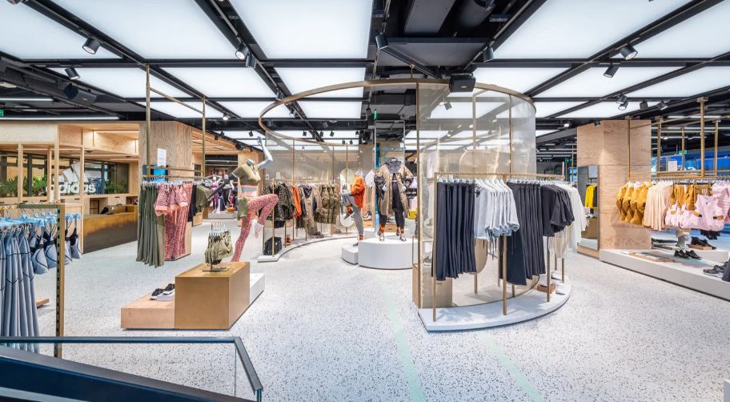
Figure 12: Germany Flagship Stores
(Source: Adidas Berlin, 2025)
In India, the company uses the same visual identity worldwide, but the store design changes depending on the conditions in the local market. The stores are designed based on their locations in shopping malls and commercially busy areas for maximum customer access. In addition, the visual merchandising includes local athletes and sporting activities to ensure the customers are more connected emotionally. Lastly, Adidas' website and mobile application are good examples of a digital shopping experience.

Critical Evaluation
A comparative analysis of the 7 Ps reveals that Adidas has been successful in combining global standardisation with local adaptation to improve its performance in international marketing. The quality of its products, its brand, and operational procedures have remained the same in Germany and India, retaining its reputation as an innovative and performance-driven brand. However, its pricing, promotion, customer service and logistics have been customised as per local market conditions. Germany being an advanced country with a high-income level allows Adidas to emphasise performance, sustainability, and innovation in its operations, but India with its growing consumer base needs more flexible pricing, a wide distribution network, and digital marketing techniques. By customising its marketing mix while maintaining a globally standardised brand image, Adidas has been able to meet local requirements and build a competitive edge in the international market.

5. Market Entry Strategy in India
Market entry strategies are the methods used by a company to enter and grow its business in an international market (Kostruba and Kostruba, 2025). In India, Adidas has adopted an active, wholly-owned subsidiary strategy, complemented by specific franchise stores. The wholly owned subsidiary allows the company to enjoy complete control and ownership in terms of management, making sure that all decisions regarding the brand and product are consistent. However, this approach involves heavy investment on the part of the business.
Adidas' market entry strategy can be further explained using Dunning's Eclectic (OLI) Theory (Batschauer da Cruz, et al., 2022; CFI, 2020). This explains that companies select the entry mode on the basis of ownership, localisation and internalisation advantages. Ownership advantages are the firm's attributes which provide an advantage in foreign markets. Adidas enjoys a worldwide reputation in terms of the brand, innovative products, research ability and a sustainable approach and thus it can distinguish itself in India’s highly competitive market for sportswear products.
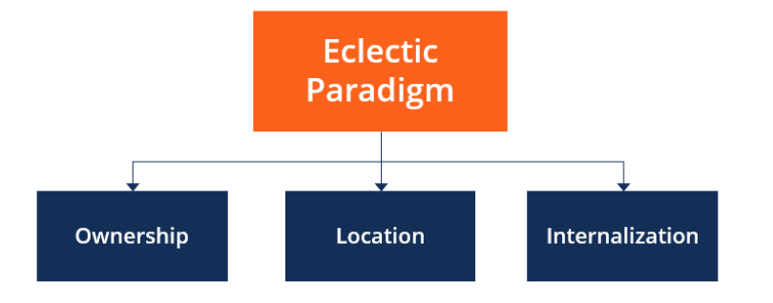
Figure 13: Elements of OLI
(Source: CFI, 2020)
The location advantages are the benefits that the host country provides to attract foreign capital. However, India offers an attractive opportunity for Adidas to continue growth, with a population of around 1.45 billion and a growing middle-class population (Worldometers, 2024). The popularity of sports among most Indians and digital retail provide additional strengthen this opportunity.
The benefits of internalisation highlight the decision of a company to internalise rather than outsource for incremental advantage. Through the use of a wholly owned subsidiary, Adidas retains full control over the quality of its products, price, brand image and customer service. Furthermore, Adidas customises the products, the marketing strategy and the go-to-market strategy based on the needs of the local consumers while maintaining its worldwide image (Adidas, 2025). This helps to improve its global marketing plan in the Indian market.
The entry strategy for Adidas is based on the concept of Dunning's OLI theory whereby strong organisational capabilities combine with favourable market conditions and operational controls. However, the company needs to continue developing its wholly owned operations alongside selective expansion of franchise partnerships in new cities.

6. Ethical Issues in India's Marketing Mix
Marketing ethics is the application of moral principles in marketing so that organisations can communicate in a responsible, honest and fair manner to consumers (Chong and Patwa, 2023). Ethical issues for Adidas in India relate to the promotional part of the marketing mix and concern the wide usage of celebrities and athletes for sportswear marketing.
Adidas partners with celebrities, key opinion leaders (KOLs), or social media influencers to enhance the brand's visibility and connect with consumers through digital channels (Guo, et al., 2024). This promotion strategy helps to help make the brand visible and it promotes active living and sportiness. However, there is another aspect which relates to ethics as the use of celebrity promotions in advertising may generate aspirations to purchase. This is especially with young buyers for whom the brand Adidas stands for luxury and success. In price-sensitive markets like India such marketing can make people feel inclined to buy which can ultimately lead to overspending.
Another ethical issue arises in connection to the transparency of influencer marketing. When there are no disclosures of the paid partnership, consumers might have problems in differentiating the recommendations from the ads. The ASCI Influencer Advertising Guidelines call for influencers and brands to clearly label content they are promoting, to ensure that marketing is not misleading (ASCI, 2026).

7. Recommendations
From the comparative analysis, it is evident that Adidas needs to improve its international marketing strategy by doing more standardisation and adaptation to the local markets. The first step is to increase the company's product line of affordable premium products in India and align it to the rising middle-income consumers without compromising the premium brand image. This approach would help to gain market share and meet consumer differences in buying power. Secondly, Adidas needs to invest more in digital marketing and create a personalised customer experience through artificial intelligence. According to GlobalWebIndex, leveraging consumer data to provide personalised product recommendations and targeted promotion campaigns could enhance customer engagement and boost brand loyalty (GWI, 2026).
Third, the company should further promote its sustainability efforts through greater adoption of recycled materials and by making it more transparent and effective to communicate its environmental performance. In both countries, transparency of these initiatives would have a positive impact on brand reputation and competitiveness as consumers are increasingly demanding to learn about responsible business practices (Agu, et al., 2024). Finally, Adidas must build relations with local sports personalities, sports bodies and community fitness initiatives especially in India. These partnerships would help to raise awareness of the brand, promote sport and create a stronger emotional bond with consumers locally, promoting long-term market growth and customer loyalty.

8. Conclusion
This report critically analysed the international marketing strategies adopted by Adidas in Germany and India focusing on the macro-environment, cultural differences, STP strategy, international marketing mix, market entry strategy and ethical issues. The findings show that Adidas has a strong global brand identity, driven by innovation, quality and sustainability but adapts some aspects of its marketing strategies to address consumer behaviour, purchasing power and cultural expectations. Germany is a mature and stable market while India has huge long-term growth potential but is more complex due to diverse customer choices. In general, Adidas' success in adapting to local requirements while maintaining global uniformity has enhanced its international competitiveness. The company's ongoing efforts to invest in digital innovation, sustainability and marketing programs that are relevant to the local markets will help it continue to grow over the long-term and maintain its leadership role in the global sportswear industry.

Section 2

Reflective Account (Gibbs' Reflective Cycle)

Introduction to Gibbs' Reflective Cycle
The Gibbs' Reflective Cycle is a step-by-step approach that allows a person to examine something experienced systematically and reflectively and to enhance his/her learning and practice (Chi, 2023).

Figure 14: Gibbs reflective Cycle
(Source: By Author)
Description
This assessment involved analysing the international market entry strategy and international marketing strategy of Adidas, comparing its operations in Germany and India. Adidas was chosen because of its strong international footprint and size in developed and emerging markets. First of all, I checked what assessments were required and then gathered data from peer-reviewed journal articles, annual reports from Adidas, government publications and industry reports. Once I collected all the literature, I compiled the data according to the required frameworks such as PESTEL, Hofstede's Cultural Dimension, STP, the International Marketing Mix, OLI Framework and ethical marketing. During the report, I made a comparison of Germany and India and ensured that every argument I gave was supported with reliable evidence.
Feelings
At First, I was certain about the concept of international marketing, but I wasn't sure how to do it when it came to comparing two countries in the same report. I soon discovered that the assessment was based on critical analysis, not description, which meant that all arguments needed to be supported with credible evidence. At first, I had some difficulty finding current information on Adidas' operations in Germany and India, but as I got to know the academic literature and the company reports, I grew more confident. I used well-known marketing concepts to better organise my thoughts and enhance my ability to present logical and coherent arguments. The process of completing the report gave me much greater depth to my understanding of international marketing strategy.
Evaluation
My research and writing process was successful because I drew from a variety of credible academic sources, company reports and official publications to support my analysis. Evidence-based research enhances academic claims and contributes to the credibility of academic findings (Shaheen, et al., 2023). I also used recognised frameworks like PESTEL, Hofstede's Cultural Dimensions, STP and the International Marketing Mix to ensure a logical structure and a consistent comparison of Germany to India throughout the report. However, I experienced some difficulties during the research process. It took some time to collect new and relevant information as markets are constantly evolving on a global scale. One of the difficulties was also balancing all the information that was provided by the Adidas reports with independent academic sources to remain unbiased. If I had planned earlier, I would have had more time to critically evaluate and refine my discussion.
Analysis
This assignment helped me to gain a deep insight into international marketing and the strategic decision-making process. The PESTEL framework helped to gain insight into external environmental influences on marketing decision-making in the various countries, and Hofstede's Cultural Dimensions offered insight into the influence of cultural values on consumer behavior and purchase decisions. Understanding cultural differences is widely recognised as essential for successful international marketing (Sahem, 2023).
Moreover, the International Marketing Mix and STP framework enabled me to develop a deeper understanding of the relationship between segmentation, targeting, positioning and marketing decisions. Instead of studying each strategy individually, I realised that international marketing strategies need to be combined with product, pricing, distribution and promotion strategies in line with local market conditions.
The OLI Framework analysis was useful for examining the international expansion decision made by Adidas. According to the framework, firms choose the strategies of entering a foreign market based on their advantages in the home country, the advantages of the host country, and the advantages of internal control over business operations (Stallkamp and Schotter, 2021). Using this framework, I realised that Adidas had to reinforce its own presence in India and maintain the brand and its standards globally. This assignment was a great development of my research, analytical and critical thinking skills as it pushed me to apply theory to business scenarios.
Conclusion
This assignment helped me to expand my knowledge about international marketing strategy and helped me to use recognised marketing frameworks to compare and contrast. I became more confident in assessing evidence and using theory and structured academic arguments. It was also a learning experience in the necessity of careful planning and critical and objective analysis in the study of issues relating to international business.
Action Plan
On future assignments, I will start my research earlier to allow me to have time to review recent academic literature and appraise industry reports. I also plan on comparing a broader spectrum of academic opinions to come to my own conclusions to make my analysis more balanced and critical. Reflection is a way of ongoing learning and professional development that helps individuals to make improvements for future performance (Moon, 2004). Furthermore, I will enhance my time management skills by establishing a research plan and developing academic skills by incorporating more peer-reviewed sources of information and ensuring that every argument is backed with credible evidence.

References
Adidas Berlin. (2025) Infusing sports retail with sustainability at adidas Berlin [Online]. Available at: https://www.checklandkindleysides.com/our-work/a-new-standard-of-sustainability [Accessed on: 8 August 2026].
Adidas. (2017) adidas expands digital presence and launches new adidas app [Online]. Available at: https://www.adidas-group.com/en/media/press-releases/adidas-expands-digital-presence-and-launches-new-adidas-app [Accessed on: 8 August 2026].
Adidas. (2023) Annual Report 2023 [Online]. Available at: https://report.adidas-group.com/2023/en/group-management-report-our-company/global-brands.html [Accessed on: 8 August 2026].
Adidas. (2024) Annual report 2024 Impact, Risk and Opportunity Management [Online]. Available at: https://report.adidas-group.com/2024/en/group-management-report-sustainability-statement/esrs-s1-own-workforce/impact-risk-and-opportunity-management.html [Accessed on: 8 August 2026].
Adidas. (2024) Annual Report 2024 Product and Marketing [Online]. Available at: https://report.adidas-group.com/2024/en/group-management-report-our-company/description-of-business-model/product-and-marketing.html [Accessed on: 8 August 2026].
Adidas. (2025) Annual Report 2025. [Online]. Available at: https://report.adidas-group.com/2025/en/group-management-report-our-company/description-of-business-model/product-and-marketing.html [Accessed on: 5 August 2026].
Adidas. (2025) People & Culture [Online]. Available at: https://www.adidas-group.com/en/people-and-culture [Accessed on: 8 August 2026].
Adidas. (2025) Product and Marketing [Online]. Available at: https://report.adidas-group.com/2025/en/group-management-report-our-company/description-of-business-model/product-and-marketing.html [Accessed on: 8 August 2026].
Adidas. (2026) A group of young people in sports attire playing soccer on a dusty field surrounded by trees and buildings. THROUGH SPORT WE HAVE THE POWER TO CHANGE LIVES [Online]. Available at: https://www.adidas.co.in/go/campaign/impact [Accessed on: 8 August 2026].
Adidas. (2026) adidas reports record revenues for 2025 and expects strong sales and profit growth to continue over the next years [Online]. Available at: https://www.adidas-group.com/en/media/press-releases/adidas-reports-record-revenues-for-2025-and-expects-strong-sales-and-profit-growth-to-continue-over-the-next-years [Accessed on: 8 August 2026].
Adidas. (2026) Cricket Clothing [Online]. Available at: https://www.adidas.co.in/cricket-clothing [Accessed on: 8 August 2026].
Adidas. (2026) Materials. [Online]. Available at: https://www.adidas-group.com/en/sustainability/planet/materials [Accessed on: 5 August 2026].
Agu, E.E., Iyelolu, T.V., Idemudia, C. and Ijomah, T.I. (2024) Exploring the relationship between sustainable business practices and increased brand loyalty. International Journal of Management & Entrepreneurship Research, 6(8), pp.2463-2475.
ASCI. (2026) The ASCI Code. [Online]. Available at: https://www.ascionline.in/the-asci-code-guidelines/ [Accessed on: 5 August 2026].
Batschauer da Cruz, C.B., Eliete Floriani, D. and Amal, M. (2022) The OLI Paradigm as a comprehensive model of FDI determinants: a sub-national approach. International Journal of Emerging Markets, 17(1), pp.145-176.
BCG. (2024) German Consumers Are Cautiously Optimistic, but Not About Prices [Online]. Available at: https://www.bcg.com/publications/2024/why-german-consumers-are-cautiously-optimistic [Accessed on:
CFI. (2020) Eclectic Paradigm. [Online]. Available at: https://corporatefinanceinstitute.com/resources/management/eclectic-paradigm/ [Accessed on: 5 August 2026].
Chi, A.L. (2023) Reflective practice: Tools and challenges in difficult contexts. Canadian Journal of Language and Literature Studies, 3(4), pp.1-16.
Chong, W.K. and Patwa, N. (2023) The value of integrity: Empowering SMEs with ethical marketing communication. Sustainability, 15(15), p.11673.
ET Brand Equity. (2026) India’s internet user base crosses 950 million in 2025: IAMAI report. [Online]. Available at: https://brandequity.economictimes.indiatimes.com/news/digital/ai-generated-ads-why-they-need-to-look-human-to-succeed/127793624 [Accessed on: 5 August 2026].
Eze, F.J., Inyang, I.B. and James, E.E. (2024) Standardization versus adaptation of marketing mix in international markets: A systematic literature review. World Journal of Advanced Research and Reviews, 22(2), pp.1192-1212.
FIFA. (2026) Adidas [Online]. Available at: https://inside.fifa.com/tournament-organisation/partners/adidas [Accessed on: 8 August 2026].
Gaiardelli, P., Pezzotta, G., Rondini, A., Romero, D., Jarrahi, F., Bertoni, M., Wiesner, S., Wuest, T., Larsson, T., Zaki, M. and Jussen, P. (2021) Product-service systems evolution in the era of Industry 4.0. Service Business, 15(1), pp.177-207.
Ghlichlee, B. and Bayat, F. (2021) Frontline employees’ engagement and business performance: the mediating role of customer-oriented behaviors. Management Research Review, 44(2), pp.290-317.
GTAI. (2026) Logistics in Germany [Online]. Available at: https://www.gtai.de/en/invest/industries/logistics [Accessed on: 8 August 2026].
Guo, Q., Huang, M. and Shi, H. (2024) Influence Unleashed: The Impact of Social Media on Consumer Perceptions Regarding on Adidas Products. Communications in Humanities Research, 41(1), pp.39-44.
Gustafsson, A., Caruelle, D. and Bowen, D.E. (2024) Customer experience (CX), employee experience (EX) and human experience (HX): introductions, interactions and interdisciplinary implications. Journal of Service Management, 35(3), pp.333-356.
GWI. (2026) Put trusted insights behind your marketing. [Online]. Available at: https://insight.gwi.com/create-ideas-that-stick-with-powerful-insights-2 [Accessed on: 8 August 2026].
ITA. (2026) High Tariffs and Protectionist Policies [Online]. Available at: https://www.trade.gov/country-commercial-guides/india-market-challenges [Accessed on: 8 August 2026].
ITA. (2026) India Country Commercial Guide. [Online]. Available at: https://www.trade.gov/country-commercial-guides/india-environmental-technology [Accessed on: 5 August 2026].
Karadzhov, V. and Patarchanova, E. (2025) How to create the best PESTEL analysis. International Journal of Digital Research, 1(3), pp.8-20.
Kostruba, A. and Kostruba, O. (2025) Strategies for companies to enter international markets: Literature review and conceptualization. DANUBE, 16(2), pp.154-175.
Kumar, H. and Navaneeth S. (2026) CONSUMER BEHAVIOUR IN INDIA. Emerging Approaches in Marketing, Branding, and Consumer Insights, 6, pp.1-9.
Loewe, P.M. (2023) How to take your company to the global market. International strategic management: Challenges and opportunities, p.99.
Marketing Monk. (2024) Impossible is Nothing: Adidas India's Marketing Strategies [Online]. Available at: https://www.marketingmonk.so/p/impossible-is-nothing-adidas-india-s-marketing-strategies [Accessed on: 8 August 2026].
Mogaji, E. (2025) Market segmentation, targeting, and positioning. In Strategic marketing management: Principles and practice (pp. 103-133). Cham: Springer Nature Switzerland.
Murugan, G.S. (2025) A Study of Indian High-Income and Low-Income Consumers Behavior Regarding Local Brand Building, Differentiation, and Revenue Management. Brand Strategy Quarterly, 1(2), pp.8-14.
Nation Master. (2026) Economy Stats: compare key data on Germany & India [Online]. Available at: https://www.nationmaster.com/country-info/compare/Germany/India/Economy [Accessed on: 8 August 2026].
PIB Delhi. (2025) PROVISIONAL ESTIMATES OF ANNUAL GROSS DOMESTIC PRODUCT FOR 2024-25 AND QUARTERLY ESTIMATES OF GROSS DOMESTIC PRODUCT FOR THE FOURTH QUARTER (JANUARY-MARCH) OF 2024-25. [Online]. Available at: https://www.pib.gov.in/PressReleasePage.aspx?PRID=2132688&reg=48&lang=2 [Accessed on: 5 August 2026].
PR Newswire. (2023) Online Fashion Retail Market In India to grow by USD 22.97 billion from 2021 to 2026, the rise of social commerce to be a key trend in the market - Technavio [Online]. Available at: https://www.prnewswire.com/news-releases/online-fashion-retail-market-in-india-to-grow-by-usd-22-97-billion-from-2021-to-2026--the-rise-of-social-commerce-to-be-a-key-trend-in-the-market---technavio-301770476.html [Accessed on: 8 August 2026].
Quintero, D. (2026) Adidas Brand Identity: From Sports Roots to Street Icon [Online]. Available at: https://newswirejet.com/adidas-brand-identity/ [Accessed on: 8 August 2026].
RBI. (2024) Annual Report 2023 – 2024. [Online]. Available at: https://rbidocs.rbi.org.in/rdocs/AnnualReport/PDFs/0ANNUALREPORT202324_FULLDF549205FA214F62A2441C5320D64A29.PDF [Accessed on: 5 August 2026].
Sahem, M.S. (2023) Cross-cultural marketing communication: A comparative analysis of strategies in global campaigns. International Journal of Engineering and Management Research, 13(6), pp.172-181.
Schlegelmilch, B.B. (2022) Segmenting targeting and positioning in global markets. In Global marketing strategy: An executive digest (pp. 129-159). Cham: Springer International Publishing.
Shaheen, N., Shaheen, A., Ramadan, A., Hefnawy, M.T., Ramadan, A., Ibrahim, I.A., Hassanein, M.E., Ashour, M.E. and Flouty, O. (2023) Appraising systematic reviews: a comprehensive guide to ensuring validity and reliability. Frontiers in research metrics and analytics, 8, p.1268045.
Sharma, R. (2026) Brand Ambassador of Adidas in India [Online]. Available at: https://brandsscroll.com/brand-ambassador-of-adidas-in-india/ [Accessed on: 8 August 2026].
Stahl, F.F., Emberger-Klein, A. and Menrad, K. (2021) Consumer preferences in Germany for bio-based apparel with low and moderate prices, and the influence of specific factors in distinguishing between these groups. Frontiers in Sustainability, 2, p.624913.
Stallkamp, M. and Schotter, A.P. (2021) Platforms without borders? The international strategies of digital platform firms. Global Strategy Journal, 11(1), pp.58-80.
The Culture Factor. (2026) Country Comparison Tool. [Online]. Available at: https://www.theculturefactor.com/country-comparison-tool?countries=germany%2Cindia [Accessed on: 5 August 2026].
Unbabel. (2022) German Consumers: Understanding Their Buying Habits and Customer Service Preferences [Online]. Available at: https://unbabel.com/german-consumers-understanding-their-buying-habits-and-customer-service-preferences/ [Accessed on: 8 August 2026].
Unlabel. (2022) German Consumers: Understanding Their Buying Habits and Customer Service Preferences. [Online]. Available at: https://unbabel.com/german-consumers-understanding-their-buying-habits-and-customer-service-preferences/ [Accessed on: 5 August 2026].
Wale. (2020) Hofstede’s Cultural Dimensions Theory. [Online]. Available at: https://corporatefinanceinstitute.com/resources/management/hofstedes-cultural-dimensions-theory/ [Accessed on: 5 August 2026].
World Bank Group. (2026) Germany. [Online]. Available at: https://data.worldbank.org/country/germany?locations=DE&subcat=373 [Accessed on: 5 August 2026].
Worldometer. (2026) India Population Live. [Online]. Available at: https://www.worldometers.info/world-population/india-population/ [Accessed on: 5 August 2026].
Zhou, J., Ho, H.W. and He, W. (2024) Physical evidence, branding, and behavior intention: Differential policy in integrated resorts marketing. Journal of Destination Marketing & Management, 34, p.100930.

