matthew
1809299@student.uwtsd.ac.uk
ACCA5000 - Forensics
Real Life Scenario

Contents
1. Induction 3
2. Computer Forensics 3
3. United Kingdom (UK) Court of Laws 3
4. Code of Practice 4
5. Chain of Custody 4
6. Forensics Stages 4
6.1 Policy and Procedure 4
6.2 Evidence Assessment 4
6.3 Evidence Acquisition 5
6.4 Evidence Examination 5
6.5 Evidence Documenting and Reporting 6
7. Research 6
7.1 Forensic tools 6
7.2 Research Table 10
7.3 Write Blockers 11
7.4 Encryption 11
8. Setting up a forensic Lab 12
9. Task 2 - Case Study 13
9.1 Scenario 13
9.2 Assumptions 13
9.3 What we know so far 13
9.4 Data recovery 14
9.4 Data Analysis 14
10. Report and findings 15
11. Conclusion 16
12. Bibliography 17

Induction
The purpose of the following report will showcase the underlying factors of an investigation, knowledge required to conduct and assess a forensics investigation and the use of tools and technology that has greatly assisted forensic development.

Computer Forensics
As described by Information Security Institute “The term forensics literally means using some sort of established scientific process for the collection, analysis and presentation of evidence which has been collected.” [1]
The word forensics means “to bring to the court” [2] as such forensics deals primarily with the above which will be then presented to the court, in this instance it would be the UK courts of law. Dependant on where you are based, the court of law in regard to forensics differ in various aspects (more information see United Kingdom (UK) Court of Laws) Computer forensics is used more and more to date with the increase in cybercrime, more cyber specialists are being trained to deal with this [3]. Adding the ability to practice computer forensics allow an organisation to ensure the overall integrity and survivability of a network infrastructure. Conducting forensics investigations is a pre-active process which reduces risk in an organisation. Similarly, the use of forensics in an investigation involving crime is greatly appreciated and has become the norm in this age of technology. [4]

United Kingdom (UK) Court of Laws
Data on a device that has been seized lawfully can be search by police under the ‘Police and Criminal Evidence Act of 1984’ [5]
In most causes a warrant is needed to investigate serious crime as Police may need to acquire information from a variety of devices including communications which may lead to Personally identifiable information. Recent GDPR laws which have come into effect in May 2018 influence the investigation to some extent. The above communications are currently governed by the “Regulatory of Investigator powers Act of 2000 [6], the Data retention and investigatory act 2014 [7] and other legislations such as interception of communications [8], Police and Crime Act 1997 [9], Serious Crime Act 2015 [10]. The Computer Misuse Act 1990 [11] is a vital piece of legislation as it was introduced to criminalise a user which acts on accessing or modifying data stored on a computer system without prior or appropriate consent or permission. All these acts and more which may or may not specifically relate to computers are considered once a case/investigation has begun.
Different nations have different laws, this is the same for computer forensics.

Code of Practice
Forensics Code of Practice is a set of Standards and accreditations that are all requirements for forensic units providing forensic science services, this including but not limited to Criminal Justice System (CJS) [12]. Each forensic science practitioner must uphold these standards by signing a confidentiality disclosure waiver to allow the accreditation body E.g. UKAS. Similarly, the accreditation body will conduct assessments against the forensics science services, this will be against ISO 17025 [13](this is not to be a substitute the standard).

Chain of Custody
The Chain of Custody is used in a variety of fields including Digital forensics, referring to paper trails or chronological documentation of electronic evidence. [12]it indicates the collection, control, transfer and analysis of the evidence. It crucially documents each person who handled the evidence. This includes and not limited to: Date/Time, Item/s, released by, received by, comments and locations. [13] 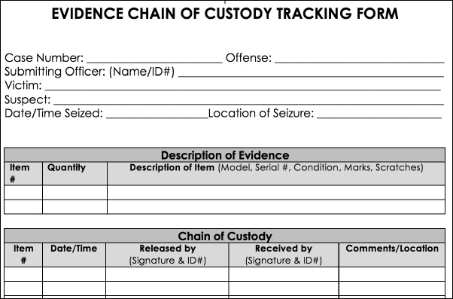
Figure 1 - Chain of Custody Template [13]
Chain of Custody is extremely important when handling and preserving evidence as they are used to prevent contamination. If any evidence has been handled without full documented it can be rule inadmissible within the courts of law, in lay man term, it will not be useable. A log in maintain to provide the court with the evidence that there is no missing link within the chain. Chain of custody are handed when presenting evidence before court begins session.

Forensics Stages

Policy and Procedure
Integral part of any investigation involves policies and procedures for law enforcement organisations that utilise computer forensics departments. An investigation must be broken down into steps. This essential enforces that proper steps are being taken to determine the details of the case at hand, doing so will allow the forensics team to understand all permissible investigative actions in relation to the case E.G. warrants, authorizations require to obtain any permissions prior to pursuing the case

Evidence Assessment
A Key component of any investigation process is to assess the potential evidence that can be used within a case. Processing of evidence is a clear understanding of the details of the case, therefore the classification of the crime. An example of this is a small forensics science investigator is searching through hard drives, email accounts and other digital archives to ascertain all information that may be of viable evidence to that of the crim at hand. This is similar to other crimes. The investigator must define types of evidence such as platform, data formats and have an understanding of how to preserve this data, then determine the source and integrity of such data before entering it into evidence.

Evidence Acquisition
This part of the forensics stage process is to acquire the evidence which is available. All forensic investigators must have documentation in place before conducting any investigation. Documents include processes and procedure to successfully record and preserve data, this also includes all hardware and software specifications, any systems used, and the system being investigated.
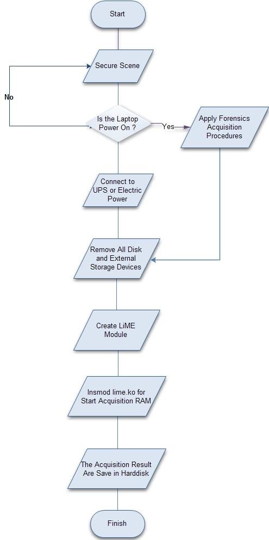
Figure 2 - Basic Offline Data Acquisition

Evidence Examination
As with previous steps, documentation must be in place to effectively investigate potential evidence. process, and procedures such as retrieving, copying, and storing evidence within appropriate storing locations. Once held safe and secure, analytic software may be used to conduct massive archive searches for specific keywords, file types as well extraction of that data so that it may be reviewed without tampering with the original files.
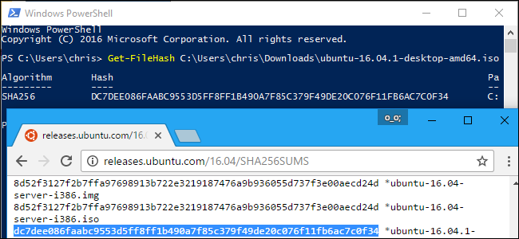
Figure 3 - Example of MD5 comparison

Evidence Documenting and Reporting
Documenting information is by far the most important information that should be kept when dealing with a forensics investigation. All actions related to a particular case will be accounted for in digital format and saved properly in the designated archives to be reviewed in the court of law. If evidence is presented without such documentation E.G. chain of custody, this evidence will be void as potential unauthorised access may have been had when acquiring the evidence, where it was stored, who had custody of the evidence and much more. The validity of the evidence is confirmed when matching the investigators digitally recorded documents to the date and times when this data was accessed by external sources.

Research

Forensic tools
I computer forensics, the rules and procedures remain the same, however the tools are forever changing due to either optimisations of the tools or the ever-changing threats that and technology emerging. As previously mentioned, a set of technical and law knowledge is required.
As the same with everyday life, certain tools are developed and maintained to support a specific job. The same applies to forensic tools, you can get tools that perform a wide variety of different tasks. For this reason, a computer forensic expert will have the insight into their selected tools and be able to use the appropriate tool for the task at hand. Additionally, Tools come in two forms; first being Commercial tools, these tools are procured, developed, and sold under appropriate licenses while the 2nd form Open Source are freely available for anyone to use. [16]
Manufacturers tend to classify computer forensics tools into two types; These are hardware and software.
- Hardware Forensic tools
Most hardware forensic tools are developed to perform specific tasks. [17]These hardware devices will have their own built-in software for acquiring images of the evidence while protecting the original from altering. Some tools include cloning devices write-blockers, sim card reader and much more. [18]

- Software Forensic tools
A variety of software forensic tools are around, as mentioned before, they are categorised into commercial or open source. The tools are developed by different companies and individuals with different capability and aims for the tool the tools below are most frequently used in the computer forensic industry. [18]

- Encase
Encase [19] is one of the most highly regarded and trusted computer forensic software tool, its most commonly used within law enforcement industry due to its high standard and reputation from its peers and customers. Developed by Guidance Software company based on the Windows Operating system. Encase is a computer forensic tool for analysing an evidence file, the file is copied using a method called bit-by-bit copy [19] which essentially creates a perfect copy of the evidence file on another external drive which the forensic investigators may use to inspect the contents. To verify the integrity of this method, a technique called MD5 hashing is used, this uses hash and Cyclic redundancy Checks (CRC) values [20]. This essentially checks for any changes, alterations or errors when transferring digital evidence.
With Encase, the investigator can perform various other tasks such as gather evidence from volatile memory areas such as Random-Access Memory (RAM) and the cache. Deep analysis is conducted to find hidden files and deleted data within the evidence files. 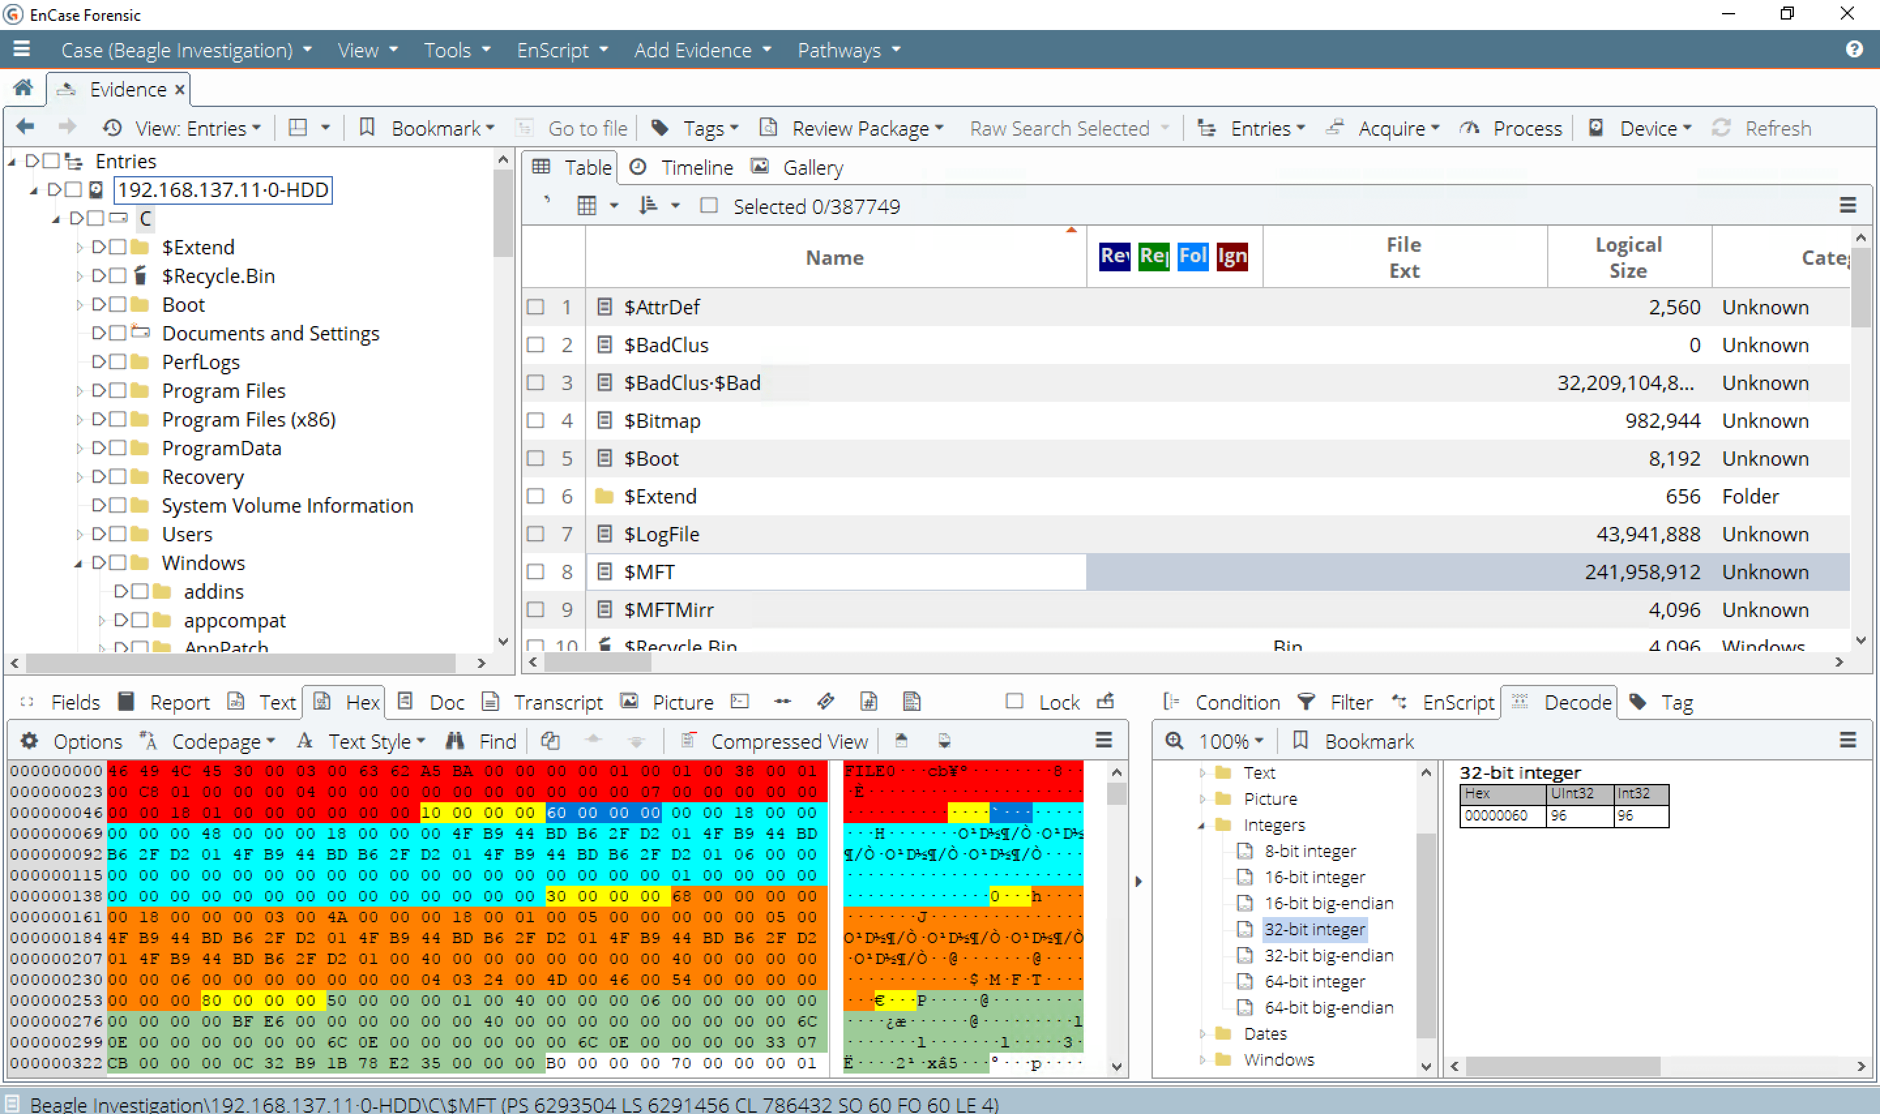
Figure 4 - Encase Application [21]

- Forensic Toolkit (FTK)
The Forensic Toolkit [23] was developed in 1987 by AccessData. It is known as one of the most powerful digital forensic tools used today to extract and examine evidence in windows based operating systems by law enforcement industry. Very similar to EnCase the FTK imager creates a duplicate of the hard disk and generates its MD5 hash values to confirm the reliability of the data. FTK is designed with many features examples of this are password cracking, file decryption, data carving [24] and able to report in a format that is suitable to be used in the court of law( this is customisable) [24].
Additionally, FTK is designed to be used in unison with other computers utilising their power for processing and analysis, this allows the processes to be sped up [25].
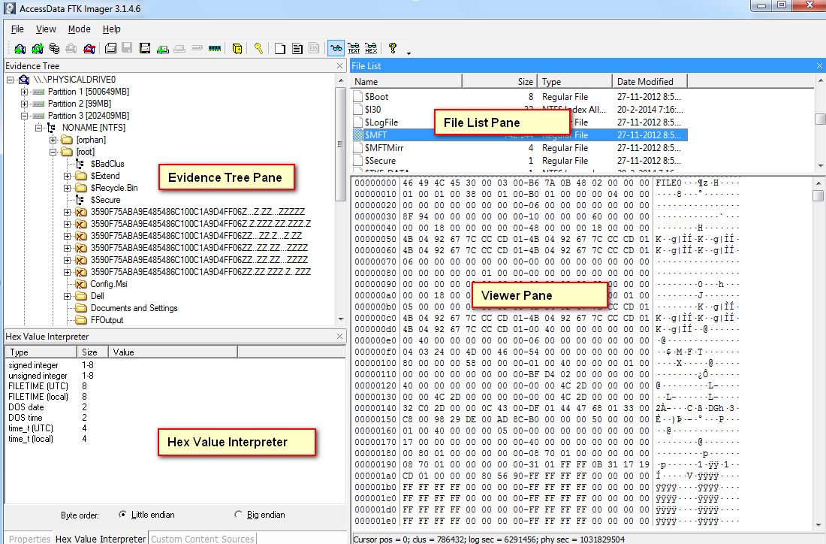
Figure 5 - FTK Application [26]
- Caine
Computer Aided Investigative Environment (CAINE) [27] is a free forensic tool which is currently project managed by Nanni Bassetti in Italy [27]. This forensic tool is based on Ubuntu [28]. this tool has a showcase of tools within and uses a more user-friendly user interface as it is an operating system/Environment itself. It is mainly used to examine and collect evidence files from mobiles, databased and network forensics, and data recovery. One of its more useful tools is that it can run live analysis of a windows OS using the Windows-Ultimate Forensics Outflow (WIN-UFO) tool.
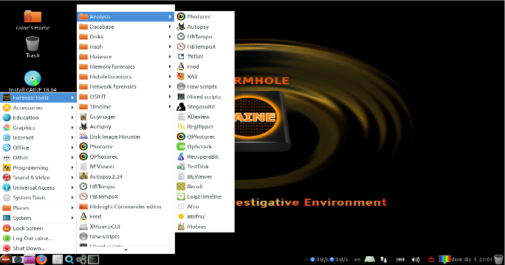
Figure 6 - Caine Application [27]
- Sans Sift
SANS Investigative forensic Toolkit (SIFT) [29] is one of the most commercially free open sourced digital forensics kits in the field which is developed by Rob Lee. Similar to Caine it is a collection of forensic tools based on the Ubuntu Linux operating system.
Some tools that are contained within the Sans Sift are: Wireshark, Hex editor, and the Sleuth Kit.
This toolkit supports multiple formats such as Expert Witness Format (E01), RAW (dd) and Advanced Forensic Format (AFF). 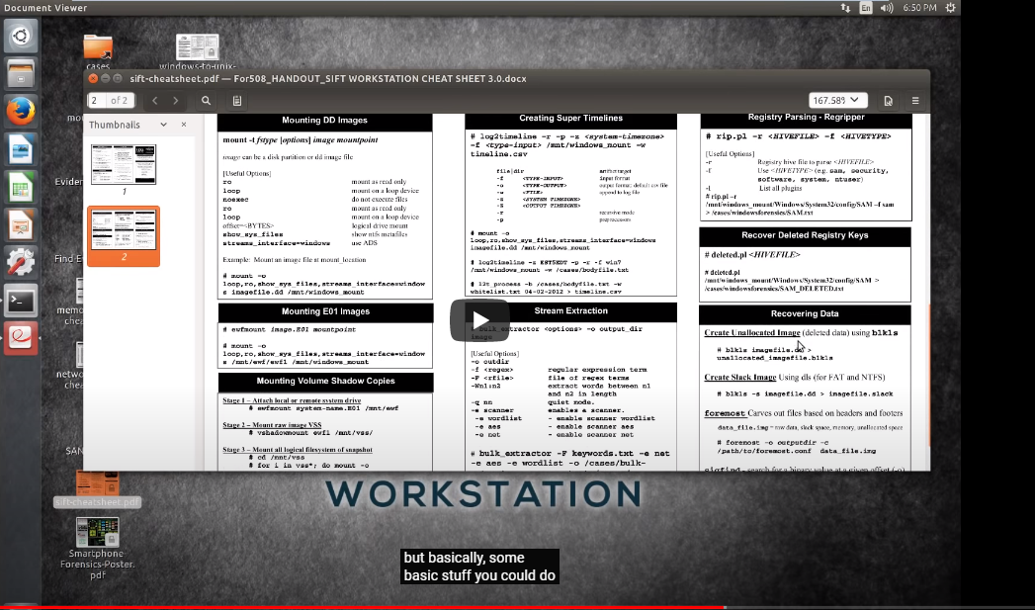
Figure 7 - Sans Sift Environment [30]
- Sleuth Kit
The Sleuth Kit is a command line based forensic tool kit that is developed on the Linux operating system. This kit is most known for its in-depth analysis of disc images and intense analysation of a variety of file systems using different methods and techniques. As with many other tools, this can be used to find deleted files and recover them to a readable and interactable state. It features a Graphical user interface (GUI) application called autopsy which is a free open source application that can be used on both Linux and Windows operating systems [31]. 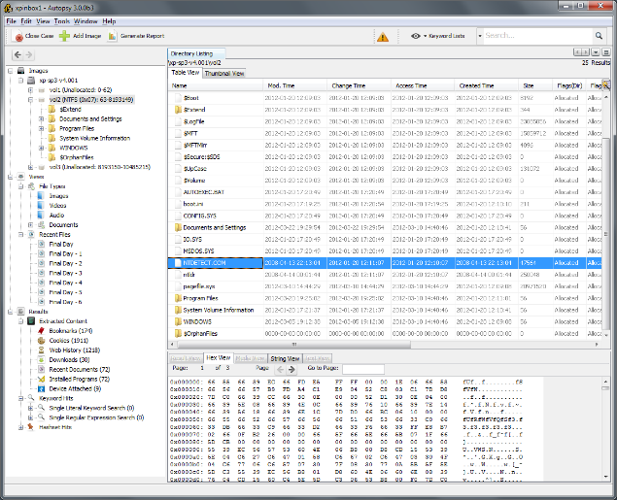
Figure 8 - Sleuth Kit – Autopsy [32]

- COFEE
Computer Online Forensic Evidence Extractor (COFEE) is similar to previous example in that it uses a collection of tools. This application is developed by Microsoft and is used on Windows operating systems for forensic uses. The tool is a small plug-in device similar to that of a Universal Serial Bus (USB) which contains a library of over 150 tools and a graphical interface on which the investigator can use to collect data.
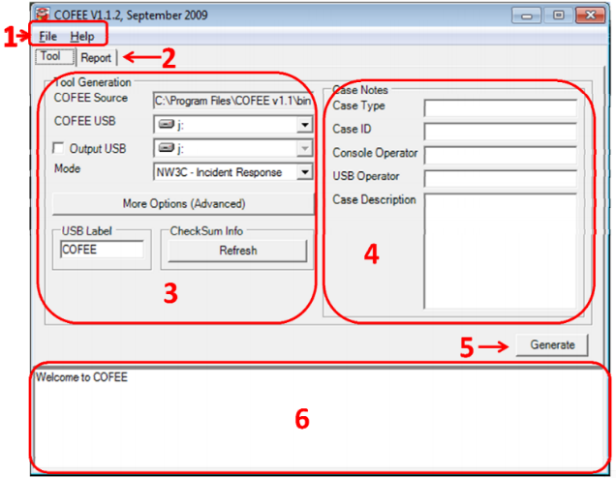
Figure 9 - Cofee V1.1.2 interface
- OSForensics
OSForensics [33] is a commercial tool that is developed by Passmark Software Company. It is deigned to work on the Windows operating system. This tool is widely used by forensic experts for performing in depth analysis on emails, files, and browsers. The application has a user-friendly interface which allows the investigator.
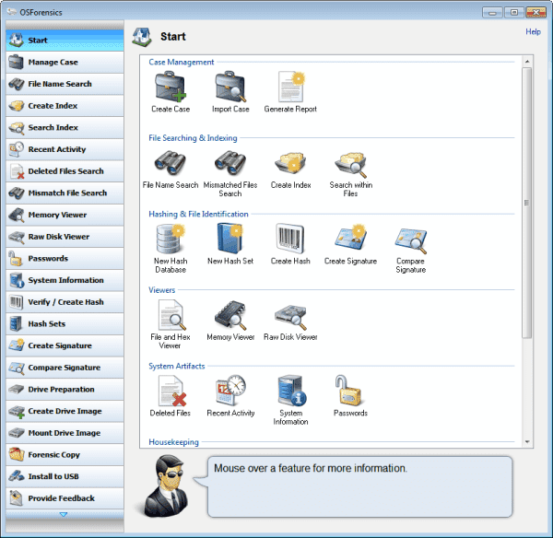
Figure 10 - OSForensic User-Interface

- ProDiscover
ProDiscover [34] is a forensic tool used by forensic professionals on the Windows operating system, developed by Dot C Technologies. This product has both commercial and free versions. They vary in capabilities depending on which version you acquire. The tool can be used to recover deleted files, search for hidden documents and content in the slack space [35], create disk images and legal reports with customizable templates.
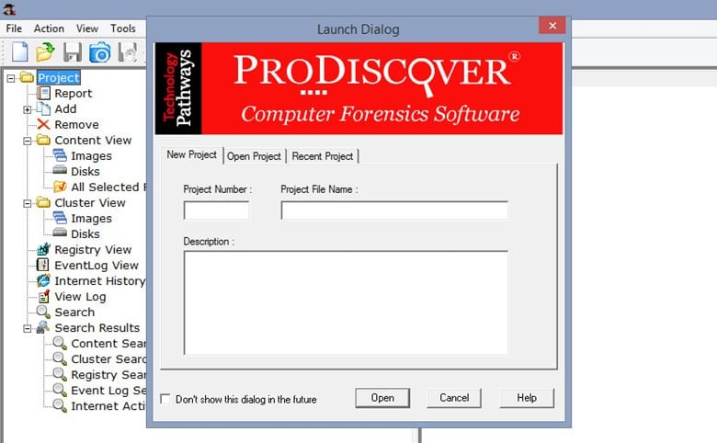
Figure 11 - ProDiscover Application
- Volatility
Volatility [36] is developed by Volatility foundation and is currently on version 2.6 for Windows operating systems. Volatility is mainly used for memory forensics; this allows the collection or analysis on a computers volatile memory (RAM).Particularly, it is designed to keep evidence information from memory that would be lost once then computer is shutdown or reset, additionally, it can also be used to automatically detect and analyse on malware by directly examining the operating system. The tool is available to use on both Linux and Windows operating systems.
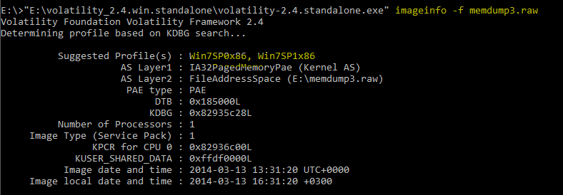
Figure 12 - Volatility profile report

- WindowsSCOPE
WindowsSCOPE [37] is a memory forensics tool that performs reverse configuration, this technique is used to examine and acquire information from physical volatile memory, it is most commonly used for detection of malicious software on a computer by using back engineering techniques in the Windows operating system. Likewise, it is used to obtain information from registry, DLLs, cache, network connections and many others. The tool supports both hardware and software products.

7.2 Research Table
Based on the research above, computer forensic tools are designed and developed to tackle one or more tasks, they are strong in certain aspects and weaken in others. The table below has been created to better show this.

Tools Name | Used for | Platform | Source | Description
Encase | Data Recovery | Windows | Commercial | GUI
FTK | Hard Disk Analysis | Windows | Commercial | GUI
CAINE | Live analysis | Linux Distribution | Free | GUI
SANS SIFT | Data | Linux Distribution | Free | GUI & Command Line
The Sleuth Kit | Email, Data analysis | Linux Distribution | Free | Command Line
Cofee | Live analysis | Windows | Commercial | GUI
OSForensics | Email analysis | Windows | Free & Commercial | GUI
ProDiscovery | Data recovery | Windows | Commercial | GUI
Volatility | Memory analysis | Windows & Linux Distribution | Free | GUI & Command Line
WindowsScope | Memory analysis | Windows | Commercial | GUI

Write Blockers
A write block is a tool which is used to only allow read-only access to a data storage, this essentially protects the data as users can no longer compromise the integrity of the data. A write block when used correctly can be used in the chain of custody. NIST general write blocking requirement must hold that of the following: [38]
The tool shall not allow protected drive to be changed
The tool shall not prevent obtaining information from or about the drive
The tool shall not prevent any operations to a drive that is not protected
There are two version of a write blocker, software, and hardware; both write blockers do the same job, this being to prevent the writing, alteration, and deletion of data. The key difference is that the hardware write blocker is installed on the controller chip inside a portable physical disk device whereas the software counterpart is installed on a forensic computer workstation.

Encryption
Encryption is a method used to protect information when in transit or at rest. Full disk encryption (FDE) is a method that can be used to secure a hard drive. Within a forensic investigation, encryption is one of the harder hurdles to overcome, as it is assumed that sensitive information may be within the hard drive, unlocking/decrypting a hard drive involves multiple processes including, password cracking and decryption.
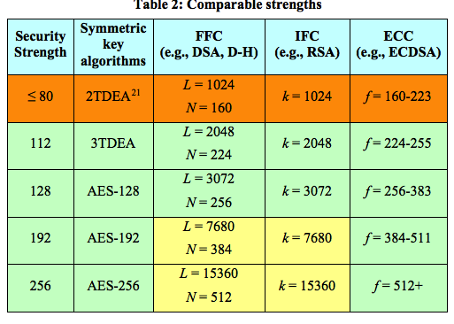

Figure 13 - Encryption Standards Table

Setting up a forensic Lab
Creating a Forensic lab/Workstation is a very important step, the lab must build to purpose, the effectiveness of the lab will depend on what software, hardware, and equipment it has.
Choosing workstation configurations is very important as this will assist the forensic investigator in being productive and effective.
As reported by Digital Forensics Corp, the following should be considered when configuring a forensic workstation:
Sound – a workstation should work as quietly as possible due to several powerful computers being within close proximity, this can generate poor health by inducing headaches and general poor health by loud computers. Silent workstations can achieve the same results with better components, using low-noise fans and passive cooling can be ideal.
Computer hardware: Although as previously mentioned in the research above, some tools are limited to Linux systems. Digital Forensic corps believe that the optimal hardware configurations are
OS: Windows 10 Pro 64-bit
CPU (2): E5-2660 v4 (14 core)
RAM: 64 GB DDR-42133 ECC
OS Drive: 1 TB SSD
Temp/Cache/DB Drive: 256 GB SS
Data Drive: 8 TB 7200rpm
RAID Drives: 5×4 TB 7200rpm
Video Card: GeForce GTX 1080
10Gbit Net Cards as this would be ideal for the transfer of ‘big data’ that is being stored within the 5x4tb Raid setup.
Two monitors for each workstation as this would allow the forensic investigator to work optimally in this environment.
Forensic Software:
Virtual environment:
While the recommended operating system is windows based. Virtual machines can be deployed on them, using software such as VMWare, you can create an unlimited amount of additional virtual environment on which you can deploy operating systems such as Kali Linux, Caine, and windows. These can be used for forensic tools that can only be used on Linux machines. Additionally, virtual machines are very secure as they essentially are segregated from the host machine.

Task 2 - Case Study

In computer forensics, the situation is forever changing, however, the procedures and tools that are used remain the same. Based on the above research investigators should maintain the chain of custody which is produced for the court of law. It is imperative to follow the rules and guidelines of computer forensic.

Scenario
In this Terrorist attack case, a known terrorist was show down at Heathrow International Airport, the terrorist was planning to bomb the Mason International airport in Fiji. This was further confirmed once matched with the known terrorists list. When attempting to flee the scene, the police onsite confronted the known terrorist, resulting in him being shot.

The Terrorist was carrying a briefcase. Mr. Mark Wales, the Chief Investigator at Heathrow Police Department made a phone call to John.
John is a detective in a professional investigation service and has been asked to participate in the investigation. John has been asked to examine the items within the briefcase.

Assumptions
Within this Terrorist attack case, I believe that Jon is an investigator, as being of an investigator rank, John can interact with the evidence and gather information from it. Main responsibilities are [39]:
- Conduct initial risk assessments based and in accordance with H&S legislation conduct [39].
- Use forensic software such as EnCase and hardware tools to capture, retrieve, recover, and extract data from mobile phones and portable devices in a forensically sound manner while keeping a log of the processes used. This is within the chain of custody.
- Responsible for directing and tasking the Digital Forensic Examiners to ensure the professional delivery of all cases.

A chain of custody has been prepared and is ready for use within this investigation, as previously mentioned, this is used to record all information such as who is currently investigating what techniques they use, how long are they interacting with the evidence. Additional information such as time, place, serial numbers and signatures of each investigators are recorded.

What we know so far
Within the scenario we discovered that the terrorist was carrying a Dell Laptop which had fingers prints that matched the known terrorists list which further confirms that this belongs to him. Pictures are taken at the crime scene of the terrorist and briefcase contents; these were taken with Johns Cannon Digital Camera for evidence.
The Laptop is running on Windows operating system Version XP Professional Service Pack 2.
The laptop was still active in Stand by mode, which will allow for better data retrieval by John as the RAM will still contain information that can be extracted.

9.4 Data recovery
John will begin by using the previously mentioned data acquisition. It is assumed that the scene has been secured and John knows that the Laptop power is currently on and in Standby mode.
John is to apply forensic data acquisition procedures, using one of the multiple data forensic tools. John is to extract all data from the RAM and other volatile areas as this data has been retained by the Laptop not being turned off. Other drives and files will also be copied across using Bit-by-bit method and then verified using both MD5 and another method such as SHA1. Most tools will automatically create a MD5 value while completing the bit-by-bit copy. Comparing the values to preserve the authenticity of the original data. At this point a chain of custody is collecting evidence through the investigation as previously mentioned.

Once John has quarantined the physical evidence device along with a sticky label, it should then be transported to a secure location in order to protect the device from physical damage, this also maintains the reliability of the evidence. Afterwards, john should start to verify if there are necessary tools to start the investigation such as a forensic lab and tools. This is also good practice as any evidence will be dismissed if the original evidence has been tampered with in any fashion. This is why forensic investigators create an exact copy on which they can investigate.

As a forensic expert, John should be able to select the correct forensic tools for the job and examine the evidence. The reason that John selects a specific tool is that each tool is designed with a purpose in mind and as such has different features and capabilities such as password cracking, memory analysis and network analysis.

Data Analysis
Once the Tools have been deployed and John can access information within the hard drives and other sources such as RAM. John look and select the best tool for data analysis, this must fall in line with what has been requested of him by Mr. Mark Wales. FTK would be a suitable tool for this as it is used to find hidden, deleted, encrypted, and camouflaged files. Once FTK has finished its initial analysis of the imaged hard drive john will be able to find information within and any encrypted files will hopefully be decrypted using the tool, additional data analysis can be done from this point, such as Key word searches. This search will look throughout the device including the slack space and volatile memory areas. Hidden files can be found much easier using the search method e.g. files that have their extensions changed may still be called “plans”, once changed back to the original extension, the file will be in a viewable format for John. John is led to Microsoft Outlook where multiple email files are within, FTK does not have this capability as such John will need to search for another tool to do this. Paraben e-mail examiner [41] this tool would be a good as in the name it is designed to examine emails. This tool can also be used to read and recover deleted history, email messages and many more.

A computer forensic expert should follow forensic procedure for legal proceeding, recording evidence when possible. Videos and text documents will be also documented and given a short description of what the video contains, this includes video creation dates and locations if possible.

From this information John will be to continue further into the investigation with more knowledge allowing him to make informed decisions.

Report and findings
John can generate a report using FTK. This FTK report can display all evidence gathered from the device if selected for the court to view. This report is in a readable format which makes it easier for John to produce multiple reports based on different findings. The report format should contain the purpose, case information, incident summary and evidence, all forensic tools used and a conclusion. The report should also be written in layman’s terms so that the court may understand the report. In this scenario John is the incident handler as such , is a forensic expert whose job is to identify, collect, analyse, preserve, and present the evidence to the court. John will produce and prepare the report which will contain all the records documented and process that were used during the forensic investigation and present this to the jury.
The table below states the report format that was written to Mr. Mark Wales. The report contains the following:
Incident handlers name
Evidence
Forensic tools used
Conclusion
This report as previously mentioned will be made so that the jury can easily understand.

Name | John
Email | John.Forensics@gmail.com
phone | 1476594584
Evidence
Gathering and analyzing all the evidence provided within the device. These files were produced as a result of the investigation.
The evidence files will support the judge and jury when making a decision, from this a concise and correct decision will be made.
all evidence files can be found here
Forensic tools used
Guidance Software Company - EnCase
Access Data - FTK Imager
Paraben Email-Examiner
All these tools were licensed before use and approved for use during the investigation by the police
Conclusion
Dear Mr. Mark Wales
Figure 14 – Sample report for investigation
Forensic Expert
Address | Kings Cross
City | London
Phone | 1445345234
Email | ForensicsPolice@London.com
Bill to:
Name | Mr.Mark Wales
Address | Cardiff
Description | Amount
Labor@£25/hr | £2,500
Tools | £3,500
report | £500
Total | £6,500
John
Phone Number: 1476594584
Figure 15 – Sample of Invoice

Conclusion
In this day and age, computer forensics is gaining a large popularity uptake due to the rise of computer related crimes in the world, However, this field is still new and as such is lacking in standard operating procedures when dealing with crimes, this is especially the case when comparing countries to another. This report discusses the four standard procedures that over arc the entire forensic process; the collection, acquisition, analyse and reporting and the tools that can be used to assist these areas.

Bibliography

[1] | R. Das, “An Introduction To Computer Forensics,” Infosec Resources, N/A NA N/A. [Online]. Available: https://resources.infosecinstitute.com/category/computerforensics/introduction/. [Accessed 25 March 2020].
[2] | Vocabulary, “forensic,” Vocabulary, N/A N/A N/A. [Online]. Available: https://www.vocabulary.com/dictionary/forensic. [Accessed 25 March 2020].
[3] | House of Parliament - Office of Science & Technology, “Digital Forensics and Crime,” Digital Forensics and Crime, vol. 1, no. 520, p. 1, N/A March 2016.
[4] | US-CERT , “Computer Forensics,” US-CERT , N/A N/A 2008. [Online]. Available: https://www.us-cert.gov/sites/default/files/publications/forensics.pdf. [Accessed 25 March 2020].
[5] | House of Commons, “E-Crime,” House of Commons, 17 July 2013. [Online]. Available: https://publications.parliament.uk/pa/cm201314/cmselect/cmhaff/70/70.pdf. [Accessed 25 March 2020].
[6] | legislation.gov.uk, “Regulation of Investigatory Powers Act 2000,” UK Gov, 25 March 2020. [Online]. Available: http://www.legislation.gov.uk/ukpga/2000/23/contents. [Accessed 25 March 2020].
[7] | Parliament UK, “Bill documents — Data Retention and Investigatory Powers Act 2014,” UK Parliament, 18 July 2014. [Online]. Available: https://services.parliament.uk/bills/2014-15/dataretentionandinvestigatorypowers/documents.html. [Accessed 25 mARCH 2020].
[8] | Philip Ward, Alexander Horne, “Interception of communications,” House of commons Library, 13 March 2015. [Online]. Available: https://commonslibrary.parliament.uk/research-briefings/sn06332/. [Accessed 25 March 2020].
[9] | Legislation UK, “Police Act 1997,” Legislation UK, 1997. [Online]. Available: http://www.legislation.gov.uk/ukpga/1997/50/pdfs/ukpga_19970050_en.pdf. [Accessed 25 March 2020].
[10] | Legislation UK, “Serious Crim Act 2015,” Legislation UK, 2015. [Online]. Available: http://www.legislation.gov.uk/ukpga/2015/9/contents/enacted. [Accessed 25 March 2020].
[11] | legislation.gov.uk, “Computer Misuse Act 1990,” legislation.gov.uk, 29 June 1990. [Online]. Available: http://www.legislation.gov.uk/ukpga/1990/18/contents. [Accessed 25 March 2020].
[12] | UK GOV, “Forensic science providers: codes of practice and conduct, 2020,” UK GOV, 22 April 2020. [Online]. Available: https://assets.publishing.service.gov.uk/government/uploads/system/uploads/attachment_data/file/880708/Codes_of_Practice_and_Conduct_-_Issue_5.pdf. [Accessed 19 May 2020].
[13] | ISO, 1 December 2017. [Online]. Available: https://www.iso.org/ISO-IEC-17025-testing-and-calibration-laboratories.html. [Accessed 19 May 2020].
[14] | INFOSEC, “Computer Forensics: Chain of Custody,” INFOSEC, [Online]. Available: https://resources.infosecinstitute.com/category/computerforensics/introduction/areas-of-study/legal-and-ethical-principles/chain-of-custody-in-computer-forensics/. [Accessed 12 May 2019].
[15] | Packt, “Digital Evidence,” Packt, N/A September 2016. [Online]. Available: https://subscription.packtpub.com/book/networking_and_servers/9781785882081/1/ch01lvl1sec12/digital-evidence. [Accessed 12 May 2019].
[16] | A. Kucherlavy, “What is the Difference Between Commercial and Open Source?,” Intechn!c, N/A N/A 2019. [Online]. Available: https://www.intechnic.com/blog/what-is-the-difference-between-commercial-and-open-source/. [Accessed 30 May 2019].
[17] | Igor Mikhailov, “Tools up: the best software and hardware tools for computer forensics,” Group IB, 26 June 2019. [Online]. Available: https://www.group-ib.com/blog/digital_forensics_tools. [Accessed 30 May 2020].
[18] | Forensic Store, “Digital Forensic Tools,” Forensic Store, 30 May 2020. [Online]. Available: https://forensicstore.com/product-category/forensic-hardware/. [Accessed 30 May 2020].
[19] | Guidance Software, “EnCase Forensic,” Opentext, 27 June 2020. [Online]. Available: https://www.guidancesoftware.com/encase-forensic. [Accessed 27 June 2020].
[20] | EDRM, “Bit-by-Bit Copy,” US Justice Department, April 2008. [Online]. Available: https://www.ncjrs.gov/pdffiles1/nij/219941.pdf. [Accessed 16 June 2020].
[21] | R. N. Williams, “A PAINLESS GUIDE TO CRC ERROR DETECTION ALGORITHMS,” RockSoft, 19 August 1993. [Online]. Available: https://www.mathpages.com/home/kmath458/kmath458.htm. [Accessed 27 June 2020].
[22] | OpenText, “7 key things forensic investigators need to do,” OpenText, 14 May 2018. [Online]. Available: https://blogs.opentext.com/7-things-forensic-investigators-need-to-do/. [Accessed 27 June 2020].
[23] | AccessData, “Forensic Toolkit (FTK),” AccessData, 27 june 2020. [Online]. Available: https://accessdata.com/products-services/forensic-toolkit-ftk. [Accessed 27 June 2020].
[24] | F. Carbone, “Carving the data,” Packt, 20 March 2014. [Online]. Available: https://subscription.packtpub.com/book/hardware_and_creative/9781783559022/5/ch05lvl1sec30/carving-the-data#:~:text=a%20FREE%20trial.-,Carving%20the%20data,adding%20evidence%20to%20a%20case.. [Accessed 27 June 2020].
[25] | AccessData, “Capabilities to empower you,” Accessdata, 27 June 2020. [Online]. Available: https://accessdata.com/products-services/forensic-toolkit-ftk. [Accessed 27 June 2020].
[26] | M. Stam, “HOW TO INVESTIGATE FILES WITH FTK IMAGER,” eForensics, 2013. [Online]. Available: https://eforensicsmag.com/how-to-investigate-files-with-ftk-imager/. [Accessed 27 June 2020].
[27] | Caine, “Caine 11.0 - Wormhole,” Caine, [Online]. Available: https://www.caine-live.net/. [Accessed 27 June 2020].
[28] | Ubuntu, “Ubuntu,” Ubuntu, [Online]. Available: https://ubuntu.com/. [Accessed 27 June 2020].
[29] | Digital-Forensic, “SIFT Workstation,” Digital-Forensic, 2020. [Online]. Available: https://digital-forensics.sans.org/community/downloads. [Accessed 27 June 2020].
[30] | SANS Digital Forensics and Incident Response, “Getting Started with the SIFT Workstation Webcast with Rob Lee,” N/A, 13 November 2017. [Online]. Available: https://www.youtube.com/watch?v=ai_7Fkv6igw&feature=emb_logo. [Accessed 28 June 2020].
[31] | Autopsy, “Autopsy and The Sleuthkit,” Autopsy, 2020. [Online]. Available: https://www.autopsy.com/about/. [Accessed 28 June 2020].
[32] | SleuthKit, “Autopsy,” SleuthKit, 2020. [Online]. Available: https://www.sleuthkit.org/autopsy/. [Accessed 28 June 2020].
[33] | OSForensic, “OSForensics V7,” PassMark Software, 2020. [Online]. Available: https://www.osforensics.com/. [Accessed 28 June 2020].
[34] | prodiscover, “Prodiscover,” prodiscover, 2020. [Online]. Available: https://www.prodiscover.com/. [Accessed 28 June 2020].
[35] | Computer Hope, “Slack Space,” Computer Hope, 16 November 2019. [Online]. Available: https://www.computerhope.com/jargon/s/slack-space.htm. [Accessed 28 June 2020].
[36] | volatilityfoundation, “volatilityfoundation,” volatilityfoundation, 2020. [Online]. Available: https://www.volatilityfoundation.org/. [Accessed 28 June 2020].
[37] | Windows Scope, “Windows Scope,” Windows Scope, 2020. [Online]. Available: http://www.windowsscope.com/. [Accessed 28 June 2020].
[38] | NIST, “SOFTWARE QUALITY GROUP,” NIST, 24 June 2020. [Online]. Available: https://www.nist.gov/itl/ssd/software-quality-group/computer-forensics-tool-testing-program-cftt/cftt-technical/hardware. [Accessed 30 June 2020].
[39] | The Chartered Society of Forensic Sciences, “Digital Forensic Investigator,” The Chartered Society of Forensic Sciences, 2020. [Online]. Available: https://www.csofs.org/Vacancies/Digital-Forensic-Investigator/37683. [Accessed 30 June 2020].
[40] | ENFSI, “Scenes of Criminal examination Best Practice Manual,” 2020. [Online]. Available: http://library.college.police.uk/docs/appref/ENFSI-BPM-v1_0.pdf. [Accessed 30 June 2020].
[41] | Insectra, “Paraben Email Examiner,” Insectra, 2020. [Online]. Available: https://www.insectraforensics.com/Paraben-Email-Examiner/en#:~:text=Paraben's%20E%2Dmail%20Examiner%20is,e%2Dmail%20examination%20tools%20available.&text=With%20the%20ability%20to%20examine,mail%20examination%20in%20your%20toolbox.. [Accessed 30 June 2020].

