

Module Name: Management and Organisational Behaviour ( Level 5 )
Module Code: BMIH5004
Student Name: Shila Begum Laskar
Student ID: 2245345
Lecturer Name: Daniel Payne

Declaration
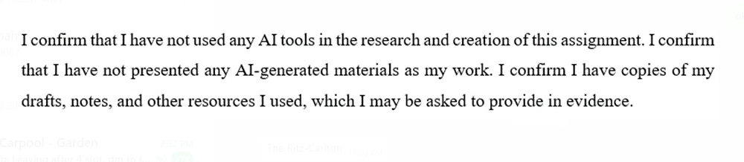
Table of Contents
1 Introduction 3
2 Main Body 3
2.1 Organisation Structure 3
2.2 Corporate Culture 4
2.3 Influence on Organisation 5
2.4 Recent Change Initiatives 6
2.4.1 Digital Transformation at Hilton 6
2.4.2 Hilton’s Sustainability Efforts 6
2.5 Strategic Direction 8
2.5.1 Market Expansion 8
2.5.2 Brand Diversification 9
2.6 Evidence-Based Analysis 10
2.7 Theoretical Frameworks 10
2.7.1 Dynamic Capabilities Theory 10
3 Recommendations 11
4 Conclusion 11
5 Reference List 12

Introduction
Hilton Hotels & Resorts is the prominent global hospitality brand, which is renowned for the extensive portfolio of the hotels and resorts. As the flagship brand of the Hilton Worldwide (Hilton, 2025). This report aims to provide the in-depth analysis of the Hilton's organisational structure, corporate culture, goals at both corporate and also the individual levels, the recent change initiatives, and also the strategic direction towards achieving the long-term objectives. The primary objective is to critically evaluate that how these components contribute to the Hilton's success in the competitive hospitality industry. By leveraging the evidence-based analysis supported by the relevant management theories, this report will assess that Hilton's strengths and areas for the improvement. The findings will inform the recommendations on how the Hilton can enhance their standing in the industry through the strategic adjustments and also the best practices implementation.
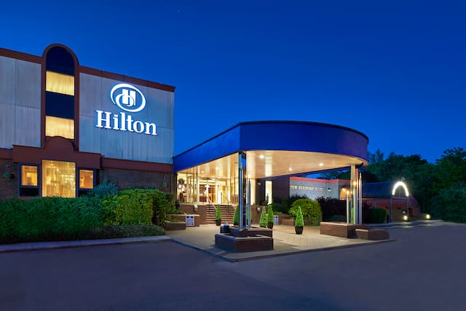
Figure 1 - Hilton Hotel & Resort
Source: (Hilton.com, 2025)

Main Body

Organisation Structure
Hilton Hotels & Resorts operates with the hierarchical and divisional organisational structure, which is typical for the large multinational corporations (Hilton.com, 2025). This framework is made to facilitate the effective management as well as the operations within the different departments like the marketing, the brand creation, the human resources, the information technology, and others. The president tops the hierarchy and is responsible for the overall hotel operations and offering the strategic direction to various departments. The business segments of the company are the ownership, the management and also franchise, and also timeshare. The ownership segment the consists of hotels owned or leased by Hilton Worldwide, whereas the management and also the franchise segment consists of properties managed by the Hilton or franchised to third parties (Hilton.com, 2025). The timeshare division has operated under the Hilton Grand Vacations as a separate entity since its spin-off. This hierarchical structure that allows for the clear decision-making processes but can sometimes slow down the communication between levels. However, initiatives such as restructuring the senior management have improved the communication between individual business units and headquarters.
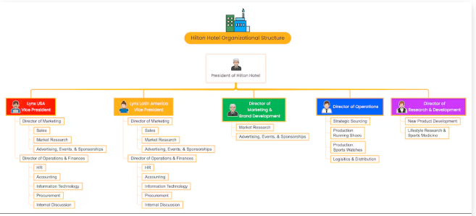
Figure 2 - Hilton Hotel Organisational Structure
Source: (EdrawMind, 2025)

Corporate Culture
Hilton's corporate culture is deeply rooted in the values, encapsulated by the acronym HILTON Hospitality Integrity Leadership Teamwork Ownership Now. These values guide the employee interactions with the guests and stakeholders, which fostering the collaborative environment that emphasises the integrity and teamwork. The company prioritises diversity equity inclusion (DEI) initiatives to create the diverse workforce capable of catering to the international clientele effectively (Rockett, 2023). The career growth opportunities are also central through the programs such as Heart of House, which focuses on the employee well-being and development. Additionally, Hilton’s culture is supported by the four core pillars such as purpose, growth, the wellness, and inclusion. These pillars help create the workplace where employees feel valued and connected to something bigger than themselves. The emphasis on purpose aligns with the Conrad Hilton's vision that travel can bridge cultures, while wellness programs support the employees throughout their careers. The Hilton’s culture plays an important role in driving the operational success by aligning the employee behaviors with the organisational goals focused around the hospitality excellence (Egamberdieva, 2024). This approach has earned Hilton recognition as one of the best workplaces for the women for five consecutive years.

Influence on Organisation
Hilton's corporate culture significantly influences their operations by fostering the collaborative environment that enhances the guest experiences (Service.gov.uk, 2024). The emphasis on the teamwork encourages the cross-departmental collaboration, which ensuring the seamless interactions with guests. The diversity equity inclusion initiatives attract the diverse workforce capable of catering to the international clientele effectively, which promoting the diverse perspectives that enhance the service quality. The programs such as Heart of House focus on the employee well-being, which creating the positive work environment where employees feel valued. This indirectly benefits customer satisfaction as the happy employees are more likely to provide the excellent service. Hilton’s culture is shaped by the compelling mission, vision, and also the value statements that drive every organisational aspect (Ertuna et al., 2022). The company's commitment to creating the world's best work environment aligns the employee behaviors with the organisational goals focused on the hospitality excellence. By prioritising employee satisfaction and diversity, Hilton ensures the workforce is equipped to deliver the exceptional experiences for the guests worldwide. This approach has contributed significantly to the Hilton being recognised as the great place to work, with the high levels of employee pride in the company.

Recent Change Initiatives
In recent years, Hilton Hotels & Resorts has embarked on the several strategic initiatives aimed at enhancing the guest experiences and operational efficiency. The two notable areas of focus have been the digital transformation and sustainability efforts.

Digital Transformation at Hilton
Hilton has implemented the various digital solutions to streamline the guest interactions and also improve the operational efficiency. The various key initiatives include, the mobile check-in or the check-out systems or the guests can now use their smartphones to check in or out. This reducing wait times and also enhancing the convenience. The digital room keys or the Hilton introduced digital key share, allowing multiple guests to access rooms via the Hilton Honors app (Baldwin et al., 2021). The company uses the AI-driven chatbots for customer support, improving response times and personalising interactions. These digital innovations have significantly enhanced the guest experience by providing seamless interactions with hotel services.

Hilton’s Sustainability Efforts
Recognising the growing demand for the eco-friendly accommodations, Hilton launched the environmental sustainability programs across the properties. These efforts aim to reduce the carbon footprints through energy-efficient practices and waste reduction strategies. For instance, installing the electric vehicle (EV) chargers at many of their North American hotels helps alleviate the range anxiety for the environmentally conscious travelers.
- Impact Analysis
Both digital transformation and sustainability initiatives have positively impacted the customer satisfaction, the digital tools provide guests with more control over their stay experience (Khalil et al., 2024). Sustainability efforts attract environmentally conscious travelers, boosting brand reputation.
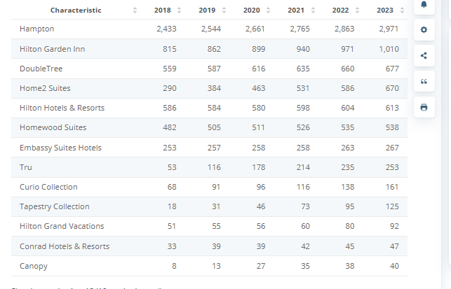
Figure 3 - Number of Hilton Worldwide Holdings hotels from 2018 to 2023, by brand
Source: (Statista, 2023)
- Management Evaluation
Hilton's effective change management process is underscored by its phased implementation approach, a strategy that allows for meticulous monitoring and iterative adjustments at each stage (Bellantuono et al., 2021). This deliberate rollout ensures employees have ample time to adapt to new systems and processes, minimising disruption to core operations. A crucial aspect of this analysis is to have diligent tracking of important operational measures to identify and counter any potential negative impacts on business performance. As an illustration, occupancy rates, guest satisfaction scores, and service efficiency are likely tracked closely to ascertain the general success of the changes (Bharwani and Mathews, 2021). Besides, the success of Hilton's change initiatives is attributed to strategic partnerships with organisations like Credera, which provide bespoke training programs. The programs enable a seamless shift towards a more agile organisational structure, enabling Hilton to rapidly adopt and deploy new technologies. To assess the efficacy of these training interventions, Hilton would likely employ a number of evaluation mechanisms. Staff survey feedback offers rich qualitative feedback regarding the perceived value and relevance of the training. Performance metrics, including improved technology adoption rates and improved operational efficacy, also offer quantitative feedback regarding the effect of the training. Overall, the effectiveness of Hilton's change management is found in its ability to adjust with evolving customer requirements while maintaining operation efficiency within its extensive global base of hotels (Wu et al., 2024). The company's capacity to foresee and respond to changing customer directions indicates a firm mechanism for observing customer satisfaction as well as taking feedback. This overall assessment system, such as phased implementation, measurement of operational key performance indicators, training program review, and feedback analysis from the customers, enables Hilton to keep refining its change management programs and remain ahead of the curve in the constantly evolving hospitality industry.

Strategic Direction
Hilton Hotels & Resorts is tactically oriented towards expanding the international presence without compromising the quality standards of services. This policy is directed by the two broad strategies such as market expansion and also the diversification of the brand.

Market Expansion
Hilton is actively expanding into the new markets, which is particularly in the Asia-Pacific region where tourism demand is surging. This strategic move aims to capitalise on the growing wealth and travel aspirations in the countries such as China and India. For instance, Hilton plans to quadruple the luxury hotel portfolio in the Asia Pacific by targeting markets with rising demand from the high-net-worth individuals. Additionally, Hilton has entered the five new markets globally, which includes the Bermuda, Paraguay, Nepal, Laos, and Timor-Leste etc.
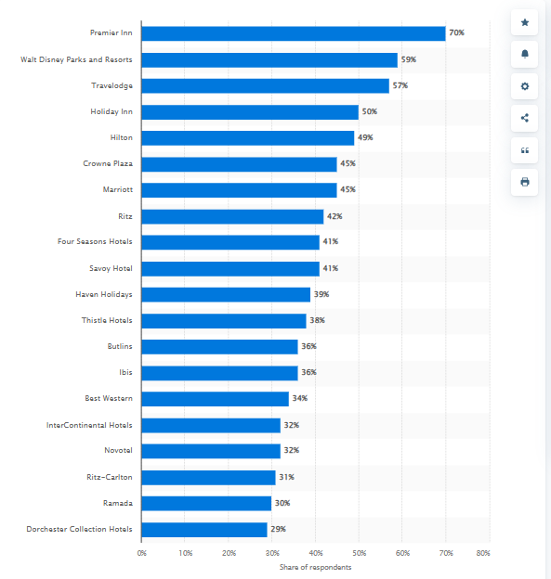
Figure 4 - Most popular hotel brands in the United Kingdom in 4th quarter of 2024
Source: (Statista, 2024)

Brand Diversification
Hilton employs a related diversification strategy, specifically horizontal diversification, by offering a diverse range of brands catering to different market segments. Within the luxury segment, brands such as Waldorf-Astoria cater to luxury seekers (de Abreu, 2023). Budget-friendly options, like Hampton Inn, appeal to budget-conscious travelers. This diversification ensures broad appeal among travelers worldwide while addressing specific market needs through localised offerings. By targeting different customer segments within the hospitality industry, Hilton maximises its market reach and minimises risk compared to entering unrelated industries.
(Anwar et al., 2024).

Evidence-Based Analysis
To support a robust analysis of Hilton Hotels & Resorts, reliance on current and relevant research is paramount. Contemporary trends in the hospitality sector underscore the significance of personalisation, sustainability, and digital experiences. Personalization has moved from being an amenity to becoming an essential expectation, with the visitors preferring hotels that are able to customize their experience to suit specific tastes. This requires a greater understanding of the guests' needs and using systems that can deliver customized experiences, ranging from choosing rooms to carefully designed activity offers. Concurrently, sustainability has moved from an add-on to a core element of the hospitality business. Consumers nowadays proactively look for hotels that reflect green responsibility, e.g., energy efficiency, reduction of waste, and sustainable sourcing. Hotels focusing on sustainability not only attract this new clientele but also build up their brand equity and enable a better future. Lastly, digital experiences are also key to defining the hospitality industry today. From mobile check-in and digital keys to AI-powered chatbots and customized recommendations, technology streamlines convenience, efficiency, and guest interaction. Hilton's ability to effectively leverage these three key areas personalisation, sustainability, and digital experiences will be crucial in maintaining its competitive edge and meeting the evolving expectations of today's travelers (Zeng, 2021). By integrating these trends into its strategic initiatives, Hilton can strengthen customer loyalty, attract new market segments, and solidify its position as a leader in the global hospitality industry.

Theoretical Frameworks

Dynamic Capabilities Theory
This theory emphasises a firm's ability to adapt rapidly changing environments through the innovation (Ye et al., 2022). Hilton’s adoption of the digital technologies such as the mobile check-in the systems reflects this capability. The company's emphasis on a strong corporate culture, embodied by the acronym HILTON, aligns with the transformational leader's focus on shared values and a sense of purpose (Adinew, 2024). By continuously updating the technological infrastructure, Hilton remains agile in responding to evolving the consumer preferences for convenience and efficiency. This adaptability allows it to maintain the competitiveness against rivals such as Marriott International in an increasingly dynamic hospitality market.

Recommendations
To further enhance standing within the industry:
- The implementation of the comprehensive training modules emphasising the cultural sensitivity given increasing international clientele diversity which can be facilitated via platforms such as Hilton University.
- The quarterly sessions starting Q2 next year focusing initially on the front-line staff before expanding the organisation-wide.
- The HR department will oversee program development assisted by the external consultants specialising in the cross-cultural communication skills training (Gutterman, 2023).

Conclusion
In conclusion, this analysis underscores the Hilton's strengths in leveraging its organisational structure and also fostering the strong inclusive culture. These are the drivers of business success globally in the hospitality sector. Hilton effectively executes the strategies directed towards the expansion, diversification, and also the technological advancements to enhance the guest experiences in a sustainable way over time. Its hierarchical structure facilitates effective management across departments such as marketing and operations.

Reference List
Adinew, Y., (2024). A comparative study on motivational strategies, organizational culture, and climate in public and private institutions. Current Psychology, 43(13), pp.11470-11492.
Baldwin, C., Pyrrhus, C., Ellis, J., Vann, Z. and Im, J., 2021. Combating Human Trafficking: Concerns With Digital Keys in a Hotel. Journal of Hospitality & Tourism Cases, 9(1), pp.34-40.
Bellantuono, N., Nuzzi, A., Pontrandolfo, P. and Scozzi, B., 2021. Digital transformation models for the I4. 0 transition: Lessons from the change management literature. Sustainability, 13(23), p.12941.
Bharwani, S. and Mathews, D., (2021). Post-pandemic pressures to pivot: tech transformations in luxury hotels. Worldwide Hospitality and Tourism Themes, 13(5), pp.569-583.
de Abreu, B.M.A.N., 2023. Leveraging Technology to Navigate the Great Resignation in the Hotel Sector: Digital Employer Branding as a Tool for Talent Attraction and Engagement (Master's thesis, Universidade NOVA de Lisboa (Portugal)).
EdrawMind. (2025). Hilton Hotel 101: The Organizational Structure of Hilton Hotel. [online] Available at: https://edrawmind.wondershare.com/org-chart/hilton-hotel-org-structure.html [Accessed 13 Feb. 2025].
Gutterman, A.S., 2023. Training and development. Available at SSRN 4555407.
Hilton.com. (2025). Hilton Hotels in United Kingdom - Find Hotels - Hilton. [online] Available at: https://www.hilton.com/en/locations/united-kingdom/hilton-hotels/ [Accessed 7 Feb. 2025].
Hilton.com. (2025). Hilton Hotels in United Kingdom - Find Hotels - Hilton. [online] Available at: https://www.hilton.com/en/locations/united-kingdom/hilton-hotels/ [Accessed 7 Feb. 2025].
Hilton.com. (2025). Hotels by Hilton - Book the Best Rates Across All Brands. [online] Available at: https://www.hilton.com/en/ [Accessed 13 Feb. 2025].
Ertuna, B., Gu, H. and Yu, L., (2022). “A thread connects all beads”: Aligning global CSR strategy by hotel MNCs. Tourism Management, 91, p.104520.
Hotels in United Kingdom - Find Hotels - Hilton. (2025). Hilton.com. [online] doi:https://doi.org/10252895/evoke-pictures-corporate-photographer-hampton-by-hilton-blackpool-015.
Khalil, N., Che Abdullah, S.N., Haron, S.N. and Hamid, M.Y., 2024. A review of green practices and initiatives from stakeholder’s perspectives towards sustainable hotel operations and performance impact. Journal of Facilities Management, 22(4), pp.653-682.
Rockett, G., (2023). History/overview of Hilton. The Routledge Handbook of Diversity, Equity, and Inclusion Management in the Hospitality Industry.
Egamberdieva, F., (2024). An orientation guide for Hilton Helsinki Strand reception team.
Service.gov.uk. (2024). HILTON UK HOTELS LIMITED overview - Find and update company information - GOV.UK. [online] Available at: https://find-and-update.company-information.service.gov.uk/company/00081009 [Accessed 7 Feb. 2025].
Statista. (2023). Hilton Worldwide hotels by brand 2023 | Statista. [online] Available at: https://www.statista.com/statistics/297753/number-of-hilton-worldwide-hotels-by-brand/ [Accessed 13 Feb. 2025].
Wu, X., Xiang, H., Wang, Y. and Huo, Y., (2024). How does customer satisfaction change after hotels start using self-service kiosks?. International Journal of Hospitality Management, 122, p.103872.
Ye, Y., Yu, Q., Zheng, Y. and Zheng, Y., 2022. Investigating the effect of social media application on firm capabilities and performance: The perspective of dynamic capability view. Journal of Business Research, 139, pp.510-519.
Zeng, L., (2021). Analysis of Hilton Worldwide Hotel Group’s Transnational Operation Strategy. Academic Journal of Business & Management, 3(11), pp.20-27.

