
Name: Nene Toure
Student ID: 2411571
Module Code: BMHP5015 Component 1
Module Title: BMHP5015-Changemakers: Building your Personal Brand for Sustainable Employment
Lecturer: Brian Mashumba
Submission Date: 31//07/2026

Reflective Portfolio: BMHP5015 – Changemakers: Building Your Personal Brand for Sustainable Employment

Introduction
The BMHP5015: Changemakers – Building Your Personal Brand for Sustainable Employment module has enhanced my understanding of personal and professional development within health and social care. Throughout this portfolio, I reflect on the four units studied during the module and explain how each has contributed to my knowledge, skills, and future career aspirations. The portfolio demonstrates how I have developed my personal brand, improved my understanding of global connections and cultural competence, recognised career opportunities, and reflected on the importance of wellbeing and resilience in professional practice.
As a support worker with over ten years of experience, I have gained valuable insights into the knowledge, skills, and values required to provide high-quality, person-centred care. The lectures, Moodle activities, and reflective tasks encouraged me to evaluate my strengths, identify areas for improvement, and develop a clearer professional identity. I have also linked my reflections to relevant academic theories and literature to demonstrate how this module has prepared me for my long-term ambition of becoming a qualified social worker. Overall, the knowledge and skills gained from this module will support my continued professional development and future career in health and social care

Reflection on Unit 1: Brand You
Unit 1, Brand You, helped me understand the importance of developing a professional identity and recognising the personal qualities and skills required for a successful career in health and social care. Throughout this unit, I explored topics including ambition, motivation, personal branding, self-awareness, emotional intelligence, and boundaryless careers. These topics encouraged me to reflect critically on my strengths, values, and long-term career aspirations while considering how they influence my professional practice.
One of the most valuable lessons I learned was that building a personal brand involves much more than obtaining qualifications. It requires understanding who I am, what I can contribute to others, and how I present myself professionally. As a support worker with over ten years of experience, I realised that qualities such as empathy, effective communication, respect, integrity, and professionalism form the foundation of my personal brand. My ambition is to become a qualified social worker, and this unit helped me appreciate the importance of setting clear career goals, maintaining motivation, and continually developing my knowledge and skills to achieve this ambition.
I also developed a greater understanding of Pink's (2009) Motivation Theory, which highlights autonomy, mastery, and purpose as the three key factors that encourage individuals to perform at their best. Reflecting on this theory helped me recognise that I am motivated by making a positive difference to the lives of vulnerable people. It also reinforced the importance of continuous learning and professional development to improve my practice and prepare for future career opportunities.
Another important topic was self-awareness. I learned that recognising my strengths and identifying areas for improvement are essential for professional growth and reflective practice. The Johari Window model developed by Luft and Ingham (1955) demonstrates that self-awareness can be enhanced through reflection and constructive feedback from others. Completing the self-awareness activities helped me identify my strengths in communication, empathy, teamwork, and problem-solving while recognising that I can continue improving my confidence in academic writing, critical analysis, and public speaking.
The unit also introduced emotional intelligence, which is fundamental in health and social care because professionals regularly support individuals experiencing emotional, physical, and social challenges. Goleman (1995) explains that emotional intelligence includes self-awareness, self-regulation, motivation, empathy, and social skills. Reflecting on the Emotional Intelligence activity helped me understand how managing my own emotions and responding appropriately to the emotions of others enables me to build trusting relationships, communicate effectively, and provide compassionate, person-centred care.
Overall, Unit 1 strengthened my understanding of personal branding and professional development. It increased my confidence, enhanced my self-awareness, and reinforced the importance of emotional intelligence, motivation, and lifelong learning. I will continue applying these skills throughout my studies and professional career as I work towards becoming a qualified social worker.

Screenshot 1 Career Goal Activity
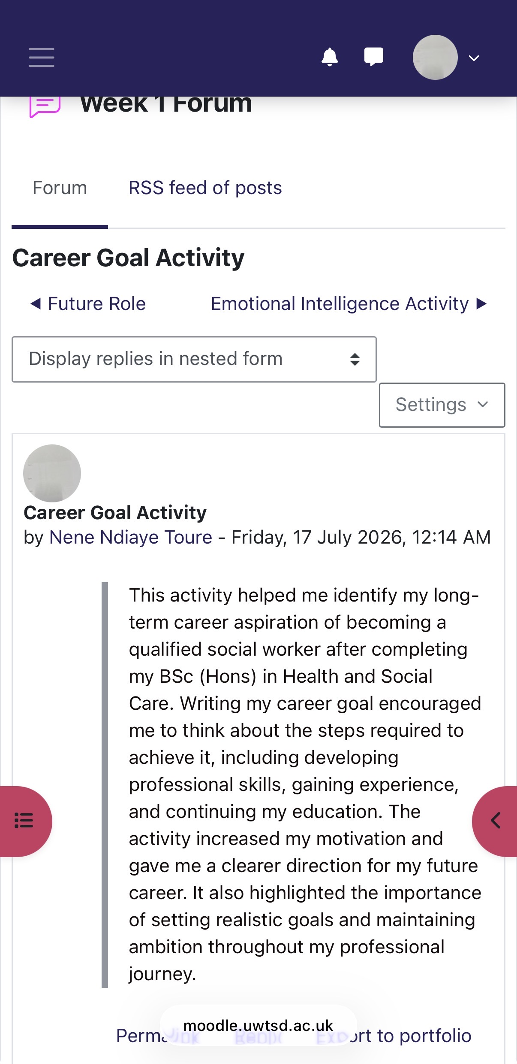
Reflection: This activity helped me identify my long-term ambition of becoming a qualified social worker. It encouraged me to develop a clear career plan and understand the knowledge, qualifications, and experience required to achieve my professional goals

Screenshot 2 – Emotional Intelligence Activity
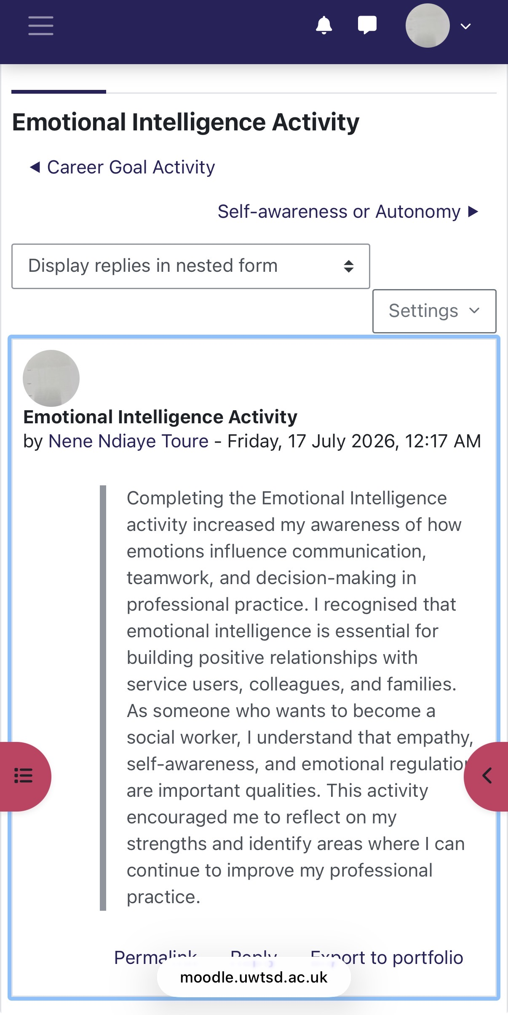
Reflection: Completing this activity increased my awareness of emotional intelligence and its importance in communication, empathy, teamwork, and decision-making. It helped me reflect on how these skills improve the quality of care I provide.

Screenshot 3 – Self-awareness or Autonomy Activity
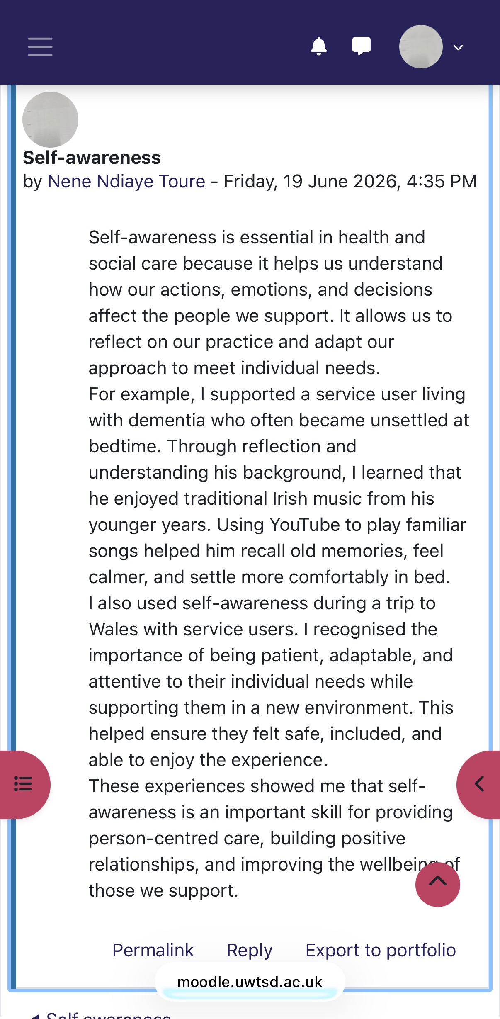
Reflection: This activity encouraged me to reflect on my personal strengths and areas for improvement. It reinforced the importance of self-reflection and continuous professional development in building a successful career in health and social care.

Task 2 – Reflection on Unit 2: It's a Small World
Unit 2, It's a Small World, helped me understand the importance of global connections, networking, organisational structures, embracing diversity, and building meaningful professional relationships to improve the quality of care. I also learned about the concepts of the Network Society, bureaucracy, hierarchy, and social prescribing, which demonstrated how collaboration between organisations and professionals can improve health and wellbeing within communities.
One of the most valuable lessons I learned was the importance of networking in supporting collaborative practice. Before studying this unit, I believed networking mainly involved meeting new people to advance a career. However, I developed an understanding that networking is about creating and maintaining professional relationships, sharing knowledge, and working collaboratively to achieve positive outcomes for service users. As a support worker, I communicate regularly with colleagues, nurses, social workers, families, and other healthcare professionals. Reflecting on this unit helped me appreciate that effective networking strengthens communication, encourages teamwork, and contributes to delivering high-quality, person-centred care. Gibson, Hardy III and Buckley (2014) argue that professional networking supports career development, knowledge sharing, and organisational success, which reflects my own experience in practice.
The unit also increased my awareness of cultural competence and diversity. Working in health and social care requires supporting people from a wide range of cultural, religious, and social backgrounds. I realised that professionals must respect different beliefs, values, and communication styles to provide inclusive and equitable care. Hofstede's Cultural Dimensions Theory (Hofstede, 2011) helped me understand how cultural values can influence attitudes towards authority, communication, and decision-making. Reflecting on this theory encouraged me to avoid making assumptions and instead treat every individual with dignity, respect, and cultural sensitivity. Developing cultural competence will help me become a more effective and inclusive social worker.
Another important topic was Castells' Network Society Theory (Castells, 2010), which explains how digital technologies have transformed communication, collaboration, and information sharing across the world. I learned that health and social care professionals increasingly rely on digital communication systems, multidisciplinary teamwork, and partnership working to coordinate services and improve outcomes. The lectures also introduced social prescribing, demonstrating that improving health often involves connecting individuals with community groups, charities, and voluntary organisations rather than relying solely on medical treatment. This strengthened my understanding of holistic and person-centred care and highlighted the importance of working collaboratively across different sectors.
Overall, Unit 2 strengthened my understanding of global connections, professional networking, cultural competence, and diversity. It increased my confidence in working collaboratively within multidisciplinary teams and reinforced the importance of treating every individual with respect, equality, and compassion. The knowledge and skills I have gained from this unit will support my future career as a social worker and help me provide inclusive, culturally sensitive, and person-centred care.

Screenshot 1 – Networking Forum Activity
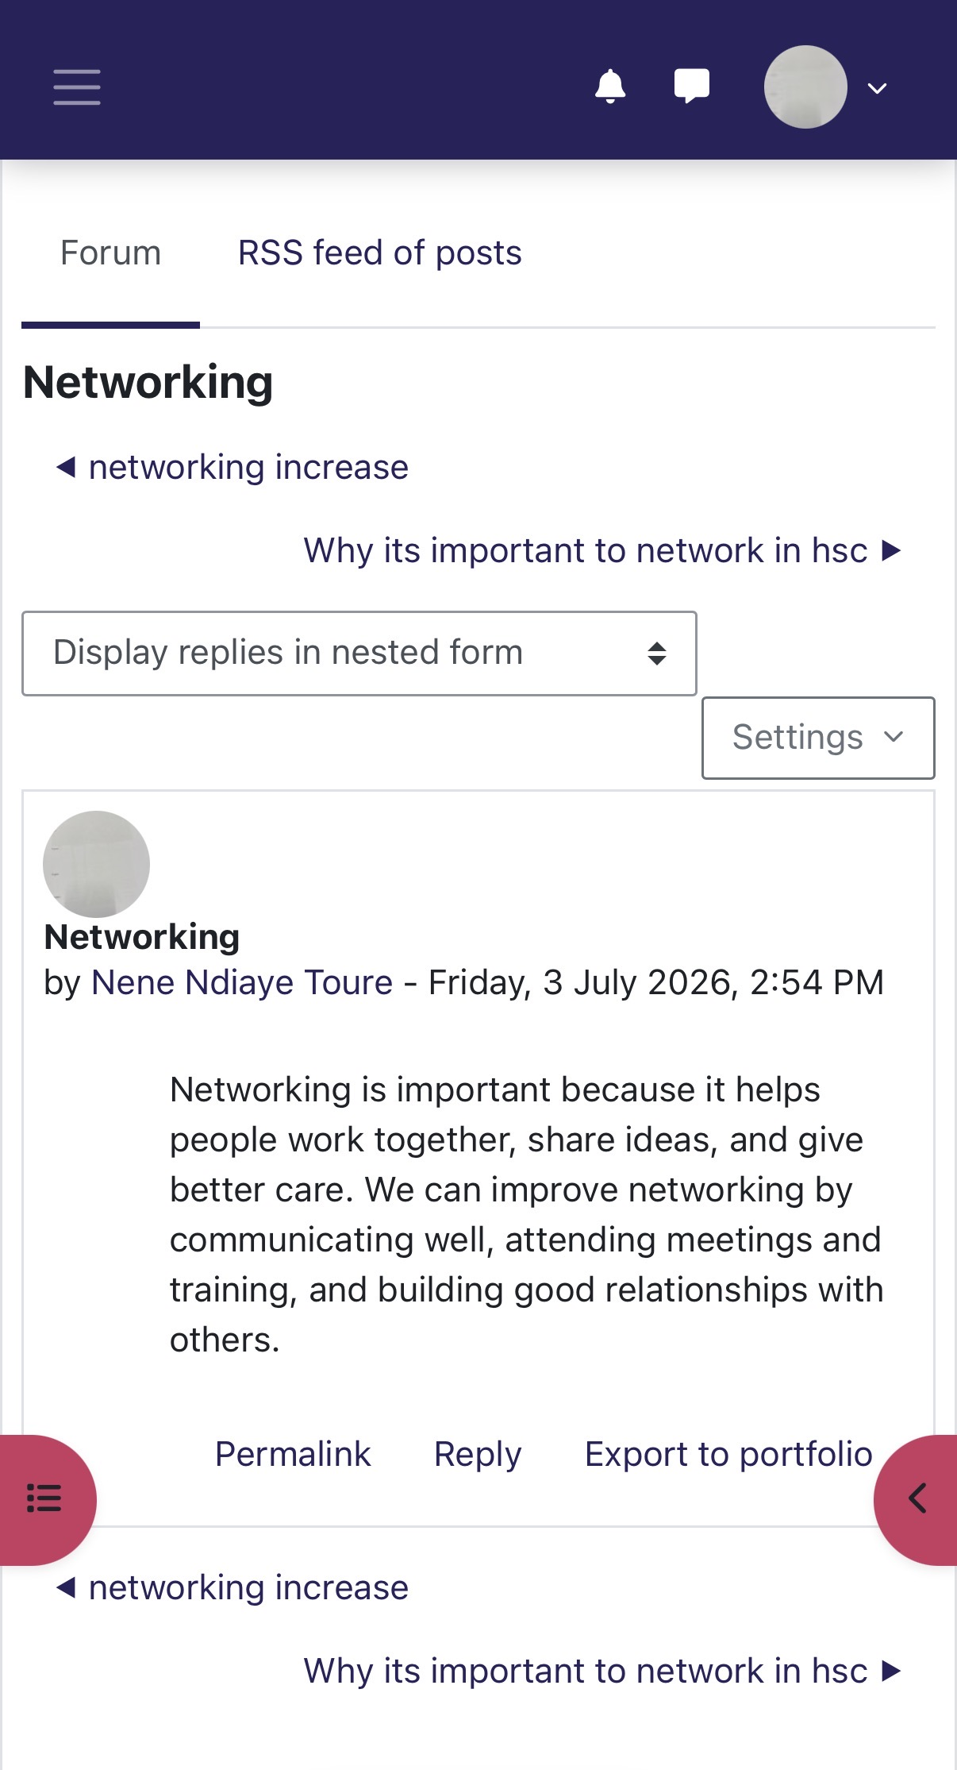
Reflection: This activity helped me understand that networking is more than building contacts; it involves developing professional relationships that encourage collaboration, knowledge sharing, and continuous professional development within health and social care.

Screenshot 2 – Diversity and Cultural Competence Activity
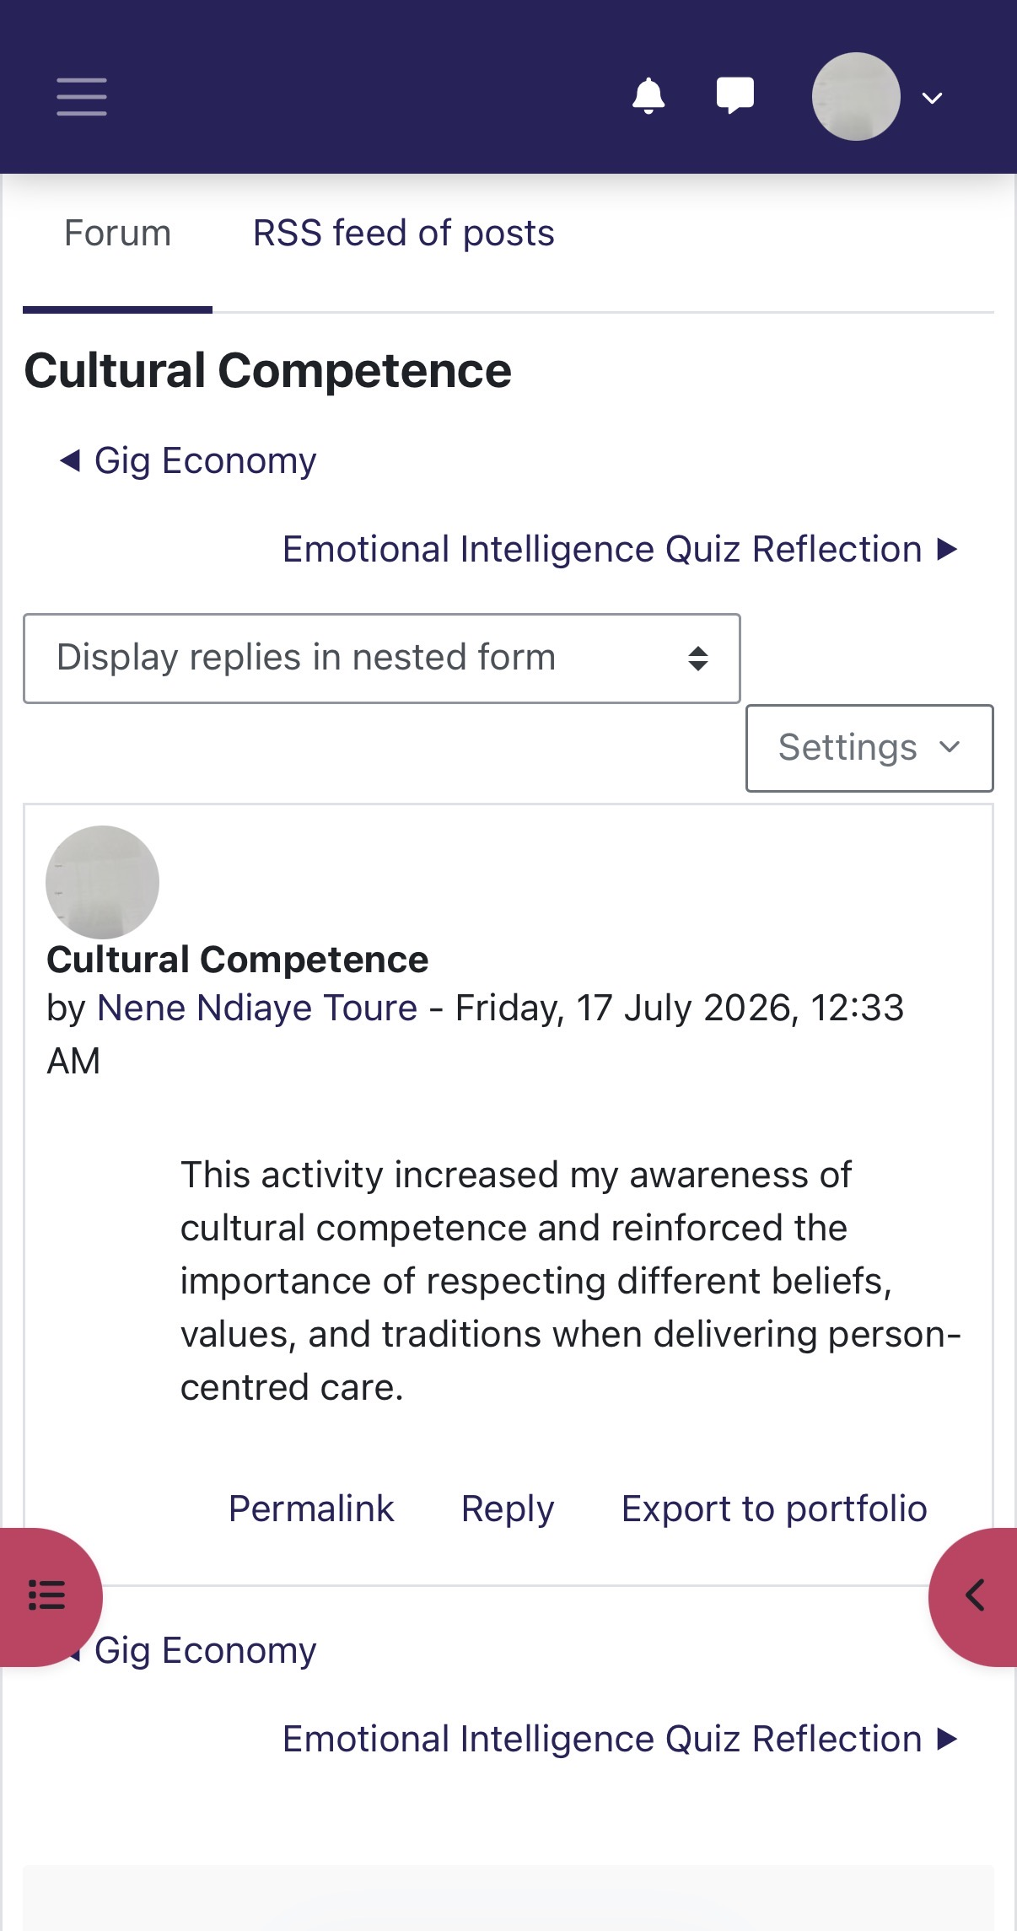
Reflection: This activity increased my understanding of cultural competence and reminded me that respecting people's beliefs, values, and backgrounds is essential for providing inclusive, person-centred care.

Screenshot 3 – Making Connections Forum Discussion
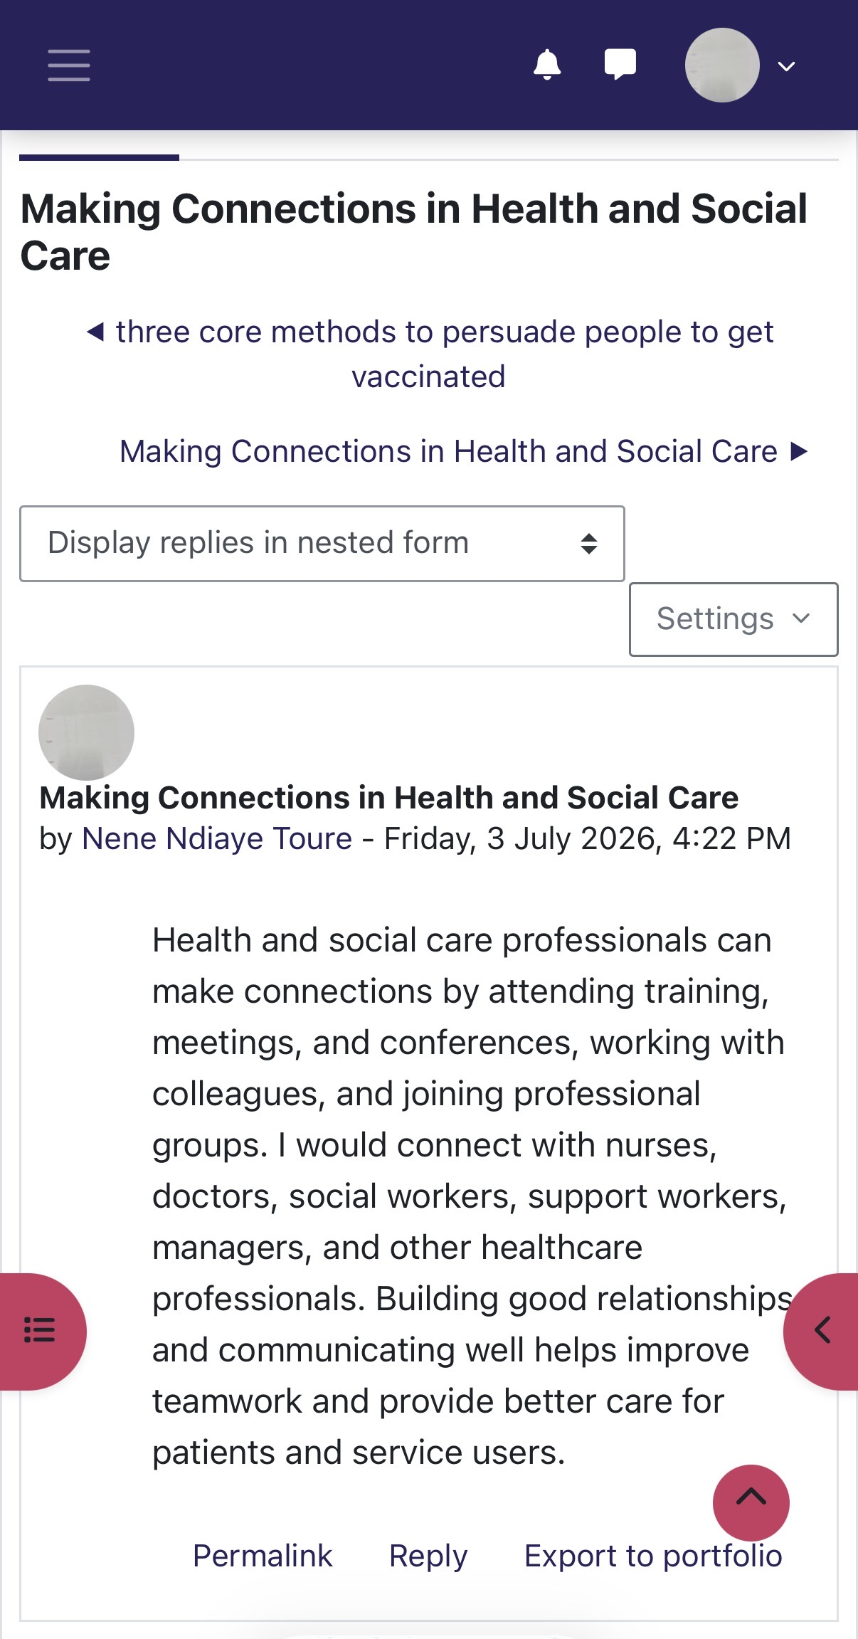
Reflection: This activity encouraged me to appreciate the value of partnership working and demonstrated how collaboration between professionals and organisations improves outcomes for individuals, families, and communities.

Task 3 – Reflection on Unit 3: Opportunity Knocks
Unit 3, Opportunity Knocks, helped me understand how recognising and making the most of opportunities is essential for personal and professional development. The unit explored topics such as spotting opportunities, changing perspectives, goal setting, recruitment, transferable skills, work values, and personal development planning. These topics encouraged me to reflect on my own career journey and helped me understand that achieving my goal of becoming a social worker requires careful planning, resilience, and a willingness to embrace new experiences.
One of the most important lessons I learned was that opportunities are not always obvious. I found that successful people actively create opportunities by developing new skills, building professional networks, and maintaining a positive attitude towards change. This changed my perspective because I realised that career progression depends not only on qualifications but also on being proactive, adaptable, and prepared to take on new challenges. As a support worker, I have developed valuable experience, but this unit encouraged me to think beyond my current role and identify opportunities that will help me progress into social work.
The unit also strengthened my understanding of goal setting and personal development planning. I learned that setting clear and realistic goals helps maintain motivation and provides a structured plan for achieving long-term career ambitions. The SMART Goals Framework (Doran, 1981) showed me how goals should be Specific, Measurable, Achievable, Relevant, and Time-bound. Applying this framework to my own career has helped me plan the steps needed to complete my degree, continue developing my professional skills, and gain experience that will prepare me for a career in social work.
Another important aspect of the unit was recognising the value of transferable skills. I reflected on the communication, teamwork, empathy, leadership, time management, and problem-solving skills I have gained through more than ten years of working as a support worker. I realised that these skills are highly valued by employers and can be applied across different health and social care settings. The unit also encouraged me to consider my personal values, including compassion, respect, integrity, and equality, which align closely with the professional values expected of social workers.
Reflecting on this unit has increased my confidence in recognising opportunities and planning for my future career. It has shown me that continuous learning, self-reflection, and a willingness to challenge myself are essential for professional success. I now feel more prepared to take advantage of future opportunities and continue developing into a confident, competent, and compassionate social worker.

Screenshot 1 – Spotting Opportunities Activity
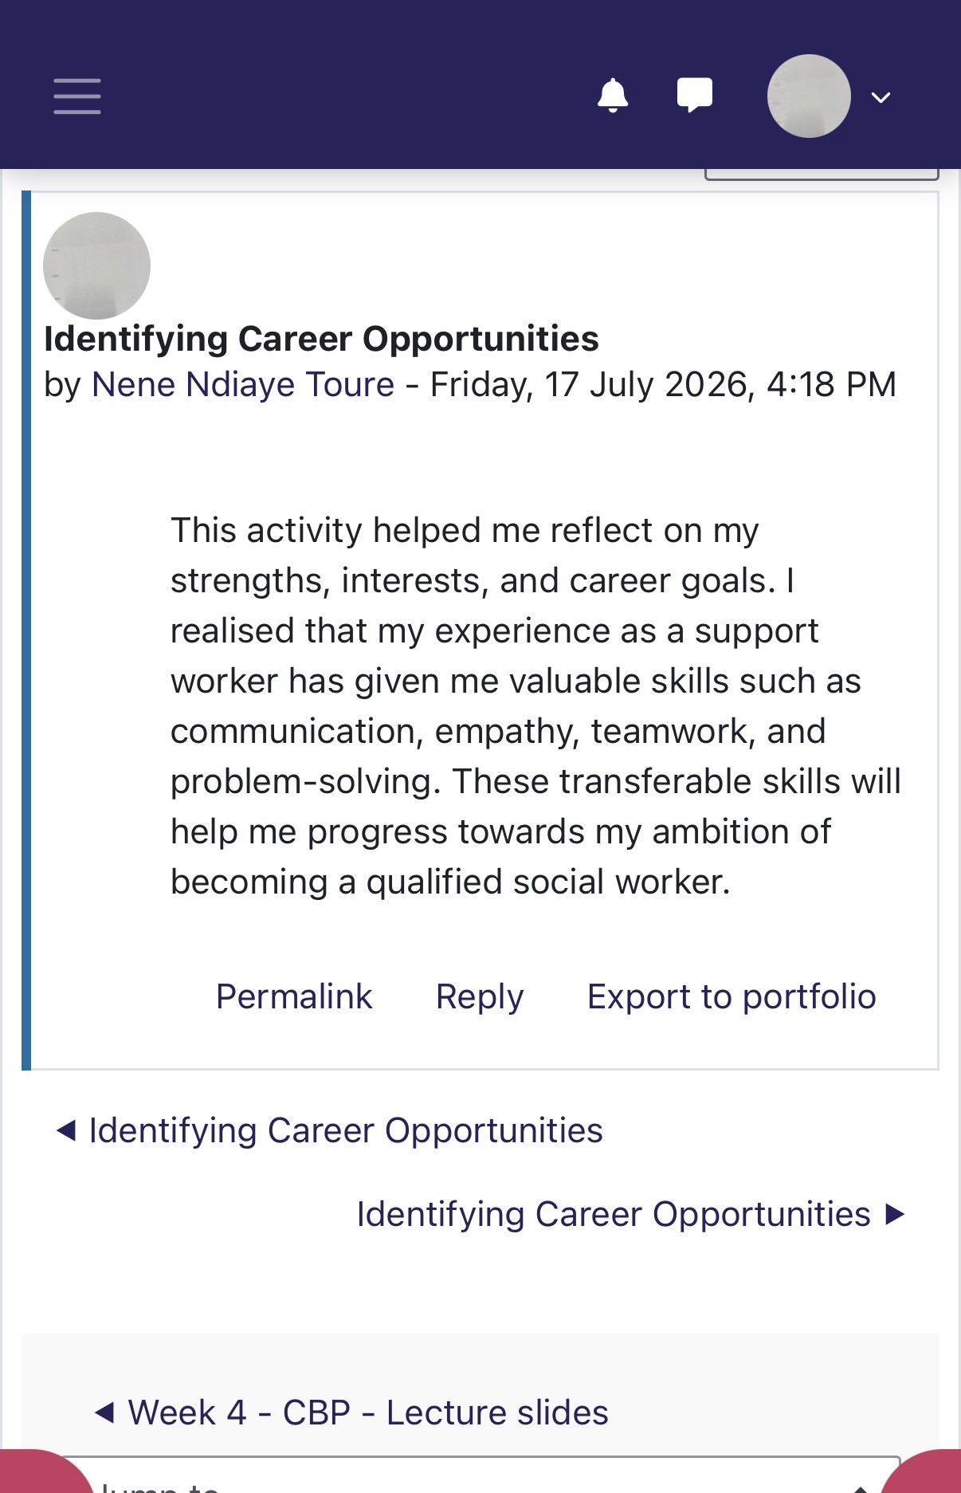
Description:
This activity helped me recognise that opportunities often arise through being proactive, developing new skills, and maintaining a positive attitude towards learning and career development.

Screenshot 2 – SMART Goals or Personal Development Planning Activity
Description:
This activity enabled me to apply the SMART Goals framework to my own career plan and identify realistic steps towards becoming a qualified social worker.

Screenshot 3 – Transferable Skills or Work Values Activity
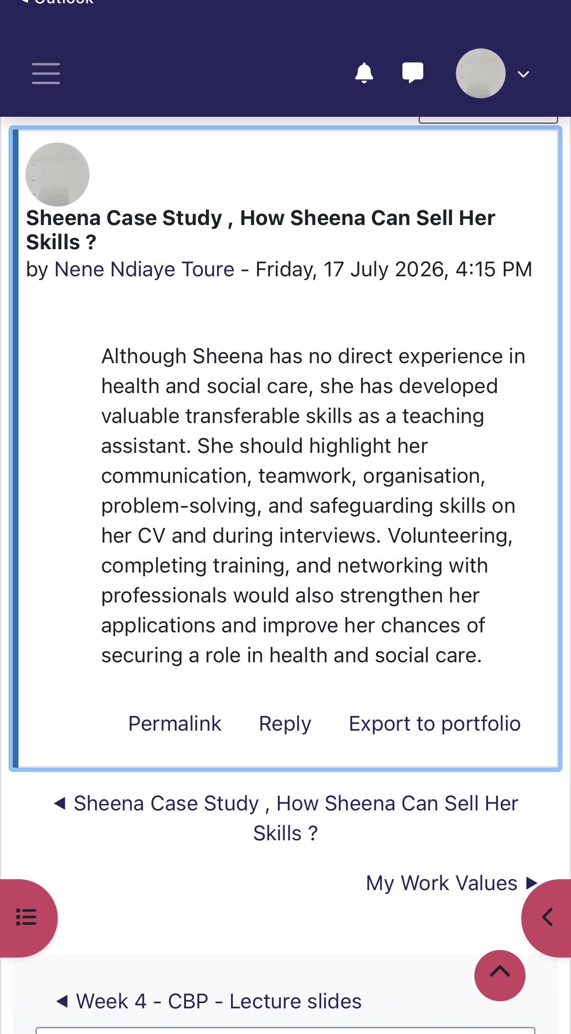
Description:
This activity helped me identify the transferable skills and professional values I have developed through my role as a support worker and how these will support my future career in social work.

Task 4 – Reflection on Unit 4: The Pursuit of Happiness
Unit 4, The Pursuit of Happiness, enhanced my understanding of the importance of wellbeing, resilience, and maintaining a healthy work–life balance in health and social care. Throughout this unit, I explored how these concepts contribute to both personal and professional success. As a support worker, I recognised that providing high-quality care requires looking after my own physical and mental wellbeing while supporting the needs of others. This unit encouraged me to reflect on my own experiences and appreciate that maintaining a positive mindset and resilience enables me to cope effectively with challenges in the workplace. Seligman's (2011) PERMA Model of Wellbeing explains that wellbeing is achieved through Positive Emotion, Engagement, Relationships, Meaning, and Accomplishment, which together promote happiness, resilience, and professional fulfilment.
Using Gibbs' Reflective Cycle (Gibbs, 1988), I reflected on what I learned during this unit by considering my experiences, evaluating my feelings, analysing what I learned, and identifying how I can improve my future practice. This reflective approach helped me recognise the importance of continuous self-development and maintaining a healthy balance between my professional responsibilities and personal wellbeing. The University of Cumbria (2020) explains that Gibbs' Reflective Cycle supports learners in developing critical thinking and improving future practice through structured reflection.
One of the most valuable lessons I learned was the importance of compassion in health and social care. I realised that showing empathy, kindness, dignity, and respect helps build trusting relationships with service users and improves their wellbeing. Reflecting on this activity also helped me understand that compassionate practice contributes to my own job satisfaction and emotional wellbeing. As I continue my journey towards becoming a social worker, I will ensure that compassion remains at the centre of my professional practice.
I also learned the importance of person-centred care, which focuses on respecting each individual's values, preferences, and choices. This strengthened my understanding of effective communication, teamwork, and collaborative practice. Reflecting on my own experiences as a support worker helped me appreciate that involving people in decisions about their care promotes dignity, independence, and better outcomes. Overall, this unit increased my confidence in maintaining my own wellbeing while providing compassionate, person-centred care. The knowledge and reflective skills I have developed will support my future career as a resilient, compassionate, and reflective social worker committed to lifelong learning (Southwick et al., 2014).

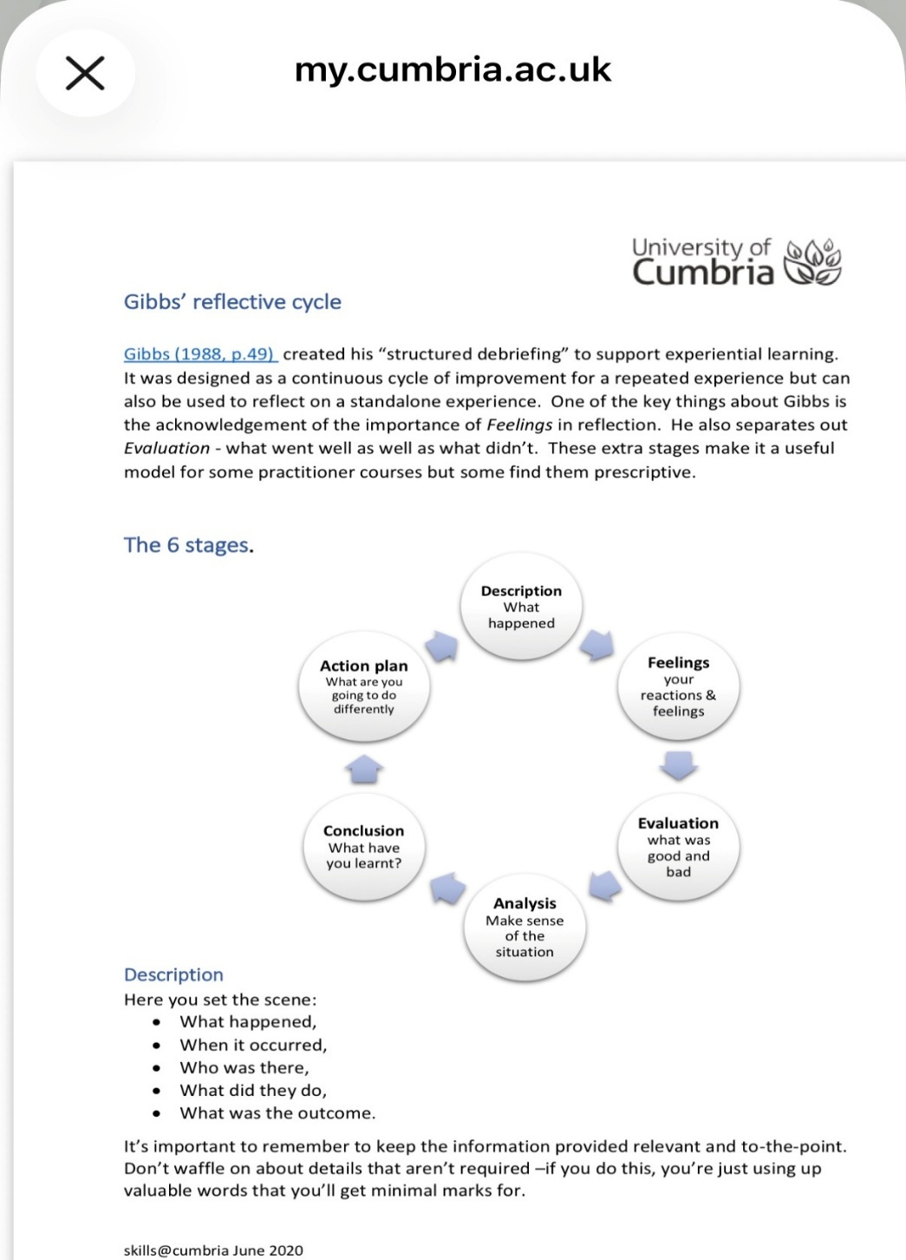
Figure 1. Gibbs' Reflective Cycle (Adapted from University of Cumbria, 2020).
Using this model, I reflected on what I learned during this unit by considering my experiences, evaluating my feelings, analysing what I learned, and identifying how I can improve my future practice. This reflective approach helped me recognise the importance of continuous self-development and maintaining a healthy balance between my professional responsibilities and personal wellbeing. The University of Cumbria (2020) explains that Gibbs' Reflective Cycle supports learners in developing critical thinking and improving future practice through structured reflection.

Screenshot 1 – The Importance of Compassion in Health and Social Care
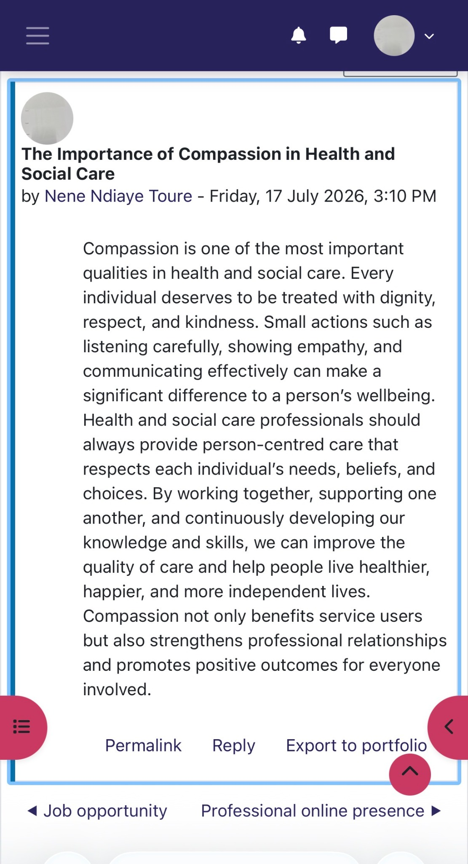
Description
This activity helped me understand that compassion is essential in health and social care. It encouraged me to reflect on how empathy, kindness, and effective communication improve the wellbeing of service users and strengthen professional relationships

Screenshot 2 – The Importance of Person-Centred Care
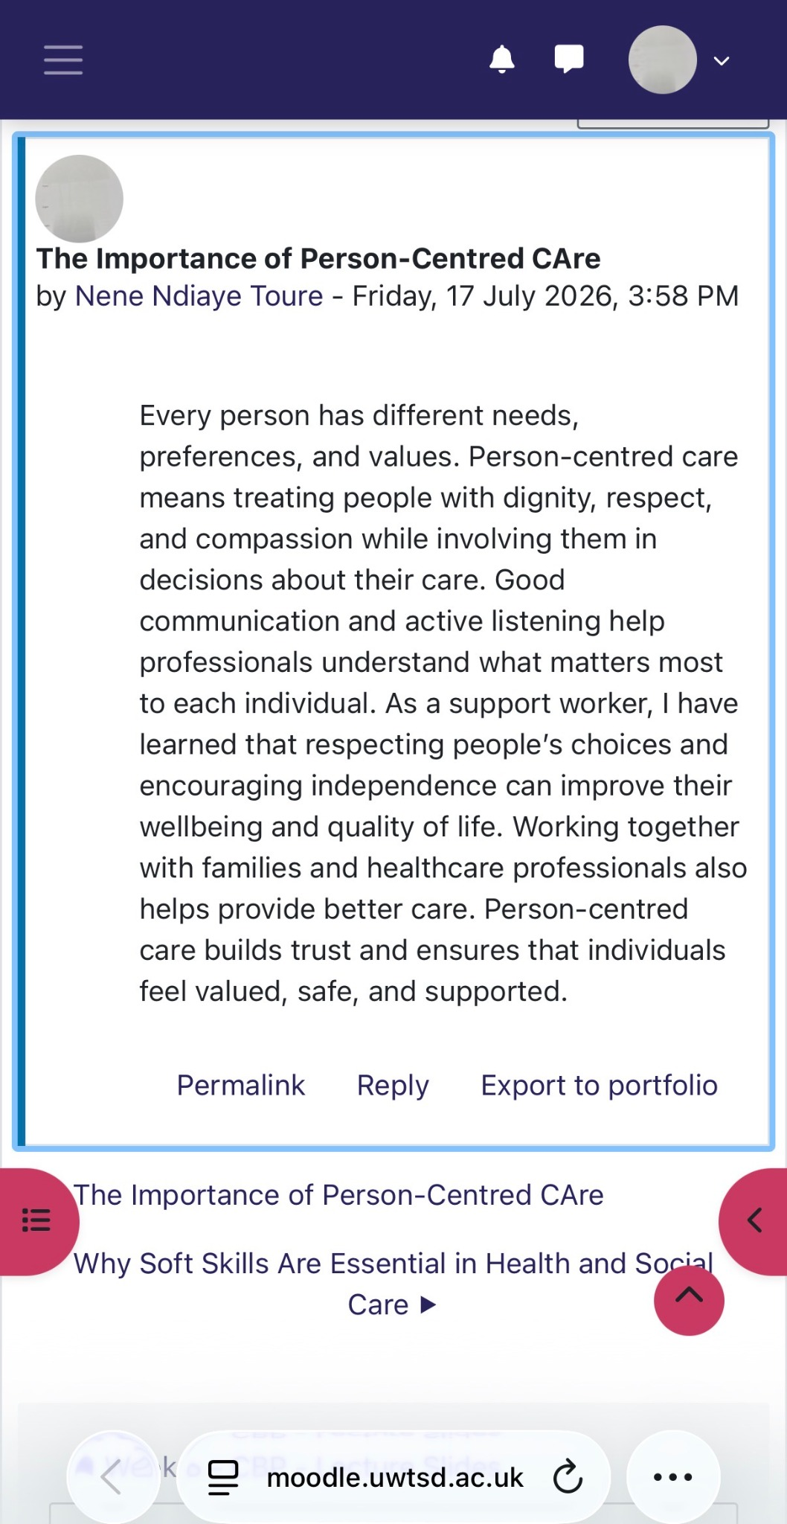
Description
This activity reinforced the importance of respecting each person's needs, preferences, and choices. It helped me understand that involving individuals in decisions about their care promotes dignity, independence, and better outcomes while supporting my development as a future social worker

Conclusion
This portfolio has enabled me to reflect on the knowledge, skills, and experiences I have gained throughout the BMHP5015: Changemakers – Building Your Personal Brand for Sustainable Employment module. Reflecting on the four units has strengthened my understanding of personal branding, networking, career development, wellbeing, and resilience. The Moodle activities and academic theories have helped me identify my strengths and areas for improvement while preparing me for my future career as a social worker. Overall, this module has increased my confidence, enhanced my professional identity, and reinforced the importance of lifelong learning, reflective practice, and person-centred care.

References
Capela, C. (2021) Personal Branding for Employability. London: Routledge.
Castells, M. (2010) The Rise of the Network Society. 2nd edn. Oxford: Wiley-Blackwell.
Doran, G.T. (1981) ‘There’s a S.M.A.R.T. way to write management’s goals and objectives’, Management Review, 70(11), pp. 35–36.
Gibbs, G. (1988) Learning by Doing: A Guide to Teaching and Learning Methods. Oxford: Oxford Polytechnic.
Gibson, C., Hardy III, J.H. and Buckley, M.R. (2014) ‘Understanding the role of networking in organisations’, Career Development International, 19(2), pp. 146–161.
Goleman, D. (1995) Emotional Intelligence: Why It Can Matter More Than IQ. New York: Bantam Books.
Hofstede, G. (2011) ‘Dimensionalizing cultures: The Hofstede model in context’, Online Readings in Psychology and Culture, 2(1), pp. 1–26.
Luft, J. and Ingham, H. (1955) The Johari Window: A Graphic Model of Interpersonal Awareness. Los Angeles: University of California.
Pink, D.H. (2009) Drive: The Surprising Truth About What Motivates Us. New York: Riverhead Books.
Seligman, M.E.P. (2011) Flourish: A Visionary New Understanding of Happiness and Well-being. New York: Free Press.
Southwick, S.M., Bonanno, G.A., Masten, A.S., Panter-Brick, C. and Yehuda, R. (2014) ‘Resilience definitions, theory, and challenges: Interdisciplinary perspectives’, European Journal of Psychotraumatology, 5(1), Article 25338.
University of Cumbria (2020) Gibbs' Reflective Cycle. Available at: https://my.cumbria.ac.uk/media/MyCumbria/Documents/ReflectiveCycleGibbs.pdf (Accessed: 30 July 2026).

