
Callum Jones
2305269
ACHA5010
Alterative Propulsion Systems
Kinetic Energy Recovery

Contents
Introduction page 3
My chosen car and data page 4
All resistance calculations page 5
KERS systems page 6
Components page 8
Cost page 9
Comparison page 10
Data page 12
Reference list 15

Introduction
I have been tasked to analyse the effects of introducing kinetic energy recovery system to reduce my chosen vehicles fuel consumption. The aim of this analysis is to evaluate KERS and the potential on either reducing fuel consumption a full electric conversion in my chosen vehicle. KERS technology captures and stores energy that would otherwise be lost during braking and subsequently reuses it to assist propulsion, thereby improving overall efficiency.
I have chosen a Vauxhall Corsa D 1.2L 2010 model for this study.
This is because I own this car, and I believe it will be more interesting to me how my car could use kinetic energy to reduce my fuel consumption.
This compact city car is widely used, so equipping it with a KERS system could significantly lower fuel consumption and emissions. This presents a valuable chance to study how regenerative energy systems might improve both performance and fuel efficiency in traditional internal combustion engine (ICE) vehicles.
Width 173.9 cm
Hight 148.8 cm
Curb Weight 1253.5kg
79 HP
59 Kw
47.1 Watts per kg or 0.0471 kw/kg
Top speed 104 Mph
Fuel Consumption - Economy - City NEDC: | 37 MPG  7.7 L/100 km  31 MPG US
Fuel Consumption - Economy-Open Road NEDC: | 60 MPG  4.7 L/100 km  50 MPG US
Fuel Consumption - Economy - Combined NEDC: | 49 MPG  5.8 L/100 km  41 MPG US
Range: | 482 miles / 775 km
Fuel Tank Capacity: | 9.9 gallons  45 L  11.9 US gallons
0 to 100 km/h 13.9s (0 to 62mph- 13.9s)
https://www.ultimatespecs.com/car-specs/Opel/1126/Opel-Corsa-D-12-16v.html

Test mass
The weight of the car is 1160kg this is without fuel, passengers and any luggage. So, to accurate run this test I will need to add them. I weighs 75kg and I only normally drive to university, so I have my bag which has a mass of approximately 0.5 kg. The fuel tank has a capacity of 45 litters, with each liter of fuel weighing 0.79 kg, resulting in a total fuel weight of 35.55 kg when the tank is full. however, I normally only run half a tank of 22.5kL so that weighs 17.775 kg which I will round up to 18 kg to account for any dirt left in the fuel tank and to make my calculations easier.
1160kg + 75kg + 18Kg + 0.5KG= 1253.5kg


Frontal area
Width: 173.9cm x Hight times 148.8= 25,876.32 cm.
Although I need to take in to account the gab under the car. To do this we need to find the Ground Clearance and the tire dimensions. My tires are 195/55/R16, 195mm is the width of one tire, so 2 are 390mm or 39cm. The ground clearance is 150mm/ 15cm. To account for the tires then take away the tire’s width from the car width then times that by ground clearance.
Finaly, take away that calculated number away from the total,
2.12 square meters.

Rolling resistance coefficient
To accurately calculate the rolling resistance, you need to tire manufacturing data to see what grip type they would fall in to, then if they are probably inflated. You may consider the road surface, but I am using standard asphalt conditions. The range of my road X tires fall into 0.010 to 0.012.
Rolling resistance force = rolling resistance coefficient x mass of vehicle x gravity.
Frr = 0.012 x 1253.5kg x 9.81 = 147.56 N
Aerodynamic resistance
Fd=1/2×ρ×v2×Cd×A
Aerodynamic resistance= ½ x Air density x Velocity2 x coefficient of drag x frontal area
Fd= ½ x 1.225 x ½ x the current velocity2 x 0.29 x 2.19m.
Coefficient of aerodynamics drag
The drag coefficient is approximately 0.29

The Worldwide Harmonised Light Vehicle Test Procedure (WLTP)
The WLTP is a test procedure to establish the official fuel consumption, CO2 emissions and pollutant emissions of light passenger cars.
Class High.

KERS system
KERS stands for kinetic energy recovery system, simply put is when breaking the system uses that waste energy and turns it into electricity which then can be used later to help propel the car. It is used race cars and normal production cars, as it can increase your top speed and for commuter cars it decreases your fuel consumption by around 25%. There are different types of the system like.
Hybrid KERS
- Engine + Electric Motor: Helps with acceleration and saves energy during braking.
- Benefits: Better fuel efficiency and lower emissions.
Plug-in Hybrid KERS
- Engine + Rechargeable Electric Motor: Recharge the battery by plugging it into an outlet.
- Benefits: Great for city driving and extends electric-only range.

Mild Hybrid KERS
- Small Electric Motor + Battery: Assists the engine and captures energy during braking.
- Benefits: Improved fuel efficiency, simpler and cheaper than full hybrids.
Regenerative Braking KERS
- Energy Recovery During Braking: Stores energy in a battery.
- Benefits: Simple, cost-effective way to boost fuel efficiency.
Hybrid vehicles can recapture 30–40% of their energy during braking through regenerative systems, storing it for later use.

I have selected regenerative braking KERS as it will fit perfectly for my vehicle as its old car and the simplest to install and run. Its not fancy and it achieves exactly what I set out the complete to reduce my fuel consumption. This method is very cost effective as the is no major drivetrain changes. A retrofitted KERS system on the Corsa would likely recover an estimated 10 to 20% of its breaking energy, this will be best used for reducing engine load and fuel consumption during city and urban environments during stop start driving. Retrofitting KERS to the Corsa will is less expensive that the total price to a new hybrid but will add weight and complexity.

Components
I would need a battery to store electrical energy, a motor/generator, a brake pedal sensor, software, and a motor controller to manage the electrical flow between the battery and the motor.
I have selected a 48v lead-acid battery, it's commonly used in automotive applications and is relatively easy to integrate with the system components.
Then a brushless DC motor (BLDC), low maintenance, high efficiency and good reliability. An electric speed controller would be required.

I have found other examples of this.
‘The Motor--is what I found is a AC motor from Hi Performance Electric Vehicle Systems. The motor would a chose between the AC-9 to AC-15
Power Output --The lowest power motor, the AC-9 will produce 28 HP and 70 FT-Lbs @ 48V/650 Amps DC. The Curtis Controller is what varies the power output and changes the DC power to AC for the motor.’
https://www.miataturbo.net/race-prep-75/miata-electric-kers-74135/
in this he was able to add 28HP with a small battery and a little motor, is I was able to even have 20hp that will decrease my fuel consumption by around 10% to 15% while motor ways driving.
Fuel Economy: my car offers 62.8 miles per gallon (mpg) and emits 102g/km of CO2.
If the car originally achieves 50 miles per gallon (mpg), a 10-15% improvement would increase it to approximately 55-57.5 mpg
That would then drop the emissions form 120g/km of co2 (10% to 20%) the new emissions would be around 95- 105g/km.
Estimated Energy Recovery around 0.5-1 kWh per 100 miles driven. This energy can be used to power auxiliary systems or assist with acceleration, further reducing fuel consumption.

Cost
Fitting a regenerative braking system can cost between £1,000 and £2,000 for basic setups, although a full set up can cost between £5,000 to £8,000 for a integrated KERS with battery and motor.
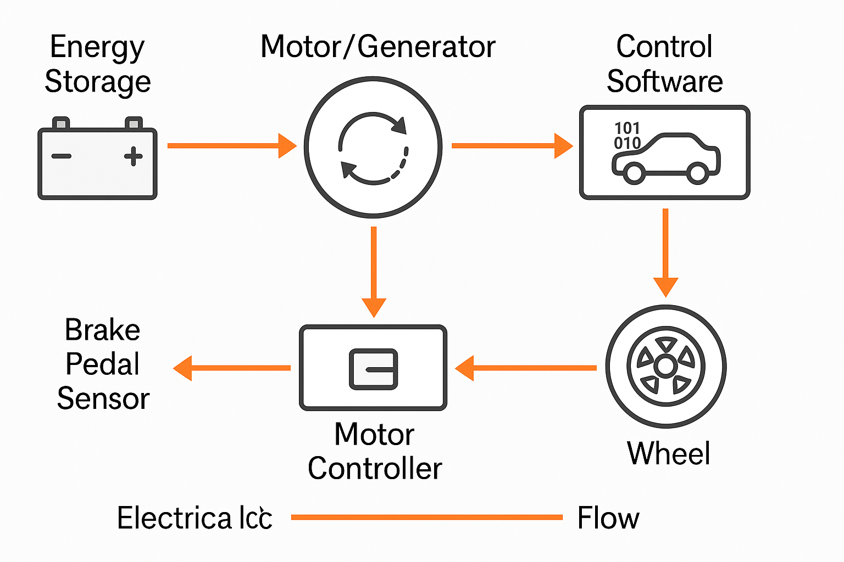

Comparison
The advantages of installing a KERS system in the Vauxhall Corsa D are evident when looking at the Toyota Yaris Hybrid, since both cars are similar in size. The Toyota is built for maximum energy efficiency, using an internal combustion engine, an electric motor, and a regenerative braking system. this example can show how my chosen vehicle could perform and highlight the gab between conventional ICE to a hybrid.
By incorporating a KERS into the Corsa, I estimate that fuel consumption will decrease by 10–20%, improving the miles per gallon from 50–60 mpg to 65–70 mpg.
The Toyota Yaris hybrid has a mpg of 65-70 and a CO2 emission of 85-90 g/km dramatically lower that the Corsa at 129 g/km. although the performance of the Toyota is much higher you can see were the improvements of adding a hybrid system and how meaningful they could be. With the KERS the Corsa could reduce the emissions by 10-15% making it not just more efficient but also but more environmentally friendly.
Feature | Vauxhall Corsa D  (ICE) | Corsa D + KERS (Estimated) | Toyota Yaris Hybrid
Fuel Economy (mpg) | 45-50 | 50-60 | 65-70
CO2 Emissions (g/km) | 129 | 110-115 | 85-90
Energy Recovery (%) | 0 | 10-20 | 30-40
System Cost (£) | 0 | 5,000-8,000 | 22,000-28,000

In summary the comparison between the Vauxhall Corsa and the Toyota Yaris Hybrid demonstrates the significant efficiency advantages of hybrid technology. While my car uses only an internal combustion engine (ICE), whereas the Yaris is a hybrid, the difference in data highlights how the Corsa can make improvements. The addition of a KERS could deliver measurable improvements in fuel economy and emissions. While these gains would not match the performance of a full hybrid, they represent a practical and cost-effective enhancement for existing ICE vehicles. KERS offers an interim way to enhance sustainability without requiring a full vehicle redesign.

Data
All different types of driving speed, with the vehicle speed against the acceleration.
Hello speed the car can achieve a higher positive acceleration when the speed increases, the acceleration tends to taper off.

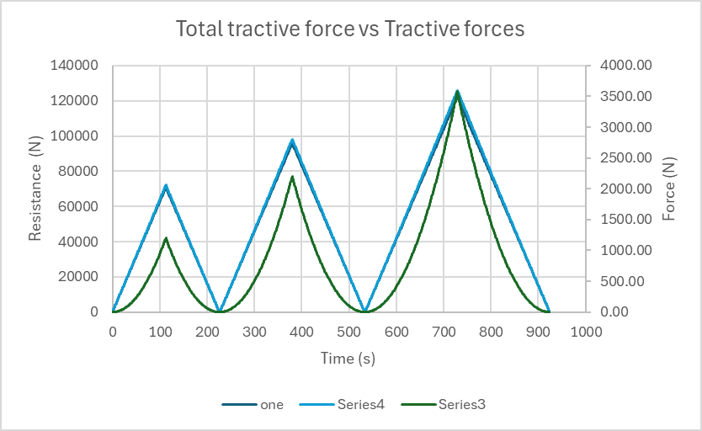

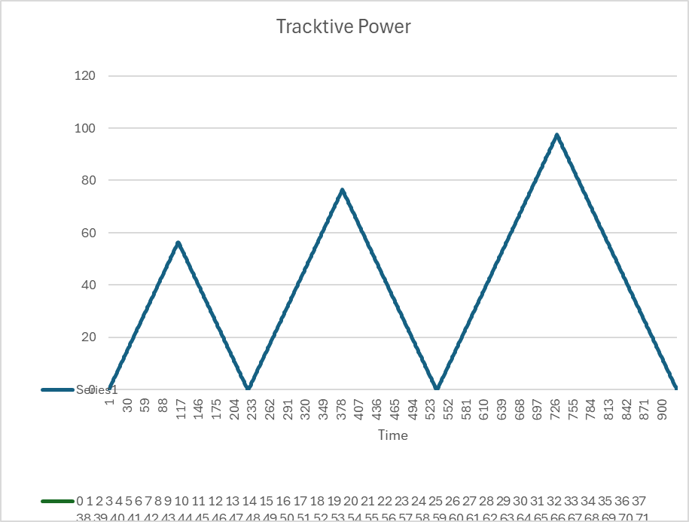
All the tractive forces that include acceleration resistance, rolling resistance and Aero resistance compared to the total of all of them. Overlaying the low mid and high driving demand. As you can see at low speeds the tip of the point is lower and then it increases the higher speed it goes over time same with attractive forces as well that's why it has that curve as at a higher speed there is more drag on everything including aerodynamic drag is the main one.

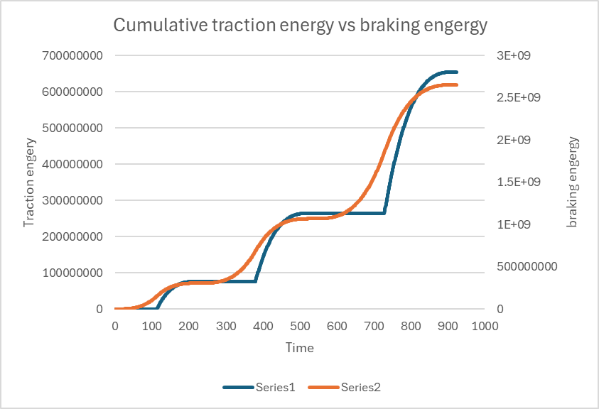
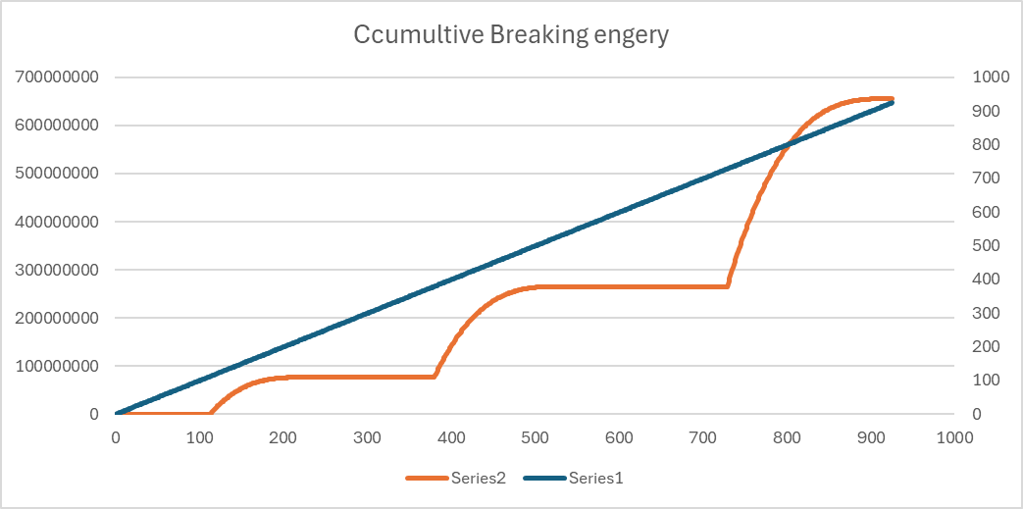

Reference list
1993ka24det. “Miata Electric KERS.” Miata Turbo Forum - Boost Cars, Acquire Cats., 28 July 2013, www.miataturbo.net/race-prep-75/miata-electric-kers-74135/. Accessed 1 Dec. 2024.

“Opel Corsa D 1.2 16v.” Ultimatespecs.com, 2014, www.ultimatespecs.com/car-specs/Opel/1126/Opel-Corsa-D-12-16v.html. Accessed 27 Nov. 2024.

