Component 2 - Report

Problem Solving & Decision-Making
(Proper Care, UK- Case Study)

Student Name: | Samir Mhanna
Student Number: | 2119514
Lecturer Name: | Chijioke Uba
Module: | Problem Solving & Decision Making
Module code: | BMSW4004

2022
Contents
Introduction 3
1. The problem – Staff Shortage 4
1.1 The Nature Of Staff Shortage In Adults Health Care Sector 4
1.2 The Impact Of The Problem 4
2. Causes of staff Shortage 5
2.1 PESTEL Analysis 5
2.2 A cause-and-effect diagram (Fishbone Diagram) 6
3. Possible Solutions 7
Solution 1 - Internal–focused strategy: paying rate, well-being, and training 7
Solution 2 - External-focused strategy: hiring overseas Health care workers 7
4. Evaluation of possible solutions using Grid analysis 8
5. Implement the decision 9
5.1 Action plan 9
5.2 Monitoring and evaluation 11
6. Conclusion 13
7. References 13

Introduction
Decision quality is improved if we basically and inventively dissect the issues confronting us by thinking about new and various choices, gauging the proof objectively, looking at an issue from an alternate point that gives us various bits of knowledge, and creating novel solutions that successfully tackle our situations, and precisely estimating the plausible effect of our choices (Williams, 2001). “In decision making, there is a classic five-step approach that you should find extremely helpful” (Adria, 2019).
Step 1: Identify the problem
Step 2: Find the causes of the problem
Step 3: Possible solutions
Step 4: Evaluation of possible solutions
Step 5: Implement the final decision.
The report is structured based on this logic and process of problem-solving and decision-making. The goal of the report is to study “staff shortage” in the adult health care sector in one local company called Proper Care in the UK. In this study, many models will be used and applied, which may be valuable, frequently producing very precise forecasts or directing difficult optimizing decisions. PESTEL Analysis and Fishbone Diagrams may be used to identify causes, while Grid Analysis can be used to evaluate the possible solutions. When putting action plans out, will use the Koontz and O'Donnell model (1955). KPLs will be the final model used in this study to quantify success indicators after implementing the chosen solution for the complicated issue of staff shortage in the UK.

1. The problem – Staff Shortage
When there is a staff shortage, it means that firms are having difficulty recruiting quality individuals for open positions. One of the key anticipated concerns for health systems worldwide is securing a skilled workforce and mitigating the negative consequences of staff shortages. (Winter ,et al., 2020). This section will examine the nature and impact of the staff shortage in the Adult health care sector in the UK.

1.1 The Nature Of Staff Shortage In the Adults Health Care Sector
According to Skills for Care, the UK's care workforce development organisation, the adult social care industry had a vacancy rate of 8.2 percent in 2021, which was more than double the UK average (3.7 percent, already the highest on record). The industry is suffering a severe labor shortage of 105,000 people. “Workforce challenges are currently the biggest threat facing the health service” (Beech et al., 2019). There is an 84,000 FTE personnel deficit in NHS hospitals and health agencies and there are 38,000 nurse job openings (the king fund,2020). Adult social care is under pressure and dealing with many of the same difficulties as the NHS. There is 1.1 million FTE employment in adult social care, and vacancies are increasing, totaling 110,000, with around one out of every ten social worker posts and one out of every eleven care worker role unfilled. There is also a 12% registered nurse vacancy rate in adult social care, meaning that there are around 5,000 nursing openings in this area (Skills for Care, 2018).

1.2 The Impact Of The Problem
Based on the case study and following the logic of problem-solving, we are going to discuss the different impacts of the staff shortage in the Proper Care agency. Proper Care management recognises that if significant staff shortages persist, waiting lists will expand, and care quality will deteriorate further, thereby jeopardising the future viability of services. The strain on adult care during the coronavirus pandemic has prompted calls for government intervention. “Unfilled vacancies increase the pressure on staff, leading to high levels of stress and absenteeism, and high staff turnover” (The King’s fund, 2022). The increased need for social care during the coronavirus epidemic has prompted new requests for government intervention. Long waiting lists aren't only an inconvenience for patients; they can have serious consequences for outcomes. According to the Care Quality Commission's (2018) latest assessment on the quality of health and social care in England, workforce issues have a direct influence on people's care. District nurse Mary Black in the East Midlands says her team and other colleagues are struggling to manage due to a combination of unfilled positions, maternity leave, and long-term illness absence, all of which have a direct impact on patient care (The Guardian, 2017).

2. Causes of staff Shortage
According to Unison's research, 85 percent of NHS trusts are having difficulty recruiting workers, and staff shortages, particularly in experienced and expert posts, are felt across about 80 percent of the sector (Beech et al., 2019). A variety of factors are influencing the attraction of the medical profession, health care, and working in the NHS. This part of problem-solving will find out the different causes of staff shortage using PESETL Analysis (external causes) and Fishbone Diagram (internal causes).

2.1 PESTEL Analysis
"The PESTEL framework is a strategic analysis tool that is an acronym for the designated macro-environmental segments: P for "political," E for "economic," S for "social," T for "technological," E for "environmental," and L for "legal." (De Sousa and Castaeda-Ayarza, 2022).
Table 1: Three main PESTEL factors identified as a cause of staff shortage in Proper Care UK
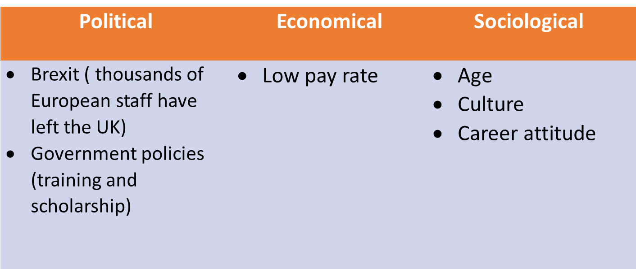

Source created by Author.
Political
With health and social care depending significantly on EU employees, Brexit can cause our existing recruiting and retention issues. According to recent research, the GP shortage in England will nearly treble from 2,500 to 7,000 by 2023-24 ( The Guardian, 2019).
Economic
There have been alarming allegations of minimum wage non-compliance and zero-hours contracts in social care, as well as a large number of employees paid at or near the minimum wage, also recognize that workforce issues in this industry are a result of low pay, terms, and conditions. (Beech et al., 2019).
Social
According to Fund Kings, 2012 during the next 20 years, the population of England is expected to rise by 8 million to slightly over 61 million, with 4.5 million coming from natural growth (births - deaths) and 3.5 million coming from net migration.

2.2 Fishbone Diagram For Staff Shortage
A cause-and-effect diagram, which includes fishbone analysis, is a technique for discovering all causative factors, not only the obvious ones. It seeks the "root" of the problem from a structural approach, rather than through human blaming (Hughes, 2009).

Diagram 1- Fishbone Diagram For Staff Shortage
Source created by Author.
In the next step, we will identify a range of possible solutions based on all main and potential causes, then evaluate these alternative solutions to find out the advantages and disadvantages of each solution.

3. Possible Solutions
As a result, we advocate a variety of strategies and measures to boost recruitment and retention in the social care sector, including a post-Brexit sector-specific international migration pathway for social care.

Solution 1 - Internal–focused strategy: paying rate, well-being, and training
Increase paying rate:
Pay is not always the primary motivator for individuals to join the organizations, nor is it the primary reason for staff to leave. it affects employee satisfaction; the proportion of employees who are 'satisfied' or 'very happy with their salary has declined to 31% in 2017. It was at its lowest point in ten years. Pay and terms and conditions cannot make integrated working happen on their own, but they can be a barrier to it. If this is the future of health and care, then remuneration and terms and conditions must be considered. (NHE, 2019)
Develop well- a being strategy:
For forward-thinking organisations, developing an effective Wellbeing Strategy is a primary responsibility. Not only has the pandemic caused exceptional long-term stress difficulties, but it is also critical for recovery to retain and engage important personnel.
Provide training for new staff:
Recruiting new employees is critical to delivering the staff that the social care business requires. Growth and improvement of this pathway into the service might make a significant contribution to recruiting enough experts to meet the long-term plan's aims.

Solution 2 - External-focused strategy: hiring overseas Health care workers
The Home Office developed a series of temporary adjustments to the immigration regulations necessary for the Health and Care Worker Visa in response to substantial staffing shortages and the detrimental impact the healthcare industry has encountered as a result of Brexit and the COVID-19 epidemic. This makes it easier for UK companies to recruit foreign health care workers. Following the announcement of changes to immigration regulations, non-UK employees in vital health and care jobs will have a better opportunity to come to the UK. Indeed, many healthcare providers hire foreign workers. The correct approach to an overseas candidate might be a critical and long-term solution to the healthcare worker problem.
Multi-criteria decision making (MCDM) is a kind of data analysis in which options or alternatives are evaluated to a set of various criteria. may use decision-making tools to help analyses and compare possibilities to determine the best appropriate solution using Grid analysis. (Belton and Stewart, 2001)

4. Evaluation of possible solutions using Grid analysis
The grid Analysis method is also known as the decision matrix. Decision matrix approaches are used to discover criteria, weight them, and then appropriately sum the weighted qualities to offer a relative ranking among potential solutions. A decision matrix is made up of rows and columns that help to evaluate options based on numerous choice criteria (Chang, 2014).
Using Grid analysis goes through step by step as follows,
- Define the possible solutions you will be evaluating: Solution 1 (internal strategy), solution 2 (external solution).
- Identify the criteria: there are 5 factors are important for making a decision; cost, processing of time, qualified staff, experienced staff, and retention rate,
- Give the criterion weights. 5 is the highest and 1 is the lowest.
- Rank each solution according to each criterion. Score each option from 0 (poor) to 3 (very good)
- Multiply the solution scores by the weighted criterion.
- Total the solution scores: Simply add the scores from the rows to see which option has the greatest score - that is your winner.
Table 2: Grid analysis evaluating the possible solutions `1 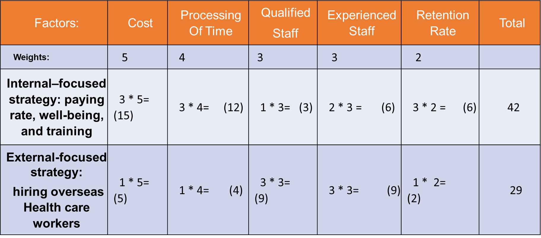
Source created by Author.
Grid analysis shows that Internal–fo7cused strategy: paying rate, well-being, and training selecting the highest scoring option that means it wins!
Grid analysis assists in determining the best solution to implement. Thus, it is critical to guarantee that the solution is implemented to provide the most effective outcome; planning helps to achieve this.

5. Implement the decision
The last phase in the logic and process of solving a problem is to implement your decision. To put your choice into action, you must take action, stay on track, and assess how well you did. These stages are referred to as action, monitoring, and feedback. (Jiwani, 2021).

5.1 Action plan
According to Koontz and O'Donnell (1955), planning is "deciding ahead of time what to do, how to do it, when to do it, and who will execute it." Planning assists us in getting from where we are to where we want to go. It enables events that would not have occurred otherwise." In this report, we will apply the Koontz and O'Donnell technique to construct an action plan for the selected solution.

Table 3 – An action plan for development Internal–focused strategy: paying rate, well-being, and training.

Achieving the actions in each action plan will be a good indicator of success in meeting our aim and objectives. But we must also take an evidence-based approach. The first task and finish group to be set up will therefore produce and agree with the performance indicators for the strategy.

5.2 Monitoring and evaluation
The completion of the steps in each action plan will be a good indicator of our progress in accomplishing goals and objectives. However, we must also utilize an evidence-based approach. Key performance indicators (KPIs) are the subset of performance indicators that are most important to your business at the highest level of your organisation. You utilise them to track your progress toward attaining your strategic objectives (Parmenter, 2015).
This section will determine the key performance indicators (KPIs) to achieve the intended outcome after implementing the action plan for the staff shortage.
Increase paying rate
The government announced the pay award for 2022/23 on July 19, 2022, and this website will be updated as soon as the newest pay scales are released (NHS, 2022). Good KPIs to measure the process of determining the appropriate pay rate:
- Timeliness
- Pay attention to the details.
- Good time management.
- Capability to function in all critical areas of the position.

Hire new staff
hiring KPIs help to ensure that you’re doing all of the right things to find top talent.
- Goal-oriented hiring
- Cost per hire
- Rate of application completion
- The ratio of interviews submitted
- Number of qualifying applicants

Develop well-being strategy
According to Herzberg valuing welfare in the workplace is critical for ensuring that your employees are motivated and energised to tackle day-to-day tasks and execute the necessary adjustments to realise the vision leaders have for their organisations. (Phillips et al., 2017).
Success indicators to examine and update based on feedback, develop a well-being action plan, and begin working toward your goals.:
- Meet with the well-being team regularly.
- Review objectives and activities, and keep each other updated on progress, obstacles, and requests for help.
- Consider strategies to obtain external assistance through the department.
Provide training for new staff
Regular development and training will assist staff stays current on best practices to give the finest care and support.
Good Indicators:
- Focus on providing objective evidence of advancement forward toward the desired outcome.
- Have a measurement that quantifies the amount of achievement variation. It is possible to monitor efficiency, effectiveness, quality, timeliness, governance, and resource use.

6. Conclusion
Staff shortages are today the most serious challenge to the healthcare system, not simply Proper care, UK. Several factors might contribute to a staff shortage. After conducting research and utilizing PESTEL analysis and the Fishbone diagram, we discovered that Proper Care, UK has two possible solutions to the staff shortage: either create an internal-focused strategy focused on pay, health and well-being and training or create an external-focused strategy focused on hiring overseas health care workers. Using grid analysis was a beneficial tool for evaluating potential solutions and making a decision, especially when there were numerous elements (criteria) to consider. The decision was taken to create an internal-focused strategy that includes increasing pay rates, developing a well-being strategy, and training new staff. The action plan was the first stage in implementing the final choice; at the time, we discovered that recruiting new personnel based on new pay rates was a good action that may help Proper Care, UK of staff shortage. during implementation, the decision determines key performance indicators (KPIs) to measure your progress toward achieving your strategic goals. The final stage in the logic and process of problem-solving and decision-making that was followed in the Proper Care, UK case study is to evaluate the outcome.

7. References
Adair, J.E. (2019) Decision making and problem solving : break through barriers and banish uncertainty at work. Fourth edition. London: KoganPage.
Aziz, Zara. (2019) GP practices are struggling – and Brexit will only make things worse. Available at GP practices are struggling – and Brexit will only make things worse | Zara Aziz | The Guardian (Accessed: 27 July 2022).
Beech, J., Bottery, S., Charlesworth, A., Evans, H., Gershlick, B., Hemmings, N., Imison, C., Kahtan, P., McKenna, H., Murray, R. and Palmer, B. (2019). Closing the gap. Key Areas for Action on the Health and Care Workforce.
Belton, V, & Stewart, T. (2001) Multiple Criteria Decision Analysis : An Integrated Approach, Springer, New York, NY. Available from: ProQuest Ebook Central. [8 July 2022].
Chang, K.H. (2014). Design theory and methods using CAD/CAE: The computer aided engineering design series. Academic Press.
CIM. (2020) Stanford research shows that working together boosts motivation. Available at Research at Stanford shows that working together boosts motivation. (Accessed: 26 June 2022).
De Sousa, G.C. and Castañeda-Ayarza, J.A. (2022). PESTEL analysis and the macro-environmental factors that influence the development of the electric and hybrid vehicles industry in Brazil. Case Studies on Transport Policy, 10(1), pp.686-699.
Hughes, B. (2009). Using Causal Analysis to Minimize Risk. In ASSE Professional Development Conference and Exhibition. OnePetro.
Jiwani, B. (2021) Implement the Decision. In Good Organizational Decisions (pp. 81-84). Springer, Cham.
National health executive. (2019) Pay and reward in the NHS needs to be taken seriously. Available at Pay and reward in the NHS needs to be taken seriously (nationalhealthexecutive.com).(Accessed: 28 June 2022).
National health service. (2021 Agenda for change - pay rates. Agenda for change - pay rates | Health Careers.(Accessed: 22 July 2022).
Parmenter, D. (2015) Key performance indicators: developing, implementing, and using winning KPIs. John Wiley & Sons.
Phillips, H. et al. (2017) ‘Commentary: Exploring Novel Approaches to Staff Rewards and Recognition’, Hospital pharmacy (Philadelphia), 52(11), pp. 729–731. doi:10.1177/0018578717736242.
Koontz, H. and O'Donnell, C. (1955) Principles of Management. New York: McGraw-HillBookCompany. Inc., 196h.
The Guardian. (2017) UK social care sector in crisis due to staff shortages. Available at UK social care sector in crisis due to staff shortages | Social care | The Guardian. (Accessed: 25 July 2022).
The King fund. (2020) 2020: the health policy year in 12 charts. Available at 2020: the health policy year in 12 charts | The King's Fund (kingsfund.org.uk). (Accessed: 27 June 2022).
Winter, V., Schreyögg, J. and Thiel, A. (2020) Hospital staff shortages: environmental and organizational determinants and implications for patient satisfaction. Health Policy, 124(4), pp.380-388.
Williams, S.W. (2002) Making better business decisions [electronic resource] : understanding and improving critical thinking and problem-solving skills . London :; Thousand Oaks, Calif. ;, SAGE

