

Assessment 1 – Reading Task Template
Upload your photo of your A3 in-class notes here:
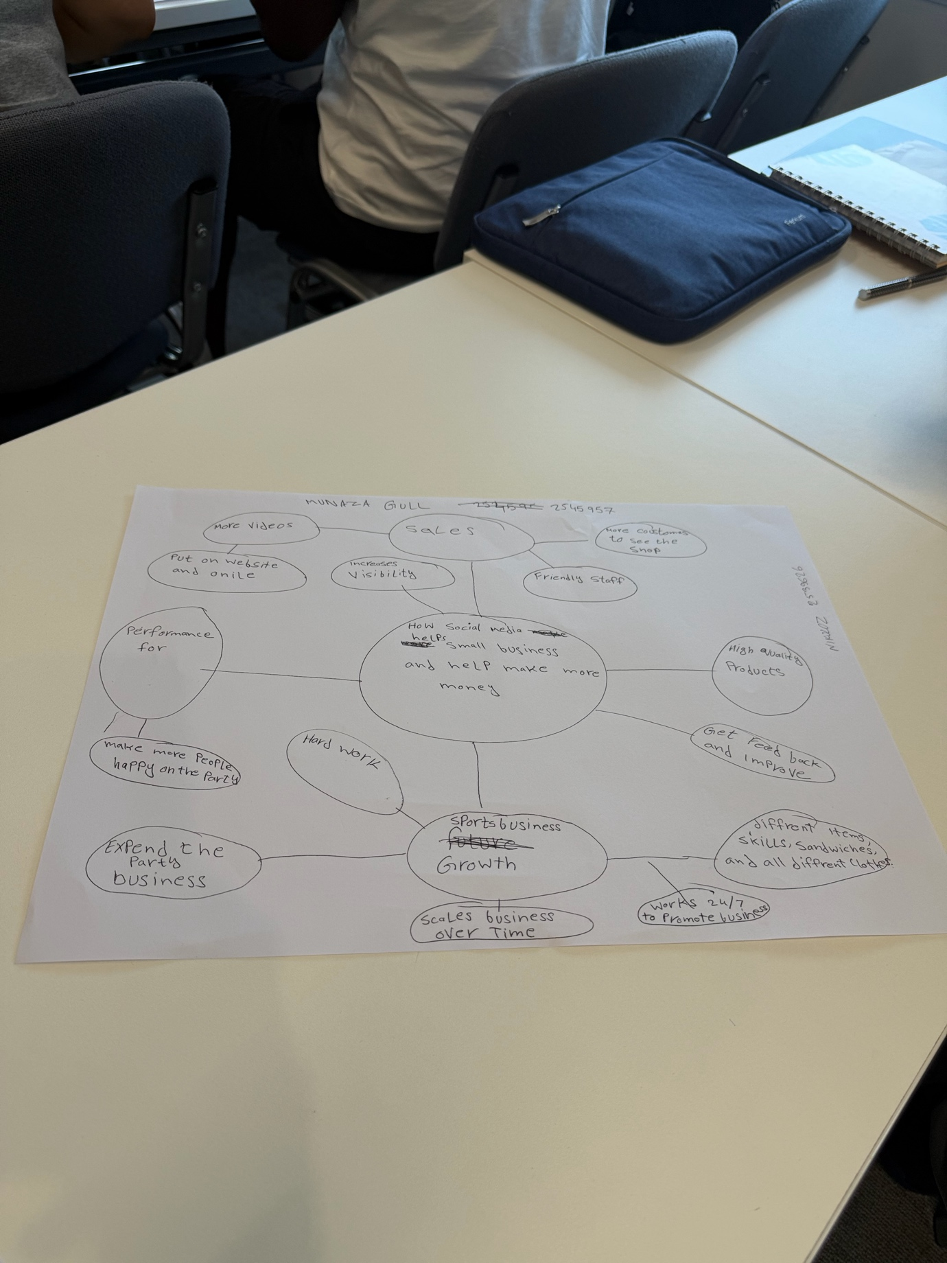

1. Answer these questions using the sentence starters below
a. What is the main idea of the text
A: The main idea is that social media is the platform is the small business by making them popular and make more customers to attract.

The main idea is that
b. What are two key points?
One key point is social media is small business
grow by attracting new customers
Real_ life example show its success
Sandwich shop boutiques,party wears, mobile assecery make gained more new customers and business through the TikTok instagram facebook.

Another key point is
c. What part of the text did you find most important? Why?
The most important part is sandwiches make more customers who traveled three hours for the chicken sandwich or cheese sandwich after seeing the social media track.
d. Was anything unclear or difficult to understand?
I was not sure about I found the text to easy understand because it’s real life to explain only one things I don’t understand how video become viral but the example helped explain it.
e. How did your group help you understand the text better?
My group helped me by understand the text by talking to each other and then explain me about which one I didn’t understand.
2. One sentence reflection
Question: What did you find challenging about this task?
The hardest part was if my group not gonna help me so I found some of the business and marketing terms little difficult, but examples made them easier to understand

