Student Name: Reshmasing Roopchund
Student Number: 2442087
Module Name: Introduction to Public Health
Module Code: LCH4008
Lecturer: Dr Pascal Navelle

Table of Contents
Introduction 1
Effects on community and NHS 1
How heart disease is controlled 2
Factors affecting health and well-being 3
Conclusion 4
Reference List 4

Introduction
Problems affecting the heart and blood arteries are referred to as heart disease. It includes illnesses like coronary artery disease, which obstructs blood flow to the heart and results in heart attacks or chest discomfort. Fatigue, shortness of breath, and chest discomfort are signs of heart disease. Sometimes there are no warning indications until a major incident occurs. In the UK and across the world, heart disease is a serious health issue. Approximately 7 million people in the UK suffer from circulatory and cardiac conditions. Heart disease affects millions of individuals annually and is the leading cause of mortality worldwide.
These figures demonstrate the severity and prevalence of cardiac disease. Knowing about heart disease enables people to detect it early and receive appropriate therapy to lower risk. The effects of heart disease on the community and the National Health Service (NHS), its management, and the variables affecting persons who have it will all be covered in this study.

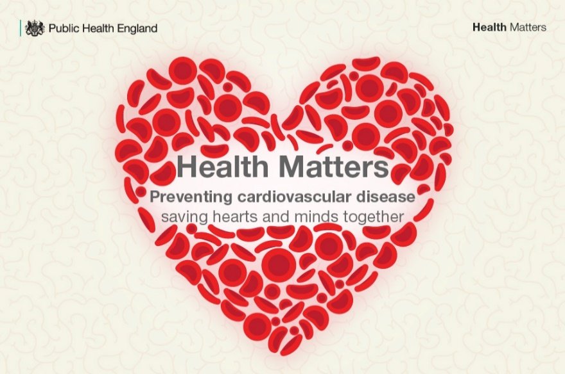
Figure 1

Effects on community and NHS
Heart disease puts a lot of strain on the NHS and has a significant impact on communities. People with heart disease are frequently unable to work or do everyday tasks in their communities. Families are impacted because they must take care of the sick individual. A person who has had a heart attack, for instance, could require assistance at home after spending days in the hospital. Family members that must make life changes experience stress as a result. Partners or kids may experience fatigue and anxiety. Additionally, heart disease causes early deaths, which results in the loss of significant community members like leaders or employees. There is less support for others and greater grief in the local surroundings.
Heart disease is a major expense for the NHS. Numerous people with heart attacks and operations are treated in hospitals. Every year, heart and circulation conditions result in thousands of hospital admissions in England. These scenarios frequently include the utilisation of beds, doctors, and nurses. There will be less room for other ailments as a result. The NHS spends billions on testing, medications, and care initiatives. Waiting times increase as the population ages because more individuals require treatment. Additionally, heart disease is more common in impoverished communities where individuals smoke more and eat less healthful foods. This leads to disparate health issues throughout the United Kingdom (British Heart Foundation, 2025). These consequences demonstrate why heart disease is a problem in the country. The NHS puts a lot of effort into managing the weakening of communities. Improved prevention might lessen these issues for all.

How heart disease is controlled
Treatments, medications, lifestyle modifications, and preventative initiatives are used to manage heart disease. The NHS and doctors collaborate to treat the illness and prevent it from growing worse. Improving blood flow to the heart, easing symptoms, and lowering the risk of heart attacks or strokes are the key objectives.
The first step towards control is changing one's lifestyle. Because smoking destroys blood arteries, patients are taught to quit. They consume less salt, sugar, and fatty meals and more fruits, vegetables, and whole grains. Walking or swimming for half an hour most days is a regular kind of exercise that keeps the heart healthy. Following a cardiac incident, the NHS provides cardiac rehabilitation programs. These include support groups, healthy living education, and exercise under supervision. Individuals who make these adjustments live longer and feel better.
Daily management is greatly aided by medications. Statins keep arteries clean by lowering blood cholesterol levels. Beta blockers and other blood pressure medications slow and ease the pulse. ACE inhibitors improve blood flow by relaxing blood arteries. Aspirin and other antiplatelet medications stop clots from obstructing arteries. Physicians administer these in accordance with the needs of each patient and use routine testing to monitor their development (National Health Service, 2025). To keep patients safe, side effects are continuously monitored.
Surgery is a crucial option in extreme situations. Angioplasty opens constricted arteries using a thin tube and a tiny balloon. To maintain the artery's width, a metal stent is frequently inserted. Many patients can return home the same day thanks to this short operation. A healthy blood vessel from the arm, leg, or chest is connected above and below the obstruction during coronary artery bypass grafting (CABG). As a result, blood has a new route to the heart. For these procedures, the NHS has specialised cardiac facilities with skilled teams. Following surgery, patients participate in physiotherapy-based rehabilitation regimens to increase their strength. In clinics or at home, nurses offer follow-up care. Patients can resume their regular lives more quickly with pain control and wound examinations. Most patients feel significantly better in a matter of weeks, and success rates are high.
Programs for prevention benefit everyone, not just patients. For those between the ages of 40 and 74, the NHS provides free health examinations to identify potential hazards such as high blood pressure, high cholesterol, or diabetes. These easy tests can result in modifications that prevent heart disease before it begins. Everyone is taught about danger indicators including fatigue or chest discomfort through public initiatives like "Know Your Numbers" and NHS Health Checks. Schools provide healthy eating workshops and activity activities to help kids develop positive habits at an early age. Workplaces provide walking challenges and assistance for quitting smoking. Free blood pressure screenings are conducted by community organisations at markets or libraries. These initiatives focus on high-risk populations, such as smokers or residents in underprivileged regions. Heart disease is prevented by emphasising accessibility and education. In the long run, this improves everyone's health and saves the NHS money.
In conclusion, control entails individual effort, medical assistance, and public health initiatives. In addition to saving countless lives, this collaboration lessens the strain on the NHS.

Factors affecting health and well-being
Heart disease has an impact on the afflicted individual as well as their family and community. The health and well-being of people with heart disease and those around them are influenced by a variety of circumstances. Lifestyle, social support, financial standing, and mental health are some of these variables.
Lifestyle is crucial. Smoking, excessive alcohol use, poor nutrition, and inactivity all raise the risk of heart disease and exacerbate its symptoms. Individuals who do not maintain an active lifestyle or consume unhealthy meals may find it more difficult to manage their disease. Conversely, heart health and quality of life can be enhanced by good practices. Patients and their family should be educated about lifestyle options.
Well-being is also impacted by social support. Patients are more likely to adhere to their treatment regimens and feel better when they have supportive friends and relatives. Stress levels might rise and motivation to maintain good health can decline when one feels alone or isolated. Carers' personal health may be impacted by feelings of fatigue or anxiety. Information and emotional support can be provided by community organisations and support services. Access to medical treatment and medications is impacted by economic circumstances. Individuals with lower incomes may find it difficult to pay for medical travel or to purchase nutritious meals. They could reside in places with less access to medical care. Heart disease outcomes may deteriorate as a result. Heart risk and mental health are significantly impacted by poverty and stress associated with financial difficulties.
Heart disease and mental health are intimately related. Heart patients frequently experience anxiety and depression, which makes managing the condition more challenging. Stress from sickness, family, or the workplace can damage the heart and increase blood pressure. Counselling and psychological assistance can help people deal more effectively and enhance their health.
A variety of variables affect the health of persons who have heart disease as well as those around them. Money, social support, lifestyle, and mental health are all crucial. Assisting patients and their families with these problems can enhance wellbeing and lessen the community's exposure to heart disease.

Conclusion
Many individuals in the UK and throughout the world suffer from heart disease, a dangerous illness. It can result in heart attacks, shortness of breath, and chest discomfort. The magnitude of this health issue is demonstrated by the approximately 7 million cases in the UK and the millions of fatalities that occur worldwide each year (World Health Organisation, 2025). According to this analysis, it has a negative impact on communities and the NHS, causing stress for families and driving up hospital expenses. It can be effectively managed with the use of control measures such medication, surgery, lifestyle modifications, and preventative examinations (National Health Service, 2025). The well-being of patients and those around them is also significantly influenced by factors including food, family support, financial difficulties, and mental health. In conclusion, early intervention and collaboration are necessary to lessen the damage caused by heart disease. Healthy lifestyle choices, increased information, and NHS assistance may reduce risks and enhance everyone's quality of life.

Reference List
British Heart Foundation (2025) Heart & circulatory disease statistics 2025. London: British Heart Foundation.
Department of Health and Social Care (2022) Cardiovascular disease profile. https://fingertips.phe.org.uk/profile/cardiovascular.
Mann, D.L., Zipes, D.P., Libby, P. and Bonow, R.O. (eds) (2022) Braunwald's heart disease: a textbook of cardiovascular medicine. 12th edn. Philadelphia: Elsevier.
National Health Service (2025) cardiovascular disease. https://www.nhs.uk/conditions/cardiovascular-disease/.
Rippe, J.M. (2023) Integrating lifestyle medicine in cardiovascular health and disease prevention. Boca Raton: CRC Press.
World Health Organization (2025) cardiovascular diseases (CVDs). https://www.who.int/news-room/fact-sheets/detail/cardiovascular-diseases-(cvds).

