Digital skills & Research methods
Report- research report.

Raya salah (2026066)
11.04.2022
BMSW4003

In this report, we will be discussing what technology is, the advantages & disadvantages of technology in the educational world, its impact and what other people think about the use of technology in the classroom, earlier in the month we did a presentation on how we collaborate technology at UTWSD and how confident students and teachers were with it at the end the question will be answered and justified to good reasoning, by including opinions we made a questionnaire with closed questions as primary research which will be covered as to what it is and why we didn’t undertake secondary research as of its reliability, we got different answers but they were mostly the same just the odd person out.

Technology is the application of scientific knowledge to the practical goals of human life, or, as it is sometimes referred to, the modification and manipulation of the human environment. The role and impact of technology in both our personal and professional lives are expanding all the time. Understanding how people shape technology and how technology shapes people's interactions with one another and with the natural world is important not only for those who research, develop, and implement new technologies but also for all the people and organisations who must use those technologies in their professional and personal lives. The term "technology" is not a neutral term. Depending on their point of view and the context, different people will interpret it differently. (What is technology? 2020)
The importance of technology in education is evident at every level of education; however, the junior and senior years of elementary school and high school are where modernization is most acutely felt because children prepare for significant challenges that await them at the next stage of education during this time, which is why it is critical that they approach learning in the appropriate manner. Many things have become simpler, allowing children to concentrate on their personal growth. Students used to spend a significant amount of time looking for information. Nowadays, information is digital, and virtually everything is accessible via the Internet. Instead of travelling to the library, students can use Google or another search engine to locate the information they need. As a result, the learning environment transforms into an online environment that offers knowledge in a variety of ways (text, audio, video, photographs, infographics, etc.).
As a result, students have a deeper comprehension of the instructional content, allowing them to study more effectively in accordance with the norms of 21st-century abilities. Because this advanced strategy is centred on tools – fast Internet, stable WiFi, and a laptop (tablet or mobile phone), many schools go to considerable lengths to provide each of their students with these resources.
Learning from home, or online learning has been tremendously facilitated by modern communication paradigms. During the global pandemic of 2020, when schools were compelled to close and fully transition to distance learning, this teaching approach became incredibly vital. Even before that, online courses were popular because they gave knowledge to people who desired professional advancement but lacked the time or resources to pursue it. Individuals can attend lectures via distance education even if the instructor is on the other side of the world. People can not only attend schools that are physically located in another part of the world via online education, but they can also work and study while doing so.

I think that even though the technology is accepted and there are still some misconceptions and concerns, however, that comes with everything students and staff are confident enough to collaborate in a classroom. In a classroom, phones as such are extremely distracting and sometimes teachers can't get their students off them but on the other hand, teachers are able to check their students' work by giving them instant feedback or when genuinely checking on them. Technology has made life easier.

The hypothesis was that because technology is not new anymore and it is everywhere meaning it’s widely accepted even though it has its misconceptions and concerns. Technology has become a part of everyone’s day today that it’s a necessity in people's lives & people rely on it heavily, so the hypothesis is that as of fact that it’s a constant in everyone’s lives one way or another, in the educational world (university or college or school) students and staff are confident in using technology to collaborate. So to argue against or for the question, the choice of the secondary and primary research was given, Secondary research, also known as desk research, is a research method that makes use of previously collected data. Existing data is summarised and compiled in order to improve the overall efficacy of the research. Secondary research includes research material that has been published in research reports and other similar documents. These documents can be made available through public libraries, websites, data obtained from previously completed surveys, and so on. Some government and non-government organisations also store data that can be retrieved and used for research purposes. (Secondary Research- Definition, Methods and Examples. | QuestionPro, 2022) And primary research is defined as a methodology used by researchers to collect data directly rather than relying on data gathered from previous studies. They technically "own" the data. Primary research is conducted solely to address a specific problem that necessitates in-depth analysis. (Primary Research: Definition, Examples, Methods and Purpose | QuestionPro, 2022).

Means primary research is more reliable, we used primary research and because there are different types of primary research methods to go with, I decided to go for questionnaires with closed questions which are multiple-choice because they are quick and are not complicated because I realised that people are not going to stand there and complete a 20 minute write up on anything, so quick and easy so basically five minutes would get me the answers I want and comparison would be obvious.

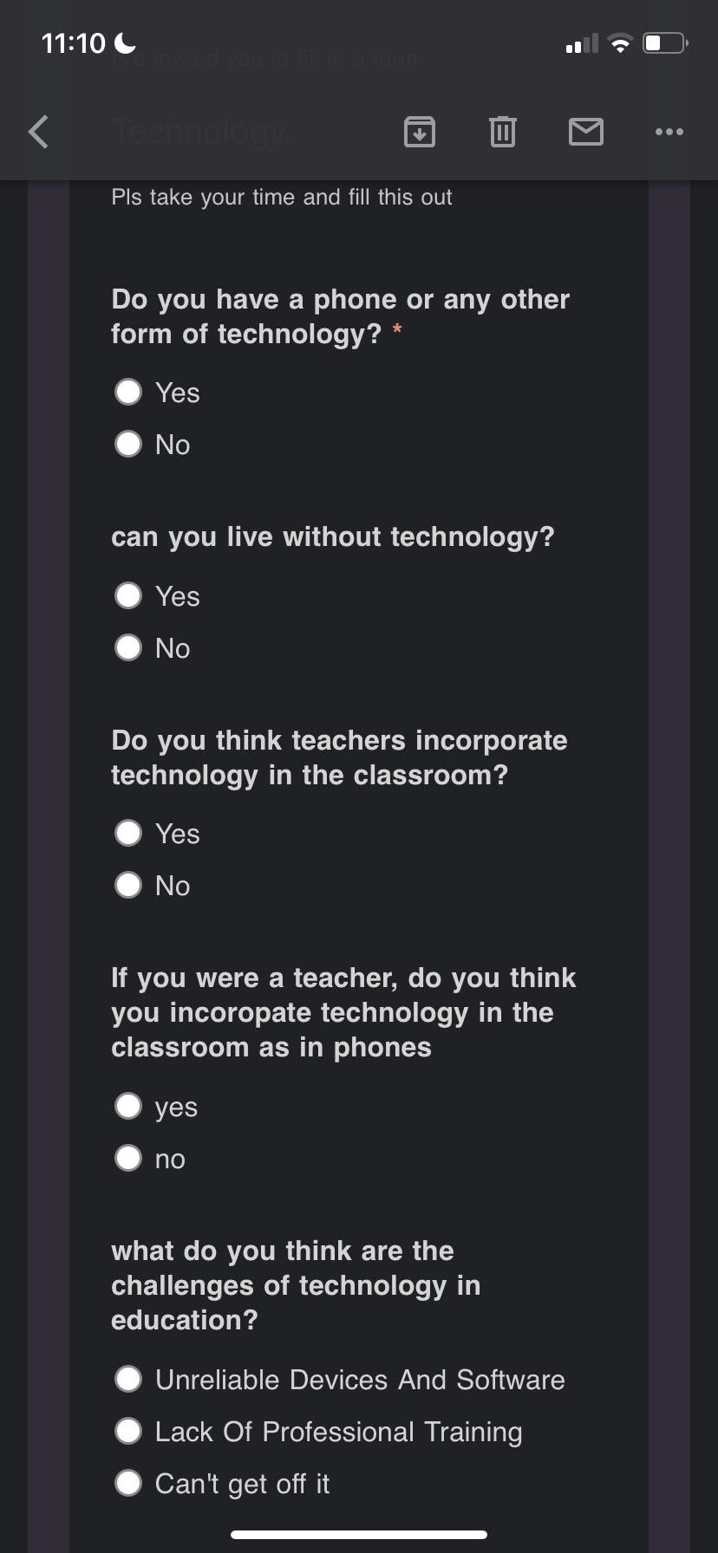
(The picture) This picture is the questionnaire we put together with 5 questions which would take up to 5 minutes and as it was online it was sent out. We had two weeks as a group of three to ask as many students and teachers whether or not they were comfortable using technology, with also conversation around the topic and we somewhat got answers and they all had reasons similar but different.

The results we got was that; with 45 people participating in this, the results were that as this was a short questionnaire, showed that 98% of the people that took part had phones and can't live without technology, they feel as though teachers do incorporate technology in the classroom however a challenge they think they, as teachers face, is that students cannot get off their phones. With this questionnaire, we found that both students and teachers feel somewhat the same. As this was a little case study the 98% does not apply to the whole world and other people may have gotten different results as we did.

The conclusion and the answer to the question are yes, students and staff are confident in using technology to collaborate because of the fact that technology was made to communicate to allow relationships to perish and flourish, everyone became confident in using it and it didn’t matter whether it was used to be good or bad, confidence using technology was a guarantee and is a given. Teachers as educators provide support, criticism, and thoughtfulness and they give a chance they use technology to support their learners with assignments or support outside the college, university or school hours and confidence as I said it's a given and is needed. Technology is now so open and given to anyone and everyone, people have adapted to having it that it’s very easy to use.

