

Student Name: Kitti Takacs
Student Number: 1906398
Lecture Name: Dan Hart
Module Title: Managing Projects in the Organisation (BMSW5104_LON)

Table of contents

1.0 Introduction
2.0 Introduces project management techniques and management tools and show the importance of this technique in a daily basic through the pandemic.
2.1 SWOT analysis
2.2 Breakthrough objectives
3.0 Clear plan for the implementation of the project and the communication strategies.
3.1 Pre and post COVID19 changes that have been implemented the organization
4.0 Self-development plan to improve your own performance in managing projects
5.0 Gantt Chart
6.0 Agile methodology
7.0 Executive Summery
8.0 References

1.0 Introduction

“A true leader has the confidence to stand alone, the courage to make tough decisions, and the compassion to listen to the needs of others. He does not set out to be a leader, but becomes one by the equality of his actions and the integrity of his intent.” ~ Douglas MacArthur
What is Managing Projects in the Organisation? Project management is knowledge, tools, skills and techniques. Project management usually a one-time project not an ongoing activity. This assignment will show tools, skills and different management techniques. Also, show different tools what Manor Park dental is using in a daily bases such as the good old-fashioned to-do list or how we collaborate. How the organization report information and details to each other. What techniques are using to manage a better and more successful working environment. Introducing the organization where I am working. The company called Manor Park Dental Practice. Manor park dental practice is a healthcare provider company who has contract with National Health Care or mostly called NHS. The company has over 100 employees as the organization have 8 practices around London. Manor park dental practice has faced many difficulties through the global pandemic. To be able to manage any projects throughout, we have different types of collaboration and techniques such as involving every staff member in the meeting and discussing all sorts of problems and finding solutions together. Showing different type of trainings on how to operate and handle the organization. Since 2020 when the COVID-19 started all dental practices forced to close down and they were aloud to reopen after 4 months. Since reopening the company is facing a huge amount back log of patient and plenty of new rules to follow day by day. Managing the organization in a daily bases and make our patient understand that the company is trying the best but without of the management tools and technique it would be very challenging. The cost of the reopening was extremely high. As the company had to buy all the equipment and safety glasses to provide the best care for patient. To be able to provide safe environment the cost was high and because of the lockdown the organization had to get some loan from the government. Without patient our company had no income through the pandemic and even after the new specific rules did not help to rise the income as we have fallow time between patient which means less patients on a daily basis.
1.2 Start cost
Manor park dental is an ongoing organization. Dental surgery starts up cost are very high. Usually start from £300,000, depend on how many surgeries and technologies are required. As manor park dental surgery has 7 surgeries and also specialized for orthodontic and implant as well the equipment can be very expensive.
Furniture for the waiting areas: Chairs, Desk(s), Computer(s), Clinic pads, Phone and phones system set up, Printer. These equipment’s was already in the practice but since covid-19 the company had to add some hand sanitizing station, glass sheal at the reception desk. All surgeries got new air purifier to clean the air between patient and FFP mask for dental staff.

Reception extra cost | £ 1,500
7 surgeries extra cost | £10,000
Total cost | £11,500
The air purifier helps reduce the waiting time between patient 80%. Without this investment the company would lose at least 50% patient. This is help to maintain profit so the company can reinvest for new equipment, refurbish and staff training.
2021 | Income | Employee wages | Profit
February | £170 000 | £101 000 | £39 000
March | £192 000 | £136 000 | £26 000
As manor park dental contracted by the national health care the organization did not need to borrow money to provide the extra cost. Also, NHS provides every month hand sanitizer, masks and cleaning wipes.
Manor park dental weekly patient target chart.
Since COVID-19, the company provide data analysing to show how far or close are we from the target. This data analysing technique helps the organization grow week by week. This pandemic effected not just the income of the practice but also the quality of the service. As many patients cannot afford private treatment but under the NHS waiting list is can be up to 18 months for a general root canal treatment or a tooth extraction. Also, the back log of patient since the lockdown are still long. The practice is focusing to finish the treatment but also receiving new cases, new emergencies and general check up appointments. The main project at Manor park dental is to see more patient and reach our targets as we have to deliver uda’s for NHS to maintain our contract.
 | Percentage of Specialist Referrals | Hyg | Percentage of Hygienist Referrals | Total Pt’s seen (exams, hyg)
dentist 1 | 4.3% | 25 | 33.3% | 75
dentist 2 | 8.5% | 8 | 22.8% | 35
dentist 3 | 0% | 0 | 0% | 34
dentist 4 | 4.9% | 12 | 14.8% | 81
dentist 5 | 2.3% | 16 | 18.6% | 86
dentist 6 | 5% | 9 | 45% | 20
dentist 7 | 0% | 0 | 0% | 30
dentist 8 | 0% | 0 | 0% | N/A
dentist 9 | 0% | 0 | 0% | N/A
hygienist 1 | 0% | N/A | N/A | 53
hygienist 2 | 0% | N/A | N/A | 51
hygienist 3 | 0% | N/A | N/A | 23

2.0 Introduces project management techniques and management tools and show the importance of this technique in a daily basic through the pandemic.

Project management tools and technique are very important in any organization. SWOT analysis is on of the most common technique that organizations use. SWOT can be used to show how opportunities able to became strengths and threats can make the organization weak. Swot diagram show both positive and negative and also external and internal part. Analysing of the strengths, weaknesses, opportunities and threats are able to show the results of the internal business analysis and also the external environment analysis. Similar analysing technique is known as PEST, examining political, economic, social and technological factor. SWOT analysis is important not just re-opening the organization after lockdown. This analysing system helps for the company to build a better understanding of the company and how to grow bigger. Understanding what is the weakness and be able to solve is the main key. Focus on the strength and make it stronger. Take all the opportunities and make it as a strength for the company. Analyse the threat and try to solve the problem.

2.1
Strengths  ▪ Increase skills with existing team and promote internally  ▪ Standing out as THE practice to go to  ▪ Teamwork and encouragement within the team  ▪ Diversity of people in practice  ▪ Loyal patient base  ▪ Good company culture  ▪ Invested management (practice level and group level)  ▪ Stable dentists  ▪ Good locations  ▪ NHS big patient lists  ▪ Invisalign Diamond | Weaknesses  ▪ Dentists changing frequently and the need for stability  ▪ Patient service  ▪ Staff turnover  ▪ Training  ▪ Communication  ▪ Staff pay  Good company culture  ▪ Invested management (practice level and group level)  ▪ Stable dentists  ▪ Good locations  ▪ NHS big patient lists  ▪ Invisalign Diamond
Opportunities  ▪ Increase skills with existing team and promote internally  ▪ More cohesion between front of house, nursing, hygiene, specialist and dentist teams – more teamwork  ▪ A new wave of people moving to West Wickham, an opportunity to reach out to the on different platforms and to attract them  ▪ Promote therapy to the patients as an addition skill the practice offers. Introduce the therapist scope of practice.  ▪ Standing out as THE practice to go to  ▪ Diversity of people in practice  ▪ Social media  ▪ Increasing dentist skills and external referrals  ▪ Relationships with local practices  ▪ CPD evenings | Threats  ▪ Team at times can be fractured  ▪ Losing strong dentists  ▪ Losing strong support team members  ▪ Lots of private practices opening  A new wave of people moving to West Wickham, an opportunity to reach out to the on different platforms and to attract them  ▪ Promote therapy to the patients as an addition skill the practice offers. Introduce the therapist scope of practice.  ▪ Standing out as THE practice to go to  ▪ Diversity of people in practice  ▪ Social media  ▪ Increasing dentist skills and external referrals  ▪ Relationships with local practices  ▪ CPD evenings

Manor park Dental main project is to see more patient and deliver excellent healthcare.

2.2 Breakthrough objectives (1 – 2 years)
Breakthrough objectives are significant improvements that require each practice to stretch itself. We cannot achieve these by doing business as usual. Regarding the global pandemic Manor Park dental focusing on more training which will help to encourage better customer service and better communication between employees.

Quality  - All dentists carrying out top industry standard dental and facial treatment  - To transform to Wytes, West Wickham – 95% patient satisfaction through reviews, surveys and mystery shoppers | People  - Reduce support team turnover  - Increase support team skills  - Increase team morale and sense of value
Operational Excellence  - Central Operating Plan introduced and used effectively  - Team members trained, understand and implement systems they are  responsible for to standard and time. | Financial  - To achieve 20% profitability  - Grow hygiene and key services (Invisalign and dental & facial aesthetics, ortho)  - To reduce wasted time and running costs  - Increased associate private hourly rate

Strategic initiatives (3 – 5 years)
Strategic initiatives are improvements that will require the practices to stretch themselves and will take three to five years to achieve. These initiatives will help achieve the vision.

Quality  To provide the best patient care and experience with notable customer service, in a relaxed and beautiful environment, with top industry standards for treatment | People  To attract, maintain and strengthen our highly skilled team
Operational Excellence  To use efficient and sustainable systems for consistency, stability and quality | Financial  To achieve 20% profitability which is sustainable and supports investment in our people and the practice

The True North
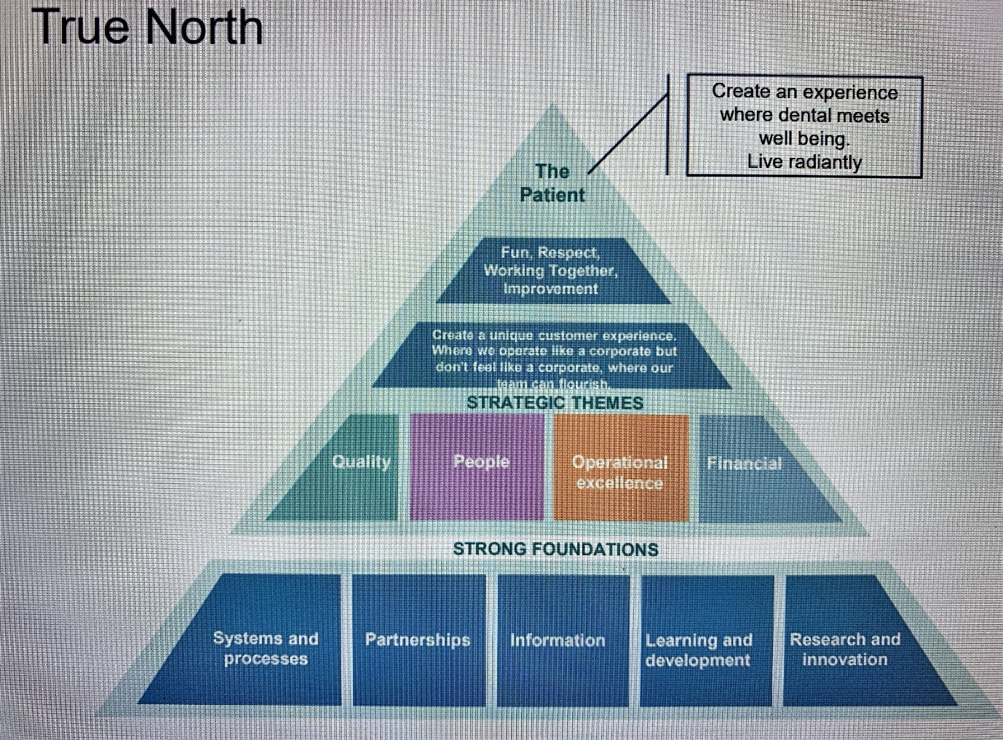
What is True North?
True North is a handful of metrics used to guide decisions and gauge progress. True North metrics are stable and few.
Every year, at manor park dental the senior leaders set new targets against the metric to push the practice closer to the goal.
Principles in Manor Park Dental
These management tools help the organization to encourage staff members to understand the basic principles.
Respect every individual:
Working to keep everyone safe from harm. Listening to and encouraging new ideas and initiatives. Give people training and freedom to fix the problems they encounter.
Lead with humility:
No one person has the answers, however, humility demands that we recognise this. In humility there is great freedom. Humility is learned behaviours. Leader role is to go and ask questions, seeking to help where they can.
Seek perfection:
Quality improvement leaders show they value life by seeking perfection. It is about chasing the absolute zero (zero infections, zero preventable mortalities). Seek perfection is always trying new ideas or methods to get close to the goal. Perfect is the goal but never let it get in the way of better.
Ensure quality at the source:
This principle is about making mistakes visible. Not allowing people to move ahead until problems/mistakes are rectified. At decision points have standard work for staff to check that particular things are done.
Think systematically:
Consider whole system all interactions and intersections both planned and accidental. Patients are the centre of the universe and everyone is organised around creating value for the customer. Leaders standard work is to be system leaders thinking of operations as one organism.

3.0 Clear plan for the implementation of the project and the communication strategies.
As manor park dentals main project is to reach more patients, in using different communication channels to reach them. Such as Email, calls and open days. Open days helps to show patient the organization. Leading my team, I mainly use the team communication strategies. As we spend plenty time together, I still organize every week meetings to discuss any changes and give a chance to my team for any ideas. Very important to be inclusive as I try to not leave any member out of the meetings. Woody Williams said “No matter how good the team or how efficient the methodology, if we’re not solving the right problem, the project fails.” The main concern as a leader to find the right problem. Respect your team members and listen to them.
Also using PDSA in designing processes and in solving every problem. Involve everyone, if used by everyone problems are addressed immediately. People usually stop half way (P,D) but here (S,A) is where I learnt what is working and what is not Structured thinking. Creating constancy of purpose. Creating a calming and quality experience for my staff members.
PDCA picture source (PDCA (Plan Do Check Act) - From MindTools.com)
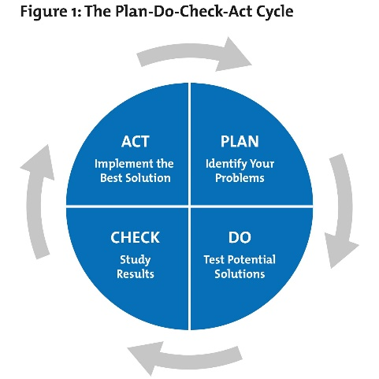
"As you navigate through the rest of your life, be open to collaboration. Other people and other people's ideas are often better than your own. Find a group of people who challenge and inspire you, spend a lot of time with them, and it will change your life." ~ (Poehler)

3.1 Pre and post COVID19 changes that have been implemented the organization
COVID-19 made many changes in the organization. The main changes were losing many patients. As a healthcare provider company, we have to communicate clearly and face to face with patient. Since COVID-19 our medical staff has to wear facemask which created more difficult communication between patient and dentist or even between dentist and dental assistant. Before the pandemic all employees could communicate face to face, since COVID admin staff cannot enter any surgeries, we have to use our SOE system to communicate with the clinical staff. The company meeting and learning sessions are only take place online. Manor park dental project is to achieve more patient and deliver excellent service. Through this project changed many things in the practice. Without face-to-face contact hard to build trust between employees.
4.0 Self-development plan to improve your own performance in managing projects
Eleanor Roosevelt said “You gain strength, courage and confidence by every experience in which you really stop to look fear in the face. You must do the thing you think you cannot do.” — Eleanor Roosevelt. Project managing is always a challenging subject as each people see businesses in a different way. Through this global pandemic i learnt a lot about how to improve my performance as an assistant manager at the dental practice. The first lock down helped us to realise any business can be closed within a day even healthcare. This pandemic also showed that never enough to self-educative myself, to be able to stand more than just one foot. Learning experience when the company shut helped me think about and learn about new things how to grow as a team and how to manage my team better. Four months of stop realised how important is communication and belief. Keep in contact with everyone and make sure when the reopening start everyone will be ready and understand all the new rules was challenging. Reading many different books and managing techniques to help improve my skills. Still many more to learn.

Personal development plan
What is my current state?

What are my strengths?  focus on my goals, good managing skills, trustable and hard-working attitude  What are my weaknesses?  too honest, believing people words and lose focus if I cannot learn  What are the common feedbacks that I receive from others? | Strengths  focus on my goals, good managing skills, trustable and hard-working attitude.  Weaknesses  too honest, believing people words and lose focus if I cannot learn  Feedback  I always say what I feel, never holding
What is my desired state?

What do I hope?  Why do I want to achieve that? What does it give me? | Desired state  more knowledge about businesses and open my own business  Why do I want it?  open my own organization and achieve and learn more very day
How do I get there? What is needed?

What must I improve/ learn/ experience to achieve the desired state?  What are the possible resources to learn/ experience/ improve? | Finish the learn must di what to are the to  1. Finish university  2. Start the master degree  3. Listen to business owners
Set timeline

My timeline has short- and long-term goals.
Short term is to finish the university.
Take a next step at my workplace

“The most challenging one to manage is you. “Self-leadership” isn’t a concept that most of us think about all that often. Yet leadership capability relates as much to how we lead ourselves as how we lead others. Some of the greatest barriers we face along the path of pushing our ideas to fruition lie within us.” ~ (Belsky, 2010)

5.0 Gantt Chart

Gantt chart is a graphical representation of a project schedule. This type of chart shows the start and finish dates of numerous elements of the project that can include resource, task and needs. Henry Gantt designed the Gantt chart who was an American mechanical engineer. Gantt chart is the most commonly used chart in project management. This chart is helpful to plan a project and describe the task and time that require for accomplishment. Gantt chart helps in managing, scheduling and also monitoring exact task and resources in a project. The Gantt chart shows the project timeline and scheduled and also completed work over the specific timeline. The chart helps to the project managers communicating about the project status and help to keep on track with the remaining project.
(Emond, 2007) in his article, looks at the significance of the use of Gantt charts in the present-day project setting. He believes that the use of a Gantt chart has involved many challengers who can be possible dangerous. The article shows that in several reviews showed, the use of Gantt charts has been considered as having close to no value, or having completely no value in simplifying the respondents manage their projects.
Manor park dental using Gantt chart to monitor and accomplish every projects. This chart helped the organization for the reopen to keep track what task need to complete and also follow the time as required. Manor park use this chart for any projects of sizes and types.
 | Task | Assigned To | Start | End | Due
 | Project |  | 01/07/2020 | 01/07/2021 | 365
1 | Categories patient risk groups as necessary according to regulatory guidelines | Reception | 01/07/2020 | 01/08/2020 | 30
2 | Categories treatment risk group as necessary according to regulatory guidelines | Principal | 01/07/2020 | 01/08/2020 | 30
3 | Associated fallow time in line with guidelines | Nurse | 01/07/2020 | 01/07/2021 | 365
4 | Team training on personal, colleague and patient protection against infection | Practice management | 01/07/2020 | 01/01/2021 | 180
5 | Yearly CPD training | Principal/ Practice management | 28/03/2021 | 28/03/2021 | 1
6 | Staff training | Management | 01/02/2021 | 01/03/2021 | 30
7 | Clinical staff training on the use of PPE and discipline | Nurse Management | 01/07/2020 | 01/02/2020 | 30
8 | Care Letter and email explaining how the practice will be operate | Management | 01/07/2020 | 03/07/2020 | 3
9 | Management patient expectation | Management | 01/11/2020 | 01/04/2021 | 150
10 | Customer feedback overview | Reception | 01/07/2020 | 01/07/2021 | 365

6.0 Agile methodology

Agile chart source (agile chart - Bing images )
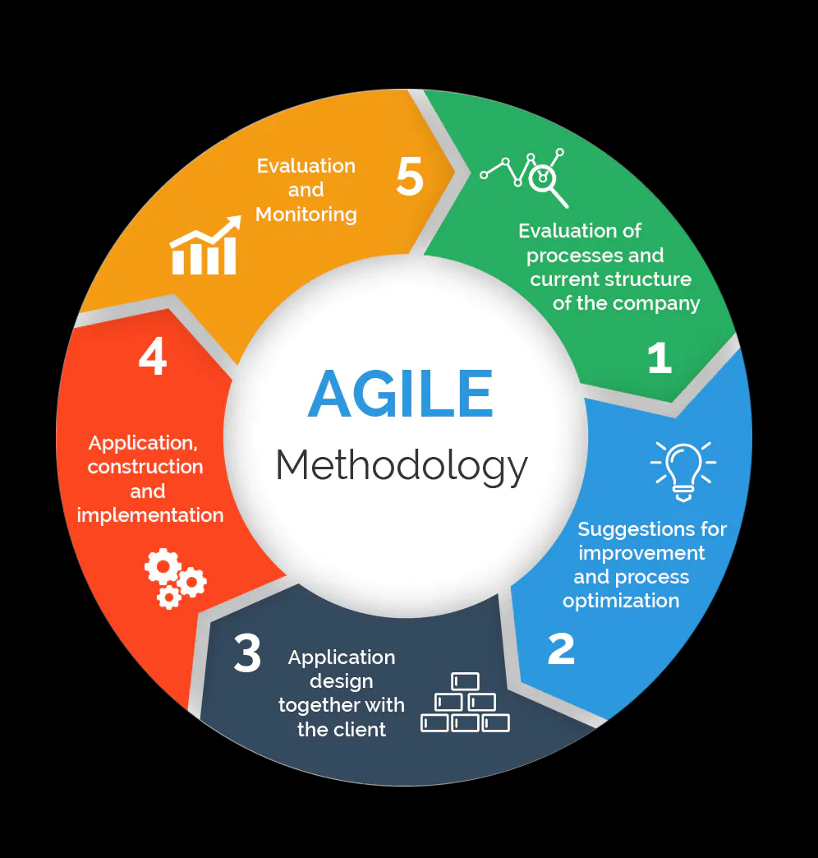
Agile methodology is focused on breaking down large projects into smaller, manageable tasks. Agile first step is calculating the process and the current structure of the company. The second part is to get all the suggestions for any improvement and process optimization. The third step is to design the application with the client. The fourth is the implementation and construction of the application and the fifth is evaluation and monitoring.
Manor part dental top priorities is not just providing excellent levels of patient care and patient care quality, as well as learning about patient and health plan member population and trying to optimizing and manage the cost to deliver the best health care. Mostly at manor park dental using lean methodology which is focus on process efficiencies and the outcome of the patient health. The lean method helps understand and improve customer values. In this case it means focus on value to both providers and patients. However agile methodology helps to support clinical and operational process improvement in any projects. This model containing process group session successively within a clear period of time. Manor park focusing on many group meetings which involves all department and open for any suggestion. We give many ideas and suggestions such as better communication or how to improve our service through covid-19 Every member sees this pandemic in a different way and all of us can add suggestion how to operate the business. When we had all the suggestion, we are working on to process them.
Agile methodology works better for our organization because agila model is focusing on team work and also prioritising suggestions. Agile helps build patient because changes are incremental and evolutionary rather than revolutionary. Agile also allow decision to be tested and reject in the early stage the sort feedback circles provide benefits in agile that are not as evident in for example waterfall. Agile focus on the customer feedback as well so we can change our project if the feedback is not good enough. All in all, agile methodology helps manor park dental to grow and work as a team and understand more about patient. Which helps create a better work environment.

7.0 Executive Summery
I believe this past year was the hardest in any organization. This global pandemic taught many different things, what is important and how to manage companies through this. As a healthcare provider company faced many challenges last year and still far from the end. Used various different management tools and technique to manage the reopening and maintain the organization in a daily basis. Communication training was one of the main objects in Manor Park. Understanding different guide lines, follow and train the staff members to not just understand but follow as well. Plenty of different training provided and still scheduled for the team maintain the high level of patient care. In the beginning of the assignment provided SWOT analysis shows what do the organization need to improve and what covid 19 changed in healthcare. Wearing special masks and keeping distance created many communication problems not just between staff members. Using SWOT analysis helps to improve the company. Using Gantt chart in a daily bases helps keep track in completed and also on ongoing tasks. Using Agile methodology helps break down the big projects into small project. The self-development plan helps me to improve learn and do better every day. The self-development plan helps not just improve my work but also to manage my time and priorities things.
All in all, various things need to still change at Manor Park dental. Communication training need to provide for all dentist to communicate with patient clearly. Managing daily tasks more efficiently. As Brian Tracy said: “Communication is a skill that you can learn. It’s like riding a bicycle or typing. If you’re willing to work at it, you can rapidly improve the quality of every part of your life.”

8.0 References

References

Belsky, S. (2010). Making Ideas Happen: Overcoming the Obstacles Between Vision and Reality. Portfolio.
Emond, C. (2007, September 13). Is the Gantt Chart Dead or Just Another Victim of Tool Disease? Retrieved July 4, 2014, from Project Times: http://www.projecttimes.com/is-the-gantt-chart-dead-or-just-another-victim-of-tool-disease.html
Roosevelt, Eleanor (1884–1962) in The Oxford Encyclopaedia of Women in World History
PDCA picture source (PDCA (Plan Do Check Act) - From MindTools.com)
Agile chart source (agile chart - Bing images )
Kharbanda, O.P. & Pinto, J.K. 1996. What made Gertie gallop? Learning from project failures. New York: Van Nostrand Reinhold.

Laufer, A., Denker, G.R., and Shenhar, A.J. 1993. Simultaneous management: The key to excellence in capital projects. Unpublished manuscript.

