A Review of the Value of Government supported Learning and Development Strategy for International Financial Services in Ireland

Table of Contents

Abstract 1

Chapter 1: Introduction 2
Introduction to Irish Financial Services 2
International Financial Services Industry Characteristics 3
Central Bank of Ireland 4
International Financial Services Strategy 6
Springboard+ 8
Rationale of Study 8
Research Objectives and Methods 10

Chapter 2: Literature Review 12
Intellectual Capital Development 12
Intangible Nature of Intellectual Capital 13
Intellectual Capital in Financial Services 14
Regulatory Environment 16
Previous Large-Scale Studies 17
- United States 17
- Europe 18
- United Kingdom 18
Leadership, Learning and Development 20
Pedagogical Considerations 22
Intellectual Capital Measurement 24

Chapter 3: Methodology 25
Philosophy 25
Research Objectives 25
Philosophical Worldview 28
Methodology Selected 28
Research Hypothesis 30
Data Collection 30
Data Analysis 32
Restrictions and Limitations 33
Time Allocation 34
Reliability, Validity, Consistency and Neutrality 35
Consideration and Bias 36
Ethical Implications 37

Chapter 4: Findings 38
Methods and Findings 38
Research Objectives 38
Reporting of Findings 39
Part I: Quantitative Findings 40
Part II: Qualitative Findings 46
Qualitative and Quantitative Conclusion 54

Chapter 5: Analysis of Findings 55
Approach 55
Inclusion and Exclusion Criteria 55
Quantitative Findings and Analysis 56
VAIC Beyond Financial Services 59
Periods of Economic Stress 60
VAIC Analysis 62
Main VAIC Limitations 66
Qualitative Findings Analysis 66
VAIC a Pedagogical View 71
Considerations on the Research Hypothesis 72
VAIC and Correlation Analysis 73
Research Recommendations 73
Progression of this Research with the Author 74

Appendices 74
Appendix 1: Summary of VAIC Model 75
Appendix 2: VAIC Calculations: Aircraft Leasing 76
Appendix 3: VAIC Calculations: Credit Unions ……………………………………………………………………………………78
Appendix 4: Semi Structured Interviews: Summaries 78
Appendix 5: Semi-Structured Interviews: Themed Analysis 80

References 82

Table of Charts, Tables and Maps

Charts
1: Transversal Skills 5
2: Factors Impacting Growth of Funds Industry in Ireland Over Next 5 Years 5
3: Skills Most Needed for the Workforce of the Future 17
4: Data Collection Analysis Planner 34
5: Average Subsector VAIC 42
6: Average Renumeration and Depreciation 2016-2018 as a Percentage of Operating Profit 44
7: VAIC Comparison Organisation and Year Map 58
8: Realtime Sahm Rule Recession Indicator (US Unemployment Percentage January 2000 – June 2020) 61
9: Average Capital Employed Efficiency, Social Capital Efficiency
and Human Capital Efficiency Analysis 64
10: Population of Ireland by Age, Sex and Education Attainment in 2015 and 2060 70

Tables
1: VAIC: Aircraft Leasing Companies 41
2: VAIC: Credit Unions 41
3: Comparison of VAIC Subsets and Standard Deviation 43
4: Inclusion and Exclusion Criteria for Analysis 56
5: VAIC Scoreboard 57
6: VAIC Components as Percentage 65

Maps
1: Catchment Areas of Major Workplace Location 2016 68
2: Regional Breakdown of Employment Supported in Investment Funds Industry in Ireland 2018 68

“An investment in knowledge pays the best interest.”
(Benjamin Franklin)
Abstract
The purpose of this research was to fulfil the requirements of the Masters in Business Administration programme through the University of Wales Trinity Saint David, while undertaken primary research into an area that explored business value through learning as an area that interested the author both academically and professionally. Of specific interest was how value could be measured and quantified providing tangible results.

The design of the research was firmly rooted to a mixed methodological approach following a comprehensive literature review. The methods included measurement of Value Added Intellectual Coefficient (VAIC) for eight organisations over a three-year period in two distinct subsectors of Financial Services (FS) inclusive of International Financial Services (IFS). To balance this and committing to the mixed methodology approach semi-structured interviews were conducted with ten students who completed Springboard+ programmes and three managers activity involved with learning and development and or recruitment.

Among the more findings, it is notable that VAIC is considered high in the Aircraft Leasing subsector of IFS, with some the measurement of Operating Profit and Depreciation contributing to this. Credit Unions as a comparison are more stable in their VAIC measurements. Qualitatively this research found that learners have a preference to study locally, while their post study experience is that IFS and FS have barriers to entry, which is supported by manager accounts.

It is interpreted that VAIC is best employed using correlation analysis and has limitations, especially when access to full financial reporting is unavailable. VAIC measurement in Ireland is underdeveloped and VAIC in FS is challenging to compare. A greater body of knowledge and research is required to progress this first offering of VAIC measurement for FS and IFS in Ireland, while qualitatively the research adds to existing narratives and synthesis of learner experience.
Chapter 1: Introduction

Introduction to Irish Financial Services
The liberalisation of financial services in the USA and UK during the 1980’s brought about a realisation that a strategic approach to governance of the Financial Services (FS) sector could have a positive impact on national economic development (Coogan, 2015). Fostering this approach, the Government of the Republic of Ireland (Irish Government) began its association with International Financial Services (IFS) in the mid 1980’s. This brought about the establishment of the International Financial Services Centre (IFSC) in 1987. Siting the IFSC in Dublin’s dilapidated docklands was a symbol of the intend behind the government’s policy, which was to liberalise the sector to attract inward investment to stimulate national economic development. This intend has and continues to characterise Irish Government strategy in the area.

The IFS sector in Ireland has consistently exploited internal and external factors to find opportunities for growth. These included foreign direct investment (FDI), where investment from outside Ireland was sought (Boland et al, 2006 and Ernst & Young, 2014), this developed to the targeting of multinational companies seeking to establish EU headquarters (Boland et al, 2006 and Quinn, 2015) capitalising on emerging technologies as globalisation was influenced by the ease of electronic communications and connectivity. British political uncertainty around its departure from the European Union (EU) identified, Ireland and specifically Dublin, as a Brexodus location of choice for many companies, compared to other EU locations (The Times, 2019).

The Irish Government’s support to the IFS industry has been applied at specific intervals; beginning in the 1980’s this was to establish the IFSC, in the 90’s it helped with deregulation of IFS (Boland et al, 2006) and from 1999, consecutive governments have developed and published strategy documents supporting the development of the industry. In 1999 the publication of Strategy for the Development of International Financial Services Industry in Ireland (Department of the Taoiseach, 1999) marked the beginning of cyclical commitment to industry development. This and subsequent strategies have assisted in the development of the sector by consistently selecting achievable strategic goals. During the period of this study Government strategy is articulated by International Financial Services 2020 Strategy (Irish Government, 2015), which sets measurable economic targets of growth and development within the industry. This document will be examined further in this paper, specifically through its educational aspirations and support. Before this, it is appropriate to consider the IFS industry as it stands in Ireland.

International Financial Services Industry Characteristics
The IFS industry in Ireland has characteristics that have contributed to its development and how it is established today. Three characteristics are considered important for this study as they specifically identify the influences on and business of IFS in Ireland. They are:
- A single national Regulator: Beyond the EU influence on IFS, the Irish context is regulated today by a single Regulator, the Central Bank of Ireland (CB).
- Government involvement: The Irish Government have been active within IFS in Ireland since the 1980’s with the establishment of the IFSC. Later involvement has focused on setting achievable strategic objectives.
- IFS subsectors: IFS in Ireland has recognisable sectors that are considered in Government strategy. These are:

        - Banking
        - Investment Funds
        - Investment Management
        - Insurance and Reinsurance
        - FinTech
        - Aircraft Leasing.

Briefly examining these characteristics will allow some context to be placed on the overall direction of this study, the first and dominant characteristic of IFS in Ireland is that there is a single regulator.

Central Bank of Ireland
The Central Bank Reform Act, 2010, replaced the previous related entities of the Central Bank of Ireland (hereafter abbreviated to CB), the Financial Services Authority of Ireland and the Financial Regulator with the CB as the single unitary body responsible for both central banking and financial regulation. Its objective is to ensure financial stability, consumer protection and market integrity (CB, 2019). The IFS industry recognises the CB as being proactive in creating the regulatory conditions to effectively and efficiently function within the EU creating stable conditions for Foreign Direct Investment (Boland et al, 2006 and Ernst & Young, 2014) and attracts those companies looking to establish an EU hub (The Times, 2019). As comparison, the UK following the Financial Services Act 2012 has three separate regulatory bodies. As the single regulator for over 10,000 firms across 17 industry and market subsectors, the CB has been criticised as adopting a “one size fits all” approach to supervision and regulation (CB, 2018b). This is evident in the prescriptive nature of competencies that the CB has introduced post the financial crisis and GFC.

Countering this approach, preferences associated with transversal skills from wider industry employers are illustrated in Chart 1.

Chart 1: Transversal Skills
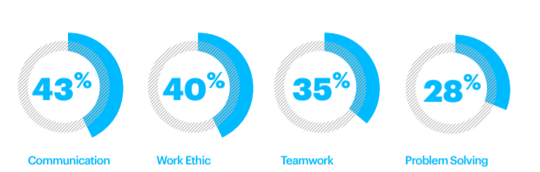
(Accenture, 2019)
These skills are recognised by higher education and are embedded in programme and modular outcomes from educational initiatives developed collaboratively between industry employers and higher education providers within Springboard+ programmes. However, MCC does not prescribe transversal skills identifying a divergence between FS industry preferences and the influence of the CB as regulator.

Chart 2: Factors Impacting Growth of Funds Industry in Ireland Over Next 5 Years – Summary of Industry Views on Relative Impacts
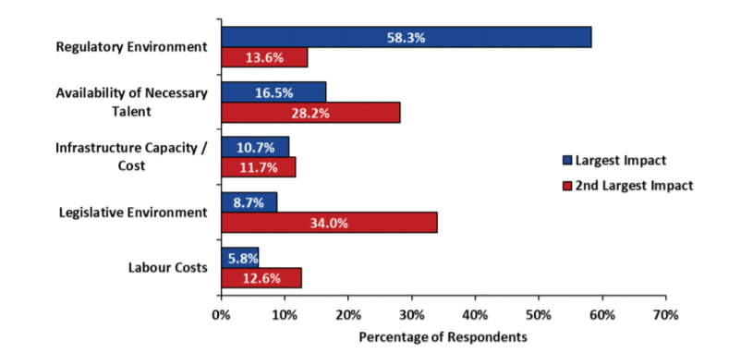
(Indecon, 2019)
In a survey of 160 different entities operating in or providing specialist supports to the funds subsector of IFS industry the regulatory environment was considered the factor most likely to affect growth prospects up to 2024 (Indecon, 2019), with most organisations agreeing that training will receive greater priority with regulatory change (Deloitte, 2019). Turning to another influencer on the IFS environment, Irish Government strategy will be briefly reviewed in the next section.

International Financial Services Strategy
Following the establishment of the IFSC in 1987, successive governments have supported the sustained development of IFS in Ireland. Stakeholders in the IFS space in Ireland argue that as a location, Ireland is considered one of the top EU choices in which to establish investment funds (Mason, Hayes & Curran, 2012 and Matheson, 2018) a position that is supported by a low corporate tax rate (Irish Funds, 2017), which has been rigorously defended by Irish governments against EU standardisation (McConnell, 2019). This is evident with the General Court of the European Union ruling in July 2020 which found in favour of Apple Inc and the Irish Government in their joint appeal against the European Commission's tax ruling on Apple’s corporate tax bill (Goodbody, 2020).

It is important to recognise Ireland’s association as a country committed to the wider European political agenda. It holds EU membership and is a member of the Euro currency, with a population that are largely pro-European. As one of the nineteen EU countries to adopt the Euro and to be included in European Central Bank (ECB) monetary policy, Ireland as a destination for IFS sectors is already networked into the European system but retains precedence for its own national central bank (Dorling Kindersley, 2017) and corporate tax trading rate (McConnell, 2019). Regulation, government strategy and a pro-European political perspective allow Ireland to be marketed as an attractive location in which to establish IFS operations allowing plug-in to other European jurisdictions, while defending its low corporate tax rate.

Interlocking strategies for IFS in Ireland published by Government have reacted to changing external factors and assisted to create the circumstances to attract investment and propagate industry growth, this has included additional financial support for educational opportunities following the result of the Brexit referendum in the UK in 2016.

The Irish Government in collaboration with IFS have been setting strategy for over 20 years, the document which is most relevant to this study is International Financial Services 2020 Strategy (hereafter shortened to 2020 Strategy), specially recognises the necessity for partnership between Government and Industry to achieve success (Irish Government, 2015). This was shaped by expectations of growth in sectors with corresponding skills requirements from 2015 to 2020.

From the six identified sectors within the IFS industry in Ireland there are 430 registered IFS companies of which 200 are foreign owned with almost 44,000 people employed (IFS Ireland ,2019). This snapshot of 2019 is comfortably with targets from 2020 Strategy to reach industry employment totalling 45,000 by year end 2019 equating to 10,000 new jobs in the lifetime of the strategy (2015-2020). One measure introduced to assist achieving this target has been the allocation of addition funding for IFS educational opportunities through National Training Fund. This Fund has financed Springboard and part financed Springboard+, upskilling initiatives which provides accredited educational opportunities indented to support employment growth inclusive of programmes designed for the IFS industry. As the educational context of this strategy and supporting action plans have been shaped by expectations of future skills requirements (Irish Government, 2015 & 2018) inclusive of possible Brexodus relocations to Ireland was an influencing factor. Some argue that such strategy development should include the management of Intellectual Capital (IC) (Stewart, 1999). Strategy 2020 has an absence of objectives associated with IC, suggesting that a focus on measurable statistical outcomes from within the IFS industry for IC were not valued.

Springboard+
While recognising the nuance and evolution between the original Springboard for the unemployed and the more inclusive Springboard+, this research will use the term Springboard+ going forward. This initiative was co-funded by the Government of Ireland and the European Social Fund to provide employability, inclusion and learning opportunities (Springboard+, 2019), these courses are offered since 2011. They are available to the unemployed for free, with 90% subsidised fees for the same courses for those in employment. In 2019 Springboard+ held a catalogue if 212 courses of which 14 were considered wholly relevant to support IFS. They range from level 7-9 on the Irish National Framework of Qualifications (NFQ) equivalent to Ordinary Degree to master’s levels (Springboard+, 2019). When considering courses wholly relevant to the IFS industry, 50% are associated with computing or Fintech competencies. This is not surprising as Fintech has been recognised as a growth sector for IFS in Ireland (Government of Ireland, 2015 and 2018). It is noteworthy that all Springboard+ Fintech courses are delivered at a postgraduate level. Springboard+ has grown from an environment where austerity measures in Irish higher education have placed it within a shifting political context where its value is under constant review (Davies and O'Callaghan 2014), how this value is reported is a measurement of success rather than a true reflection of industrial job creation or individual entrance into the FS industry.

Rationale of Study
There are challenges in the financial services learning space as it is heavily influenced by the need to retain MCC designations through compliance or Continued Professional Development (CPD) schemes (Brophy, 2014). Designations are the industry standard for the recognition of a professional function within financial services, that maps the competences of practitioners. Designations must be approved by the Regulator and maintained with a CPD programme. The corresponding training culture in financial services is through annual measured and recorded CPD schemes, this approach promotes compliance as a dominant characteristic. Appreciation of learning processes, design and intellectual exploration receive less emphasis from the financial services industry (Brophy, 2014) owing to both the processes associated with job functions and the regulators influence. Contrastingly, a more agile employee would reward the employer and economy with a greater likelihood to achieve success, particularly through the employment of innovation and the ability to react to change (Little, 2014).

Organisational theory recognises the importance of Intellectual Capital (IC) in achieving successes, such as an agile workforce through supported IC processes (Bontis, 2004, O’Regan et al, 2005 and Little, 2014). This is mirrored through the desire to embed non cognitive learning in second and third level education (Morgan, 2017) to achieve greater agility and character in the workforce. The nexus between Government strategy and third level educational programmes to support sustained growth of IFS in Ireland emerges as an area worthy of in-depth study. This would consider value to individual, industry and the economy by applying IC processed in learning and organisational development. Governments internationally seek to achieve longer term economic growth through educational investment (Dorley Kindersley, 2017), by assessing the views of individuals and management of learning relatable to IFS operations this study will seek to identify different perspectives on how learning opportunities can provide organisational value.

Of specific interest is how value can be measured and quantified providing tangible results. In accepting the relevance of IC theory and practice this research has set its own objectives to provide relevant results.

Research Objectives and Methods
To address the requirements of the title of this research, f Research Objectives have been developed.
- Explain the environment of Irish International Financial Services sector.
- Identify and compare Government approaches to support Learning and Development Strategy for Financial Services in Ireland.
- Evaluate the level and potential value of intellectual capital achieved by these approaches.
- Synthesis objectives 1 (environment), 2 (initiatives) and 3 (intellectual capital) by identifying how intellectual capital can be assessed within the context of Irish International Financial Services.

To achieve the listed objectives above, three data collection methods will be used to gather information for the research. These are:
- Literature review and with a documentary evidence review of reports associated with stakeholder performance.
- Semi-structured interviews of 10 learners.
- Detailed interview of 3 learning managers.

Looking forward to Chapter 2, it will begin to consider literature that quantifies the challenges of designing and delivering Government sponsored educational programmes that seek to create employment opportunities or economic growth, while defining IC for the context of this study. This will be approached by using a base assumption that knowledge assets can contribute to improved competitiveness (Marr and Schiuma, 2001).

Chapter 2: Literature Review

Intellectual Capital Development
Intellectual Capital (IC) is at the heart of this study and a detailed contextualisation of IC is needed to inform, review and synthesis how it is and can be applied for IFS and FS in Ireland. As a starting point, a descriptive review of IC beginning with early chronological developments will set the tone to address objectives set in Chapter 1.

The American economist John Kenneth Galbraith is credited with the first use and publication of the phrase Intellectual Capital in 1969 (Feiwal, 1975), however it is the work of Teece (1987) and Stewart (1994 & 1999) that pioneered IC as a recognised discipline. By providing evidence to link knowledge and measurable business performance Bontis set the conditions in which the recognition of IC became an approach for organisational development strategy (1999), although Porter’s Competitive Forces (1979 & 1980) were well established in the application of business strategy and provided an established alternative view to IC.

Research on IC in the 1990’s was supplemented by that of Sullivan (2000) and Stewart (2001). Their publications were at a fortuitous point in modern communications development where globalisation emerged in tandem with the economic development of former Eastern Bloc countries and the economic recovery of Asian markets after the economic crisis of the 1990s (Coogan, 2015). The matching of these economic developments with political and legislative reform in Europe and the US (Chang, 2010) fostered globalised knowledge-based sectors as part of the New Economy, where IC management was a technique to gain competitive advantage (Bontis, et al, 2000 and Radianto, 2011) in increasingly global competitiveness, indeed Khan asserts that IC can deliver sustainable competitive advantage (2014), a position which potentially units IC with Porter’s Competitive Forces.
The inevitable academic reflections on this overlap have brought Dean and Kretschmer to refer to IC as new factor of production for economic modelling as late as 2007 (pp.573). Brown (2007) in his analysis of the synergies between Porter’s model of competitive advantage and Human Capital, a recognised component of IC (Bontis, 1999, Stewart, 1994 & 1999 and Teece 1987), argues that a unique team is one of the best ways to create sustainable advantage and that Porter’s model of competitive advantage is not flexible enough to adopt this approach. Considering the post-industrial economy which is characterised with knowledge capital being the most essential economic resource (Vidickiene et al, 2016). Returning to Dean and Krestschmer, their study reviews factors of production in the post-industrial economy and concludes that a further position could be to consider IC as a metaphorical, this view being supported by their research that identifies the limitations of the use of traditional factors of production when considering competitive advantage, most importantly the generators of competitive advantage are described as dynamic and changing (2007).

Intangible Nature of Intellectual Capital
Intellectual Capital has not been accepted into traditional accountancy practices, and there are few companies that will include it as an asset in annual financial statements (Nadeem et al, 2016). The difficulty in effectively measuring IC as an asset with a financial value remains an obstacle in complex and continuously developing knowledge economies influenced by technology and globalisation, particularly when some remain within a consolidation phase following the international financial crisis of 2008. However, consensus has emerged on IC’s defining features and characteristics, these are centred on the central intangible nature of IC (Khan, 2014) and specifically include human capital (HC), relationship capital (RC) and structural capital (SC) (Bontis, 1999, Chaminade & Catasús, 2007, Edvinsson & Malone, 1999 Pett & Gurthries, 2000), other approaches have included a different mix of components (human capital, organizational capital, and social capital or human capital, organizational capital and relational capital) (Bhardwaj & Singh, 2018). Examining the relationship of these characteristics with measurable value specifically; financial performance (FP) and market value (MV) is a modern feature of IC research (Sardo & Serrasqueiro, 2017).

This intangible nature of the components of IC present a central challenge of IC measurement. The management of this assets requires an entrepreneurial approach, rather than a traditional administrative management style (Teece, 2009). The intangibles of IC have been described as the value contained in thoughts, skills innovation and abilities (Sullivan, 2000), their delivery at the right time and place is the management challenge in achieving competitive success (Klein, 1998). These intangibles are Human Capital (HC), Structural Capital (SC) and Relational Capital (RC) (Bontis, 1998, Stewart, 2001 and Sullivan, 2000). Recognising the management challenge of IC, it should be supported by an overall strategic vision (Fruin, 1998), and enabling structural and management frameworks (Chaminade and Catasús, 2007) arguable there then exists place for leadership of IC. When IC is reviewed from the perspective of business function with inevitable professional biases on performance measurement, interpretation of intangibles, nuances of definition become pronounced (Verdecho et al, 2011). The management of IC is a strategic activity and IC is considered a strategic asset (Liu, 2017 and Petrović et al,2017), as such the management of IC can positively influence business operations (Petrović et al,2017).

Intellectual Capital and Financial Services
Progressing from the new and post-industrial economies the knowledge economy and its relevance to financial services should be investigated as a driver for the development of IC and its management. The OECD describes the knowledge economy as a feature of advanced economies where information, high skill levels and ready access to these by the business and public sectors enables growth (OECD, 2005). The knowledge economy grows on the back of human mental activity (Lev, 2001), the employment of HC in this way is also a feature of modern financial service driving business and organisational performance (Bontis and Serenko, 2009). It has been suggested that IC can explain the gap between firm’s market value and book value (Lev, 2004) recognising appreciation associated with IC. In a knowledge economy, or indeed within financial services as a subset of that economy, the successful management IC has gained greater influence as it is associated with gaining competitive advantage (Cabello-Medina et al., 2011, Chaminade & Catasús, 2007 and Lev, 2001, 2004;). Of further importance is that IC research has connected IC and innovative capabilities (Liu, 2017, Ornek & Ayas, 2015, Sardo & Serrasqueiro, 2017 and Savolainen & Fresno, 2013).

Studies into the generic financial services sector recognised that employees are homogeneous compared to other industries and that the banking sector is highly regulated industry (Kubo & Saka, 2002) as indeed are financial services generally in Ireland (O’Regan, 2012). It is recognised that regulated industries such as financial services employ a HC approach, to support performance associated with knowledge management (Royal & O'Donnell, 2008). The management of HC is often driven by training and education (Ahonen, 2000), while advocates of a broader IC approach argue that training and education should be continuous and ongoing process (O’Regan et al, 2005b). Research in the Australian financial sector has found that Human Capital Efficiency (HCE), a method to measure the value added by the Human Resources of an organization is linked to financial performance and is the most valued component of IC in the sector. Efficiencies do not necessarily lead to a return on investment, physical capital remains the significant factor to achieve return on investment (Joshi. et al., 2013) and the gap between book value and market value remains (Lev, 2004). It is worthwhile to examine other financial services sectors with developed countries to find comparable evidence and findings.

In summarising Joshi, et al observe that IC has a complex relationship to financial services in Australia following their second study of the area published in 2013. This is evident in other comparable and later studies in developed western economies, including the United States, Kehelwalatenna and Premaratne (2014), Europe, Menicucci and Paoluccis (2016) and United Kingdom, Nadeem, et al (2016). These studies mirror that observations from broader literature of empirical studies, where a focus on developed countries, public listed companies and strategy has emerged (Guthrie et al, 2012).
Regulatory Environment
The Global Financial Crisis (GFC) brought a state rescue of the banking sector in Ireland, through a €64 billion state bailout of banks. The GFC had been compounded in Ireland due to the lack of diversity in business models in the banking sector, with a heavy reliance on bond funding and the property market resulting in excessive barrowing. At the same time, a lack of emphasis on the supervisory process from the CB increased risk exposure. This demonstrated an absence of a single coordinated supervisory approach which facilitated excessive risk taking (Eichengreen, 2015), in the presence of flawed regulation, supervision or both (Aikman et al., 2018). In the aftermath the regulatory response from CB fused regulation and supervision employing a risk-based approach (CB, 2018a) introducing a single regulator for the IFS and FS industries. The employment of a single regulator is not without criticism, as a mechanism of control it avoids conflict between multiple regulators and supervisors at the expense of developed institutional mechanisms for resolution (Patil, 2001). Other EU countries including Denmark, Finland Germany and Poland also utilise a single regulator.

The Minimum Competency Code (MCC) 2011, introduced by the CB, set out statutory minimum professional standards for staff of regulated FS providers was a reaction to the challenges identified in the wake of the GFC in Ireland. It prescribes standardisation of learning to the FS industry, with associated individual Continued Professional Development (CPD) requirements. This response takes little account of transversal skills, which are valued both by employers and higher education provider. By introducing a compliance-based approach to functional, but limited skills, the CB have stifled creativity in the learning environment.

Chart 3: Skills most needed for the workforce of the future (adapted)

The emerging national workforce have identified their transversal skills requirements in Chart 3. These are captured within programme learning outcomes from Springboard+ programmes, but as this study will investigate, the achievement of learning outcomes does transfer into employment opportunities. (adapted from Accenture, 2019)

Previous Large-Scale Studies:
United States
Years of study 2000- 2010
Group: 191 listed banking sector firms in the New York Stock Exchange
Measurement tool employed: Value Added Intellectual Coefficient (VAIC)
Relevant Research observations:
- The findings show that the IC level of firms has declined over the years with a substantial decrease in 2001, 2002, 2007 and 2008, seemingly, during the financial turbulent situation in the economy.
- There was a negative relationship between IC and productivity except for 2009 and 2010.
- The average IC value of selected firms declined by 50% during the period selected for the study and the decline was substantially high during the GFC
- Financial turbulence plays a significant role in diminishing the IC base.
(Kehelwalatenna & Premaratne, 2014).

Study takeaway: IC can be negatively influenced by external economic factors.

Europe
Years of study 2009-2013
Group: 35 top European banks
Measurement tools employed: Financial ratios and variables
Relevant Research observations:
- Banks with higher deposits and loans ratio tend to be more profitable but the effects on profitability are statistically insignificant in some cases.
- From a regulatory perspective, the performance of a financial sector is based on its efficiency and profitability.
- Information on employees, management and board members, all of which are increasingly important in understanding bank profitability.
(Menicucci & Paoluccis, 2016)

Study takeaway: The value of Huan Capital (HC) has been recognised within financial services, although IC has not penetrated common accountancy and reporting practices.

United Kingdom
Years of study 2005-2014.
Group: 774 public listed firms from the London Stock Exchange
Measurement tool employed: Value Added Intellectual Coefficient (VAIC)
Relevant Research observations:
- The interaction terms of IC and financial crisis 2008 report that IC efficiency is generally unchanged during the financial turmoil.
- IC efficiency is related with past firm performance up to three years.
- IC resources take some time to payback.
(Nadeem, et al 2016).

Study takeaway: IC success is related to previous performance, it is a long-term investment for a business in its people. It does show some short-term resilience to external economic factors.

An earlier study, pre international financial crisis (1999-2005) within the UK financial services introduces the concept of IC variables by identifying the negative impact of investment in information technology systems on the motivations of measurable HC performance (El-Bannany, 2008). Here there is a suggestion that the assumptions that IC mediates between knowledge and performance (Chaminade & Catasús, 2007) is incorrect as the introduction of information technology systems and disrupt the performance (El-Bannay, 2008). When considering all the studies listed above there is some disagreement about the response of IC to external economic factors, where; IC reacts to financial turbulence (Kehelwalatenna & Premaratne, 2014) and IC efficiency is generally unchanged during the financial turmoil (Nadeem, et al 2016). With the recognition of the contribution of HC and IC to financial services there needs to be consistency with the IC discipline to promote adoption of IC to common accountancy practices.

This position is further muddied by conflicts identified by Nadeem, at al, where studies both support the positive influence of IC on firm performance, while there is also evidence of no relationship whatsoever between these two entities (2016). However, some consistency exists in that IC for firms UK is beneficial (Nadeem, et al 2016).

Recent Developments in IC Literature
Research on IC is heavily weighted to investigation within a particular company of specific sector of the economy, indeed it is been observed that business development is a driver for IC research (Khan, 2014) enhancing productivity, efficiency, effectiveness, while supporting innovation (Goh & Lim, 2004). With this perspective, consideration of the tools employed to measure the value of IC have become a dominant feature of recent academic debate (Fijałkowska, 2014a, Mohammad, Bujang & Naharu, 2018, Svanadze & Kowalewska, 2015) with innovation emerging also (Ornek & Ayas, 2015 and Ji & Mi, 2018). The emergence of Value Added Intellectual Coefficient (VAIC) as a preferred tool will be explored later in this chapter. When managing IC, leadership to influence the achievement of common goals is a factor for greater success (Petrović et al, 2017). There is growing realisation of the importance and measurable value of an organisations IC and this is visible in annual reports, leadership that recognises this is more likely to employ and develop IC (Slack & Munz, 2016), Klein suggests that early success will be achieved through Involved Leadership (1998).

Joshei et al, emphasise the importance of a deep understanding of IC and its methods of measurement for those in decision making positions in financial services (2013). Globally macro forces are influencing the business landscape by creating value dynamics by employing IC which influences the quality and performances of organisational and business models (Lerro et al, 2014). Slack and Munz recognise how factors external to direct IC management, such as restructuring, diversification and globalisation can affect the growth of SC, HC and RC, importantly they suggest that organisational leadership has a significant role to play in influencing, recognising and managing the components of IC (2016).

Leadership, Learning and Development
Organisational leadership has a part to play in the identification and management of IC. When examining the future learning needs based on the knowledge economy and globalisation, Schein, proposes the requirements for perpetual leaners in a complex, fast-paced and culturally diverse environment (2004). Few will have the ability to concentrate their work efforts on the leadership and development of IC in an organisation. Leadership is likely to prioritise other areas before IC but may include IC as part of broader approaches.

Results from another industry (study UAE hospital employees) demonstrated that transformational leadership, defined by Northouse as “the process that changes and transforms people” (2016, pp.161) has a significant positive effect on organisational performance, and this relationship is moderated by IC (Al-Abrrow, 2014). The growth and development of IC is central in sustaining innovativeness and competitiveness in business (Savolainen & Fresno, 2013), arguable then, the leadership of IC is an important organisational capability.

While HC has a positive and even significant effect on the Learning Organisation, SC and RC have been found to have no significant effect (Omar et al, 2018). Reversing this and placing innovation to the fore, growth in HC is a consequence of the development of organisational innovation behaviour (Liu, 2017). This trait of innovation is important to any knowledge-based industry.

The possession of knowledge is a commodity that can be exploited through decision-making and appropriated timely actions. HC, SC and RC have a positive relationship with decision making which support organisational development (Al-Shra'ah, 2015) however the presence of HC, SC and RC alone do not guarantee the enhancement of existing IC (Bhardwaj & Singh, 2018). HC in expressed as knowledge can only be effectively disseminated with the support of structural formats and the understanding of their employment through SC (Bhardwaj & Singh, 2018) and is dependent on SC enhanced by RC. It is arguable that firms should invest in continuous training programs because it increases HCE and the performance of managers and employees. However, it may occur that the outcomes of IC are not immediate being influenced by styles of leadership, management, internally applied processes (Sardo & Serrasqueiro, 2017) and associated decision-making. Taking an operational and practical perspective, knowledge creation, knowledge repository and knowledge dissemination are factors which enhance the efficacy of decision making and are often supported by human relationships within an organisation (Bhardwaj & Singh, 2018).

Exploring the banking sector identified patterns in Irish retail banks found that leadership, strategic decision-making and mind-set, amounting to cultural understanding, were key influencers (Central Bank, 2018b), further risk has been show by boards delegating risk management functions to committees (Organ & Stapleton, 2018). The introduction of an intrusive supervisory culture from the Central Bank has resulted in the scale of financial regulation sharply increasing in recent years (Breslin, 2017). Both broader IFS and banking are immersed in the growing knowledge economy, this involves an accompanying increase in the importance of defining and measuring IC (Chaminade & Catasús, 2007), allowing it to be employed effectively and efficiently through an appropriate pedagogical approach for learning and workplace support.

Pedagogical Considerations
Recent trends in pedagogical research and suggested practice has brought into consideration learner demographics and culture (Ladson-Billings, 2009, McGee, 2012, Taylor & Sobel, 2011, Ferguson, 2019). Taylor & Sobel have asserted that culture is central to teaching and learning (2011), while the Culturally Responsive Teaching approach employed in pedagogical design recognises the importance of including students' cultural references in all aspects of learning (Ladson-Billings, 1994 & 2009). Sharpe and Breunig propose a variation on this approach which recognises culture by encouraging healthy counter-praxes and counter-hegemonic examination between teaching staff that benefits an enhanced and rounded learner experience (2009).

Reflecting on how Culturally Responsive Teaching approaches have been applied, Ladson-Billings recognises the symbiotic relationship between pedagogical theory and practice is needed to support those delivery educationally to improve their teaching practices (2014). It has been suggested that the successful on-boarding process of teaching staff does influence engagement with pedagogical approaches and ultimately student success (Sebastian, et al, 2019). The competencies of teachers undertaking culturally informed pedagogies must spread across various responsibilities including assessments and student driven learning (Ladson-Billings, 2009), implying the need for multi skilled teaching staff.

Staff competency needs will also be driven by pedagogical approaches influenced by new technologies, the Open University have identified 10 new approaches for 2019, summarised as technology with holistic learning (Ferguson, 2019). These include specific employment of new technologies, such as drones and virtual studies to facilitate blended learning, placing further demands on additional competency development for teaching staff. Blended learning is recognised as supporting diverse learners through pedagogical design (McGee, 2012). Considering this at the implementation level through the traditional face-to-face learning environment, support through blended learning using additional resources and supplementary materials online is suggested is suggested (McGee, 2012). Following this approach, then requires teaching staff to be skilled in relevant platforms supporting technologically enhanced learning enabling them to be culturally responsive to pedagogical demands from learners seeking learning interaction and flexibility (Taylor & Sobel, 2011), appropriate support at an organisational level is then needed (NFTL, 2019).

The need for both learner and staff supports to implement appropriate pedagogical approach is identified in the Irish context. Irish mature part-time students, employed in Irish insurance, a subset of IFS in Ireland, demonstrated a preference to engage in their learning through a Blended Learning Environment (BLE) (Griffin, 2014). The provision of a BLE alone is not enough to engage learners as it is that recognised it must be inclusive of potentially diverse learners with different learning styles (Maes & Isaccs, 2016).

While pedagogical approaches design the learning experience, learning remains an outcome focused trade and the focus of this study is to explore IC and how it can be effectively measured.

Intellectual Capital Measurement
The measurement of IC often employs the Value Added Intellectual Coefficient (VAIC) as a methodology approach to produce measurable data, this is particularly evidence in the financial services industry (Kehelwalatenna & Premaratne, 2014). There the appetite for numerical value is likely to influence methodological approaches to producing data, which suits the VAIC approach.

Listed by its component parts, VAIC employs; capital employed efficiency (CEE) and human capital efficiency (HCE) positively affect the financial performance of banks (Ozkan, 2017 pp.190). Like the components of IC, the measurable can be argued to have different degrees of influence, specifically CEE has more influence on the financial performance of banks compared to HCE (Nadeem et al, 2016, Ozkan, 2017, Sardo & Serrasqueiro, 2017), meaning the employment of financial and physical capital will have a greater influence on profitability (Ozkan, 2017). Joshi, M. et al. found that there is no measurement tool that is universally accepted for IC but that VAIC has a significant relationship with human costs and value addition in the Australian banking sector, further they argue that this approach has been tested internationally and robustly validating is suitability (2013). VAIC is positively and significantly related to firm performance and accountable returns (Nadeem et al, 2016). However, it is arguable that the basic assumptions underpinning VAIC are not broad enough as they do not account for Research and Development or Intellectual Property which could have expenditure and revenue associated with IC processes (Joshi et al, 2013). Further the inability of VAIC to measure structural capital is a criticism, however it does provide managers with a method of recording their own and competitor’s IC efficiency (Nadeem et al, 2016). VAIC is then an imperfect approach to measure IC, put no perfect alternative has been identified in the literature.

Having described the characteristics of IC and how these apply to financial services in Ireland, the next Chapter will propose and defend a methodology for further primary investigation of IC by identifying the data collection methods.
Chapter 3: Research Strategy and Methodology

Philosophy
This research has employed a strategic approach from the beginning and will continue to do so as it commits to a methodological implementation design that is described throughout this chapter. Building toward this, research philosophy underpins the decision-making process which shapes methodological design. There are three components involved in research design, the first of which is a philosophical worldview (Creswell, 2014).

By fixing a philosophical worldview to research it begins to shape how outcomes of that research are achieved. Reflection and justification are required early in research designs to account for selections that have not been made excluding approaches that could influence or alter outcomes (Johnson & Clark, 2006), this in turn directly relates to research strategies and methods, which are the two remaining components of research design identified by Creswell (2014). The nexus of all three components determines the research design.

Progressing to consider the philosophical worldview of this research it is timely to reflect on the research objectives identified in Chapter 1. For ease of reference to the reader these are copied below.

Research Objectives
Returning to consider the four Research Objectives for this research, identified in Chapter 1, it is recognised that have influenced the research methodology employed.
- Explain the environment of Irish International Financial Services sector.
- Identify and compare Government approaches to support Learning and Development Strategy for Financial Services in Ireland.
- Evaluate the level and potential value of intellectual capital achieved by these approaches.
- Synthesis objectives 1 (environment), 2 (initiatives) and 3 (intellectual capital) by identifying how intellectual capital can be assessed within the context of Irish International Financial Services.

To achieve these research objectives both qualitative and quantitative data is required. Building up to this, some review is needed into the subsectors of IFS in Ireland.

This can be gleaned from review of financial statements on companies or Irish subsidiaries of companies in IFS subsectors, those active in Ireland:
- Investment Funds
- Investment Management
- Insurance and Reinsurance
- FinTech
- Aircraft Leasing.

IFS are complex and it can be difficult to find true commonality between entities, an example of this is that there are ten distinct insurance functions within international financial services (IFSC, 2019). This complexity also includes significant foreign ownership, low employee head count (averaging approximately 5 employees in reinsurance companies 2011-2012) and highly specialised skill levels with corresponding salaries (Kelly and O’Leary, 2014). When considering the components that are included in VAIC, these characteristics can potentially skew results from VAIC calculations compared to other IFS subsectors. An additional limitation is that financial statements are needed to calculate VAIC. In this research financial statements are limited to those that are available open source, restricting the depth of the study to those entities that publish financial statements for access to the public.

The calculation used to measure VIAC throughout this study is abbreviated below:

VAIC = HCE + SCE + CEE
ICE: HCE + SCE
VAIC = ICE + CEE
(Public, 2000)
The financial elements that contribute to this are:
- Operating Profit
- Depreciation
- Renumeration
- Total assets
- Current liabilities
- Renumeration
(Fijalkowska, 2014)
Unless obliged to, companies are unlikely to make this information available as it could be used by competitors for business intelligence purposes.

A comprehensive explanation of the components and calculations of VIAC measurement are listed in Appendix 1.

Philosophical Worldview
The research philosophy for this project must recognise that a practical and outcome-oriented method is required to achieve the objectives that have been set. When considering the objectives there is strong justification to consider using mixed methods for the overall research design. As the philosophical worldview will directly influence how data is gathered, analysed and employed the need to accommodate a mixed methods research is a significant factor to accommodate to achieve success.
Considering the four main philosophical worldviews of; (1) Positivism, (2) Constructivism, (3) Advocacy/Participatory and (4) Pragmatism (Creswell, 2014), the fourth emerges as a suitable choice because of its flexibility. While Positivism, Constructivism and Advocacy/Participatory worldviews have been considered they have been discounted on the grounds that they are likely to limit the ability to be flexible and achieve the objectives of this study. Pragmatism allows for enhanced management of assumptions, data collection and data analysis (Creswell, 2014), compared to the other worldviews.

Methodology Selected
Pragmatism has been championed for research in the context of higher education (Biesta, 2013) and it is this methodology that will be used within this research as it provides freedom to work with mixed methods research toward paradigms that address the research questions (Scott, 2016), that may shift during research (Joke, et al. 2013) and facilitate a dialectic approach (Greene, 2007). Further using pragmatic methodology allowing problems solving by employing a ‘‘what works’’ perspective in the research (Joke, et al. 2013).

Methodology has been described as, the craft to harvest the resulting new knowledge (Knottnerus & Tugwell, 2019, pp vi). Qualitative research continues to be challenging when reviewed in isolation as there is no universally accepted criteria used to evaluate it (Nobel & Smith, 2015).

As this study will evaluate learners experience as part of Government sponsored educational programmes, qualitative research will be used. This approach has been criticised as lacking in scientific rigour and transparency while in the worst instance it can evolve into a collection of personal opinions with heavy researcher bias (Noble & Smith, 2015)

Qualitative research must demonstrate rigour, understanding how the themes were developed is an essential part of demonstrating the robustness of the findings (Smith & Noble, 2014). To reduce comparison across participant accounts will be used with awareness that outliers can exists (Smith & Noble, 2014). A mixed methods approach is considered a viable option, bringing together the expertise of two fields of research into a single approach, compared to mediating the ongoing debates on the relative merits of qualitative research compared to quantitative and vice versa (Feilzer, 2010 ).

Modern mixed methods recognise the importance of paradigms and that multiple perspectives can be employed by researchers (Onwuegbuzie, 2012), this provides a base in which to conduct interviews within an identified group. Recognising selection bias influences the recruitment of participants for the inclusion of a study, meaning that specified inclusion criteria may be required (Smith & Noble, 2014).

Research Hypothesis
Having described the methodology of this research it must be connected to a coherent hypothesis creating the marriage of the essential components of to enable the study to achieve an outcome that contributes to existing knowledge and interpretation (Knottnerus & Tugwell, 2019) of IC investigate through the measurement of VAIC. Employing a deductive method this research will investigate the hypothesis:

That Government Learning and Development Strategy for International Financial Services is not recognisable in measurable VAIC for top companies based in Ireland.

Recognising that preparing a hypothesis is part of the process in data collection and question design are the tools used to assure scientifically sound research (Knottnerus & Tugwell, 2019).

Data Collection
Qualitative review is led by ten semi-structured interviews, these were conducted with learners who have recently undertaken Springboard+ programmes. These programmes were funded, or part funded by the government and are relevant to the financial services industry. Interviews assessed student engagement, experience and onward IFS career progression. Programme titles and institutions attended are included in the analysis of Chapter 4.

It is recognised that interviews dialogue and results have been influenced by the time that has passed from the learner's completion of the programme. Smith and Noble observe that where retrospection is part of the research process, an inherent limitation exists, in that events may not be remembered with enduring accurately (2014), however learner lived-experience has created opportunities for learner reflection that have provided.

Comprehensive quota sampling, with associated stratification sampling, will not be possible as restrictions associated with the time, access channels to learners and resources available to this study mean fuller penetration of student groups is not achievable. The preponderance of student quota group selected is open to some inclusion bias, where participants are representative of the study population (Smith & Noble, 2014). While the group is weighted towards a single course from a single third level institution, where possible other voices have been included to provide some perspective from learners outside this group. The relevance to this study of quantitative data collection to interpret value beyond learner narratives has been represented using triangulation, whereby different methods and perspectives enable the production of detailed findings (Noble & Smith, 2015). This has proven essential, owing to the lack of programme and institution diversity among learners and the need of a mixed methodological approach. Accurate data collection with mitigation for bias was essential for maintaining integrity in this research, to this end source triangulation for semi-structured interviews has been underpinned with follow-on surveys and detailed VAIC evaluation as collective group discussion was not a viable option. There is a need for source triangulation because of the mixed methods approach to this research and as VAIC is not universally accepted as an effective or accurate calculation of IC. The primary argument in favour of VAIC, is that it indicates the efficiency of the company’s labour and capital investments, however doubts remain over its correlation to IC or actual stock market value (Stahle, et al.2011). Source triangulation as used here, is not considered a source of absolute truth, but as a tool to improve the quality of qualitative research Golafshani (2003), this arguments is strengthened by VAIC not receiving universal support from those informed through empirical and scientific research, notably Stahle, et al have positioned themselves with a strong critique of its employment (2011).

A limited longitudinal study is employed to consider VAIC over six consecutive years gaining insight from emergent patterns over this period. Four companies from the following industry subsections have been reviewed considering VAIC: Investment Funds, Investment Management, Fintech and Aircraft Leasing. This approach does not allow for the reduction of selection bias by introducing random selection of participants (Smith & Noble, 2014), as the companies have been deliberately chosen due to their subsector allocation, registration as a LTD Company, or a Private Company Limited, availability of financial statements (2013-2018) and size. 2013 has been determined as the point of origin for possible positive effects to VAIC based on learner participation in Springboard+ courses beginning from the 2011 academic year.

Data Analysis
There are two points of data analysis, these are listed in the chronological order in which analysis was conducted:
Financial Statements: In the absence of an alternative approach to measure IC, VAIC will remain the examination method of choice for this study with the validation of the Literature review completed in Chapter 2.
Semi-structured interviews: Qualitative data from 13 interviews, among two data groups was reviewed and thematic analysis was applied to identify commonalities between responses to semi-structured questions. Further detail is available in Appendix 4.

Thematic analysis as prescribed by Braun and Clarke has been employed using 6 phases, in summary these assign codes, identify, review and define research themes (2006). An overview of this is included in Appendix 5. The analysis this data collection has identified some restrictions and limitations to the study.

Restrictions and Limitations
The design behind the methodology in this research will have an influence on the interpretation of findings. As such there are recognisable limitations embedded in the study will have an impact on its findings. Limitations, relating directly to the subject area of IC and data collection, have been identified. These are not considered prohibitive to the completion of the work, but o deserve consideration prior to data collection and analysis.

Literature: It has not been possible to employ a deductive method, as two main requirements are absent in fully matured literature and hypotheses exploration (Robson, 2011 and Van Rijn & Jansen, 2015). The literature available on IC is not yet fully mature and VAIC hypothesises testing is open to critique. The emphasis of qualitative research from an interpretivist approach is then relevant to IC and this study.

Learner Inclusion: The inclusion of learners’ voices through semi-structured interview was limited by time and access channels to greater student numbers and diversity of programmes attended. This has meant that the overall sample size of the study was limited to 10 students.

Insurance and Re-insurance: The fuller spectrum picture of Irish IFS was not achieved as owing to the inability to accurately account for the insurance and re-insurance sub-sectors of the industry because of the way they are accounted for within overall company financial reports. This meant that is was not possible to effectively calculate VAIC because of this limitation.

A constraint that is very much part of this this research being embedded in a programme has meant that the time in which the project is completed is restricted by the deadline imposed to complete the work.

Time: The timeline associated with completing this research within the deadlines for its associated University programme has set restrictions that influence methodological design. Chiefly these restrict broadening the base of sources used and the later source triangulation to achieve greater qualitative quality from data analysis.

More details associated with time and deadlines are considered through time allocation which visualises data collection and analysis.

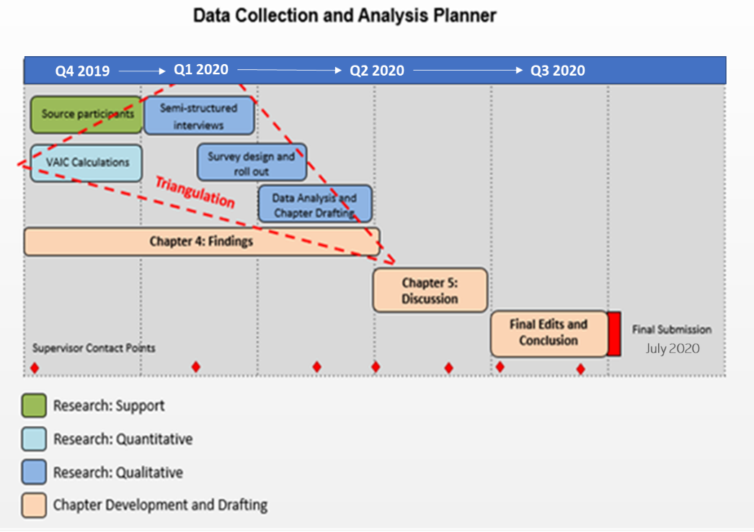
Chart 4: Data Collection Analysis Planner
Time Allocation
The time allocation for the data collection and analysis phase of this research is visualised in the Gantt chart opposite. Continually reviewed during the research and report writing processes overall completion was agreed for July 2020.

Having considered the design, limitations and restrictions of this study it is timely to probe the trustworthiness of the overall research.

Reliability, Validity, Consistency and Neutrality
The trustworthiness of research provides creditability to what if not properly considered and designed becomes limited to an opinion piece. As described, there is a significant qualitative aspect to the methodology of this work, therefore triangulation has been employed to demonstrate validity. Reliability, validity and associated triangulation are key components of good qualitative research which require consideration of what they really mean (Golafshani, 2003):

Reliability: This seeks to establish consistency of the analytical procedures and will be achieved by detailed description of data analysis in the following chapter. Recognising that personal bias and research method biases can influence findings the overall area of bias will be given greater consideration in the following paragraphs.

Validity: The precision in which the findings accurately reflect the data collected is underpinned by the triangulation process which brings together results from semi-structured interviews, surveys and calculations of VAIC. This has facilitated the emergence of themes within the research area which is a key product of the triangulation process (Creswell & Miller, 2000).

Truth value recognises that multiple realities exist (Smith & Noble, 2014), there are challenges in according for this is the data collection using a qualitative approach.

Consistency: Embedding trustworthiness in research requires the researcher to communicate with clarity and transparency (Nobel & Smith, 2015), progressing from this the research data and findings has been presented with the intention that independent researcher could achieve comparable findings.
Neutrality: Neutrality is challenged through established or establishing relationship with sources, the limitations or this research have somewhat mitigated against this risk. The research perspective has been divided from those who have contributed to the data inclusive of semi-structured interviews and surveys, which recognises current approaches (Nobel & Smith, 2015).

Findings are considered dependable, these accurately and fairly represent the data collected throughout this research, bringing deliberate credibility (De Jonckheere & Vaughn, 2019) encircled by ethical consideration and approval through the processed employed by the University of Wales, Trinity Saint David. However, an introductory conversation has already begun in the paragraphs above on potential bias within the study, it is necessary to consider this further.

Considerations on Bias
It is fact of research that bias can occur at any point of investigation, from preconceived or unintentional bias, to emerging bias in design, data collection and analysis (Pannucci & Wilkins, 2010). Returning to truth value, it is centred on the principal that multiple realities exist, these can include the researchers own personal bias established from experiences and viewpoints (Smith & Noble, 2014). This is somewhat mitigated for by the examination of trustworthiness in earlier paragraphs. There do remain other potential sources of bias, identification of these enables better critical evaluation of the research findings and conclusions (Smith & Noble, 2014).

Potential areas that could be biased through data collection on analysis include:
- Government communication and reporting of IFS policies
- Student group identify
- The Irish regulatory environment
- IFS industry culture
- Style and format of financial reports of companies included in the study
These areas have been accounted for in both semi-structured interview and survey question design. They have been considered in more detail as part of data analysis in Chapter 4.

Ethical Implications
Taking an axiological perspective, researchers have an ethical duty to outline the limitations of studies and account for potential sources of bias, as further research in the area based on these findings could have a negative impact on future real world applied research (Smith & Noble, 2014). This action research attempts to develop results of practical value for participant while adding to the theoretical knowledge for the broader IC environment. Crucial to this achievement has been interaction through semi-structured interviews with learners who have taken part in educational programmes. Sensitivity towards these participants throughout the research process was advised as there was constant potential that personal information could be revealed directly to the interviewer, any potential for a power imbalance as a research ethical risk (De Jonckheere & Vaughan, 2019) was avoided between the researcher and the participant through establishing a comfortable environment and good rapport, while clearly communicating the boundaries of the research relationship (Sivell et al., 2019)
Chapter 4: Findings

Methods and Findings
By employing the research methods described in Chapter 3, this chapter will describe the findings in a recognisable traditional approach, which will be followed by separate and supporting discussion and conclusions (Bernard, et al. 2008) in Chapter 5. The broader aim of this research has been to review of the value of strategies supporting financial sectorial educational initiatives in Ireland. What emerged from the literature is that value can be measured and interpreted differently. By employing two methods to measure value fitting into both quantitative and qualitative categories, the intention has been to find the type of data that is omitted from open access reporting and to further contribute to existing literature and research of Value Added Intellectual Coefficient (VAIC) and understanding of Financial Services (FS) in Ireland.

Before continuing with the descriptive approach employed in this chapter, some revision of the objectives of this research will assist in refocusing on the intent that have shaped the methods employed and have influenced the findings that will define this chapter.

Research Objectives
- Explain the environment of Irish International Financial Services sector.
- Identify and compare Government approaches to support Learning and Development Strategy for Financial Services in Ireland.
- Evaluate the level and potential value of intellectual capital achieved by these approaches.
- Synthesis objectives 1 (environment), 2 (initiatives) and 3 (intellectual capital) by identifying how intellectual capital can be assessed within the context of Irish International Financial Services.

Reporting of Findings
Findings apply to two main areas: (1) the application of VAIC to the Aircraft Leasing and Credit Union subsectors of financial services (FS) and (2) the individual perspective from both learners and management of the value Springboard+ programmes. By proposing to provide a clear, complete and valid representation of the data the first area to be considered in findings is VAIC.

A bottom-line upfront reporting approach identifies the significant variances between Aviation Leasing and Credit Union VAIC results in the period 2016-2018. Where appropriate tables and graphs have been used as visual aids to illustrate comparable data.

Qualitative data has been gathered from two distinct data groups: (1) learners and (2) managers, using semi-structured interviews. Direct quotations are identifiable by italics and have been utilised to identify emerging themes from interviews.

PART I: Quantitative Findings

Findings: VAIC
VAIC calculations were applied to the annual reports of 8 companies’, 4 from each subsector of FS, Aircraft Leasing and Credit Unions. Financial and Annual Reports were used from businesses available as open source documents. As data was limited to being sourced in this way, the selection of business was dictated firstly by sectorial subsector commonality and availability of data for the reporting period 2016-2018. Throughout VAIC calculations employed mirror those described in the last chapter. Full details of this computation are available in Chapter 3, for ease of the reader the abbreviated version is outlined below:

VAIC = HCE + SCE + CEE

Aircraft Leasing companies and Credit Unions sit comfortably within the FS industry, while representing very different subsectors and business types. Aircraft Leasing is characterised by considerable holdings of assets, which depreciate in significant numerical values. Credit Unions have limited scope to expand their membership growing business while operating on a not for profit basis. They are suitable to compare within the process of applying VAIC calculations.

Throughout this chapter numerical value has been reported to two decimal places, rounded up or down as appropriate, following standard financial and VAIC reporting practices. Two currencies are used, USD$ for Aircraft Leasing and € for credit unions, reflecting the currencies that these businesses operate with.

Table 1. VAIC: Aircraft Leasing Companies

Company | Aer Cap |  |  | Air Lease Corporation |  |  | Dubai Aerospace Capital* |  |  | SMBC Aviation Capital
Year | 2016 | 2017 | 2018 | 2016 | 2017 | 2018 | 2016* | 2017** | 2018 | 2016 | 2017 | 2018
VAIC | 10.35 | 10.3 | 11.06 | 12.15 | 16.11 | 13.39 | 0.37 | 124.52 | 174.00 | 29.57 | 48.00 | 41.60
*Based on AWAS annual report
**AWAS taken over by Dubai Aerospace Capital in 2017

VAIC has some fluidity and has shown evidence of decrease and bounce back within the limited timespan of analysis between 2016 and 2018:
- Aercap: VAIC decreased by 0.48% between 2016 and 2017 before increasing in 2018
- SMBC Aviation Capital: in 2018 saw VAIC decrease by over 13%.

Moving onto the sample group of credit unions there is more stability in results over the period examined and displayed in Table 2.

Table 2. VAIC: Credit Unions

Credit Union | An Post Employees’ |  |  | Capital |  |  | Health Services Staff |  |  | Progressive
Category | Medium Industrial |  |  | Large Community |  |  | Large Industrial |  |  | Large Community
Year | 2016 | 2017 | 2018 | 2016 | 2017 | 2018 | 2016 | 2017 | 2018 | 2016 | 2017 | 2018
VAIC | 5.64 | 4.40 | 4.45 | 3.09 | 3.13 | 2.56 | 4.13 | 4.37 | 4.80 | 3.51 | 3.10 | 3.13

Immediately it is evident that VAIC in the credit union subsector is lower than Aircraft leasing. Chart 5 assists in demonstrating the divergence in subsector VAIC measurement over the period of this study. There it should be noted, that VAIC for AWAS/Dubai Aerospace Capital was excluded from the sample as the failing business of AWAS skewed results. Chart 5 then represents liquid businesses as AWAS was excluded.

Chart 5. Average Subsector VAIC
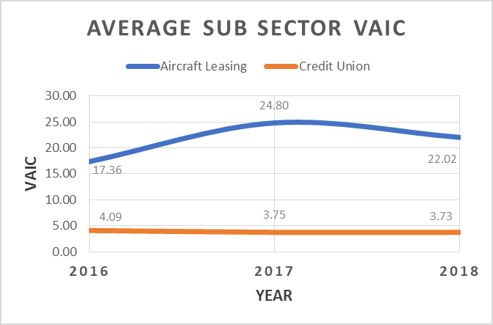
Note Excludes Dubai Aerospace Capital the period involved a takeover of AWAS in 2017
The greatest average annual subsector variance is 21.05, while the highest VAIC score for Aircraft Leasing was 174.00 and the lowest from credit unions was 2.56 recognising a greater divide between these subsectors. Recognising differences in VAIC in this way, there is a need to examine the elements that amount to VAIC and what patterns exists within them between subsectors. VIAC calculations have been broken down to demonstrate subsector averages for Human Capital Efficiency (HCE), Social Capital Efficiency (SCE) and Capital Employed Efficiency (CEE) in Table 3.

Table 3: Comparison of VAIC, VAIC subsets and Standard Deviation
 | Maximum | Minimum | Average | Range | Standard Deviation
Aircraft Leasing
HCE | 172.33 | 0.69 | 39.86 | 171.64 | 66.52
SCE | 0.99 | -0.45* | 0.82 | 1.44 | 0.91
CEE | 0.38 | 0.09 | 0.25 | 0.29 | 0.28
VAIC | 174.00 | 0.37 | 40.93 | 173.63 | 67.27
Credit Unions
HCE | 4.70 | 1.94 | 3.02 | 2.76 | 3.06
SCE | 0.79 | 0.48 | 0.65 | 0.31 | 0.29
CEE | 0.27 | 0.12 | 0.19 | 0.15 | 0.21
VAIC | 5.64 | 2.56 | 3.86 | 3.08 | 2.47
*Represent AWAS in 2016 prior to take over by Dubai Aerospace Capital

By comparing, average, range and standard deviation, it can be concluded that there is greater stability in the environment of credit unions compared to that of Aircraft Leasing. Further there are some similarities CEE between Aircraft Leasing and credit unions, particularly when considering standard deviation.
Progressing the exploration of the use of capital, some further consideration is deserved in how this is employed. Additionally, depreciation, a characteristic of aircraft leasing accounts will be included. Findings are displayed in Chart 6.

Chart 6: Average Remuneration and Depreciation 2016-2018
as a percentage of Operating Profit
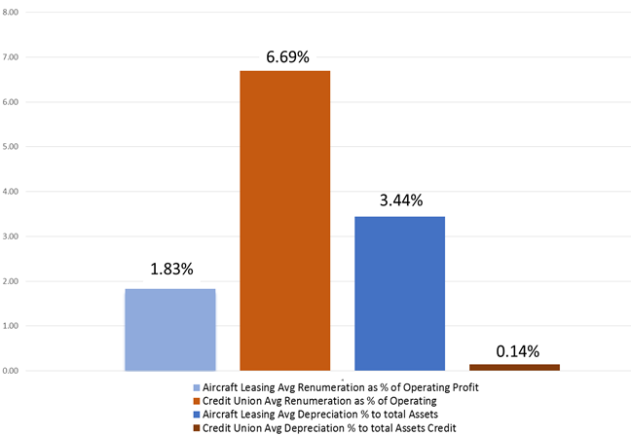

As presented earlier, Operating Profit (OP) was on average $626,297,333 within Aircraft Leasing, while for Credit Unions it was €2,252,501. Comparing subsector, remuneration in credit unions is higher as a percentage of OP. Considering this, it is not surprising that Remuneration (R) is lower in Aircraft Leasing as a percentage of OP. Depreciation (D) in the same context is twenty five times greater in Aircraft Leasing companies compared to credit unions compounding it as a true characteristic of Aircraft Leasing.

These imbalances are relevant to VAIC as, Operating Profit, Remuneration, Depreciation and Amortisation when compounded equate to Value Added (VA).

VA = OP + D + R + (A)

As has been demonstrated in VAIC measurements are higher for Aircraft Leasing companies compared to credit unions. The value of the contributing elements to VA recorded in Appendix 1, show significantly higher values in Aircraft Leasing with a significant contribution from Depreciation. There the value of and deprecation of assets does have an elevating influence on VA, which in turn has a corresponding effect on VAIC.

Having provided quantitative results, the attention of this chapter will divert to qualitative findings in Part II.
PART II: Qualitative Findings

Findings: Semi-Structured Interviews
In progressing to describe the experiences of learners and managers of Springboard+ programmes emphasis is made on the qualitative nature of the research where findings rather than results are the product (Burnard, 2004). Some characteristics of the learning and working environment have emerged during interviews that are common between participant subsets.

Four dominant themes emerged from analysis of semi-structured, these are outlined below using quotations to support themes as findings.

- Geography limits learner choices
Across the spectrum of programmes and students, the location of delivery is the primary factor in decision-making. Some commented how they did not look beyond their local higher education provider. In some cases, learners could only find one programme locally, which they met entry requirements for and give professional development opportunities. Many learners felt that they had a single option to choose from within the Springboard+ catalogue.
Speaking broadly a manager identified the geographical divide between staff preferences for educational opportunities:

“We have two locations in Ireland, when studying the Cork guys tend to stay in Cork and Dublin is similar.”

From a learner’s perspective travelling to undertake learning is a heavily weighted factor when evaluating options. A learner who was unemployed at the time of study when considering options IFS courses in Dublin and Carlow commented:

“It was available to me in Carlow that was a very easy commute from where I live.”

Similarly, a second student who was living and employed in the same town as a third level institution asserted:

“It was local to me. So that was probably the primary reason because at the time I was working there and it was just convenience, more so than anything else.”

With an identified preference among learners to study locally, geographical location of industry and corresponding availability of programmes locally to learners will result in localised pools of specific skills and competencies. Learners have completed programmes and may not have opportunities of sector specific employment locally as Brexit relocations have not materialised. As learners were unwilling to travel for learning it could be assumed that many will be unwilling or unable to travel or relocate for employment.

- Programme workload, assessments and Quality Assurance are learner concerns
For the majority, expectations of the workload associated with part-time study did not match experiences. The balance between the triangulation of assimilating information, class attendance and assessment submissions suffered. It was discussed, by several learners, how some of their cohort forfeited attendance in class to work on assignments. This was both the case for individual and group assignments.

“We did our group project work in the library when classes were on as it was the only real way to meet as a group.”

A learner completing their second Level 9 programme in recent years was both reflective and had tangible experiences comparisons. When discussing learning on the part-time Springboard+ Masters programme, compressed into one academic year, he reflected:

“It seemed to be too much and I found you could never really assimilate any of the information. Because you're more concerned about finishing the project. You were never given that time to take on the information.”

A second learner on the same programme expressed dissatisfaction with the assessment schedule:

“We got the impression that they [lecturers] were used to just throwing out the assignments and people just getting on with it.”

Switching to a different programme at a different level of the NFQ, a learner who was unemployed during study commented:

“And I think that the course was a lot more intense and more work was necessary than a lot of people may have originally anticipated, but the reality is the workload was such that you weren't so inclined to learn how to do it.”

Experiences from these mature learners, who has all completed a primary degree programme previously suggests that quality and experience have been compromised.

- The Financial Services industry has barriers to entry
One Manager was particularly sceptical, perhaps explaining why some learners have not integrated into the industry.

“I was very suspicious, why people would be changing industry, especially as they age. Some of the candidates coming through to me, it was quite evident that they were just applying for every single role that was available.”

A learner who made the transition into the International Financial Services (IFS) workspace commented he got the job based on his interview, rather than his CV and qualifications, as the company were seeking to hire people who they can shape with their own culture and values. Reflecting on his working environment he estimated that 20% of his learning on a Level 8 IFS Diploma is useful in his job. Many of his co-workers from the same intake have since moved on.

“There has been a lot of personnel change in his year on the job. I'm the last one left after from 12 after a year.”

One learner questioned the ability of the programme to provide for employee needs within the structure of IFS companies:

“[Springboard+] how legitimate is the result? It’s not very legitimate because very few people can do what it says on the tin, [or] move sideways over into a new role.”

One unemployed learner bypassed normal industry entry barriers by partaking in an employee female only return to work programme separate to Springboard+ and outside of student supports:

“I ended up doing what's called a Restart Programme, which is being employed for a certain amount of time. And then they decide if they're going to keep you as a returner… they don't bring you in at the bottom entry level. They can bring you in with a healthy income.”

When considering the broader industry context IFS Springboard+ programmes were developed in the context of Brexit planning. A learning and development manager observed how reactive and agile planning has been inhibited by the processes of approval and unknown political eventualities:

“As with all of Springboard programs you have to a professional and academic skills aspect. You don't know what you will receive funding for. So you're making all these logistical plans in the background. And then ultimately you find you only got funding for this particular course and for this number of students.”

This rationale was explained in the context of opportunities associated with Brexit:

“We developed this course based upon the idea at the time, should Brexit happen… it was based upon the potential for a lot of financial services companies relocating from the UK to Ireland. It was expected, I think that 4000 jobs would be attracted post Brexit.”

The necessity of partnership between industry and learning providers to support Springboard+ has brought a product that is failing to meet the needs of both learners and industry as Brexit prolongs, as the programme provides neither experience of a recognised professional designation.

“At the end of the course, if you wanted to professionally take part in that industry at any level, you'd still have to go to professional exams. And I thought to myself, a professional body or something into the process, even if you had no experience in the industry, you still could have taken something out of this.”

Continuing he identified the limitations of a broad industry qualification without a recognised professional designation.

“I definitely would have had a different viewpoint on what I got out of it after that. If I'd come out with something more tangible as opposed to kind of a general understanding of the fund industry.”

Commenting on the same area of recognised professional competence an experience manager from a financial services company said:

“A few years ago, the Minimum Competency Code was introduced into the industry by the Central Bank of Ireland. If somebody had experience within the financial background, that was always appealing. But if someone had the qualifications, it was certainly an advantage, it was very unlikely we were going to get the candidates with the experience and the qualifications we were looking for. I would always favour experience.”

This was experienced by a learner who had achieved a recognised FS professional designation:

“I applied to several places as a mature entrant, fully QFA qualified. Didn't have much joy.”

Returning to the learner’s experience of a return to work programme described earlier:

“I ended up doing what's called a Restart Programme, which is being employed for a certain amount of time…”

While the FS industry recognises Springboard+ qualifications there is no clear evidence that they provide enough to distinguish a candidate from others to secure employment.

- There is Limited application of new skills in the workplace
Of the ten learners interviewed 3 began studying while unemployed, 2 of these have since secured employment and both within IFS. Of the remaining 7, job changes have taken place for 5. All have found limited value of programme learning outcomes to their current work. The learner with the job most aligned to their programme studied, accessed the relevance of programme learning as approximately 20% in their workplace. Recognising that some are working outside of the sector studied there is difficulty linking learning to their current roles. One learner commented:

“I haven't employed learning from the course day to day.”

A second saw little relevance presently, but identified potential in the future:

“Limited relevance but could help me get a new position in the future.”

While a third could not identify current or future opportunities to employ skill and knowledge from the programme:

“It doesn't have any kind of relevance to what I'm doing. [In hindsight] I wouldn't have gone, I would have chosen something else.”

With the IFS sector supporting Springboard+ programmes financially, there must be limited tangible returns in the workplace.
Qualitative and Quantitative Conclusion
Semi-structure interviews identified four themes relating to industry entry, geography, programme experience and application of skills. These will be brought forward with findings from VAIC measurement:
- Aviation Leasing scores highly on VAIC, owing to the components of VA, and shows deviation between companies.
- The more stable environments of credit unions measure lower on VAIC and has less deviation between entities.
Higher-level analysis of these findings within the context of the existing literature (Wu, et al. 2016) will be explored in the next chapter.

Chapter 5: Analysis of Findings

Approach
In the last chapter, quantitative and qualitative findings particular to this study were identified. Progressing into further analysis of these and remembering the title of this research, A Review of the Value of Government supported Learning and Development Strategy for International Financial Services in Ireland, this chapter will firstly identify exclusion criteria before examining quantitative findings. This chapter describes the correlation of Intellectual Capital (IC) measurement between multiple studies of Financial Services (FS) organisations using the Value Added Intellectual Coefficient (VAIC) model where Human Capital Efficiency (HCE) is a common dominant feature.

Inclusion and Exclusion Criteria
The criterion for inclusion and exclusion of other research for analysis has been set and designed to provide a workable comparison for measured VAIC in FS. As available research on VAIC in FS is limited, inclusion criteria is broad. Exclusion criteria then set limits allow analysis of the information drawing direct comparison between VAIC scores in Table 5.

There is a place for analysis using conventional financial equations when comparing VAIC to tangible returns. This includes Return on Capital Efficiency (ROCE) and Return on Assets (ROA). ROCE can be used to compare companies in capital-intensive operations, while ROA will measure the efficient use of assets. However, when employing these to compare companies with similar operating models, greater access to financial information is required over a VAIC score. For this reason, it has not been possible to carry these tools forward for more detailed analysis in Table 5. Further, the inclusion and exclusion criteria for VAIC results are described in Table 4.

Table 4: Inclusion and Exclusion Criteria for Analysis
Inclusion Criteria | Exclusion Criteria
- VAIC results for Financial Services organisations outside of Ireland  - Results for Financial Service organisation outside of Ireland that can be used to calculate VAIC  - VAIC results from other industries measuring >100 and <2  - VAIC results from broader developed industries to compare. | - Studies where less than four companies were measured  - VAIC results that did not cover a full calendar or financial year  - VAIC results prior to the year 2002.

Quantitative Findings Analysis
Value Added Intellectual Coefficient (VAIC) was the primary tool employed to produce quantitative findings as it was identified as a tool to measure the intangible value of Intellectual Capital (IC) across comparable studies. In Chapter 2 is was described that there is difficulty in effectively measuring IC as an asset in complex and continuously developing knowledge economies influenced by technology and globalisation. The findings in Chapter 4 have made progress in providing data from International Financial Services (IFS) companies and FS community-based organisations operating in Ireland. This data set can be compared to existing data sets from FS outside of Ireland to explore and compare VAIC results.

By comparing VAIC results in Table 5, it is evident that there is much variation between industry, industry subsectors and other defining business financial characteristics, such as business model. Data from previously published studies has been adapted or carried forward as appropriate to provide comparable but diverse results covering 144 organisations in eight countries between 2002 and 2018.

Table 5: VAIC Scoreboard
 | Average VAIC | Industry | Industry subsector | Country | Data Period | Number of companies/  organisations | Author(s)
 | 40.93 | Financial Services | Aircraft Leasing | Ireland | 2016-2018 | 4 | McGeeney, 2020 (this research)
 | 38.16 | Financial Services | Investment Companies | Australia | 2006-2008 | 4 | Joshi et al., 2013
 | 5.12 | Financial Services | Banking | Pakistan | 2002-2007 | 6 | Makki, 2008
 | 4.24 | Financial Services | Diversified Financials | Australia | 2006-2008 | 9 | Joshi et al., 2013
 | 3.88 | Financial Services | Banking | Turkey | 2005-2014 | 44 | Ozkan et al., 2017
 | 3.86 | Financial Services | Credit Unions | Ireland | 2016-2018 | 4 | McGeeney, 2020 (this research)
 | 3.76 | Financial Services | Banking | Morocco | 2014 | 6 | Lofti, et al., 2014
 | 3.67 | Financial Services | Banking | Australia | 2006-2008 | 8 | Joshi et al., 2013
 | 3.58 | Financial Services | Banking | Turkey | 2017 | 13 | Arslan & Kizil, 2019
 | 3.23 | Financial Services | Banking | Poland | 2005-2009 | 10 | Śledzik, 2012
 | 3.08 | Financial Services | Insurance | Australia | 2006-2008 | 4 | Joshi et al., 2013
 | 2.43 | Financial Services | Banking | Indonesia | 2009-2012 | 32 | Ulum, et al., 2014

Reviewing Table 5, the top four VAIC scores, four industry subsectors are included: (1) Aircraft Leasing, (2) Investment Companies, (3) Banking and (4) Diversified Investments. At least three of these require significant amounts of capital to operate within the knowledge economy. This suggests that VAIC returns more positive for companies who employ a model requiring large amounts of capital which returns high profits and or depreciation. However, there is not a broad enough set of data in this range to employ greater analysis using ROCE and ROA. VAIC remains an invisible fuzzy tool for measurement (2013), when simple listed as a set of values. Looking deeper into the data available to this study for FS, it is possible to extract further meaning. The data range available for Table 5 is considered in Chart 7 below.

Chart 7: VAIC Comparison Organisation and Year Map
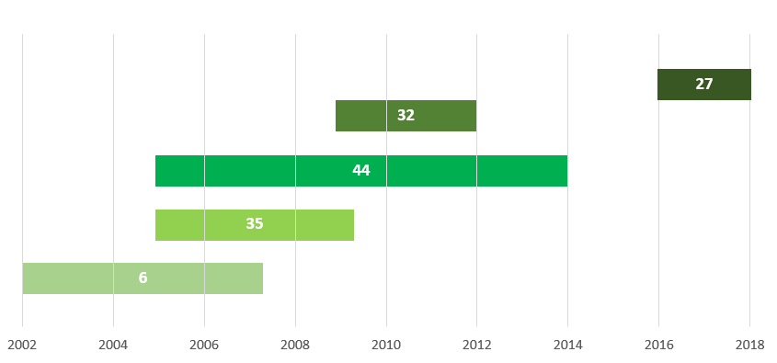

While Table 5 offers the most comprehensive comparison of FS available to this study, it does have its own embedded limitations, these have been illustrated in Chart 7. The number of organisations included in studies or matched over time are disproportionately weighted between 2005-2014 with no comparable data available between 2014-2016. Nonetheless these recognised limitations do not negate meaningful comparison of VAIC results based in the same broad industry but separated by subsector characteristics, financial reporting periods and national influences. Some of these limitations were originally discussed over twenty years ago (Edvinsson & Malone, 1999), leading research on National Intellectual Capital (NIC) indices (Bontis, 2013), broader international studies describing the components of NIC as:
- Human capital
- Market capital
- Process capital
- Renewal capital and
- Financial Capital
(Lin & Evidsson, 2010)

NIC using these components has been proposed as a tool to use for wider adoption and comparison assisting predictive assessment of performance (Edvinsson, 2013), while industry comparison across international boundaries remain rooted with VAIC. Both the evolution of VAIC and NIC have been championed by a limited number of published authors and leaders in the field. This evolution can be linked to commentary on Knowledge Management – Intellectual Capital (KM-IC) publications, where Editorial Board Interlockings (EBI) mapping is suggestive of limitations in the diversity of thought and research approaches due to publication commonalities on KM-IC topics (Teixeira & Oliveira, 2018).

VAIC Beyond Financial Services
Broadening a review outside of FS into other industries to identify a recorded spectrum of VAIC results, across all accessed studies the highest level of VAIC recorded was with Turkish listed soccer club Fenerbahce, registering VAIC as 160.26 between (Yassar, et al., 2015). Across the four listed soccer clubs included in the study an average VAIC of 65.58 was recorded (Yassar, et al., 2015) being greater than the highest result from Aircraft Leasing companies in the VAIC Scorecard in Table 5. At the lower end of the spectrum of VAIC results consulted for this study the lowest results come from four biggest Polish media sector companies, there an average VAIC of 1.56 was recorded in 2011, with an industry and study low of 1.21 (Fijalkowska, 2014b). A range then exists of 159.05. This range is of course demonstrative of different studies, across different industries, at different times and in different geographical, political and legislative environments. Nonetheless, it does prompt analysis of why VAIC results differ.

The Global Financial Crisis (GFC) 2007-2008 was followed by a period of austerity and slow recovery. Eight of the 12 data sets in Table 5 fall within a 2007-2012 bracket, while four of these eight are in the bottom five results. Within this grouping, banking represents four of the five listed subsectors. Two of the bottom three VAIC results span the 2007-2008 with the period where the GFC begin.

Periods of Economic Stress
Kehelwalatenna and Premaratne identify that the decline of IC is substantial during crisis situations in the economy (2019). The Sahm Indicator, a predictive tool used to identify indicators of a start of a recission argues when the three-month average unemployment rate is at least 0.5 percentage above the minimum based on the preceding 12 months, the economy is in a recession (The Economist, 2019). Chart 4 shows a current example spanning 2000-2020 of a Sahm Rule Indicator using figures from the US. Argued to be the most successful early detector of recessions, the Sahm Indicators and rule, recent research indicates that an adjusted Sahm rule can more accurately diagnoses a recession in its early stages (Feng and Sun, 2020), this is visually depicted in Chart 4 below.

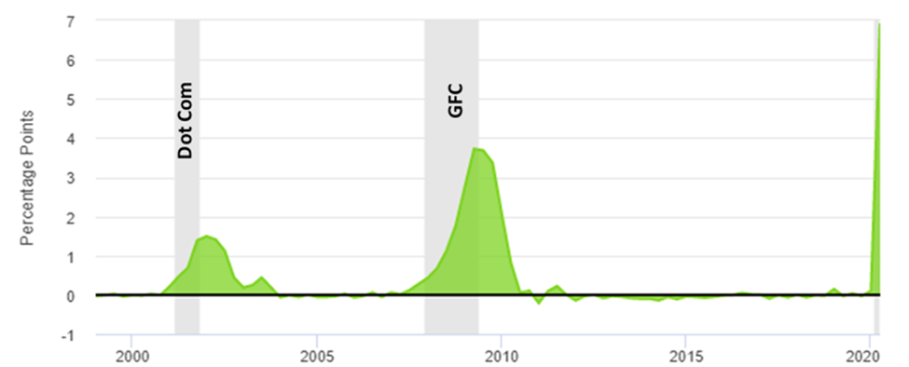
Chart 8: Real-time Sahm Rule Recession Indicator (US Unemployment Percentage January 2000 – June 2020)
Covid-19
Percentage

(adapted from Federal Reserve Bank of Saint Louis, 2020)

There are three main unemployment spikes in the US between 2000-2020, illustrated on Chart 8 and taking place in 2002, 2009 and 2020. The spikes in 2002 and 2009 are related to the Dot Com bubble collapse and the GFC respectively, these areas are shaded grey, while the marked 2020 spike is associated with the pandemic of Covid-19.

Recognising that the emerging challenges of Covid-19 are likely to lead to a prolonged global recession, recent commentary suggest that the aviation industry will not recover to its previous levels of operations (The Economist, 2020). Indicators of this are evident across the spectrum of business associated with passenger air travel and as large aircraft manufacturers indicate staff layoffs (Financial Times, 2020a) and international airlines warn staff of layoffs (Financial Times, 2020b) and international accommodation rental companies lead the way with confirmed global layoffs (Horgan-Jones, 2020).

The retrospective analysis of reporting VAIC does not assist planning for a new emerging GFC associated with Covid-19 with an unprecedented multi-industry decline. Describing a new approach to IC, Edvinsson described capital in waiting as the opportunity space for future well-being and wealth creation with IC being exponential growth ecosystem (2013). There is then a need to align IC measurement with IC forecasting and risk exposure, allowing reaction to fiscal shock. The same author in a different study claims that when interpreting NIC data, it is possible to detect the early signs of financial crisis in some cases (Lin & Edvinsson, 2010).

VAIC Analysis
In two cases ROCE was unaffected by a decrease in VAIC compared to the previous year’s results, these were; (1) Aercap 2017, VAIC decreased by 0.48%, in 2018 VAIC increased but ROCE fell by almost 1% (2) SMBC Aviation Capital 2018 where VAIC decreased by over 13%, but led to only 0.35% decrease in ROCE.
Immediately it is evident that VAIC in the credit union subsector is lower than Aircraft leasing. There is greater parity in ROCE, with an average of 10.20% in Aircraft Leasing and 9.47% in credit unions. Some comparison with VAIC in Chart 1. It should be noted for Chart 1 that VAIC for AWAS/Dubai Aerospace Capital was excluded from the sample as the failing business of AWAS skewed results. This chart then represents liquid businesses.

Recognising differences in VAIC in this way, there is a need to examine the elements that amount to VAIC and what patterns exists within them between subsectors. VIAC calculations have been broken down to demonstrate subsector averages for Human Capital Efficiency (HCE), Social Capital Efficiency (SCE) and Capital Employed Efficiency (CEE) in Table 3.

By comparing, average, range and standard deviation, it can be concluded that there is greater stability in the environment of credit unions compared to that of Aircraft Leasing. Further there are some similarities CEE between Aircraft Leasing and credit unions, particularly when considering standard deviation.

Progressing the exploration of the use of capital, some further consideration is deserved in how this is employed. Additionally, depreciation, a characteristic of aircraft leasing accounts will be included. Findings are displayed in Chart 2.

As presented earlier, Operating Profit (OP) was on average $626,297,333 within Aircraft Leasing, while for Credit Unions it was €2,252,501. Comparing subsector, remuneration in credit unions is higher as a percentage of OP. Considering this, it is not surprising that Remuneration (R) is lower in Aircraft Leasing as a percentage of OP. Depreciation (D) in the same context is twenty five times greater in Aircraft Leasing companies compared to credit unions compounding it as a true characteristic of Aircraft Leasing.
Chart 9: Average Capital Employed Efficiency, Social Capital Efficiency and Human Capital Efficiency Analysis
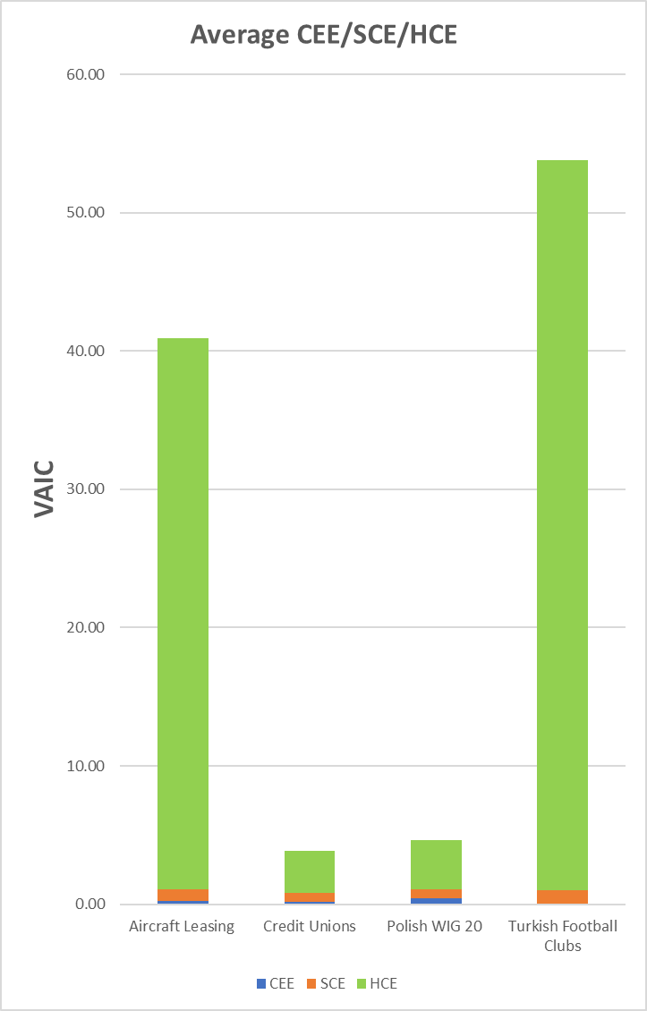
The information in the chart represent the average CEE, SCE and HCE from three financial services subset, (1) 4 Aircraft Leasing companies in Ireland between 2016-18, (2) 4 Credit Unions in Ireland 2016-18 and 20 companies from the Polish WIG 20 Index in 2013. While there are several variables in this comparison that do not represent perfect partnerships but are suitable for some comparison based on the availability of information to this study.

Chart 9 shows our data group from Ireland compared to Polish WG 20 Index companies, in all cases HCE is the dominant component of VAIC and CEE is the least dominant. Considering this detail in its relationship to building a VAIC score and including additional data groups, Table 6 demonstrates the percentage of each component part to the whole.

VAIC = HCE + SCE + CEE

Table 6: VAIC Components as Percentage
 | HCE | SCE | CEE
Aircraft Leasing | 97% | 2% | <1%
Credit Unions | 78% | 17% | 5%
Polish WIG 20 (adjusted from Svanade & Kowlewska, 2015) | 77% | 14% | 9%
Car Manufacturing (Kopia, 2019) | 66% | 18% | 16%
Turkish Soccer Clubs (adjusted from Yasar, et al 2015) | 98% | 2% | <1%

The elements of HCE are: VA/HC breaking these down further their components are listed below:

VA = Operating Profit + Depreciation + Renumeration + (Amortisation)
HC = Renumeration

The proportion of Operating Profit and Depreciation compared to Renumeration is a considerable factor is the positioning of Aircraft Leasing companies at the top of Table 6 as the group with the highest percentage of HCE.

Main VAIC Limitations
There are limitations for using VAIC as a tool to measure and compare IC have been suggested and emerged through the examination and discussion of this research. Chief among these are those that restrict the ability to gathering usable data and compare it to other available information. These can be summarised in by the points below.

- VAIC calculations are dependent on availability of financial statements or annual reports that can be translated into the various components that are used to measure VAIC.
- The reporting of VAIC is not standardised, which disqualifies some studies for deeper and more meaningful comparison.
- The comparison of VAIC is limited by what, where and when data is available:
  - What: industry and industry subsector
  - Where: is the company based and what national economic characteristics influence it performance
  - When: the financial reporting period for which information is used.

Qualitative Findings Analysis
Chapter 4 presented 4 qualitative findings identified through thematic analysis of learner and manager semi-structured interviews:

- Geography limits learner choices
- Programme workload, assessments and Quality Assurance are learner concerns
- The Financial Services industry has barriers to entry
- There is Limited application of new skills in the workplace

These findings will be analysed divided by subparagraphs in the same sequence presented about. There, research and data largely based in an Irish context with drawn out synergies of learner experience and national habits.

Geography limits learner choices
The learner voice was strong that courses provided locally was a main factor in their considerations of attending Springboard+ programmes. In the absence of any further available studies in a similar context of part-time study, this study has turned to Irish commuter habits which presents a visual display of habits that can be compared between commuters and learners.

Map 1: Catchment areas of major workplace locations, 2016  (Central Statistics Office, 2020)  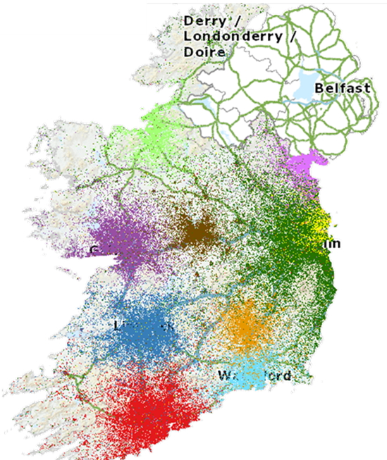  Each of the coloured areas on the map of Ireland from the Central Statistics Office represents a least one major town or city. In areas of population density, a single coloured area can represent multiple locations. In this case the colours show the hinterland areas from where people commute to work in 2016.  Each coloured area also represents at least one third level education provider who delivery Springboard+ programmes. As most Springboard+ courses are delivered part-time, some continuity between commuter and learners’ habits and preferences can be assumed in the context of Ireland. |  | Map 2: Regional Breakdown of Employment Supported in Investment Funds Industry in Ireland – 2018  (Indecon, 2019)  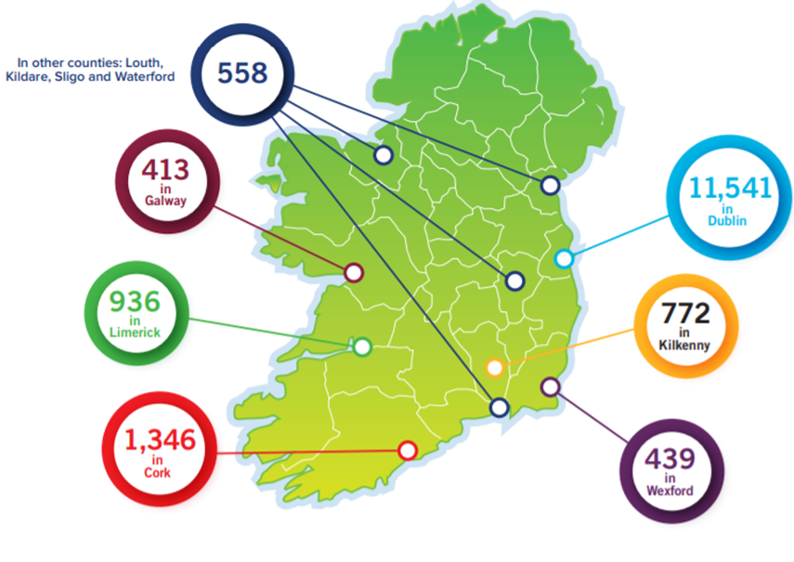  Map 2 identifies the Funds Industry as a subsector of IFS. There are similarities between Map 1 and Map 2, with some deviation in the midlands. Combining these with the finding from Chapter 4: Geography limits learner choices, it is suggestive that Springboard+ courses should be delivered in areas where jobs exists.

Programme workload, assessments and Quality Assurance are learner concerns
The GFC resulted in 9 years of austerity for the higher education sector in Ireland (Clarke, et al. 2017).

A key piece of research communicating the Irish student experience, ‘Making a Difference’ A Student View of Excellent Teaching found:

“Students want their higher education experience to connect with the ‘real world’ and to prepare them for work and the world beyond higher education.”
and
“Teachers’ characteristics, behaviours and skills impact on student learning; how teachers teach impacts on student learning.”
(NFTL, 2019b)

The Financial Services industry has barriers to entry & There is Limited application of new skills in the workplace
Barriers to entry into IFS and the limited application of new skills by Springboard+ graduates could be explained by the high levels of educated younger people available to the workforce, limited industry entry to older graduates who may be less amenable in adapting to a new workplace culture. Ireland is noteworthy as it has one of the highest educational levels in the EU, with 47% of the population holding at a minimum a post-secondary school qualification (European Commission, 2018). Returning to this source to visually demonstrate the Irish learning demographic, reproduced below:

Chart 10: Population of Ireland by age, sex and educational attainment in 2015 and 2060
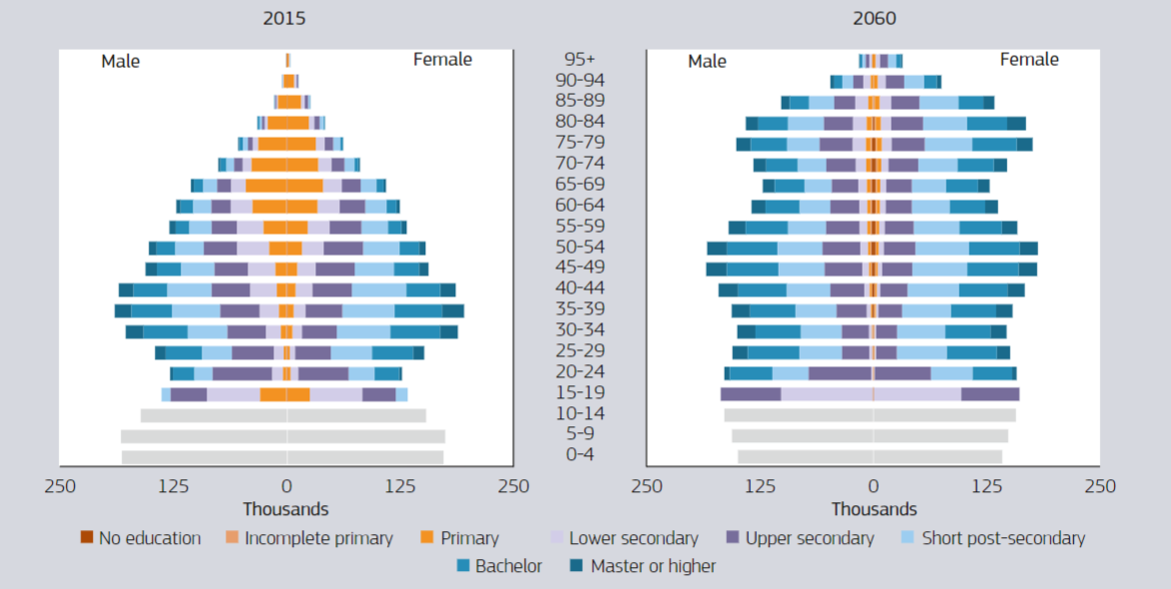
(European Commission, 2018)

The IFS Strategy 2025 for Ireland brings forward this same information asserting that, over 50% of Irish 30–34 year olds hold a third-level degree or postgraduate qualification, this being higher than any other country in the EU (Government of Ireland, 2019). The implication for the IFS industry being to attract new people into the industry a postgraduate programme is needed as a progression route of existing levels of learning. However, these do not provide the skills, experience of cultural acumen to enter the industry as demonstrating experience is a preference of management, this further restricts the practice of industry focused skills developed from Springboard+ courses.

The Irish Government have developed another strategy paper for IFS working towards 2025. It ringfences funding for educational programmes and continued support of Springboard+, this is in part justified by the uncertainties of Brexit and an industry being influenced by Artificial Intelligence (AI). In responding to the potential AI challenging job retention, it asserts:

“The best way to respond to this challenge is to ensure that we prepare for and educate the workforce so that the high value jobs will be located in Ireland.”
(Government of Ireland, 2019).

The commitment to the development of a workforce capable of adjusting to the challenges of the knowledge economy is evident, however the vagueness of details on education in both IFS Strategy 2020 and IFS Strategy 2025 are suggestive that the provision of educational opportunities is a desired end outcome that can be reported quantitatively as success.

VAIC a Pedagogical View
The limitations of VAIC are suggestive that it is best suited as a consultative tool, allowing depth of research through access to financials, this suggests that greater industry collaboration yields better results. With this in mind, austerity has impacted Irish Higher Education negatively (Davies & O'Callaghan 2014 and Clarke, et al. 2017), there were whispers of this from learner experience in this research, suggesting that industry collaboration for training or staff is a better solution.

Skillnet Ireland is a business support agency of the Government of Ireland mandated to support over 18,000 businesses with increased participation in enterprise training and workforce learning (Skillnet Ireland, 2020). This approach to training and skill delivery as opposed to educational provision provides greater pedagogical control, this will only be reflected in VAIC should the cost of employee training increase dramatically. As Tables 1-3 of research identify, Human Capital Efficiency (HCE) is the highest value element of VAIC. As still is reached by dividing Value Added (VA), where employee cost are embedded by Human Capital (HC) pedagogical change is unlikely to be visible in the first instance, however over this time may be accountable as learning brings positive changes in profitability.

Current pedagogical change, focused on revised delivery methods in response to Covid-19, are unlikely to be visible in the short-term in VAIC as fees are largely unchanged for learners for either training courses or educational programmes.

Considerations on the Research Hypothesis
The research hypothesis of this study was stated in Chapter 3 as:

That Government Learning and Development Strategy for International Financial Services is not recognisable in measurable VAIC for top companies based in Ireland.

Results and findings support a high probability of this hypotheses. The research endeavoured to identify and track tangible value through VAIC measurement. It is now clear that VAIC does not uncover finer detail encompassing spending and investment in training and education. Deeper investigation breaking down components of employee costs complementing VAIC may indicate that VAIC is suitable to indicate firm performance.

The findings from the qualitative analysis inform specific areas for improving individual's readiness and preparedness' for employment in IFS, while identifying local employment opportunities as an addition challenge. Managers concerns in the development and delivery of training programmes intended for IFS matched with a desire for experienced employees when aligned with current political and economic uncertainty means the student cohorts cannot be assured of employment opportunities in their areas of study.
VAIC and Correlation Analysis
The correlation of VAIC must then be synergised with financial performance, to demonstrate any relationship. By employing a form of communication assessable to business and detached from consultative processes, VAIC could become more valuable to organisations. A proposed way to achieve this is through evaluating Economic Value Added (EVA) with Intellectual Capital Efficiency (ICE) and VAIC, this approach allows for perspectives from shareholders and stakeholders (Lazzolino et al, 2014). Alternatively, the correlation of VAIC and Return on Assets (RoA) is proposed (Gde & Mirhard, 2016 and Arslan & Kizil, 2019). A further correlation would be the use of Return on Capital Employed (ROCE) (Martins & Lopes, 2015) an additional step in this direction is the use of Modified-Value Added Intellectual Coefficient (M-VAIC) to predict future financial performance (Ulam et al, 2017).

Research Recommendations
Recognising the limitations of VAIC and based on the primary empirical research from this study, the following points are recommended:

- Further research on intangible organisational value should be undertaken in Ireland to enhance knowledge available
- Future research should include correlation of financial analysis with intangible measurement to demonstrate dual value
- Educational programmes through Springboard+ should support students to gain deeper industry understanding assisting them to gain employment associated with their field of study
- Springboard+ should map employment opportunities within the industry areas studied as a measure of success

Progression of this Research with the Author
It is believed that the correlation of VAIC or M-VAIC would represent a form of analysis absent in the Irish context. This is best placed as a future research question for the author to address through research and a desire to publish findings:

How can the measurement of IC be effectively analysed through correlation to accurately predict future organisational performance?

Appendices

Appendix 1
Summary of VAIC Model

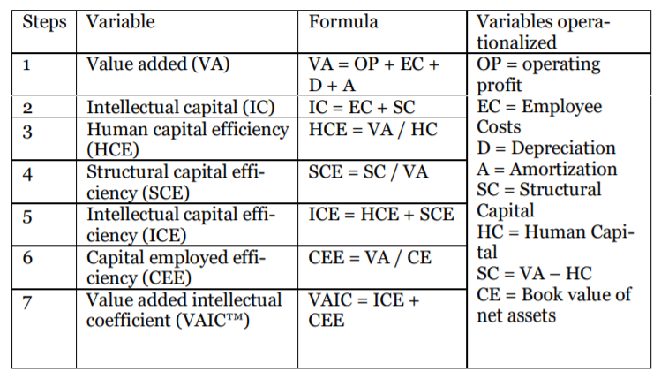

(Fijalkowska, 2014)

This VAIC model from Fijalkowska was used as a base to calculate VAIC measurement for Aircraft Leasing companies and credit unions in Chapter 4, these are further detailed in Appendix 2.
The caveats below were employed in the calculation of VAIC in this study:
- Employee Costs = Renumeration
- Were there was no evidence of amortisation in the financial statements it was calculated as 0.

Appendix 2
VAIC Calculations: Aviation Leasing

 | SMBC Aviation Capital |  |  | Aer Cap
Formula | 2018 | 2017 | 2016 | 2018 | 2017 | 2016
Operating Profit | $ 595,664,000 | $ 613,382,000 | $ 473,396,000 | $ 1,015,632,000 | $ 1,076,151,000 | $ 1,046,630,000
Depreciation | $ 296,099,000 | $ 347,736,000 | $ 320,967,000 | $ 1,679,074,000 | $ 1,727,296,000 | $ 1,791,336,000
Renumeration | $ 22,558,000 | $ 20,931,000 | $ 28,875,000 | $ 305,226,000 | $ 348,291,000 | $ 351,012,000
VA: OP+D+R+(A) | $ 914,321,000 | $ 982,049,000 | $ 823,238,000 | $ 2,999,932,000 | $ 3,151,738,000 | $ 3,188,978,000
CE: total assets minus current liabilities | $ 9,768,376,000 | $ 9,516,282,000 | $ 8,768,000,000 | $ 8,880,614,000 | $ 8,638,814,000 | $ 8,582,264,000
CEE: VA/CE | 0.09 | 0.10 | 0.09 | 0.34 | 0.36 | 0.37
HC = Renumeration | $ 22,558,000 | $ 20,931,000 | $ 28,875,000 | $ 305,226,000 | $ 348,291,000 | $ 351,012,000
HCE: VA/HC | 40.53 | 46.92 | 28.51 | 9.83 | 9.05 | 9.09
SC: VA-HC | $ 891,763,000 | $ 961,118,000 | $ 794,363,000 | $ 2,694,706,000 | $ 2,803,447,000 | $ 2,837,966,000
SCE: SC/VA | 0.98 | 0.98 | 0.96 | 0.90 | 0.89 | 0.89
ICE: HCE+SCE | 41.51 | 47.90 | 29.48 | 10.73 | 9.94 | 9.98
VAIC HCE+SCE+CEE | 41.60 | 48.00 | 29.57 | 11.06 | 10.30 | 10.35

 | Dubai Aerospace Capital |  |  | Air Lease Corporation
Formula | 2018 | 2017 | AWAS 2016 | 2018 | 2017 | 2016
Operating Profit | $ 83,900,000 | $ 381,600,000 | $ (112,699,000) | $ 510,835,000 | $ 756,152,000 | 374,925,000
Depreciation | $ 63,800,000 | $ 307,100,000 | $ 362,690,000 | $ 581,985,000 | $ 508,352,000 | $ 452,682,000
Renumeration | $ 7,866,000 | $ 5,631,000 | $ 48,552,000 | $ 97,369,000 | $ 91,323,000 | $ 82,993,000
VA: OP+D+R+(A) | $1,355,566,000 | $ 694,331,000 | $ 249,991,000 | $ 1,190,189,000 | $ 1,355,827,000 | $ 910,600,000
CE: total assets minus current liabilities | $3,524,838,000 | 3,162,750,000 | $1,894,134,000 | $ 4,806,900,000 | $ 4,127,442,000 | $ 3,382,187,000
CEE: VA/CE | 0.38 | 0.22 | 0.13 | 0.25 | 0.33 | 0.27
HC = Renumeration | $ 7,866,000 | $ 5,631,000 | $ 362,690,000 | $ 97,369,000 | $ 91,323,000 | $ 82,993,000
HCE: VA/HC | 172.33 | 123.31 | 0.69 | 12.22 | 14.85 | 10.97
SC: VA-HC | $1,347,700,000 | $ 688,700,000 | $(112,699,000) | $ 1,092,820,000 | $ 1,264,504,000 | $ 827,607,000
SCE: SC/VA | 0.99 | 0.99 | (0.45) | 0.92 | 0.93 | 0.91
ICE: HCE+SCE | 173.33 | 124.30 | 0.24 | 13.14 | 15.78 | 11.88
VAIC HCE+SCE+CEE | 173.71 | 124.52 | 0.37 | 13.39 | 16.11 | 12.15

Appendix 3
VAIC Calculations: Credit Unions

 | HSS |  |  | Progressive
 | 2018 | 2017 | 2016 | 2018 | 2017 | 2016
Operating Profit | € 4,204,053 | € 2,679,768 | € 4,231,634 | € 2,661,488 | € 2,317,441 | € 2,317,441
Depreciation | € 553,434 | € 465,918 | € 494,381 | € 343,576 | € 316,540 | € 209,496
Renumeration | € 3,228,350 | € 2,890,327 | € 2,700,266 | € 2,244,444 | € 2,004,703 | € 1,509,298
VA: OP+D+R | € 12,242,376 | € 9,826,634 | € 8,627,414 | € 5,249,508 | € 4,638,684 | € 4,036,235
CE: total assets minus current liabilities | € 45,498,768 | € 37,005,247 | € 34,614,942 | € 24,046,925 | € 21,672,005 | € 19,619,054
CEE: VA/CE | 0.269070494 | 0.265547045 | 0.249239591 | 0.218302673 | 0.214040371 | 0.205730358
HC = Renumeration | € 3,228,350 | € 2,890,327 | € 2,700,266 | € 2,244,444 | € 2,004,703 | € 1,509,298
HCE: VA/HC | 3.79 | 3.40 | 3.20 | 2.34 | 2.31 | 2.67
SC: VA-HC | € 9,014,026 | € 6,936,307 | € 5,927,148 | € 3,005,064 | € 2,633,981 | € 2,526,937
SCE: SC/VA | 0.74 | 0.71 | 0.69 | 0.57 | 0.57 | 0.63
ICE: HCE+SCE | 4.53 | 4.11 | 3.88 | 2.91 | 2.88 | 3.30
VAIC HCE+SCE+CEE | 4.80 | 4.37 | 4.13 | 3.13 | 3.10 | 3.51

 | Capital |  |  | An Post
 | 2018 | 2017 | 2016 | 2018 | 2017 | 2016
Operating Profit | € 1,881,550 | € 1,887,584 | € 2,139,731 | € 856,655 | € 806,265 | € 1,046,399
Depreciation | € 180,077 | € 206,424 | € 188,905 | € 47,076 | € 47,870 | € 44,212
Renumeration | € 2,195,734 | € 1,507,192 | € 1,748,486 | € 346,704 | € 333,128 | € 294,487
VA: OP+D+R | € 4,257,361 | € 3,601,200 | € 4,077,122 | € 1,250,435 | € 1,187,263 | € 1,385,098
CE: total assets minus current liabilities | € 30,850,162 | € 23,217,638 | € 22,142,061 | € 10,397,817 | € 9,852,341 | € 9,414,976
CEE: VA/CE | 0.138001253 | 0.155106217 | 0.184134711 | 0.120259378 | 0.12050567 | 0.14711647
HC = Renumeration | € 2,195,734 | € 1,507,192 | € 1,748,486 | € 346,704 | € 333,128 | € 294,487
HCE: VA/HC | 1.94 | 2.39 | 2.33 | 3.61 | 3.56 | 4.70
SC: VA-HC | € 2,061,627 | € 2,094,008 | € 2,328,636 | € 903,731 | € 854,135 | € 1,090,611
SCE: SC/VA | 0.48 | 0.58 | 0.57 | 0.72 | 0.72 | 0.79
ICE: HCE+SCE | 2.42 | 2.97 | 2.90 | 4.33 | 4.28 | 5.49
VAIC HCE+SCE+CEE | 2.56 | 3.13 | 3.09 | 4.45 | 4.40 | 5.64

Appendix 4
Semi Structured Interviews: Sample Questions

 | Learners |  | Managers
 | What was your motivation to study? |  | How is your role associated with learning, specially Springboard+ programme?
 | What programme did you study, where and when? |  | How many learners are enrolled on these programmes?
 | What made you choose this programme? |  | How do you identify/develop programmes?
 | What was your employment situation when enrolling? |  | What programmes do you offer/enrol staff on?
 | Has there been any change to your job/employments status since completing the programme? |  | What learning outcomes/skills are you seeking/developing?
 | Have you sought other roles/employment? |  | Describe your recruitment/selection criteria?
 | How have you used your learning from the programme? |  | What do you observe in your employees as learners?
 | How would you describe your experience on the programme? |  | What feedback do you get from your learners?
 | How would you describe the student group as a cohort? |  | How do learners select programmes to attend?
 | What memories of the programme has this discussion reminded you of? |  | What if any competency frameworks do you employ? In the absence of these, how do you monitor employee development?

Appendix 5
Semi-Structured Interviews: Themed Analysis Sample
Decision-Making | Experience | Quality Assurance | Relevance to Employment | Employment: Programmes, Qualifications and Designations
Across the spectrum of courses and students, the location of delivery is the primary factor is choosing a  course for students. While there is evidence of some students broadening their horizon in considering programmes and providers, many felt that they had a single option to choose from. | The following issues were identified;  1. Workload  2. Scheduling and deconfliction of assessments between modules and lecturers  3. Scheduled lectures were fortified by students to use as time to work on assignments.  4. Learners shared their frustrations within their peer groups  5. Students who have recently graduated from other 3rd level programmes found the Springboard learning experience less enjoyable. | There was consensus that Learning Outcomes were met across all programmes and modules.  L2: It seemed to be too much, and I found you could never really assimilate any of the  information. Because you're more concerned about finished the project that had  that taken it all and you were never given that time to take on the information.  L3: We got the impression that they were used to just throwing out the assignments and people just getting on with it.  L6: I just felt that the project management aspect was a little wishy washy and a little unstructured in the classroom.  L8: They [lecturers] just start teaching at a much higher level of knowledge.  M2: My own my own personal experience is certainly that although the majority of the modules  work, there was generally one module per program that lacked an experienced facilitator. | 7 of 10 learners have changed job since beginning studies. Those currently working in IFS only find limited value of applying programme learning outcomes to their current work. The learner with the job most aligned with the programmes and Springboard+ wider aspiration accessed relevant of learning outcomes to work as approximately 20%. Some outside of this narrow bracket cannot equate learning to their current roles.  One Manager was even more skeptical, perhaps explaining why some learners have not migrated into the industry;  M1: [Changing sector or industry] I was very suspicious, why people would be changing industry. Especially as they age some of the candidates coming through to me, it was quite evident that they were just applying for every single role that was available. They were just wanting to work basically in. They might have had insurance experience but not banking experience. | L6: there was no professional link between the course and the professional body.  At the end of the course, if you wanted to professionally take part in that industry at any level, you'd still have to go to professional exams. And I thought to myself, a professional body or something into the process, even if you had no experience in the industry, you still could have taken something out of this  I definitely would have had a different viewpoint on what I got out of it after that. If I'd come out with something more tangible as opposed to kind of a  general understanding of the fund industry.  [Springboard] And actually how legitimate is the result is not very legitimate because very few people can do what it says on the tin, move sideways over into a new role.  L8: ...this six [unemployed] people, I would still kind of know they all did end up employed in the industry.  M3: As with all f springboard programs that you have to have a professional and academic skills aspect.  As with all f springboard programs that you have to have a professional and academic skills aspect, don't know what you will receive funding for. So, you are making all these logistical plans in the background. And then ultimately you find you only got funding for this course and for this number of students.

References

Accenture (2020). Learning to Lead: Preparing for Tomorrow’s Jobs Today. Dublin, Accenture.

Ahonen, G. (2000), Generative and commercially exploitable intangible assets in Gröjer, J.E. and Stolowy, H. (Eds) (2000) Classification of Intangibles, Groupe HEC, Jouy-en-Josas, pp. 206-13.

Aikman, D., Bridges, J., Kashyap, A. and Siegert, C. (2018). Bank of England Staff Working Paper No. 747, “Would macroprudential regulation have prevented the last crisis?”. Available: https://www.bankofengland.co.uk/-/media/boe/files/working-paper/2018/would-macroprudential-regulation-have-prevented-the-last-crisis.pdf?la=en&hash=C51D3AE3EB9166F298AF7B5856BB863DE16D3A55 [accessed, 17th July 2020].

Al-Abrrow, H. (2014). Transformational Leadership and Organisational Performance in the Public Healthcare Sector: The Role of Organisational Learning and Intellectual Capital in Irish Journal of Management, Volume 33, Number 1, pp. 27-48.

Al-Shra'ah, A.E.M. (2015). The Impact of Decision Making Styles on Organizational Learning: An Empirical Study on the Public Manufacturing Companies in Jordan in International Journal of Business and Social Science, Volume 6, Number 4, 2015 pp. 55-62.

Arslan, M.L and Kizil, C., (2019). Measuring Intellectual Capital of Turkish Banks Listed on Borsa Istanbul Banking Index (BIST XBANK) with the Market Value / Book Value Method and Value Added Intellectual Coefficient (VAIC) Model in Emerging Markets Journal, Volume 9, Number 1, pp.101–116.

Berzkalnea, I and Zelgalve, E. (2014). Intellectual capital and company value in Procedia - Social and Behavioral Sciences, Issue 110, pp. 887 – 896.

Bhardwaj, R and Singh, H. (2018). Modelling the Effects of Intellectual Capital on Decision Making - A Study of Interaction Moderation with Knowledge Management Process in International Journal of Computer Applications, Volume 180, Number 35, pp. 37-50.

Biesta, G.J. (2013). The Beautiful Risk of education. Paradigm Publishers: London

Boland, C., Charnaux, C., Greenman, M., Ó hÓgáin, E. and Staud, C. (2006). The Dublin International Financial Services Cluster. Microeconomics of Competitiveness May 5, 2006. Harvard Business School: Harvard.

Bontis, N. (1998), Intellectual capital: an exploratory study that develops measures and models in Management Decision, Vol. 36 No. 2, pp. 63-76.

Bontis, N. (1999). Managing an organizational learning system! by aligning stocks and flows of knowledge; an empirical examination of intellectual capital, knowledge management and business performance. Management of Innovation and New Technology Research Centre, (86).

Bontis, N., Keow, W.C. and Richardson, S. (2000). Intellectual capital and business performance in Malaysian industries in Journal of Intellectual Capital, Volume 2, No, 1 pp. 85-100.

Bontis, N (2004) National Intellectual Capital Index: A United Nations initiative for the Arab region in Journal of Intellectual Capital Volume 5 issue 1, pp13-39.

Bontis, N. and Serenko, A. (2009) A causal model of human capital antecedents and consequents in the financial services industry in Journal of Intellectual Capital, Volume 10, issue 1, pp. 53-69.

Braun, V. and Clarke, V. (2006). Using Thematic Analysis in Psychology in Qualitative Research in psychology, Volume 2, Issue 3, pp. 77-101.

Breslin, J. (2017). Ireland: Financial regulator restructuring in International Financial Law Review, June 28, 2017.

Brophy, R. (2012). Development of insurance regulation in Ireland in Journal of Financial Regulation and Compliance, Volume 20, No. 3, pp. 248-263.

Brophy, R. (2014). Financial services education: An Irish perspective in Journal of Financial Regulation and Compliance, Volume 22, No 2, pp 78-95.

Brown, E. (2007). Competitive Advantage – The Human Capital approach. Available: https://ericbrown.com/competitive-advantage-the-human-capital-approach.htm. [accessed, 31st May 2019].

Burnard, P. (2004) Writing a Qualitative Research Report in Nurse Education Today, Volume 24, issue 3, pp 174-79.

Burnard, P., Gill, P., Stewart, K., Treasure, E. and Chadwick, B. (2008). Analysing and presenting qualitative data in British Dental Journal, Volume 204 No. 8, pp. 429-432.

Central Bank. (2017). Prospectus Regulatory Framework Questions and Answers 1st Edition. Published 4 August 2017. Available: https://www.centralbank.ie/docs/default-source/Regulation/industry-market-sectors/securities-markets/prospectus-regulation/regulatory-requirements-guidance/prospectus-reg-framework-qas-1st-ed-4-aug-2017.pdf?sfvrsn=2 [accessed, 20th February 2019].

Central Bank. (2018a). The Banking Crisis – A Decade On. Available: https://www.centralbank.ie/news/article/the-banking-crisis-a-decade-on-ES12Sept2018 [accessed, 17th July 2020].

Central Bank. (2018b). Behaviour and Culture of the Irish Retail Banks Published July 2018. Available: https://www.centralbank.ie/docs/default-source/publications/corporate-reports/behaviour-and-culture-of-the-irish-retail-banks.pdf?sfvrsn=2%20 [accessed, 20th May 2019].

Central Bank. (2018c). PROSPECTUS HANDBOOK: A guide to prospectus approval in Ireland Published 19 November 2018. Available: https://www.centralbank.ie/docs/default-source/regulation/industry-market-sectors/securities-markets/prospectus-regulation/prospectus-handbook/prospectus-handbook.pdf?sfvrsn=10 [accessed, 20th February 2019].

Central Bank. (2019). Monetary Policy. Available: https://www.centralbank.ie/monetary-policy [accessed, 20th February 2019].

Central Statistics Office (2020). Catchment areas of major workplace locations, 2016. Available: http://census.cso.ie/p6map43/ [accessed, 14th July 2020].

Chaminade, C. and Catasús, B. (2007). Intellectual Capital Revisited: Paradoxes in the Knowledge Intensive Organization. Cheltenham: Elgar Publishing.

Chang, H. (2010). 23 Things they don’t tell you about Capitalism. Penguin: London.

Chatzkel, J. (2002). Intellectual Capital. Capstone Publishing: Oxford.

Claire, T.R., (2018). Kate L. Turabian: A Manual for Writers of Research Papers, Theses, and Dissertations: Chicago Style for Students and Researchers in Publishing Research Quarterly, Volume 34, issue 3, pp. 482-484.

Clarke, M., Drennan, J., Hyde, A and Yugos, P. (2017). The impact of austerity on Irish higher education faculty in Higher Education: The International Journal of Higher Education Research, Volume 75, Issue 6, pp.1047–1060.

Coogan, P. (2015). The Money Machine: How the City Works, 7th Edition. London: Penguin.

Creswell, J.W. (2014). Research design: qualitative, quantitative, and mixed methods approaches 4th Edition. Los Angeles: SAGE.

Davies, H., & O'Callaghan, C. (2014). All in this together? Feminisms, academia, austerity in Journal of Gender Studies, Volume 23, Issue 3, pp. 227–232.

Dean, A., & Kretschmer, M. (2007). Can Ideas Be Capital? Factors of Production in the Post industrial Economy: A Review and Critique. The Academy of Management Review, 32(2), pp. 573-594.

De Jonckheere, M. and Vaughn L.M. (2019). Semi structured interviewing in primary care research: a balance of relationship and rigour in Family Medicine and Community Health 2019, Volume 7, issue 2, pp1-8.

Deloitte (2019). Deep sector analysis of future Sustainable Finance skills and talent requirements in Ireland. Available: https://www.skillnetireland.ie/wp-content/uploads/2019/11/Sustainable-Finance-Skillnet-Deloitte-Report-Nov-2019.pdf [accessed, 20th July 2020].

Department of the Taoiseach. (1999). Strategy for the Development of International Financial Services Industry in Ireland. Department of the Taoiseach: Dublin.

Dillon Eustace (2015). A Guide to UCITS in Ireland. Available: https://www.dilloneustace.com/uploads/files/A20Guide20to20UCITS20in20Ireland.pdf [accessed 16 January 2019].

Dorling Kindersley (2017). How Money Works. London: Dorling Kindersley.

Dumay, J. (2016). A critical reflection on the future of intellectual capital: from reporting to disclosure in Journal of Intellectual Capital, Volume 17, Number1, pp. 168-184.

Edvinsson, L. and Malone, M. (1999). Intellectual Capital. Paris: Maxim.

Edvinsson, Leif (2013) IC 21: Reflections from 21 Years of IC Practice and Theory in Journal of Intellectual Capital, Volume 14, Issue 1, pp. 163-72.

Eichengreen, B. (2015). The Irish Crisis and the EU from a Distance. Available: https://www.elibrary.imf.org/view/IMF087/22904-9781513587363/22904-9781513587363/ch09.xml?rskey=UB47ZB&result=7&redirect=true [accessed, 17th July 2020].

El-Bannany, M., 2008. A study of determinants of intellectual capital performance in banks: the UK case. Journal of Intellectual Capital, Volume 9, Number 3, pp. 487-498.

Ernst and Young (2014). The historical development and international context of the Irish corporate tax system. Available: http://www.budget.gov.ie/budgets/2015/documents/ey_historical_dev_international_context_irish_%20corporation_tax.pdf [accessed: 28th February, 2019]. EY: Dublin

European Commission (2018). Demographic and Human Capital Scenarios for the 21st Century: 2018 assessment for 201 countries. Publications Office of the European Union, Luxembourg

Federal Reserve Bank of Saint Louis (2020). Available: https://fred.stlouisfed.org/series/SAHMREALTIME#0 [accessed: 12th July, 2020].

Feiwal, G.R. (1975). The Intellectual Capital of Michal Kalecki: A Study in Economic Theory and Policy. The University of Tennessee Press; Knoxville.

Feng, S. & Sun, J. (2020). Misclassification-errors-adjusted Sahm Rule for Early Identification of Economic Recession, GLO Discussion Paper, No. 523, Global Labor Organization (GLO), Essen

Fijałkowska, J. (2014a). CSR Reporting and XBRL Standard Alignment Decisive for the Future of Finance and Accounting. In Acta Universitatis Lodziensis. Folia Oeconomica, Issue 2, pp. 300.

Fijałkowska, J. (2014b). Value Added Intellectual Coefficient (VAIC™) as a Tool of Performance Measurement in Przedsiębiorczość i Zarządanie (Entrepreneurship and Management), Volume 15, Issue 1, pp. 129-140.

Finnegan, A. (2014). Conducting qualitative research in the British Armed Forces: theoretical, analytical and ethical implications. Journal of the Royal Army Medical Corps, Volume 160, issue 2, pp. 135.

Ferguson, R., Coughlan, T., Egelandsdal, K., Gaved, M., Herodotou, C., Hillaire, G., Jones, D., Jowers, I., Kukulska-Hulme, A., McAndrew, P., Misiejuk, K., Ness, I. J., Rienties, B., Scanlon, E., Sharples, M., Wasson, B., Weller, M. and Whitelock, D. (2019). Innovating Pedagogy 2019: Open University Innovation Report 7. Milton Keynes: The Open University.

Fruin, W. (1997). Knowledge Works: Managing Intellectual Capital at Toshiba. Oxford: Oxford University Press.

Gde, S. and Mirhard, R. (2016). The Influence of Sustainability Report Disclosure as Moderating Variable towards the Impact of Intellectual Capital on Company's Performance in International Journal of Economics and Financial Issues, Volume 6, Issue 3, pp. 1262-1269.

Giuliana, M. (2012) The Creation and Destruction of Value: The Intellectual Capital Cycles. Kidmore End: Academic Conferences International Limited.

Goh, P. C., & Lim, K. P. (2004) Disclosing intellectual capital in company annual reports: evidence from Malaysia in Journal of Intellectual Capital, issue 5, volume 3, pp. 500-510.

Goodbody, W. (2020). Apple win won't ease pressure on Irish Corporation Tax system. Available: https://www.rte.ie/news/business/2020/0718/1153979-apple-tax/ [accessed, 18th July 2020].

Golafshani, N. (2003). Understanding Reliability and Validity in Qualitative Research in The Qualitative Report, Volume 8, issue 4, pp. 597-606.

Government of Ireland (2015). IFS2020: A Strategy for Ireland’s International Financial Services sector 2015-2020. Stationary Office: Dublin, March 2015.

Government of Ireland (2018) IFS2020: A Strategy for Ireland’s International Financial Services sector 2015-2020, Action Plan 2018. Stationary Office: Dublin.

Government of Ireland (2019) IFS2025: IRELAND FOR FINANCE The strategy for the development of Ireland’s international financial services sector to 2025. Stationary Office: Dublin.

Greene, J. C. (2007). Mixed methods in social inquiry. San Francisco: Jossey-Bass.

Griffin, Ian (2014). A Case Study Analysis of Student Engagement and Experiences within a Blended Learning Environment in Irish Insurance Education, in Irish Journal of Academic Practice: Volume 3, issue 1, Article 10.

Guthrie, Ricceri, and Dumay (2012). Reflections and Projections: A Decade of Intellectual Capital Accounting Research in The British Accounting Review, Volume 44, Number 2, pp. 68-82.

Harris, S. (2015). The Future of International Financial Services in Ireland. Business. Irish Independent. [online] 12 March 2015, Available: https://www.independent.ie/business/irish/the-future-of-international-financial-services-in-ireland-31059190.html accessed 21 October 2018.

Hadijah, H.S., Sule, E and Mulyana, A. (2015). The Effect of Transformational Leadership and Knowledge Management on Intellectual Capital and Its Implication on the Performance of State Owned Bank Branch Offices in West Java. Conference Paper: October 2015

Hendrikse, R.P. (2013) Entangled geographies of “Irish” finance in Eurasian Geography and Economics, Volume 54, Issue 2, pp. 182-201.

Horgan-Jones, J. (2020). Airbnb to lay off 25% of its workforce: Some 1,900 Airbnb employees worldwide will be affected, CEO wrote in email to staff in The Irish Times, published 9th May 2020.

Iazzolino, G. and Laise, D. (2013). Value added intellectual coefficient (VAIC): A methodological and critical review in Journal of Intellectual Capital, Vol. 14 No. 4, pp. 547-563.

Iazzolino, G., Laise, D. and Migliano, G. (2014). Measuring value creation: VAIC and EVA in Measuring Business Excellence, Volume 18, Issue 1, pp. 8-21.

Indecon (2019). Assessment of Economic Impact of the Funds Industry on the Irish Economy. Available: https://irishfunds-secure.s3.amazonaws.com/1557395102-Indecon-Report-FINAL.pdf [accessed, 17th July 2020].

International Financial Services Centre (2019). Insurance. Available: https://www.ifsc.ie/listing.aspx?id=74 [accessed, 29th October, 2019].

International Financial Servies Ireland (2019). Ireland for International Financial Services: International Messaging, February 2019. IFS: Dublin.

Irish Funds (2017). WHY IRELAND: Excellence, Innovation, Reach. Available: https://files.irishfunds.ie/1489525513-IF_WhyIreland_Brochure_euro_03-2017.pdf [accessed 19 January 2019].

Jensen, J.L., Bailey, E. G., Kummer, T. A. and Weber, K.S, (2017). Using Backward Design in Education Research: A Research Methods Essay in Journal of Microbiology & Biology Education, Volume 18, issue 3, pp. 1-6.

Ji, J and Ma, L. (2018). Research on the Relationship Among Intellectual Capital Learning from Failures and Enterprise Innovation Performance in Advances in Economics, Business and management Research, Volume 68, pp. 476-479.

Johnson, J., Clark, M. (2006). Mapping the terrain: an overview of business and management research methodologies. London. Sage.

Joke, B., Burns, D. and Creswell, J. (2013). Mixed Methods Research in Music Therapy Research in Journal of Music Therapy, Volume 50, issue 2, pp. 123-48.

Joshi, M., Cahill, D. and Sidhu, J. (2010). Intellectual capital performance in the banking sector: An assessment of Australian owned banks in Journal of HRCA: Human Resource Costing & Accounting, Volume 14, Number 2, pp. 151-170.

Joshi, M., Cahill, D. and Sidhu, J. (2013). Intellectual capital and financial performance: an evaluation of the Australian financial sector in Journal of Intellectual Capital, Volume 14, Number 2, pp. 264-285.

Kehelwalatenna, S. and Premaratne, G. (2013). An Empirical Investigation into the Behavior of Intellectual Capital in Journal of Knowledge Management, Volume 11, Number 1, pp. 38-57.

Kehelwalatenna, S. and Premaratne, G. (2014). Intellectual capital performance am dots long-run behaviour: the US banking industry case in New Zealand Economic Papers, Volume 48, Number 3, pp. 313-333.

Kelly, AM. And O’Leary, B. (2014). Reinsurance in Ireland: Development and Issues. Available: https://www.centralbank.ie/docs/default-source/publications/quarterly-bulletins/quarterly-bulletin-signed-articles/reinsurance-in-ireland-dev-issues.pdf?sfvrsn=4 [accessed 29th October, 2019].

Khan, M. (2014). A Critical Review of Empirical Studies in Intellectual Capital Literature in International Journal of Academic Research in Business and Social Sciences, November 2014, Vol. 4, No. 11, pp.159-176.

Klein, D. (1998). The Strategic Management of Intellectual Capital. Woburn: Butterworth-Heinemann.

Knottnerus, J.A. and Tugwell, P. (2019). Research without good questions is a waste in Journal of Clinical Epidemiology, Volume 108, pp. vi-viii

Kopia, J. (2019) Effective Implementation of Management Systems: Management Systems as a Success Factor for the Efficiency of Organizations. Springer Gabler [online] available: https://books.google.ie/books?id=oOaYDwAAQBAJ&pg=PA140&lpg=PA140&dq=average+vaic&source=bl&ots=ZEhkFAIDYH&sig=ACfU3U3ibR5vKrL3Qq8fzE4-hfxEy9iGqQ&hl=en&sa=X&ved=2ahUKEwjOvtf8nqXqAhXpSRUIHa07DW8Q6AEwCnoECAsQAQ#v=onepage&q=average%20vaic&f=false [accessed 28 June 2020].

Kubo, I. and Saka. A. (2002). An Inquiry into The Motivations of Knowledge Workers in The Japanese Financial Industry.” Journal of Knowledge Management 6, No. 3, 2002, pp. 262- 271.

Ladson-Billings, G. (1994). The Dreamkeepers. San Francisco: Jossey-Bass Publishing Co.

Ladson-Billings, Gloria (2014). Culturally Relevant Pedagogy 2.0: A.k.a. the Remix." Harvard Educational Review, Volume 84, issue 1, pp. 74-135.

Lerro, A., Linzalone, R. and Schiuma, G. (2014), “Managing intellectual capital dimensions for organizational value creation”, Journal of Intellectual Capital, Vol. 15 No. 3, pp. 350-361.

Lyon, A. (2005) 'Intellectual Capital' and Struggles over the Perceived Value of Members' Expert Knowledge in a Knowledge-intensive Organization in Western Journal of Communication, Volume 69, issue 3, pp. 251-271.

Lev, B. (2001). Sharpening the intangible edge in Harvard Business Review, Volume 82, Number 6, pp. 109-116.
Lin, C. and Edvinsson, L. (2010). What National Intellectual Capital Indices Can Tell About the Global Economic Crisis of 2007-2009? in Electronic Journal of Knowledge Management, Volume 8, Issue 2, pp. 253-65.

Liu, C., H. (2017). Creating Competitive Advantage: Linking Perspectives of Organization Learning, Innovation Behavior and Intellectual Capital in International Journal of Hospitality Management, Issue 66 pp. 13-23

Lofti, M., Elkabbouri, M and Ifleh, Y. (2014). The Relationship between Intellectual Capital, Firm Value and Financial Performance in the Banking Sector: Empirical Evidence from Morocco in International Journal of Innovation and Applied Studies, Volume 17, Number 3, pp.1004-1013.

Maes, J. and Isaacs, G. (2016). Changing Cultures through Interactive Leadership E-Learning: A Global Challenge in Organization Development Journal Volume 34, issue 1, pp. 97-108.

Makki, M.A.M. (2008). Intellectual Capital Performance of Pakistani Listed Corporate Sector in International Journal of Business and Management, Volume 3, No. 10, pp. 44-51.

Martins, M. and Lopes, I. (2015). Intellectual Capital and Profitability: A Firm Value Approach in the European Companies in European Conference on Knowledge Management, pp.496–503.

Marr, B. and Schiuma, G. (2001). Measuring and managing intellectual capital and knowledge assets in new economy organisations in Handbook of Performance Measurement, M Bourne (ed), Gee: London.

Mason, Hayes and Curran (2012). A Guide to UCITS in Ireland. Available: https://www.mhc.ie/uploads/mhc-a-guide-to-ucits-jan-2012.pdf [accessed 19 January 2019].

Matheson (2018). UCITS Overview. Available: https://www.matheson.com/images/uploads/publications/Briefing_Note_Overview_of_UCITS_August_2017.PDF [accessed 15 January 2019].

McConnell, D. (2019). Ireland under fresh attack from EU on corporation tax in The Examiner, Tuesday 15th January 2019.

McGee, P. (2012). Blended Course Design: A Synthesis of Best Practices in Journal of Asynchronous Learning Networks, Volume 16, issue 4, pp. 7-22.

Menicuucci, E and Paolucci, G. (2016). The determinants of bank profitability: empirical evidence from European banking sector in Journal of Financial Reporting ad Accounting, Volume 14, Number 1, pp86-115.

Morgan, N. (2017). Taught Not Caught: Educating for 21st Century Character. John Catt Educational: Woodbridge.

Nadeem, M., Gan, C. and Nguyen, C., 2016. Intellectual Capital and Firm Performance: Static or Dynamic Estimation: Evidence From the UK. Kidmore End: Academic Conferences International Limited.

National Forum Teaching and Learning (NFTL) (2019a). Let’s Talk About Assessment: Exploring QQI’s Green Paper on Assessment in Higher Education. Available: https://www.teachingandlearning.ie/publication/lets-talk-about-assessment-exploring-qqis-green-paper-on-assessment-in-higher-education/ [accessed 12 July, 2019].

National Forum Teaching and Learning (NFTL) (2019b). Making A Difference: A Student View of Excellent Teaching. Available: https://www.teachingandlearning.ie/wp-content/uploads/NF-Making-a-Difference-web-ready.pdf [accessed July 14, 2020],

Noble H, Smith J. (2015). Issues of validity and reliability in qualitative research in Evidence-Based Nursing, Issue 18, pp. 34-35.

Northouse, P.G. (2016). Leadership: Theory and Practice 7th Edition. Sage: London.

Omar, M.D., Kamaal, K.A. and Alkhalaf, T. (2018). The intellectual capital and the learning organization in International Journal of Public Leadership, Volume 14, Number 2, pp. 109-118.

Onwuegbuzie, A. (2012) "Introduction: Putting the MIXED Back into Quantitative and Qualitative Research in Educational Research and Beyond: Moving toward the Radical Middle in" International Journal of Multiple Research Approaches, Volume 6, issue pp. 192-219.

Organ, J and Stapleton, J. (2018). The Control of Human Factors in Catastrophic Financial Systems Risk: A Case Study of the Irish Banking Crisis in International Federation of Automatic Control, Volume 51, issue 30, pp.580–585.

Organisation for Economic Co-operation and Development (OECD), (2005). Knowledge Economy. Available: https://stats.oecd.org/glossary/detail.asp?ID=6864 [accessed, 01st June, 2019].

Orneck, A.S. and Ayas, S. (2015). The Relationship Between Intellectual Capital, Innovative Work Behaviour and Business Performance Reflection in Social and Behavioral Sciences, Issue 195 pp. 1387-1395.

O’Regan, P., O’Donnell, D., Kennedy, T., Bontis, N. & Cleary, P. (2005a). Perspectives of Intellectual Capital: Irish Evidence in Journal of Human Resource Costing and Accounting, Vol 6, issue 2, pp. 29-38.

O’Regan, P., Kennedy, T., O’Donnell, D., Bontis, N. and Cleary, P. (2005b) Exploring Intellectual Capital Practice in the Irish ICT Sector. [online] available: https://www.cimaglobal.com/Documents/Thought_leadership_docs/2010-06-29-Exploring%20intellectual%20capital%20practice%20in%20the%20Irish%20ICT%20sector.pdf [accessed 10 Apr 2019].

Ozkan a, N., Cakan, S., Kayacan, M. (2017) Intellectual capital and financial performance: A study of the Turkish Banking Sector in Borsa Istanbul Review. Volume 17, issue3, pp. 190-198.

Pannucci, C.J. and Wilkins, E.G. (2010). Identifying and Avoiding Bias in Research in Plastic Reconstructive Surgery, Issue 126, volume 2, pp.619–625

Petrović, N., Sajfert, D., and Ivin, D. (2017). The impact of intellectual capital and leadership on the business performance of companies in Journal of Engineering Management and Competitiveness, Volume 7, issue 2, pp. 109-117.

Pett, R. and Guthries, J. (2000). Intellectual capital literature review: measurement, reporting and management in Journal of Intellectual Capital, Volume 1, Number 2, pp 155-176.

Patil, R.H. (2001). Financial Sector: Single vs Multiple Regulators in Economic and Political Weekly, Volume 3, Issue 45, pp.4255–4257.

Porter, M.E. (1979). How Competitive Forces Shape Strategy, in Harvard Business Review, Harvard Business Review, 57(2), pp.137.

Porter, M.E. (1980) Competitive Strategy, Free Press, New York

Pulic, A. (2000). VAIC™ - An accounting tool for IC management: International Journal of Technology Management, Volume 20, Issue 5, pp. 702-714.

Quinn, A. (2015). The impact that financial technology known as FinTech is having on the financial services industry in Ireland. Unpublished (MBA), Dublin Business School.

Radianto, W. (2011). The Influence of Intellectual Capital in Banking Industry Performance: A Case in Indonesia Stock Exchange Before and After The 2008 Global Financial Crisis in Asia Pacific Journal of Accounting and Finance, Volume 2 (1) pp. 39-50, December 2011.

Robson, C. (2011). Real World Research: A Resource for Users of Social Research Methods in Applied Settings. Blackwell Publishing.

Royal, C. and O'Donnell, L. (2008). Differentiation in financial markets: the human capital approach in Journal of Intellectual Capital, Vol. 9 Issue: 4, pp.668-683

Sardo, F. and Serrasqueiro, Z., (2017). A European empirical study of the relationship between firms' intellectual capital, financial performance and market value in Journal of Intellectual Capital, Volume 18, Number 4, pp. 771-788.

Savolainen, T. and Fresno, P.L. (2013). Trust as Intangible Asset - Enabling Intellectual Capital Development by Leadership for Vitality and Innovativeness in Electronic Journal of Knowledge Management, Volume 11, Number 3, pp. 244-255.

Scott, L.M. (2016). Theory and research in construction education: the case for pragmatism in Construction Management and Economics. Volume 34, issue 7&8, pp.552–560.

Schein, E. (2004). Organizational Culture and Leadership 3rd Edition. Jossey-Bass; San Francisco.

Sebastian, J., Herman, K.C., and Reinke, W.M. (2019). Do Organizational Conditions Influence Teacher Implementation of Effective Classroom Management Practices: Findings from a Randomized Trial in Journal of School Psychology, Issue 72 pp. 134-49.

Sivell S, Prout H, Hopewell-Kelly N (2019). Considerations and recommendations for conducting qualitative research interviews with palliative and end-of-life care patients in the home setting: a consensus paper in British Medical Journal Supportive & Palliative, Volume 9, issue 14.

Sharpe, E. and Breunig, M. (2009). Sustaining Environmental Pedagogy in Times of Educational Conservatism: A Case Study of Integrated Curriculum Programs in Environmental Education Research, Volume 15, issue 3, pp.299-313.

Skillnet Ireland (2020). Your business is our business. Available: https://www.skillnetireland.ie/about/ [accessed, 20th July 2020].

Slack, R. & Munz, M., (2016). Intellectual capital reporting, leadership and strategic change. Journal of Applied Accounting Research, Volume 17, issue 1, pp.61–83.

Smith, J and Noble, H. (2014) Bias in research in Evidence Based Nursing, Volume 17, issue 4. pp.100-1.

Springboard+. (2019). Financial Services Courses. [online] Available: https://springboardcourses.ie/ [accessed 10 Mar 2019].

Stahle, P., Stahle, S. and Aho, S. (2011). Value added intellectual coefficient (VAIC): a critical analysis in Journal of Intellectual Capital, Volume 12, issue 4, pp. 531-551.

Stewart, T. (1994). Your Company's Most Valuable Asset: Intellectual Capital in Fortune Volume 130, issue 7, pp. 68.

Stewart, T. (1999). Intellectual Capital: The New Wealth of Organisations. London: Nicholas Brealey Publishing.

Stewart, T. (2001). The Wealth of Knowledge: Intellectual Capital and the Twenty-First Century Organization. Brealy Publishing: London.

Sullivan, P. (2000). Value Driven Intellectual Capital: How to Convert Intangible Corporate Assets into Market Value. New York: Wiley.

Taylor, S., and Sobel, D.M. (2011). Culturally Responsive Pedagogy: Teaching Like Our Students' Lives Matter. Emerald: Bingley.

Teece, D. (Ed). (1987). The Competitive Challenge: Strategies for Industrial Innovation and Renewal. Ballinger Publishing: Cambridge MA.

Teece, D. (2009). Managing Intellectual Capital. Oxford: Oxford University Press.

Teixeira, E. and Oliveira, M. (2018). Editorial Board Interlocking in Knowledge Management and Intellectual Capital Research Field in Scientometrics, Volume 117, Issue 3, pp. 853-869.

The Economists (2019). How to spot a recession. The Economist, published 11th June 2019. Available: https://www.economist.com/graphic-detail/2019/06/11/how-to-spot-a-recession [accessed, 12th July 2020].

The Economist (2020). What if aviation doesn’t recover from covid-19?: How the pandemic transformed the travel industry. An imagined scenario from May 2022. The Economist, published 4th July 2020. Available: https://www.economist.com/the-world-if/2020/07/04/what-if-aviation-doesnt-recover-from-covid-19 [accessed, 12th July 2020].

The Times, (2019). Tougher Rules for Finance Firms: EU forces London based banks to set-up branches inside the Bloc in The Times, published 8th January 2019, pp. 29.

Ulum, I., Ghozali, I. and Purwanto, A. (2014). Intellectual Capital Performance of Indonesian Banking Sector: A Modified VAIC (M-VAIC) Perspective in Asian Journal of Finance & Accounting, Volume 6, Number 2, pp. 77-84.

Ulum, I., Kharismawati, N. and Syam, D. (2017). Modified value-added intellectual coefficient (MVAIC) and traditional financial performance of Indonesian biggest companies in International Journal of Learning and Intellectual Capital, Volume 14, Issue 3, pp. 207-209.

Van Rijn, M. & Jansen, D. (2015). Performance Measurements for Social Enterprises: With focus on Small and Medium sized Social Enterprises. Jönköping International Business School, Sweden. Unpublished.

Vidickiene, D., Melnikiene, R., and Gedinaitė-Raudonė, Ž. (2016.) The influence of the post-industrial economy on economic cooperation needs and forms at Cooperative Identity and Growth, 18th Conference Proceeding of ICCS 2016 in Lucerne / Switzerland, p. 495-502.

Wu, Y., Thompson, D., Aroian, K., McQuaid, E. and Deatrick, J. (2016). Commentary: Writing and Evaluating Qualitative Research Reports in Journal of Pediatric Psychology, Volume 41, Issue 5, pp 493-505.

Yasar, N.N., Isik, M. & Calisir, F. (2015). Intellectual Capital Efficiency: The Case of Football Clubs in Procedia - Social and Behavioral Sciences, Issue 207, pp.354–362.

