

BA Business Management

Data Handling and Business Intelligence

LCBB5000

Student: Daniel Catrina
Lecturer: Zahra Mohammadnazari

Contents
Introduction 1
Coffee Consumption and Effects 2023 2
Mean value for coffee consumption. 2
Median value for coffee consumption. 4
Mode value for the coffee consumption. 6
Standard deviation for effects on the human body. 8
Which one of the two variables has a larger variance? 10
Which one of the two variables has a larger standard deviation? 13
Can you interpret the last three outcomes? 15
Data presentation 15
SPSS 19
Correlation between coffee consumption and the health index score 19
Scatterplot of the two variables 21
Advantages and disadvantages of using SPSS and Excel 23
SPSS 23
MS Excel 24
Meaning and importance of Data Mining Cycle 26
Conclusion 28
References 29

Introduction
Coffee is a popular choice in beverages worldwide and is consumed by individuals of varying ages, ethnicities or cultural backgrounds. In the UK, coffee consumption has reached a staggering 98 million cups/day and approximately 80% of households buy instant coffee as opposed to ground coffee (Brown, 2021). Its impact on health is a topic of debate even to this day, with various research done in order to establish if coffee consumption is either beneficial or harmful. According to Poole et.al (2017), coffee consumption within normal ranges doesn’t seem to have a major negative impact on health index, except in some particular cases such as pregnancy. Furthermore, the author states that coffee can even have positive health benefits especially in chronic liver disease.
As a data analyst, I’ve been presented with a dataset covering information regarding daily coffee consumption. This dataset is comprised of a pool of 40 participants, their daily coffee intake represented in cups (cups/day) and the impact that consumption has on the health index respectively.
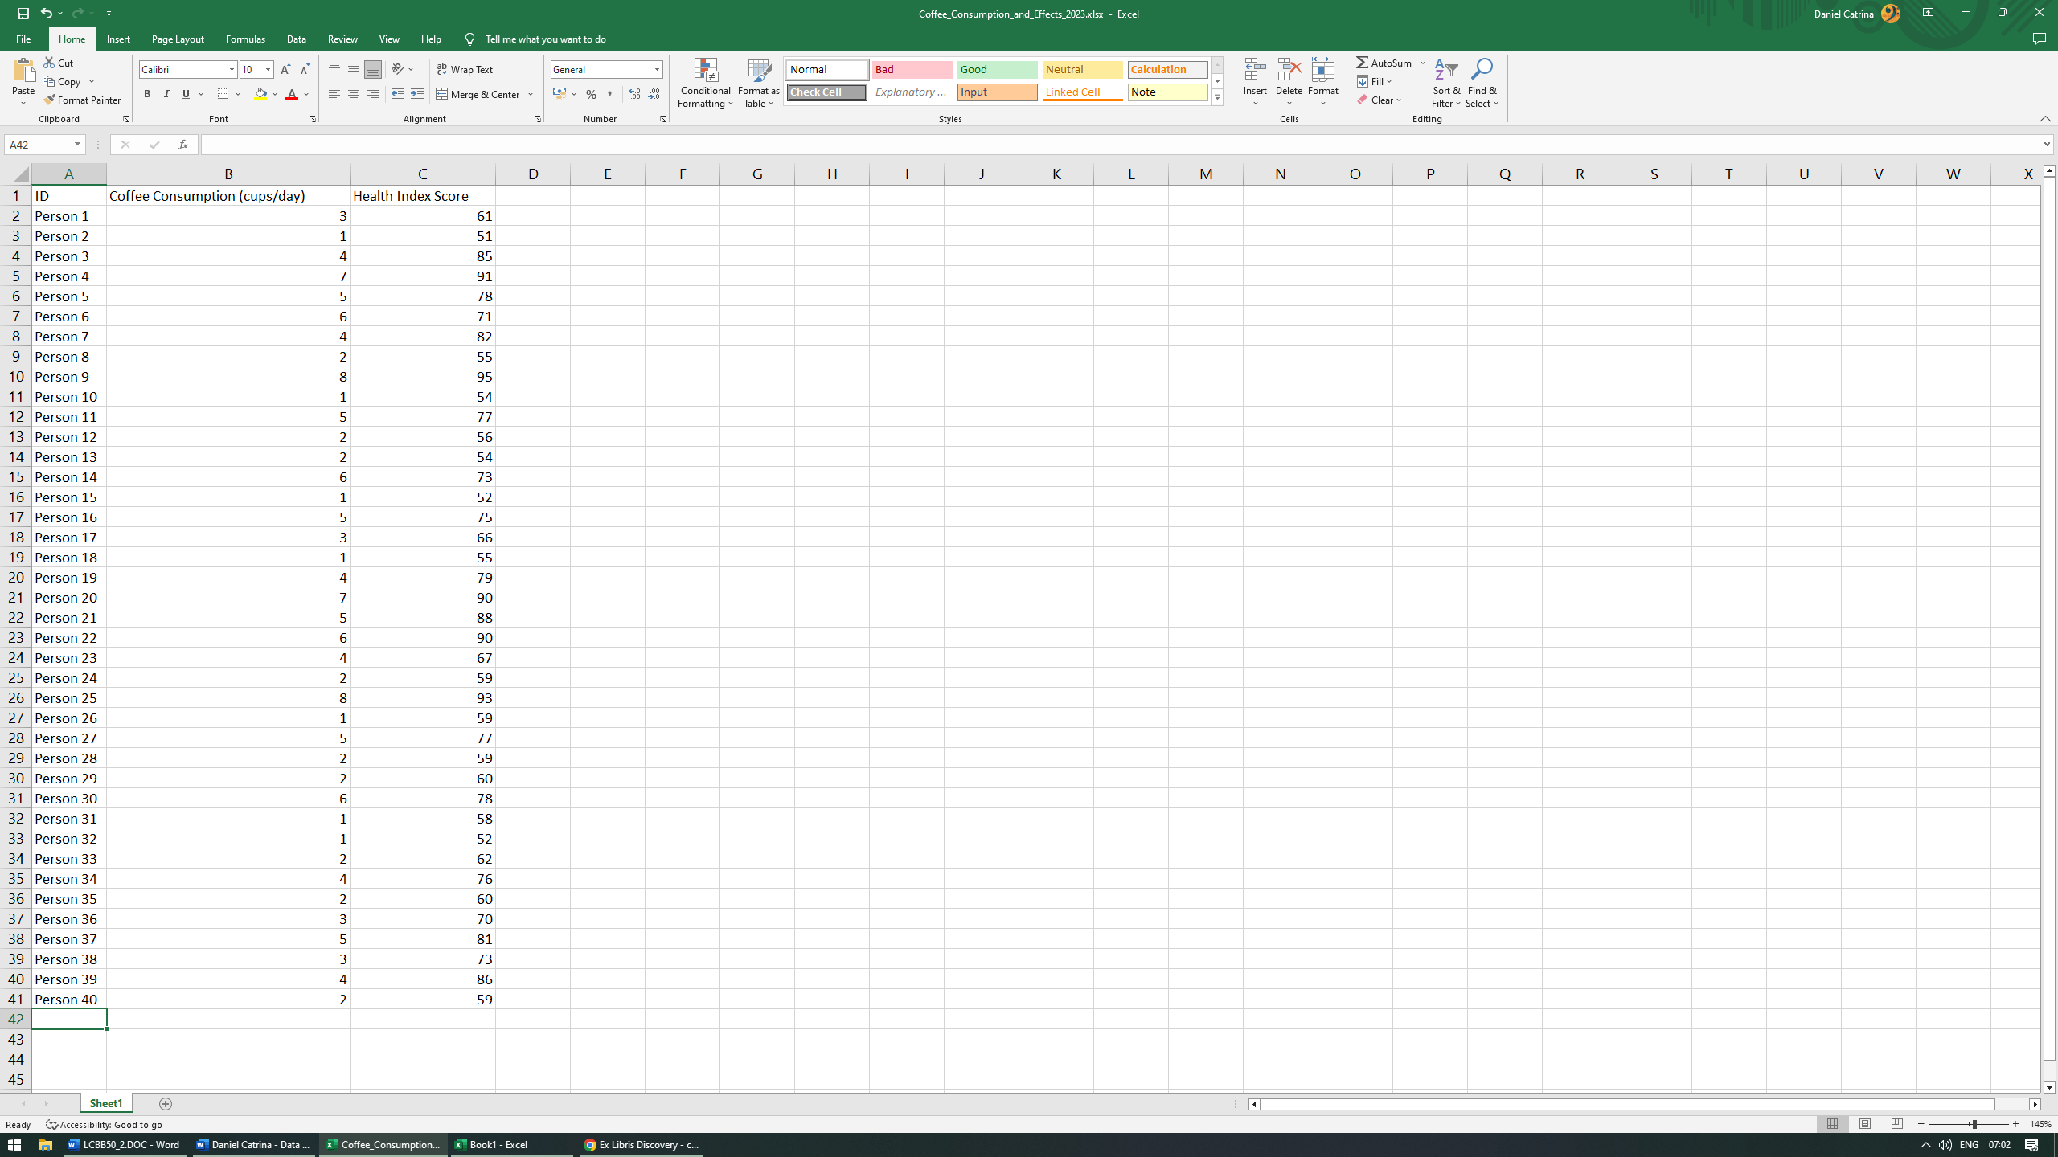

Since data has already been collected, my goal is to analyse and interpret the results in order to gain new insights regarding the coffee consumptions and its impact on human health. As such, I will be conducting my work using MS Excel and SPSS alike, on a step-by-step basis, showing my results along the way.
Furthermore, I will also discuss some advantages and disadvantages of using various statistical analysis software such as the aforementioned MS Excel and SPSS.

Coffee Consumption and Effects 2023
For the following section, I’ve chosen to use MS Excel due to its complexity and a more hands on approach.

Mean value for coffee consumption.
Mean value is a type of average. It is the sum of the values in the dataset divided by the number of values on the list. In MS Excel, any formula must start with the equal sign (=). This is because the cell contains or is equal to the formula and the value it calculates.
- In a new cell, start the function by adding the = sign then procced to type the desired function name (in our case AVERAGE) using TAB to chose our option.
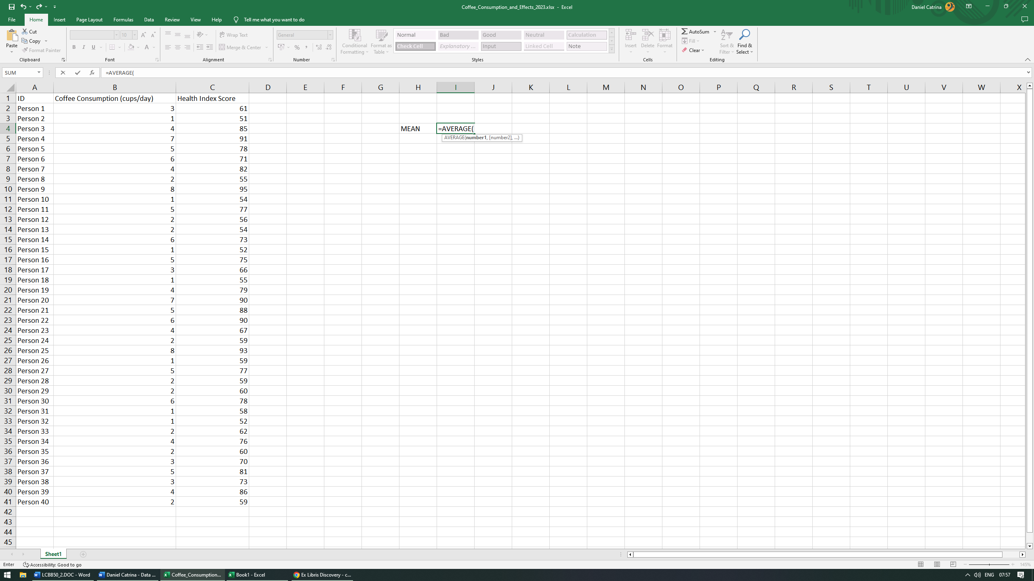

- Select the desired arguments or values necessary (in our case, column B).
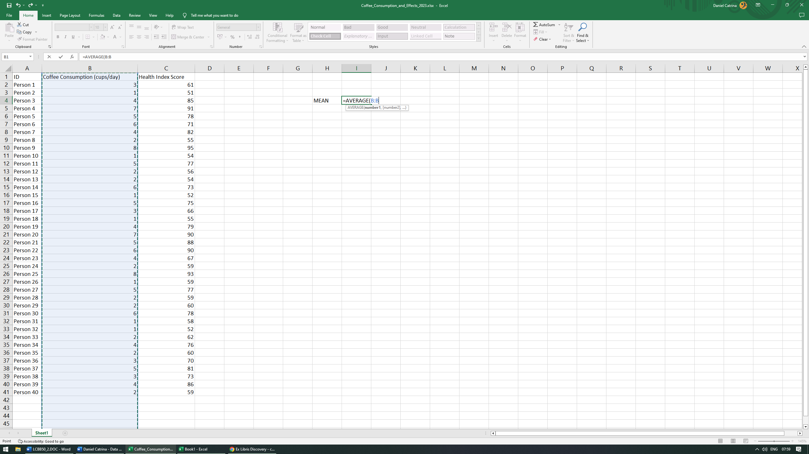
- In order for the function to be complete, we always have to close the parenthesis otherwise our function will be invalid. Then press ENTER to display the result.
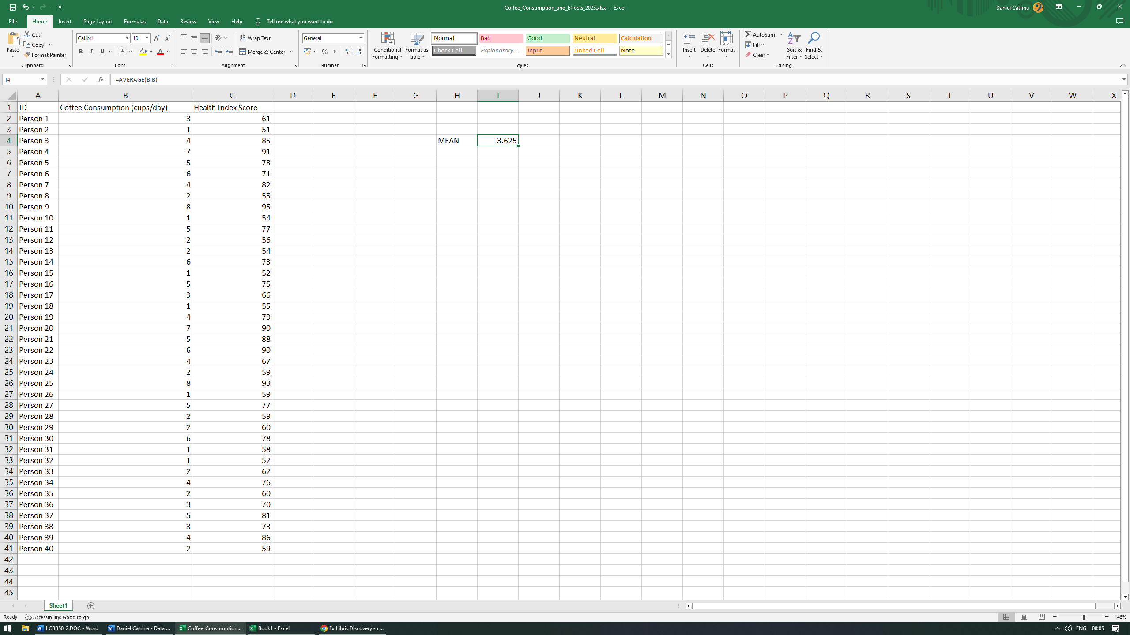
Conclusion: Our mean value is 3.625. This represents our average coffee cups consumption/day between our 40 participants.

Median value for coffee consumption.
The median is the middle value in a set of data. In order to manually calculate, you have to first organize the data from smallest to largest. As an example, if we have the following values: 1,5,3,8,7,13,10 we have to initially organize them in ascending order as such: 1,3,5,7,8,10,13. In this case our midpoint value is 7. If by any chance, we have two middle numbers, the mean will be the average of those two. For example, 1,3,5,7,8,10. Our middle numbers are 5 and 7. The median would then be (5+7)/2=6.
- In a new cell, start the function by adding the = sign then procced to type the desired function name (in our case MEDIAN) using TAB to choose our option.
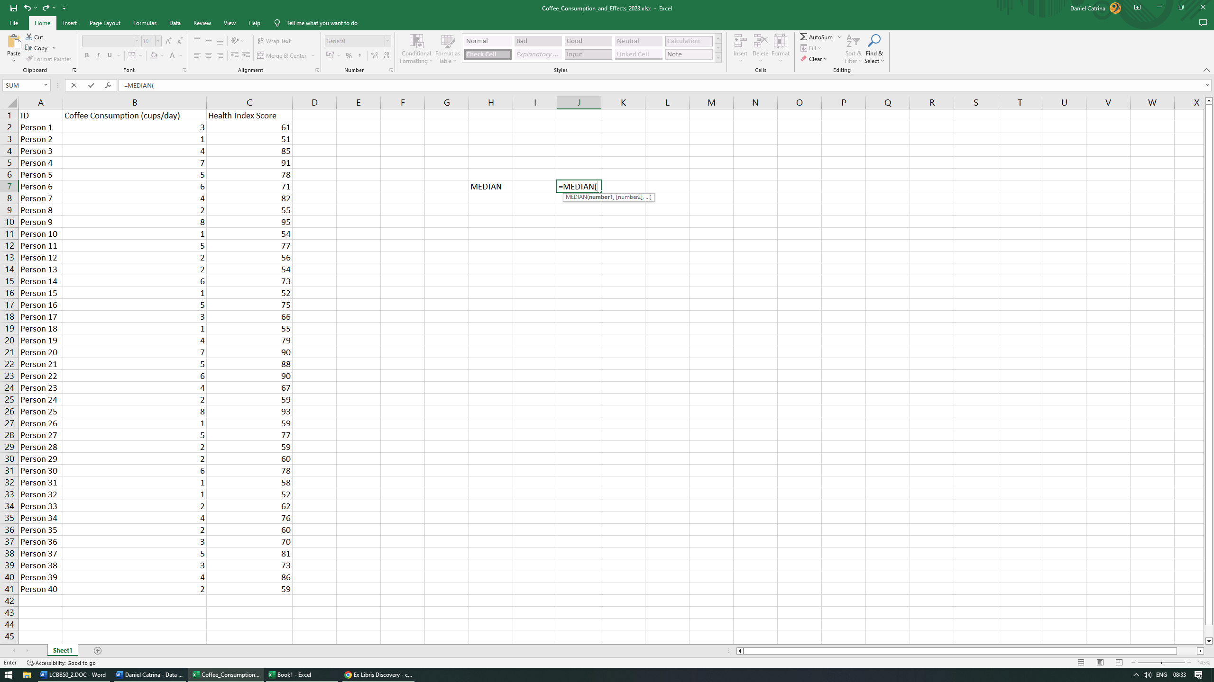

- Select the desired arguments or values necessary (in our case, column B).
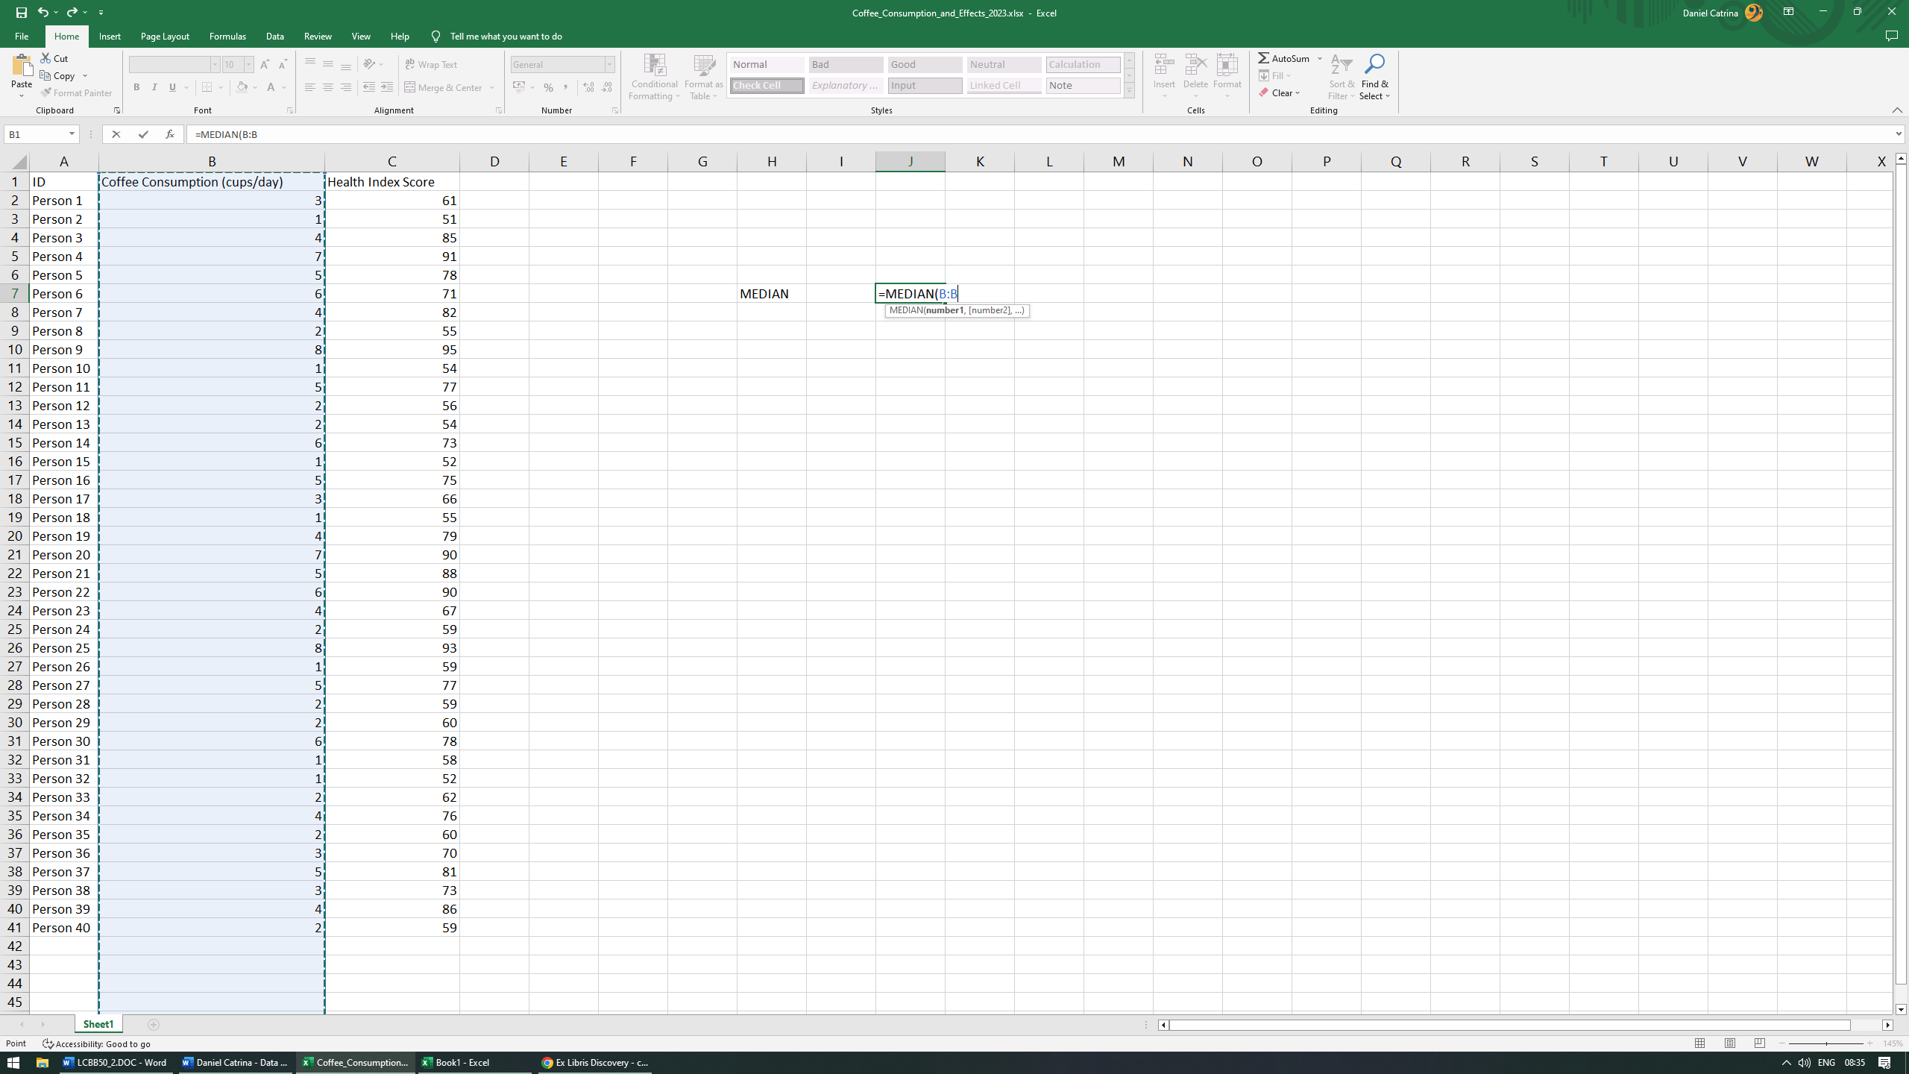
- In order for the function to be complete, we always have to close the parenthesis otherwise our function will be invalid. Then press ENTER to display the result.
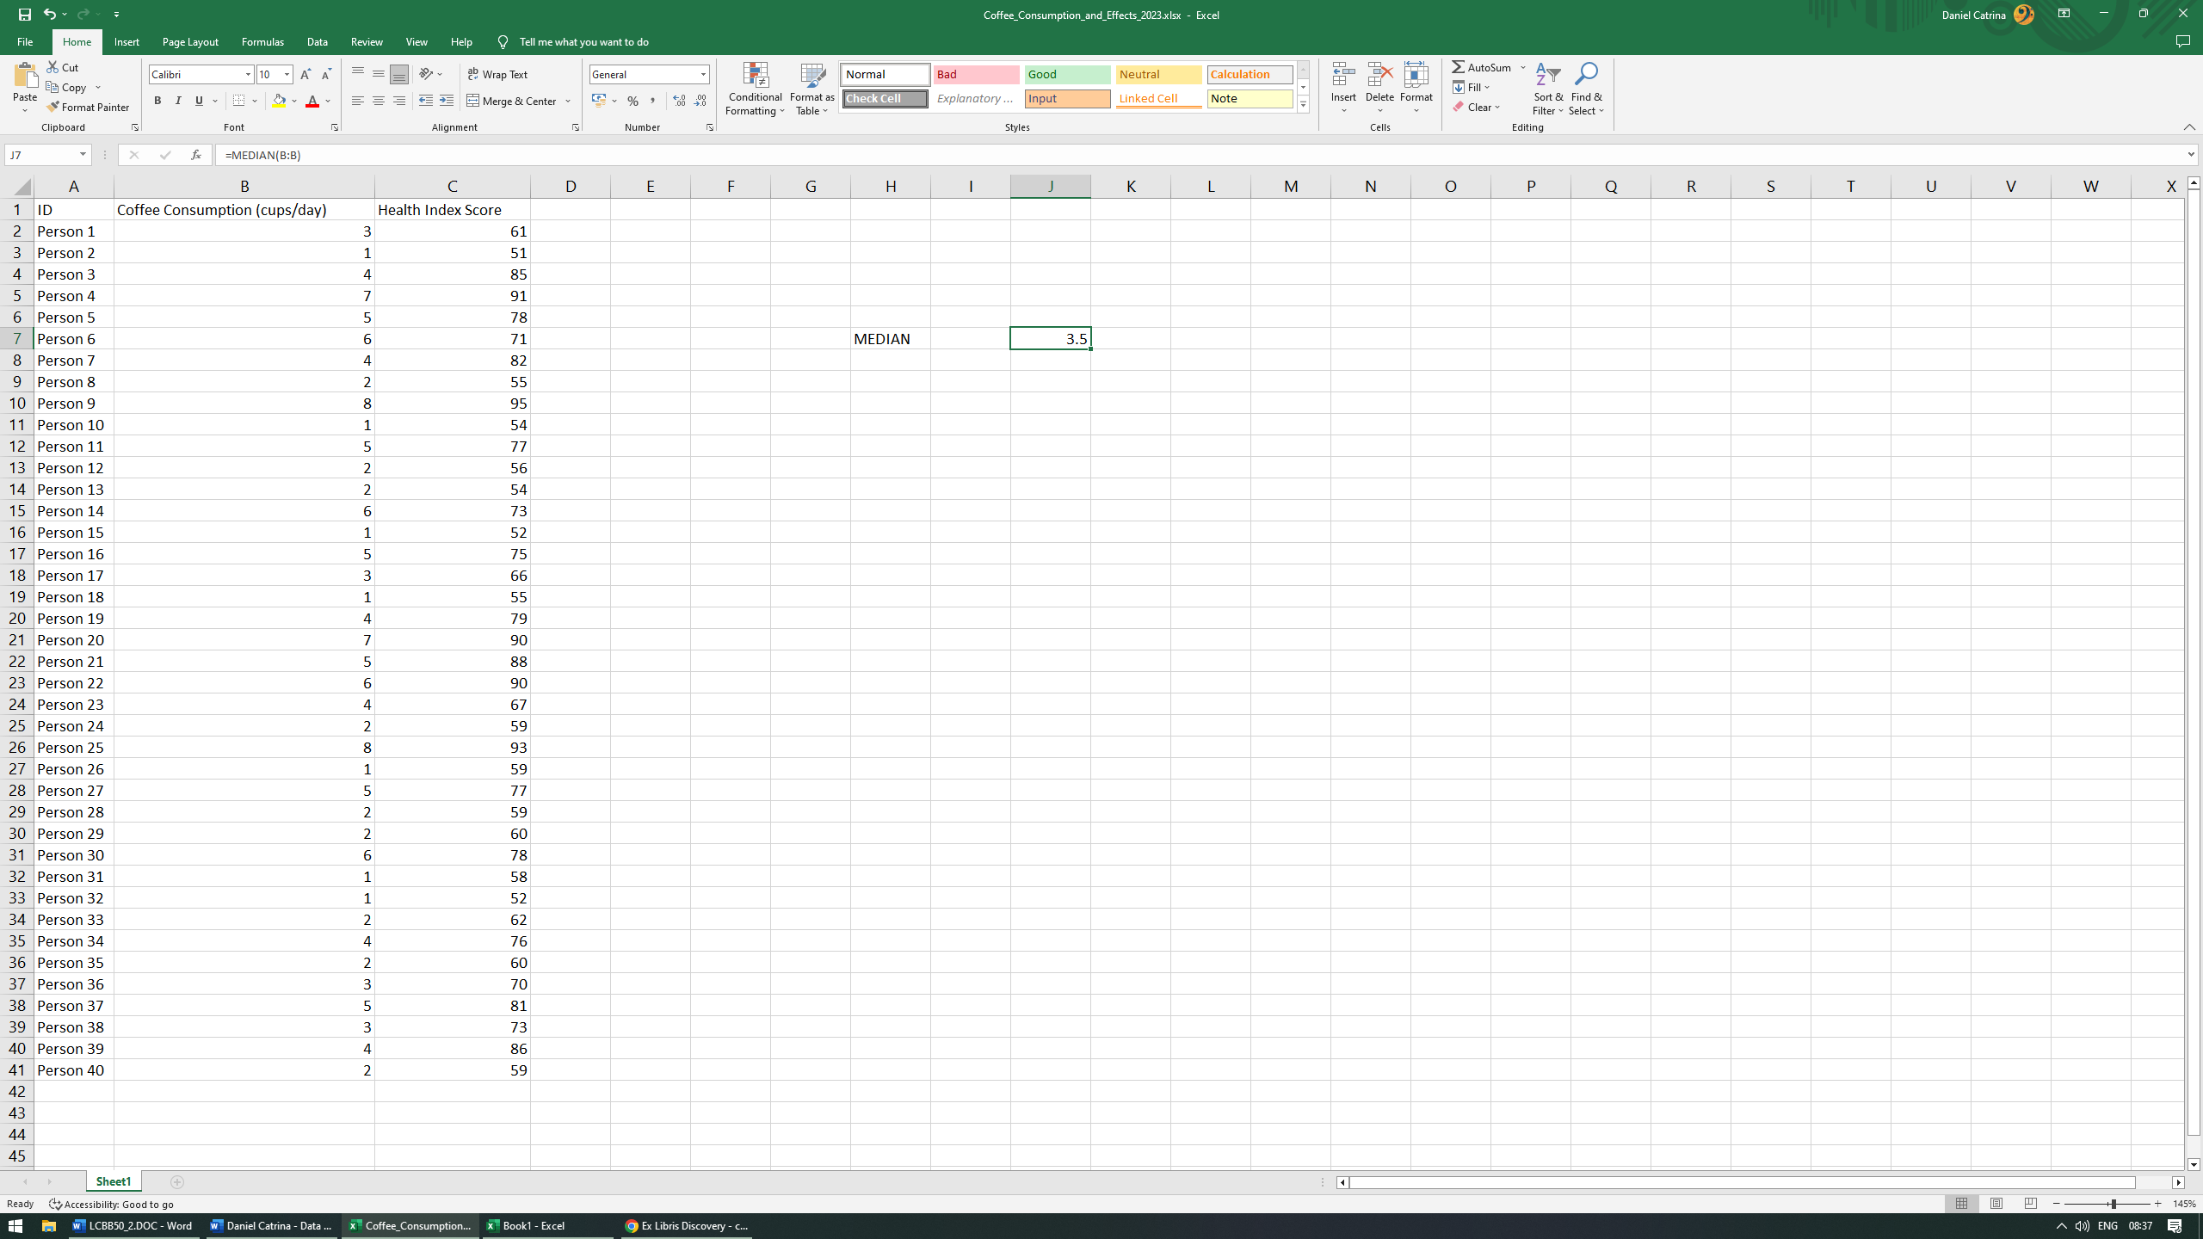
Conclusion: our median is 3.5. This means that 50% of our participants fall below this number and 50% fall above.

Mode value for the coffee consumption.
The mode is the value that occurs most often in a dataset. For example, within a set of values of 1,3,3,4,5,8 our mode would be 3 since it’s the number that’s shows up multiple times. As well, in a dataset with values as follows 1,1,3,3,4,5,8 its mode is not unique (1 and 3) and as such the dataset is bimodal or even multimodal if there are more that two numbers repeating such as 1,1,3,3,4,4,5,8.
- In a new cell, start the function by adding the = sign then procced to type the desired function name (in our case MODE) using TAB to choose our option.
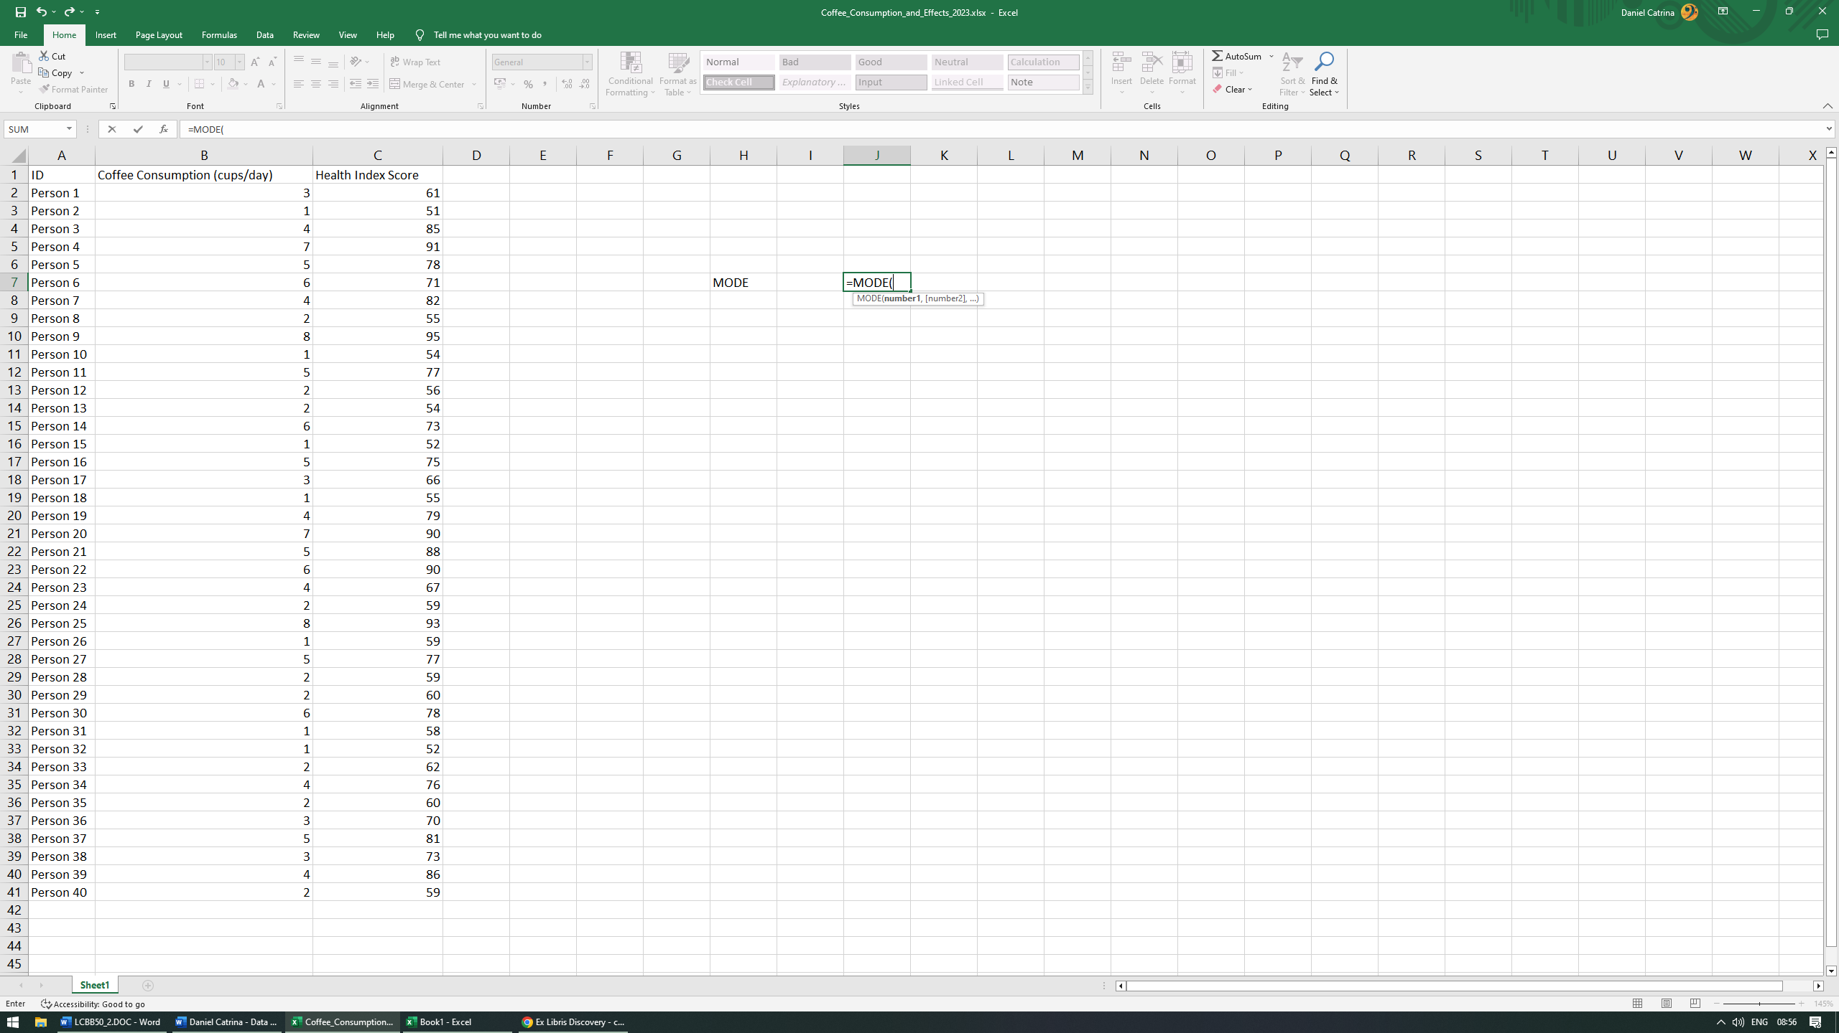

- Select the desired arguments or values necessary (in our case, column B).
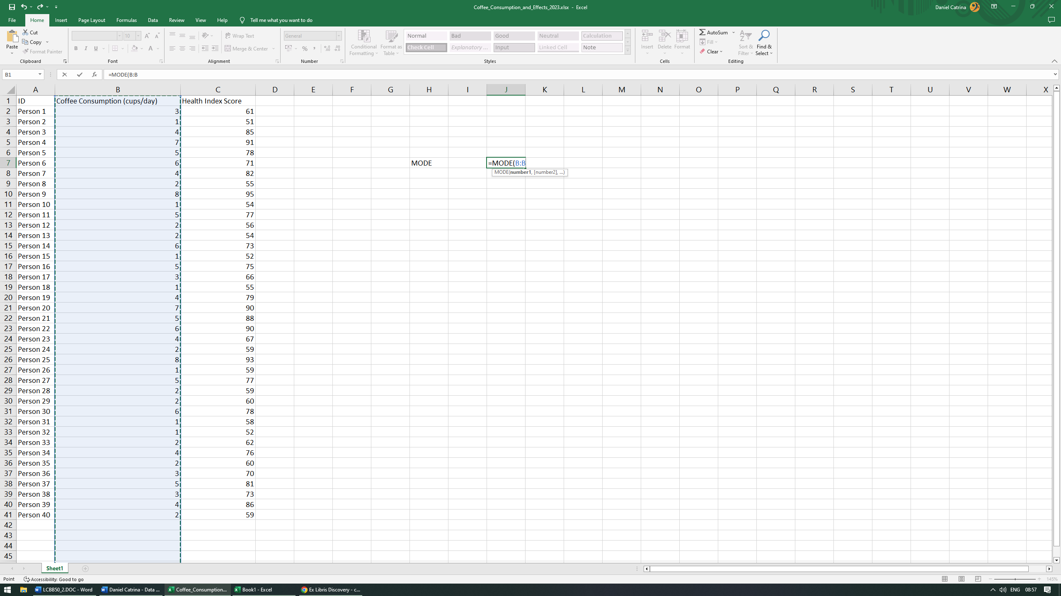
- In order for the function to be complete, we always have to close the parenthesis otherwise our function will be invalid. Then press ENTER to display the result.
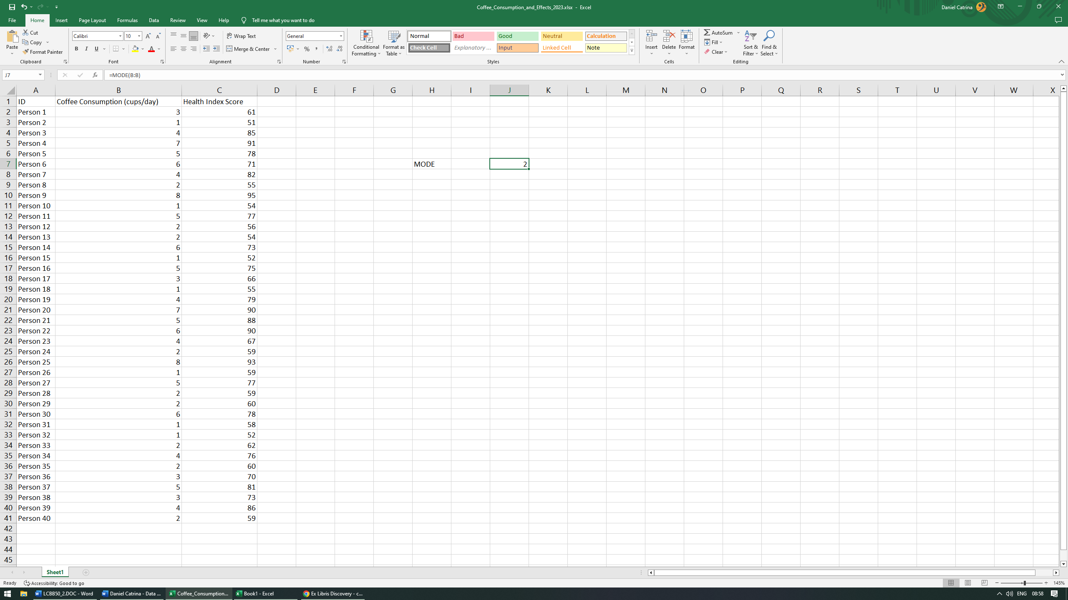
Conclusion: our mode is 2. This means that out of our 40 participants, 2 cups/day is the most often amount seen.

Standard deviation for effects on the human body.
Standard deviation measures data dispersion in a distribution that is typical. It indicates how accurately the mean represents the sample data (Lee, In and Lee, 2015). A low standard deviation shows that data is closer to the mean and a high standard deviation shows the data is more spread out.
- In a new cell, start the function by adding the = sign then procced to type the desired function name (in our case STDEV.S) using TAB to choose our option.
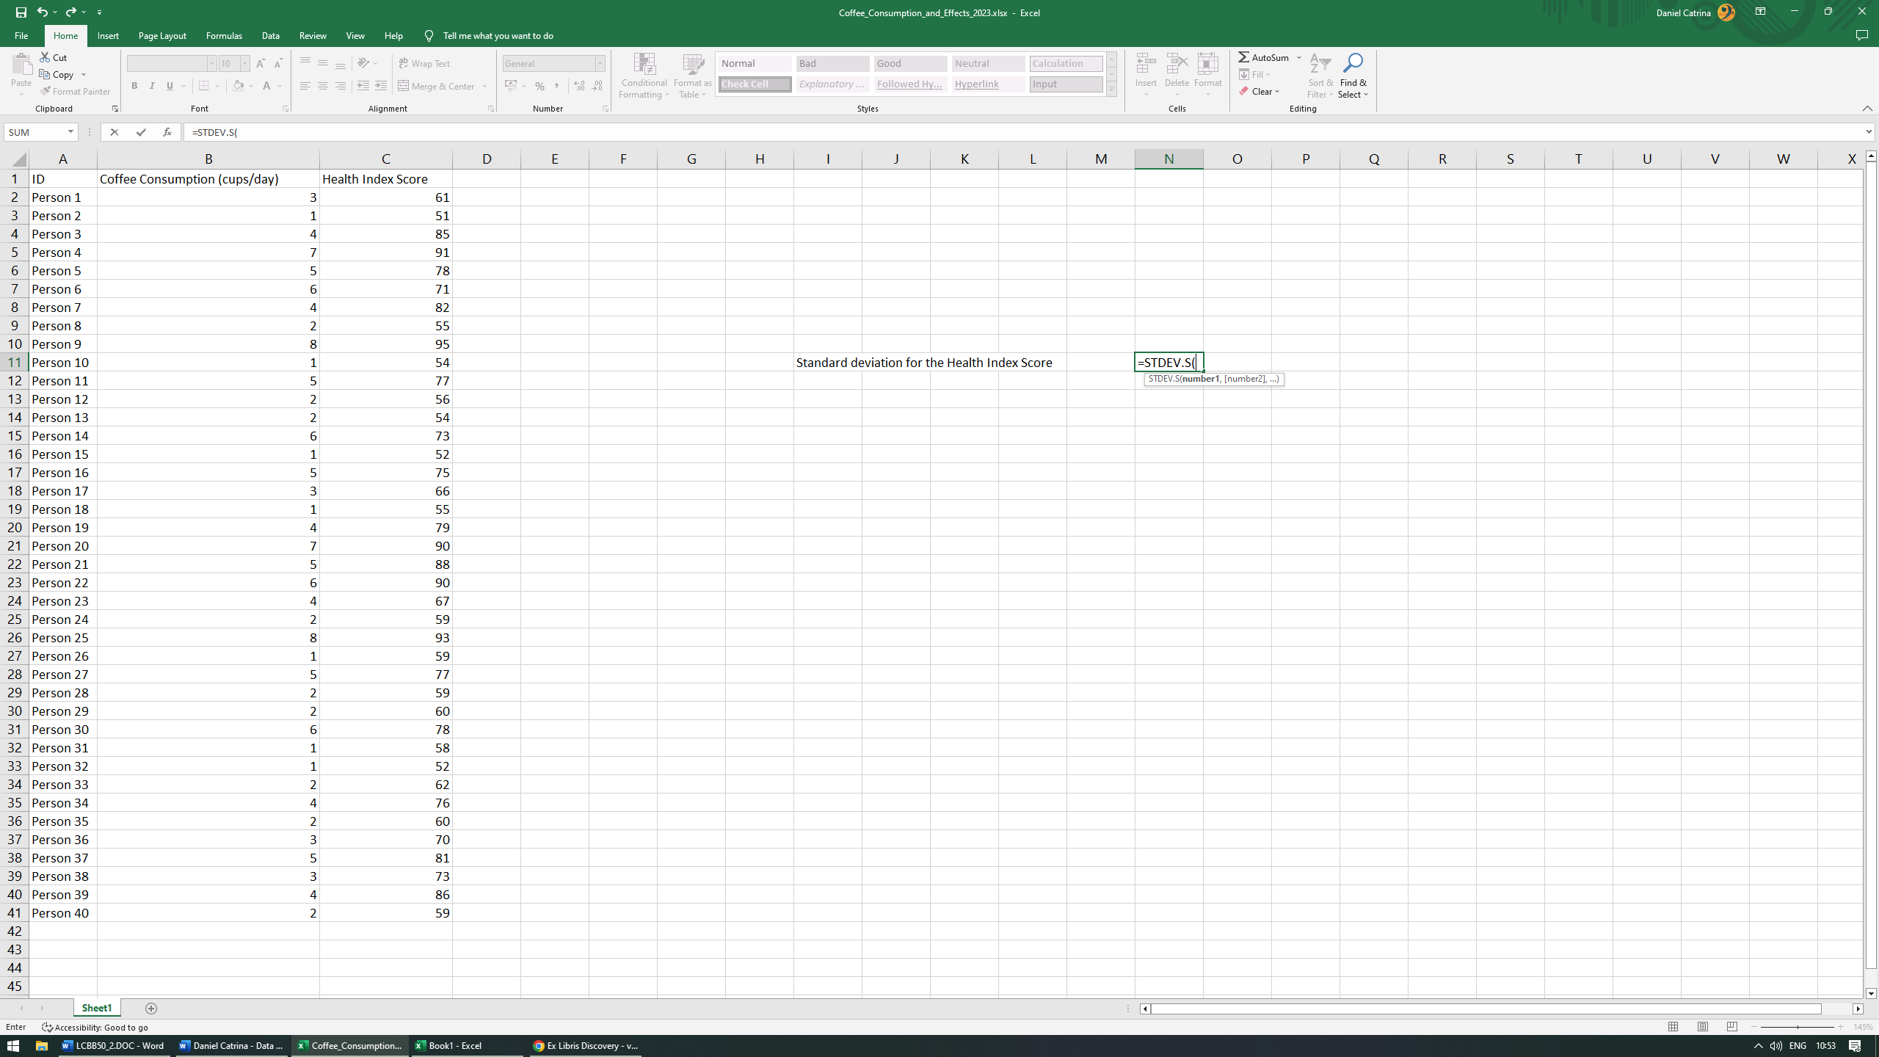

- Select the desired arguments or values necessary (in our case, column C).
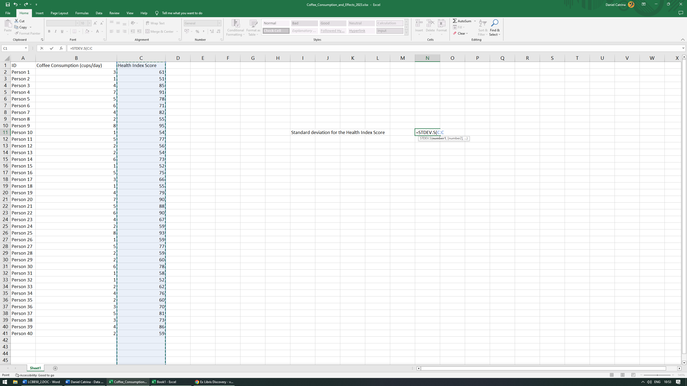
- In order for the function to be complete, we always have to close the parenthesis otherwise our function will be invalid. Then press ENTER to display the result.
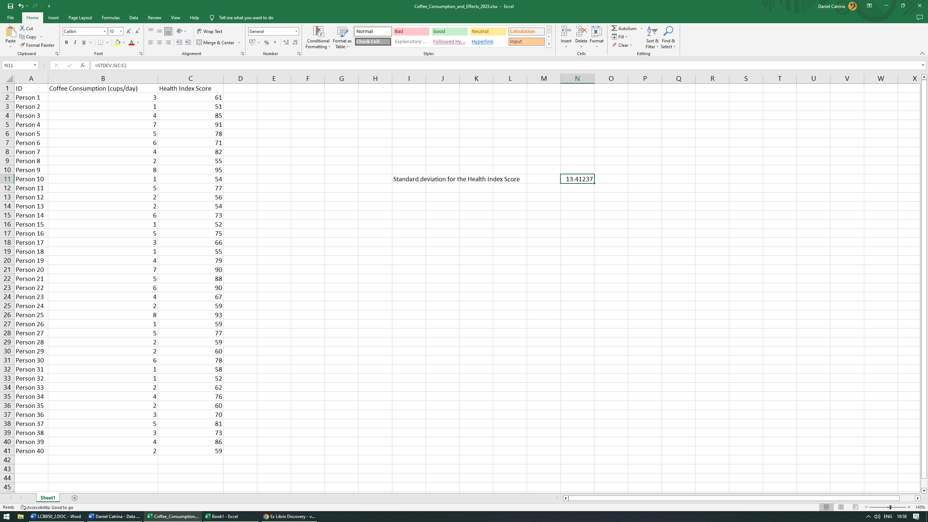
Conclusion: our standard deviation of the health index score is 13.41237.

Which one of the two variables has a larger variance?
First and foremost, what is variance and how does it differ from standard deviation? In terms of the distribution, they're equivalent (yet obviously not interchangeable), but in terms of estimators they're not. Whilst standard deviation measures the data dispersion from the mean, the variance measures the degree to which point differs from the mean. According to Zeller (1999, p.352), “the variance is the average of the squared deviations”.
In order to determine which variable has the largest variance, we must first establish what their respective variance is.
Coffee consumption variance
- In a new cell, start the function by adding the = sign then procced to type the desired function name (in our case VAR.S) using TAB to choose our option.
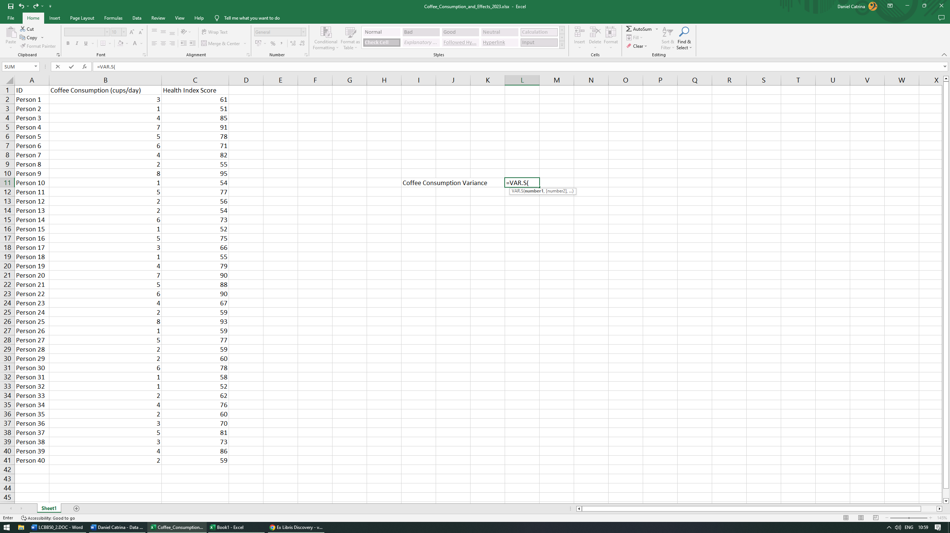

- Select the desired arguments or values necessary (in our case, column B).
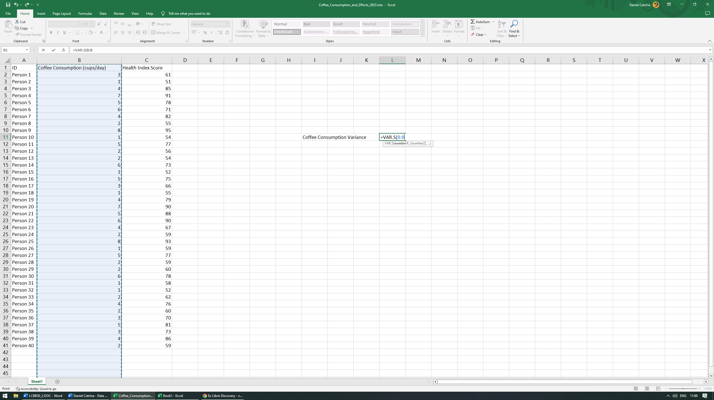
- In order for the function to be complete, we always have to close the parenthesis otherwise our function will be invalid. Then press ENTER to display the result.
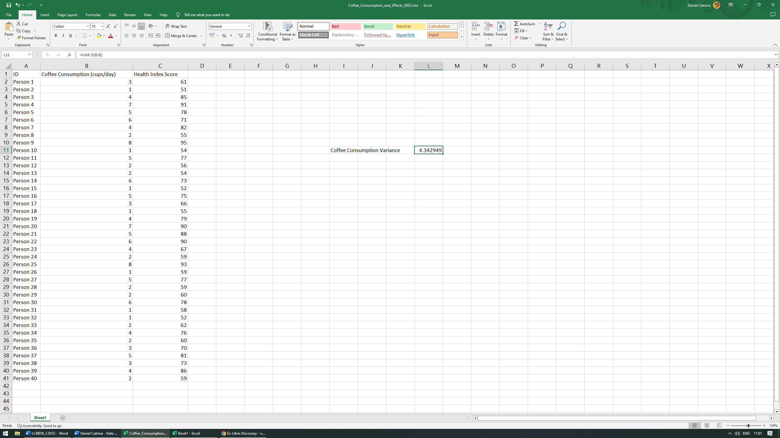
Conclusion: our coffee consumption variance is 4.342949.

Health Index variance
- In a new cell, start the function by adding the = sign then procced to type the desired function name (in our case VAR.S) using TAB to choose our option.
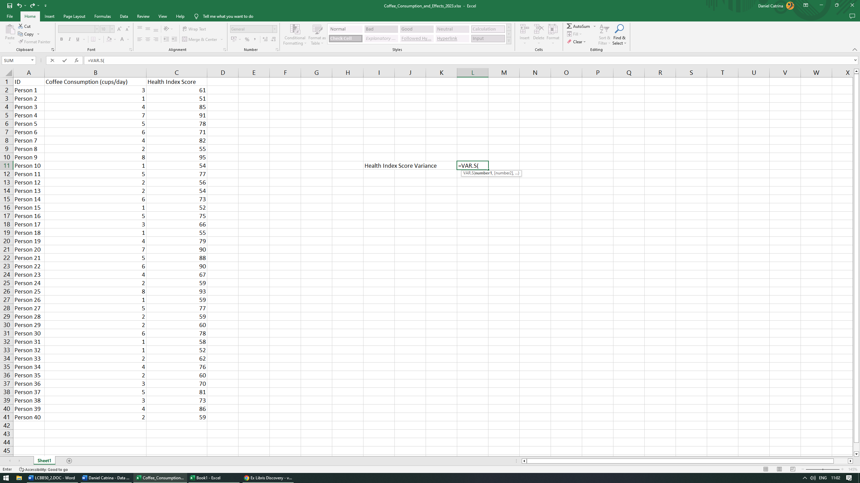
- Select the desired arguments or values necessary (in our case, column C).
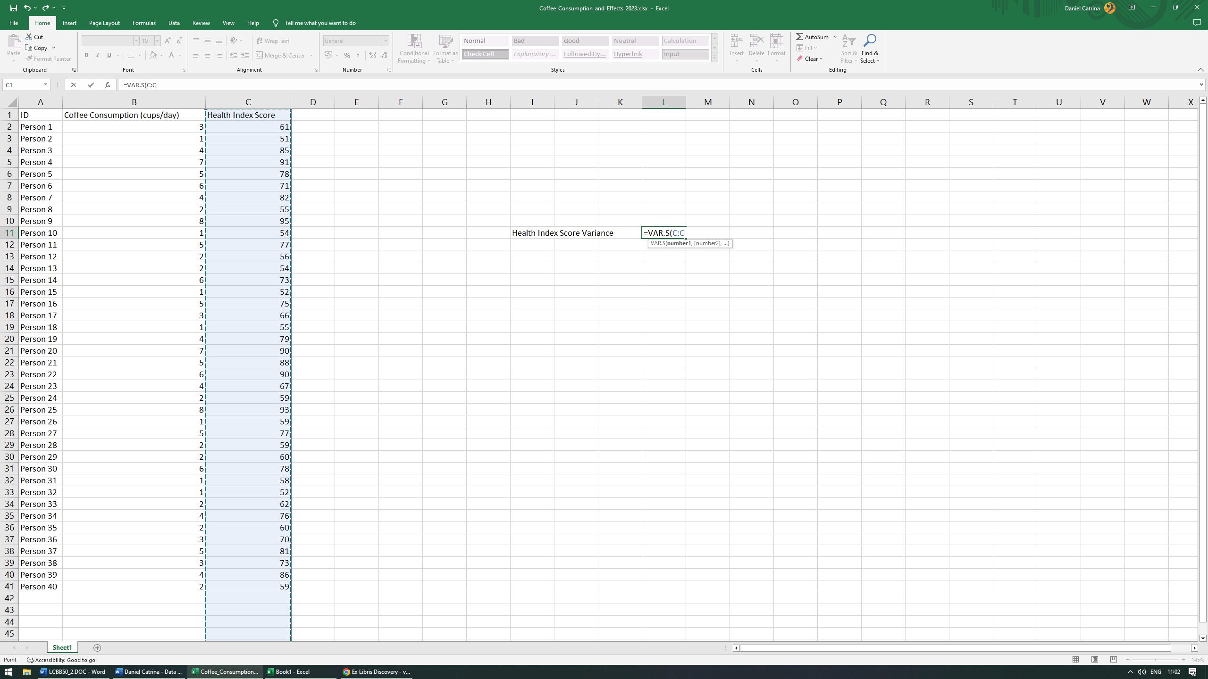
- In order for the function to be complete, we always have to close the parenthesis otherwise our function will be invalid. Then press ENTER to display the result.
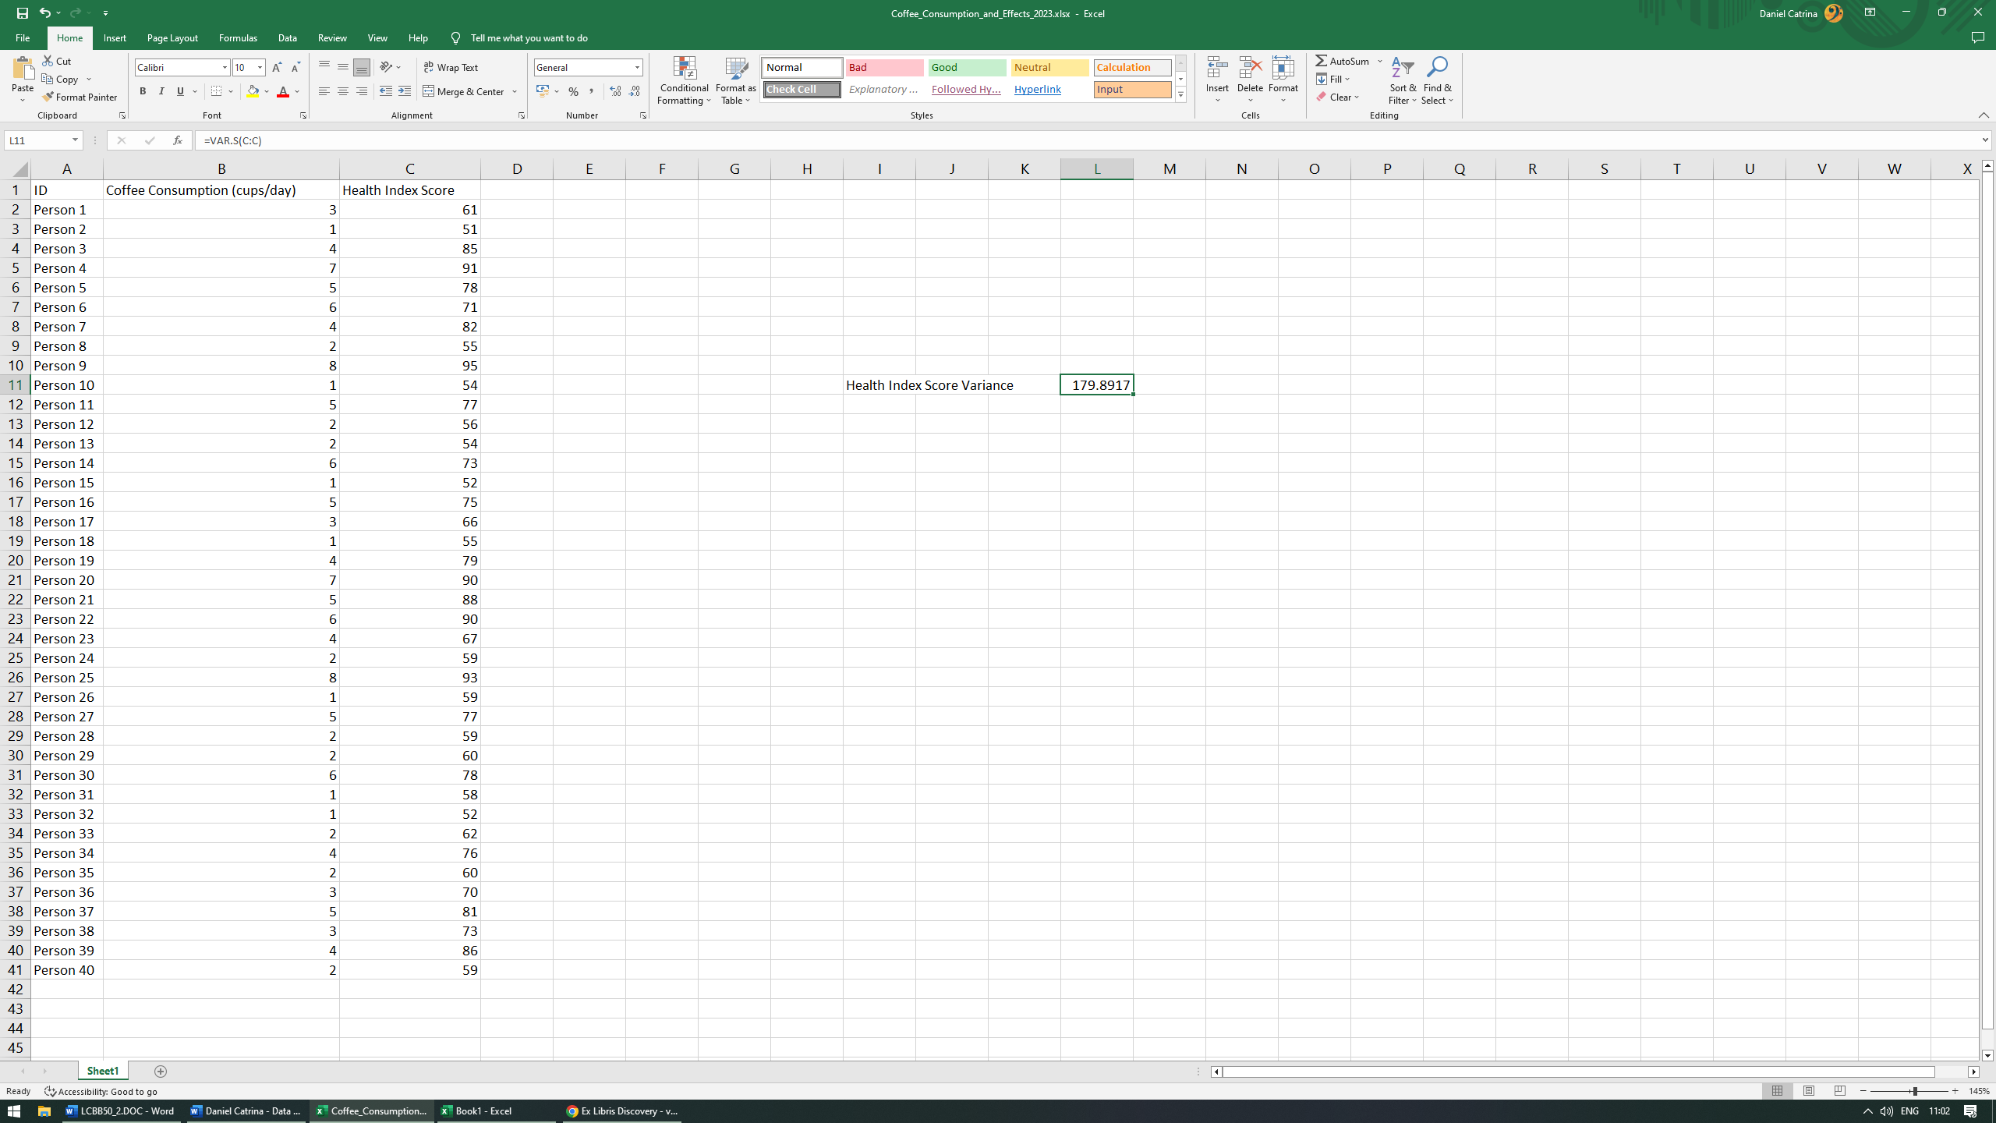
Conclusion: our variance for the Health Index Score is 179.8917.
Interpretation: So, let’s summarise. The variance for the coffee consumption is 4.342949 and the variance for the Health Index Score is 179.8917. We have also established earlier that the mean for coffee consumption is 3.625. We can now add the mean for the health index score in order to have the full picture. Thus, following the same process, the mean for the health index score will be 70.175.
Relating this information to their respective means, we can conclude that the health index score has a much larger variation. This indicates there is a higher dispersion between the values in health index score than the ones in coffee consumption.

Which one of the two variables has a larger standard deviation?
As we have already established that the standard deviation for the Health Index Score is 13.41237, all that remains is to calculate the same for the Coffee consumption variable.

- In a new cell, start the function by adding the = sign then procced to type the desired function name (in our case STDEV.S) using TAB to choose our option.
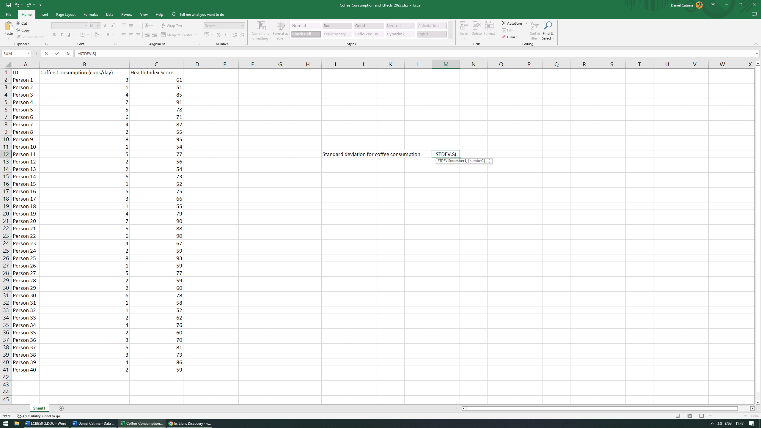
- Select the desired arguments or values necessary (in our case, column B).
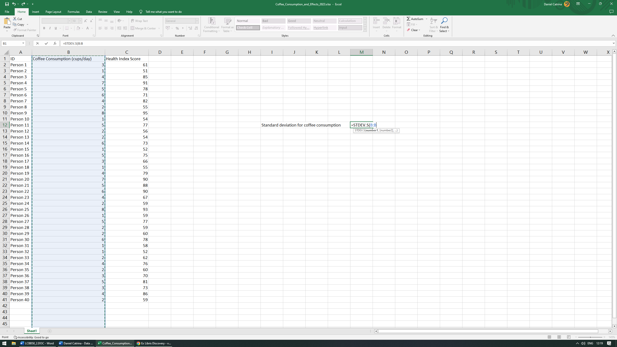

- In order for the function to be complete, we always have to close the parenthesis otherwise our function will be invalid. Then press ENTER to display the result.
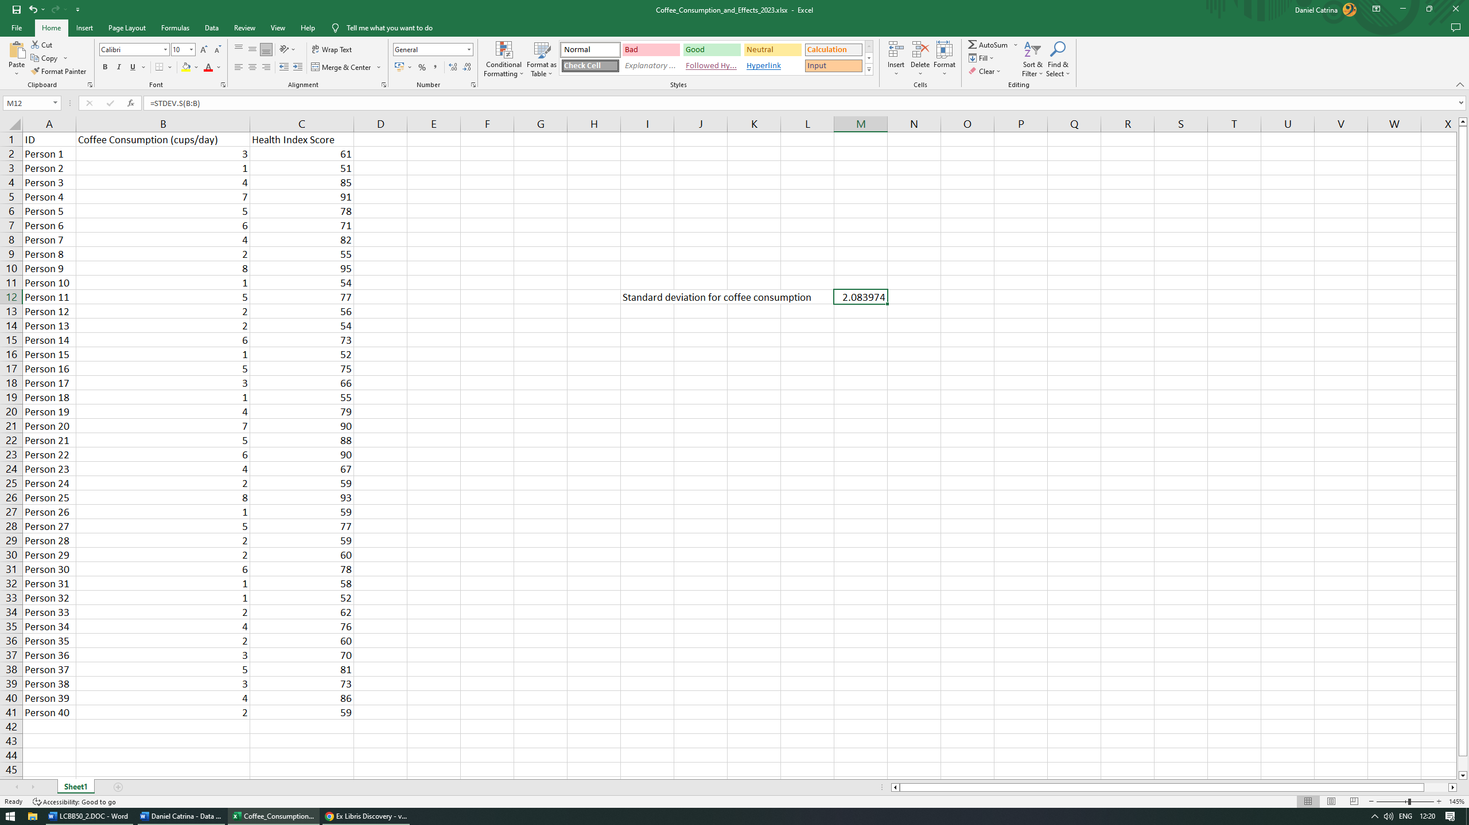
Conclusion: our standard deviation for the coffee consumption is 2.083974.
Interpretation: We can observe that our heath index score standard deviation is much larger than its counterpart since its wider dispersion from the respective mean. In the case of coffee consumption standard deviation, we observe that the data is more clustered around the mean.

Can you interpret the last three outcomes?
After presenting the results, we can observe that the data dispersion in our health index score is much wider, thus the datapoints are further away from the mean. This indicates there is a greater variation of impacts on the health of our participants. Our coffee consumption variance and standard deviation are much smaller, thus the datapoints are closer to the mean. This shows that the coffee consumption of our participants is more stable and linear, with very little variation.

Data presentation
In order to have a visual representation of our findings, in the following section I will “translate” the results into an easier to read graphical form. This will be done through the use of graphs, tables and charts and will ensure the findings are presented in a more user-friendly manner.
Summary table statistics for Coffee consumption and Health Index Score
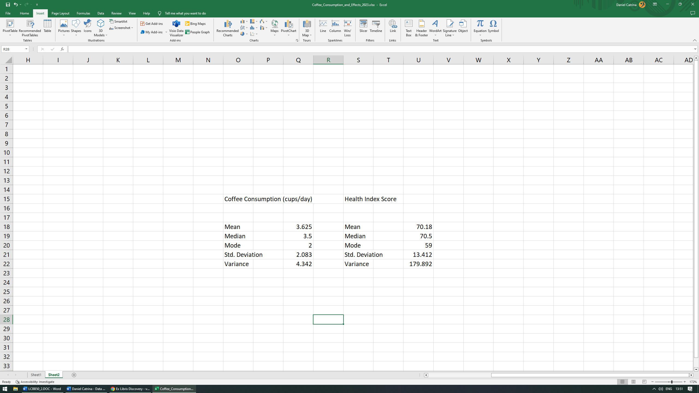

Dataset Clustered Column
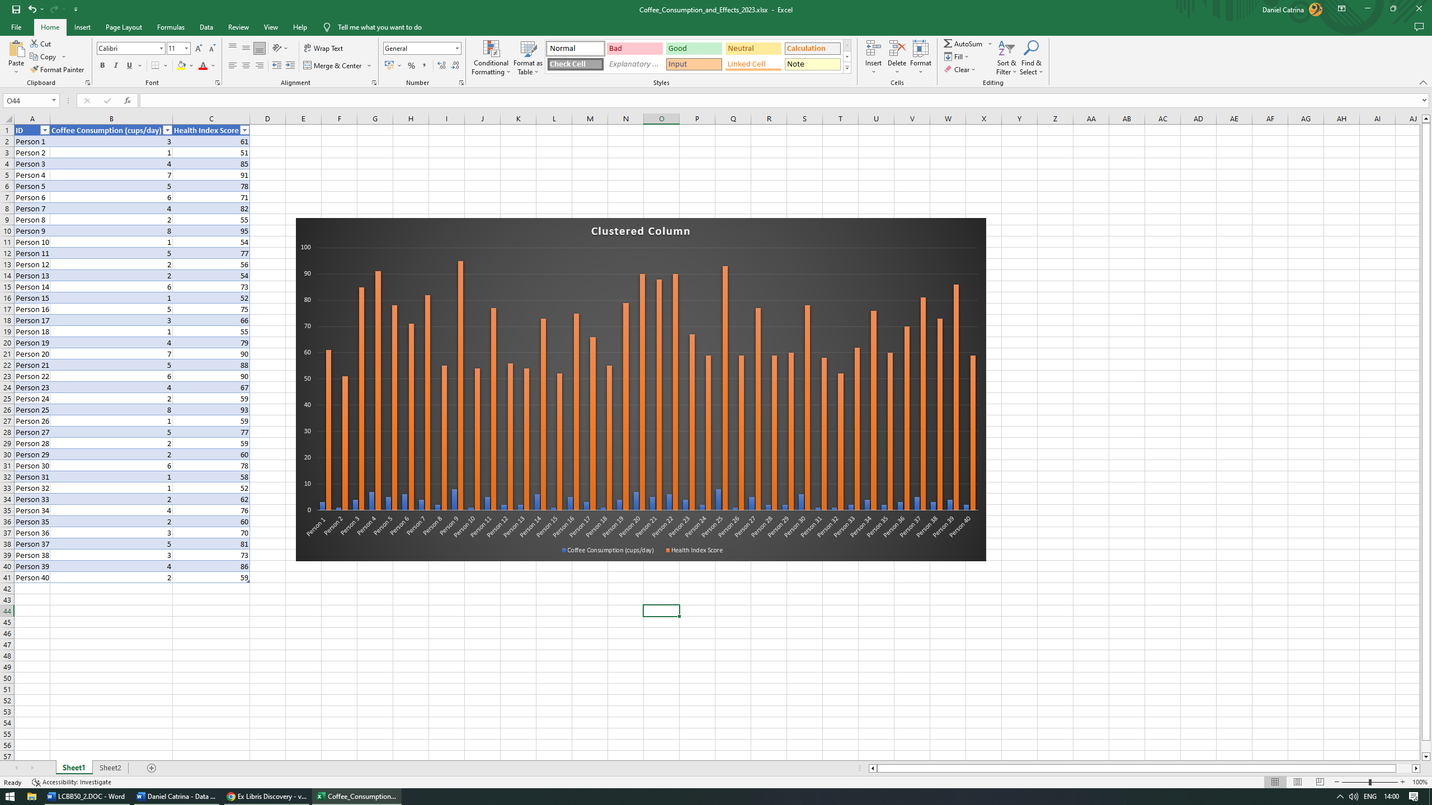

Standard deviation of Health Index Score pivot table
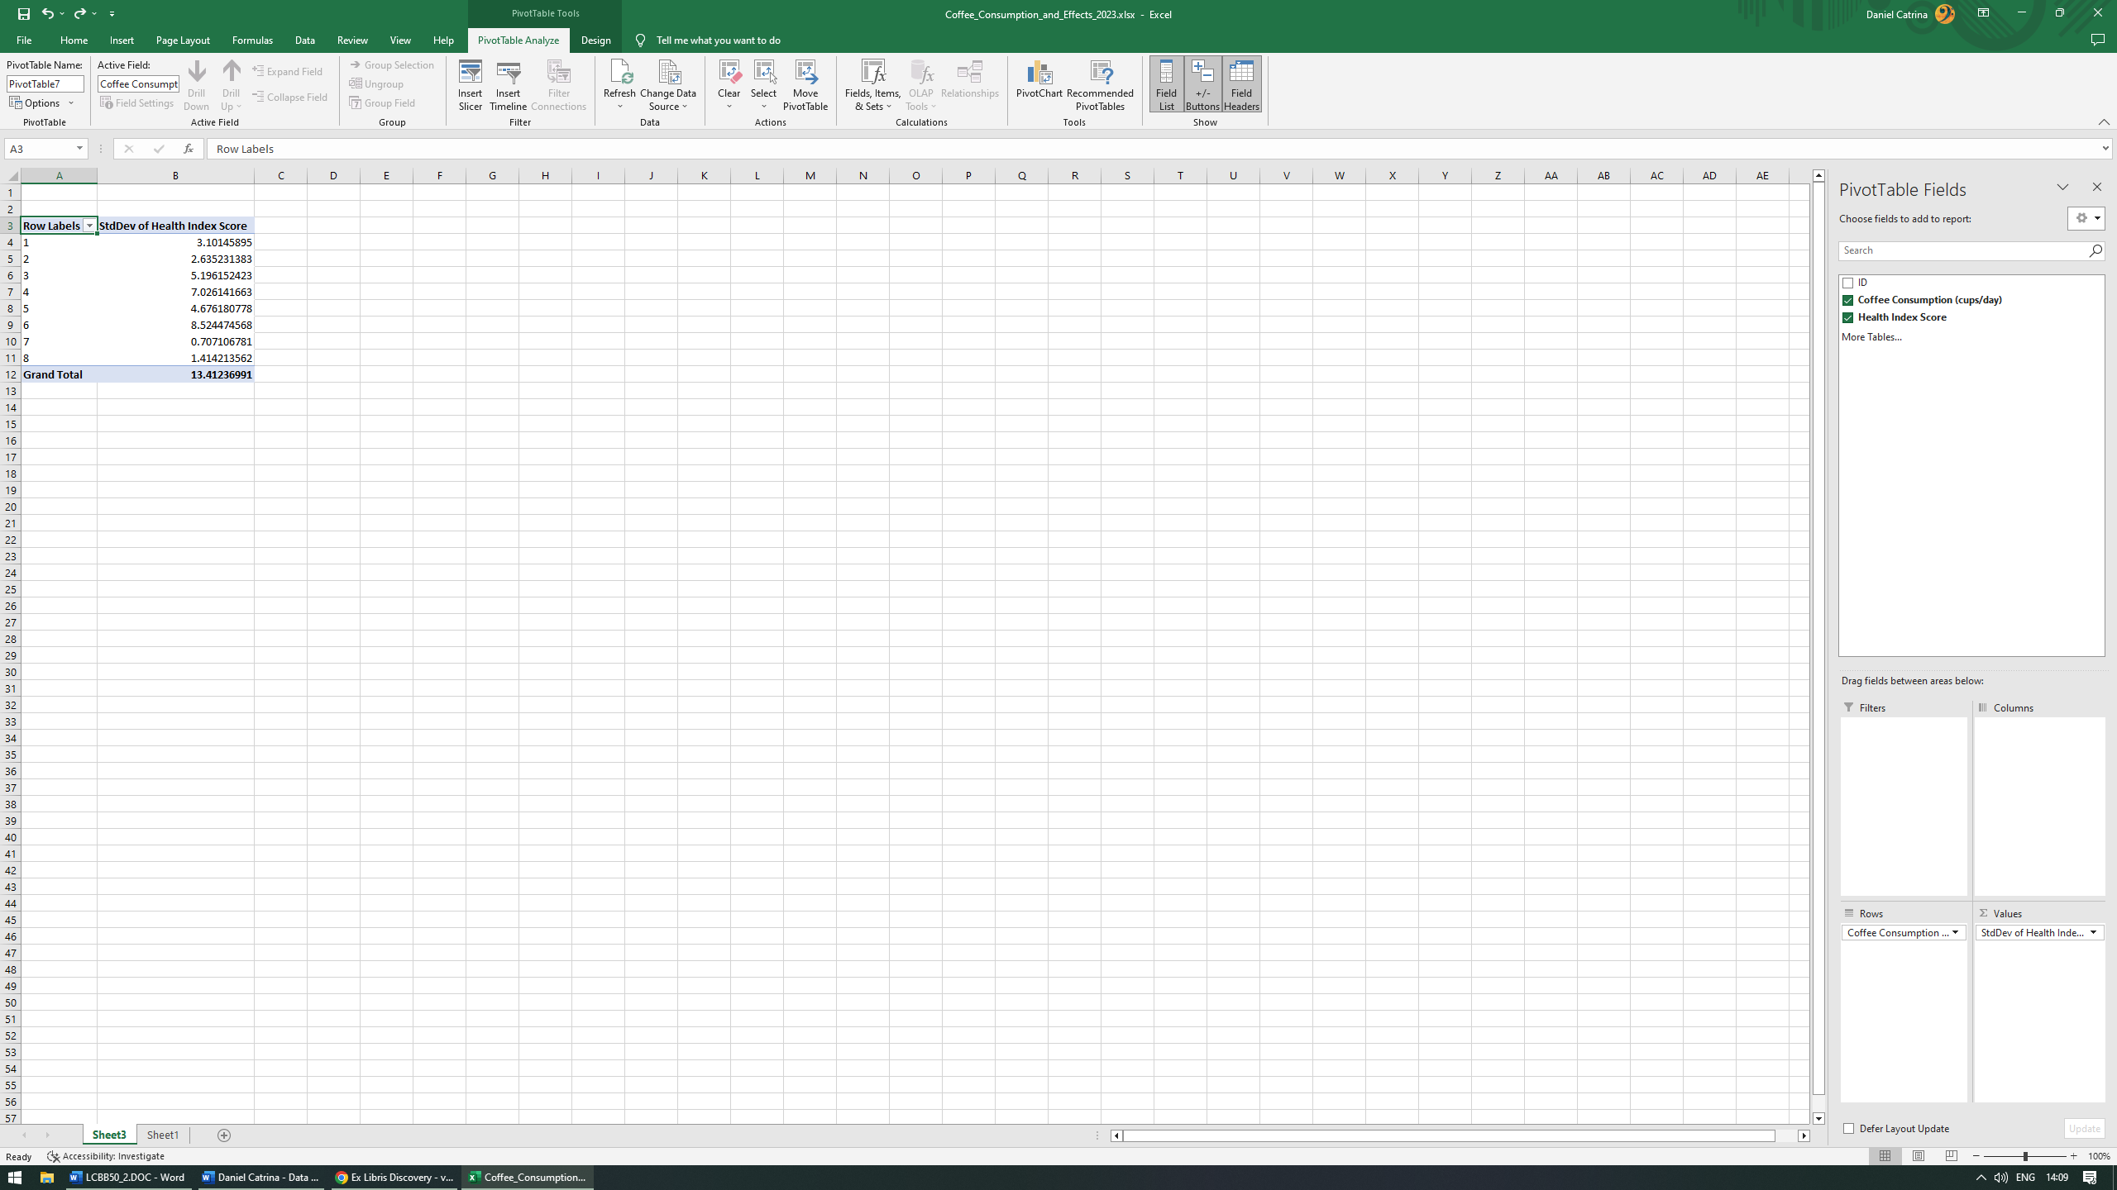

Mean value for coffee consumption and health index score chart
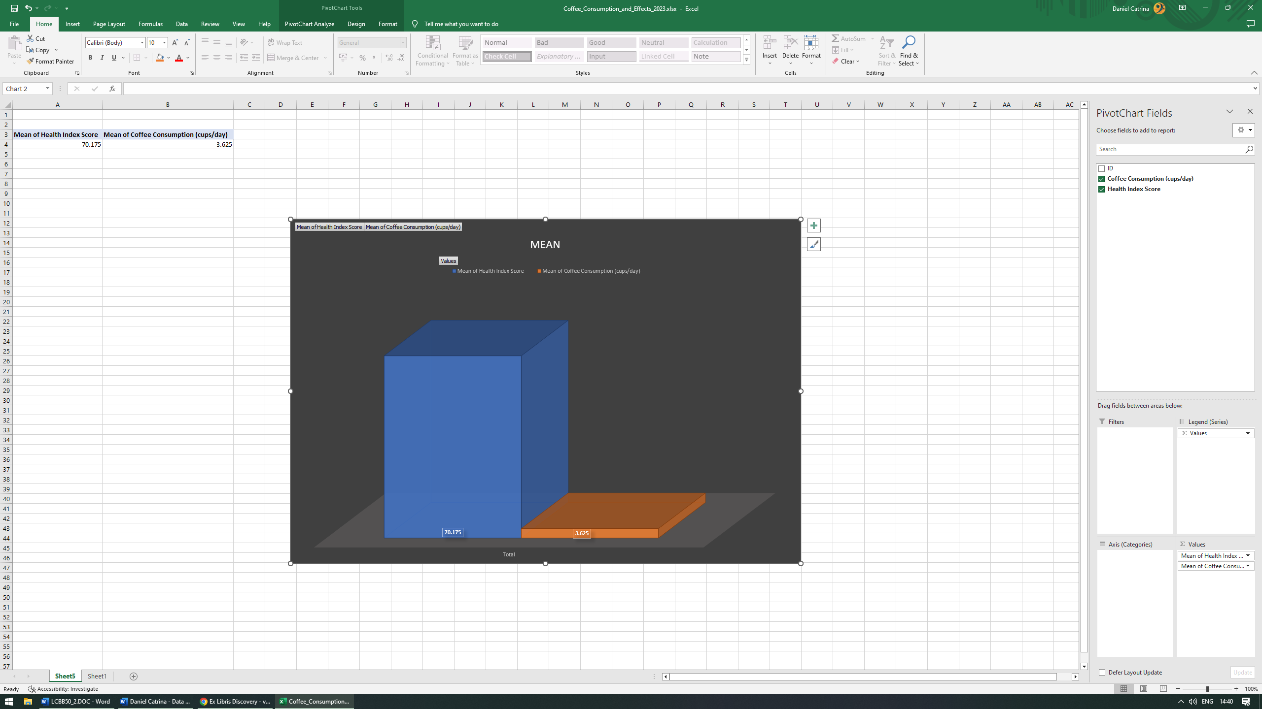

Variance for coffee consumption and health index score chart
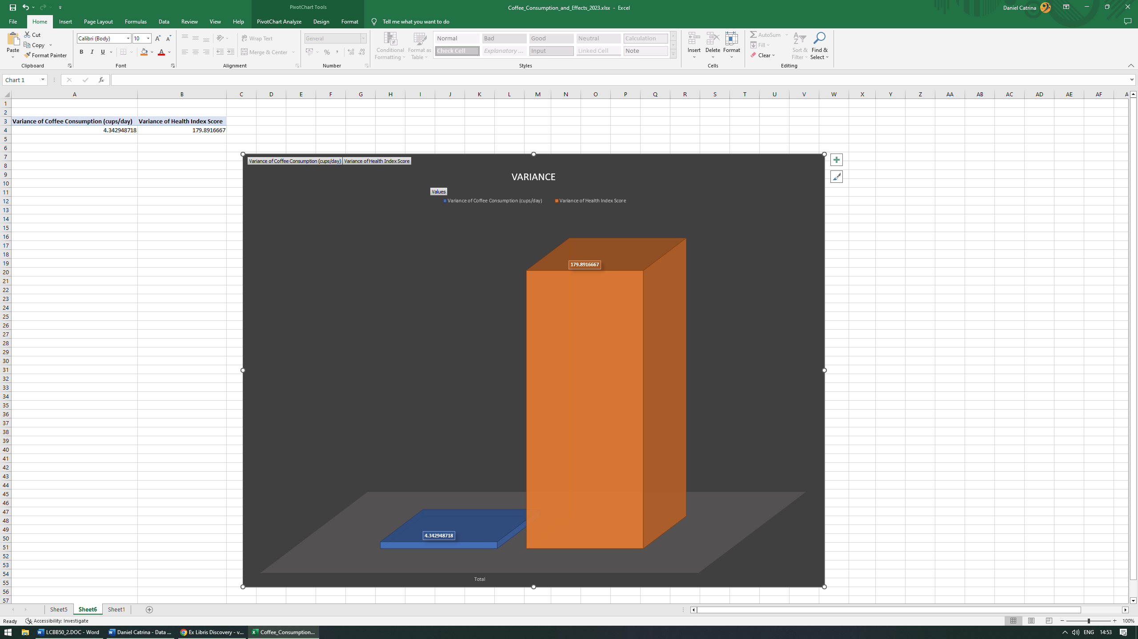

Total cups/day grouped and expressed in percentages
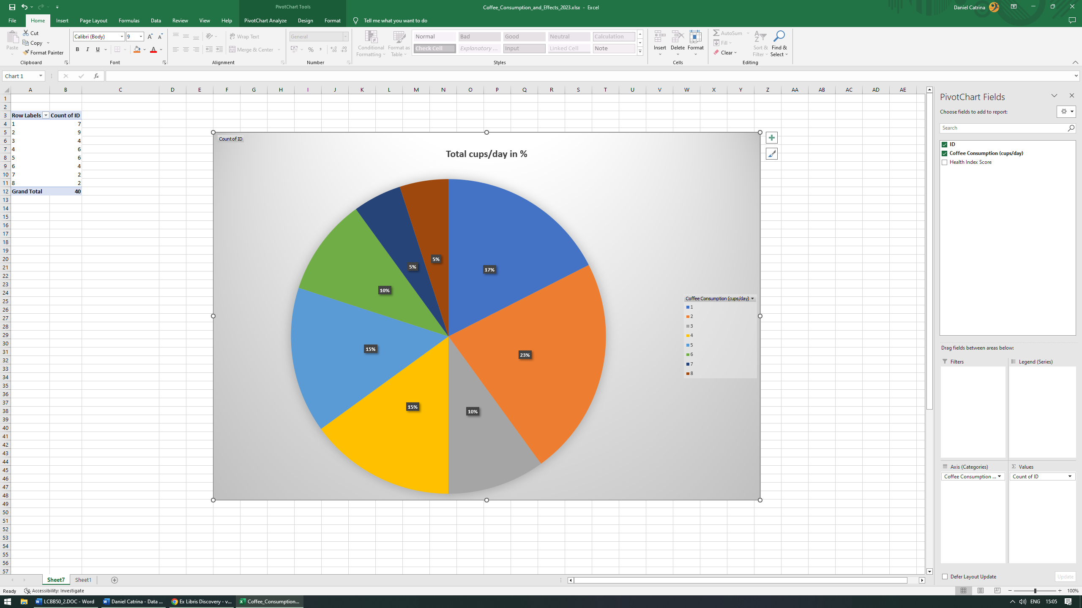

SPSS

Correlation between coffee consumption and the health index score
First, we must open our dataset in SPSS, then navigate to Analyze – Correlate – Bivariate.
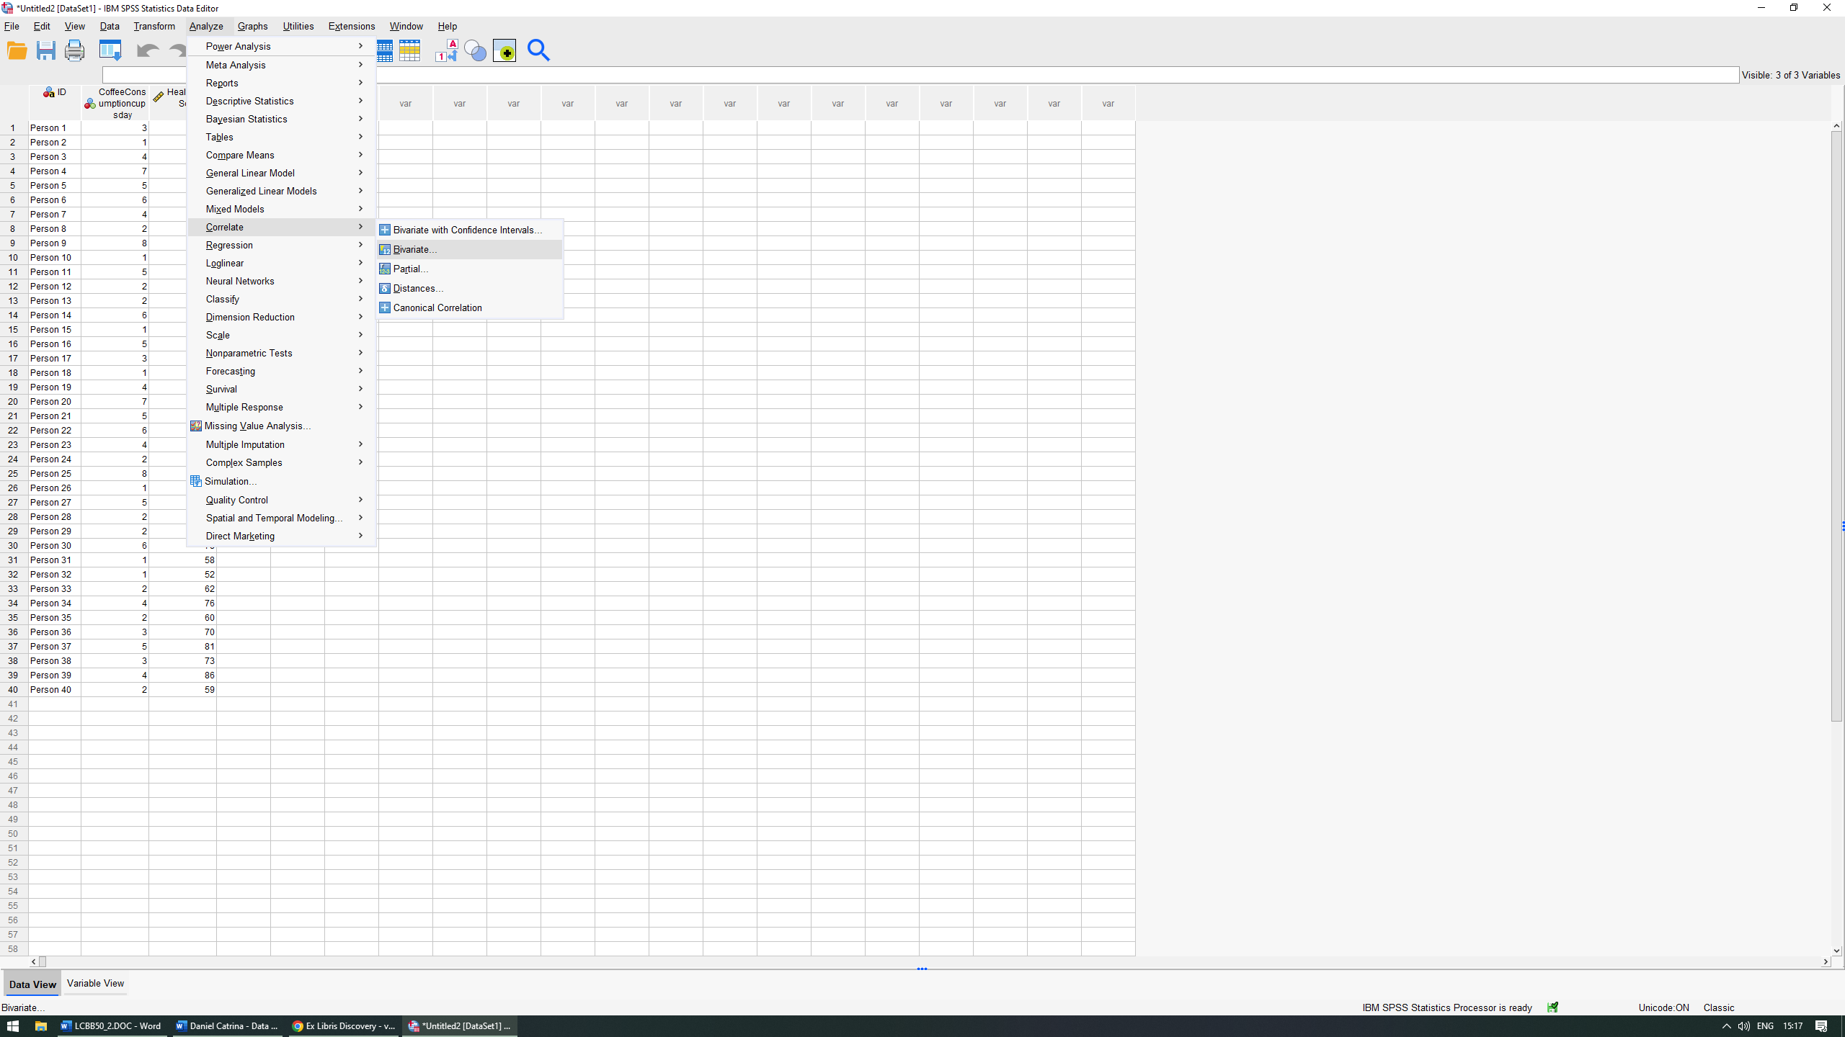
On the Bivariate Correlation panel, we must input our desired variable in the right section with the use of the arrow (in our case this would be the Coffee Consumption and the Health Index Score). 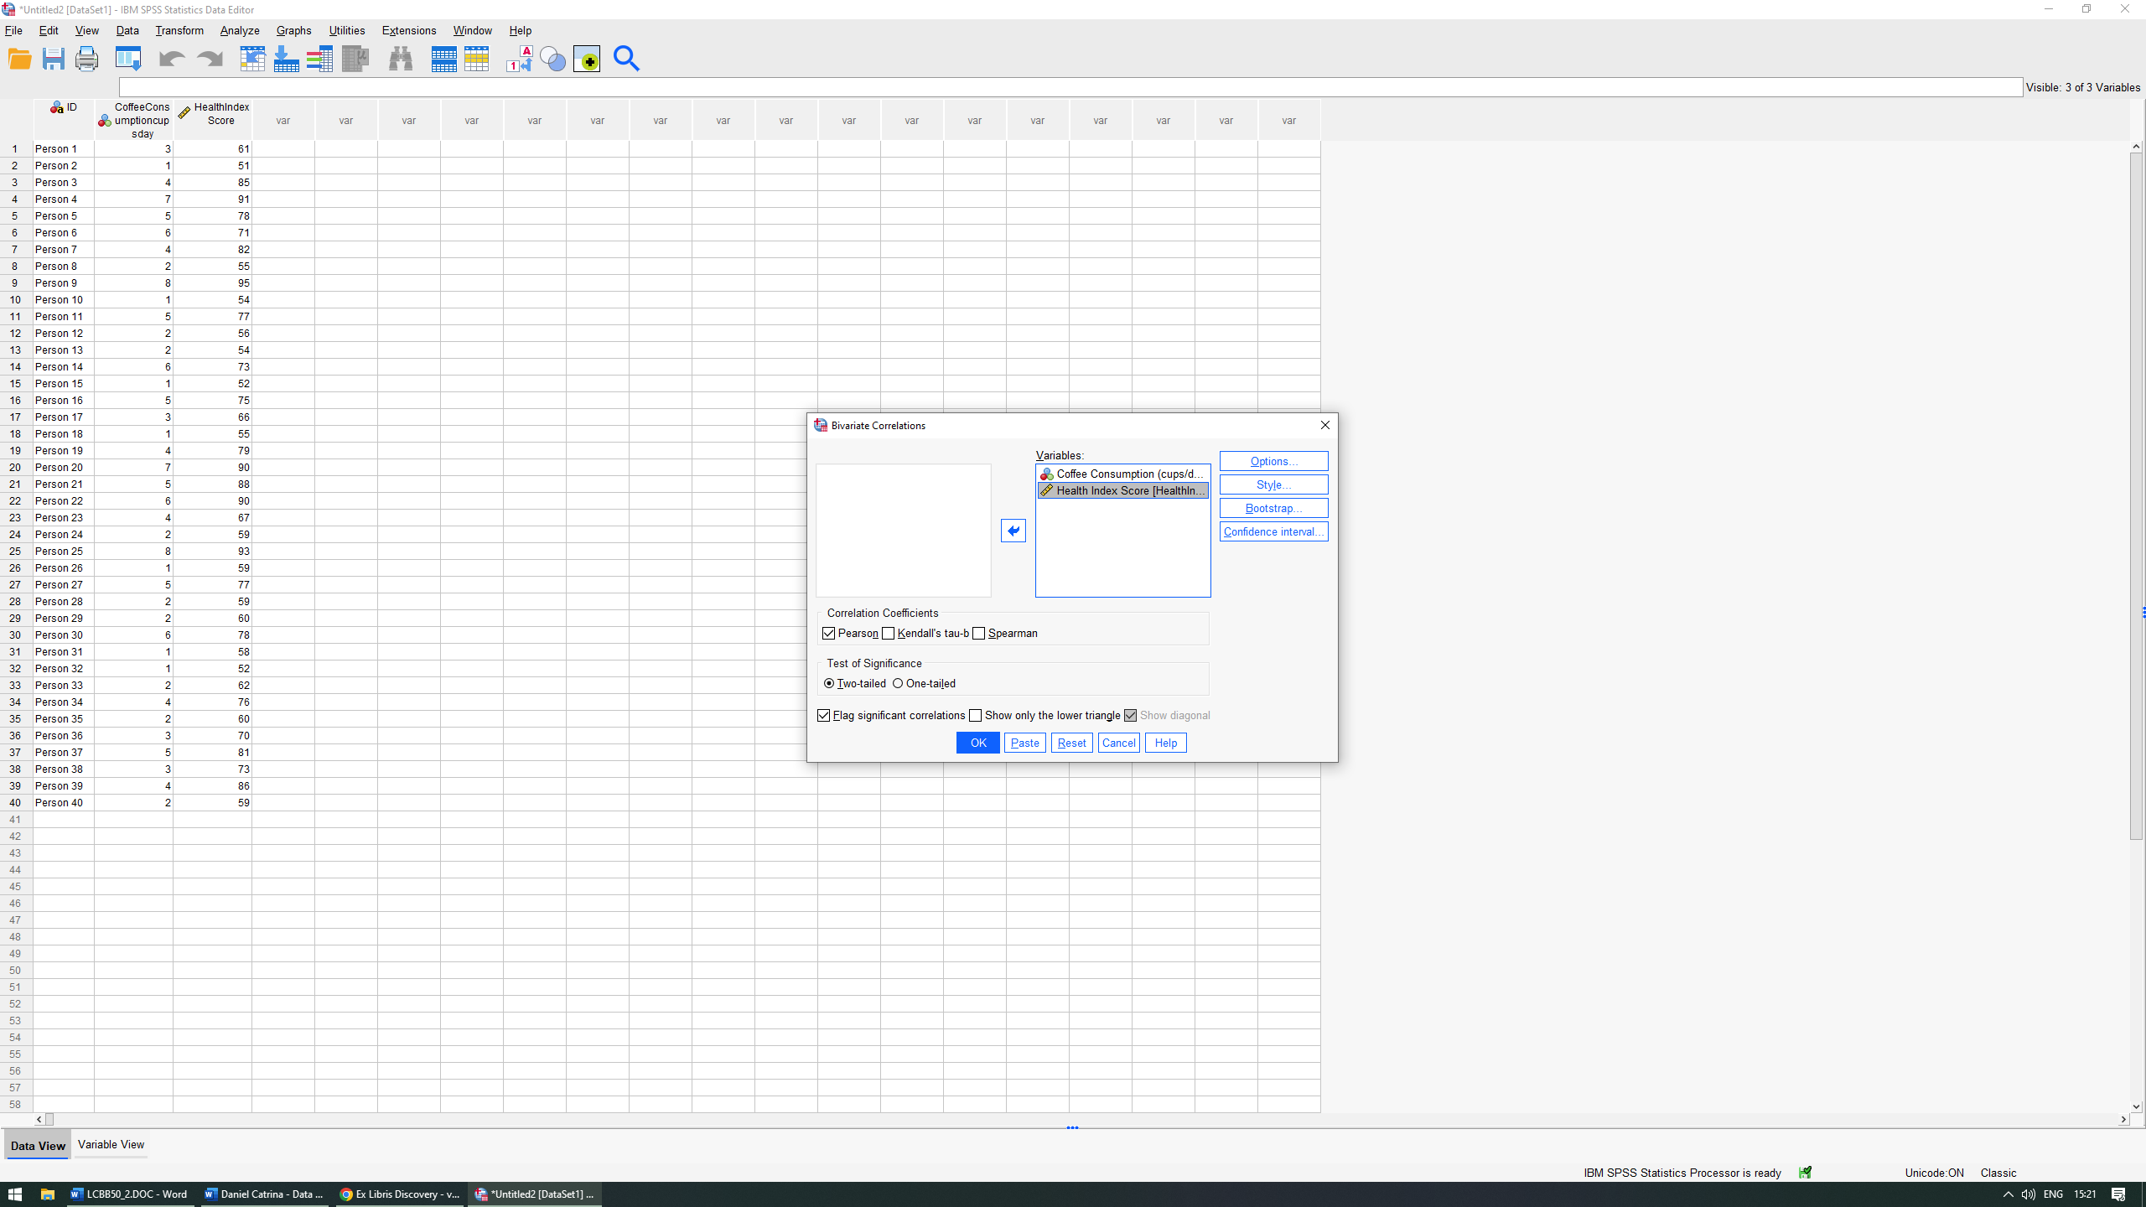
Click OK.
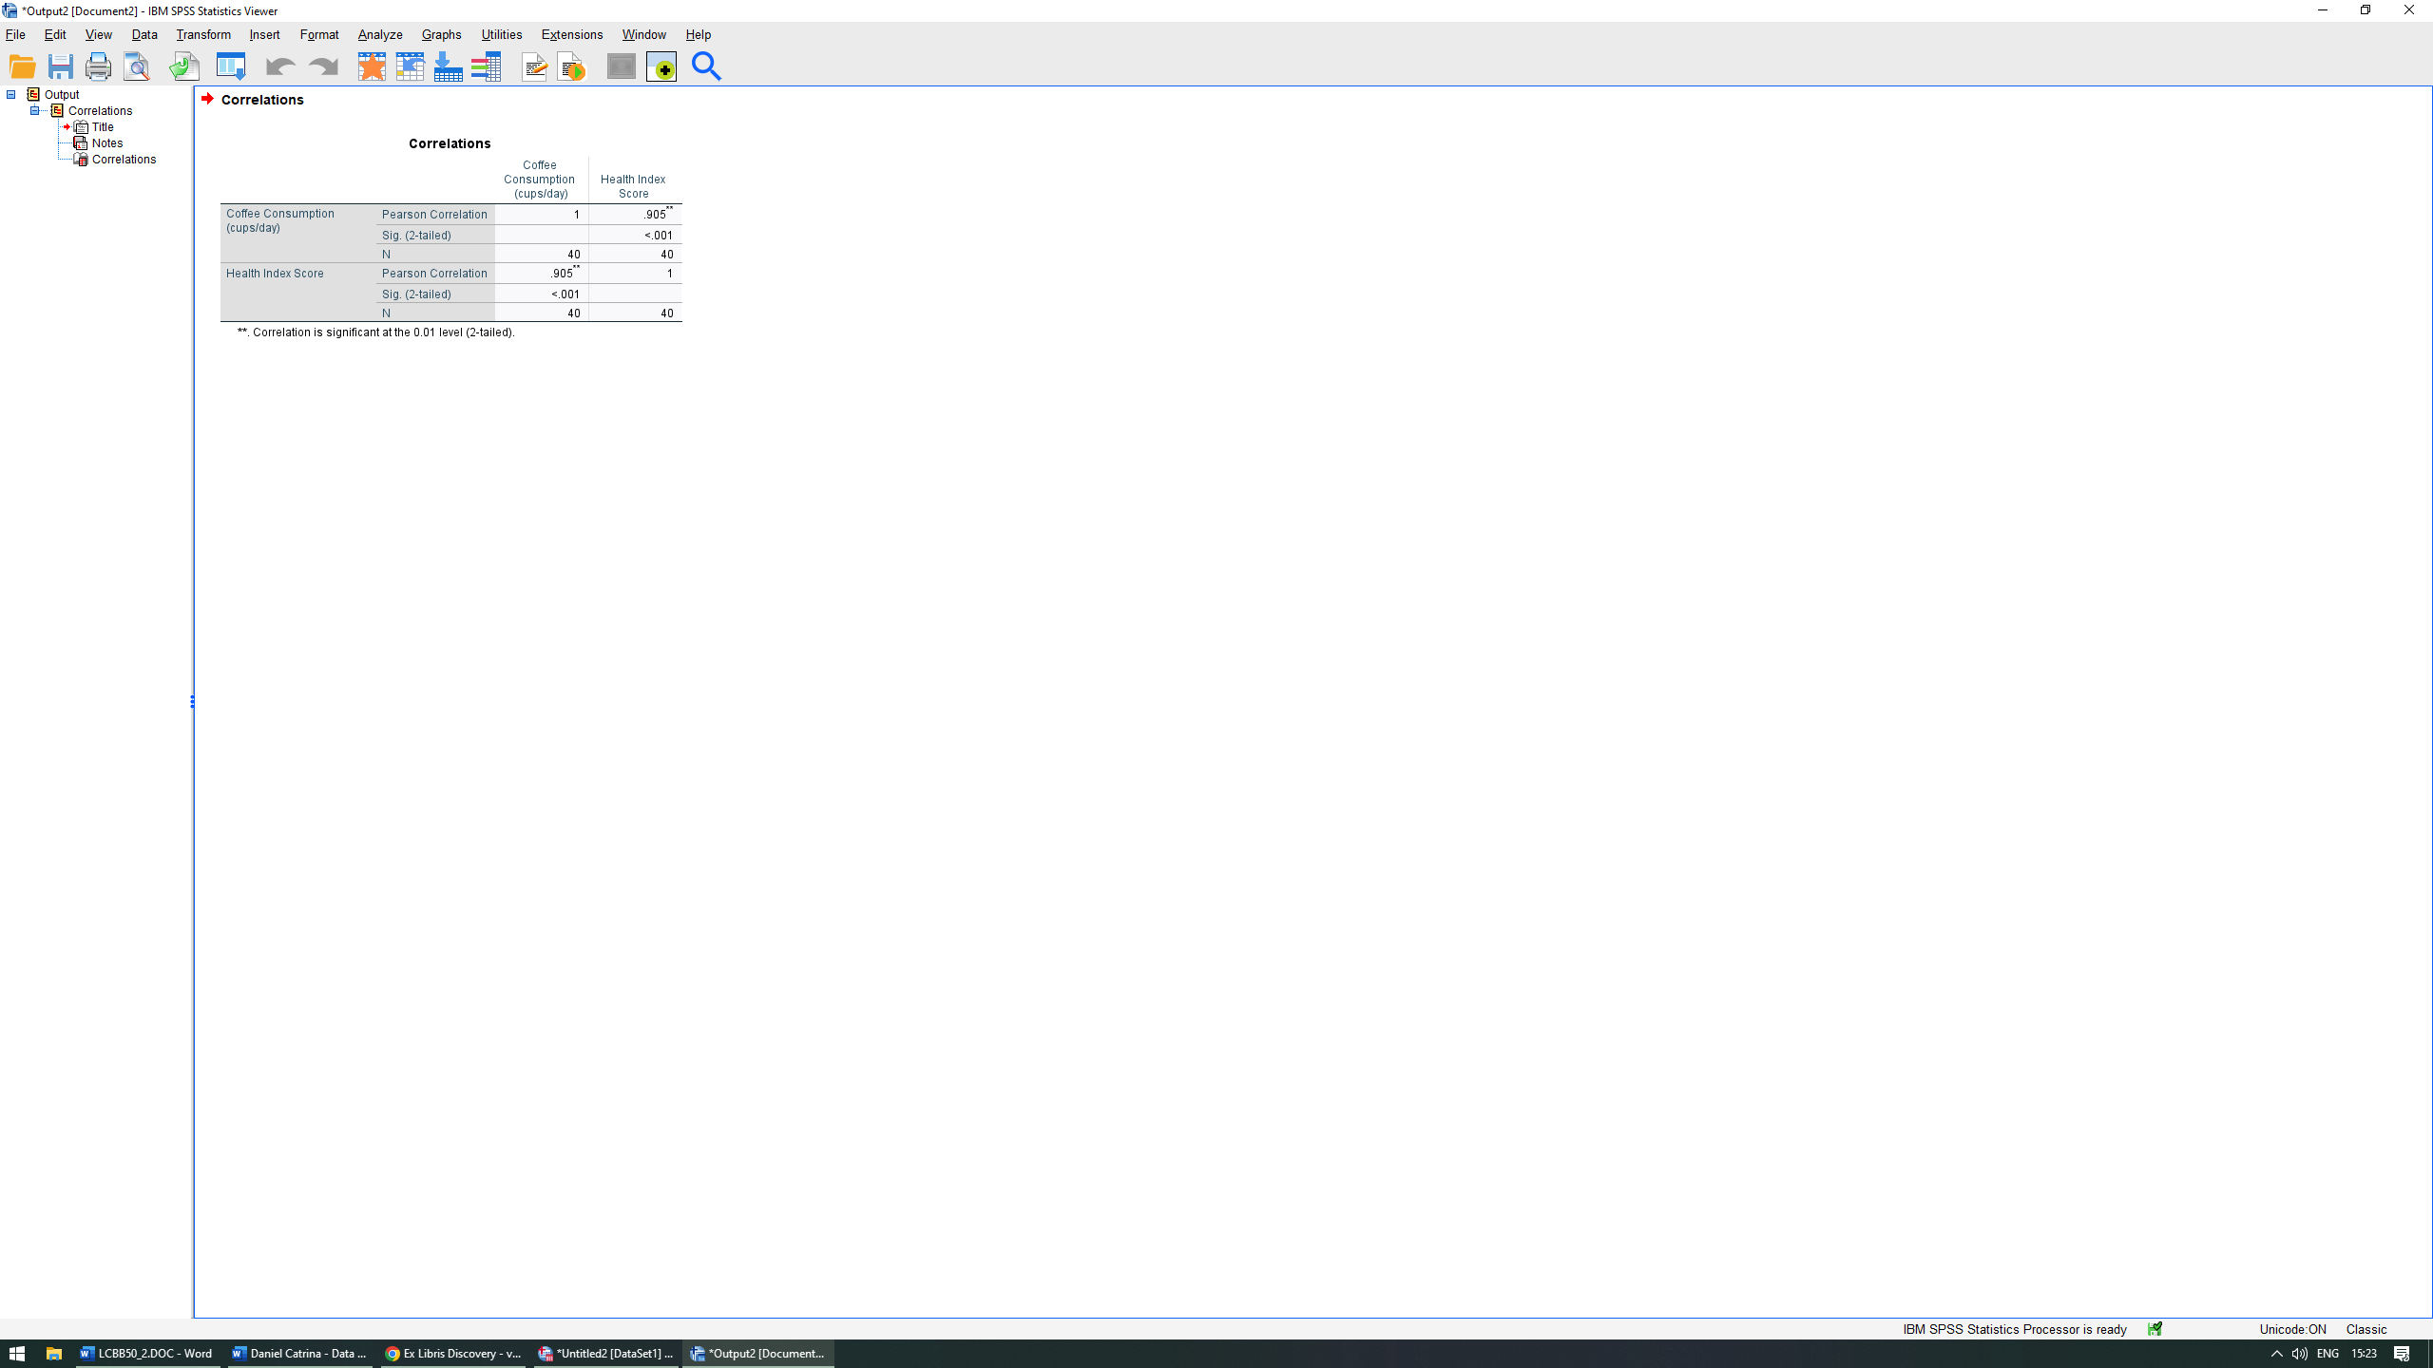

Correlations
 |  | Coffee Consumption (cups/day) | Health Index Score
Coffee Consumption (cups/day) | Pearson Correlation | 1 | .905**
Coffee Consumption (cups/day) | Sig. (2-tailed) |  | <.001
Coffee Consumption (cups/day) | N | 40 | 40
Health Index Score | Pearson Correlation | .905** | 1
Health Index Score | Sig. (2-tailed) | <.001
Health Index Score | N | 40 | 40
**. Correlation is significant at the 0.01 level (2-tailed).

As we can observe, there is a positive relation between the two variables. This could indicate that a higher consumption of coffee could result in a higher health index overall.

Scatterplot of the two variables
In order to create a scatterplot, we must first open SPSS and navigate to Graphs – Chart Builder.
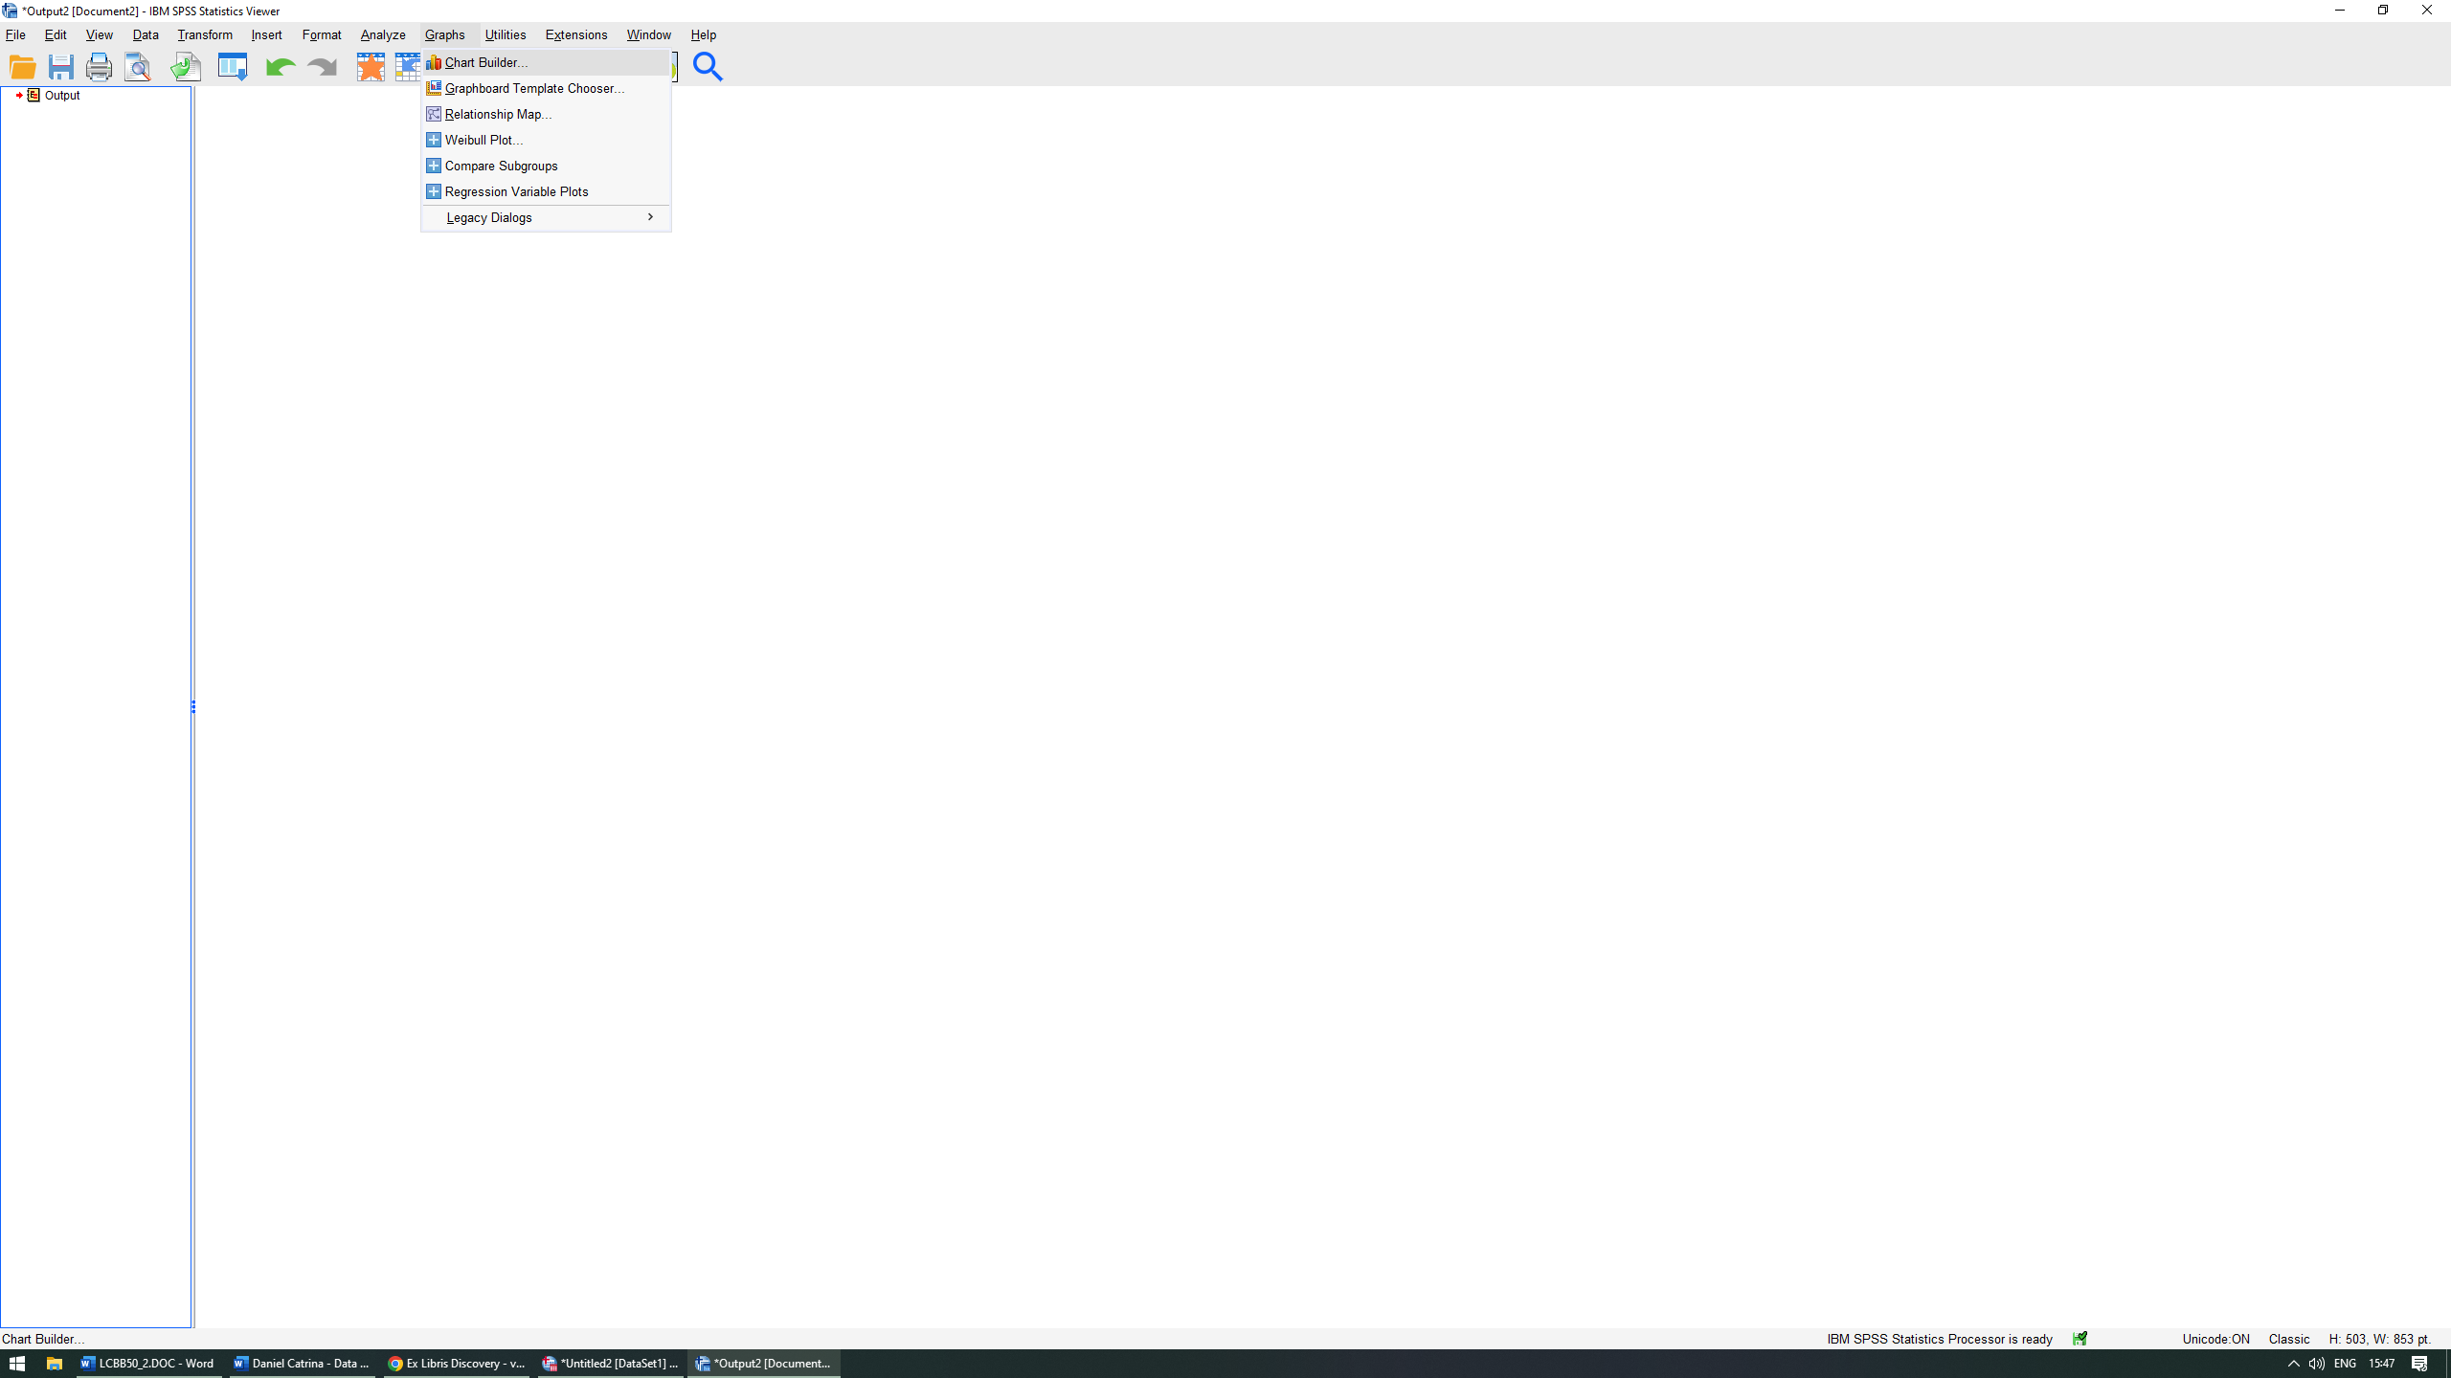
Next, in the gallery section we select Scatter/Dot and drag it in the preview panel.
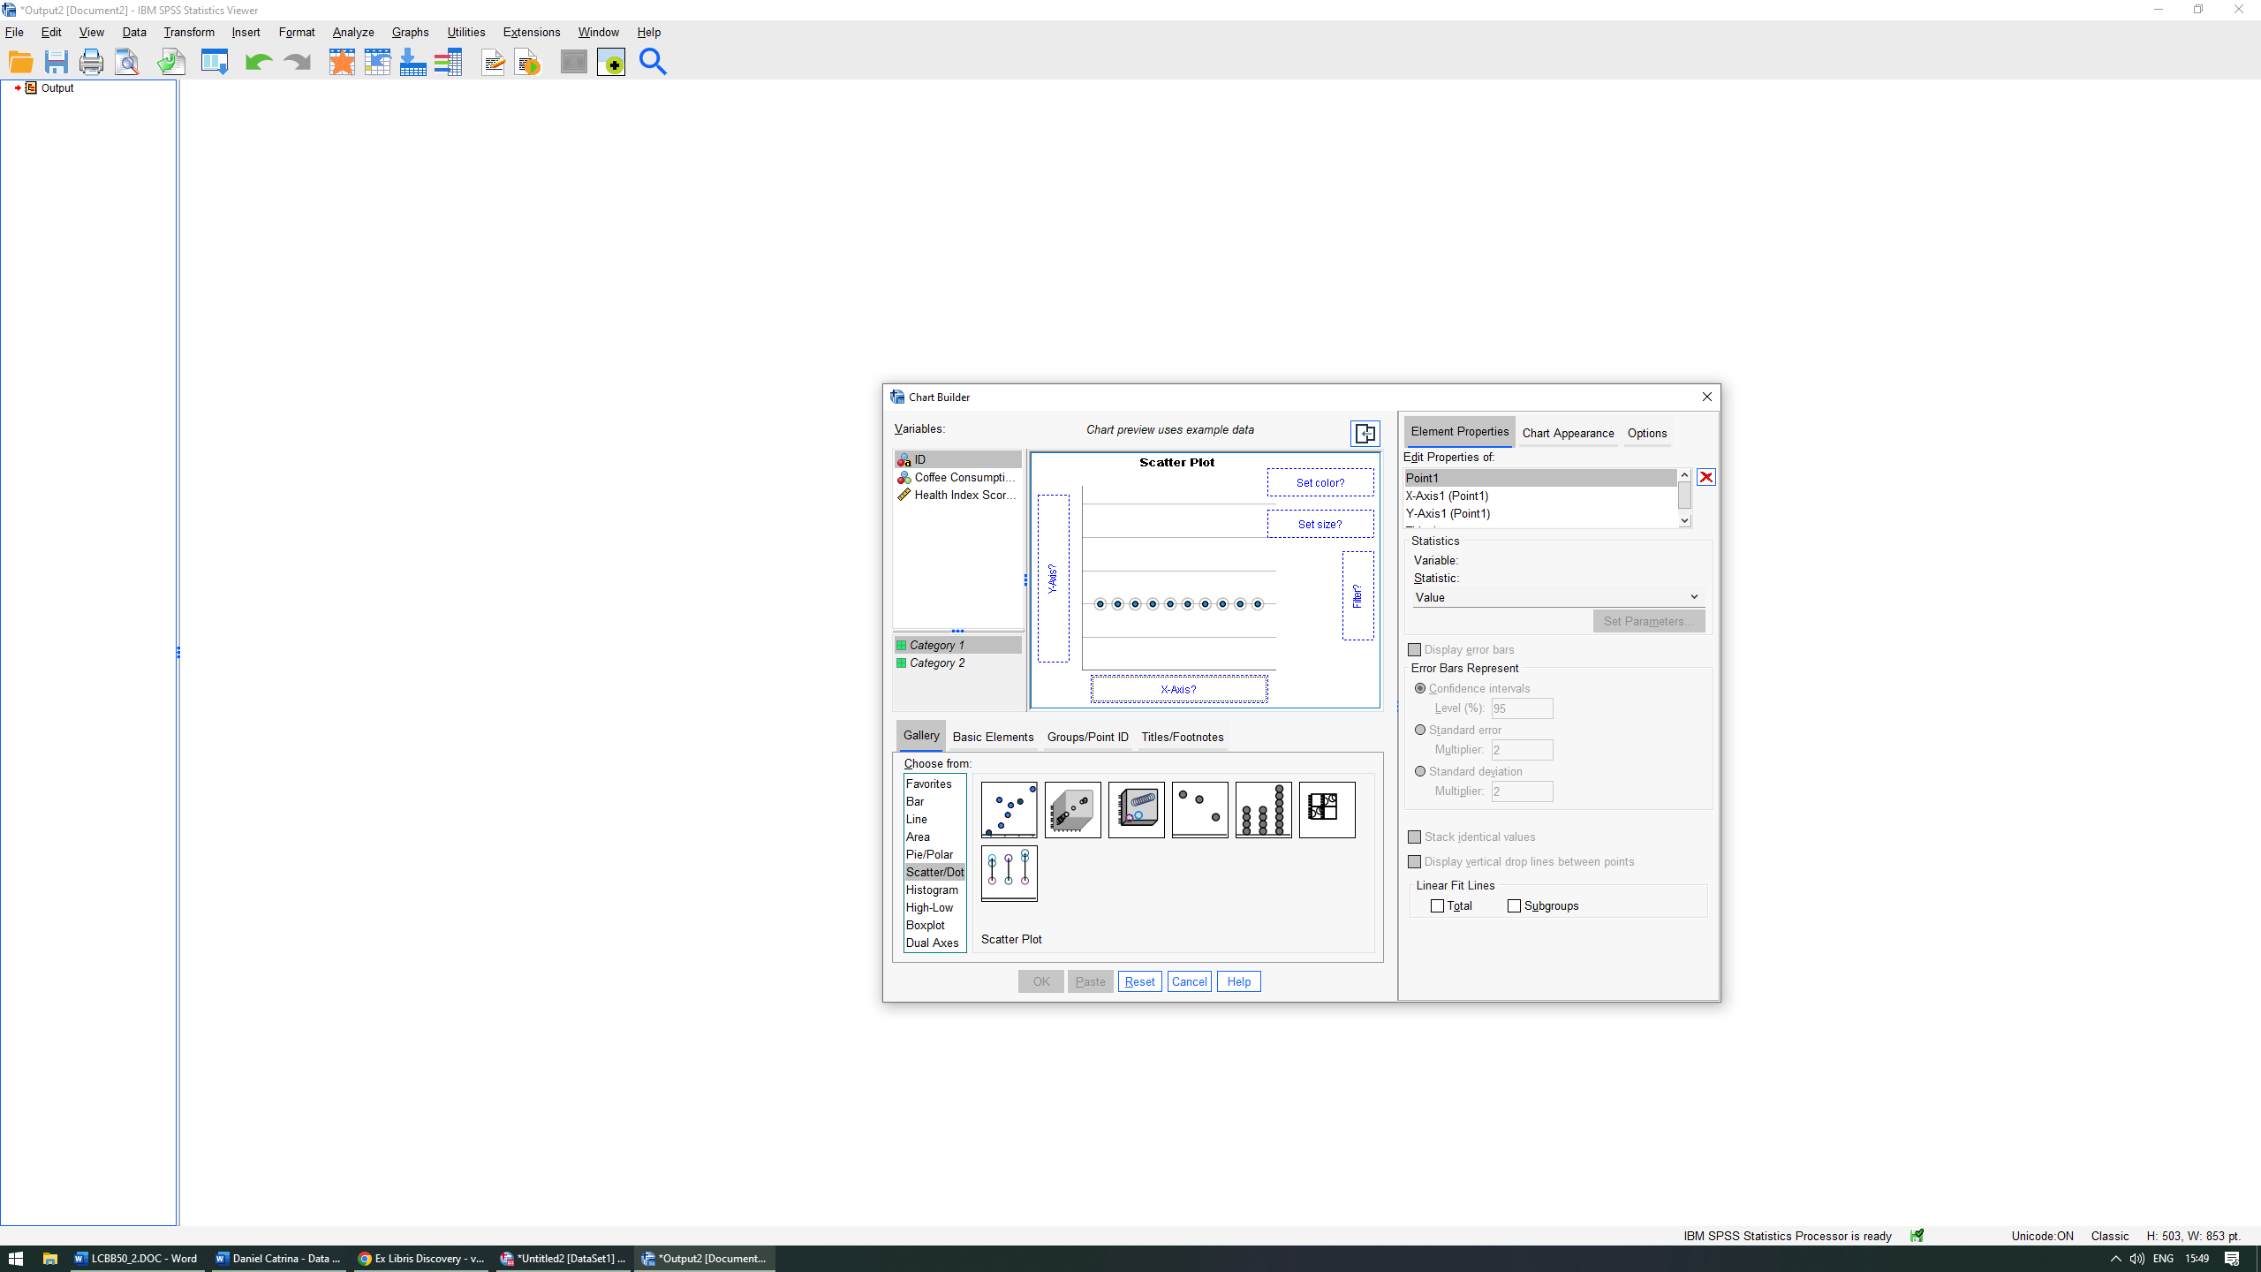

The next step is to drag our variables into the X and Y axis respectively (in our case coffee consumption on the X-axis and Health Index Score on the Y-axis). Afterwards, in the Element Properties panel we select Y-axis1 (Point1) and untick the Minimum Scale Range.
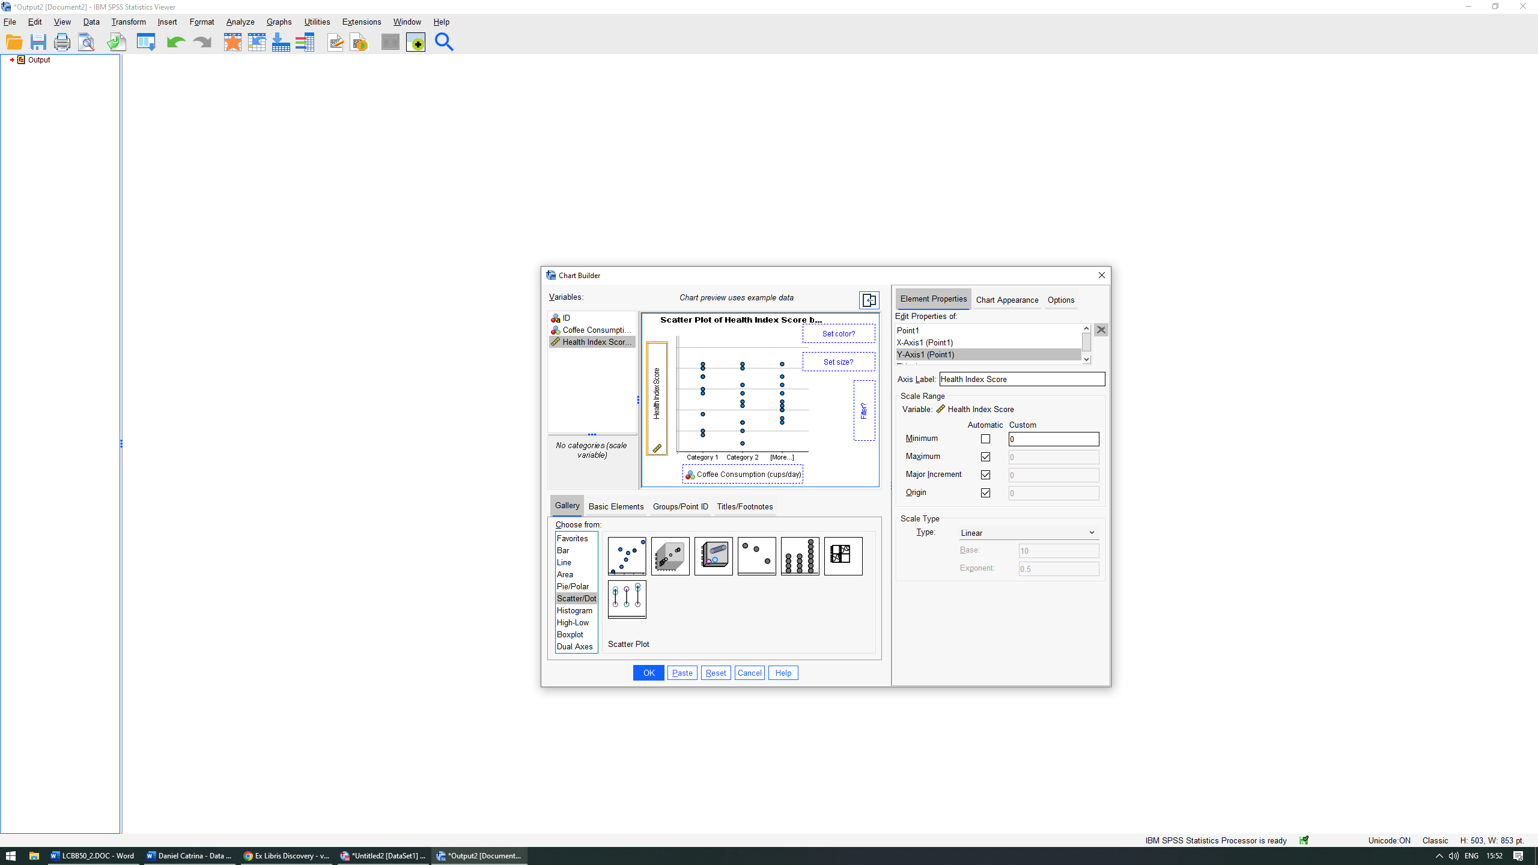
Click OK.
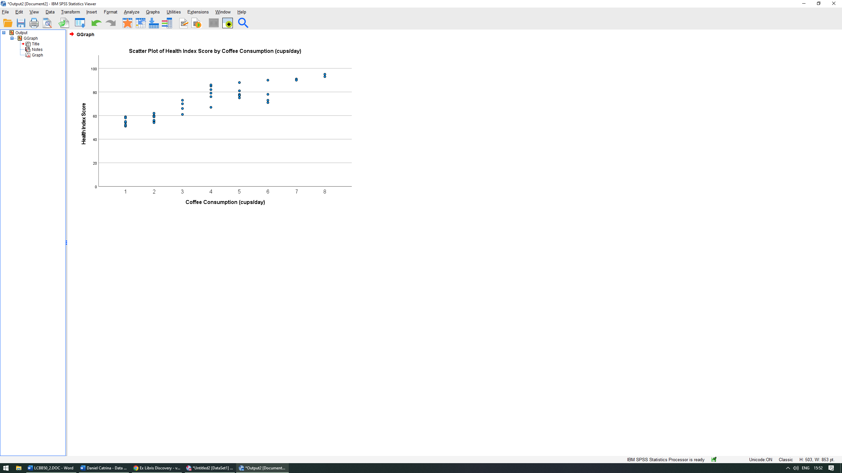

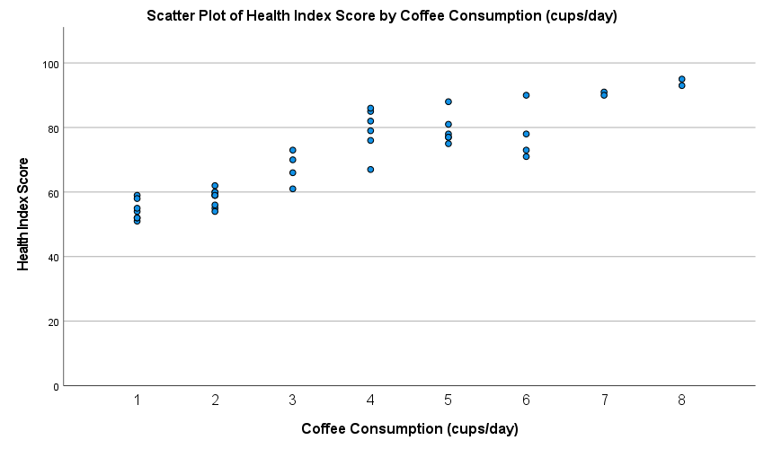

Scatterplots are graphs used to represent the relationship between two variables. In this case, we have used Coffee consumption and Health Index Score from our dataset. In a scatterplot the independent variable is represented on the X-axis and the dependent on the Y-axis.
We can observe, once again, that there is a positive linear correlation between the two variables, hence the upwards trend the graph is illustrating.

Advantages and disadvantages of using SPSS and Excel
In my next section I will focus on listing and explaining some key advantages and disadvantages of SPSS and Excel. I’ve chosen these two particular ones since I’ve been using them extensively in this report thus making them relevant to the cause at hand.

SPSS
SPSS is a well-known research, evaluation, and decision-making tool. Given its appealing features, it is one of the most extensively used statistical software in the world. SPSS enables us to perform an extensive variety of statistical analyses with little difficulty, even with the most basic of statistical knowledge on the user’s side (Hinton, 2004).
Furthermore, SPSS has been available in multiple variants for many years and has evolved into the 'industry standard' software for data analysis (Brace, Kemp and Snelgar, 2016).

Advantages of SPSS
- It provides the optimal platform for conducting numerous descriptive and inferential statistical tests. It has even been referred to as a drag and drop software, even though that would be an exaggeration.
- It’s straightforward and intuitive for the end-user.
- Has the ability to run complex statistical analysis such as factor analysis, logistic regression or cluster analysis.
- Can handle large amounts of data and has a visual appealing interface.
- Ability to import data from other sources (such as MS Excel) when said data is organized as a database (Paura and Arhipova, 2012).

Disadvantages of SPSS
- Doesn’t interpret the data output or results.
- It’s a costly solution compared to its counterparts such as R and Python which are open sourced.
- It’s maybe “too straightforward” in some cases. Exclusively using SPSS, from a user perspective, can create a dependency on its features. Thus, when the user doesn’t have access to SPSS anymore, it will be difficult to adapt to a more challenging software like R for example.
- Because it is such a “point and click” process, it limits the user in understanding why and how things are done. Thus, by not understanding the process, its impossible to understand the outcome.

MS Excel
Excel is a software owned by Microsoft that allows users to typically organize data through the use of spreadsheets. This is done with the help of functions or formulas. The outcome can then be presented in its raw form or through the use of visual aids such as charts and graphs. It is often used by business in order to make their financial analysis, task management or financial modelling.

Advantages of MS Excel
- Ability to organize data. Arguably the best attribute of Excel is its inherent ability to organize large amounts of data into orderly spreadsheets.
- Its integration and correlation with other Office software. Excel is owned and distributed by Microsoft as an Office bundle alongside other programs like PowerPoint or Word. These programs synergise with each other and for example, can allow the user to easily import or export spreadsheets into PowerPoint or Word if they so desire.
- Lower cost of purchase compared to its competitors. The Microsoft Office bundle is currently being sold as a yearly plan with the cost of £79.99/year (Microsoft, 2023).
- Learning curve. Excel can be described as an easy to learn but difficult to master software. Due to it hands-on approach, it allows the user to better understand the process behind its features. As opposed to SPSS, Excel requires more knowledge and practice in order to be used at its full capacity.
- Mastering the use of Excel is a highly sought after trait by employers. Most companies nowadays require the potential candidate to be proficient in Excel and are even required to demonstrate their abilities prior to employment.

Disadvantages of MS Excel
- Data volume. Excel cannot handle large amounts of data like its counterpart, SPSS.
- The usage of functions and formulas take a while to get used to. This could be seen as a disadvantage and advantage simultaneously. Whilst it is more difficult to learn and implement functions properly, this also allow the user to add another level of complexity to his knowledge base.
- It’s not a specialized statistical package. Although a very good tool to use in data organizing and analysis, Excel cannot surpass more complex and specialized software such as SPSS, thus making it inappropriate for advanced empirical analysis (Barreto, 2015).

Meaning and importance of Data Mining Cycle
Data mining is the process of analysing large sets of data with the purpose of extracting information and identifying trends and patterns. Data mining uses a variety of mathematical models such as regression, time series, clustering or association rules (Olszak, 2020).
The standard for developing data mining as a process is a model called Cross-Industry Standard Process for Data Mining (CRISP-DM). This model is comprised of six phases: Business understanding, Data understanding, Data preparation, Modelling, Evaluation, and Deployment (Martinez-Plumed et.al, 2021).
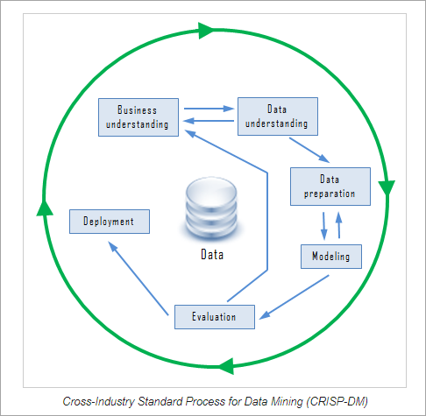
Source: Softwaretestinghelp.com, (2019)

- Business understanding.
Just like any other project, data mining start with the fundamental understanding of the objectives and requirements. Furthermore, a plan should always be produced based on the goals set out initially, the resource availability at hand and a risk assessment.
- Data understanding.
This phase is represented by the process of collecting your initial data, document its properties, visualise it and verify its quality. It is important to first understand what the data tells us in order to understand the potential opportunities and challenges for data analysis.
- Data preparation.
This phase is one, if not the most important step in the data mining cycle. It involves preparing the data for the upcoming phase, modelling. With our desired data selected, our first step is to clean it, by correcting, adding or removing values that are invalid. Cazacu and Titan (2020), states that “in this direction, we are looking for completeness, consistency and accuracy in our data”.
Next, we need to construct and integrate our data by deriving new attributes and merging said data from a multitude of sources. Lastly, if required, we need to format the data by for example giving our entries numerical values as necessary.
- Data modelling.
This phase typically involves delivering a learning algorithm with training data in order to generate a model with fixed parameters (Singh and Joshi, 2022). After determining which type of algorithm to use (regression for example), the user needs to create a test design based on his modelling approach, build the actual model and asses it by interpreting the results in concurrence with the test design.
- Evaluation.
The evaluation phase is where we establish if our generated model fits our criteria and is fit for purpose, we review our process and ensure we haven’t missed any steps and lastly, based on this information, we establish if it’s necessary to circle back and make adjustments or if the project is ready for deployment.
- Deployment.
The deployment phase can be simple or complex but generally follows a set of tasks the user needs to fulfil. Planning how and when to deploy, monitoring during the operational phase and review the outcomes and delivery considering if improvements can be made in future projects.

Conclusion
Acting as a data analyst and with the help of the provided dataset, in my report I’ve explored the impact that coffee consumption has on our participants health by generating a statistical analysis accordingly. We have observed the tendencies in coffee consumption and established the large variety of effects it can have on health. Furthermore, we have established the relationship between the two and presented our findings with the help of visual representation, as well as enlisting some key advantages and disadvantages of using SPSS and MS Excel. Lastly, the data mining cycle and its afferent steps have been presented accordingly.

References

- Barreto, H. (2015). Why Excel? The Journal of Economic Education, 46(3), pp.300–309.

- Brace, N., Kemp, R. and Snelgar, R. (2016) ‘SPSS for psychologists: (and everyone else)’ 6th edition. Basingstoke, Hampshire: Macmillan educational/Palgrave.

- Brown, T. (2021) “Coffee consumption,” British Coffee Association. Available at: https://britishcoffeeassociation.org/coffee-consumption/.
- Cazacu, M. and Titan, E. (2020) ‘Adapting CRISP-DM for Social Sciences’, Brain. Broad research in artificial intelligence and neuroscience, 11(2sup1), pp. 99–106.

- Hinton, P.R. (2004) SPSS explained. London; Routledge.

- Lee, D.K., In, J. and Lee, S. (2015) ‘Standard deviation and standard error of the mean’, Korean journal of anaesthesiology, 68(3), pp. 220–223.

- Martinez-Plumed, F. et al. (2021) ‘CRISP-DM Twenty Years Later: From Data Mining Processes to Data Science Trajectories’, IEEE transactions on knowledge and data engineering,33(8), pp.3048–3061.

- Microsoft Corporation (n.d.). Compare All Microsoft 365 Plans (Formerly Office 365) – Microsoft Store. [online] Available at: https://www.microsoft.com/en-gb/microsoft-365/buy/compare-all-microsoft-365-products.

- Olszak, C.M. (2021) Business intelligence and big data: drivers of organizational success. Boca Raton, Florida; CRC Press.

- Paura, L. and Arhipova, I. (2012). Advantages and Disadvantages of Professional and Free Software for Teaching Statistics. Information Technology and Management Science, 15(1).

- Poole, R. et al. (2017) ‘Coffee consumption and health: umbrella review of meta-analyses of multiple health outcomes’, BMJ (Online), 359, pp. j5024–j5024.

- Singh, V.K. and Joshi, K. (2022) ‘Integrating Fairness in Machine Learning Development Life Cycle: Fair CRISP-DM’, E-service journal, 14(2), pp. 1–75.

- Softwaretestinghelp.com. (2019). Data Mining Process: Models, Process Steps & Challenges Involved. [online] Available at: https://www.softwaretestinghelp.com/data-mining-process/.

- Zeller, R.A. (1999) ‘On teaching about descriptive statistics in criminal justice: Mean, variance, and standard deviation’, Journal of criminal justice education, 10(2), pp. 349–360.

