
Professional career development and importance of self awareness


Magdalena Grabowska
2029015
June 18, 2021
University of Wales Trinity Saint David

Contents

0
Introduction 2
Main Findings 3
1. Motivation and SMART goals 3
2. SWOT Analysis & Conversion 5
3. Employability 6
4. Learning Styles 7
5. Personal Development Plan 8
Conclusion 0
Bibliography 1
Appendices 2

Introduction

This reflective report covers knowledge and skills that I have acquired during the online learning undertaken through which I was introduced to the concept of self-awareness which is ‘the ability to see yourself clearly and objectively through reflection and introspection.’ ( Courtney E. Ackerman, MA., 2021) and that is our ability to recognize our own emotions and traits which leads to personal and professional development.

Professional development ‘refers to all training, certification and education that a worker needs to succeed in his or her career.’ (American Hospitality Academy World Campus., 2017). It is identifying our goals and creating a new and clear path in order to reach them, a notion that is a very important part of a career because it helps sharpen professional skills, increase productivity and efficiency and facilitates employability which leads to success.

Employability is not just about getting a job; it is ‘a set of achievements – skills, understandings and personal attributes – that makes graduates more likely to gain employment and be successful in their chosen occupations, which benefits themselves, the workforce, the community and the economy’ (Yorke, M. 2004, p.2)

I went on this self-development journey by establishing my SMART Goals, applied a SWOT analysis on my abilities and skills, I also applied conversion strategies and a detailed analysis of Myers Briggs Personality Test and VARK learning questionnaires, how I tested on them, and what sort of learner I am through these lenses. I will also cover the relevant employability skills needed to achieve the SMART Goals set. I will also be using Gibbs and Kobe’s theories to support my reflection, alongside other academic sources to ensure that I have explored all the possibilities and potential downfalls of each section.

Main Findings

Motivation and SMART goals

As a single mother who’s from Poland and living in Wales I went through a lot of struggles in order to be where I am today: I worked for 8 years from home and recently I opened my own beauty shop. However, I had found myself motivated to improve myself and in need of reaching higher objectives.
My constant need of developing myself and my career lead me to doing my hardest to reach the highest position of the permanent makeup domain. Applying Maslow Pyramid to my situation, currently I am on the last stage: Self Actualisation. ‘Maslow's hierarchy of needs is a motivational theory in psychology comprising a five-tier model of human needs, often depicted as hierarchical levels within a pyramid. From the bottom of the hierarchy upwards, the needs are: physiological (food and clothing), safety (job security), love and belonging needs (friendship), esteem, and self-actualization.’ (Dr. Saul McLeod, 2020)
After learning the SMART goal technique, I have been able to set myself a SMART goal, which is Specific, Measurable, Achievable, Realistic, and Time Bound. I have used the SMART Goal tool below to assess this, and to ensure it is something I am able to achieve:

S-Specific
My goal is to become a permanent makeup trainer by 2022.
M-Measurable
I will comply with the most recent trainings, apply them in the UK standards and teach my students the most effective methods of permanent makeup. I intend to complete a weekly course in London and obtain the title of trainer.
A-Achievable
Firstly, I must complete a permanent makeup trainer course. I plan on doing this course in august 2021. My next step will require to equip and prepare my studio for training with students. For that I have to first prepare my business plan, and all my paperwork: licences.
R-Realistic
I am qualified and experienced permanent makeup artist. Over the last 6 years I have completed lots of different courses in permanent make-up. Those courses gave me a professional knowledge and experience needed to complete my goals. I have learnt a variety of methods and techniques which I would like to share with my students.
T-Time bound
By 2022 I will be qualified as a permanent makeup trainer and I will be able to provide trainings for student in my Permanent Make Up Academy.

In order to achieve my goals, I will be using the third and fifth habits of the 7 Habits of Highly Effective People by Stephen R. Covey it is a ‘self-improvement book. It is written on Covey's belief that the way we see the world is entirely based on our own perceptions. In order to change a given situation, we must change ourselves, and in order to change ourselves, we must be able to change our perceptions’ (Anum Hussain, 2021)
Stephen Covey. The third habit is ‘Put First things First’ , I need to practice this habit because I tend to have organisational problems and I have to learn to prioritize my missions as I lean to postponing the things I have to do. The fifth habit being: ‘Seek First to Understand, then to be Understood’ I see myself as a good communicator and I have a great sense of understanding what clients need which is why they choose to come to me and this is why I need to work on being a more careful listener.

Through learning the SMART Goal technique, I can ensure that my goals are clearer and give me a focus on what I can achieve and what is unachievable, this will allow me to become much more focussed in the future and to not waste time on endeavours which are beyond my reach, by analysing the goal I will know if I am able to do it in time, and that I will be able to measure my progress with a goal meaning I will not lose my passion or focus for the goal at hand.

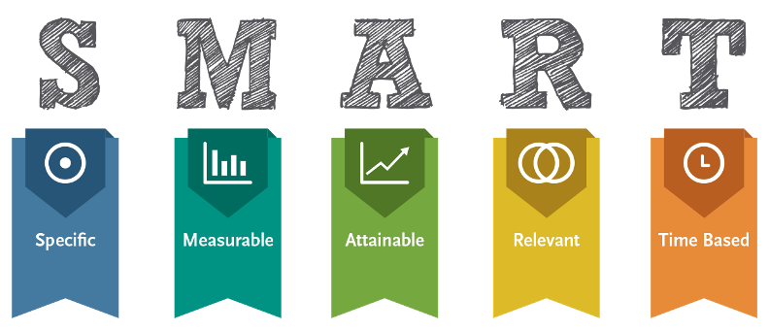

SWOT Analysis & Conversion

With my goals in mind, one challenge is the COVID-19 Pandemic which has led to the closure of my business temporarily, and has meant clients have been unable to access the services over a long period of time, and a large number of services have not been able to resume until the pandemic becomes more manageable. This had meant that I have been unable to practice the skills I have now to keep them honed.
I have been pursuing online learning to ensure my skills and knowledge remain up to date, and seeking opportunity in the face of adversity by ensuring I use the period of time where the business is closed to the greatest advantage
Originated by Albert S Humphrey in the 1960s, A SWOT Analysis is a basic, straightforward model that evaluates any concept or goal to make sure that every possibility is considered, the positive and the negative. I have conducted a SWOT analysis against my SMART Goal set above, and have found the following:

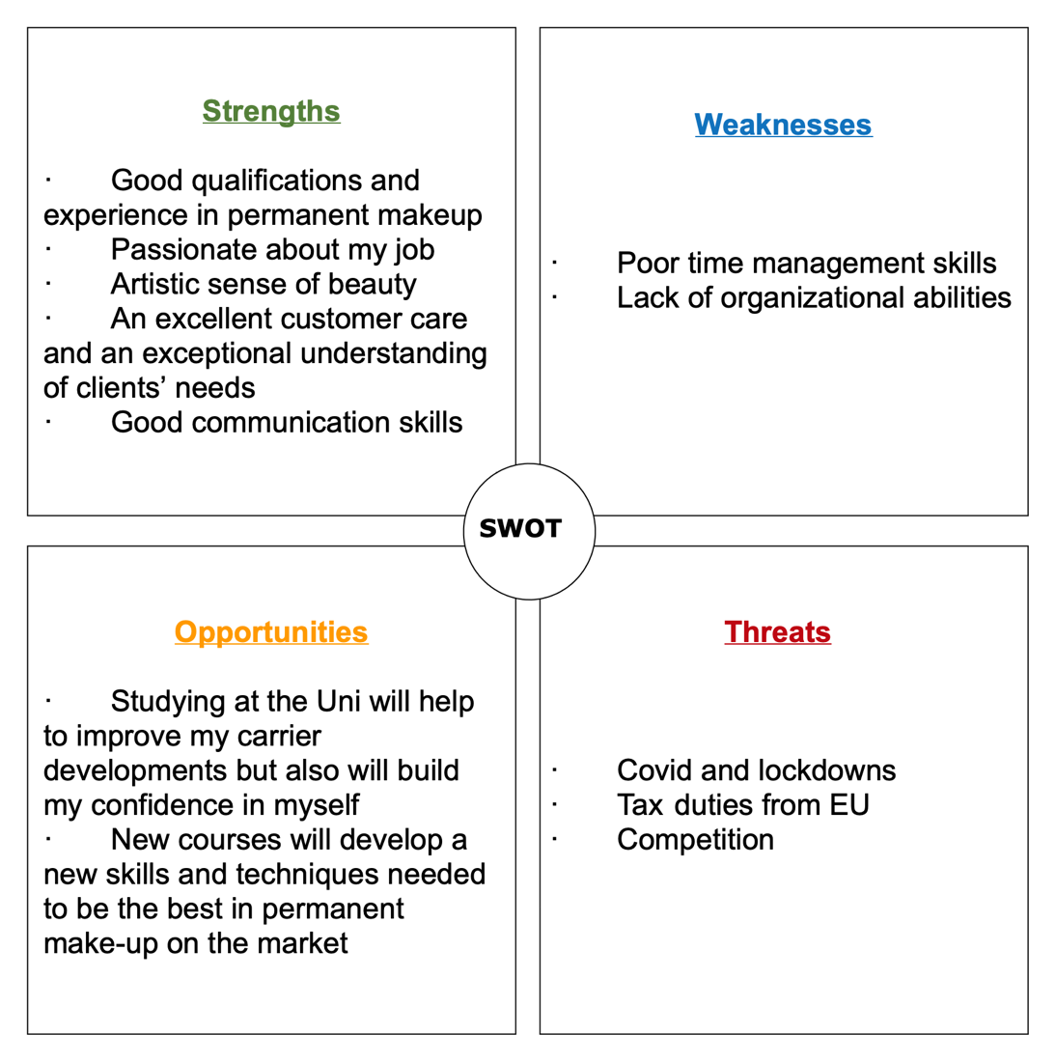
By using the SWOT Analysis, I can use this against the smart goal I have set to make sure I have considered all possibilities. Looking at the output from my SWOT analysis I found three conversions possible:
Conversion 1, Opportunity to Strength:
I am very passionate and enthusiastic about my job; I will use the opportunity of taking new courses in order to gain more skills and be the best on the market in my domain and strengthen my already existing expertise.
Conversion 2, Weakness to opportunity:
I will overcome my lack of organisational abilities by studying at the university and learning how to improve my career development.
Conversion 3, Threat to Weakness:
As I’m very busy with work and having very poor time management, the lockdown will give me more time to organise my tasks properly.

Employability

Employability is ‘A set of achievements, - skills, understandings and personal attributes – that make graduates more likely to gain employment and be successful in their chosen occupations, which benefits themselves, the workforce, the community and the economy.’(Higher Education Academy (HEA) , 2016)

In order for me to reach my goal, and after analyzing my skills through the SWOT tool, I was able to identify the gap between my current abilities and my desired objective, which is why it is necessary for me to have these skills:
The first skill would be Time management and the second one is Organizational and planning skills, I think these two skills are my real weaknesses, one can see it through the repetitive delays when answering my clients, or through forgetting to do some tasks, leaving them to the last days or hours before the deadlines. There are even other skills I want to develop as a permanent makeup artist such as my marketing and advertising competences. I will be doing that by applying the habits I mentioned above. For this I applied The Johari Window which is ‘a simple and useful tool for illustrating and improving self-awareness, and mutual understanding between individuals within a group. This model can also be used to assess and improve a group's relationship with other groups’ ( BusinessBalls , 2021) . It is a self-awareness tool, developed in 1950s by Joseph Luft and Hari Ingham
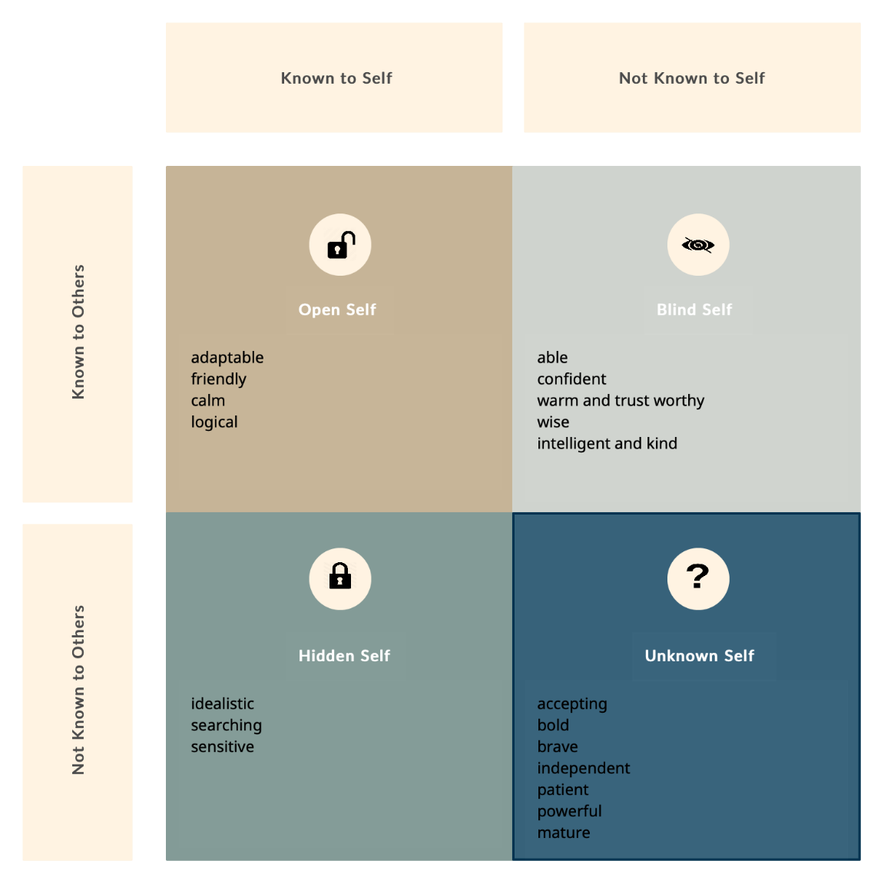

Learning Styles

‘Neil Fleming's VARK model is one of the most popular. Fleming introduced an inventory in 1987 that was designed to help students and others learn more about their individual learning preferences.’(Aron Janssen, MD , 2019) VARK
Honey and Mumford ‘The Honey and Mumford learning styles are four distinct styles of learning. The theory states that each one of us will prefer to learn using one, or at most two, of these different learning styles.’ (https://expertprogrammanagement.com/2020/10/honey-and-mumford/?fbclid=IwAR1dMwJ_gX-CxGxHuDahiilfLXzr1Ri2ZsH4Jm45bNLKVYdJWuvuOZIylRM)
Applying VARK learning style to myself, when I finished my questionnaire, I found out that the most suitable learning style to me is “very strong aural”. Aural learners learn best by hearing information, listening to audiobooks and podcasts. And I learn best by being involved and taking part of a discussion.
However, after applying Honey and Mumford, I found that I am an activist learner, which means I love new experiences , only learn by doing and by getting involved in new problems and opportunities.

Personal Development Plan

Personal development plan is the perfect way in order to know your exact objective, in order to work on them and expect the problems that will face you while trying to achieve them. This is mine :

Development objective | Specific actions | Blockers and how they will be removed | Support required | How I will know when I have achieved the objective
- Good communication with students and employees by having good presentation and I.T skills | To train and to have more courses to practice Microsoft PowerPoint, word and excel  To work on my public speaking | Being afraid of judging so I have to be able to trust my skills and knowledge | Extra courses | When my students clearly understand everything.
2. Design my academy so clients and students feel welcome and comfortable | To Hire an interior designer  To buy the necessary equipment | Budget and savings; I have to make a business plan and follow it | Working and saving more  Business Plan | When the place is stylish, beautiful and has a good atmosphere.
3. Demonstrate my skills and teaching students (theatrically and practically) | To work on my listening and teaching methods  To work on my organisational skills to demonstrate in a correct order | Facing challenging situations, I have to have wise knowledge to be able to answer, work through tough problems and make the right decisions. | Confidence and supporting materials | When my students and employees are able to do the things I do.

“The purpose of the Indicator is to implement C. Jung's (1923) theory of type. The gist of the theory is that much apparently random variation in human behavior is actually quite orderly and consistent, being due to certain basic differences in the way people prefer to use perception and judgment.” (Myers, I. B. (1962). The Myers-Briggs Type Indicator: Manual (1962). Consulting Psychologists Press. https://doi.org/10.1037/14404-000)

Conclusion

In conclusion, when I did my analysis of SMART goals “To Be a professional make-up trainer”, I understood that I need to develop some abilities such as time management and organisational and I.T skills. I found out that I have a lot of skills to improve and a lot of things to learn and figure out. After this, I discovered different theories and models, I found out that the learning method that best fit me “Very Strong Aural” which will enable me to understand how I can learn quicker. Finally, I applied all of this to my personal development plan that I will follow to reach the goal I have stated. However, I met some technical issues because of my lack of I.T skills and knowledge, but thanks to this online course and my brilliant lecturers, I was able to improve them.

Bibliography

American Hospitality Academy World Campus., 2017

Anum Hussain, 2021 : https://blog.hubspot.com/sales/author/anum-hussain

Aron Janssen, MD , 2019 : https://www.verywellmind.com/vark-learning-styles-2795156

BusinessBalls , 2021 : https://www.businessballs.com/self-awareness/johari-window-model-and-free-diagrams/
Courtney E. Ackerman, MA., 2021

Myers, I. B. (1962). The Myers-Briggs Type Indicator: Manual (1962). Consulting Psychologists Press. https://doi.org/10.1037/14404-000

Dr. Saul McLeod, 2020 : https://www.simplypsychology.org/maslow.html

igher Education Academy (HEA) , 2016) http://www.heacademy.ac.uk/employability

Translated ContentEngine LLC, 2021. Smart goals against restlessness. CE Noticias Financieras, pp.CE Noticias Financieras, 2021–02-02.

Yorke, M. (2004), Employability in higher education: what it is – what it is not, The Higher Education Academy/ESECT

Appendices

https://vark-learn.com/the-vark-questionnaire/

https://www.mint-hr.com/mumford.html

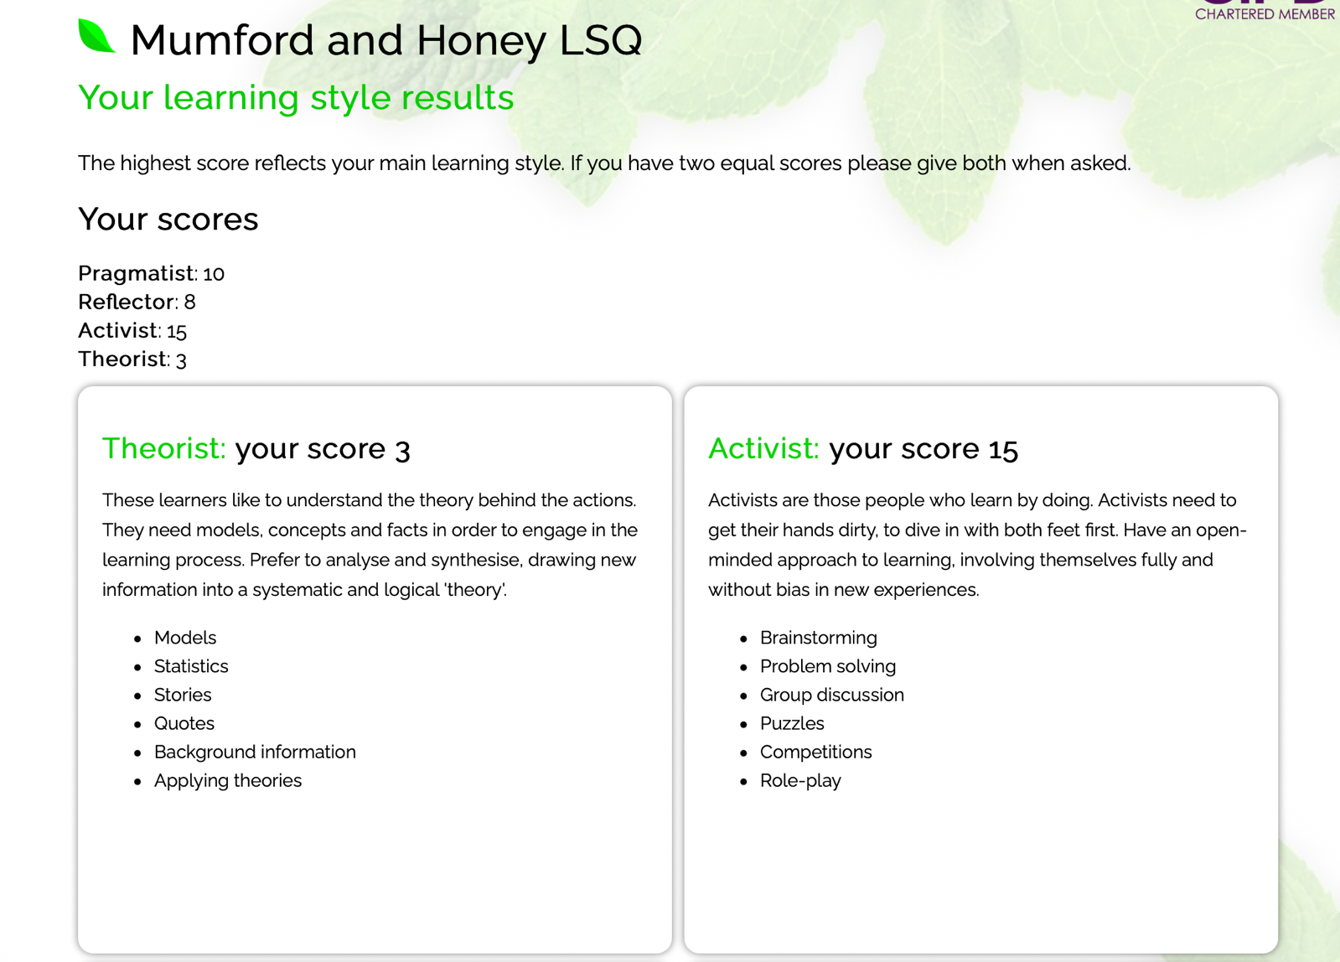

https://www.16personalities.com/free-personality-test

