INTERNATIONAL FINANCIAL MANAGEMENT A1

Lecturer: Dr Taye Timothy Osadiya

Student name:Diana Velikova

Student ID: 1916908
Contents
Essay- International Financial Management 3
References- 8

Essay- International Financial Management
Introduction-
The essay will discuss the analysis of Imperial Brands Plc Company. It is a company that is a manufacturer and distributor of various tobacco-related products to consumers. The essay will determine a detailed analysis of the business firm concerning international financial management. Some of the challenges and problems confronted by Imperial Brands Company will be presented to ensure that these challenges are overcome easily. Information about dividends and the policy of Imperial Brands Plc Company will be considered. The significance of financial management will also be explained in detail.
Importance of International Financial Management-
The management of the tasks and activities of the company is evaluated through the assistance of financial management. International financial management is the advanced financial management that guides companies and business firms in the right direction by protecting the business firm from risks and other factors (Apte and Kpashe 2020). This is an important aspect of the business as financing the business operations is important, and the company needs to manage its respective activities to improve the overall structure. Through financial management guidance, the goal of increasing the shareholders' wealth is increased.
Importance of International Financial Management in Imperial Brands Plc-
Increase in Wealth- Maximizing the company's profit has been the major target and focus towards attaining the goal. The financial management guides the business firm to increase the overall wealth of the business by providing planning on the financial operations to ensure that each tobacco production activity is allocated effectively (Apte and Kpashe 2020).
Financial Planning- Financial Management is an important aspect of business operations as procurement of funds and utilization of the same towards different activities is important. Hence, it can be said that international financial management is significant to business operations as financial planning will help Imperial Brands Company determine whether the production department or distribution sector of tobacco will provide the returns.
Planning of Tax Returns- A company's tax returns are considered essential as paying the effective tax on time helps the business organization avoid any complexities. International Financial Management guides the Imperial Brands Company in planning the tax returns to save money and ensure that the amount of taxes is paid on time (Annual Report 2021).
Challenges Experienced by Imperial Brands Company in International Financial Market -
- Exchange rate- Trading in different countries brings different challenges. One of the challenges could be the exchange rate. Modifications in the current rates bring a great problem for the company. Being a tobacco-related company, it can be said that Imperial Brands Company faces this problem to a greater extent as every country has different regulations concerning such products (Pons et al.2021).
- Political Policies- Policies such as political laws and regulations has a major influence and impact on the overall trading of a company. Imperial Brands Company has been facing this issue of the political policy of other countries. Tobacco is banned in New Zealand and Bhutan (Annual Report 2021). Therefore, Imperial Brands Company cannot trade in these countries due to their regulations and guidelines for business operations.
- Tax Rates- A country's tax rates are observed to be different for different products, respectively. Considering the case of Imperial Brands Plc Company, it can be observed that if the business trades in Australia, then a 12.5% excise duty needs to be paid (Pons et al.2021). Therefore, it can be said that different tax rates must be paid by Imperial Brands Company, making it difficult for the business to operate.
Theories Relevant to International Financial Management -
Efficient Market Hypothesis Theory- This theory has a scenario that demonstrates that price is the only factor with relevant data and information about the changes in the price level of the goods or services effectively. This theory demonstrates that to understand the changes in the price level, the factor of the price will only be relevant for the same understanding (Thune 2021).
Arbitrage Pricing Theory- The utilization of assets in a business firm depicts the return that will be generated. In simpler words, the return of assets can be projected based on the returns that have been gained in the previous years.
Modern Portfolio Theory- This theory helps select the best investments and projects to improve the overall portfolio by selecting those investments that will help provide the best and most effective return to reduce the level of risk that might affect the business structure.
Dividend Distribution Policy of Imperial Brands Plc-
The value of capital invested by the shareholders is returned in the form of dividends. This value is generated as a profit to the shareholders or as the return against the value invested for the company. The dividend amount is decided by the company's management and as per the value of the capital amount being invested accordingly (Husain et al. 2020).
Imperial Brands Plc applies a stable dividend policy for its shareholders. The stable dividend policy is one of the policies where the dividend payments are made to the shareholders, and the dividend value is received on a scheduled basis. However, the dividend rate is not fixed (Husain et al. 2020). In simpler words, this dividend policy is considered effective as the investors find such policy effective and income-oriented accordingly.
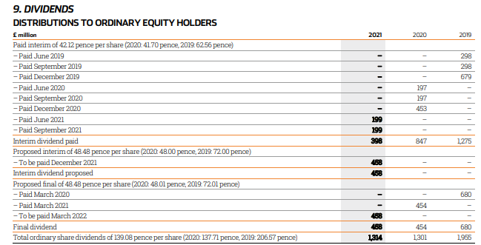
(Source: Annual Report 2021).
The dividend policy of the Imperial Brands Company has been shown above. The payments of dividends demonstrate that stable dividends are being provided to the shareholders of Imperial Brands Plc Company. The dividend payments are considered stable dividends as it can be observed that the dividends are being paid on a fixed, regular basis. However, the rate is not fixed. The interim dividends are being paid every quarter, hence, being regular. The dividend payments show that the company has been paying the effective amount of dividends (Husain et al. 2020).
Efficient Market Hypotheses Theory in Imperial Brands Plc Company-
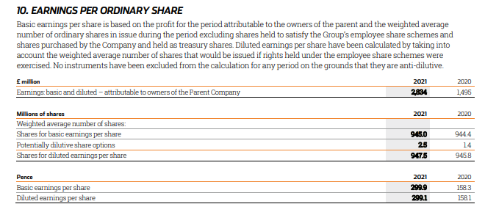
(Source: Annual report, 2016).
The company's dividend payments are deriving that the stable dividends are being paid to the shareholders of the company, i.e. Imperial Brands Plc Company. The efficient market hypothesis theory demonstrates that the price level changes are inside the shares' price level. Based on the dividends being distributed, it can be observed that the dividend per share has been reduced. It has been reduced from 2019 to 2021 (Thune 2021). The main reason behind such a reduction in the company's overall dividends is more retained earnings.
The company's earnings per share have increased from 2020 to 2021. However, the payment of dividends has been low. This shows that the company has saved more towards retained earnings. Therefore, per the efficient market hypothesis theory, it can be said that changes in the price level of goods and services have been because of the changes in the earnings per share and low dividends per share (Thune 2021). In Imperial Brands Plc Company, it can be determined that the application of efficient market hypothesis theory has been in the operations of the business structure accordingly.
Imperial Brands Company's Methods of Appraising Projects-
Payback Period- It is one of the methods of appraising the projects to generate the return as and when the amount of capital is being invested. The amount being invested determines the return of the company. Through the help of the payback period, it can be observed that this method guides the company to generate the period in which the company will receive the returns. Most companies use such a period to understand the value of the return that will be received (Pons et al. 2021).
Net Present Value- Another method of appraising a project is the net present value. A company using the application of net present value as a method understands the return effectively. The guidance of net present value as a method of appraising the projects helps Imperial Brands Plc Company to evaluate the business operations more effectively. (Pons et al. 2021). Through this method, it is easier for the operations to understand whether the company can earn a good amount of money in the future period or not.
Imperial Brands Plc Company uses the above two methods to appraise their projects and ensure that effective results will be gained.
Conclusion-
The above essay has concluded the detailed analysis that is being carried out for Imperial Brands Plc Company. The essay has included the significance of the financial market. It has been derived that the application of such international financial management brings many benefits to the business of Imperial Brands Plc. Therefore, the application of the same will lead the structure of Imperial Brands Plc Company to improve respectively. The dividend policy adopted by Imperial Brands Plc Company is stable accordingly.

References-
- Annual Report (2021). Imperial Brands Plc Company (online). Available at: https://www.imperialbrandsplc.com/content/dam/imperialbrands/corporate2022/documents/investors/reports/annual-report-2021.pdf.downloadasset.pdf Accessed on: 12th July 2022.
- Apte, P.G. and Kapshe, S., 2020. International Financial Management|. McGraw-Hill Education.
- Kadim, A., Sunardi, N. and Husain, T., 2020. The modeling firm's value based on financial ratios, intellectual capital and dividend policy. Accounting, 6(5), pp.859-870.
- Madura, J., 2020. International financial management. Cengage Learning.
- Pons, A., Cristobal-Fransi, E., Vintrò, C., Rius, J., Querol, O. and Vilaplana, J. (2021). An Application of the IFM Method for the Risk Assessment of Financial Instruments. Computational Economics, pp.1-21.
- Thune, K. (2021). Efficient Market Hypothesis (EMH) (online) The Balance. Available at: https://www.thebalance.com/efficient-markets-hypothesis-emh-2466619 Accessed on: 12th July 2022.

