+

Tiegen Lillicrap
P149406
Tlillicrap.149406@studnet.uwtsd.ac.uk
Abstract
A report summarizing the subsequent effects to vehicle handling and performance when modifications to the aerodynamic configuration are made. Consideration is also given to factors such as rake and ride height.
Aerodynamic Vehicle Testing and Analysis
Advanced Vehicle Dynamics – M6X00415

Contents
1.0 Introduction 3
2.0 Methodology 4
2.1 Test Plan 4
2.2 Calculations 5
Total aerodynamic Lift Coefficient 5
Rolling Resistance and Total Aero Drag 6
2.3 Motec 8
2.3.1. Constants 8
2.3.2 Expressions 9
2.3.3 Channels 10
3.0 Analysis 11
3.1 Straight Line Test 11
3.2 Coast Down Test 12
3.3 Circuit Lap Testing 16
3.4 Ride Height and Rake Angle Study 21
3.5 Understeer Consideration 26
4.0 Conclusion and Evaluation 28
References 29
Appendix A - Test Plan 32
A1 - Calculating the Coefficient of Lift and Drag for Multiple Aerodynamic Configurations 32
A2 - Investigation of Ride Height and Rake Angle 33
A3 – Schedule: 2 hours 34
Appendix B – Motec Equations 34

Table 1: Table of Simulator Tests (Lillicrap, 2018) 4
Table 2: Table of Math Channels (Lillicrap, 2018) 10
Table 3: Key for Figure 11 (Lillicrap, 2018) 16
Table 4: Key for Figure 12 (Lillicrap, 2018) 17
Table 5: Table of Driver Feedback (Lillicrap, 2018) 21
Table 6: Schedule (Lillicrap, 2018) 34
Table 7 : Motec Equation Reasoning (Lillicrap, 2018) 34

Figure 1: Example of Velocity-Time Graph for Coefficient of Lift Calculations (Lillicrap, 2018) 5
Figure 2: Example of Velocity-Time Graph for Rolling Resistance Calculations (Lillicrap, 2018) 6
Figure 3: Motec Constants (Lillicrap, 2018) 8
Figure 4: Motec Expressions (Lillicrap, 2018) 9
Figure 5: Motec - Straight-Line Test with Wings Equal Configuration (Lillicrap, 2018) 11
Figure 6: Straight-Line Test - Downforce and Cl Results (Lillicrap, 2018) 11
Figure 7: Example of Coast Down Test in Motec - Wings Equal Configuration (Lillicrap, 2018) 12
Figure 8: Graph of drag force and Cd (Lillicrap, 2018) 13
Figure 9: Aerodynamic Efficiency (Lillicrap, 2018) 14
Figure 10: Graph of Centre of Pressure (Lillicrap,2018) 15
Figure 11: Downforce and Understeer Comparison for Wings Equal, Max and Min Configurations (Lillicrap, 2018) 16
Figure 12: Downforce and Understeer Comparison for Wings Equal, Fmax/Rmin and Fmin/Rmax Configurations (Lillicrap, 2018) 17
Figure 13: Graph Comparing Downforce and Lap Times (Lillicrap, 2018) 18
Figure 14: Graph Comparing Downforce and Centre of Pressure for Circuit Tests (Lillicrap, 2018) 18
Figure 15: Motec Screenshot of Various Handling/Driving Style Channels (Lillicrap,2018) 19
Figure 16: Downforce Scatter Graph (Lillicrap, 2018) 20
Figure 17: Areo Drag Scatter Graph (Lillicrap, 2018) 20
Figure 18:Graph of Lap Time, Centre of Pressure and Rake Angle (Lillicrap, 2018) 22
Figure 19: Graph of Downforce and Rake Angle (Lillicrap, 2018) 23
Figure 20: Motec Screenshot of Various Handling/Driving Style Channels (Lillicrap, 2018) 23
Figure 21:Graph of Ride Height and Rake Angle Effects on Cop and Lap Time (Lillicrap, 2018) 24
Figure 22:Motec Screenshot of Handling/Driving Style Channels for Ride Height Test (Lillicrap, 2018) 24
Figure 23: Graph of Ride height and Downforce (Lillicrap, 2018) 25
Figure 24:Front Right Tyre Information (Lillicrap, 2018) 26
Figure 25: Tyre Information for Front Left (Lillicrap, 2018) 27

1.0 Introduction

Over the last few years, the application of simulators within motorsport has increased dramatically, so much so that many F1 teams will have a consistent driver in the simulator at the factory during qualifying and practice sessions to verify and aid with the analysis of problems experienced by drivers on track. This report covers an analysis into how and to what extent variations to a vehicles aerodynamic set-up have on a vehicle performance, with a specific investigation into effects on handling. Typically, when testing aerodynamic devices multiple test procedures are applied including wind tunnels and on-track testing. However, for this report all testing was carried out using a Base Performance Simulator, driven by Andrew Noble with all test using either the Skid-Pan or Pembrey Race Circuit.
The vehicle used for the testing within this report was a GP2 circuit car, as the feeder series to F1, the GP2 cars were designed to be only one step below the performance of the top tier cars. However, unlike F1 the aerodynamics do not vary over the course of the season meaning it is crucial to get the best set-up from the start.
As detailed by the test plan, numerous laps of the circuit were completed with a 0.3 second consistency and with minimal variation in driving style to ensure the repeatability of results. Multiple aerodynamic set-ups were applied to the vehicle and a range of tests done to determine the vehicle sensitivity to changes in ride height and rake angle. Throughout consideration was given to driver feedback as research shows the more comfortable a driver is the greater their performance level is, and thus more competitive results are obtainable.
Initially it can be hypothesised that when aerodynamic set-ups are put to the extremes the performance levels of the vehicle will be highly effected and typically the vehicles performance reduces drastically. Hence it is expected that conclusions will reveal it is necessary to compromise between the extremes for a more comfortable and better performance vehicle.

2.0 Methodology

2.1 Test Plan

Every project needs a disciplined and well thought out plan to ensure the quick completion of tasks and prevent delays from occurring (Forsyth, 2013). Making a detailed test plan before commencing allows for all the individuals involved to fully comprehend the nature of the tasks at hand. Easy to follow test plans, with simple instructions help make test sessions flow as smoothly as possible and certify that all the necessary data is collected and appropriately recorded (Kerzner, 2017).
A detailed test plan was produced and can be found with appendix A. The simulator test allows for multiple vehicle set-ups to be easily tested. The combination of slow, medium and high-speed corners provides a collective overview of the entire vehicle’s behaviour through a range of scenarios, thus allowing data for almost all the driving parameters to be collected (Niegzgoda, et al., 2011).
For the circuit lap tests the driver was instructed to continue driving until 3 laps were completed within 0.3 second difference of each other. Pembrey Circuit was used as being a short circuit it allowed a higher number of laps to be completed within the test session available. The data collected will also be minorly effected by gradient change from this circuit as there is minimal elevation change.
The implemented tests are:
Table 1: Table of Simulator Tests (Lillicrap, 2018)
Test | Reason for Test
A Straight-Line Constant Speed Test – 5 runs at 4th Gear Limiter: | Test defines the coefficient of lift. In real life this test would be run in both directions to determine the extent of wind however the simulator does not model wind, so it is not necessary for this report. According to Alex Somerset, former chief of Triple Eight Racing, straight line testing is still the most effective way of testing the aerodynamic set-up of a vehicle (McBeath, 2015)
A Coast Down Test – 5 runs from 3rd Gear Limiter in neutral to stationary | The results of this test determine the rolling resistance of the vehicle; however, this only works if it is assumed that the aerodynamic forces are negligible at low speeds. This then allows purely the aerodynamic resistive forces to be calculated and therefore the coefficient of drag can be found. This method is preferred over wind tunnel testing as the results achieved are not so greatly affected by ground plane simulation problems or model scale issues (R.A.White & Korst, 1972).
Circuit Laps testing multiple aerodynamic set-ups | This test shows the outcomes of varying aerodynamic loads on the vehicles handling. When paired with driver feedback, the data can be used to assess the understeer/oversteer handling characteristics of the vehicle. This test also shows the vehicles sensitivity to aerodynamic modifications.
Ride Height Circuit Test | Various ride/rake set-ups were tested to assess the effect ride height has on both the aerodynamic and overall performance of the vehicle.
Rake Angle Study | Multiple rake settings were applied to the vehicle and monitored throughout circuit laps again this assesses how alterations result in changes to the handling and performance.

2.2 Calculations

Total aerodynamic Lift Coefficient
To calculate the coefficient of lift, first the total aerodynamic load must be determined. Below is an example of a velocity-time graph.
At 1: Velocity, acceleration and weight transfer all equal 0.
At 2:
- Velocity = V₁
- Acceleration = a₁
- Weight Transfer = WT₁
At 3: Vehicle is at constant speed.
- Velocity = V2
- Acceleration = 0
- Weight Transfer = 0
1
1
2
3
Velocity
Time
The three points on figure 1 can be used to summarise the change is resisting force throughout a vehicle’s movement. At point 1, the vehicle is stationary meaning there is currently no aerodynamic loading hence the resisting force experienced by each tyre can be added to give the weight of the vehicle. During acceleration (point 2) the vehicle experiences tyre loading from both the aerodynamic changes and the weight transfer of the vehicle thus it is difficult to distinguish between the two loadings. However, at point 3 the vehicle reaches a constant speed and the resulting weight transfer cancels. This happens as weight transfer is a result of the longitudinal acceleration shifting the weight to one end of the vehicle but at constant speed the weight doesn’t move as the longitudinal acceleration equals 0 (Jalali, et al., 2013). Thus, the resisting force is only the tyre loads and the aerodynamic load and gives the following equations:
Figure 1: Example of Velocity-Time Graph for Coefficient of Lift Calculations (Lillicrap, 2018)
$$R_{f}=\left({FL}_{o}+{FR}_{0}\right)+{Aero}_{f}$$
$$R_{f}=\left({RL}_{0}+{RR}_{o}\right)+{Aero}_{r}$$

Where R_{f} = Front Resistant Force, R_{r}= Rear Resisting Force, FL = Front Left Load, FR = Front Rear Load, RL = Rear Left Load, RR = Rear Right Load, Aero_{f} = Front Aero, Aero_{r} = Rear Aero
These equations rearrange and combine to give the total aero force of the vehicle:
Weight Transfer
Constant (Static Wheel Load)
Tyre Loads
$${Aero}_{f}=\left(FL+FR\right)-\left({FL}_{0}+{RR}_{0}\right)+{WT}_{L}$$

$${Aero}_{r}=\left(RL+RR\right)-\left(RL_{0}+{RR}_{0}\right)-{WT}_{L}$$
$${Aero}_{Tot}={Aero}_{f}+{Aero}_{r}$$
By using the above equations and Bernoulli’s 1st law of thermodynamics, the above equations can be rearranged to calculate the coefficient of lift (C_{L}). The equation below is submitted into motec using the maths tool to show the variation of C_{L} over the course of a lap.
$${Aero}_{Tot}=\frac{1}{2}ρV^{2}C_{L}A$$
$$C_{L}=\frac{{Aero}_{Tot}}{\frac{1}{2}ρV^{2}A}$$
A channel for the centre of pressure (CoP) as a percentage can also be created by manipulating the above equations to give the following:
$$CoP=\frac{{Aero}_{f}}{{Aero}_{f}+{Aero}_{r}}×100$$

Rolling Resistance and Total Aero Drag

Looking again at the simplified velocity-time graph, different approximations can be made to calculate the rolling resistance. To determine the rolling resistance of the vehicle it is necessary to carry out a coast down test where the vehicle speed reduces to less than 50 Kph.
Figure 2: Example of Velocity-Time Graph for Rolling Resistance Calculations (Lillicrap, 2018)
1
1
2
3
At 1: The values give the static loads on the vehicle.
At 2: The vehicle is at constant speed.
At 3: The vehicle is in neutral and coasting to a halt.
Velocity
Time
To calculate the rolling resistance certain assumptions are made. When at high speed the resistance (the deceleration experienced by the vehicle) is a result of the drag and mechanical resistance and thus Newton’s second law of motion ($F=ma$) can be applied to give $Drag=ma$. To get this value as pure aero drag the mechanical resistances must be calculated and then subtracted from the original value. Mechanical resistance is found by applying F=ma at low speeds such as the end of the coast down test.
In contrast, at low vehicle speeds the rolling resistance causes the decelerations and so $Rolling Resistance=ma.$This can be plotted against the speed to show the extent of variation, although it is assumed that the rolling resistance wont drastically change.
To obtain the coefficient of drag (C_{d}), determine the gradient of the slope during deceleration, this allows drag to be calculated using the same principle as explained in the previous section for rolling resistance. Using small increments, find the velocity at 2 points and subtract these away from each other to obtain the gradient change, hence:
$$Aero Drag=ma_{1}-ma_{2}$$
This can then be rearranged to calculate the coefficient of drag:
$$Cd=2×\frac{Aero Drag}{ρV^{2}A}$$

2.3 Motec

2.3.1. Constants

Certain channels need setting up using the equation function found under the math section in the motec toolbox. For some of these equations, it is necessary to add constants. This can be done by either using a set-up sheet or by using the constant function in the maths section.
The constants needed are:

- Air Density [Kg/m³]
- Centre of Gravity [%]
- Front Left Static Load [N]
- Front Right Static Load [N]
- Rear Left Static Load [N]
- Rear Right Static Load [N]
- Frontal Area [m²]
- Gravity [m/s²]
- Vehicle Mass [Kg]
- Wheelbase [m]

Mass of Vehicle

Most of the constants can be found in the manufacturer’s vehicle specifications or from the brief, however the mass of the vehicle must be accurately calculated.
To do so, at the start of the straight-line tests leave the vehicle stationary to allow the tyre load sensors to get a reading without any effects from aerodynamic loading or weight transfer. Graphically display these loadings in Motec, the stationary point will be clearly shown with a straight line. Note the tyre load for each tyre and sum together to get the mass of the vehicle in newtons. Convert this value from newtons to kilograms by dividing by 9.81.
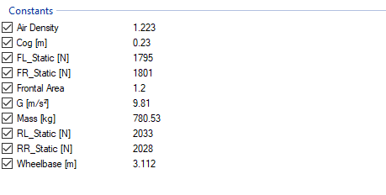
The figure below shows the constants listed in Motec.
Figure 3: Motec Constants (Lillicrap, 2018)

2.3.2 Expressions

A range of equations must be inserted into Motec as expressions to allow for a detailed analysis to be carried out. Although the equations are detailed below and how to apply them in motec is shown by figure 4, a further glossary defining the necessity for each equation can be found in appendix B.
The equations applied in Motec calculate the following:

- Longitudinal Weight Transfer
- Front Aero Load
- Rear Aero Load
- Total Aero Load (Downforce)
- Centre of Pressure
- Corner Radius
- Understeer
- Theoretical Steer
- Corrected Theoretical Steer
- Coefficient of Lift
- Aero Drag (With Cd from set-up sheet)
- Rear Ride Height
- Front Ride Height
- Front Left Tyre Temp
- Front Right Tyre Temp

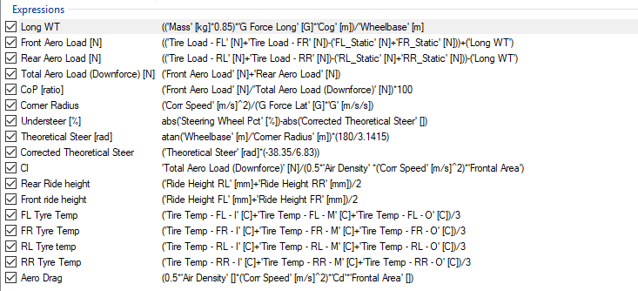
Figure 4: Motec Expressions (Lillicrap, 2018)

2.3.3 Channels

Across numerous worksheets, a variety of channels depict the necessary factors for analysis. These channels are categorised as follows:

Table 2: Table of Math Channels (Lillicrap, 2018)
Mass Calculations | Tyre loads (FL, FR, RL, RR)  Engine RPM  Corrected Speed  Acceleration
Aerodynamics | Corrected Speed  Total Aero Load  Front Aero Load  Rear Aero Load  Coefficient of Lift  Centre of Pressure
Steering | Steering Wheel Percentage  Theoretical Steer  Corrected Theoretical Steer  Understeer
Tyre Degradation | Tyre Loads (FL, FR, RL, RR)  Tyre Temperatures (FL, FR, RL, RR)  Understeer
Rake Analysis | Front and Rear Ride Height  Rake (Gyro Pitch Angle)
Other Necessary Channels | G Force Lat  Brake Pedal Position  Throttle Position  Steering Wheel Pct.

3.0 Analysis

3.1 Straight Line Test
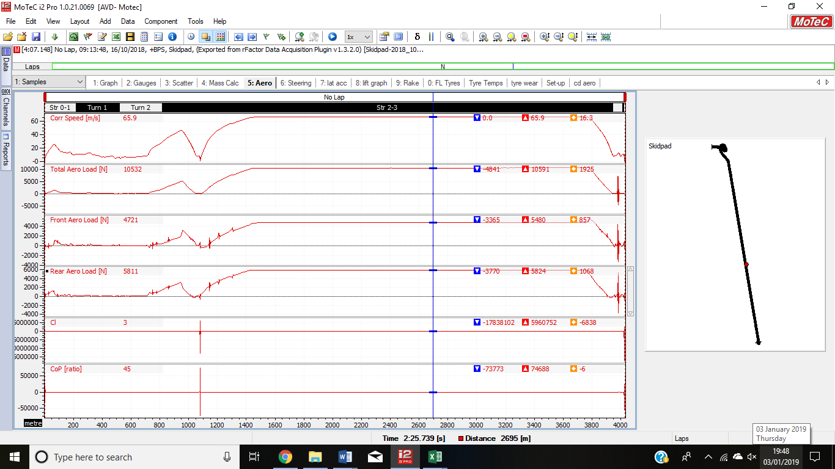
Figure 5 shows an example of the straight-line test in motec, the yellow rectangle highlights the area of data needed for analysis.
Figure 5: Motec - Straight-Line Test with Wings Equal Configuration (Lillicrap, 2018)
Zooming in on a 3 second section of the straight-line data, the values of total downforce can be determined. The results are shown in figure 6, where downforce is compared with the cl value at each point. Typically, the values for cl should be taken as negative because the vehicle is producing downforce however for the ease of graphical displays these values have been plotted as absolute values.
Figure 6: Straight-Line Test - Downforce and Cl Results (Lillicrap, 2018)

Figure 6 shows how the cl value directly relates to the amount of downforce produced by the vehicle. Often considered the ‘good’ force having enough downforce is important as it greatly improves the vehicle performance during cornering, as it boosts the grip levels. However, in straight-line situations downforce needs to be limited to prevent the vehicle experiencing high amounts of drag and subsequently being unable to achieve top speeds (Torquelife, 2015).
To combat this issue installing a drag reduction system (DRS) would be recommended, as it helps to minimise the level of downforce and drag. The DRS can be initiated from a button pressed by the driver when on a straight to help aid with overtaking procedures. This system function as the rear aerofoil (wing) is comprised of two separate halves, one is considered the main plane and the other the flap (Formula1 Dictionary, 2018). When the button is pressed the main plane remains in a fixed position and the leading edge of the flap moves upwards. This typically occurs near to the trailing edge and results in a gap between the wings appearing (Formula1 Dictionary, 2018). Therefore, two of the wing elements no longer function in harmony and the airflow around the wing separates (Katz, 1995). When the airflow separates away from the surface it begins to ‘stall’ and consequently causes a large decrease in downforce and drag (Katz, 1995). As a result, the vehicles straight-line speed improves, overtaking becomes easier, and the vehicle is more economic on fuel during this set-up (Formula1.com, 2018).
The graph in figure 6 shows that as cl decreases so do the level of downforce. For straight line scenarios having the wings set to the minimal angle of attack offers optimum downforce which is supported by research from (Kajiwara, 2017) which states it is desirable to have both a small Cl and Cd during high speed testing. The difference between the wings being set to minimum or maximum is 3446 N almost a 50% increase in downforce showing that the vehicle is highly sensitive to changes. This does, therefore, limits the possible set-up choices as minor difference can result in extreme variation in downforce.

3.2 Coast Down Test
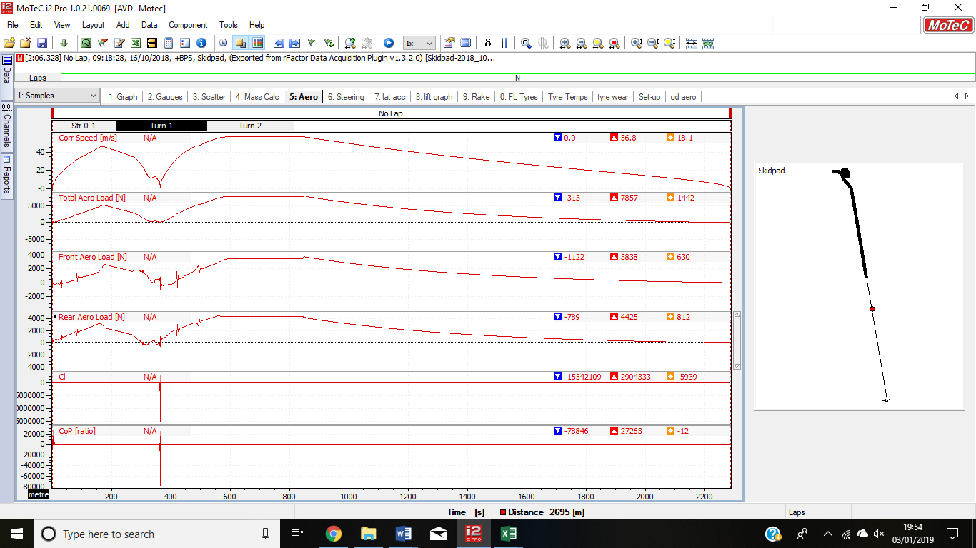
Figure 7: Example of Coast Down Test in Motec - Wings Equal Configuration (Lillicrap, 2018)
Figure 7 shows an example of the coast down testing, again the area of interest is highlighted by the yellow circle. The values for analysis were found by zooming in on a 3 second section. The results of this analysis are shown by the graph in figure 8.
Figure 8: Graph of drag force and Cd (Lillicrap, 2018)
As before, the configuration with the wings at minimum yields the least amount of drag force and the lowest coefficient of drag. Furthermore, the difference between the level of drag when the wings are at minimum to when the wings are at max is greater than under cl, with the drag at max being more than double at min.
The most interesting characteristic is the variation between the Fmax/Rmin and Fmin/Rmax sections of the graph. Initially these would be expected to be the same as the set-up has in principle been reversed, however this is not the case. Both figures 7 and 8 show that greater force is achieved when the front wing is set to max. This would suggest that the front wing is most powerful and effective at producing downforce. Research from (Gaware, et al., 2017), further supports this as the front wing is the first wing to approach the air mass. Therefore, it must not only create downforce but efficiently redirect air towards the rear of the vehicle without inducing a large amount of turbulent flow (Gaware, et al., 2017). Minimising turbulent flow is important as the velocity of air-flow at the boundary layer is much greater with turbulent air, meaning that the wing is subject to greater drag and subsequently lap times would become slower (AeroSpace Engineering, 2016).
In contrast the rear wing is less effective as the defuser is situated below them which offers a high level of downforce and so it is not as crucial for the wing to add to the load (Gaware, et al., 2017). This is because the function of a diffuser is to increase the speed of airflow underneath the car, thus reducing its pressure resulting in a greater variation between the lower and upper surface of the vehicle (Racecar Engineering, 2018). The pressure difference causes a ‘suction’ effect and so the car should have greater downforce and more grip without contributing to the drag (Katz, 1995).
In relation to single seater set-ups it is common to comprise between the two configurations to provide a high level of downforce for corners without greatly impacting top end speed. Typically for a GP2 vehicle, the front would be set to a higher angle of attack whilst the rear would be set lower as it is paired with the diffuser to correct the variation in airflow caused by the component further forward on the vehicle (Yager, 2001).
The distribution between the front and rear wings is known as the aerodynamic efficiency or lift-to-drag ratio. The aerodynamic efficiency of a vehicle shows how effective the aerodynamics are at creating lift without producing excessive drag. As mentioned, the wings min configuration offers enough downforce with low drag, hence when the efficiency is plotted (see figure 9) it comes out the best. However, the other four configurations give an efficiency of around 4.8 ±0.4, which from research is a reasonable value for the efficiency for these types of configurations (Mcay & Gopalarathnam, 2002).The Fmax/Rmin set up gives the second highest efficiency value, which would further support the earlier conclusion that the front wing is stronger and has a greater effect on vehicle performance. Research suggests that compromising between the front and rear angle of attack proves beneficial when the vehicle is fitted with aerodynamic devices as maintaining the correct lift to drag ration yields the best performance results (Devaiah & Umesh, 2013). It is worth mentioning that the aerodynamic efficiency can be further improved by installing a gurney flap. A gurney flap is a short strip installed perpendicular to the trailing edge of the wing and is usually 1%-5% the size of the wing chord (Zhang, et al., 2006). This device significantly contributes to the downforce without massively effecting the stalling incidence, thus they are usually found on rear wings to give a better Cl value (Liebeck, 1978).
Figure 9: Aerodynamic Efficiency (Lillicrap, 2018)

Figure 10 shows how the centre of pressure (CoP) varies depending on the aero configuration. This CoP comes from the straight-line testing, given that the vehicle during this time is not subject to any weight transfer, these values can be considered the ‘true’ CoP values. Four out of the five values shown lie within ±1.5% of 45% suggesting that the vehicle is normally slightly offset towards the rear with a 45% front 55% Rear split. There is, however, an exception. When configuration is set to front max/rear min, the balance shifts and the front experiences a greater load. Figures 8 and 9 support this as both show greater downforce is achieved. In relation to handling the centre of pressure determines the distribution of down force between the front and rear axles (McBeath, 2015). Typically, designers aim to keep the CoP and centre of gravity closer to one another to provide maximum stability (Machin, 2016). Although both the front and rear wings will affect the location of the CoP, it is important to also consider the mid-section of the vehicle. Often roof spoilers will be installed to provide downforce to the middle of the vehicle whilst streamlining and redirecting air towards the rear wing (Devaiah & Umesh, 2013). However, for roofless vehicles the front wing is solely responsible for channelling air to the rear hence these styles of cars rely on the CoP being in the mid-point. The CoP is usually only varied to suit either circuit demands or driver preference, which in both cases will improve performance levels.
Figure 10: Graph of Centre of Pressure (Lillicrap,2018)

3.3 Circuit Lap Testing

Below figure 11 shows a comparison between the total downforce experienced by the vehicle when the wings are set to equal, max or min and its distribution between the front and rear. Similarly, to straight-line testing, the data follows the same trends for each configuration. However, motec shows that setting the wings to a minimum (green line) the vehicle experiences much great understeer throughout every corner on the circuit, when paired with the lap time shown in figure 14, it can be said that this is no longer the best set-up for the vehicle. Looking at the driver feedback for this set up (table 5) it is clear that the driver is no longer comfortable in the vehicle and having to battle for grip throughout the corners. This is because for this configuration the downforce has greatly reduced hence there is lower loading on the tyres which equals less grip and so the vehicle is unable to withstand such high side forces meaning it constantly wants to understeer (Kegl, 2002).
Key for figure 11
Table 3: Key for Figure 11 (Lillicrap, 2018)
Configuration | Line Colour
Wings Equal | Red
Wings Max | Black
Wings Min | Green
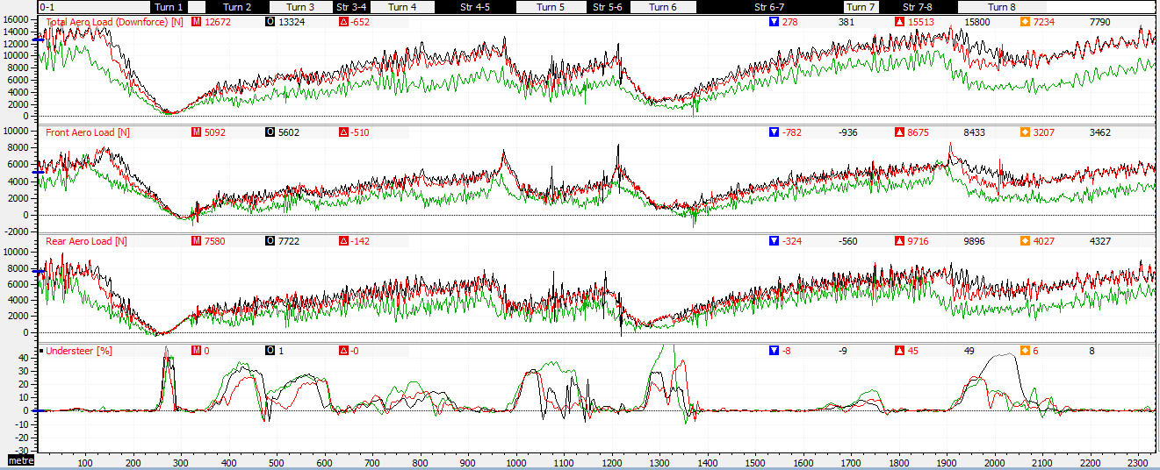
Figure 11: Downforce and Understeer Comparison for Wings Equal, Max and Min Configurations (Lillicrap, 2018)

Key for Figure 12
Table 4: Key for Figure 12 (Lillicrap, 2018)
Configuration | Line Colour
Wings Equal | Red
Wings Max | Black
Wings Min | Green
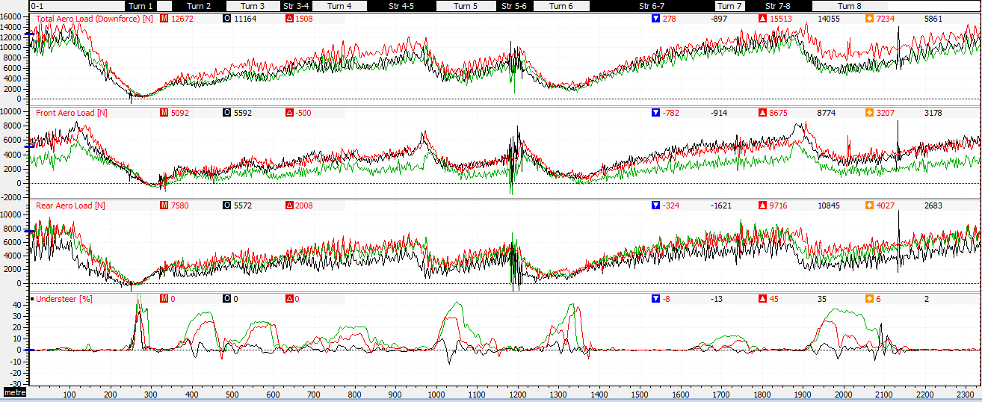
Figure 12: Downforce and Understeer Comparison for Wings Equal, Fmax/Rmin and Fmin/Rmax Configurations (Lillicrap, 2018)
Interestingly in figure 12 (where wings equal data is overlaid with the Fmax/Rmin and Fmin/Rmax data) both split configurations produce slightly less downforce throughout the entire lap. Again, as expected the two set ups offer similar levels of downforce however the distribution between the front and rear is clearly different meaning that the vehicle is handling in two contrasting manners. Figure 13 shows the Fmax/Rmin configuration boasts a significantly higher load on the front of the vehicle which from figure 12 is causing the vehicle to oversteer in most corners. This hampers performance as from the driver feedback and the throttle positions shown in figure 15 the driver is having to lift off considerably earlier. This driving style is a result of the oversteer causing the rear of the vehicle to become unstable as the grip is greatly reduced (Bastow, et al., 2004). Typically for circuit cars this set up would be undesirable as it produces too much ‘drift’ during highspeed cornering, to combat this the diffuser would need to add more downforce than the front is currently producing as despite figure 13 suggesting the vehicle is well balanced it is not handing in this manner (Bastow, et al., 2004).
Lap times from figure 14 and figure 15 together, suggest the driver is having to be more conscious of the vehicles reaction to cornering thus is driving much slower. Coincidentally this links with the CoP which figure 13 shows is more biased towards the front for the Fmax/Rmin configuration. When the CoP is biased towards one end, the downforce is greatly affected and since downforces raises as the square of speed it is almost impossible to design the car perfectly for both low and high-speed corners (Dominy & Dominy, 1984). Hence the CoP must be modified for each circuit. Variation between the tyre balance can also play a role in achieving the best set-up and since there is normally a difference between the tyres for qualifying and those for the for the race it can almost impossible to get the configuration exactly right (Dominy & Dominy, 1984).
Figure 13: Graph Comparing Downforce and Lap Times (Lillicrap, 2018)
The fastest lap time (6.7% quicker than the slowest) comes from the wings max configuration which is also producing the maximum level of downforce for the vehicle. Since Pembrey has a high number of corners it is effective to set the aero configuration to this as it will allow the highest amount of grip. Furthermore, when considering the driver feedback for this configuration, the driver appears to be happier. The feel of the car is more balanced and predictable, the slight understeer in mid-corner suits his driving style and the car offers good traction and braking stability. This is seen in figure 15 which compares the wings max configuration to the two split configurations, clearly with wings at max the driver can apply the throttle slightly earlier and brake heavier without experiencing high lateral G forces from the vehicle trying to throw him from one side to the other.
Figure 14: Graph Comparing Downforce and Centre of Pressure for Circuit Tests (Lillicrap, 2018)
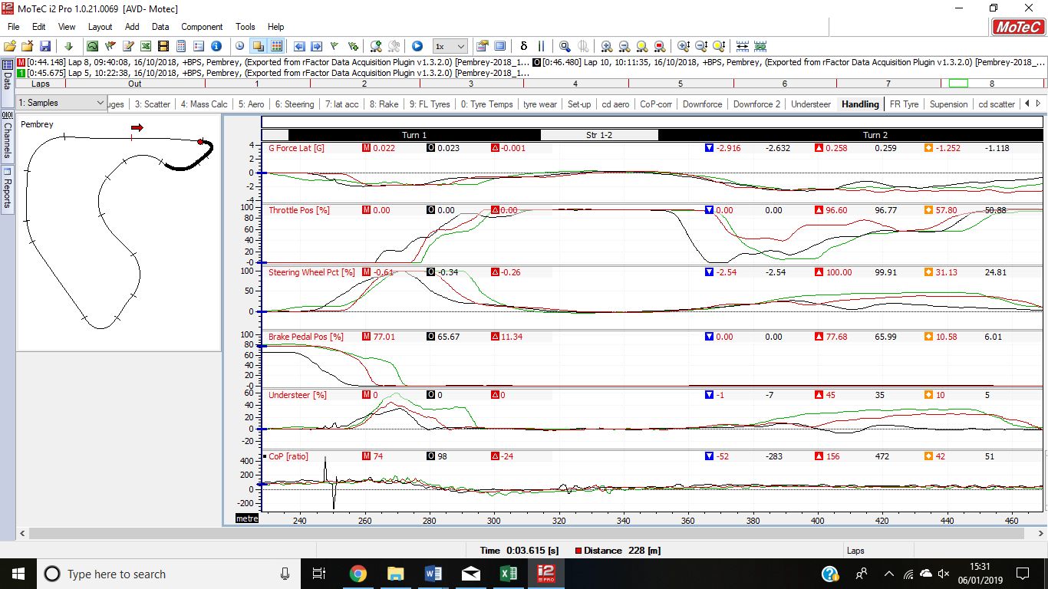
Contrastingly, in figure 15 the Fmax/Rmin configuration experiences a large spike in the lateral G force when entering the second corner, this is uncomfortable for the driver and highlights the car is going into oversteer. The throttle position is let off and then gently applied throughout whereas for the Fmin/Rmax configuration which has similar downforce, the throttle can be applied earlier and held throughout the corner, thus being quicker. The steering wheel percentage graph also shows more sudden changes when the Fmax/Rmin configuration is applied this relates back to the driver feedback which states that the vehicle is “very difficult to drive”.
Figure 15: Motec Screenshot of Various Handling/Driving Style Channels (Lillicrap,2018)
Shifts in the CoP during heavy braking can also contribute to understeer/oversteer. Highlighted by a yellow circle in figure 15, the Fmax/Rmin configuration experiences this during the first corner. This causes the driver to change the steering wheel pct. much earlier than the other configurations, however the CoP quickly returns to a 50/50 and the throttle is applied for exiting the corner.
Figure 16 shows a scatter graph of the total downforce against speed. As stated previously, the downforce of the vehicle increases with the square of speed (Dominy & Dominy, 1984) hence the high-speed data points appear to be greater spread. The mid-section of the graph appears fuller, because for most of the lap the vehicle sits at speeds between 30m/s and 60m/s meaning there is significantly more data for this section. Therefore, it is ineffective to design the vehicle with the wing min configuration as for Pembrey circuit the vehicle is rarely at high end speeds. Furthermore, the wings max configuration doesn’t prevent the vehicle from reaching tops speed and as shown in black the vehicle still achieves the same speeds of around 75m/s. Although there are a few exceptions where greater speeds are obtained. Again, the Fmax/Rmin and Fmin/Rmax set ups lie in the mid-range of the data suggesting it is necessary to compromise between the two extremes to achieve a well-balanced car with enough downforce for cornering. The scatter graph also highlights a few anomalies within the data, where data is plotted significantly lower or higher than the rest of the data, these are likely a result of inaccurate driving standards such as cutting corners/contact with kerbs.
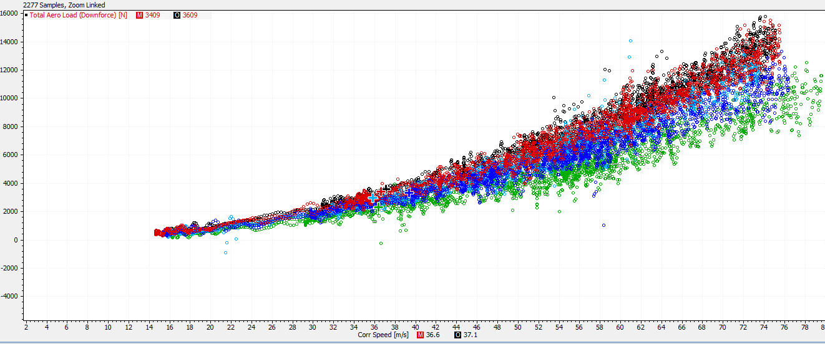
Key for figures 16 and 17.
Figure 16: Downforce Scatter Graph (Lillicrap, 2018)
Configuration | Data Colour
Wings Equal | Red
Wings Max | Black
Wings Min | Green
Fmax/Rmin | Light Blue
Fmin/Rmax | Dark Blue
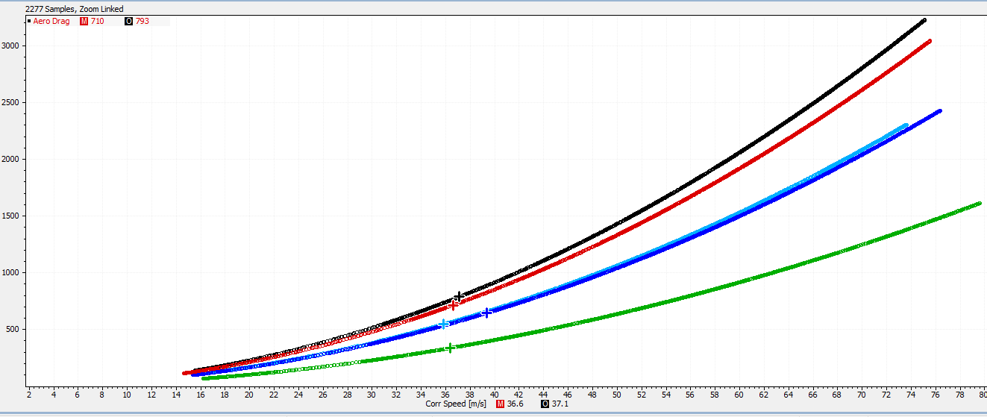
Similarly, to the downforce scatter graph, the scatter graph for aero drag shown in figure 17, follows the same trends. As the speed of the vehicle increases so does the drag experienced by the vehicle, with the wings max configuration experiencing the highest amount of drag. When the wings are set to a minimum a considerably lower amount of drag is felt by the vehicle, yet the lap time is not significantly faster.
Figure 17: Aero Drag Scatter Graph (Lillicrap, 2018)

Table 5: Table of Driver Feedback (Lillicrap, 2018)
Configuration | Driver Feedback
Wings Equal | Tends towards understeer, especially in mid corner, but overall good balance. No real braking or traction issues.
Wings Max | Car generally well-balanced giving good confidence in corners, although slight tendency towards understeer mid-corner. Traction and braking stability very good, able to get on throttle slightly earlier and brake harder from high speed.
Wings Min | Car understeering in high speed corners, but generally stable balance between front and rear. Having to brake slightly earlier to avoid locking and traction under power is slightly worse.
Fmax/Rmin | Car very difficult to drive. Tends towards oversteer, especially in high speed turn-in and direction change. Having to be very smooth and progressive to maintain stability, but corner speeds were having to be compromised as a result.
Fmin/ Rmax | Car clearly front limited, lots of mid corner understeer being felt which is compromising corner entry speed in order to maintain control mid-corner. Good traction in low or high speed

3.4 Ride Height and Rake Angle Study

It is worth noting that motec gives rake from the gyroscopic pitch sensor, so the values are negative and have been plotted this way. In real life negative lift would never be used for race vehicles.
Rake and ride height not only relate to each other but closely effect the aerodynamics of a vehicle. These factors highly influence the ground effects experienced by a vehicle, and since this contributes to the handling characteristics the must be monitored closely. Ground effect functions by limiting the airflow over the suction surface, thus increasing suction (Kegl, 2002). This in turn effects the level of downforce produced as when the front wing is close to the ground the boundary layer begins to separate as a result of the large suction and adverse pressure gradient (Zhang, et al., 2006). Consequently, the air stalls and the wing is inefficient. Setting the right rake allows the front wing to sufficiently redirect airflow over the car to the rear wing as well as letting the undertray of the car work effectively with the airflow around it (Mclaren, 2018). This uses the venturi effect to accelerate the air-flow back and through the diffuser which creates the necessary low pressure which results in the downforce desired to counteract the lack of downforce produced by the rear wing (Racecar Engineering, 2018). Vertical ‘fences’ can be added to the diffuser to ensure it only draws air from the underbody thus making it as efficient as possible (Racecar Engineering, 2018).
The Fmax/Rmin configuration raises the front of the car, so it is likely that the venturi effect will stop functioning and the airflow speed will reduce. Consequently, the diffuser becomes inefficient and the rear wing is in disturbed air thus minimal downforce is created. If this is the case the centre of pressure becomes unbalanced and the vehicle experiences more understeer. On the other hand, as the undertray and diffuser become more efficient at low rake angles, then the Fmin/Rmax configuration should give the best lap times as the vehicle gets the correct level of downforce without excessive understeer traits being added.
This explains why figure 19 shows the most downforce is achieved for the Fmax/Rmin set up. However, this rake angle test pushes the cop of pressure (see figure 18) to the rear of the vehicle (40%-60% split) and as shown in figure 20 the vehicle becomes more susceptible to understeer. As such the vehicle is understeering whilst the driver is heavily breaking, meaning that the steering must be applied much sharper and higher levels of lateral G force are experienced. These driving traits meant the Fmax/Rmin configuration is the slowest of them all which shows that having the most downforce isn’t always beneficial as more drag also occurs and the vehicle becomes slower.
When the Fmin/Rmax configuration is applied, the rake angle is at its largest and the centre of pressure is 44.07 (see figure 18), meaning the vehicle is well balanced, with only a slight biased to the rear. As expected, the Fmin/Rmax set-up follows the same trends as before with the vehicle experiencing less downforce throughout the course of the lap yet being surprisingly quicker. From figure 20 this configuration understeers considerably less that the other two, making it the most pleasant to drive and fastest of the three. The variation in lap times however is almost 2 seconds, in terms of racing this can be significant especially in a head to head situation along a straight. This suggests the vehicle is highly sensitive to rake changes and even slight increments could be detrimental. Research states that if the rake angle is too steep the undertray will be less efficient aerodynamically, similarly too shallow and the undertray/diffuser will fail to function correctly (Mclaren, 2018).
Figure 18:Graph of Lap Time, Centre of Pressure and Rake Angle (Lillicrap, 2018)
Figure 19: Graph of Downforce and Rake Angle (Lillicrap, 2018)
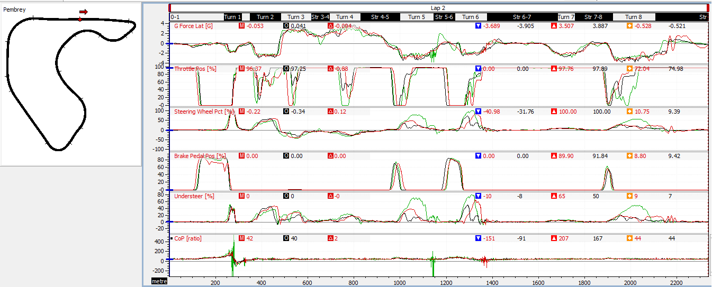
Figure 20: Motec Screenshot of Various Handling/Driving Style Channels (Lillicrap, 2018)
Figure 21 shows that for the ride height circuit tests the mean centre of pressure doesn’t differ greatly and remains approximately 43.8 ±0.5. For these tests all configurations achieved a lap time of around 43.65 seconds which in comparison to the other circuit tests is one of the quickest times.
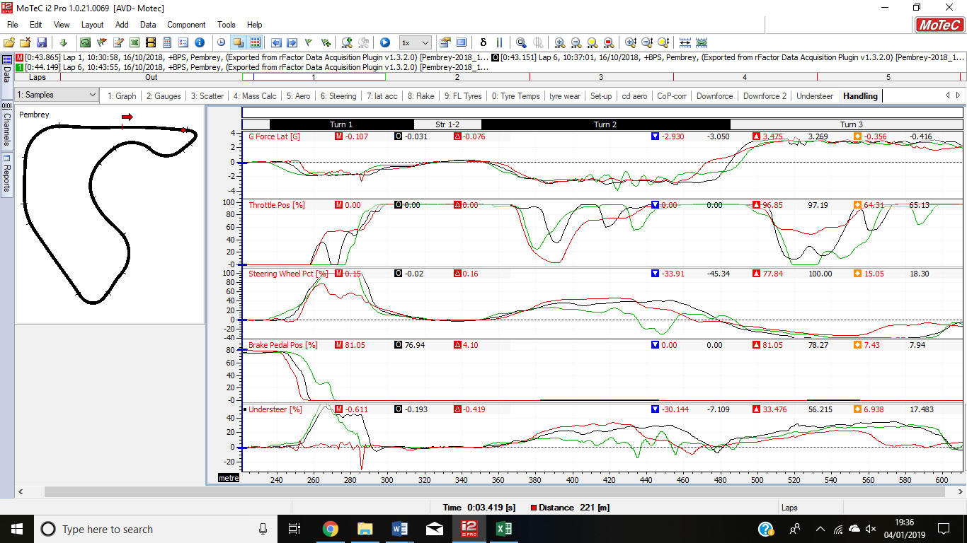
At standard the rake angle is over double what it is for the other two configurations, however because of the changes to the ride height the CoP does not change and so the handling characteristics do no vary greatly. This means the vehicle still experiences a high amount of understeer. However, when comparing the fastest lap times, there appears to be an anomaly in the standard test data as it suggests the vehicle does not understeer and in fact oversteers. This is an error as when looking at the other laps from the test, the standard data follows the same pattern as the two other configurations. The anomaly is highlight in the yellow circle in figure 22.
Figure 21:Graph of Ride Height and Rake Angle Effects on Cop and Lap Time (Lillicrap, 2018)
Figure 22:Motec Screenshot of Handling/Driving Style Channels for Ride Height Test (Lillicrap, 2018)
Similarly, to before as soon as the brake pedal is released, and throttle applied, the vehicle begins to understeer, and the driver experiences an increase in lateral g force. When entering the second corner the minimum configuration experiences oversteer and hence the throttle is released much sooner.
Figure 23: Graph of Ride height and Downforce (Lillicrap, 2018)
Figure 23 shows how the downforce at standard and maximum does not greatly vary when the ride hide changes, however when the ride height is decreased the level of downforce experienced by the vehicle greatly reduces which as expected given research by (Zhang, et al., 2006) states at low ride height the wing and ground boundary layer merge and result in lower downforce. Another factor to consider it that diffusers are highly sensitive to ride height variation. Typically, peak diffuser performance is at low ride heights as this allows the venturi effect to work for efficiently, so the airflow is in a low-pressure, high velocity state when it reaches the diffuser (Seljak, 2008). To overcome diffuser sensitivity, it is possible to modify the angle of the diffuser. To produce greater downforce, a higher angled diffuser is needed with a higher ride height (Knight, et al., 2018) Alternatively, low angle diffusers have peak performance with low ride heights. Research shows that typically downforce increases with low ride height, but if the ride height is too low separation bubbles form and eventually burst (Toet, 2017). This causes the vehicle to be aerodynamically unstable as the airflow separates thus creating two vortices and the amount of energy available decreases. After this occurs it is necessary to return to a higher ride height to allow the flow to return to an almost ‘symmetrical’ state (Toet, 2017).
For the number of corners at Pembrey circuit a reduction in downforce not ideal, as downforce is needed to help provide grip. This decrease in grip results in the oversteer shown in figure 22 as the vehicle enters the second corner.

3.5 Understeer Consideration

Some consideration must be given to why for all the circuit testing it appears that the vehicle, no matter what the aero configurations, tends to understeer. One such reason would be that vehicle lacks front end mechanical grip, which is usually due to the tyres or suspension set-up.
Firstly, looking at the tyres it is known that over the duration of a race, both temperature and wear levels vary and can affect the vehicles performance. Unfortunately, the simulator does not give out data for tyre wear and so this cannot be compared. Despites this, an analysis of how the front tyre temperatures vary for the wings equal, Fmax/Rmin and Fmin/Rmax configurations can be carried out.
During the fast lap of each configuration, the tyre temperature reached by the front right tyre is much lower than those of the front left due to the cornering layout of the circuit. As there are predominantly right-hand corners, the front left tyre is subject to more loading from weight transfer, this means that for a race at Pembrey the front left tyre will degrade at a much quicker rate (Quintarelli, 2018)
Comparing the tyre temperatures to the aero configuration, when the CoP is bias to the rear of the vehicle and the downforce distribution is to the back, the tyres fail to reach a suitable operation temperature and thus the vehicle tends to oversteer, as shown by the black line on the graph in figures 24 and 25. These under/oversteer characteristic suggest that there insufficient tyre grip to handle the high the front and rear axle loading (Santos, 2015). Therefore, it is recommended that for this circuit, and other tracks with high downforce needs for example Monaco, a GP2 car is fitted with soft or super soft tyres to provide the necessary mechanical grip (Pirelli, 2016).
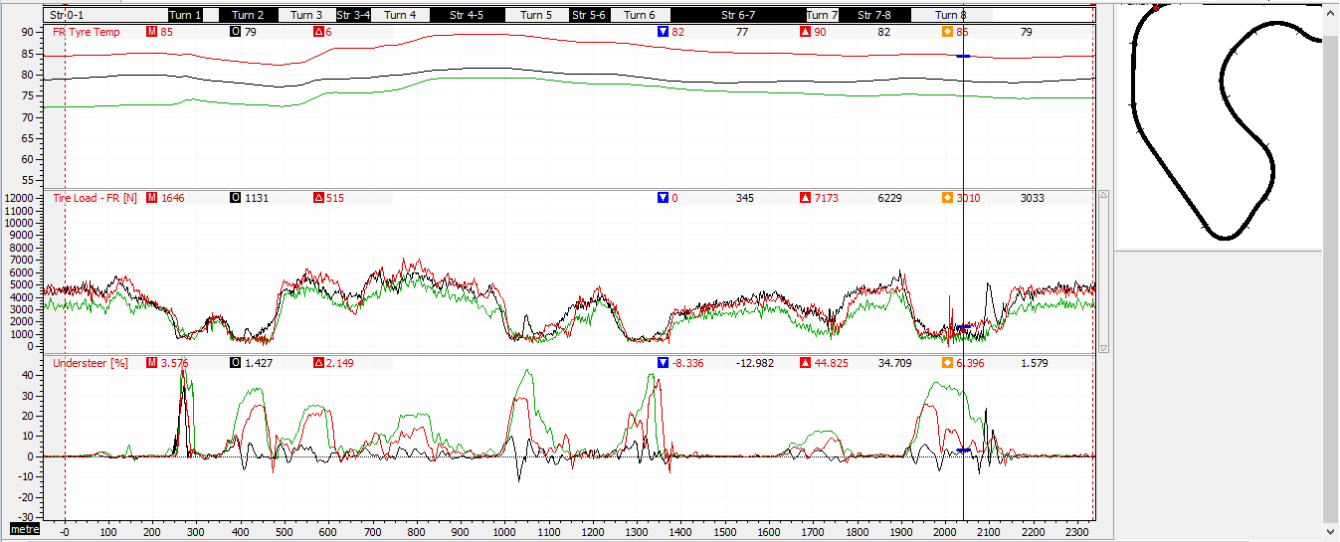
Figure 24:Front Right Tyre Information (Lillicrap, 2018)
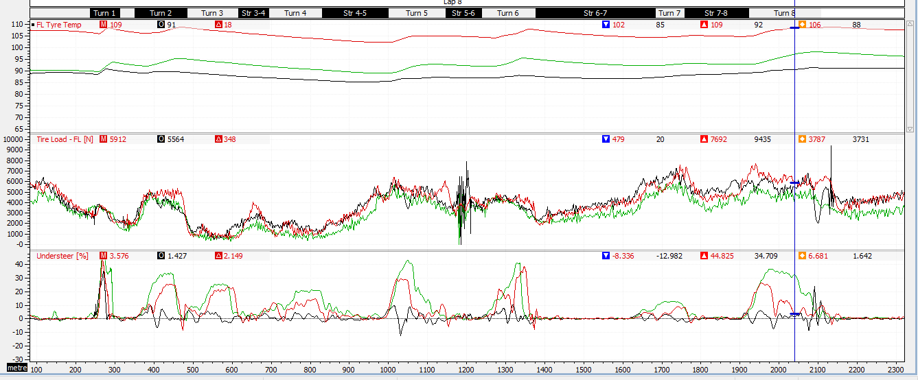
Figure 25: Tyre Information for Front Left (Lillicrap, 2018)
As the tyres don’t offer a great deal of resolution for the understeer problem, it is necessary to consider the suspension. One area to look at is the roll stiffness of the vehicle, if the rear shocks are set to be stiff then the car is likely to oversteer and softening them would make it understeer, the opposite happens with the front (Bergman, 1966). Typically race cars have stiffer suspension to prevent excessive roll in the corners, thus allowing quicker changes in direction (Hillier, 1991). This is beneficial from an aerodynamic point of view as less roll allows smoother airflow characteristics throughout cornering which results in better cornering speeds (McBeath, 2015).
The best aerodynamic set-up comes from the centre of pressure being slightly towards the rear, so it would be reasonable to suggest stiffening the rear shocks slightly. This would allow the front of the vehicle to maintain the same level of grip without causing a dramatic change to the amount of roll experienced during cornering. The adjustment should be minor as making the rear shock too stiff can prevent the car from accelerating smoothly out of corners or when the track is uneven cause the car to spin as result of the loss in grip (Milliken, 1995). Ideally when adjusting factors such as the suspension stiffness, on track testing is recommended or further simulator testing as small changes can dramatically affect the handling characteristics, and some drivers may prefer slight over/understeer to suit their driving style (RapidRacer, 2016).
The camber and toe angles of the wheels can also contribute to the understeer characteristics of the vehicle. Although for this vehicle the exact values for these angles are unknown, it can be suggested that the tyres do not have enough front camber or toe-out thus allowing the front of the car to understeer more. Therefore, to reduce the understeer particularly at corner entry, it is necessary to increase the front camber and toe-out (Pratte, 2015).

4.0 Conclusion and Evaluation

As proven throughout this report the aerodynamic configuration greatly effects vehicle performance and handling. Although many of the test results follow the same trends, none give a definitive answer to what is the best configuration. However, the tests have determined that the front wing is considerably more effective than the rear, having the front set to maximum caused such high disturbance to the airflow that the lap speed was considerably slower. From a handling point of view, having the wings set at this configuration was the drivers least favourite which is no surprise given the amount of oversteer produced. In contrast, having the wings set to a minimum was considerably easier to control. Overall from the vehicle testing, having the aero configurations balanced so the CoP was not excessively biased, and a minimal rake gave the best handling characteristics. As the handling characteristics improved so did lap time and performance as the driver’s comfort was greatly improved. Both the straight-line and coast down testing were effective for obtaining the baseline Cl and Cd values, however defining a Cd value for the rake and ride test was unable to occur. This is due to no straight-line or coast down tests being completed for these configurations. If the testing carried out throughout this report was to be repeated it would be recommended that coast-down test where done for all the rake and ride height settings.
Further to this, it would be recommended that the ride height testing be repeated, particularly with regards to the standard set-up. As explained, there is clearly an anomaly within the data and so it is difficult to draw accurate comparisons with the other test data. Moreover, the data from all the test procedure could be smoothed to allow for an easier analysis. The data shown in this report is affected by random spikes, which occur as a result of the driver contacting kerbs or uneven surfaces. If the data was to undergo smoothing it would eliminate the excessive variation with the data points but would cause the data to be considered less accurate.
Originally it was hypothesised that extreme aero configurations would have a detrimental effect on vehicle performance and handling. Even through in certain tests the extreme configurations came out fastest, it can be concluded that it is necessary to compromise between a range of factors to achieve the optimum configuration. The exact configuration is still to be determined especially as there are many factors such as the suspension, that need further investigation to find the real cause of the excessive understeer.

References
AeroSpace Engineering, 2016. AeroSpace Engineering: Boundary Layer Seperation and Pressure Drag. [Online]
Available at: https://aerospaceengineeringblog.com/boundary-layer-separation-and-pressure-drag/
[Accessed 20 December 2018].
Bastow, D., Howard, G. & Whitehead, J., 2004. Car Suspension and Handling. Warrendale: SAE International.
Bergman, W., 1966. The Basic Nature of Vehicle Understeer-Oversteer. SAE Transactions, Volume 74, pp. 387-422.
Devaiah, B. & Umesh, S., 2013. Enhancement of Aerodynamic Performance of Formula-1 Race Car Using Ass-on Devices. SASTech Journal, Issue 12, pp. 72-79.
Dominy, J. & Dominy, R. G., 1984. Aerodynamic Influences on the Performance of the Grand Prix Racing Car. Proceedings of the Institution of Mechanical Engineers Part D. Transport Engineering , Volume 198-202, pp. 87-93.
Formula1 Dictionary, 2018. Technical F1 Dictionary: Adjustable Rear Wing - Drag Reduction System (DRS). [Online]
Available at: http://www.formula1-dictionary.net/drs_wing_rear_movable.html
[Accessed 2 January 2019].
Formula1.com, 2018. Formula1: Overtaking and the DRS. [Online]
Available at: https://www.formula1.com/en/championship/inside-f1/understanding-f1-racing/Overtaking_and_the_DRS.html
[Accessed 1 January 2019].
Forsyth, P., 2013. Successful Time Management. London: Kogan Page Ltd..
Gaware, P., Maniyar, A., Sonawane, V. & Gorade, N., 2017. Aerodynamic Study of F1 Car. Dumbarwadi, International Journal of Research in Advent Technology.
Hillier, V., 1991. Fundamentals of Motor Vehicle Technology. 4th ed. Cheltenham: Stanley Thornes (Publishers) LTD.
Jalali, K., Uchida, T. K., Lambert, S. & Mcphee, J., 2013. Development of an Advanced Torque Vectoring Control System or an Electric Vehicle with In-Wheel Motors using Soft Computing Techniques. Alternative Powertrains, Issue 2, pp. 261-278.
Kajiwara, S., 2017. Passive Variable Rear-Wing Aerodynamics of an Open-Wheel Racing Car. Automotive and Engine Technology, 2(1-4), pp. 107-117.
Katz, J., 1995. Race Car Aerodynamics. Cambridge: BentleyPublishers.
Kegl, S. P. B., 2002. Aerodynamics Aspects of Formula S Racing Car. Dubrovnik, Internation Design Conference.
Kerzner, H., 2017. Project Management: A Systems Approach to Planning, Scheduling and Controlling.. Hoboken: John Wiley & Sons Inc..
Knight, J. et al., 2018. Investigation of Vehicle Ride Height and Diffuser Ramp Angle on Downforce and Efficiency. Automobile Engineering.
Liebeck, R. H., 1978. Design of Subsonic Airfoils for High Lift. Journal of Aircraft, 15(9), pp. 547-561.
Machin, R., 2016. Competition Car Engineering, s.l.: Mantium Challenge.
Mcay, N. J. & Gopalarathnam, A., 2002. The Effects of WIng Aerodynamics on Race Vehicle Performance. Passenger Car: Mechanical Systems Journal, 111(6), pp. 2254-2263.
McBeath, S., 2015. Competition Car Aerodynamics: A Practical Handbook. 3rd ed. s.l.:Veloce Publishing.
Mclaren, 2018. F1 Playbook: Rake. [Online]
Available at: https://www.mclaren.com/formula1/f1-playbook/rake/
[Accessed 2 January 2019].
Milliken, W. F. M. a. D. L., 1995. Race Car Vehichle Dynamics. 1st ed. USA: SAE International.
Niegzgoda, M., Kaminski, T., Ucinska, M. & Kruszewski, M., 2011. Effective Methods for Drivers Research with Use of a Driving Simulator. Journal of KONES Powertrain and Transport, 18(3).
Pirelli, 2016. Pirelli: Latest News. [Online]
Available at: https://www.pirelli.com/tyre/ww/en/news/2016/05/24/soft-and-supersoft-p-zero-tyres-for-gp2-in-monaco/
[Accessed 23 December 2018].
Pratte, D., 2015. Turn14: How to Fix Understeer or Oversteer: Simple Suspension Tuning Guide. [Online]
Available at: https://speed.academy/how-to-fix-understeer-or-oversteer-suspension-handling-setup-tuning/
[Accessed 22 December 2018].
Quintarelli, A., 2018. Racingline: Home: Race Car Tech: Race Car Tech Explained. [Online]
Available at: http://theracingline.net/2018/race-car-tech/race-tech-explained/tyres-load-sensitivity/
[Accessed 22 December 2018].
R.A.White & Korst, H., 1972. The Determination of Vehicle Drag Contributions from Coast-Down Tests. SAE Transactions, 81(1), pp. 354-359.
Racecar Engineering, 2018. Racecar Engineering: Diffusers: Engineering Basics: Aerodynamics. [Online]
Available at: http://www.racecar-engineering.com/technology-explained/diffusers-engineering-basics-aerodynamics/
[Accessed 2 January 2019].
RapidRacer, 2016. RapidRacer: Suspension Tuning. [Online]
Available at: http://www.rapid-racer.com/suspension-tuning.php
[Accessed 17 December 2018].
Santos, R. d. O., 2015. A Discussion on Steady State Lateral Weight Transfer and How to Use it In Setup. [Online]
Available at: http://racingcardynamics.com/weight-transfer/
[Accessed 25 January 2018].
Seljak, G., 2008. Race Car Aerodynamics, s.l.: University of Ljubljana.
Toet, W., 2017. Race Tech Motorsport Engineering: Willem Toet Explains Motorsport Diffusers. [Online]
Available at: https://www.racetechmag.com/2017/08/willem-toet-explains-motorsport-diffusers/
[Accessed 4th January 2019].
Torquelife, 2015. Oppositelock: Aerodynamics 101: Lift, Downforce, and Drag. [Online]
Available at: https://oppositelock.kinja.com/aerodynamics-101-lift-downforce-and-drag-1687401001
[Accessed 21 December 2018].
Yager, B., 2001. Nas: Educational Resources: Rear Wing Assembly. [Online]
Available at: https://www.nas.nasa.gov/About/Education/Racecar/rearwing.html
[Accessed 3 January 2019].
Zhang, X., Toet, W. & Zerihan, J., 2006. Ground Effects Aerodynamics of Race Cars. Applied Mechanics Reviews, Issue 59, pp. 33-49.

Appendix A - Test Plan

For each of the following tests the driver was instructed to maintain the same driving style and restrict the amount of contact with kerbs to prevent errors within the data. Before recording data for use, a lap should be done to ensure the tyres are at temperature to provide a more accurate test scenario. Further to this no test session will be over until 0.3 second consistency is achieved to reduce the likelihood of anomalies and giving a high level of repeatability. After each test note the driver’s response and feedback to any aerodynamic adjustments this can then be use with a comparison of data to show trends.

A1 - Calculating the Coefficient of Lift and Drag for Multiple Aerodynamic Configurations

Use the Skid Pan (FSAE Circuit) to conduct both the straight-line constant speed test and the coast down test. The use of this circuit eliminates any variation in data as the runway is modelled as perfectly level thus preventing anomalies as a result of gradient changes.
Coefficient of lift:
For the coefficient of lift, a straight-line constant speed test must be carried out. To achieve constant speed run the test with the vehicle in 4th gear at the limiter, repeat until 5 runs are complete to obtain comparable data.
The aerodynamic settings are as follows:
- Wings Equal (Standard)
- Wings Max
- Wings Min
- Front Max – Rear Min
- Front Min – Rear Max
Coefficient of drag:
To obtain the coefficient of drag, complete a coast down test with the same aerodynamic configurations as detailed above. Test from 3rd gear limiter and run the vehicle in neutral until it reaches a halt, again repeat the test 5 times.
Mapping Lift and Drag Forces over the course of a lap
To gain enough data to compare lift and drag over the duration of a lap, numerous runs must be completed until 3 laps are within a 0.3s consistency of each other. Complete circuit laps with the following range of aero configurations:
- Wings Equal (standard)
- Wings Max
- Wings Min
- Front Max- Rear Min
- Front Min – Rear Max
Recommendation: If possible complete this test using Pembrey Circuit. This circuit has a range of high speed and low speed corners, there is also minimal gradient change on the circuit meaning the likelihood of variation due to dynamic gradient change is minimised. Furthermore, the first corner is at such a low speed that the aerodynamic forces are negligible giving an accurate representation of the mechanical grip/load transfer.
To plot the above study, create the necessary maths channels in motec, suggested channels are found in section 2.3.3 of the main body.
It is necessary to consider the mass of the vehicle, to do so take a reading of the tyre loads at static and subtract this value from the dynamic tyre load that the vehicle experiences during motion. The resulting value is the total downforce levels over the course of a lap. Export this data from motec as a CSV file and plot the results in excel. This method is repeated and applied to each variation of aerodynamic tested.
Plotting Front and Rear Downforce for a lap
Firstly, set up the tyre load maths channels in motec, a channel for longitudinal weight transfer must also be added. Using the maths tools, click to add an equation and insert the equation below, the figures can be either inserted as values or by using the constants function. Repeat this step for each aerodynamic set-up.
$$Longitudinal weight transfer=\frac{\left(\frac{Vehicle Mass ×Acceleration}{G}\right)×CoG Height}{Wheelbase}$$
Where G is gravity and CoG stands for Centre of Gravity.

A2 - Investigation of Ride Height and Rake Angle

The follow investigations should all be tested by running circuit laps, preferably of Pembrey, until 5 runs are complete within a 0.3 second variation of each other.
Test 1: Default Ride Heights & Rake Angles
Test 2: Whilst maintaining standard rake angle, increase the ride height by 10mm from standard on each axle. This highlights ride height sensitivity.
Test 3: Keeping the front ride height at default, adjust the rear ride height to 10mm higher and determine the resultant change in rake angle.
Test 4: Modify the front ride height by increasing it 5mm from the default setting and increase the rear ride height by 10mm. Again, determine the extent of change in the rake angle.
Test 5: Investigate vehicle behaviour with the vehicle set to 0 rake angle. For this test set front ride height at default and adapt the rear to match.
Map all results to allow comparisons to be drawn.

A3 – Schedule: 2 hours

Table 6: Schedule (Lillicrap, 2018)
Set- up | 10 Minutes – ensure driver comfort
Straight-line Test | 20 Minutes
Coast-down Test | 20 Minutes
Ride Height Investigation | 30 Minutes
Rake Angle Investigation | 30 Minutes
Clear Down | 10 Minutes

Appendix B – Motec Equations
Table 7 : Motec Equation Reasoning (Lillicrap, 2018)
Equation | Reason For
Longitudinal Weight Transfer | This is needed for the aero load equations. Weight transfer contributes to the load experienced by each axle during acceleration and cornering.
Front Aero Load | To show the distribution of downforce. This gives the amount of downforce on the front axle.
Rear Aero Load | To show the downforce distribution. This is the amount of downforce on the rear axle.
Total Aero Load (Downforce) | This is overall amount of downforce experienced by vehicle and is needed to assess how the aerodynamics configurations effect handling.
Centre of Pressure | This is used to assess the distribution of the downforce. It shows how and where the downforce acts.
Corner Radius | This is needed for the theoretical steer channels.
Theoretical Steer | This is needed for understeer equation
Corrected Theoretical Steer | This is needed for understeer equation
Understeer | Needed for analysis of handling characteristics and how they vary with different configurations.
Coefficient of Lift | This equation can be model as a channel to show how lift varies over the course of a lap, and how this effects downforce.
Rear Ride Height | This equation gives an average of the rear axle ride height and is necessary for analysis its effects on downforce.
Front Ride height | This equation gives an average of the front ride height and is necessary for analysis of downforce effects.
Aero Drag | Using Cd from the set-up sheet this shows how drag varies with each aero configuration.
Front Left Tyre Temp | This is to see if tyre temperatures are causing any understeer issues.
Front Right Tyre Temp | This is to see if tyre temperatures are causing any understeer issues.

