The Circular Economy: What, How and Why

Business is at a crossroads; continue to follow the existing linear economy of 'Take, Make, and Dispose' or move towards a more sustainable circular economy, utilising products at their highest value in a loop system for as long as possible. This article will compare the two economies and consider how they are currently used, with examples taken from Wales.
The traditional linear economy is the system where raw materials are extracted, a product created, and then disposed of (Ellen MacArthur Foundation, 2023). This is often characterised by the term “Take, Make, Dispose” (Daga et al., 2025) and is the system which has generally been used historically.
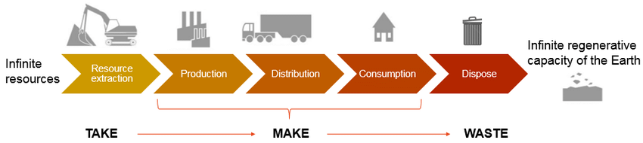
Wautelet, 2018)
There are moments in economic history where consumer demand and the mass scaling of production have clearly accelerated the linear economy and globalised this concept. For example, in the 16th century new and exciting textiles were imported for use in the fashion industry for the affluent European

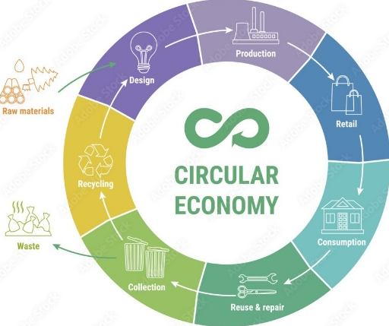
Circular Economy UK, 2025
population. This desire for new products created an endless supply and dispose culture (Morseletto, 2023) and cemented the linear economy.
The industrial revolution in the 1700’s is more commonly recognised, however, as the starting point of the linear economy (Ellen MacArthur Foundation, 2023., Petrova, 2023). The introduction of steam power during this time allowed for the scaling of resource extraction by enabling steam powered machinery to be used in any location instead of labour force (von Tunzelmann, 1978., Jonell et al., 2024). The industrial revolution continued into the 1900’s and saw the expansion of global trade which meant an ever-increasing demand for materials and products leading to consumerism in the 20th century where mass production made products inexpensive allowing consumers to increase buying and so

encouraging replacement over repair (Godfrey, Price and Lusch, 2022). These advantages of low price and increased speed of production are a huge advantage to a consumerist world; however, consumer awareness of its impact on the environment is escalating.
In as early as 1960, Rachel Carson’s Silent Spring (Carson, 2022) and the Brundtland Report in 1987 (WCED, 1987) highlighted the impact of the linear system on the earths ecosystems. More recently, research goes further to suggest that damage to ecosystems has a knock-on effect on humanity through climate change, biodiversity loss and natural disasters. A pertinent example of this is that the damage to ecosystems brings humans and animals in closer contact which increases the risk of animal to human disease infection. 60% of human infections are claimed to have animal origins (UNEP, 2020) and some scientists demand that Covid 19 was a zoonotic natural event (Mun-Keat Looi, 2024) passing from racoon dogs to humans.
Economically, the linear system works but is facing increased pressure. The depletion of the resources needed for the linear system has led to volatility in prices of scarce raw materials. Additionally, supply chains now cross multiple national borders with increasing policies on export, import and sustainability making supply chains more complex. Finally, any waste created now has to be handled with increased scrutiny adding to cost and time pressures (Hartley, van Santen and Kirschherr, 2020). These all provide businesses with cost and time challenges, which directly conflict with the linear economy’s benefits of cheap and fast (Zimmermann, Hofer et al., 2025).
The circular economy is the system of using a product in its most valuable form for as long as possible and then recycling and recovering all components in a closed loop system (Kirchherr et al., 2023. Jaio and Boons, 2017). The concept of circular economy was originally conceived by Boulding in 1966 (Boulding,1966). They described the existing linear economic system as a “cowboy Economy” that treated the worlds resources as infinite with little or no forethought to the consequences of the system. In comparison, Boulding (1966) suggested a closed system that they coined a “Spaceman Economy” where resources are finite and careful management is needed. Boulding's (1966) work influenced Pearce and Turner (1991) who discussed materials being re-used and recycled and first introduced the term ‘circular economy’ (Donaghy, 2022).
The circular economy is based on the three principles of eliminating waste and pollution, circulating products and materials, and regeneration (Ellen MacArthur Foundation, 2024). These principles are commonly expressed in a R-Ladder which signifies the levels of impact certain strategies have on sustainability (Potting et.al, 2017).
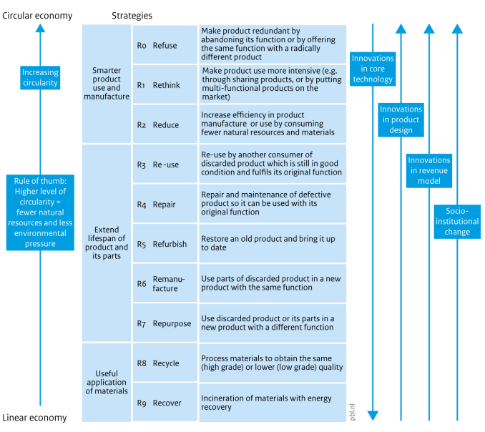
Ellen MacArthur Foundation (2024)
Potting et al. (2017) and Ellen MacArthur Foundation (2024) use the R-Ladder to organise the circular economy into three sections; strategies aimed at creativity and innovation in product use and manufacture, extending the lifespan of a product and the useful application of the base materials at the end of the products lifespan.
Cwm Environmental states that they are “The UK’s Circular Economy Experts” (Cwm Environmental, 2025) and are in the process of redeveloping the recycling centre to not only recycle waste but to re-use and recover materials. They have opened the largest re-use village in Europe, allowing the public to donate and purchase items which would have been sent to landfill. They are also in the process of creating a state-of-the-art resource recovery and manufacturing zone, aimed at reducing the need for raw materials in the building and textile sectors. This is an excellent example of the circular economy in action in Wales.
At first glance, CWM appear to highlight 3 of the Rs from the previously mentioned R-Ladder (reduce, reuse and recycle). However, further research suggests that they are engaging in many more and are a clear example of how innovation with sustainability as a core value can close the existing linear system creating a circular economy, a view shared by Elkins et al. (2019).
The move to the circular economy is now at a critical point and unless this change is made then resources and materials will become even scarcer, habitats and eco systems destroyed, species lost to extinction and parts of the human population driven further into poverty (UNDP, 2023). However, there are still advocates of the linear system who, in general, profit from the system such as businesses who extract the raw materials, governments in material rich countries and economists who are solely focused on profit growth (United Nations Environment Programme, 2021). This research suggests that changing to the circular economy is vitally important, but this represents real world challenges for businesses who already have a system in place that may be profitable, successful and deeply engrained in their history. These challenges will differ depending on size, location, industry etc (De Giovanni, 2022., International Chamber of Commerce and EY, 2024).
Understandably financial considerations and barriers will impact businesses changing to the circular economy. High initial investment may be needed to redesign products, technology, infrastructure and production processes and investment could be difficult to obtain due to perceived risks due to circular economy models having unproven business models (WRAP Cymru, 2023) and widely accepted claims that circular economy projects require long periods of time before financial returns are seen (Kirchherr, Reike and Hekkert, 2017., EIB, 2021., OECD, 2022).
For financial returns to be seen from a circular economy economic model there needs to be demand from consumers and heavily relies on engaging consumers in the principles of the circular economy. For years consumers have been encouraged to continually buy new, upgrade and replace and throw away old products in the linear economy. This habitual behaviour will need to be adapted if consumers are to adopt a circular approach. Lopez and Legardeur (2024) suggest cultural habits place a higher intrinsic value on new items above that of re-using and repairing. This behaviour has also led to a consumerist desire for the convenience of buying new, affordable products over sourcing materials to repair or finding experts who can do this.
How consumers treat products they no longer need is dependent on what they perceive to be convenient. For example, if recycling, donating or re-selling is perceived as too complex or time consuming then it becomes less convenient than disposing (Wrap, 2020), something which has also been observed in environmentally conscious consumers (European Commission, 2018). This clearly highlights the high regard of convenience for consumers and the challenge that business has to overcome this. The obsolescence of products has also led to consumers engagement in buying new products.
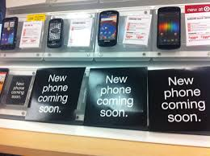
Xuereb, n.d.
Terms such as ‘not built to last’ influence consumers to believe that longevity and durability of products is low which reduces the desire to re-use and recycle (Kirchherr, J., Reike, D., Hekkert, M. 2017 and Ellen MacArthur Foundation (2020).
Businesses also face challenges when conforming with regulation and policies. Often the speed of innovation required to create products and practices required for a circular economy is not matched by the speed of policy and regulatory change (OECD, 2022). Businesses can often resist moving away from a linear system to a circular economy as it requires business to overlap between industries and regions, meaning businesses need to navigate policies, regulations and legislations that are still aligned to the linear economy.
The challenges are, as discussed, varied from business to business and across regions. In Wales there is the added challenge of its rurality which adds cost pressure to business and consumers when considering waste. Are rural businesses able to move from linear to circular economies if locality to partner businesses restricts this? In Urban areas, infrastructure density is higher, making it easier to move products and materials around the circular economy without high transport costs, thus creating business ecosystems, and generating symbiosis between consumers and business (Fuller-Love & Murphy, 2023). Consumer engagement is key to the success of the circular economy and higher engagement is found in urban areas. Consumers in cities experience far higher exposure to circular economy campaigns and initiatives along with convenient access to re-use and repair hubs and shops (WRAP, 2020., Europa.eu, 2017). Rural areas often experience cultural shifts more slowly than cities, with consumers often attached to existing linear behaviours and a lack of peer influence or visibility of circular economy practices to instigate change (Hobson 2015).
Although the circular economy may present challenges to businesses, any challenge comes opportunities and benefits. Virgin raw materials are costly to extract, due to their reducing volume and locations, and once extracted experience volatile pricing structures. Businesses that can re-use and recover materials and components become much less reliant on sourcing such materials and WRAP (2020) suggest that UK businesses could save £23 billion a year through improvements to the efficient use of resources. Globally this figure could reach £3.7 trillion per year. Reducing waste has financial benefits too; the Wales and England landfill tax has risen by 21% from 2024 to 2025 (HM Revenue and Customs, 2025).
There are many benefits to communities from the circular economy. Re-using can make products cheaper and more accessible to more diverse groups of consumers (Valencia et al., 2023). Community initiatives, such as repair hubs and re-use centres foster community engagement in sustainability practices (Szabo et al, 2024). Kosta, Keramitsoglou and Tsagarakis, (2025) and Tiippana-Usvasalo, Pajunen and Maria, (2023) make the argument that Circular Education should be included in education from primary ages through secondary to build engagement in children and the Ellen MacArthur Foundation (2025) suggests that the circular economy should be part of lifelong learning. Community initiatives require upskilling of participants and employees with new skills which can be passed on to future generations in the community (UNESCO-UNEVOC, 2021).
The most obvious benefit of the circular economy is to the environment with its principles of eliminating waste and pollution, circulating products and materials and regenerating nature (Ellen MacArthur Foundation, 2025). Any attempt to reduce the extraction and use of fossil fuels by reusing and recovering existing materials will benefit ecosystems and the earth's climate (Wang et al., 2022).
Evidence of the Circular Economies benefits can be seen throughout Wales. One example is Bluestone National Park Resort (Warpole et al., 2023).
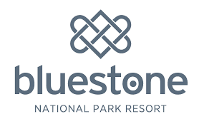
Bluestone National Park Resort, n.d.
Bluestone is a luxury family holiday resort in Pembrokeshire, welcoming over one hundred and fifty thousand guests annually and turning over £30 million per year (Visit Wales, 2025). They are the first business in the world to recycle nappies and use the recovered material to create asphalt for construction (Bluestone, 2025). They are also the first resort in the UK to stop selling bottled water and replace it with water fountains, eliminating approximately fifty thousand plastic bottles per year (Business Wales, 2025). When the lodges are due for upgrades, the items normally earmarked for landfill, such as sofas and beds, are passed on to the local community and charity organisation Pembrokeshire Frame. (Bluestone, 2025). The organisation takes two approaches: sofas that are saleable are sold to the public at a discount, while the sofas that need repairing are passed to a charity that teaches practical skills to disabled and disadvantaged adults. Once repaired the sofas are passed back to charitable projects in Pembrokeshire (Circular, 2025., Warpole et al., 2023).
It's clear that a shift from the linear economy to the circular economy has numerous financial, social and environmental benefits, such as reducing waste bills, creating community hubs of knowledge and skills, and reducing damage to ecosystems. However, there are substantial challenges faced by businesses to make this change. These challenges can only be overcome with leaders in place who can inspire the cultural shift needed and are willing to take the risks perceived with investing in the circular economy. Collaboration is needed between multiple business sectors and communities to motivate engagement and share knowledge. Finally, innovation is required to make the changes needed to products, machinery and infrastructure to facilitate the Circular Economy.
Enomia (2024) ranked Wales 2nd in the world in its global recycling league table. This, along with the Welsh Government's ‘Beyond Recycling strategy’ (Welsh Government, 2021), aimed at accelerating the journey in Wales to a circular economy, shows the desire from leaders in Wales to make the cultural shift.
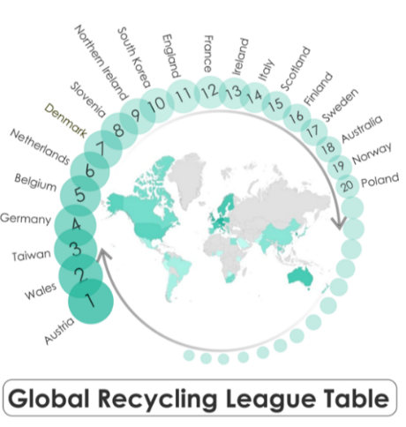
Eunomia, 2024
The Circular Economy Fund (Welsh Government, 2024) provides financial support for businesses and communities for planned innovation in Circular Innovation initiatives to make Wales zero waste by 2050.
The circular economy is a cultural shift that requires innovation, leadership and collaboration. There are many challenges ahead for businesses willing to make this change, but examples like Bluestone and Cwm Environmental show that these challenges can be embraced and positive results achieved.

References
Bluestone (2025) Bluestone National Park Resort. Available at: https://www.visitwales.com/accommodation/holiday-village/bluestone-national-park-resort-1831720 (Accessed: 31 October 2025).

Bluestone National Park Resort (n.d.) Bluestone Wales. Available at: https://www.bluestonewales.com/ (Accessed: 5 November 2025).

Boulding, K. (1966) The Economics of the Coming Spaceship Earth. In: Jarrett, H., Ed., Environmental Quality in a Growing Economy, Resources for the Future/Johns Hopkins University Press, Baltimore, 3-14.
Business Wales (2025) Bluestone Sustainability and Circular Economy Initiatives. Available at: https://www.bluestonewales.com/sustainability/circular-economy (Accessed: 31 October 2025).
Carson, R. (2002). Silent Spring. Mariner Books (Houghton Mifflin).
Circular (2025). Reuse charities call for government support to achieve circular economy goals. Available at: https://www.circularonline.co.uk/news/reuse-charities-call-for-government-support-to-achieve-circular-economy-goals (Accessed: 31 October 2025)
Circular Economy UK (2025) What is the circular economy? [Online]. Available at: https://circulareconomyuk.co.uk/what-is-the-circular-economy/ (Accessed: 5 November 2025).
Cwm Environmental, 2025. Cwm Gwyrdd: Leading the Circular Economy in Wales. [online] Available at: https://www.cwmenvironmental.co.uk [Accessed 31 Oct. 2025]
Daga, S., Yadav, K., Singh, P. and Mishra, V. (2025). Beyond the Take-Make-Dispose Model—Unlocking the Power of Circular Economy for an Environmentally Resilient Future. pp.1–11. doi:https://doi.org/10.1007/978-3-031-93091-1_1.

Donaghy, Kieran. (2022). A Circular Economy Model of Economic Growth with Circular and Cumulative Causation and Trade. Networks and Spatial Economics. 22. 1-28. 10.1007/s11067-022-09559-8.
Ekins, P., Domenech, T., Drummond, P., Bleischwitz, R., Hughes, N. and Lotti, L. (2019). Managing Environmental and Energy Transitions for Regions and Cities How and Where Background Information. [online] Available at: https://discovery.ucl.ac.uk/id/eprint/10093965/1/Ekins-2019-Circular-Economy-What-Why-How-Where.pdf.
‌Ellen MacArthur Foundation (2025) Circular Economy Education & Learning Resources. Available at: https://www.ellenmacarthurfoundation.org/resources/education-and-learning/overview (Accessed: 31 October 2025).
Ellen MacArthur Foundation, 2023. The Global Commitment Progress Report 2023. [online] Available at: https://www.ellenmacarthurfoundation.org/global-commitment-2023/overview [Accessed 31 Oct. 2025]
Ellen MacArthur Foundation. (2020) Reuse – Rethinking Packaging. Available at: https://www.ellenmacarthurfoundation.org/reuse-rethinking-packaging (Accessed: 31 October 2025).
Ellenmacarthurfoundation.org. (2024). The Ellen MacArthur Foundation’s Impact Report Summary 2024. [online] Available at: https://www.ellenmacarthurfoundation.org/annual-impact-report-2024.
‌Eunomia (2024) Global Recycling League Table – Phase One Report. Available at: https://www.eunomia.co.uk/reports-tools/global-recycling-league-table-phase-one-report (Accessed: 31 October 2025).
Europa.eu. (2017). Circular by design - Products in the circular economy. [online] Available at: https://www.eea.europa.eu/en/analysis/publications/circular-by-design [Accessed 13 Jan. 2025].

European Commission. (2018) Behavioural study on consumers’ engagement in the circular economy. Brussels: European Commission. Available at: https://commission.europa.eu/system/files/2018-10/ec_circular_economy_executive_summary_0.pdf (Accessed: 31 October 2025)

European Investment Bank (EIB). (2021) Circular Economy Overview 2021. Luxembourg: EIB. Available at: https://www.eib.org/en/publications/circular-economy-overview-2021 (Accessed: 31 October 2025).
Giovanni, D. (2022). Cases on Circular Economy in Practice. IGI Global.
Godfrey, D.M., Price, L.L. and Lusch, R.F. (2022) ‘Repair, consumption, and sustainability: Fixing fragile objects and maintaining consumer practices’, Journal of Consumer Research, 49(2), pp. 229–251. Available at: https://doi.org/10.1093/jcr/ucab067 (Accessed: 31 October 2025).

Hartley, K., van Santen, R. and Kirchherr, J. (2020). Policies for transitioning towards a circular economy: Expectations from the European Union (EU). Resources, Conservation and Recycling, 155, p.104634. doi:https://doi.org/10.1016/j.resconrec.2019.104634.

HM Revenue & Customs (2024). Landfill Tax rates for 2025 to 2026. [online] GOV.UK. Available at: https://www.gov.uk/government/publications/landfill-tax-rates-for-2025-to-2026 [Accessed 22 Nov. 2024].

Hobson, K. (2015). Closing the loop or squaring the circle? Locating generative spaces for the circular economy. Progress in Human Geography, 40(1), pp.88–104. doi:https://doi.org/10.1177/0309132514566342.

International Chamber of Commerce and EY. (2024) Putting the circular economy into motion: From barriers to opportunities. Paris: ICC. Available at: https://iccwbo.org/global-insights/sustainability-and-climate-action/circular-economy-challenges-and-opportunities-for-businesses-and-policymakers (Accessed: 31 October 2025).

Jiao, W. and Boons, F., 2017. Policy durability of Circular Economy in China: A process analysis of policy translation. Resources, Conservation and Recycling, 117, pp.12–24. Available at: https://doi.org/10.1016/j.resconrec.2015.10.010

Jonell, T.N., Jones, P., Lucas, A. and Naylor, S. (2024). Limited waterpower contributed to rise of steam power in British ‘Cottonopolis’. PNAS Nexus, [online] 3(7). doi:https://doi.org/10.1093/pnasnexus/pgae251.

Kirchherr, J., Reike, D. and Hekkert, M. (2017). Conceptualizing the Circular economy: an Analysis of 114 Definitions. Resources, Conservation and Recycling, [online] 127(1), pp.221–232. doi:https://doi.org/10.1016/j.resconrec.2017.09.005.

Kirchherr, J., Yang, N.-H.N., Schulze-Spüntrup, F., Heerink, M.J. and Hartley, K. (2023). Conceptualizing the Circular Economy (Revisited): an Analysis of 221 Definitions. Resources, Conservation and Recycling, 194(1), p.107001. doi:https://doi.org/10.1016/j.resconrec.2023.107001.

Kosta, A.D., Keramitsoglou, K.M. and Tsagarakis, K.P. (2025). Circular economy and sustainable development in primary education. Frontiers in Sustainability, 6. doi:https://doi.org/10.3389/frsus.2025.1414055.

Lopez, N.S.R. and Legardeur, J. (2024). Consumer behaviour in the context of circular economy: a systematic literature review. Proceedings of the Design Society, [online] 4, pp.1417–1426. doi:https://doi.org/10.1017/pds.2024.144.
Morseletto, P. (2023). Sometimes linear, sometimes circular: States of the economy and transitions to the future. Journal of Cleaner Production, 390, p.136138. doi:https://doi.org/10.1016/j.jclepro.2023.136138.
‌Mun-Keat Looi (2024). Will we ever know where covid-19 came from? BMJ, [online] 386. doi:https://doi.org/10.1136/bmj.q1578.
Nerys Fuller-Love and Murphy, L. (2023). Circular economy implementation: Case studies in Wales. Aberystwyth University. [online] doi:https://hdl.handle.net/2160/5bfb86f3-4a16-4cfb-a5f5-638298489e67.
‌OECD. (2022) The OECD RE-CIRCLE project: The economics of the transition to a more resource-efficient, circular economy. Paris: OECD Publishing. Available at: https://www.oecd.org/en/publications/the-oecd-re-circle-project_5ed5352b-en.html (Accessed: 31 October 2025).
OECD. (2022) The OECD RE-CIRCLE project: The economics of the transition to a more resource-efficient, circular economy. Paris: OECD Publishing. Available at: https://www.oecd.org/en/publications/the-oecd-re-circle-project_5ed5352b-en.html (Accessed: 31 October 2025)

Pearce, D.W. and Turner, R.K. (1991). Economics of Natural Resources and the Environment. American Journal of Agricultural Economics, 73(1), p.227. doi:https://doi.org/10.2307/1242904.

Petrova, V. (2023). THE IMPACT OF THE INDUSTRIAL REVOLUTIONS IN THE TRANSITION FROM LINEAR TO CIRCULAR ECONOMY. Zenodo (CERN European Organization for Nuclear Research). doi:https://doi.org/10.5281/zenodo.8339129.
Potting, J., Hekkert, M., Worrell, E. and Hanemaaijer, A. (2017). CIRCULAR ECONOMY: MEASURING INNOVATION IN THE PRODUCT CHAIN Policy Report. [online] Available at: https://www.pbl.nl/sites/default/files/downloads/pbl-2016-circular-economy-measuring-innovation-in-product-chains-2544.pdf.

Szabó, M., Gimkiewicz, J., Cappellaro, F., Innella, C. and Noémi Csigéné Nagypál (2024). Transition to circular economy of urban areas and communities with special attention to lifestyles. Discover Sustainability, 5(1). doi:https://doi.org/10.1007/s43621-024-00726-0.

Tiippana-Usvasalo, M., Pajunen, N. and Maria, H. (2023). The role of education in promoting circular economy. International Journal of Sustainable Engineering, 16(1), pp.92–103. doi:https://doi.org/10.1080/19397038.2023.2210592.

Tunzelmann, V. (1978). Steam Power and British Industrialization to 1860. Oxford University Press, USA.
UNDP. (n.d.). Revisiting Circular Economy in 2023 | United Nations Development Programme. [online] Available at: https://www.undp.org/pacific/blog/revisiting-circular-economy-2023 [Accessed 14 Jul. 2023].
UNESCO-UNEVOC (2021) UNEVOC Quarterly Issue #6 – June 2021. Available at: https://unevoc.unesco.org/home/UNEVOC+Quarterly+Issue+June+2021 (Accessed: 31 October 2025)
United Nations Environment Programme (UNEP). (2020) Preventing the next pandemic: Zoonotic diseases and how to break the chain of transmission. Nairobi: UNEP. Available at: https://www.unep.org/resources/report/preventing-future-zoonotic-disease-outbreaks-protecting-environment-animals-and (Accessed: 31 October 2025).

Valencia, M., Bocken, N., Loaiza, C. and De Jaeger, S. (2023). The social contribution of the circular economy. Journal of Cleaner Production, [online] 408, p.137082. doi:https://doi.org/10.1016/j.jclepro.2023.137082.
‌Visit Wales (2025) Bluestone National Park Resort. Available at: https://www.visitwales.com/accommodation/holiday-village/bluestone-national-park-resort-1831720 (Accessed: 31 October 2025).
Walpole, G., Treadwell, P., Steffes, L., Bacon, E. and Clifton, N. (2024). Supporting circular economy innovation: An analysis of a circular economy intervention in Wales. Welsh economic review, 29, pp.36–49. doi:https://doi.org/10.18573/wer.270.

Wautelet, T. (2018) *Exploring the role of independent retailers in the circular economy: a case study approach*. Master’s thesis, eufom European University for Economics and Management A.s.b.l. Available at: https://www.researchgate.net/publication/323809440_Exploring_the_role_of_independent_retailers_in_the_circular_economy_a_case_study_approach (Accessed: 5 November 2025)
Welsh Government (2021) Beyond Recycling: A strategy to make the circular economy in Wales a reality. Available at: https://www.gov.wales/beyond-recycling (Accessed: 31 October 2025).
Welsh Government (2024) Circular Economy Fund – Support for Businesses and Public Bodies. Available at: https://businesswales.gov.wales/topics-and-guidance/develop-innovative-ideas-organisations-products-or-services/support-and-funding/smart-flexible-innovation-support-fis/what-smart-fis/circular-economy (Accessed: 31 October 2025).
‌World Commission on Environment and Development (WCED). (1987) Our Common Future. Oxford: Oxford University Press.
WRAP Cymru. (2023) Citizen Insights: Re-use, Repair and Rental in Wales – Spring 2023. Available at: https://wrapcymru.org.uk/resources/report/recycling-tracker-survey-wales-spring-2024 (Accessed: 31 October 2025).
WRAP. (2020) How moving to a Circular Economy can help the UK to Build Back Better. Banbury: WRAP. Available at: https://cdn.ca.emap.com/wp-content/uploads/sites/6/2020/06/WRAP-Circular-Economy-Build-Back-Better.pdf (Accessed: 31 October 2025).
WRAP. (2020) UK Plastics Pact Annual Report 2019/20. Banbury: WRAP. Available at: https://static.wrap.org.uk/beta/ukpp-report/The-UK-Plastics-Pact-Annual-Report-19-20.pdf (Accessed: 31 October 2025).

WRAP. (2020) WRAP’s vision for the UK circular economy. Banbury: WRAP. Available at: https://www.wrap.ngo/taking-action/climate-change/circular-economy/wraps-vision-uk-circular-economy (Accessed: 31 October 2025).

Xuereb, N. (n.d.) Planned Obsolescence. Available at: https://nataliexuerebplannedobsolescence.weebly.com/ (Accessed: 5 November 2025).

Yang, M., Chen, L., Wang, J., Msigwa, G., Osman, A.I., Fawzy, S., Rooney, D.W. and Yap, P.-S. (2022). Circular economy strategies for combating climate change and other environmental issues. Environmental Chemistry Letters, [online] 21(1). Available at: https://link.springer.com/article/10.1007/s10311-022-01499-6.
‌Zimmermann, H.-D., Hofer, M., & others. (2025) Digitalization meets circular economy. St. Gallen: Eastern Switzerland University of Applied Sciences. Available at: https://www.researchgate.net/publication/392363125_Digitalization_meets_Circular_Economy (Accessed: 31 October 2025).

‌

‌

