Module Name

Digital Skills and Research Methods Task 2
Health and Social Care
London Campus

Module No: BMSW4003
Lecturer: Modak Koushik
Student name: Maria Cristina Dumitru
Student id: 2008177

Table of Contents

Introduction 3
Rationale 3
Research objectives 3
Literature review 4
Research Methodology 5
Qualitative data methods 5
Quantitative data methods 5
Primary and secondary data 5
Population 5
Sample 5
Sample size 5
Data collection process 5
Ethics in data collection 6
Results/Findings and analysis 6
Summary of findings 11
Conclusions and Recommendation 11
References 12
Appendix 1 (Questionnaire) 13
Appendix 2 (Excel results interpretation) 15

Introduction
A Virtual Learning Environment is an artificial world that replaces real life, designed and created as a space for teaching and learning. The best virtual learning software accommodates recent innovation in learning technology (Liber, O. 1999). This report is designed to offer a deeper understanding of the impact of Virtual Learning Environment (VLE) on students’ learning experience at the University of Whales Trinity Saint David (UWTSD), London Campus, using primary research represented by a Questionnaire, created and distributed among fellow students. The sample will be 20 students at UWTSD studying Health and Social Care, Level 4.
My results will be represented and interpreted by using Data Visualisation (Bar-Graphs and Pie-Charts). A Literature Review will also be conducted online as secondary research, where the work and outcomes of researchers in the VLE field will be reviewed and presented. At the end, conclusions will be stated as a result of primary and secondary data collection and the impact will be quantified end summarised.

Rationale
The reason for my research is to see how students react to the newly implemented online learning system, how interactive this environment is, and have a better understanding of their preferences between tradition and innovation (classroom vs VLE). We are finding ourselves in troubling times and VLE might be here to stay for many months to come. As a result of the Coronavirus Pandemic many courses have moved in the online and seeing what impact has had this on students is very important.

Research objectives
My research objectives are to quantify the student’s motivation, VLE effectiveness and functionality, information retention and recall, and being in the Technology Era that we are, I am hoping to see what students expect from the future of VLE. I am hoping to achieve an insight on what VLE means to students, and what the work of other researchers has to say about the topic.

Literature review
According to the Dearing Report also known as the National Committee of Inquiry into Higher Education (1997) a complex of reports designed to look at UK’s future of Higher Education that was commissioned by the Government, showed the students and teachers acknowledged some immediate benefits of the VLE system such as:
- flexibility of time and place
- sharing and reusing resources
- collaborative work
- student-centred learning
Sir Ronald Dearing and his study, Communication and Information Technology is crucial for the future of higher education (NCIHE 1997). The research outcome showed that “The technology is changing in the way information is stored and transmitted. This has implications both for the skills which higher education needs to develop in students, and for the way in which it is delivered” (chapter 14, Point 14).
Robin Mason conducted a research in 1998 called “Models of Online Courses”. She proposed a framework where online courses were considered as a new educational approach as a way of pedagogical evolution. She successfully proves that the VLE is providing new opportunities to enhance the quality of learning that are not achieved using current methods (Mason 1998) and that the online educational context is indeed reaching students. Along her research she produces publication in the early ‘80s about computer mediated conferencing as representing the future of academic learning. The research was conducted as experimental, where e-learning was tested on students. She concluded that VLE may not be as appropriate for urban students with full time computer access as oppose to remote students with no computer access. “In education, one size does not fit all!” (Mason 1998)
Flexibility of “anytime, anywhere”, a study conducted by Jacobsen and Kremer (2000) showed that students who use educational technology in school were more motivated and successful in learning, had higher levels of self-esteem and self-confidence. Their subjects consider a technology-enhanced environment more stimulating than a traditional classroom. The two researchers conducted this experiment through observation hoping to better understand the role of technology in learning and its flexibility.
“Impact of virtual Learning Environment on Students – Satisfaction, Engagement, Recall, and Retention” (Ryan 2019). Anonymous questionnaires were distributed to 40 attendees at the end of two teaching sessions about radiation therapy. In the second session VLE was used as the first was solely didactic. Findings showed that Virtual Learning had increased impact on student engagement and satisfaction, and material recall was much higher as oppose to the didactic presentation. The research outcome proved that there is a need of visual material during lectures and the importance and role of VLE.
This 2004 a research is conducted in eight UK schools with 219, 11-year-old children and investigates the impact of using Information and Communication Technology (Watts, M.& Lloyd, C.). Pre and post-test assessment are used to collect data, alongside 48 interviews. The outcome demonstrates children became considerably more active, exploratory and self-directive, and quickly enjoy the freedom the virtual system offered them.
It is clearly seen that their area of research was the same and VLE was studied as an alternative or addition to the traditional didactic teaching since early 1980s. Benefits and positive effects were spotted immediately and hopes in technological evolution is still very hight, however, my focus is the impact VLE has on students today, how this is interacting with their learning experience and what challenges they face attending UWTSD.

Research Methods
Qualitative research involves collecting and analysing non-numerical data to understand experience, concepts or ideas. “Qualitative research is used to understand how people experience the world” (Bhandari, P.).
The Survey created for the purpose of this research contain open-ended question that will give the students the opportunity to express freely.
Quantitative research is the contrast of qualitative data as everything is about figures and numerical aspects. Researchers often rely on quantitative data when quantifying variables is necessary. “Qualitative research seeks to answer questions about why and how people behave in the way that they do. it provides in depth information about human behaviour.” (Aliaga & Gunderson 2005)
In my research I will be using both methods, pie and graph charts as an interpretation of the Questionnaire conducted to better quantify the impact of VLE on students in my group.
I consider the Questionnaire as the best research method considering the current climate; answers are retrieved quite easy, cost is inexistent and is time efficient, Easy to analyse. Combine the research approach Is greatly improving the quality and accuracy of findings and adds breadth and depth to the research.
Primary data is raw information collected by a researcher directly from main source. The data collection process will be evidenced by a Questionnaire that due to the Pandemic and restrictions was conducted online. Everyone was responding by email, WhatsApp or text-messages and all findings were put in an Excel document (Appendix 1).
Secondary data is information already collected through primary data collection. In my research this was exemplified by researching journals, e-books, thesis and web sites in order to find out about other researchers work and they findings on the subject.
Population is the entire group that you want to draw conclusions from, this being the broader group of people to whom the results of a study can be generalized. In my research’s case the population is the entire UWTSD London Campus consisting of more than 2500 students.
Sample and sample size measure the number of individual samples measured or observation used in a survey or experiment (Aliaga & Gunderson 2005). The data is Directly collected and gathered from these units.
The questionnaire will be conducted on twenty students from the UWTSD campus, this being my sample size. The focus of the questionnaire is to quantify the impact of VLE on Their academic experience.
Data collection process
This is a process of collecting information from all the relevant sources in order to discover answers and patterns to the research focus.
My questionnaire design includes a mixture of open-ended and closed-ended questions, in order to conduct both qualitative and quantitative research, but also Likert scale in order to measure the level of agreement or disagreement of different statements that point out the impact of VLE.
Ethics in data collection
Conducting the questionnaire, I have always been honest and never tried to influence the results. I took permission to collect the data from my sample population, all their data is confidential and is not being shared with third parties.

Results and findings
Impact of VLE on students in UWTSD London campus

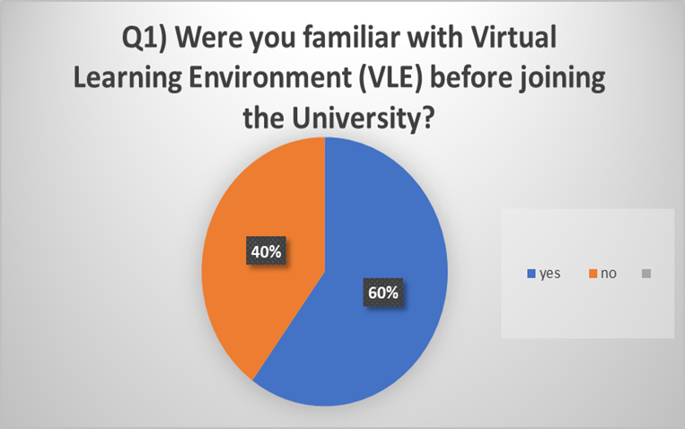

Q1) Graph Analysis: 60% of population where familiar with a form of VLE even before joining UWTSD courses, whilst 40% replied “no”.
As a result, it is clearly seen that different virtual learning environment are gaining ground and that education it is heading towards e-learning Due to an increased number of students already familiar with VLE. Inclusion considerations need to be made for the remaining population that is not yet familiar with VLE so they are not deprived from education when traditional classroom pedagogy is not available, and they are not being left behind due to low IT savviness.

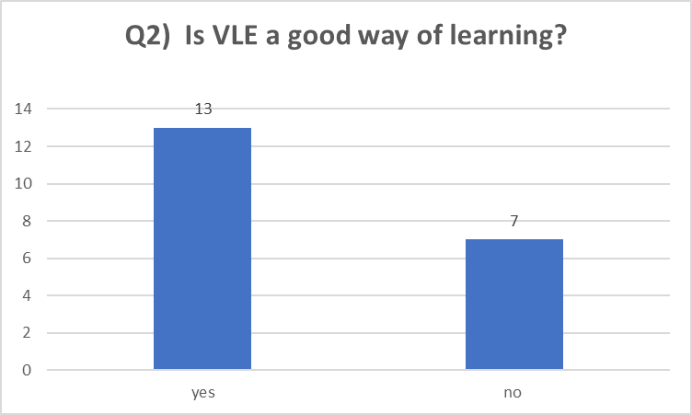

Q2) 65%, meaning 13 individuals, consider VLE a good way to learn, whilst 35% answered no.
As a result, most students consider VLE to be a beneficial meaning of learning acknowledging all the positive aspects of the system whilst 35% says it is not. This is not indicative of the fact that other learning Methods are dismissed or even preferred by students, but a confirmation that VLE is considered effective by most.

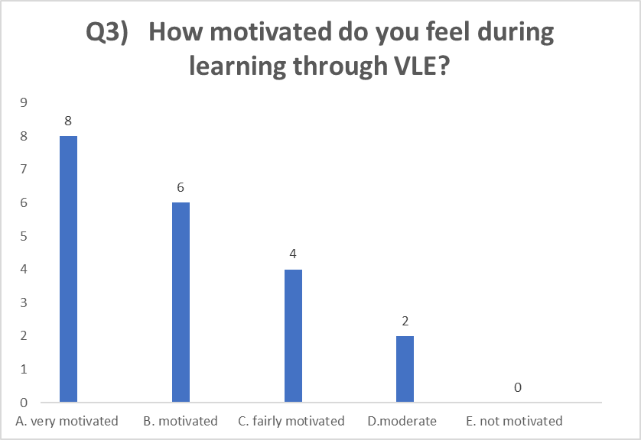
Q3) 40% Feel very motivated whilst learning through VLE, 30% motivated, 20% fairly motivated and 10% moderate.
the analysis shows a total of 14 out of 20 feels Motivated to very motivated while using VLE. This very high percentage show that virtual learning environment is indeed catching their attention Making them feel driven and stimulated. The remaining of 30% fill a range of motivation from fairly to moderate this raising the alarm that some students need more stimulation during VLE.

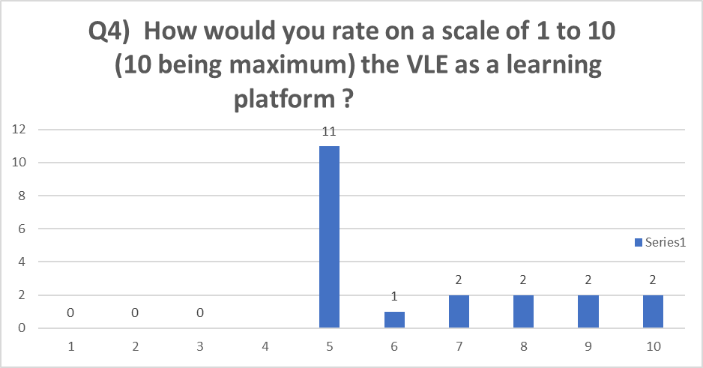
Q4) 11 students rated VLE with 5, 1 with 6, 2 with 7, 2 with 8, 2 with 9 and another 2 with 10.
As a result, it is understood that VLE is appreciated among students inconsiderate a good learning platform That clearly has benefits on their studies. Data shows that students are happy using VLE, this meaning they are managing it and use it in their advantage.

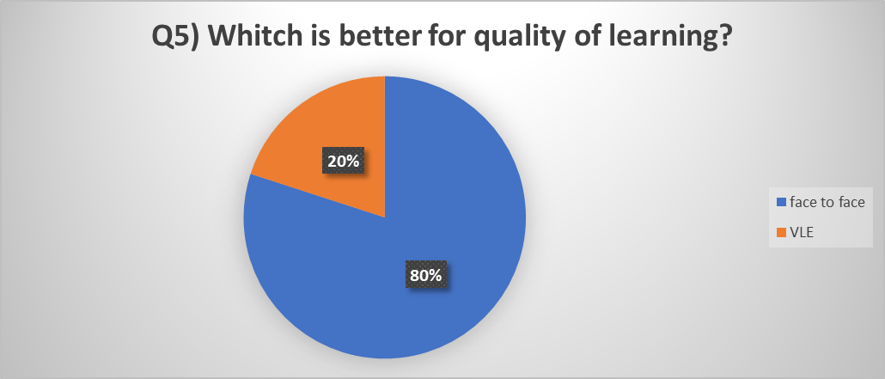

Q5) 80% answered face to face and 20% chose VLE
As a result, it is clearly seen that when students were asked what method of learning is offering a better quality most of them replied “face to face”, clearly showing that traditional pedagogy it's still preferred among students, that would rather stay in a classroom where the lecturer presents the pedagogical material. The remaining of 20% consider the current VLE as being the most efficient form of learning.

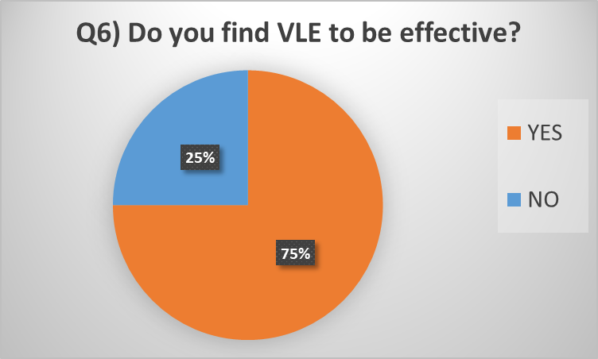
Q6) 75% consider VLE effective, whilst 25% ineffective
As a result, I can say the vast majority consider the tools and features of VLE to be efficient in their learning experience. This shows VLE Is providing vital and much needed information in a very effective manner that is appreciated by students.

Q7) How do you feel about going back to traditional classroom learning?
As a result, when asked this question majority replied good, fine, and would prefer classroom learning showing that learning is still associated with the classroom as opposed to a virtual environment. Some students felt anxious, showing that mental health should be taken in consideration, and worried about travel cost and extra time for travel.

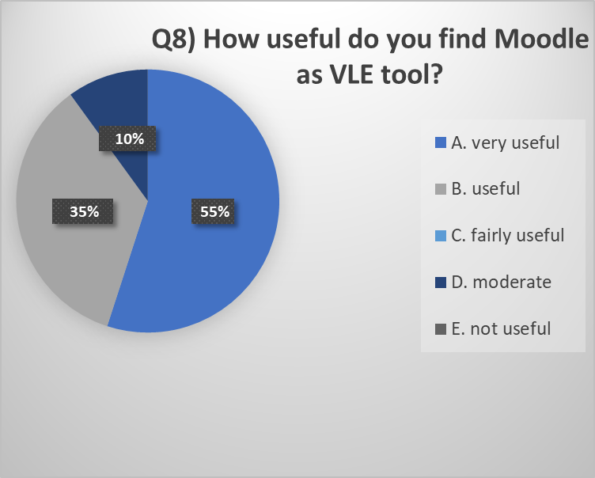

Q8) 55% consider Moodle very useful, 10% moderate whilst 35% think of Moodle as not useful
As a result, I can say the vast majority of 65% label Moodle from moderate to very useful, showing that this is a fairly successful VLE platform offering useful information in a useful and productive manner that students appreciate in access quite easily.

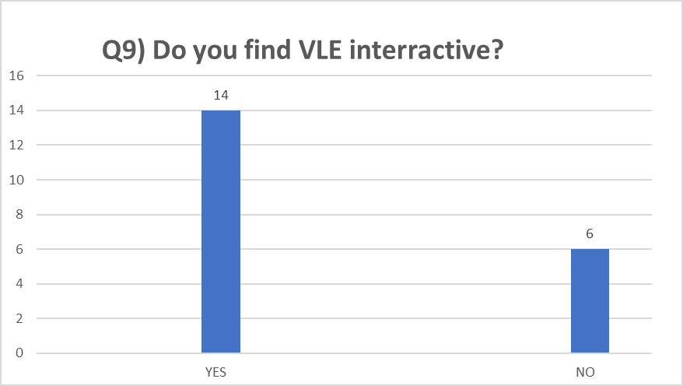
Q9) 14 representing 70% find VLE interactive, whilst 30% represented by 6 replied with no
as a result, it is clearly that most students find VLE as being interactive. Classroom interaction has shown to have a positive impact on information retention and recollection. The interaction in VLE is supported by video material, pictures, graphs and visual material that students find interactional and alert.

Q10) How do you think VLE will evolve in the following years?
Most students consider this the future as a learning method that will evolve over the following years considering it becoming very popular and more creative. As a result, it is shown from analysis that most students believe VLE will occupy first place in education in the following years even if they like it or not. Being in the technology innovation era VLE Can only evolve in the near future as technology innovation is happening on a daily basis.

Summary of findings
From analysing the data collected I can say most students consider VLE as being interactive and very useful. The majority stated that VLE is a good motivation learning method meaning that this is a great way to be encouraged to learn. When asked to quantify the quality of learning between traditional or VLE the majority selected face to face meaning the interaction with lecturers is still a key factor in education and the great vector in transmitting information. Conducting the questionnaire help me understand better the toll VLE Has taken on students in UWTSD and how this is impacting their life and academic experience.

Conclusions\ Recommendation
Virtual learning is the future that is already here, either by being necessary as it is during current events, or by bringing innovative methods of learning from which students can benefit and make them thrive academically.
It is necessary for new students that are not familiar with VLE to receive the much-needed support in order not to be deprived of essential education because of them not being up to speed with technology.

References
Britain, Sandy Liber, Oleg (1999). "A Framework for Pedagogical Evaluation of Virtual Learning Environments" (PDF). JISC Technology Applications Programme (Report 41). Archived from the original (PDF) on 9 July 2014. Retrieved 1 February 2015 (online) https://web.archive.org/web/20140709094115/http://www.jisc.ac.uk/media/documents/programmes/jtap/jtap-041.pdf [Accessed 25 December 2020]
National Committee of Inquiry into Higher Education (1997) ‘Higher Education in the Learning Society’ (online) http://www.leeds.ac.uk/ncihe/ [Accessed 2 January 2021]
Mason, R. (1998) ‘Models of Online Courses’. ALN Magazine 2, (online) http://www.aln.org/alnweb/magazine/vol2_issue2/Masonfinal.htm [Accessed 25 December 2020]
Milligan, C. (1998) ‘The role of VLEs in on-line delivery of staff development’ JTAP Report 573. (online) http://www.icbl.hw.ac.uk/jtap-573 [Accessed 2 January 2021]
Jacobsen and Kremer, (2000) Flexibility of ‘anytime, anywhere’ access 2nd. (online) https://www.researchgate.net/publication/220286343-Access_Anytime_Anywhere [Accessed 2 January 2021]
Jacobsen, M. & Kremer, R. (2000). ‘Online Testing and Grading Using Web CT in Computer Science’ In Proceedings of Web Net World Conference on the WWW and Internet 2000 (pp. 263-268) Association for the Advancement of Computing in Education (AACE), . San Antonio, Texas (online) https://www.learntechlib.org/primary/p/6371/ [ Accessed 2 January 2021]
Ryan, E. (2019). “Impact of Virtual Learning Environment on Students’ Satisfaction, Engagement, Recall, and Retention” Journal of Medical Imaging and Radiation Sciences, Volume 50, Issue 3, Pages 408-415
Watts, M. &Lloyd, C. (2004) “The use of innovative ICT in the active pursuit of literacy University of Surrey Roehampton” London, UK. (online), Pdf available Watts, Lloyd - 2004 - The use of innovative ICT in the active pursuit of literacy.pdf [Accessed 3 January 2021]
Bhandari, P. (2020) Revised on July 30, 2020“An introduction to qualitative research” (online) https://www.scribbr.com/methodology/qualitative-research/ [Accessed 3 January 2021]
Lani, J. (n.d.) Statistic Solutions (online) https://www.statisticssolutions.com/new-about-us-page [Accessed 3 January 2021]
Aliaga & Gunderson (2005) ‘Interactive Statistics ‘3rd Edition (online) https://www.skillsyouneed.com/learn/quantitative-and-qualitative.html [Accessed 3 January 2021]

Appendix 1 - Questionnaire

Questionnaire
Student Name: Maria Cristina Dumitru
Student ID: 2008177
Module Name: Digital Skills and Research Methods (H&Sc) Term 2 Group: 2
Question 1:
Were you familiar with virtual learning environment before joining the University courses?
A. Yes
B. No
Question 2:
Is VLE a good way of learning?
A. Yes
B. No
Question 3:
How motivated do you feel during learning though VLE?
A. Very motivated
B. Motivated
C. Fairly motivated
D. Moderate
E. Not motivated
Question 4:
How would you rate on a scale from 1 to 10 (10 being maximum) the virtual learning environment as a learning platform?
Question 5:
Which is better for quality of learning?
A. Face to face
B. Virtual learning environment

Question 6:
Do you consider virtual learning environment to be effective?
- Yes
- No
Question 7:
How do you feel about going back to traditional classroom learning?
Question 8:
How useful Do you find Moodle as a virtual learning environment tool?
A. very useful
B. Useful
C. Fairly useful
D. Moderate
E. Not useful
Question 9
Do you find virtual learning environment interactive?
A. Yes
B. No
Question 10:
How do you think virtual learning environment will evolve in the following years?

Thank you,
Maria Cristina Dumitru

Appendix 2 – Excel results interpretation

