CERTHE COMPUTING SKILLS FOR THE WORKPLACE

Sukhpreet kaur
ID: 2542000

university of wales trinity saint david

software solutions for business

module code: acca4046
lecturer: osman elgawi

mohd syafiq bin zolkeply

Contents
0
Task 1. e-Commerce Website builders/software solutions 2
Task 2. Mind-map of contemporary software applications 3
Task 3. Office Applications for creating, storing, presenting, and analysing information/data 4
Task 4. Communication and Collaboration applications 5

Task 1

E-Commerce Website builders/software solutions

E-commerce website builders such as Shopify and Wix help people for businesses to create online stores without needing technical skills. They offer ready-made templates, easy-to-use tools, payments gateway integrations, allowing businesses to build professional websites at a low cost. These platforms also include essential features like inventory management, analytics, mobile responsiveness and marketing tools to help business compete online.

In addition, platforms like Shopify and Wix offer simple marketing tools, such as search engine optimization and social media links, to help businesses reach more customers. While they offer flexibility and customization, some platforms may have fee limitations for advanced needs. Overall, e-commerce website builders are very useful for beginners and small businesses because they save time, reduce costs, make it easier to sell products online.

Wix
Wix is a popular website builder that includes e-commerce functionality. It is general-purpose website builder that allows users to create blogs, portfolios and business websites, as well as online stores. Wix is known for its drag-and-drop editor, which gives users full creative control over the design of their websites. This allows users to create visually attractive websites without needing coding skills. Wix provides wide range of pre-designed templates specifically for online stores, which can be easily customized. For e-commerce, Wix offers features such as product management, secure checkout, and support for multiple payment methods. It also has built-in marketing tools, including email campaigns, social media integration, and search engine optimization to help businesses engage customers. A major advantage of using Wix is affordability and simplicity, making it ideal for small businesses or people starting an online store. Wix has some limitations when it comes to handling very large-scale stores. It is less scalable than specialized platforms and may not perform as efficiently with high volumes of products or transactions.
Overall, Wix is flexible, easy-to-use, and cost-effective solution for individuals and small businesses wanting to create an attractive online store without technical complexity.

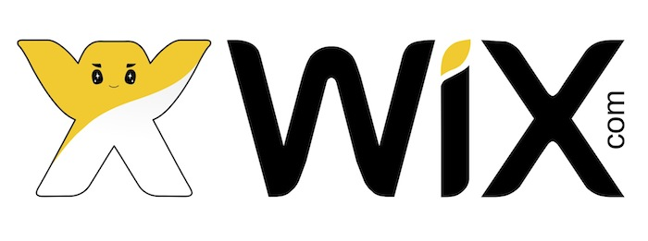

Figure 1 Wix

Shopify
Shopify is an e-commerce platform designed specifically for creating and managing online stores. It is cloud-based solution, users can access it via web browser without installing software. Shopify allows businesses to sell products online and in physical locations through its integrated POS system, which connects in-store sales with online Shopify store. One of the key strengths of Shopify is ease of use, which allows users to choose pre-designed templates and customize them using a simple drag-and-drop interface. (Ltd, 2013) Shopify also supports secure payments processing, including its own (Shopify payments) and third-party providers such as PayPal and stripe. Another major advantage of using Shopify is scalability. Small businesses can start with basic plans and upgrade as they grow. Users can add wide range of features such as inventory management, order tracking, marketing tools like, discounts codes. In addition, Shopify does have some limitations. Monthly subscriptions and transaction fees can increase costs, especially for smaller businesses. Monthly subscription fee depending on plan selected, as business grows, it may need to upgrade to a higher plan.


Figure 2 Shopify

Task 2

Mind-map of contemporary software applications

Mind Map is a visual technique to use to organise information by placing a main idea in the centre and connecting related ideas through Braches. It helps users break down complex topics into smaller, clearer sections. Mind-maps often use keywords, colours, and simple diagrams, making information easier to understand and remember. (J. M. Coulter Journal of business and educational leadership, Oct. 2016)

In business operations, mind mapping offers several important benefits. First, it improves Planning and Decision-making by giving managers a clear overview of tasks, goal, and resources. Instead of reding long documents, teams can quickly see how different parts of a project connect. Second, mind-mapping supports Problem Solving. By visually exploring different options, businesses can identify solutions that may not appear in traditional linear notes. Thirdly, it supports Project Planning and Task Management. Businesses can use them to outline project stages, allocate responsibilities, and track progress. Another benefit is enhanced collaboration. Many contemporary mind-mapping tools, such as, Miro, Mind Meister allow users to continue simultaneously. This supports Teamwork, especially in remote and hybrid working environments.

Overall, Mind-Mapping is a practical tool that helps businesses organise information, generative ideas, and work more efficiently.

Mind Map

The Mind Map shows how contemporary software applications support day-to-day business operations. Communication and Collaboration tools such as Microsoft Teams and Zoom enable employees to communicate effectively regardless of location. Productivity applications including Microsoft Word, Excel, and PowerPoint assist with document creation, data analysis, and presentations.
Business Management software such as SAP ERP, Salesforce CRM, and Oracle NetSuite helps organisations manage resources, customers, and business processes. Cloud Storage solutions like One Drive and Google Drive provide secure access to files and support remote working.
Project Management applications including Trello, Asana, and Jira assist teams in planning, tracking, and completing projects efficiently. Finally, Data analytics tools like Power BI and Tableau help organisations analyse data and make informed strategic decisions.
Together, these software applications improve productivity, collaboration, efficiency, and competitiveness in modern organisations.

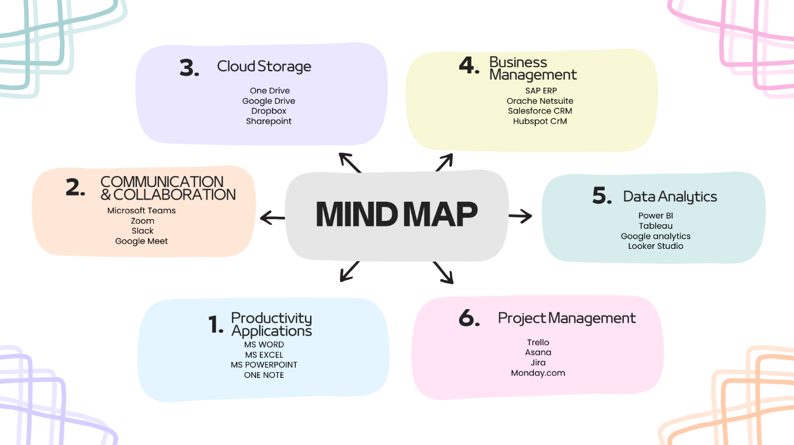

Figure 3Mind Map

Task 3

Office Applications for creating, storing, presenting, and analysing information/data

Modern organizations rely heavily on office applications to create documents, manage information, analyze data, and communicate effectively. Microsoft Office remains one of the most widely used productivity suites in businesses worldwide because it provides applications that support different operations with the Microsoft Office Suite are Microsoft Word, Microsoft Excel, Microsoft PowerPoint, and Microsoft Access. Each application has unique features that assist organizations in improving productivity, collaboration, and decision-making.

This report discusses the major features, benefits, and limitations of these four software solutions and explains how they support modern business operations.

MS Word
Microsoft Word is a word-processing application used to create, edit, format, and shape professional documents. It is widely used for reports, business letters, contracts, manuals, and meeting notes. Microsoft Word provides extensive formatting options, templates, collaboration tools, and integration with other Microsoft 365 applications.
Key Strength of Microsoft Word is its formatting tools. Users can adjust fonts, colors, spacing, margins, and alignment to create professional – looking documents. Features such as headers, footers, page numbers, and styles help maintain consistency throughout long documents. Word also includes templates for resumes, letters, and reports, which save time and ensure a polished layout. The ability to insert tables, charts, images, shapes, and SmartArt makes documents more visually appealing and easier to understand.
Microsoft Word also supports strong editing and reviewing tools. Spell check and grammar check help improve writing quality, while Track Changes and Comments allow multiple people to review a document at the same time. This is especially useful in workplaces where teams collaborate on reports, reducing mistakes and improving accuracy. Another important benefit is Word’s integration with cloud services such as OneDrive and SharePoint. This allows users to save documents online, access them from any device, and work together in real time.

MS PowerPoint
Microsoft PowerPoint is one of the most widely used presentation software tools in education, business, and professional communication. It allows users to create structured slide shows that combine text, images, charts, and multimedia to present information in a clear and engaging way. PowerPoint is a part of Microsoft Office Suite and has become a standard tool for delivering lessons, business pitches, project updates, and training sessions because of its flexibility and ease of use.
A major strength of PowerPoint is its design and layout features. Users can choose from a large library of templates and themes to create professional presentations quickly. These templates support different scenarios such as business reports, lessons, and creative projects. PowerPoint also supports images, videos, audios, charts, and SmartArt, making it easy to communicate ideas visually. PowerPoint includes transitions and animations that improve the flow of presentation. Slide transitions such as Morph create smooth movement between slides, while object animations allow text and images to appear with controlled timing. These tools highlight key points and maintain audience attention. PowerPoint also provides strong support for presenters. Features such as Presenter View, speaker notes, and live subtitles help users deliver presentations confidently. (S. Kaplan Organization science (Providence, Mar. 2011) (J. M. Coulter Journal of business and educational leadership, Oct. 2016) (S. Kaplan Organization science (Providence, Mar. 2011)
Overall, Microsoft PowerPoint is a flexible and powerful tool that helps users communicate information effectively.

MS EXCEL
Microsoft Excel is one of the most powerful and widely used spreadsheet applications in the world. It is part of the Microsoft Office suite and is used across industries for organizing, analysing, and presenting data. Excel structures information into rows and columns, allowing users to perform calculations, create charts, and build financial models. It is commonly used in business, education, finance, administration, and IT because it supports both simple tasks and advanced data analysis.
A major strength of Excel is its ability to organize and manage data. Users can enter information into cells, sort and filter data, and create structured tables that make large datasets easier to understand. Excel is widely used for accounting, bookkeeping, budgeting, inventory tracking, and project management. Its grid layout helps users store information clearly, while built-in-tools make it easy to update and analyse data.
Excel also includes powerful formulas and functions. Common functions such as SUM, AVERAGE, IF, VLOOKUP help user’s calculations quickly and accurately. These functions support financial analysis, forecasting, and decision-making. Advanced users can build complex models for budgeting, sales analysis, and performance tracking. Excel’s calculation engine makes it suitable for both everyday tasks and professional data analysis. In addition, businesses use Excel to analyse sales performance, track KPI’s and create dashboards for management. These tools support data-driven decision-making and improve productivity in the workplace.

Microsoft Access
Microsoft Access is a relational database management system (RDBMS) used for storing, organizing, and managing structured data. It is part of the Microsoft 365 suite and provides a user-friendly interface that allows users to build databases without needing advanced programming skills. Access Database Engine with graphical tools for creating tables, queries, forms, and reports, making it suitable for beginners and professionals.
A major benefit of Microsoft Access is its ability to store in structured tables with defined relationships. Users can link tables using primary and foreign keys, which helps maintain data integrity and presents duplication. This relational structure makes Access more powerful than spreadsheet tools like Excel when handling large or connected datasets and suitable for small to medium-sized business applications.
Another important feature is the ability to create forms for data entry. Forms help users enter and view data accurately by providing dropdowns, validation, and customized layouts. Reports allow users to present data professionally with grouping, sorting, charts, and formatted summaries. Reports can be exported to PDF, Excel, or Word, making Access useful for business for reporting and documentation.
Overall, Microsoft Access is a practical and flexible database tool that bridges the gap between simple spreadsheets and complex server-based systems.

Practical Demonstration of features in Microsoft Excel

IF Function
The IF function was used to automatically determine whether a student passed or failed based on their marks. Students scoring less than 40 were classified as “Fail”, while students scoring 40 or above were classified as “Pass”. The formula used was: =(C7<40, “Fail”, “Pass”)
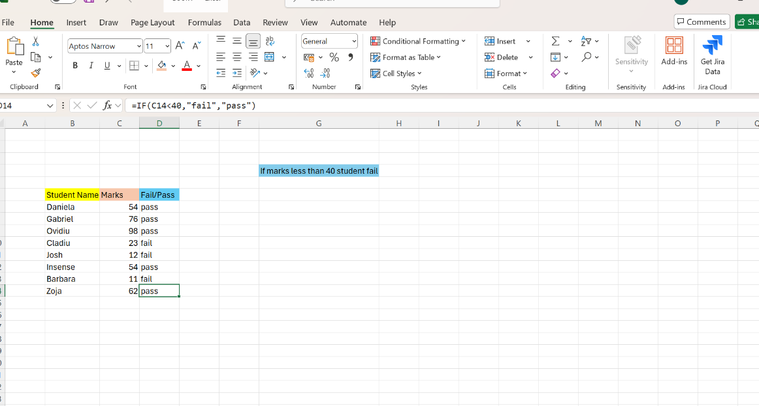

Figure 4Screenshot of IF function

VLOOKUP
This Excel sheet shows how the VLOOKUP function is used to find specific information from a larger table. The main table contains student details such as name, gender, age, class, and test scores. The second table uses VLOOKUP to automatically pull the Final Test marks for selected students by matching their names. This helps quickly search and retrieve accurate data without manually checking each row.

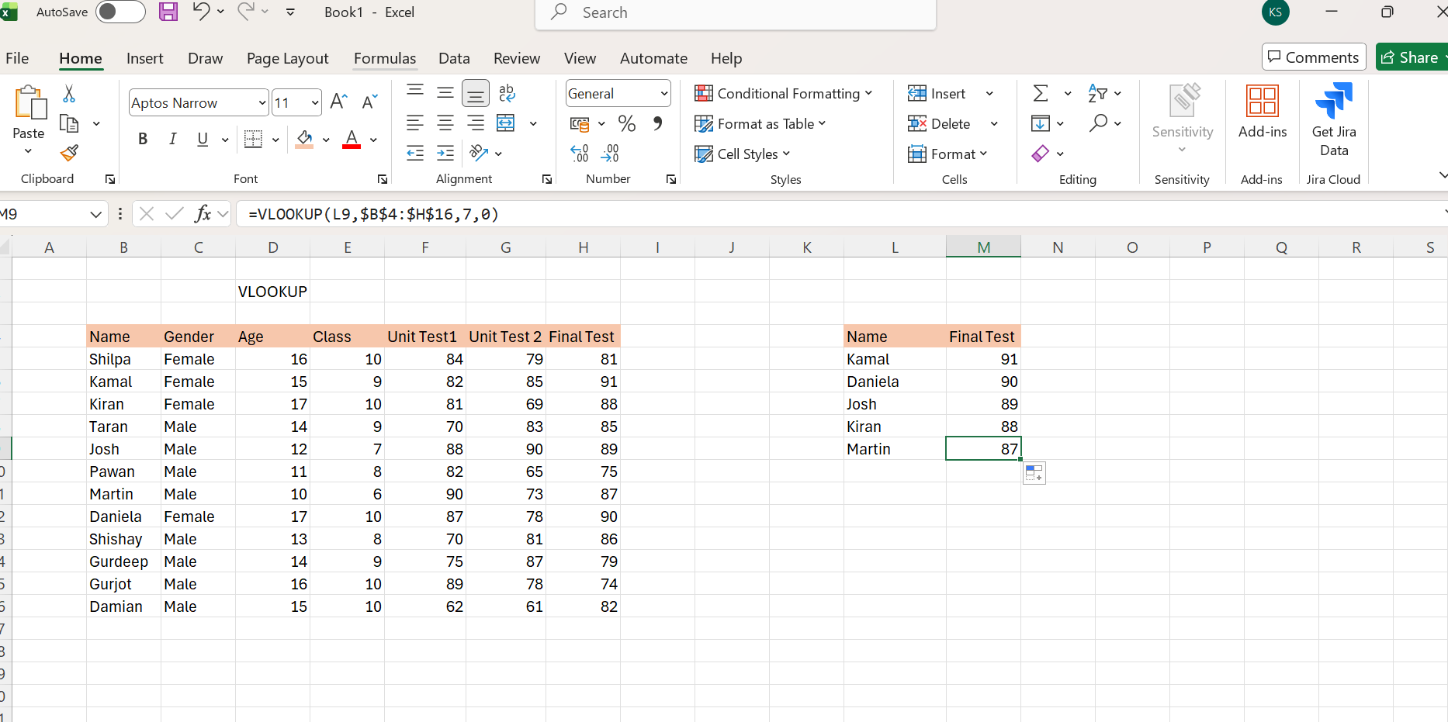

Figure 5Screenshot of VLOOKUP

Task 4

Communication and Collaboration applications
Effective communication and collaboration tools are essential in modern business because they help teams work faster, stay organised, and share information easily. Companies rely on digital platforms to connect employees across different locations and support remote or hybrid working. This report analyses two widely used business applications: Microsoft Teams as a communication tool and Microsoft OneDrive as collaboration tool. Both applications are part of the Microsoft 365 ecosystem and are commonly used in organisations for messaging, meetings, file sharing, and teamwork. The report also includes practical testing of one feature from each tool with screenshots and brief descriptions.

Communication Tool Analyse: Microsoft Teams

Microsoft Teams is a communication platform used by businesses to support messaging, meetings, calls, and teamwork. It allows employees to communicate instantly, reducing delays and improving productivity. Teams is especially popular in organisations that use Microsoft 365 because it integrates smoothly without Outlook, OneDrive, SharePoint, and other Microsoft apps.
One of the key features of teams is instant messaging, which allows users to send text messages, emojis, GIFs, and attachments. This helps teams communicate quickly without needing long emails. Another is video and audio meetings, which supports screen sharing, background effects, meeting recording, and live captions. These tools make remote work easier and allow teams to collaborate even when they are not in the same location.
Teams also includes Channels, which are organised spaces inside a Team where members can post updates, share files, and work on tasks, Channels help keep communication structured and reduce confusion. Security is another major strength of Teams. It includes multi-factor authentication, encrypted data, and compliance tools that protect business information. This makes Teams suitable for organisations that handle sensitive data.

Collaboration Tool Analyse: Microsoft OneDrive

Microsoft OneDrive is a cloud-based storage and collaboration tool used by businesses to store, share, and manage files. It allows employees to access their documents from any device, making it ideal for remote work and flexible working environments. OneDrive is part of Microsoft 365, which means it integrates with Word, Excel, PowerPoint, Teams, and SharePoint.
One of the main features of OneDrive is cloud storage, which gives users a secure place to save files online instead of only on their computer. This prevents data loss and makes it easy to access files from different locations. Another key feature is file sharing, which allows users to send documents to colleagues using secure links. Permissions can be set to “view only” or “edit,” giving users control over who can change the file.
OneDrive also supports real-time collaboration. When a file is opened in Word Online or Excel Online, multiple people can edit the document at the same time. Changes appear instantly, and users can see who is typing or editing. This feature reduces the need to send multiple versions of a file and helps teams work more efficiently.
Version history is another useful feature. OneDrive automatically saves older versions of a file, allowing users to restore previous versions if needed. This is helpful when mistakes are made or when a team wants to compare changes.
Security is a major advantage of OneDrive. Files are encrypted, and organisations can use advanced security policies to protect sensitive information. This makes OneDrive suitable for businesses that need reliable and secure file management.
Overall, OneDrive is a strong collaboration tool that supports cloud storage, file sharing, real-time editing, and secure teamwork.

Practical Testing — Microsoft Teams Feature

For the communication tool test, I used the Chat feature in Microsoft Teams, which is one of the most used functions in business environments. The chat tool allows employees to send instant messages, share updates, and communicate quickly about operational issues. This makes it an essential feature for teamwork and daily coordination.

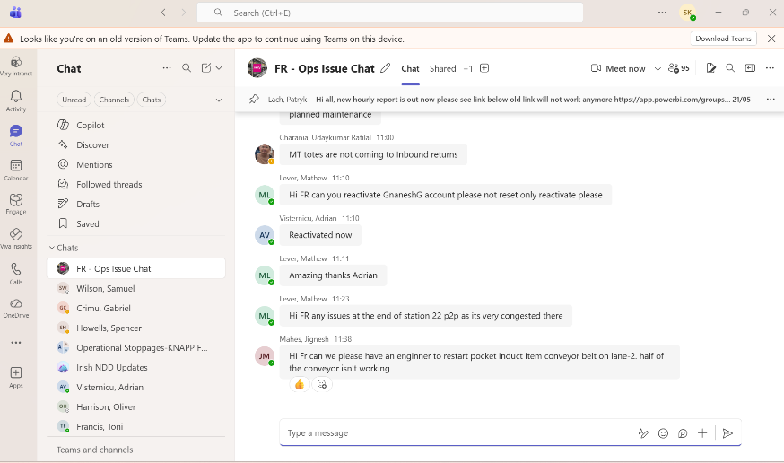

Figure 6Teams chat screenshot

Screenshot Evidence: The screenshot shows an active Teams chat named “FR – Ops Issue Chat”, where multiple team members are discussing real-time operational problems. Messages include updates about reports, requests to reactivate accounts, and technical issues such as conveyor belt faults. This demonstrates how Teams chat supports fast communication between different departments. The screenshot also shows timestamps and names, which highlight how Teams keeps communication organised and traceable. This is useful for accountability and follow-up actions. The chat interface also includes options for attachments, reactions, and message formatting, which help users share information clearly.
This screenshot also shows other chats and channels, proving that Teams allows users to manage multiple conversations at once.

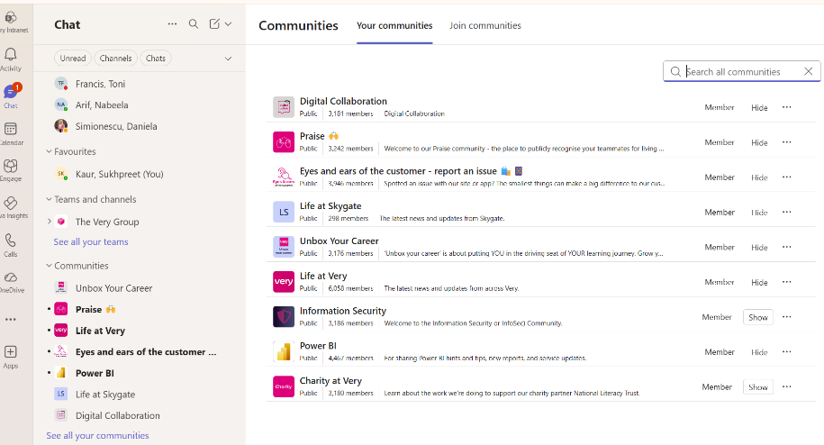

Figure 7Channels and communities on Team
Overall, this test shows that the Teams chat feature is effective for quick communication, problem-solving, and keeping teams connected during daily operations.

Practical Testing – Microsoft OneDrive Feature (Collaboration Tool)

For the collaboration tool test, I used the File Management and Recent Activity feature in Microsoft OneDrive. This feature allows users to upload, access, and organise files in the cloud, which is essential for teamwork and remote working. OneDrive automatically shows recently opened or edited files, making it easy for users to continue working without searching through folders.
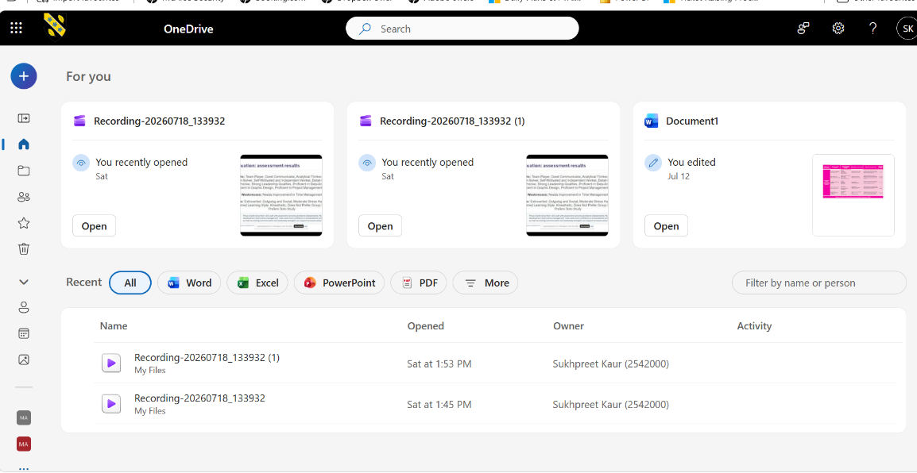

Figure 8OneDrive

Screenshot Evidence: The screenshot shows the OneDrive home dashboard with a section labelled “For you”, displaying recently accessed items such as recordings and a Word document. Each file includes an “Open” button and activity labels like “You recently opened” or “You edited,” which demonstrate how OneDrive tracks user actions. The sidebar on the left shows navigation options including Files, Photos, Shared, and Recycle Bin, proving that OneDrive provides a clear structure for managing documents.
The “Recent” section at the bottom list’s files with timestamps and file locations, showing how OneDrive keeps a detailed history of user activity. This helps employees quickly return to important documents and maintain organised workflows.
Overall, this test shows that OneDrive supports effective collaboration by providing easy access to files, tracking recent activity, and keeping documents securely stored in the cloud.

References
J. M. Coulter Journal of business and educational leadership, .. (Oct. 2016). “MIND MAPPING AS A TOOL TO IMPROVE AUDIT EDUCATION,”. San Diego ., 2.
Ltd, A. I. (2013). Bharti Airtel’s e-Commerce platform - Shopify - for SME customer. PC Quest : The Personal Computing Magazine, {1}.
S. Kaplan Organization science (Providence, R. (Mar. 2011). “Strategy and PowerPoint: An Inquiry into the Epistemic Culture and Machinery of Strategy Making. Organization science (Providence, R.I.), 3.

References
J. M. Coulter Journal of business and educational leadership, .. (Oct. 2016). “MIND MAPPING AS A TOOL TO IMPROVE AUDIT EDUCATION,”. San Diego ., 2.
Ltd, A. I. (2013). Bharti Airtel’s e-Commerce platform - Shopify - for SME customer. PC Quest : The Personal Computing Magazine, {1}.

