Tutorial Tasks

This activity is in continuation which the Library management system scenario created earlier

Library Management System: MS Access Forms Creation Worksheet

Worksheet Objectives:
- Design forms to simplify data entry for library staff.
- Add buttons for basic operations (Add, Save, Delete, Close).

Step 1: Books Table

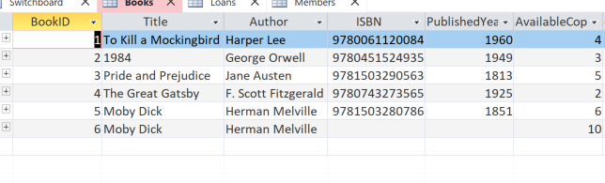

Step 2: Members Table

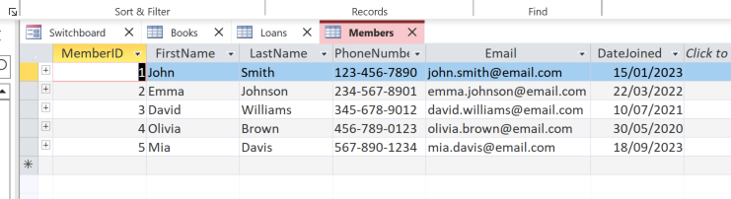

Step 3: Loans Table
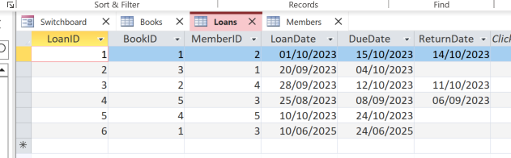

Creating Forms for Data Entry

Step 1: Create a Form for the Books Table
- In the Navigation Pane, select the Books table.
- Go to Create > Form.
- MS Access will automatically create a form based on the Books table.
- Save the Form as BookForm.

Step 2: Create a Form for the Members Table
- In the Navigation Pane, select the Members table.
- Go to Create > Form.
- MS Access will create a form based on the Members table.
- Save the Form as MemberForm.

Step 3: Create a Form for the Loans Table
- In the Navigation Pane, select the Loans table.
- Go to Create > Form.
- MS Access will create a form based on the Loans table.
- Save the Form as LoanForm.

Part 4: Adding Buttons to Forms

Step 1: Adding Buttons to the BookForm
- Open BookForm in FormDesign View.
- Go to the Design tab and click Button.
- Add the following buttons using the Command Button Wizard:
  - Add New Record: Select Record Operations > Add New Record.
  - Save Record: Select Record Operations > Save Record.
  - Delete Record: Select Record Operations > Delete Record.
  - Close Form: Select Form Operations > Close Form.
- Save the changes.

Step 2: Adding Buttons to the MemberForm
- Repeat the same steps to add buttons for adding, saving, deleting, and closing records on MemberForm.

Step 3: Adding Buttons to the LoanForm
- Repeat the same steps to add buttons for adding, saving, deleting, and closing records on LoanForm.

Part 5: Testing the Forms
- Switch to Form View for each form and test the buttons.
- Use the forms to add, edit, and delete records in the Books, Members, and Loans tables.

