

BA Developing Leadership and Management
Module: Managing Projects in the Organisation (BMSW5009)
Lecturer: Lan Zhang
Student: Florina Țuțuiu (2409707)

Attend-X: A Critical Evaluation of a Smart Attendance Verification Project

Table of Contents

Executive Summary 3
1.0 Introduction 4
2.0 Project Lifecycle Evaluation 4
2.1 Project Initiation 4
2.2 Planning 6
2.3 Execution and Monitoring 9
2.4 Evaluation 10
3.0 Conclusion 12
4.0 Recommendations 12
References 13
Appendix A - Detailed Proposed Budget Breakdown 16
Funding Sources 16
Budget Rationale 16
Proposed Allocation of Funds 17

Executive Summary
This report critically evaluates the development of Attend-X, a proposed smart attendance verification system designed to make attendance recording in higher education more accurate, efficient and reliable. The project was completed as part of the Managing Projects in the Organisation module and focused on producing a realistic proposal rather than a fully working system.
Using the project lifecycle as a framework, the report looks at how Attend-X developed from initiation and planning through to execution, monitoring, evaluation and final recommendations. Throughout the project, project management principles, tools and theories helped guide decisions on scope, stakeholder management, communication planning, scheduling, budgeting and risk management. Applying these ideas helped the team review decisions at each stage and recognise that the proposal needed to be checked and refined as it developed. The report also considers how lecturer feedback, team discussions and ongoing review influenced the proposal, showing that project management is not always a fixed process, as decisions often need to be challenged and improved when new information becomes available. Rather than only describing the project, the report evaluates how effective the decisions were across the project lifecycle, reflecting on the strengths of the proposed approach and the areas that still need further development.
The report concludes that applying project management techniques to a realistic organisational problem gives the team a deeper understanding of how projects develop in practice. Although Attend-X remained a conceptual proposal, the project showed the importance of balancing scope, time, cost and stakeholder expectations while adapting to new information as the proposal changed. Overall, Attend-X provides a realistic foundation for future development and offers practical recommendations to strengthen the proposal before implementation is considered.

1.0 Introduction
Attend-X is a proposed smart attendance verification system designed to make attendance recording quicker, more accurate and less disruptive in university classrooms. The idea was developed in response to the limitations of traditional attendance methods, which can be time-consuming, prone to human error and open to attendance fraud. Rather than developing a fully operational application, the aim of the project was to produce a realistic proposal that could support future implementation within a university environment. The project was completed over an eight-week period as part of the Managing Projects in the Organisation module. Working within a fixed timeframe meant that the focus was on planning and demonstrating the feasibility of the concept rather than developing the software itself. The project followed the main stages of the project lifecycle, from identifying the problem and defining the project's aims and scope to stakeholder analysis, planning, risk management, budgeting, prototype design and the final presentation.
This report critically evaluates how these project management tools and techniques supported the development of Attend-X. It reflects on the decisions made throughout the project, discusses both the strengths and limitations of the approaches used, and makes recommendations that could strengthen the project if it progressed to real-world implementation.

2.0 Project Lifecycle Evaluation

2.1 Project Initiation
The Attend-X project began with the aim of developing a realistic proposal to improve attendance recording in university classrooms. During the initial meetings, members of Team Perspective shared and discussed different project ideas before evaluating their feasibility, potential impact and alignment with the project's objectives. After considering several options, the team selected Attend-X because it addressed a genuine organisational problem while remaining realistic within the available time and resources. Establishing clear aims, objectives and project boundaries provided a strong foundation for planning and helped the team maintain a consistent project direction (Project Management Institute, 2021; Heagney, 2022; Graham, 2024).
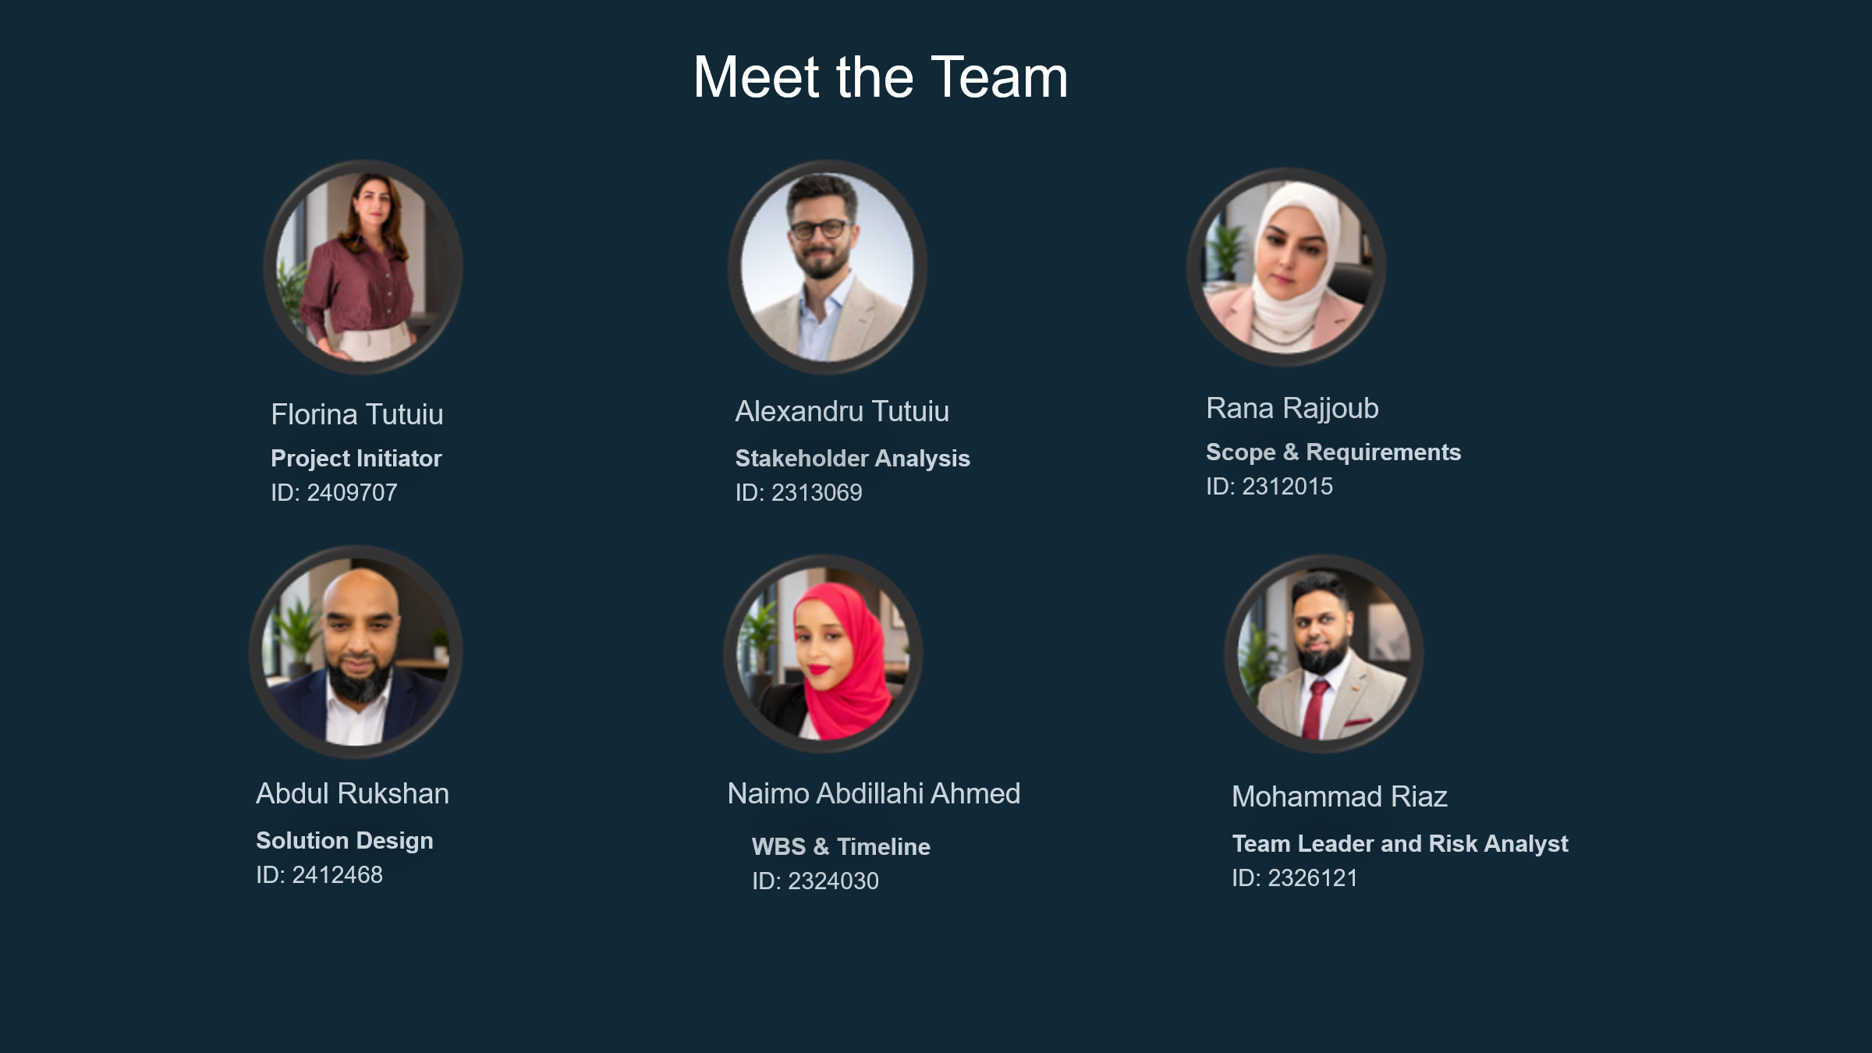
Team Perspective consisted of six members, each taking responsibility for a different area of the project, including project initiation, stakeholder analysis, solution design, scope and requirements, risk management, and project scheduling.
Responsibilities were allocated according to individual strengths and interests, allowing members to contribute effectively. Belbin's Team Roles provide a useful framework for reflecting on this approach, suggesting that balanced teams perform more effectively when different behavioural strengths complement one another (Belbin, 2010; Aranzabal, Epelde and Artetxe, 2022). However, roles were not fixed throughout the project. As planning developed, decisions in one work package often affected others, so members reviewed each other's work and adapted collaboratively.
This shows that while Belbin's model helped allocate responsibilities, the project's success also relied on flexibility, communication and ongoing peer feedback (Monsalves, Cornide-Reyes and Riquelme, 2023). The team's development broadly reflected Tuckman's (1965) Forming stage as members explored ideas and agreed on a shared project direction. However, the project did not progress through the model as neatly as the theory suggests. Discussions around project scope, stakeholder priorities and individual responsibilities continued throughout the planning stage, indicating that team development was more iterative than sequential.
This highlights that, while Tuckman's model provides a useful framework for understanding teamwork, small project teams often move between stages as ideas evolve, strengthening the final project (Guttenberg, 2020; Mircea and Nguyen, 2023).

2.2 Planning
Following initiation, the team planned how Attend-X would be organised and managed. As the project was a realistic proposal rather than a finished product, careful planning was needed to keep it achievable and aligned with its objectives. This stage focused on identifying stakeholders, organising activities, estimating resources and anticipating risks. For Attend-X, planning was especially important because later decisions, including stakeholder engagement, budgeting and risk management, depended on the objectives set at this stage. This supports the Project Management Institute's (2021) view that effective planning provides a framework for informed decision-making throughout the project lifecycle (Verzuh, 2021).
Stakeholder analysis shaped the project from an early stage. Using the Power-Interest Grid, the team identified the University Administration, IT Department, students and lecturers as the stakeholders with the greatest influence on project success, helping determine engagement approaches and inform the communication plan.
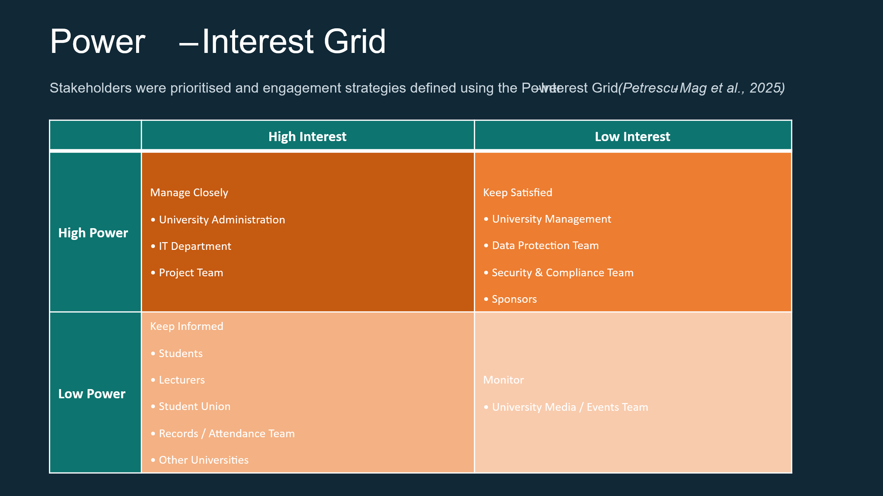
However, lecturer feedback led the team to reconsider the original stakeholder structure. Initially, the proposal relied on existing university IT infrastructure, which would have made the university the project owner rather than Team Perspective. In response, the team revised the approach by distinguishing ownership from implementation, allowing Team Perspective to retain project ownership while recognising the university as a key implementation stakeholder. This showed the value of external feedback during planning, as challenging assumptions strengthened the governance structure and feasibility of the project (Buhmann et al., 2024). Although the revised stakeholder analysis remained theoretical, it provided a more realistic basis for future implementation (Buhmann et al., 2024; Tuan and Sherif, 2021).
The planning process also relied on a Work Breakdown Structure (WBS) and Gantt Chart to organise tasks and monitor progress (Gray and Larson, 2021). Breaking the project into smaller activities made it easier to allocate responsibilities and maintain a logical sequence of work, while the Gantt Chart helped the team plan the order of activities.
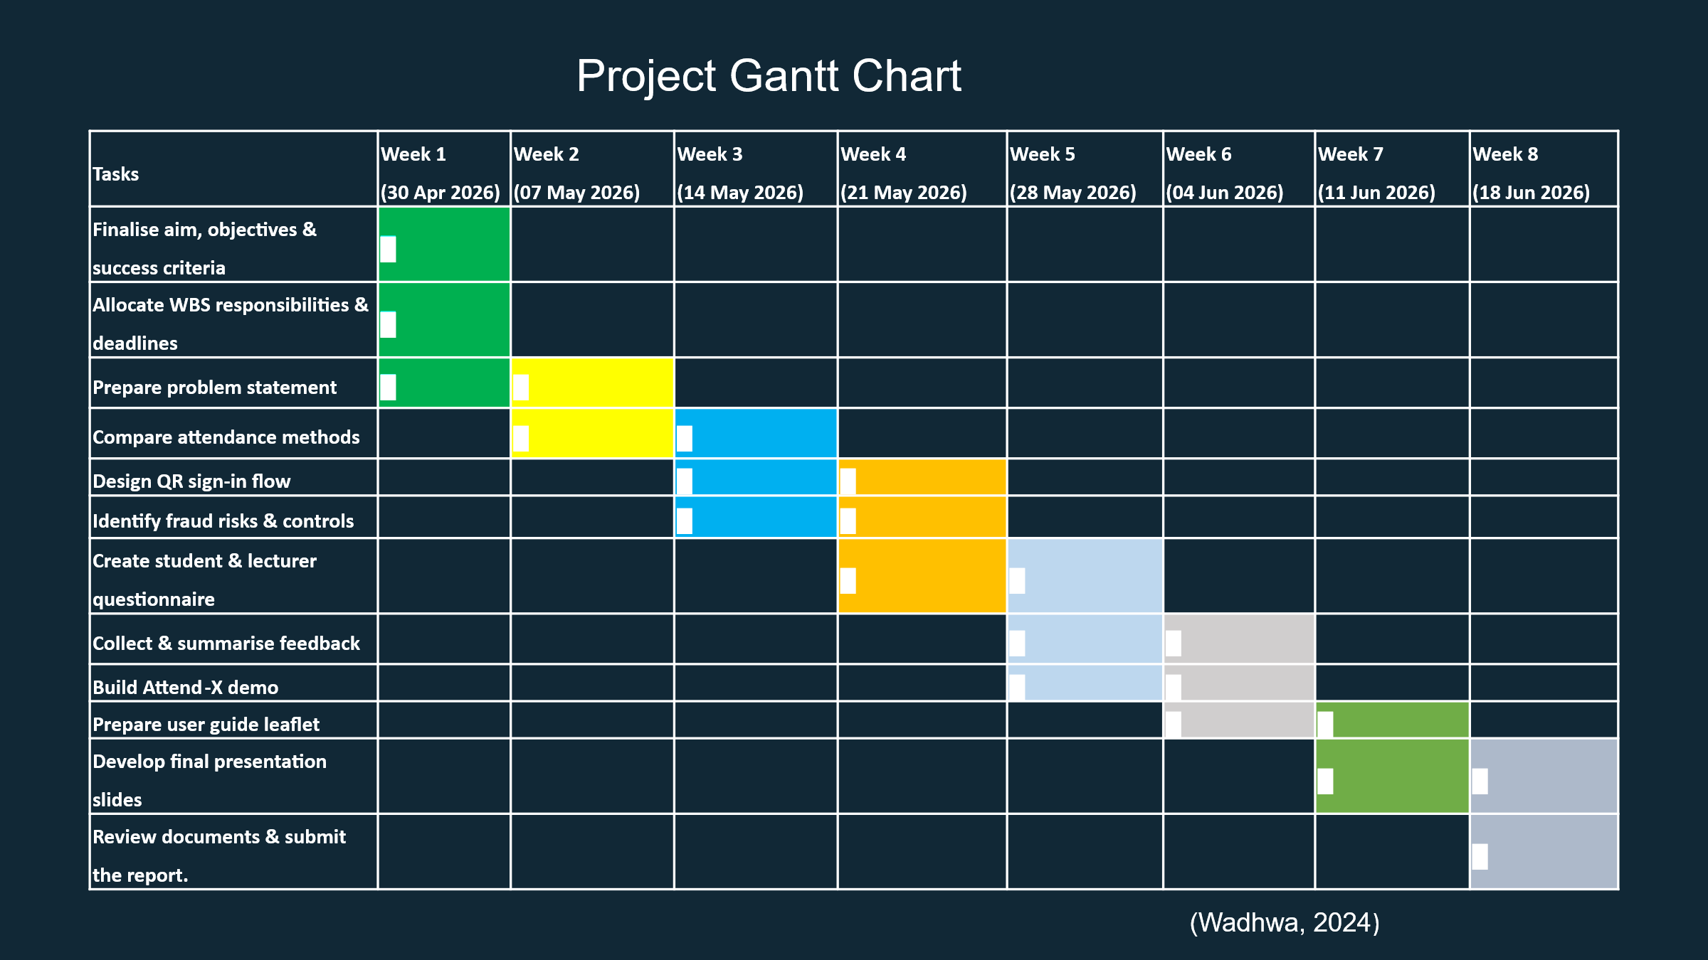

These tools were particularly useful because each member was responsible for a different section of the project but still depended on the completion of other tasks. However, the project also demonstrated that planning tools alone, were insufficient.
As individual work packages became increasingly connected, regular communication was needed to maintain consistency across the project, suggesting that the WBS supported coordination but did not replace collaborative decision-making (Burghate, 2018; Gray and Larson, 2021; Heagney, 2022; Severino, 2024). Planning also included an initial budget and risk assessment to consider the resources required for future implementation. Looking back, one limitation of the original budget was that it presented an overall funding requirement without fully explaining how individual costs had been estimated. 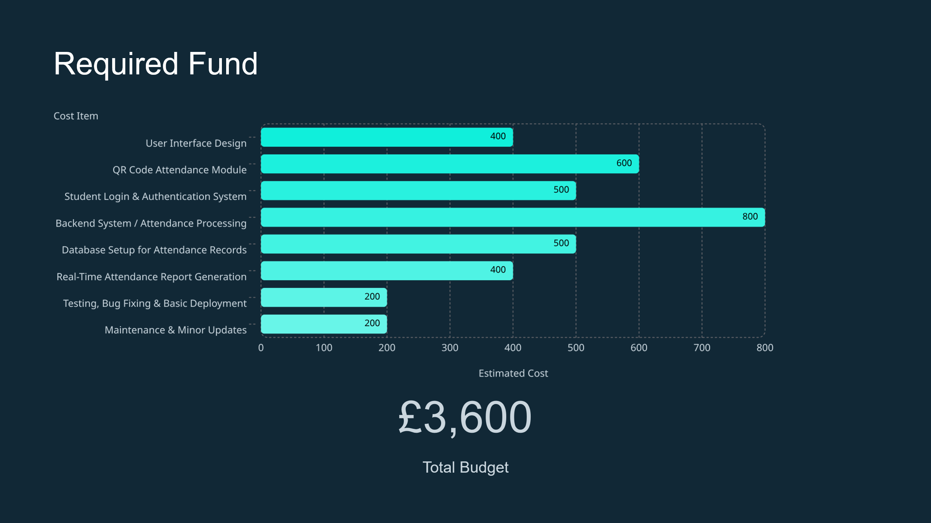 Although this was acceptable for a conceptual proposal, a more detailed breakdown would improve transparency and provide greater confidence for potential sponsors and decision-makers (Meredith and Mantel, 2017). Following reflection, a more detailed budget breakdown has been developed to improve transparency and is provided in Appendix A. Similarly, identifying risks such as attendance fraud, user resistance and technical challenges during planning allowed mitigation strategies to be considered before implementation.
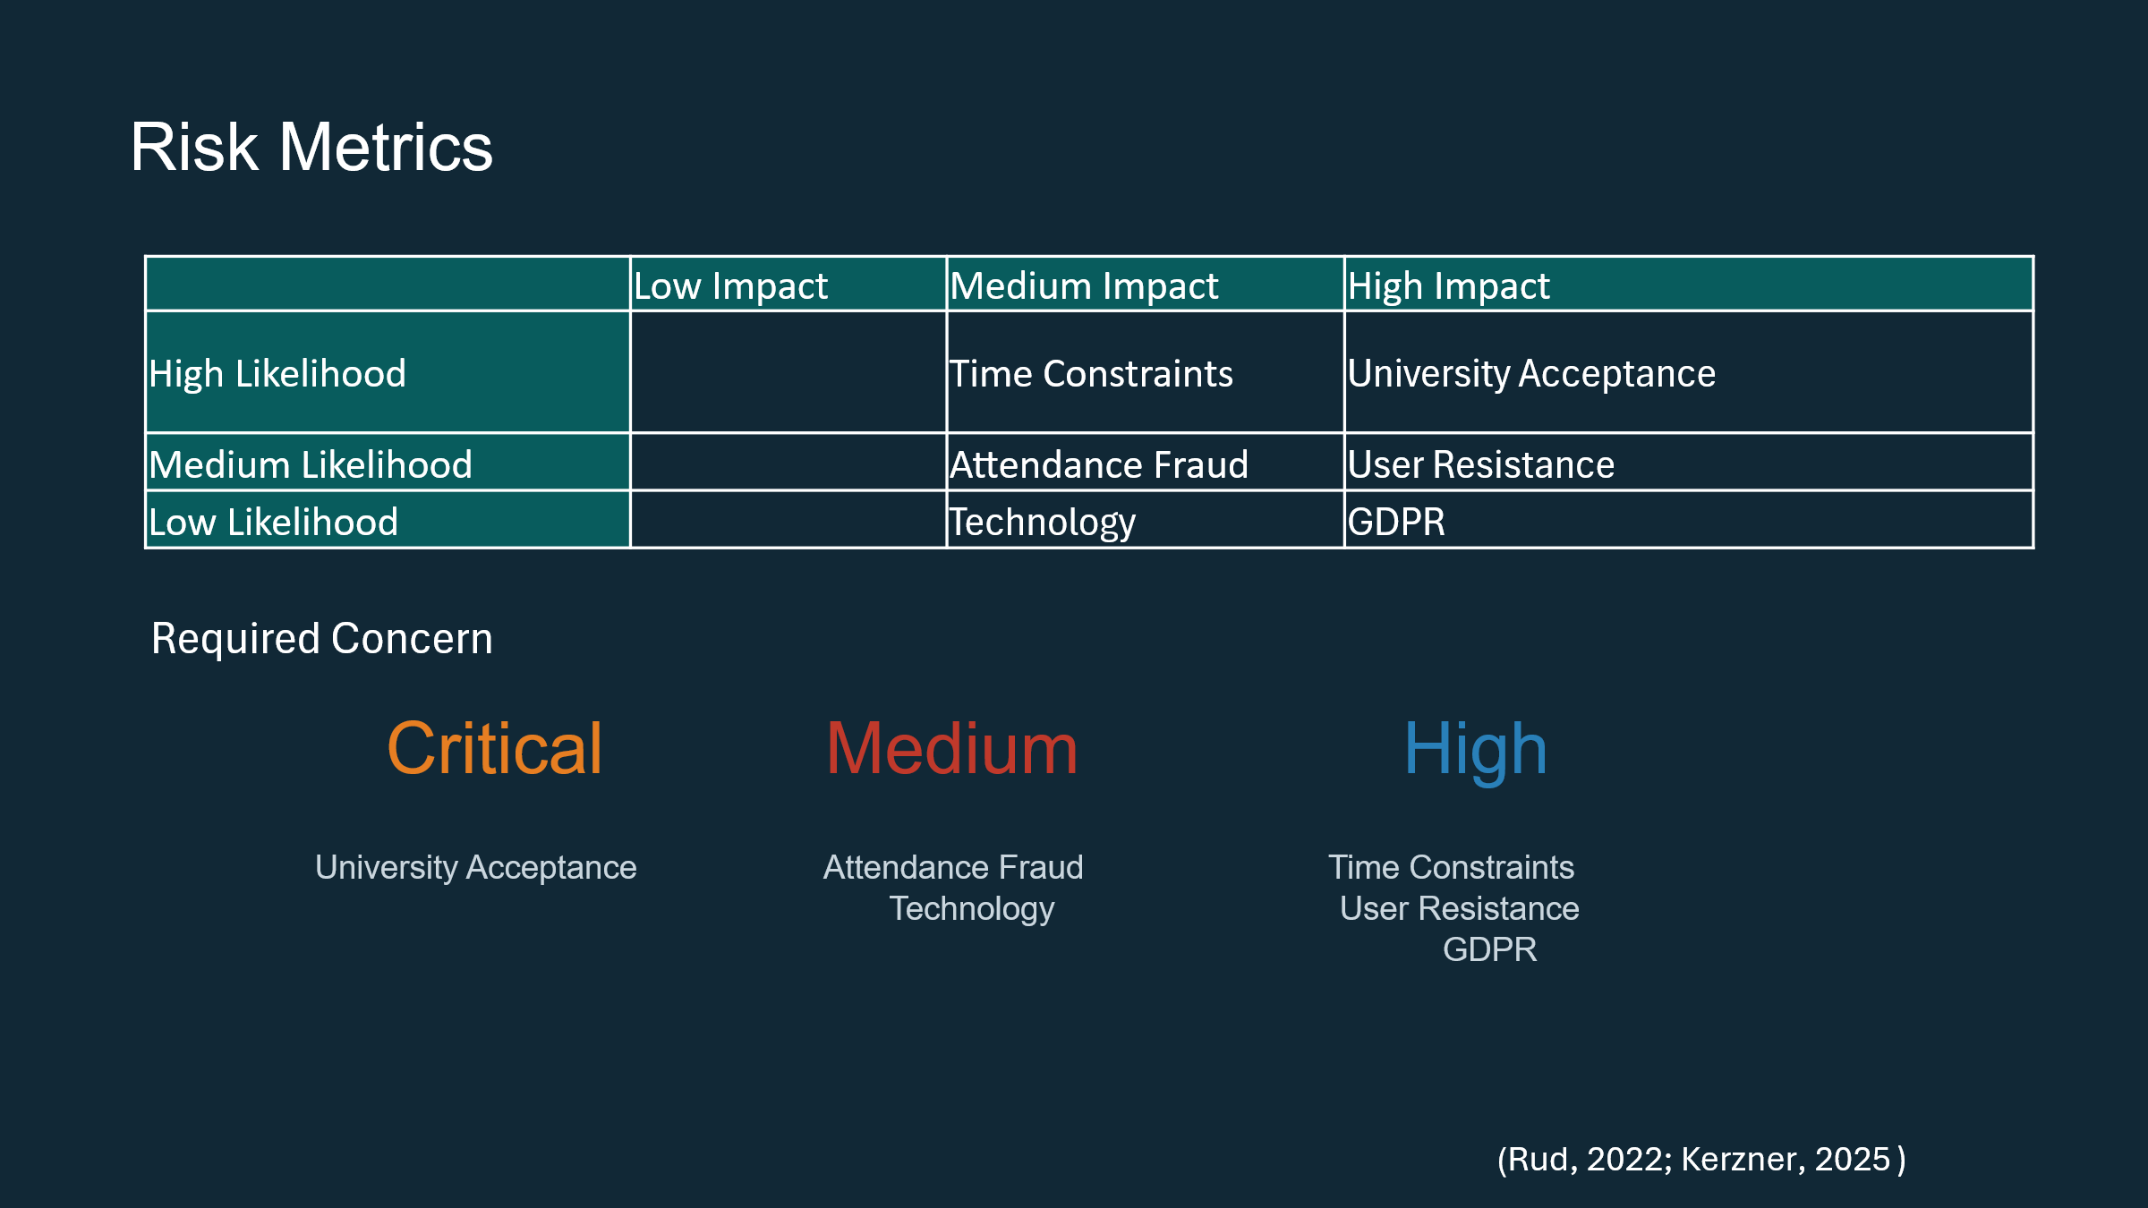
However, because these risks were assessed theoretically rather than through practical testing, their likelihood and impact remain assumptions. This highlights that risk management should continue throughout the project lifecycle rather than end during planning (Graham, 2024; Project Management Institute, 2021).

2.3 Execution and Monitoring
As the project progressed, it became clear that developing Attend-X involved more than simply following the plan created during the planning stage (Huemann and Turner, 2024). Each weekly workshop introduced a new project management technique, encouraging the team to revisit earlier decisions and consider whether they still supported the overall proposal. Rather than treating planning as a completed stage, the proposal developed through continuous discussion and review, making it progressively more realistic (Rodzvilla, 2024).
This supports Heagney's (2022) view that project management should remain flexible throughout the project lifecycle rather than following a fixed sequence of activities. Similarly, Clegg, Skyttermoen and Vaagaasar (2020) argue that projects create value through continuous learning and adaptation rather than rigidly following an initial plan.
Applying the project management tools also demonstrated that they worked best when used together rather than in isolation. The WBS and Gantt Chart provided a clear structure for organising activities and managing the proposed schedule, but they also highlighted dependencies between tasks that were not obvious initially. As the proposal developed, monitoring progress against the timeline helped identify where activities overlapped and where adjustments were required, reinforcing the importance of regularly reviewing project plans rather than treating them as static documents (Burghate, 2018; Janhunen, 2022). Similarly, the proposed communication plan appeared appropriate during planning, yet lecturer feedback challenged some of the team's assumptions about stakeholder ownership. Linking Attend-X to existing university systems would have strengthened implementation, but it also raised questions about who would own and manage the project. Revisiting this decision improved the proposal by ensuring that governance remained consistent with the project's original objectives. This reflects the view that stakeholder expectations and governance arrangements should evolve as projects develop rather than remain fixed throughout the project lifecycle (Buhmann et al., 2024; Petrescu-Mag et al., 2025).
The same process highlighted limitations within the proposed budget and risk management strategy. Although the original budget demonstrated that the project appeared financially achievable, it lacked sufficient justification to convince potential sponsors how resources would be used. Developing a more detailed cost breakdown improved the credibility of the proposal rather than simply adding information, reflecting the importance of transparent financial planning within project management (Graham, 2024; Kerzner, 2025).
Likewise, reviewing the risk register showed that risk management should continue throughout a project's development, as new issues emerged alongside new decisions. Looking back, the project demonstrated that successful project management was not achieved by following individual tools, but by questioning earlier assumptions and adapting the proposal as it developed, balancing decisions relating to scope, time and cost throughout the project lifecycle (Pollack et al., 2018; Nahid et al., 2024).

2.4 Evaluation
Looking back, developing Attend-X showed that identifying a genuine organisational problem was only the starting point of creating a realistic project proposal. At the beginning, the team assumed that once the main project management tools had been completed, the proposal would naturally fit together.
However, as the project developed, it became clear that every decision influenced another part of the project. Applying stakeholder analysis, communication planning, scheduling, budgeting and risk management to the same proposal helped the team understand not only what each technique was designed to achieve, but also how they worked together and why decisions often needed to be revisited. This reinforced that successful project management depends on informed decision-making rather than simply completing project documentation (Clegg, Skyttermoen and Vaagaasar, 2020; Graham, 2024; Kerzner, 2025).
Working as a team also shaped the quality of the proposal (Tavoletti et al., 2023). Although responsibilities were allocated according to individual strengths, different opinions often challenged the direction of the project. At times, reaching agreement took longer than expected because members approached problems from different perspectives. Looking back, those discussions probably added more value than simply dividing the work because they encouraged the team to justify decisions before they became part of the proposal. Lecturer feedback supported this process by highlighting assumptions that had been overlooked and encouraging the team to reconsider them from a more realistic project management perspective. Rather than seeing these changes as setbacks, they became opportunities to strengthen the proposal through continuous discussion and adaptation (Buhmann et al., 2024; Petrescu-Mag et al., 2025).
Preparing the final presentation probably changed the team's perspective more than any other stage of the project. Treating it as a funding pitch shifted the focus from explaining the Attend-X idea to demonstrating why it deserved investment and how it could realistically be delivered. Perhaps the biggest lesson from the project was recognising that a good idea alone is rarely enough to make a project credible. It also needs clear justification, realistic planning and the ability to convince others that it can be delivered successfully. Although Attend-X remained a conceptual proposal, working through each stage of its development provided a much deeper understanding of project management than simply learning the theories in class (Mirzaei, Mabin and Zwikael, 2025; Nahid et al., 2024; Project Management Institute, 2021).

3.0 Conclusion
This report has critically evaluated the development of Attend-X by applying project management principles to a realistic organisational proposal. Although the project remained at the proposal stage, working through each phase of the project lifecycle provided a much better understanding of what is involved in managing a project successfully. Looking back, it became clear that developing a realistic proposal involved much more than completing project management documentation.
One of the main conclusions from this project is that effective project management relies on continuously reviewing decisions, responding to feedback and adapting as new challenges emerge. Throughout the project, ideas were discussed, challenged and, where necessary, reconsidered, resulting in a stronger and more realistic proposal. Overall, Attend-X demonstrated that successful project management is not about producing a perfect plan from the outset, but about being willing to question assumptions, learn from the process and continuously improve the project.

4.0 Recommendations
Building on the findings of this report, the next stage should focus on strengthening the proposal before implementation is considered. Working more closely with the university's IT and data protection teams would help confirm that the proposed system is technically feasible, compliant with GDPR and compatible with existing university systems (Rud, 2022; Nadhan et al., 2022).
The planned pilot phase should then be used to gather structured feedback from users, allowing the proposal to be refined before any wider implementation. This would help test the assumptions made throughout the project and ensure that future decisions are based on evidence rather than expectations (Janhunen, 2022; Mirzaei, Mabin and Zwikael, 2025).
Overall, the project has shown that Attend-X has the potential to become more than just a classroom proposal. Although further development would be needed before implementation, the work completed throughout this project provides a realistic foundation for taking the idea forward.

References

Aranzabal, A., Epelde, E. and Artetxe, M. (2022) ‘Team formation on the basis of Belbin’s roles to enhance students’ performance in project based learning’, Education for Chemical Engineers, 38, pp. 22–37. Available at: https://doi.org/10.1016/j.ece.2021.09.001.
Belbin, R.M. (2010) Management Teams: Why They Succeed or Fail. 3rd edn. Oxford: Butterworth-Heinemann.
Buhmann, K., Fonseca, A., Andrews, N. and Amatulli, G. (eds.) (2024) The Routledge Handbook of Meaningful Stakeholder Engagement. 1st edn. Abingdon: Routledge. Available at: https://doi.org/10.4324/9781003388227.
Burghate, M. (2018) Project Management. New Delhi: Pearson India Education Services.
Clegg, S., Skyttermoen, T. and Vaagaasar, A.L. (2020) Project Management: A Value Creation Approach. London: SAGE Publications Ltd.
Graham, N. (2024) Project Management. 3rd edn. Chichester: John Wiley & Sons.
Gray, C.F. and Larson, E.W. (2021) Project Management: The Managerial Process. 8th edn. New York: McGraw-Hill Education.
Guttenberg, J.L. (2020) ‘Group development model and Lean Six Sigma project team outcomes’, International Journal of Lean Six Sigma, 11(4), pp. 635–661. Available at: https://doi.org/10.1108/IJLSS-09-2018-0101.
Heagney, J. (2022) Fundamentals of Project Management. 6th edn. Nashville, TN: HarperCollins Leadership. Available at: ProQuest Ebook Central (Accessed: 10 June 2026).
Huemann, M. and Turner, J.R. (2024) The Handbook of Project Management. 6th edn. Abingdon: Routledge. Available at: https://doi.org/10.4324/9781003274179.
Janhunen, J. (2022) Project Monitoring and Control: Modern Approaches to Project Performance. Cham: Springer.
Kerzner, H. (2025) Project Management: A Systems Approach to Planning, Scheduling, and Controlling. 14th edn. Hoboken, NJ: John Wiley & Sons.
Meredith, J.R. and Mantel, S.J. (2017) Project Management: A Managerial Approach. 9th edn. Hoboken, NJ: John Wiley & Sons.
Mircea, M. and Nguyen, T.M. (eds.) (2023) Project Management – New Trends and Applications. London: IntechOpen. Available at: https://doi.org/10.5772/intechopen.1002510.
Mirzaei, M., Mabin, V.J. and Zwikael, O. (2025) ‘Customising hybrid project management methodologies’, Production Planning & Control, 36(9), pp. 1188–1205. Available at: https://doi.org/10.1080/09537287.2024.2349231.
Monsalves, D., Cornide-Reyes, H. and Riquelme, F. (2023) ‘Relationships between social interactions and Belbin role types in collaborative agile teams’, IEEE Access, 11, pp. 17002–17020. Available at: https://doi.org/10.1109/ACCESS.2023.3245325.
Nadhan, H., Raj, P. and Ojo, A. (2022) Enterprise Integration and Digital Transformation. Birmingham: Packt Publishing.
Nahid, O.F., Rahmatullah, R., Al-Arafat, M., Kabir, M.E. and Dasgupta, A. (2024) ‘Risk mitigation strategies in large-scale infrastructure projects: A project management perspective’, Journal of Scientific Engineering Research, 1(1), pp. 21–37. Available at: https://doi.org/10.70008/jeser.v1i01.38.
Petrescu-Mag, R.M. et al. (2025) ‘A stakeholder analysis based on project managers’ perceptions: Unlocking transformative potential in Natura 2000 projects’, Environmental Science & Policy, 164, article 104011. Available at: https://doi.org/10.1016/j.envsci.2025.104011.
Pollack, J., Helm, J. and Adler, D. (2018) ‘What is the Iron Triangle, and how has it changed?’, International Journal of Managing Projects in Business, 11(2), pp. 527–547. Available at: https://doi.org/10.1108/IJMPB-09-2017-0107.
Project Management Institute (2021) A Guide to the Project Management Body of Knowledge (PMBOK® Guide) – Seventh Edition and The Standard for Project Management. 7th edn. Newtown Square, PA: Project Management Institute.
Rodzvilla, J. (2024) Project Management for Book Publishers: The Programs and Workflows Behind Making Books and Digital Products. Cambridge: Cambridge University Press.
Rud, O. (2022) Data Governance: Creating Value from Information Assets. 2nd edn. London: Kogan Page.
Severino, H. (2024) Managing Projects with Microsoft Teams. LinkedIn Learning. Available at: https://www.linkedin.com/learning/managing-projects-with-microsoft-teams-24037411 (Accessed: 10 June 2026).
Tavoletti, E. et al. (2023) ‘Peer performance evaluations in global virtual teams: A longitudinal analysis of surface- and deep-level attributes’, Journal of International Management, 29(3), pp. 1–21. Available at: https://doi.org/10.1016/j.intman.2023.101029.
Tuckman, B.W. (1965) ‘Developmental sequence in small groups’, Psychological Bulletin, 63(6), pp. 384–399. Available at: https://doi.org/10.1037/h0022100.
Tuan, S.N. and Sherif, M. (2021) ‘Mediation effect of stakeholder management between stakeholder characteristics and project performance’, Journal of Engineering, Project, and Production Management, 11(2), pp. 102–117. Available at: https://doi.org/10.2478/jeppm-2021-0011.
Verzuh, E. (2021) The Fast Forward MBA in Project Management: The Comprehensive, Easy-to-Read Handbook for Beginners and Pros. 6th edn. Hoboken, NJ: John Wiley & Sons.

Appendix A - Detailed Proposed Budget Breakdown

Funding Sources

Funding Source | Contribution (£) | Percentage
Global Foods Ltd (Sponsor) | 900 | 25%
Euro Foods Ltd (Sponsor) | 900 | 25%
Project Team (6 × £300) | 1,800 | 50%
Total Funding | 3,600 | 100%

Budget Rationale
The budget has been broken down to demonstrate how the available funding would support the planned project activities rather than simply presenting an overall cost. This improves transparency, helps justify resource allocation and provides potential sponsors with greater confidence in the proposal. Including a contingency fund also reflects recognised project management guidance that project budgets should account for uncertainty and emerging risks throughout the project lifecycle (Project Management Institute, 2021; Meredith and Mantel, 2017; Kerzner, 2025).

Proposed Allocation of Funds

Budget Category | Estimated Cost (£) | Purpose
QR code platform and subscription services | 350 | Generation and management of secure QR codes for attendance verification during the pilot phase.
Website, domain and cloud hosting | 300 | Hosting project documentation, prototype access and secure cloud storage.
Prototype materials and testing resources | 450 | Printing QR codes, testing materials and supporting pilot activities.
Communication and promotional materials | 350 | Posters, user guides and promotional resources to engage participants during the pilot.
Pilot implementation activities | 800 | Costs associated with conducting a small-scale pilot, including logistical support and participant engagement.
GDPR and data protection consultation | 450 | Professional guidance to ensure compliance with UK data protection requirements.
Monitoring and evaluation | 450 | Collection and analysis of user feedback to evaluate the pilot and identify areas for improvement.
Contingency (approximately 12.5%) | 450 | Allowance for unforeseen costs, technical issues or additional project requirements.
Total Estimated Expenditure | 3,600

