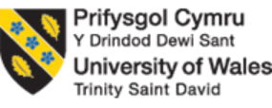
LEVEL 4 ASSESSMENT SPECIFICATION
Assessment 1

Student name: | SARAH BINTI JOHAN SHAH | Student ID number: | 2527783
Programme: | BACHELOR IN ACCOUNTING
Module: | Contemporary Challenges: Making a Difference
Module code: | MWBA4000 | Contribution to Overall Module Assessment (%): | 100%
Lecturer: | Emma Roberts | Internal Verifier: | Vic Saunders
Assignment Title: | Group Presentation with supporting material (max 4 in a group) | Word count (or equivalent): | 1,657 words
Submission deadline: | Monday 24th August 2026 (23.55/ 11.55pm British Summer Time BST) | Return date of provisional marks & written feedback: | 21st September 2026
Submission method: | All written assessments, where practical and possible, must be submitted via Turnitin unless otherwise instructed by the Lecturer. (Please DO NOT put this assessment specification into Turnitin or it will match many similarities with other students’ submissions.)  Alternative submission method (if applicable):  Late submission of the assessment will result in a late penalty mark:  Work which is submitted up to 1 week late will be capped at 40% for the first attempt and will be awarded a mark of 0% for re-assessment. Late submission penalties may be lifted only if there is an approved extenuating circumstances claim.  Work submitted more than 1 week late will be considered as a non-submission and will not be marked. The work may be considered as a submission for reassessment if offered by an Examining Board or if there is an approved extenuating circumstances claim.
Academic honesty / referencing: | Academic honesty is required. In the main body of your submission you must give credit to authors on whose research and ideas your work is based. Append to your submission a reference list that indicates the books, articles, etc. that you have used, cited or quoted in order to complete this assessment.

TABLE OF CONTENT
SECTION 1 - PRESENTATION 2
SECTION 2 - DISCUSSIONS 4
SECTION 3 - CRITIQUES 6
SECTION 4 – REFLECTION 7
REFERENCES 10

SECTION 1 - PRESENTATION
The link provided is the video presentation for the whole of Group 2.
https://drive.google.com/file/d/1PsED7T-G_0WyGG-u7H56Wlvdi6fGDdVX/view?usp=sharing
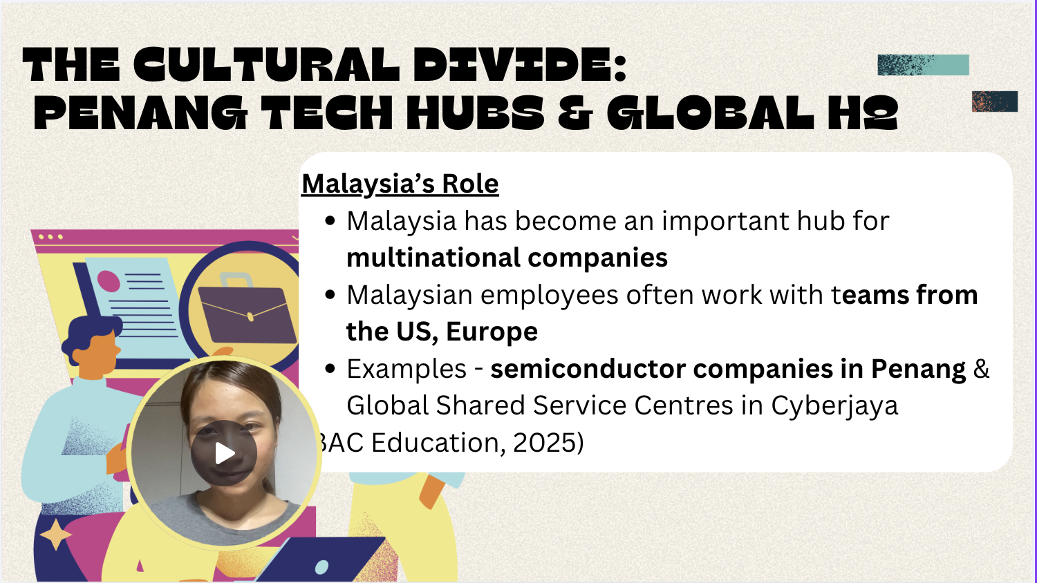
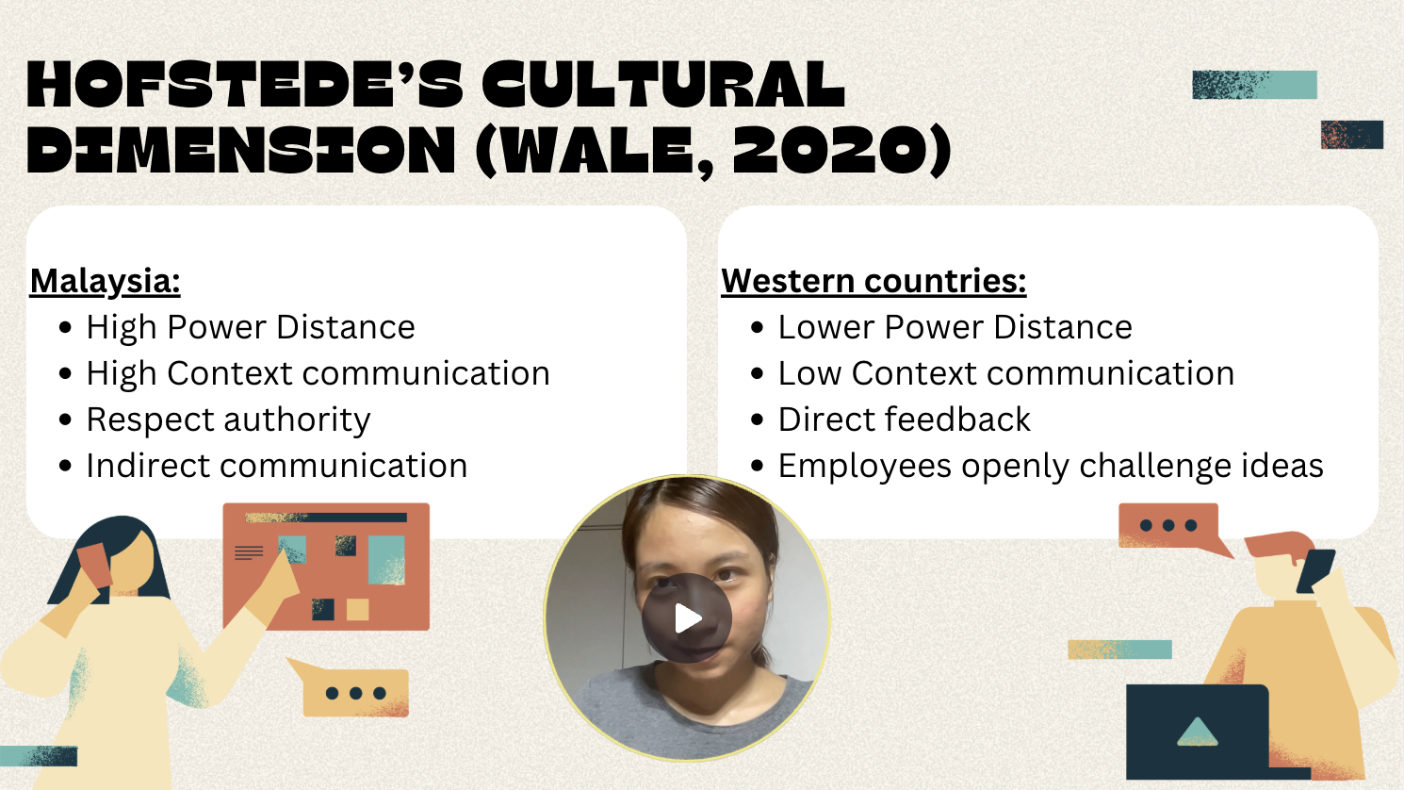
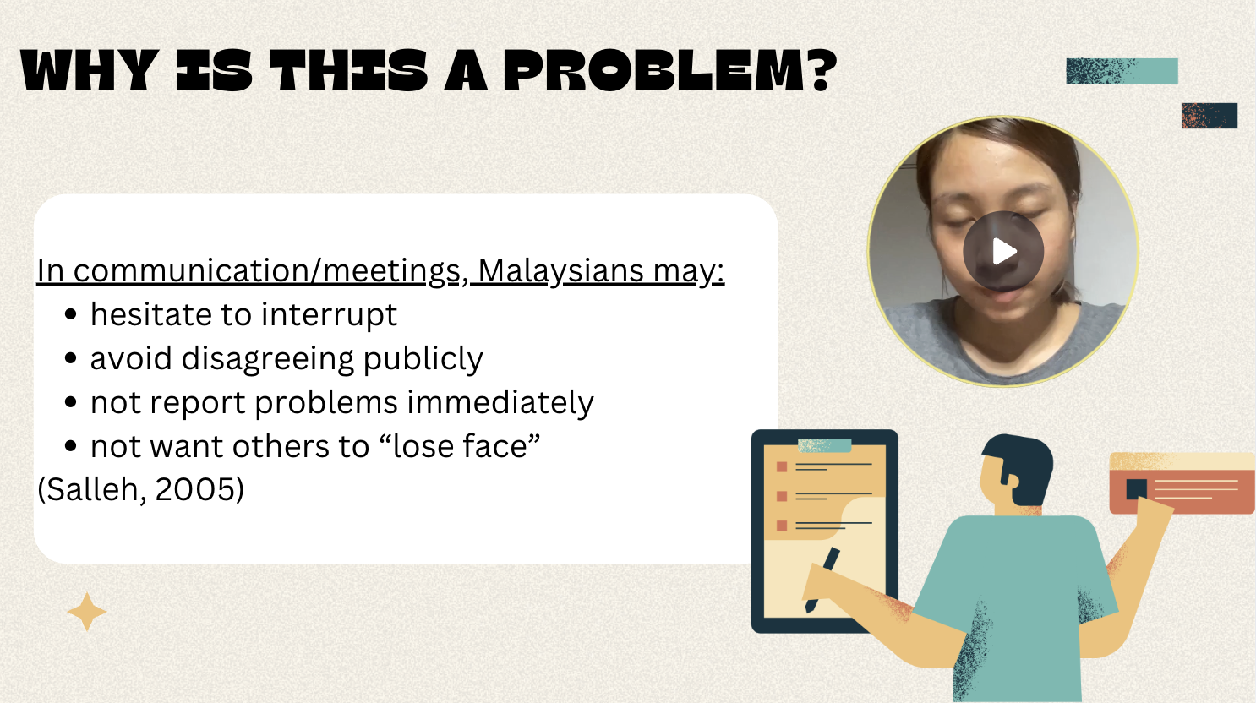
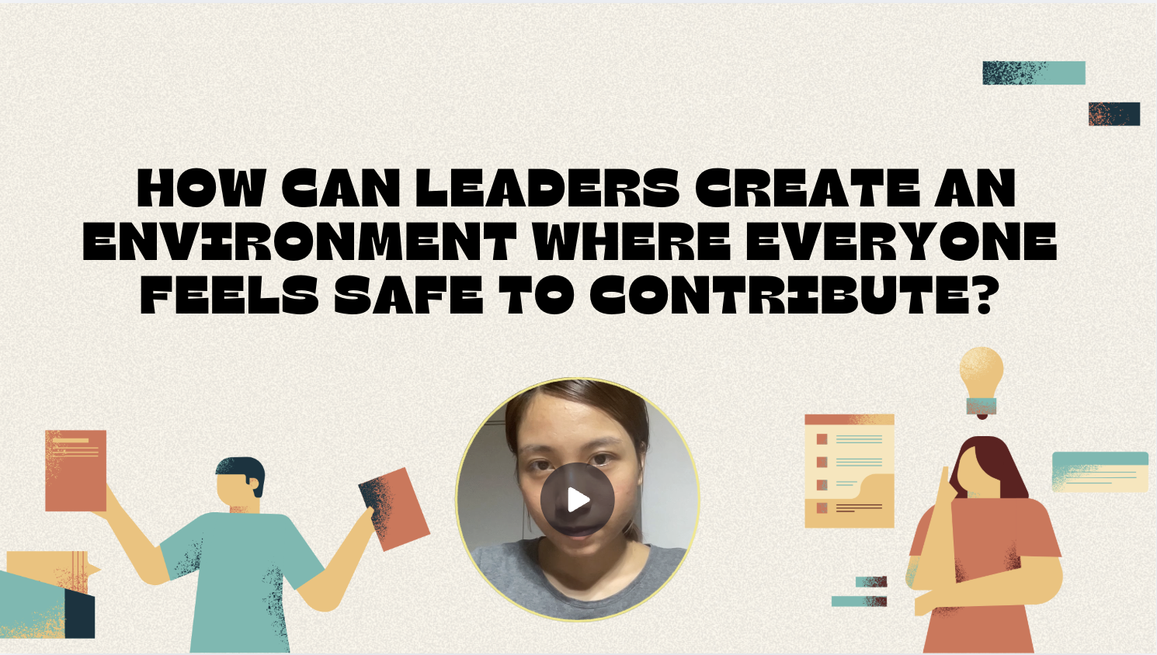

SECTION 2 - DISCUSSIONS
There are four students in our group, which was given the name 'Group 2' to represent us. The first member to present is Sarah Johan, who started with slides 3 to 6; then Nur Sabrina continued with slides 7 to 10, Madeeha Mohamudiah explained slides 11 to 14, and Mya Syahindah finished up and concluded the whole presentation and its notes.

The presentation that is named “Leading Asynchronous & Cross-Cultural Global Teams from Malaysia” talks about the cultural challenges that a global team of Malaysian employees may face when joining forces with Western peers and the significance of having effective problem-solving when dealing with these challenges.
The content of the slides mainly encompasses the cross-cultural communication gaps that may occur using Hofstede’s cultural dimension theory (Wale, 2020), language barriers, psychological barriers to employee voices, and understanding the risk of burnout being caused by time-zone differences using the JD-R model. and the virtual leadership strategies needed for a global team to work together and maintain productivity in a global environment. The overall conclusion of the slides is that to properly have global synergy through virtual leadership, the management has to adapt to new forms of monitoring progress through more focus on the outcome rather than real-time monitoring and trust-based virtual leadership, allowing for sustainable working models and closing the gap between the cultural & operational divide between Malaysian and Western employees.
The first of Sarah’s slides explains the role of Malaysia in being one of the major hubs for multinational companies in all multiple kinds of sectors worldwide. With the rapid expansion of Malaysia in these markets, they are bound to work with Western teams, consisting of those from the US and Europe. An example being Penang's semiconductor hubs and Cyberjaya's shared service centres (BAC Education, 2025). The next slide explains the differences and contrasts in work culture between both sides with Hofstede’s Cultural Dimensions framework, with Malaysians having high power distance, high context, respect for authority and indirect communication, while the Western counterparts have low power distance, low context, direct feedback and a willingness to challenge ideas. The third slide then highlights how these cultural differences can be a future risk and problem to the company's projects by having Malaysian employees hesitate to interrupt, avoid public disagreement, delay reporting current and potential problems, and prioritise saving face among fellow employees (Salleh, 2005). The last slide then asks the core questions of the introduction: "How can leaders create an environment where everyone feels safe to contribute?"
The next slide continues with Sabrina, who first introduces Amy Edmondson’s concept of psychological safety (Edmondson, 1999)., which explains the belief that the team is safe for interpersonal risk-taking and explains why employees stay silent through the "Fastest Speaker Wins" problem. They then propose several leadership interventions and the link of psychological safety to the better quality of work done and early defect reporting. Sabrina builds on the foundation by providing the psychological framework and interventions that are needed to overcome the cultural gaps Sarah has recognised.
Next is Madeeha, who discusses the “12-Hour Gap” and time zone differences between Penang and the US, interprets the burnout mechanism using the Job Demands-Resources (JD-R) Model (Bakker & Demerouti, 2007)., introduces Swift Trust Theory for virtual meetings of teams, and gives actionable solutions such as "no-call" hours and increased autonomy (Meyerson et al., 1996).. Their slides address the physical and time-zone structure challenges that may occur. The hesitation to speak up from a high-power-distance culture clarifies the stress of late-night calls and time-zone friction.
Lastly, Mya concluded the presentation by defining e-leadership through technology, trust, communication, and emotional intelligence and summarised global virtual leadership strategies to address the issues that were brought up in the presentation. They had also established measures for success with asynchronous efficiency and team retention and summarised the core drivers of global synergy.
Sarah’s slides introduce the foundational problem statement for the entire presentation for the group. The acknowledgement of the cultural difference between both work norms and expectations allows for the explanation of why each other's cultures' conventional leadership models may fail in global teams. It helps conclude that corporations should find methods to overcome this issue and must adapt towards more culturally inclusive and outcome-orientated virtual leadership models.

SECTION 3 - CRITIQUES
While the presentation had carefully explained how Hofstede’s cultural dimensions can be applied to the relationship between Malaysian employees and Western management in global teams, a key area of critique that can be worked on is the generalisation of a culture’s traits and their people, which can lead to the stereotyping of an employee rather than properly directed leadership. The personal viewpoint that I have on this issue differs slightly from the group's, with disagreement on the interventions made through the Edmondson’s psychological safety protocols. My personal experience of working with Western counterparts but still under the influence of Malaysia's culture is that it shows that high power distance is deeply ingrained in our culture and that purely formal methods rarely work without the help of non-hierarchical rapport building between two parties.
According to Meyer (2014), theories such as The Culture Map focus more on the positional differences between national cultures rather than on whole collectives, allowing for leaders to adapt more flexibly in more common situations in global teams rather than to fixed dimensional scores.
I had applied critical thinking by properly setting up an introduction that clearly explains the foundation needed to be put in place, rather than just listing the cultural traits. I had influenced the member that presented after me, Sabrina, by connecting our topics together from my cultural analysis straight to psychological safety. I had practised conflict management by devising how much time is appropriate for each slide to get enough information to be explained.
In conclusion, managing this reflection within this group task requires me to be aware of what my group members will be explaining in order for the presentation order to go smoothly and for the information to be understood cohesively. By starting the presentation, I had laid the foundation for what was the issue that needed to be solved through my member’s chosen theories and how they relate to real-world global leadership strategies.

SECTION 4 – REFLECTION
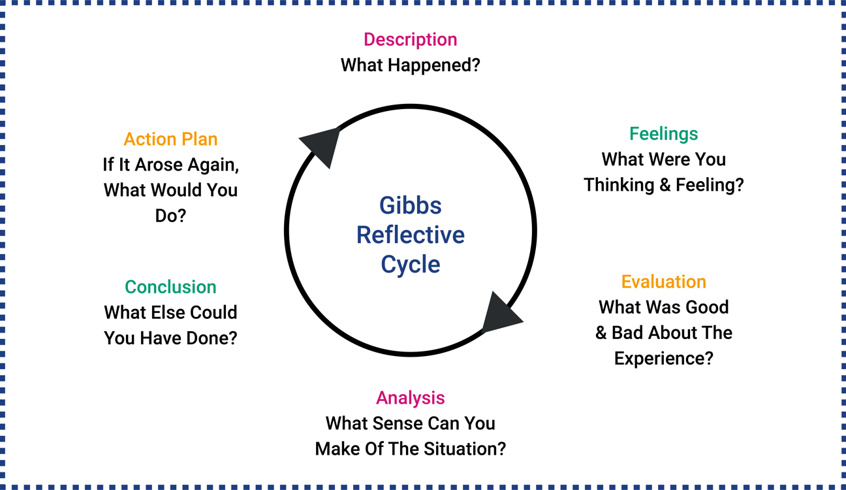
Dynamic Training. (n.d.). Reflective accounts and Gibbs' reflective cycle. https://www.dynamictraining.org.uk/learner-pulse/reflective-accounts-and-gibbs-reflective-cycle/

Gibbs’ Reflective Cycle (1988) is a model of reflection that examines experiences through six distinct stages: Description, Feelings, Evaluation, Analysis, Conclusion, and Action Plan. This framework allows for working dynamics to turn into structured learning and make reflective writing feel more manageable.
The first part of the cycle is the Description. Our group that is named Group 2 had delivered a team presentation that is named “Leading Asynchronous & Cross-Cultural Global Teams from Malaysia". I had opened the presentation by speaking and explaining through slides 3 to 6, exposing the core problem and framework by establishing Malaysia as a global hub and using Hofstede’s Cultural Dimensions framework to contrast the differences between Malaysian and Western work cultures. Nur Sabrina then followed with slides 7–10 on Edmondson’s psychological safety framework. Madeeha Mohamudiah had encompassed the 12-hour time zone gap utilising the JD-R model in slides 11–14, and Mya Syahindah ended the slides by explaining the integration of virtual leadership strategies and performance metrics.
The next part is Feelings. I was excited due to the fact that I have previously studied and analysed the Hofstede framework, meaning that I can explore more in depth about the topic due to the task given. I felt confident enough to be able to build the baseline for the other members to obtain information from my part and for them to be able to build a cohesive flow making the presentation. Though the more I study the theory, the more I have felt as if it is too stiff to properly judge a nation's culture on when matched against virtual workplace interactions.
The third part is Evaluation. The teamwork of our group had gone smoothly, and we had enough members to divide the tasks of the presentation slides. While there were some issues such as in time management and following set deadlines, we managed to push through it and finish the work that was assigned to us.
As part of the Analysis, this group task allowed for us to apply collaborative skills together to help manage both the task and the division. We chose parts that were the most suitable for us and what we could explain the best, starting with the cultural analysis of Malaysia by Sarah, to psychological safety with Sabrina, structural time-zone limitations with Madeeha, and Mya finishing it off with overarching virtual leadership strategies.
In the Conclusion part, I had realised the limits that may occur in global team meetings and risks that pure reliance on formal methods such as Edmondson’s psychological safety may not be as suited for the average Malaysian due to the highly ingrained high power distance. Meyer’s (2014) Culture Map allows for more flexibility for the improvement of teamwork between both sides to work together. Collaboration for this assignment requires a shared vision r and a surface-level understanding of the theories the teammates have allocated and how they can all be correlated all together.
My Action Plan regarding if I were to do this assignment again, is to have clearer time frames of when my group should've finished their work in order to prevent any rush and last-minute changes. Instead of only relying purely on one formal theory, I should have studied more on multiple theories that explore national culutes in a different manner to prevent any rigid pieces of information and to allow for more openness to discuss.
My Overall Reflection on this assignment is that factors of how well a presentation may go, including planning, shared accountability, and active listening, should be prioritised. Studying the relationship between cultural theory, psychological safety, and virtual team operations has helped me gain more knowledge in dealing with international affairs for potential future studies or careers.

REFERENCES
BAC Education. (2025). Penang's Silicon Valley: Inside Malaysia's booming semiconductor industry. https://www.bac.edu.my/bac/penangs-silicon-valley-inside-malaysias-booming-semiconductor-industry/

Bakker, A. B., & Demerouti, E. (2007). The Job Demands-Resources model: State of the art. Journal of Managerial Psychology, 22(3), 309–328. https://doi.org/10.1108/02683940710733115

Edmondson, A. (1999). Psychological safety and learning behavior in work teams. Administrative Science Quarterly, 44(2), 350–383. https://doi.org/10.2307/2666999

Gibbs, G. (1988). Learning by doing: A guide to teaching and learning methods. Further Education Unit, Oxford Polytechnic.

Meyer, E. (2014). The culture map: Breaking through the invisible boundaries of global business. PublicAffairs.

Meyerson, D., Weick, K. E., & Kramer, R. M. (1996). Swift trust and temporary groups. In R. M. Kramer & T. R. Tyler (Eds.), Trust in organizations: Frontiers of theory and research (pp. 166–195). SAGE Publications.

Salleh, L. M. (2005). High/low context communication: The Malaysian Malay style. Proceedings of the Association for Business Communication Annual Convention, 1–11.

Wale, H. (2020). Hofstede’s cultural dimensions theory. Corporate Finance Institute. https://corporatefinanceinstitute.com/resources/management/hofstedes-cultural-dimensions-theory/

