

Institute of Inner-City Learning, Birmingham Campus
BSc (Hons) Health and Social Care
My project title: Work-Related Stress and Its Effects on Mental Health and Retention of Staff in Health and Social Care Settings

Student Name: Joyrul Haque
Student ID: 2131666
Lecturer Name: Chloe Harries

Table of Contents
CHAPTER 3 – Methods and Search Strategy 3
3.1 Introduction 3
3.2 Search Strategy 3
3.3 Searching for Information 3
3.4 Research Validation 4
3.5 Inclusion and Exclusion Criteria 4
3.6 Analysing Research 5
3.7 Ethical Considerations 5
3.8 Chapter Conclusion 6
References 7
Appendix 9
Appendix A: Source Tracking Table 9

CHAPTER 3 – Methods and Search Strategy

3.1 Introduction
This chapter attempts to describe the research methodology employed in conducting a study that is desk-based and based on the literature on the subject of work-related stress and its effect on mental health as well as staff retention in health and social care. The post is an addition to the post about the academic methodology, where the steps of the research process are explained in detail. Such kinds of techniques were critical in the selection, identification, and analysis of the credible sources, which will be used in the thematic presentation of the findings in the fourth Chapter of the dissertation (Maslach and Leiter, 2016).

3.2 Search Strategy
To inform the literature search, several key terms were identified on the basis of the title of research as follows: work-related stress, mental health, staff retention, health and social care. It was also termed as occupational stress, burnout, and employee turnover. The refinement of the results with the help of Boolean operators (AND, OR, NOT) was also used, e.g., stress AND retention or mental health NOT students (West et al., 2019). A well-defined search strategy was used, where all keyword searches that were successfully used are documented, and searches were iterated depending on relevance or on results that could be obtained, depending on the database concerned.

3.3 Searching for Information

Figure: Searching for Information (Khamisa et al., 2016)
The scrutiny of the literature was performed with the help of a variety of academic sources and websites, such as Google Scholar, PubMed, CINAHL, and UWTSD Online Library. These sources were chosen because they were credible, offered access to peer-reviewed articles and applied to the health and social care issues. They also provided search facilities that were well developed and presented Boolean logic and search filters (NHS Confederation, 2023).
To increase its relevance, the filters were conducted to present only the results within the scope of peer-reviewed journal articles published in the past 10 years (2015-2024), in the English language, and either UK-or cross-country, similar health systems-oriented. A full-text availability filter and the subject-specific domains of interest, including the words: nursing, social work and occupational health, were also employed.
In the procedure, the search terms were repeatedly adjusted to achieve greater precision as well as produce more aligned articles. As another example, the broader terms were narrowed in favour of more specific phrases, and Boolean operators were restricted to precision. A source tracking table was formed to record article titles, authors, databases, key findings and relevance, and is reproduced in the appendix to improve transparency and replicability.

3.4 Research Validation
As a way of guaranteeing quality and relevance of the sources that were selected, the researcher utilised the skimming methods by going through the title, the abstract, introduction and conclusion of every article. This step has allowed us to rapidly determine whether the material was consistent with the research objectives. Each source was subsequently evaluated according to the CRAAP test (Currency, Relevance, Authority, Accuracy, and Purpose) in order to assess the academic rigour of individual sources. The Currency, relevance, and Authority were given a specific focus. As an example, a 2023 report by the NHS Confederation was included because it provided updated information, was directly relevant to the United Kingdom healthcare context, and had an especially weighty source. This methodical process assisted in determining that only reliable and appropriate sources could be used to help in the thematic analysis of the dissertation (Teoh et al., 2023).

3.5 Inclusion and Exclusion Criteria
The researcher considered peer-reviewed journal articles, official reports and publications from highly trusted organisations published no earlier than a ten-year term (2015-2025). Preference was put on research within the UK and those which targeted health and social care professionals. Those that were rejected were outdated materials, non-English articles, opinion blogs and non-academic websites not good enough to be referred to. These standards also made the research up-to-date, as well as relevant and academically valid. The reduced age and the high quality of the literature ensured a definite scope of the study, as well as increased the reliability and effectiveness of its conclusions in the selected context (Bailey, 2021).

3.6 Analysing Research
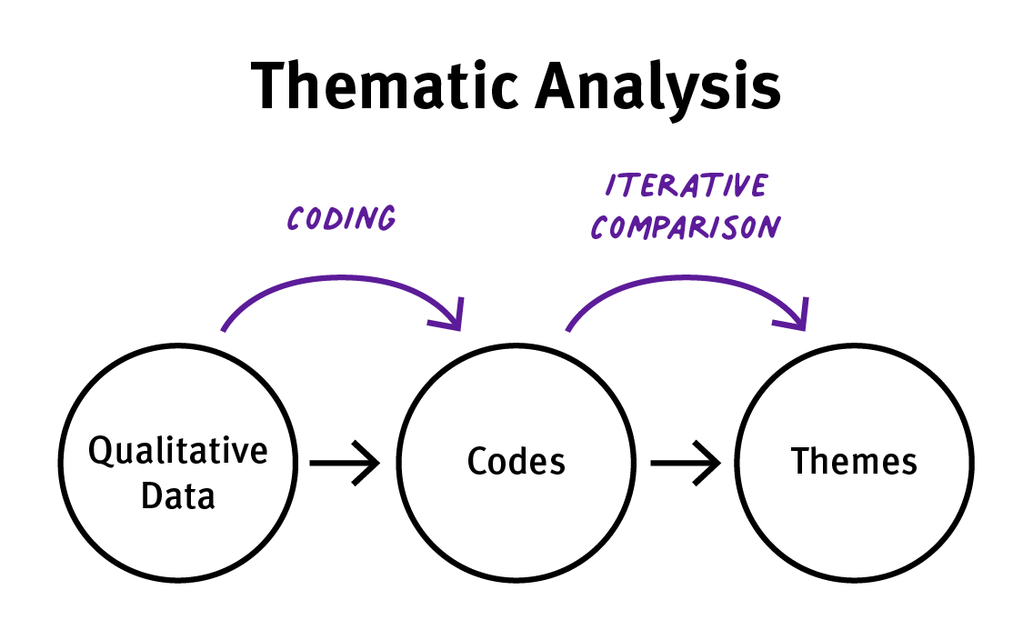
Figure: Analysing Research (Booth et al., 2021)
There were some sources selected, and they were analysed in a systematic way based on the thematic coding approach. All the articles were thoroughly read to find common concepts, keywords, and concerns of working stress, mental illness and employee retention within health and social care. First codes were created using typical trends in literature (Bettany-Saltikov and McSherry, 2024). These codes were, in turn, sorted into larger categories to get general themes to meet the goals of the research.
In order to be systematic and not misled, Excel worksheets and also use of colours in tables helped. These tools allowed the researcher to check out individual codes, their frequency and how they helped develop each theme. This plan helped to maintain uniformity in the analysis literature and has provided the prerequisite to Chapter 4, where the results will be summarised into themes. The process enabled a clear audit trail of decisions made during the analytical process as well (Lame, 2019).

3.7 Ethical Considerations
There is no primary data collection or contact with human participants in this research, and this research was fully secondary and there were no ethical risks in this research in regards to consent and confidentiality (Hasan, 2021). Academic integrity was maintained through referencing appropriately all resources used according to the Harvard referencing style, with original authors being acknowledged and no plagiarism or misrepresentation. Credibility and transparency were achieved by selecting good, peer-reviewed literature, which was also presented when objective, or free of personal bias, to help in an honest and fair evaluation of the research topic.

3.8 Chapter Conclusion
This chapter has discussed the desk-based methodology evidenced in identifying, picking and analysing academic literature to support the study. It outlined how a planned search strategy was developed, how inclusion and exclusion criteria were applied, which databases with credentials were used, and how it was validated by using the CRAAP test. Thematic-coding was utilised to cluster repeated thoughts and come up with meaningful themes. These measures provided a proper and intensive consideration of applicable sources. The results of this analysis will be provided in chapter 4 under thematic sections that will be in line with the research question and objectives.

References
Bailey, S. (2021) Parliamentary report on workforce burnout and resilience. BMJ, 373.
Bettany-Saltikov, J. and McSherry, R. (2024) How to do a systematic literature review in nursing: A step-by-step guide. 3rd edn. London: Open University Press.
Booth, A., Martyn-St James, M., Clowes, M. and Sutton, A. (2021) Systematic approaches to a successful literature review. London: SAGE. Available at: https://www.torrossa.com/it/resources/an/5282271 [Accessed 20 Jul. 2025].
Hasan, A. (2021) Ethical considerations in the use of secondary data for built environment research. In: M. Mela and B. Wilkinson (eds.) Secondary Research Methods in the Built Environment. London: Routledge, pp.26–39.
Khamisa, N., Oldenburg, B., Peltzer, K. and Ilic, D. (2016) Work-related stress, burnout, job satisfaction and general health of nurses. International Journal of Environmental Research and Public Health, 12(1), pp.652–666. Available at: https://doi.org/10.3390/ijerph120100652 [Accessed 20 Jul. 2025].
Lame, G. (2019) Systematic literature reviews: An introduction. In: Proceedings of the Design Society: International Conference on Engineering Design, 1(1), pp.1633–1642. Cambridge: Cambridge University Press. Available at: https://www.cambridge.org/core/journals/proceedings-of-the-international-conference-on-engineering-design/article/systematic-literature-reviews-an-introduction/40D4CEA7A7CC3FB6ED6233E79A0A2A1F [Accessed 20 Jul. 2025].
Maslach, C. and Leiter, M.P. (2016) Understanding the burnout experience: Recent research and its implications for psychiatry. World Psychiatry, 15(2), pp.103–111. Available at: https://doi.org/10.1002/wps.20311 [Accessed 20 Jul. 2025].
NHS Confederation (2023) The state of the NHS workforce: Addressing the mental health of frontline staff. London: NHS Confederation. Available at: https://www.nhsconfed.org/news/nhs-confederation-comment-nhs-pressures [Accessed 20 Jul. 2025].
Teoh, K., Dhensa-Kahlon, R., Christense, M., Frost, F., Hatton, E. and Nielsen, K. (2023) Organisational wellbeing interventions: Case studies from the NHS. London: Birkbeck University of London. Available at: https://eprints.bbk.ac.uk/id/eprint/50880/ [Accessed 20 Jul. 2025].
West, M., Bailey, S. and Williams, E. (2019) The courage of compassion: Supporting nurses and midwives to deliver high-quality care. London: The King’s Fund. Available at: https://www.kingsfund.org.uk/publications/courage-compassion-supporting-nurses-midwives [Accessed 20 Jul. 2025].

Appendix

Appendix A: Source Tracking Table
No. | Author(s) and Year | Title of Study | Database Used | Keywords/Combinations Used | Main Findings | Relevance to Research Aim
1 | Maslach and Leiter (2016) | Understanding the Burnout Experience | Google Scholar | "burnout AND health care" | Identifies emotional exhaustion as a key stressor | Supports Theme 1: Burnout and Mental Health
2 | West et al. (2019) | The Courage of Compassion | UWTSD Library | "Staff Wellbeing AND NHS" | Highlights the need for mental health support in the NHS | Aligns with staff wellbeing and retention
3 | Khamisa et al. (2016) | Stress and burnout in nurses | PubMed | "occupational stress AND nursing" | Shows correlation between stress and job dissatisfaction | Supports Theme 2: Job Satisfaction and Retention
4 | NHS Confederation (2023) | Mental Health of Frontline Staff | NHS Confederation | "NHS staff mental health" | Discusses COVID-19 impact on staff wellbeing | Informs post-pandemic context
5 | Teoh et al. (2023) | Organisational Wellbeing Interventions | CINAHL | "workplace wellbeing interventions" | Case studies on NHS interventions | Relevant to policy and practice solutions

