University of Wales Trinity Saint David
School of Engineering

Analysis of power generation cycles & application of compression-vapour cycle
Thermofluid Mechanics
ACMA5011

Richard Parker
1902504
08/01/2021
Contents
1 Introduction 1
2 Part A 2
3 Part B 10
4 Part C 12
5 References 15

Introduction
This report will first look at several analytical problems regarding various gas-power cycles, finding values for several parameters in Part A. It will then consider ways to improve efficiencies of gas and steam turbine power systems in Part B, before explaining the vapour-compression cycle with a focus of refrigeration and heat pump cycles in Part C.

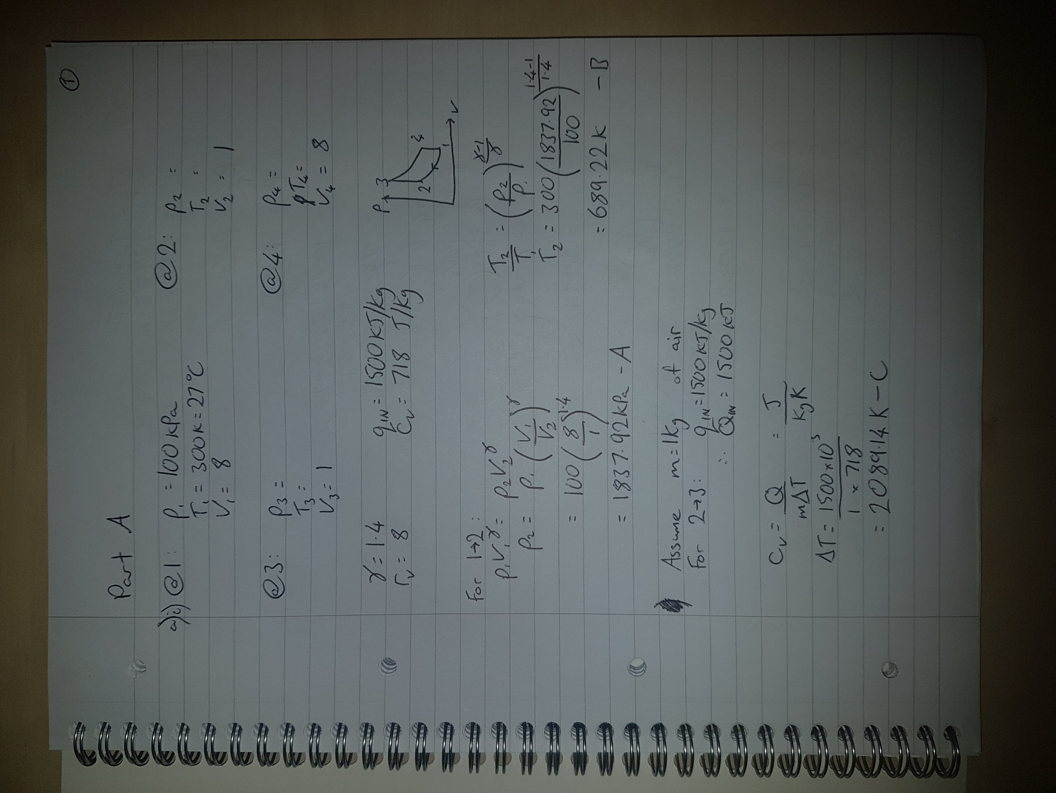
Part A
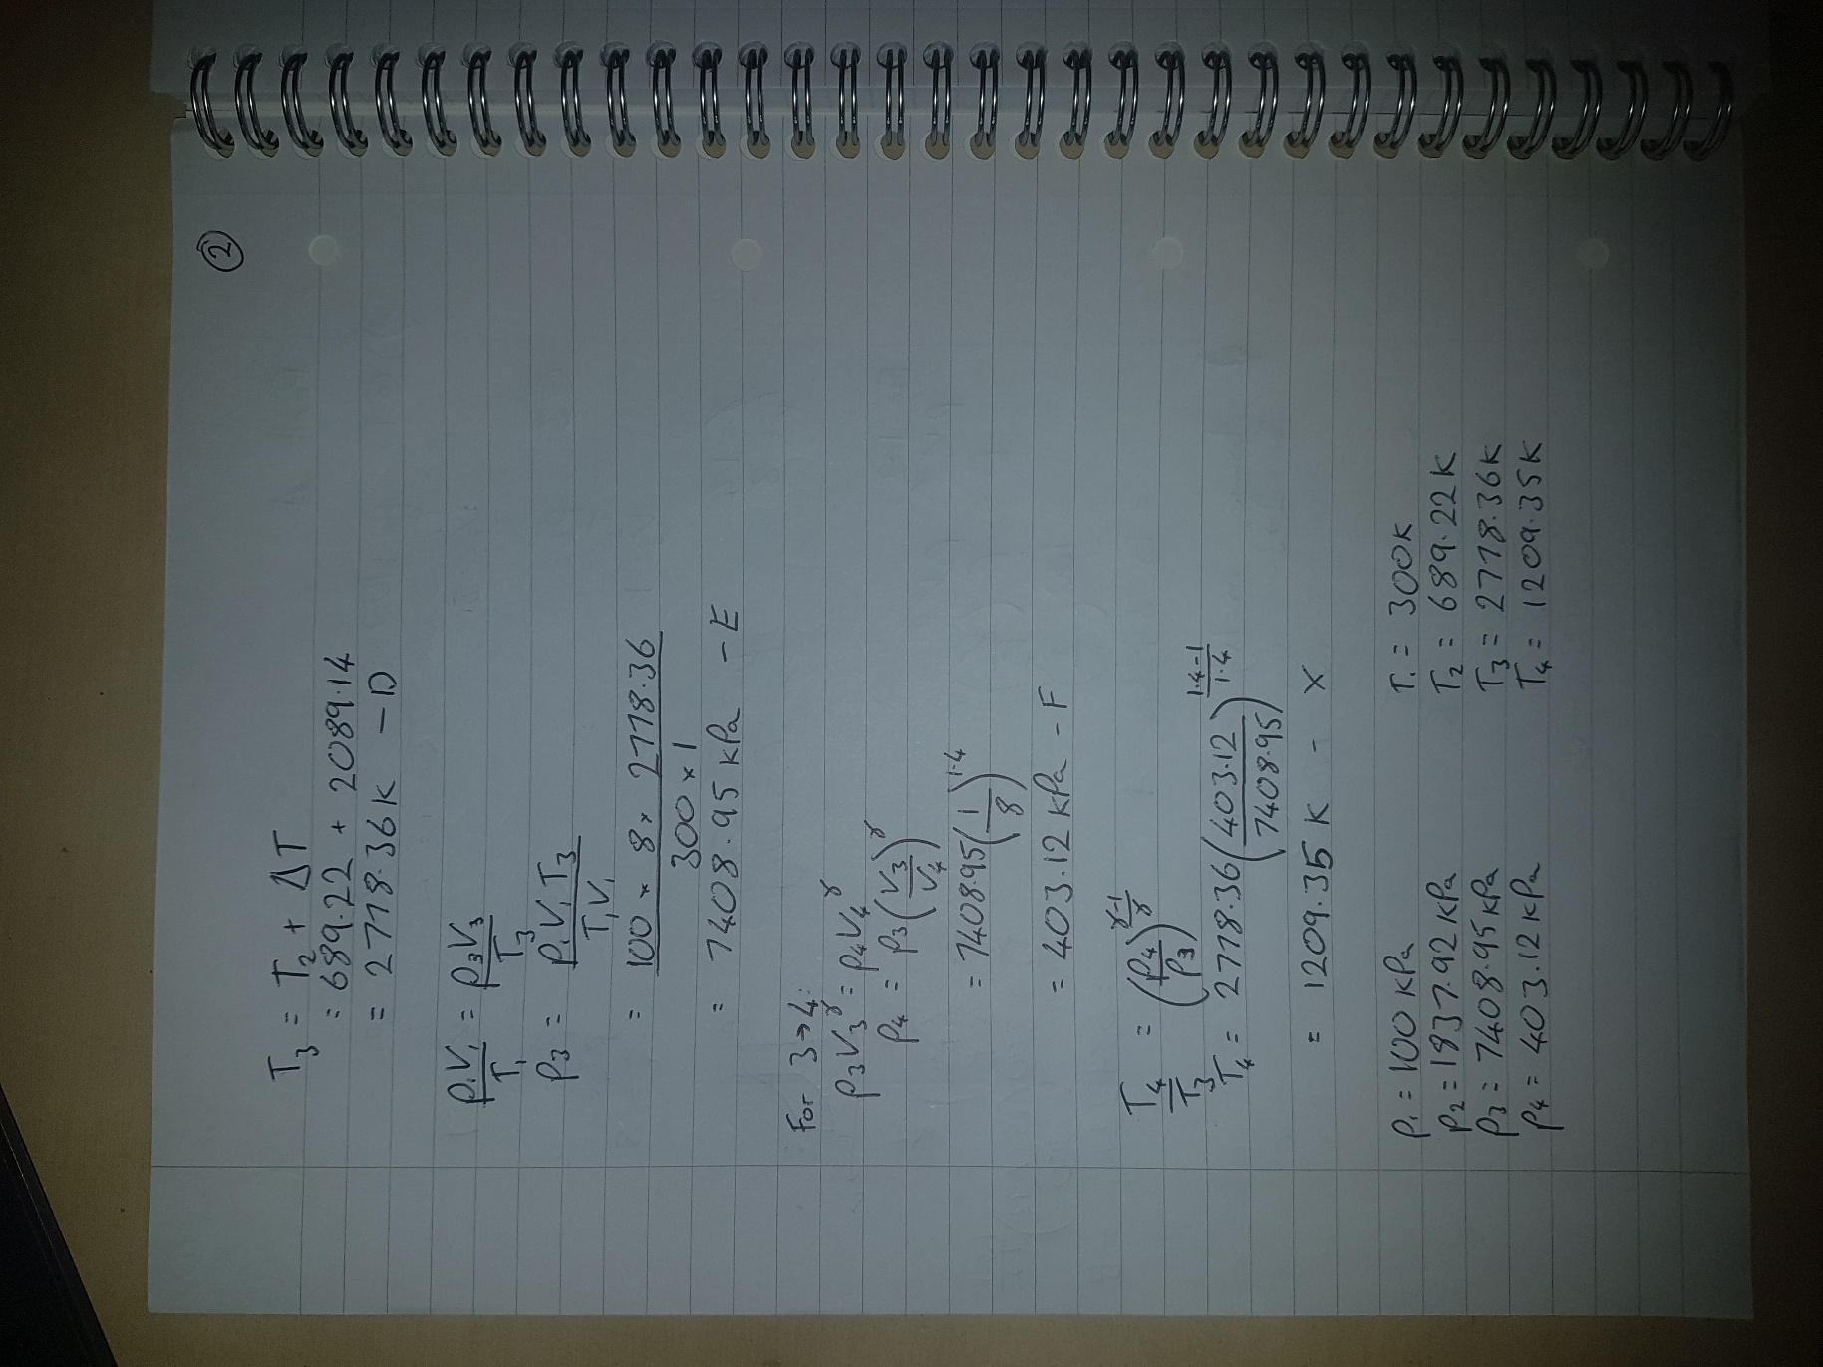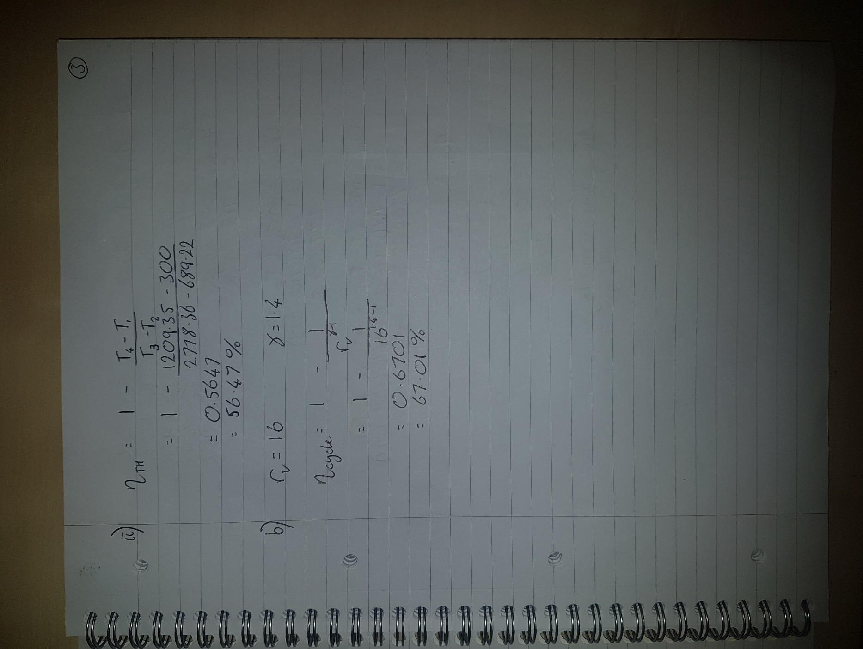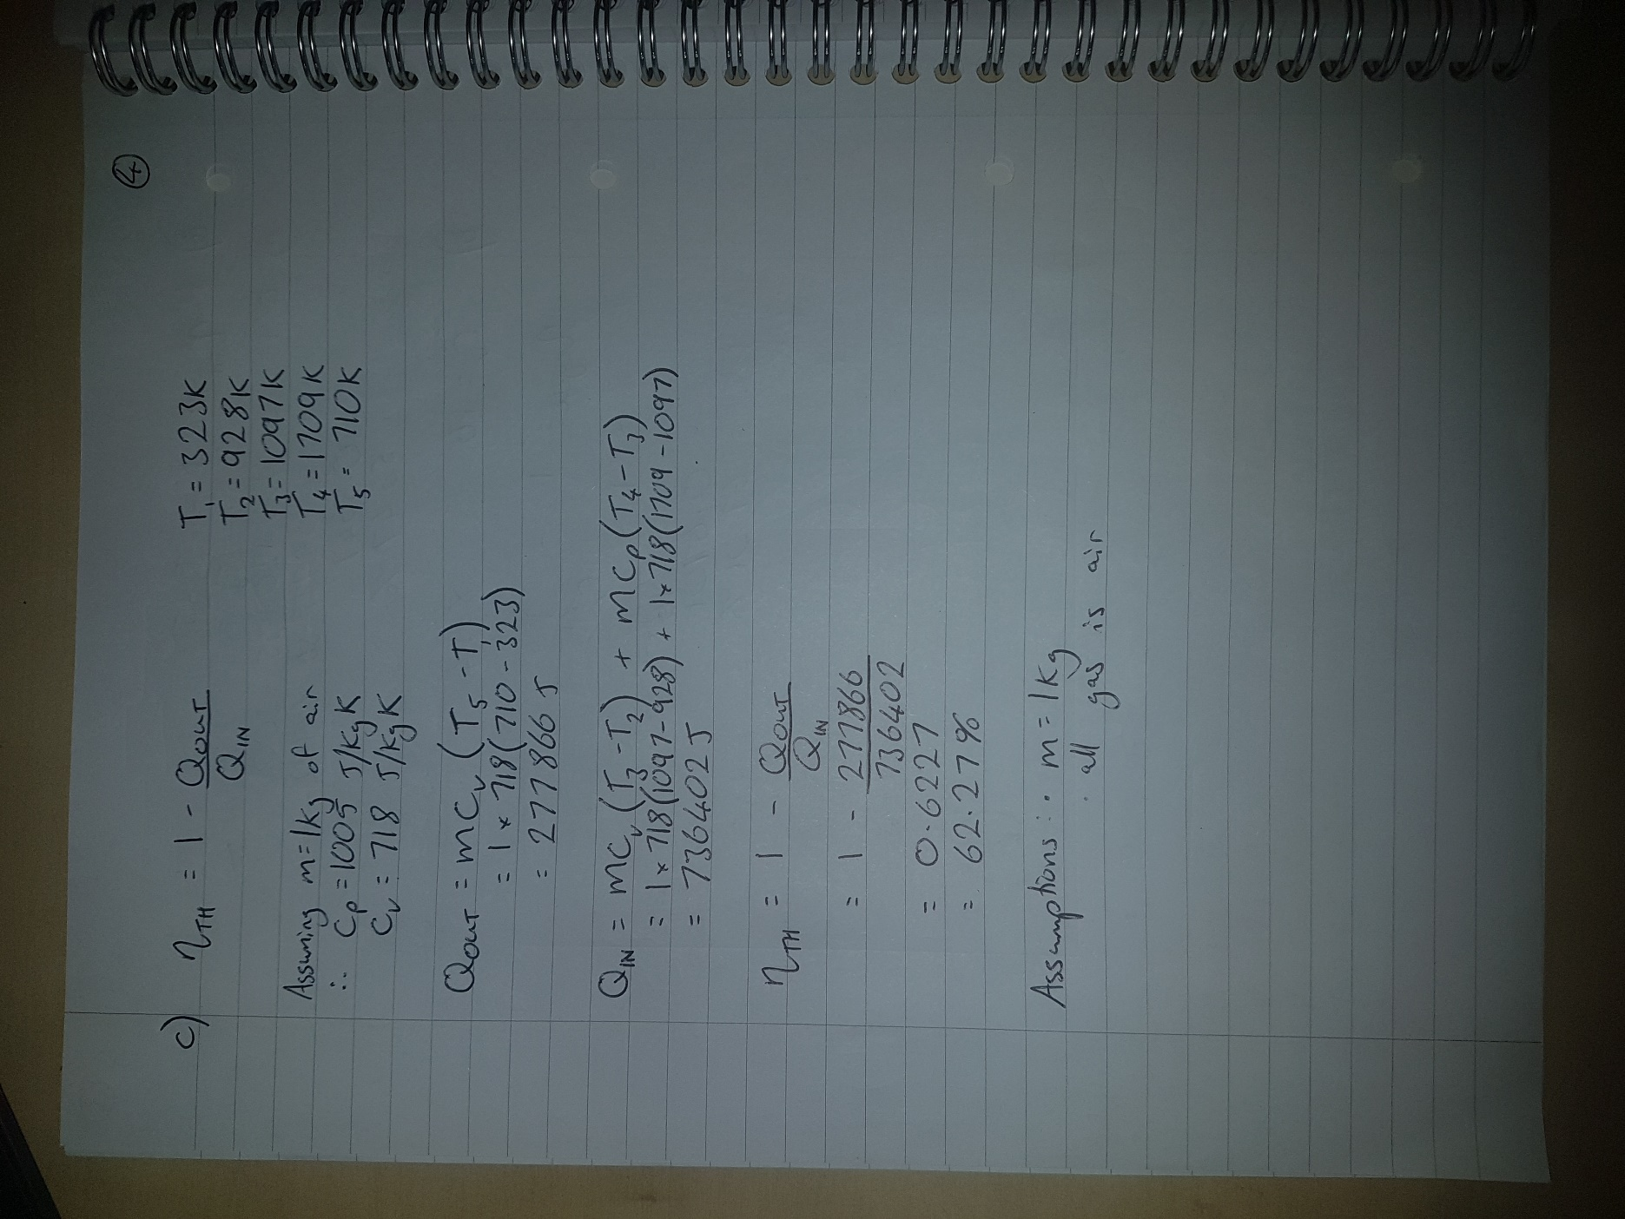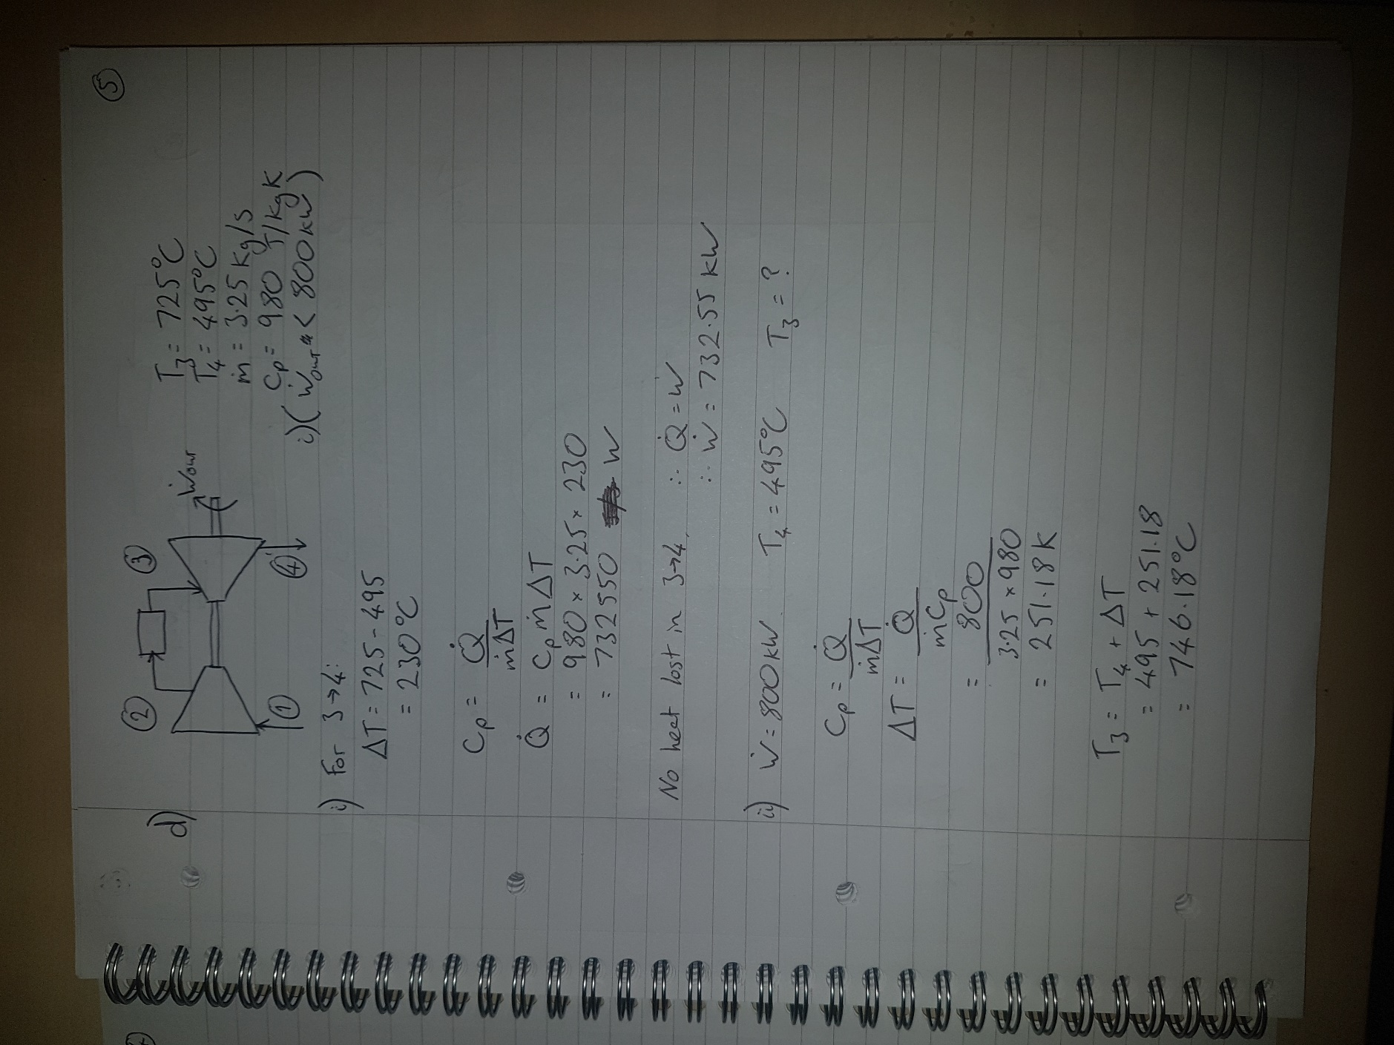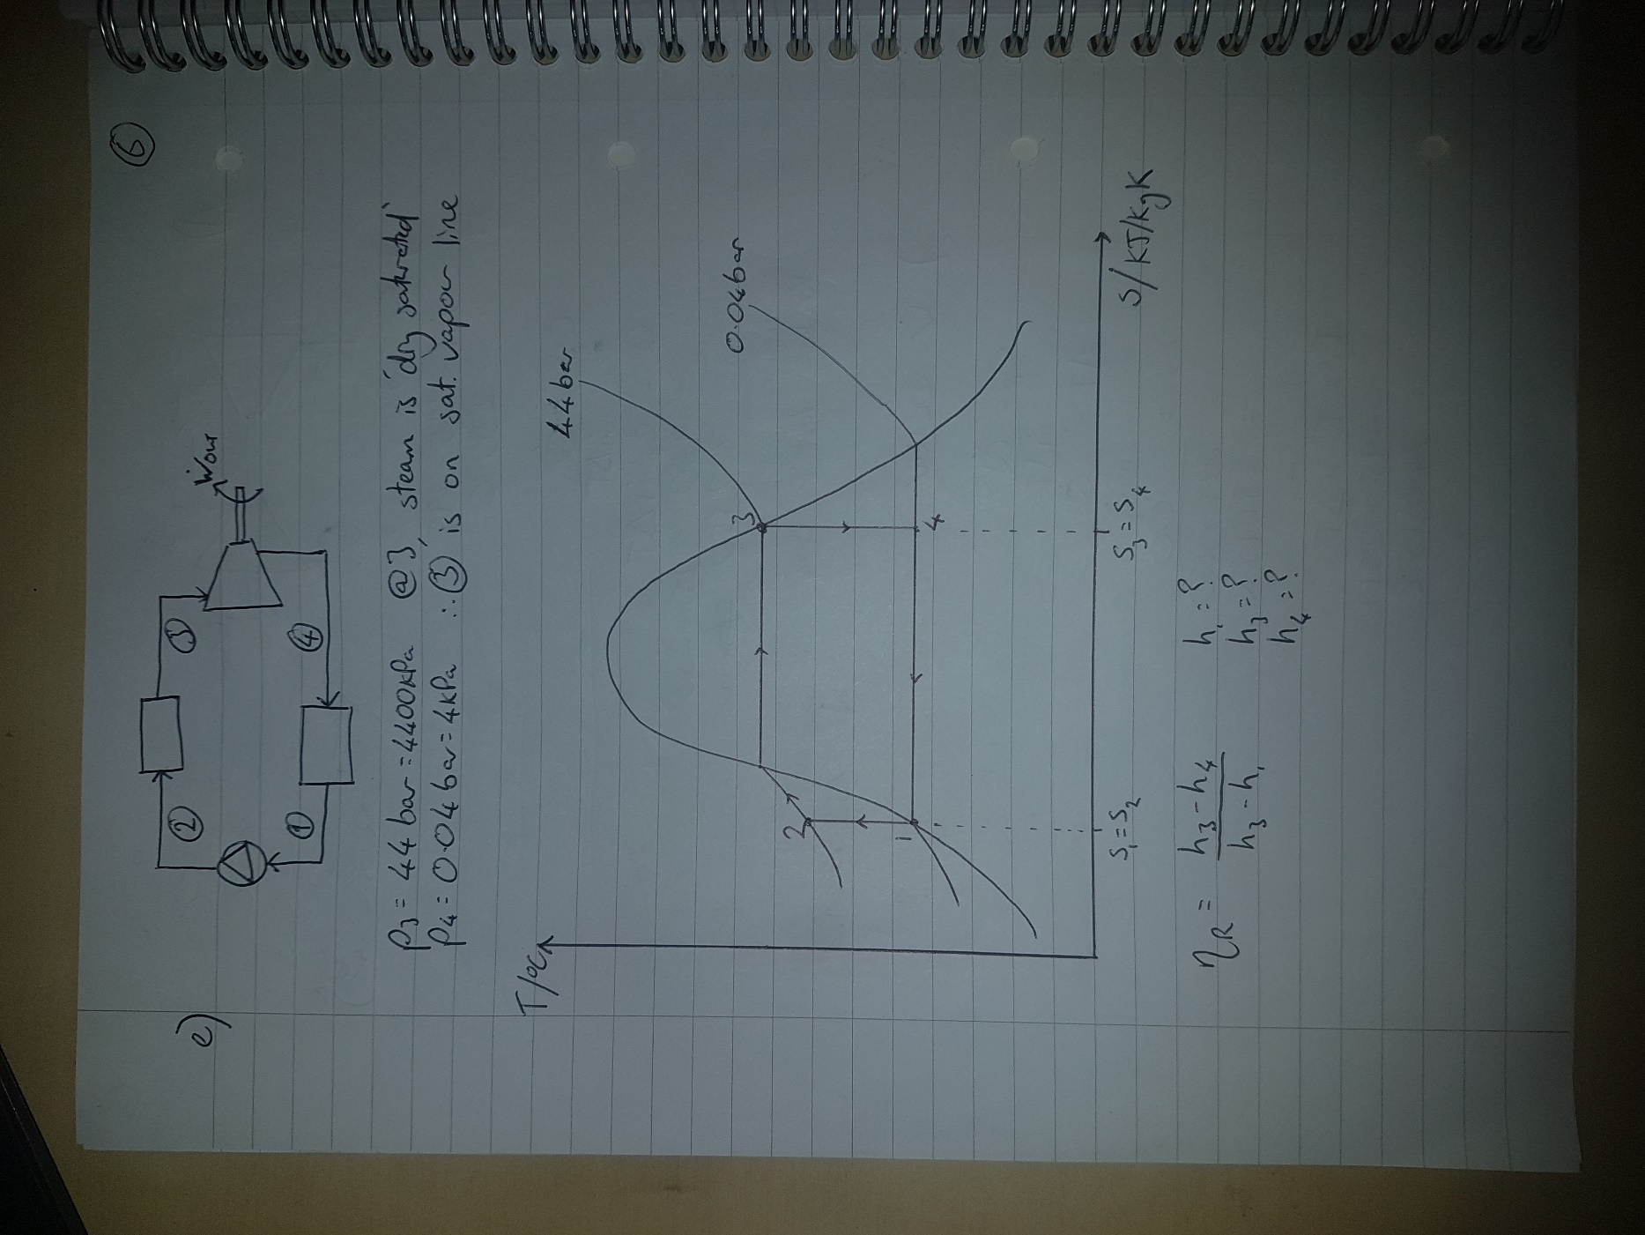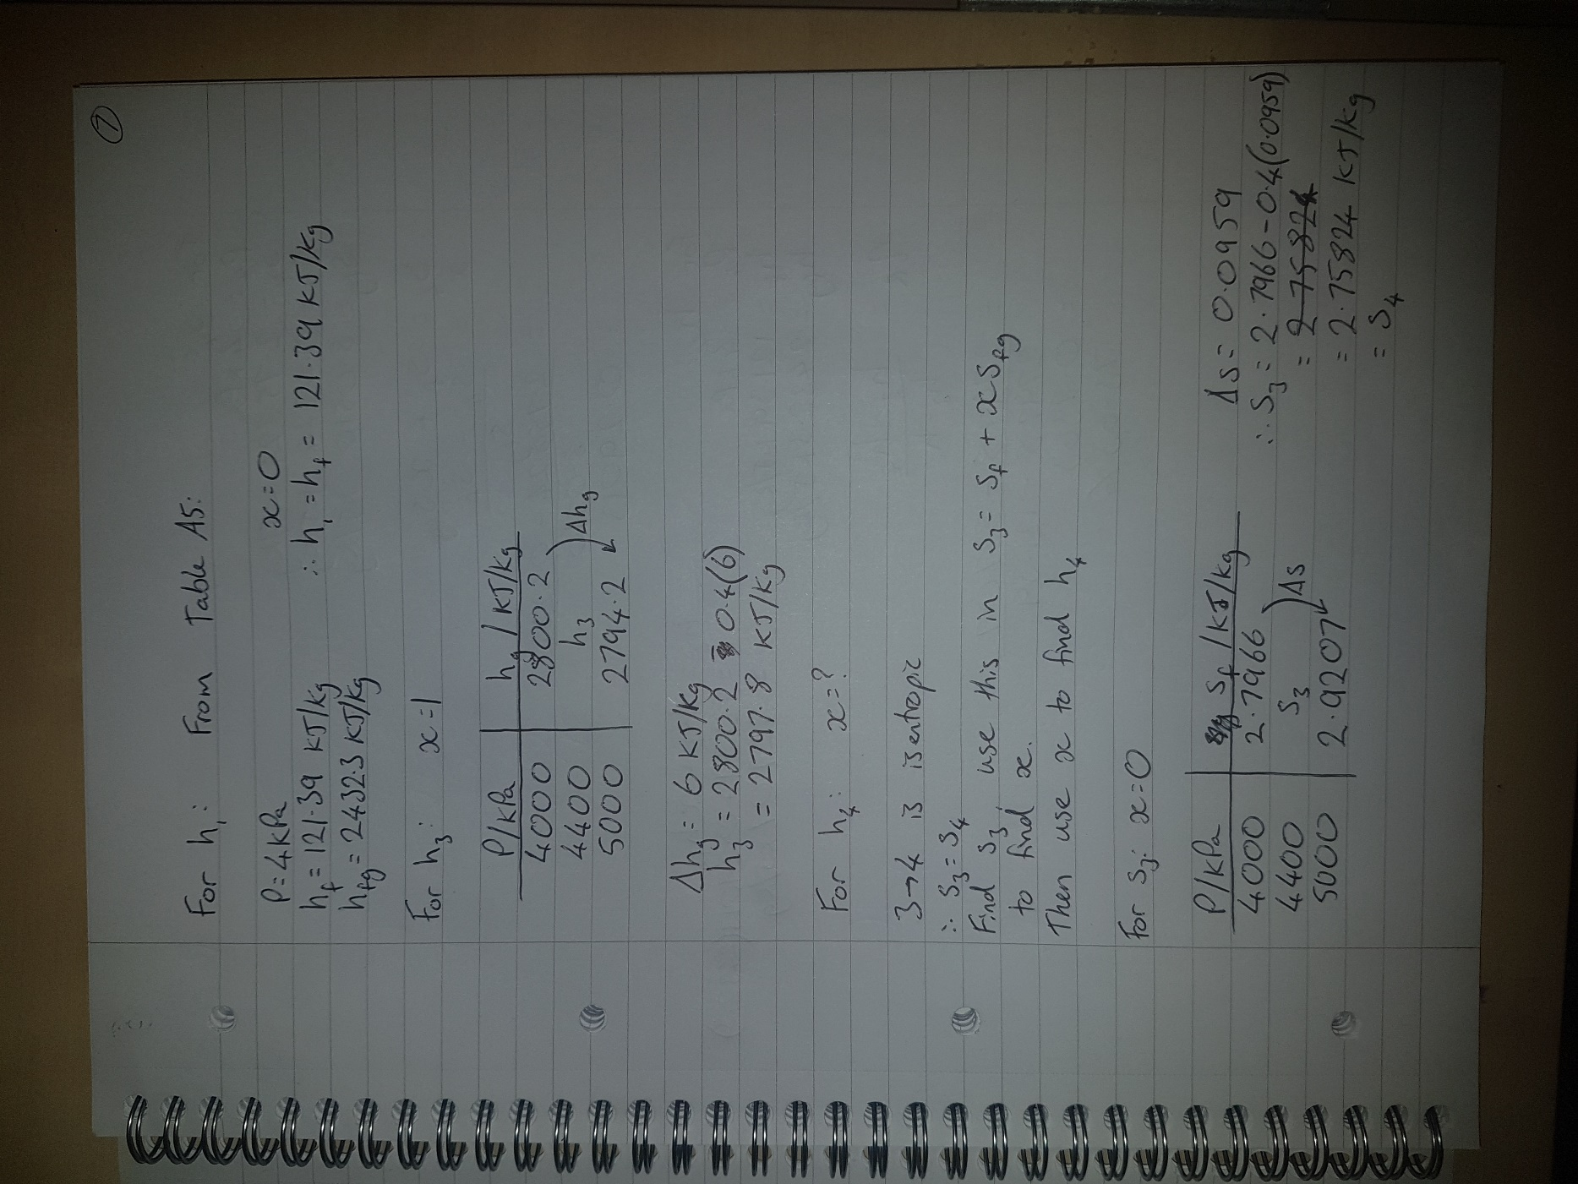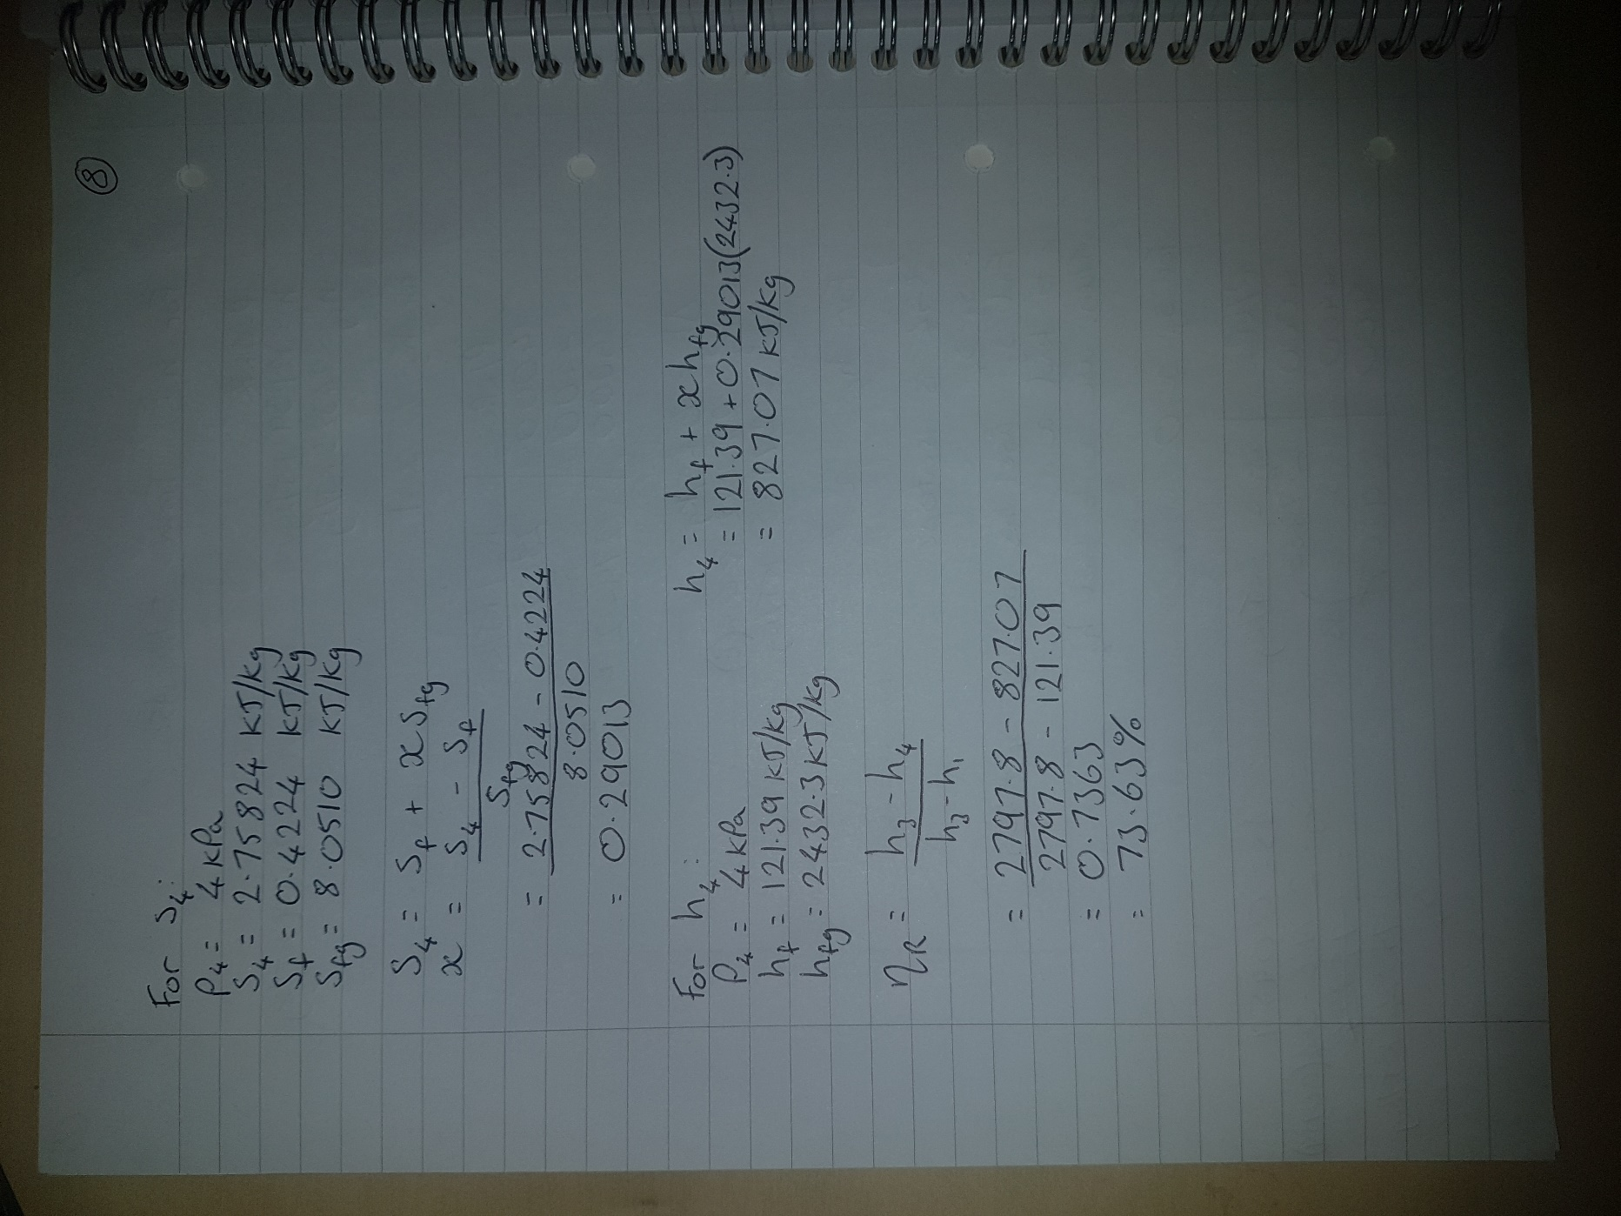

Part B
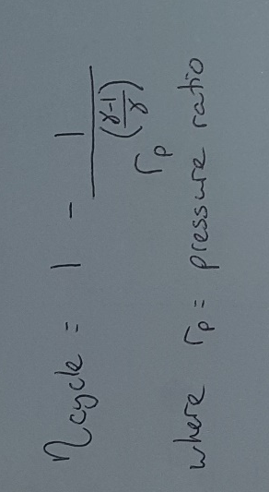
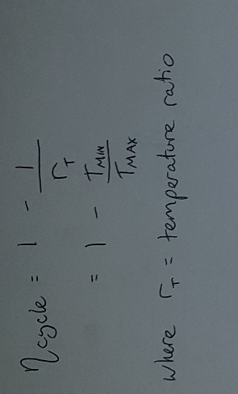
One method of increasing the cycle efficiency of a Joule cycle, shown in Eq 1, is to increase the compressor exhaust temperature. In the past, doing this led to practical issues from running compressors at such high temperatures, but recent advances have made this possible (Colin F. McDonald, 1996). For larger engines, internal cooling of blades has allowed them to run faster and hotter without risking failure; and for smaller engines where this is not possible, blades are now made from ceramic with properties suitable for the high stresses and temperatures inside compressors (Colin F. McDonald, 1996). Similarly, these improvements also help at the system’s turbine, and developments in CFD have allowed more effective aerodynamic design of the blades.
Equation 2
Equation 1
The other way to improve the cycle efficiency from Eq 1 would be to reduce the air intake temperature, which is possible through humidification of the air (Mahmood Farzaneh-Gord, 2009). In this process, water is added to the intake in some form, which then absorbs some of the air’s heat energy, and the water is later removed in some form of dehumidifier or condenser. The most common use of this principle is the Cheng cycle.
As shown in Eq 2, reducing the pressure ratio would increase cycle efficiency, although any system would have to be scaled up to account for resulting power output drop. Similarly, decreasing the heat added in combustion would improve efficiency, but at the cost of power.
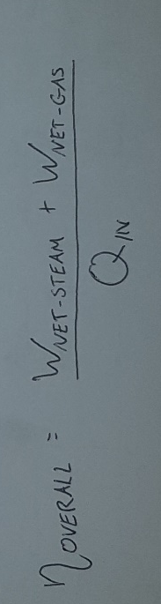
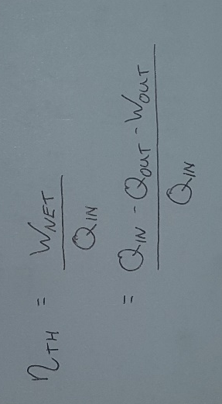
Equation 3 shows that increasing the net power output in relation to the heat input would increase thermal efficiency, and the two options for this are to decrease the heat rejected or the work done on the system by the compressor. Intercooling between multi-stage compression would give this desired reduction in work done, and the same principle works in reverse when reheating between multiple turbines.
Equation 4
Equation 3
In a Joule cycle, the exhaust gasses from the turbine contain heat energy which is then lost in the cooler. Recovering this heat and adding it back into the system would mean less energy wasted and more energy added, and it is this principle that is one of the most substantial ways of improving efficiency (Colin F. McDonald, 1996). This can be done in many ways but is most often done through the addition of recuperators and regenerators. A system with a regenerator stores some of the heat from turbine exhaust in a thermal medium, later passing in onto the gasses prior to combustion. An example which also includes two-stage turbine reheating is shown in Figure 1. A recuperator uses the same principle, but does away with the intermediary heat storage, instead using counterflow heat exchangers to pass heat directly between fluids.
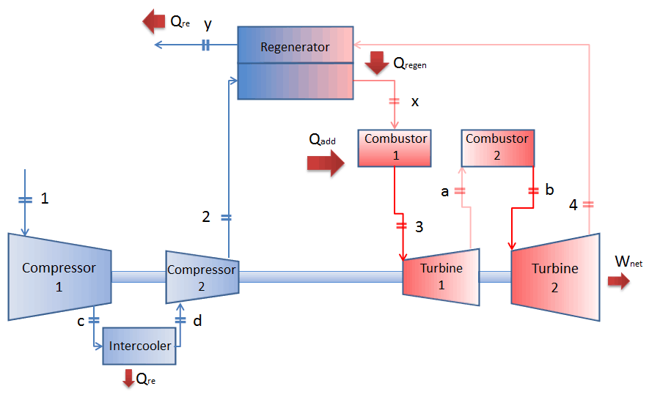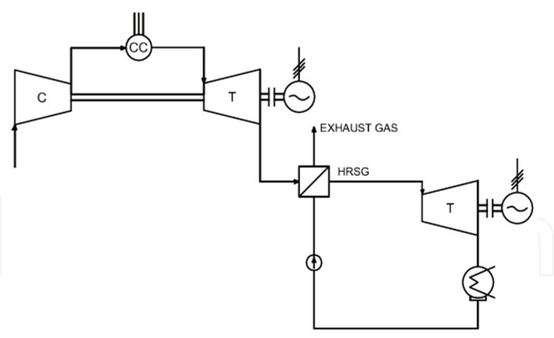
Figure 1 - Joule Cycle with Heat Regeneration Figure 2 - Schematic of CCGT Cycle
(Connor, 2019) (Roberto Carapellucci, 2012)
A Combined Cycle Gas Turbine system, or CCGT, uses this same principle of exhaust heat recovery, but instead of passing the heat energy back to the combustion gasses, it passes it onto steam in a separate cycle. The attached Rankine cycle then produces work, and the efficiency of this combined system is simply the sum of the two efficiencies, as shown in Eq 4. The simple CCGT system shown in Figure 2 can reach efficiencies in excess of 55% (Roberto Carapellucci, 2012), and if the system is improved through the uses of intercooling, reheating, and optimisation of blades, components and combustion, then the efficiencies could be considerably better again.

Part C
The primary function of any refrigeration cycle is to draw absorb heat energy from a desired heat source, and transfer it to another body which is often of a higher temperature. This initially sounds like it contradicts the laws of thermodynamics, as net heat transfer should only be from a hot body to a colder one. However, Clausius’ Statement of the Second Law says: “It is impossible to construct a device which, operating in a cycle, will produce no effect other than the transfer of heat from a cooler to a hotter body.” Therefore, to make such a refrigerator possible, work must be done on the system; generally, this is done by a compressor.
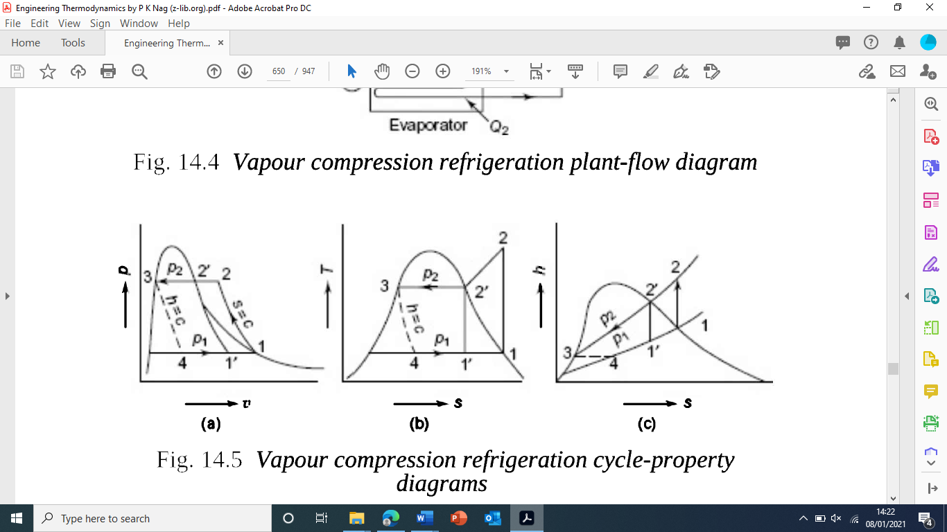
A refrigeration cycle is a form of vapour-compression cycle that takes advantage of the fact that a relatively large amount of energy is needed in the phase change of a fluid. The working fluid in a refrigeration system is pressurised to such a level that it’s saturation temperature is near to the temperatures inside the body being cooled. Through a heat exchanger, heat energy is absorbed into the liquid refrigerant, turning it into vapour. This vapour is then drawn through the pipes and compressed by a compressor, continuing onto another heat exchanger. In this second heat exchanger, the vapour passes it’s heat energy on to the surroundings, changing phase back to a liquid again. It then passes through an expander, either a turbine or an expansion valve, before continuing the cycle again.
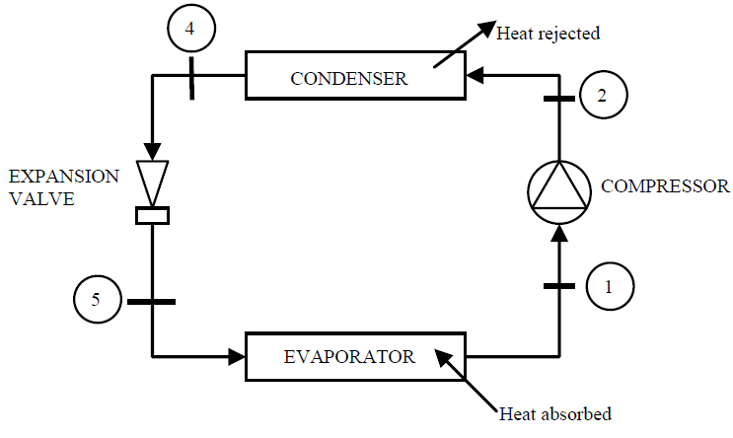
Figure 3 – Standard Vapour-Compression Cycle (Ques10, 2019)
Figure 4(a) – Pressure-volume diagram of a typical vapour-compression cycle (Nag, 2013)

Figure 4(b) – Temperature-entropy diagram of a typical vapour-compression cycle (Nag, 2013)

All Refrigeration Cycle have 4 main processes: Compression, Condensation, Expansion, and Evaporation:
Compression (1-2) : In this isentropic process, work is done on the refrigerant to compress it to the desired pressure, from p_{MIN} to p_{MAX}, where the Work Done on the system = W_{IN} = Q_{H} - Q_{C}
Condensation (2-3) : At a constant pressure, the refrigerant passes through a heat exchanger, passing it’s heat energy to the hot body, the surroundings. It changes temperature from T_{MAX} to T_{MIN}, where Heat Rejected = Q_{H}.
Expansion (3-4) : In this process, the liquid refrigerant expands from p_{MAX} back to p_{MIN}. In doing so, it must produce work. In larger systems, this could be used in a turbine, though generally it is uneconomical to add this component, so it is done by an expansion valve where the work output is negligible. If it is not negligible, the work is given by W_{OUT}.
Evaporation (4-1) : It is in this stage where the primary function of the Refrigeration Cycle is directly done. At a constant pressure, the low pressure refrigerant passes through another heat exchanger, where it absorbs heat from the cold body, going from T_{MIN} to T_{MAX}, Heat Absorbed = Q_{C}.
In a refrigeration cycle, the primary role of the system takes place at the evaporator, where heat is absorbed from the colder body to then be transferred to the hotter body. The same principle can be used to for space heating in homes, but in these systems the heat energy is absorbed from the hot body – often the ambient air outside a home, and then transferred to the colder body of air inside the house. The heat source could be the ambient air, ground temperature, water sources or any convenient low temperature heat source (Balmer, 2011). Often it is possible for one heat pump system to do both the functions of a Refrigeration Cycle and a Heat Pump Cycle depending on which setting it is in. This is done by reversing the direction of flow.
Heat engines are often compared by their efficiencies, where even for a Carnot engine the efficiency would never reach 100%. If the same measure were used for Refrigeration and Heat Pump Cycles, the efficiencies would generally be over 100%. Efficiencies over 100% are deemed illogical, and as such the Coefficient Of Performance is used instead, with values generally between 1 and 10 (Balmer, 2011). Relationships for Coefficients of Performance for given below:

Refrigeration Cycles: COP_{REF} = Desired effect = Q_{C}
Work Input Q_{C} - Q_{H}

Heat Pump Cycles: COP_{HP} = Q_{H}
Q_{C} - Q_{H}

For identical systems: COP_{HP} = COP_{REF} + 1

References
Afsaneh Noroozian, M. B., 2016. An applicable method for gas turbine efficiency improvement. Case study: Montazar Ghaem power plant, Iran. Journal of Natural Gas Science and Engineering, Volume 28, pp. 95-105.
Balmer, R. T., 2011. Chapter 13 - Vapour and Gas Power Cycles. In: Elsevier, ed. Modern Engineering Thermodynamics. Burlington: Elsevier, pp. 447-534.
Balmer, R. T., 2011. Chapter 14 - Vapor and Gas Refrigeration Cycles. In: Elsevier, ed. Modern Engineering Thermodynamics. Burlington: Elsevier, pp. 535-590.
Colin F. McDonald, D. G. W., 1996. The utilization of recuperated and regenerated engine cycles for high-efficiency gas turbines in the 21st century. Applied Thermal Engineering, 16(8-9), pp. 635-653.
Connor, N., 2019. Thermal-Engineering.org. [Online]
Available at: https://www.thermal-engineering.org/what-is-brayton-cycle-with-reheat-regeneration-and-intercooling-definition/
[Accessed 05 01 2021].
Mahmood Farzaneh-Gord, M. D.-D., 2009. A new approach for enhancing performance of a gas turbine (case study: Khangiran refinery). Applied Energy, 86(12), pp. 2750-2759.
Maria Jonsson, J. Y., 2005. Humidified gas turbines—a review of proposed and implemented cycles. Energy, 30(7), pp. 1013-1078.
Matjanov, E., 2020. Gas turbine efficiency enhancement using absorption chiller. Case study for Tashkent CHP. Energy, 01 02, 192(116625), pp. Ref - 116625.
Nag, P. K., 2013. Engineering Thermodynamics. 5 ed. New Delhi: McGraw Hill Education (India) Private Limited.
Nuclear-Power.net, 2021. Nuclear-Power.net. [Online]
Available at: https://www.nuclear-power.net/nuclear-power-plant/turbine-generator-power-conversion-system/theory-of-steam-turbines-thermodynamics/thermal-efficiency-of-steam-turbine/
[Accessed 04 01 2021].
Ques10, 2019. Ques10.com. [Online]
Available at: https://www.ques10.com/p/38994/standard-vapour-compression-cycle-1/
[Accessed 07 01 2021].
Rahim K. Jassim, M. M. A. a. G. M. Z., 2012. Energy and Exergy Analysis of Reverse Brayton Refrigerator for Gas Turbine Power Boosting. Efficiency, Performance and Robustness of Gas Turbines, 04 04, pp. 97-120.
Roberto Carapellucci, L. G., 2012. The Recovery of Exhaust Heat from Gas Turbines. Efficiency, Perforamnce and Robustness of Gas Turbines, 4 April, pp. 165-190.
Shahid Islam, I. D., 2018. 4.1 The Role of Energy Conversion. Comprehensive Energy Systems, Volume 4, pp. 1-39.

