Burhan Ali (2018947)
BMSW4006
Managing Enterprise in the 21st Century

Plan for introducing a new energy drink named “AMASK Energy Drink”

Table of Contents
Introduction 3
Business description 3
Aim and objectives 3
Mission and vision 4
Business structure 4
Product description 5
Marketing research 5
Marketing mix analysis (4P) 5
Target Market 6
Goals of the business 6
Competitors of the business 6
SWOT analysis 7
PESTLE analysis 7
Operations plan 8
Technology plan 9
Management and Organization 9
Social Responsibility and Sustainability 9
Development, Milestone and exit plan 10
Financial plan 10
Projected profit and loss accounts 11
Projected Cash flow statement 12
Projected Balance Sheet 12
Conclusion 13
References 14

Introduction
This report has discussed developing a plan for bringing a new beverage which is an energy drink. A plan has been developed for bringing a new energy drink that combines caffeine, vitamins, and herbal supplements. This report includes the discussion of the basic idea and objectives of the business by discussing the structure of the business. Also, the product description and the market analysis for the new product have been done throughout this particular report. The operations plan, management plan, and financial planning have been developed in this report as well. The financial analysis has also been done based on the assumption of the potential profit and sales revenue that the new product can earn in the UK market.

Business description
A new non-alcoholic beverage drink is going to be launched named AMASK Energy Drink which is an energy drink that combines caffeine, vitamins, and herbal supplements. This new energy drink is going to be developed as an organic energy drink that will also use recyclable packaging (Ariffin, et al., 2022). This AMASK Energy Drink is going to be advertised for the target customers who are the employees or the truck drivers who had to work long shifts. Some eco-friendly products are going to be used such as bamboo, geami paper, and recycled newspaper. Bamboo is going to be used for the packaging of the energy drink which is recyclable.

Aim and objectives
The aim of bringing this new product is to offer an organic energy drink for the people in the society and make profits with sustainable business practices.
Some objectives of the business plan are:
- To get 12% profit in the initial year of launching.
- To reach more customers by establishing the business in a good location.
- To ensure at least 4% growth after 3 years.

Mission and vision
Mission: The mission for this new energy drink business plan used to ensure sustainable business growth and meet the requirements of the customers by offering them good quality products (Ballinger, 2022).
Vision: The vision of that particular business plan is to “Become the leading energy drink brand in the world by offering sustainable growth options for the business”.

Business structure
The structure of business means the establishment of the hierarchy of the business which is followed for managing the internal operations (Benson, et al., 2021). Here, the tall structure of business has been selected to start the business as the business includes only 5 partners. The structure of the business has been shown below.
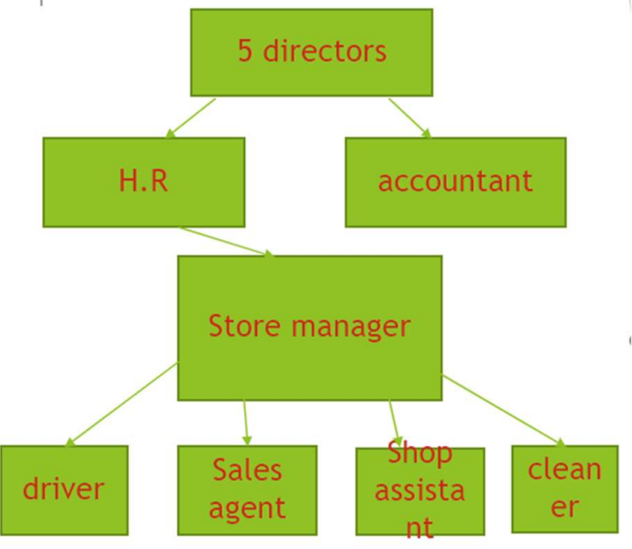
Figure: Business Structure of AMASK Energy Drink (Tall Structure)
Source: Self-made
Here, the five directors of the business who are the partners are in the top position of the hierarchy (Clapp, et al., 2019). They provide guidelines to the assistant and the HR department and the HR department is responsible for managing the store manager. The store manager of the business managers the individuals such as sales agents, drivers, short assistants, and cleaners.

Product Description
The product which is a healthy energy drink has been developed by using the organic method of preparing energy drinks (Devi, et al., 2022). The bamboo type packaging has been used which is unique. Here, non-carbon bamboo cans have been developed from bamboo which has been used for product packaging.
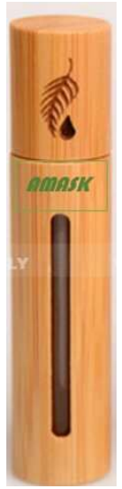
Figure: AMASK Energy Drink
Source: Self-made
The product has some other features such as it includes zero sugar and also includes a lot of calories and chemicals that provide instant energy. AMASK has been used in this product which increases the help nutrition of the product and also helps to burn the body fat of the human body and also celebrates metabolisms.

Marketing research

Marketing mix analysis (4P)
Product: The new energy drink is going to be designed by using caffeine, vitamins, and herbal supplements for ensuring instant energy (Dickson, et al., 2021). The packaging of the energy drink is going to be done by using highly recyclable bamboo bottles. The product has been developed for adults aged from 18 to 40.
Price: For setting the price of AMASK Energy Drink the competitive pricing method is going to be applied. The less expensive pricing is going to be used compared to other brands available in the UK related to the energy drink type of products (Fisk, et al., 2021). A special discount is going to be offered to the students.
Place: Initially, AMASK Energy Drink is going to be launched in the UK market and it will cover the whole geographic region of the UK. On both online and offline platforms, AMASK Energy Drink is going to offer its products to customers.
Promotion: The new product named AMASK Energy Drink is going to be promoted in both traditional and digital marketing channels. Such social media advertisements and television advertisements will be highly focused.

Target Market
The main target customers of the new product named AMASK Energy Drink is the adults aged from 18 to 40. Behavioral targeting is going to be followed in order to target those people who look after their health (Johnson, et al., 2022). Also, people who are trying to lose weight and who are active in gym activities are also targeted for selling the product. Also, moms are the target customers who look for healthy options for eating.

Goals of the business
The main goal of the business of AMASK Energy Drink is going to enlarge the business in a sustainable manner and reach people to offer products (Marinoni, et al., 2021). Also, another goal is to help the immune system of the people across the UK by offering healthy energy drink that includes a lot of vitamins and minerals. To operate a profitable business to ensure sustainable growth of the business is another crucial goal of the business plan.

Competitors of the business
There are few amounts of competitors available for AMASK Energy Drink in the UK market. Such as 3D Energy, Alani NU, Bang Energy, Cellucor, and Ghost Lifestyle are considered the most common energy drink supplements available in the UK (Nadeem, et al., 2021). So, they are the direct competitors of AMASK Energy Drink. But no energy drink company is offering their products in recyclable bamboo cans, so AMASK Energy Drink can get a competitive advantage regarding this fact.

SWOT analysis
Strengths: The biggest strength of the business plan for AMASK Energy Drink has been the eco-friendly features related to packaging and the ingredients used in the product. Bamboo has been used for product packaging which is easily recyclable (Satti, 2015). Also, organic ingredients have been used and no sugar has been added which can encourage the customers to purchase the products and that can be considered a strength of the plan.
Weaknesses: Less variety of products are going to be offered compared to other brands which can be a major weakness (Svikis, et al., 2022). The only available tastes for the product of AMASK Energy Drink are strawberry, raspberry, and coconut milk. Also, starting the business by taking a large amount of loan from the bank can be another weakness as it required to be a lot of interest rate initially which can reduce the profitability of the business compared to the expectations.
Opportunities: The increasing health consciousness of the people in the UK society can increase the cells of AMASK Energy Drink. Also, offering a good quality product at a decent price can engage more customers which is another opportunity (Svikis, et al., 2022). Moreover, reaching customers by using social media platforms can also be a crucial opportunity for AMASK Energy Drink.
Threats: The increasing competition in the retail drinking sector can create a threat for AMASK Energy Drink to ensure sustainable growth. Also, the raw material price is regularly increasing which can also create threat factors for AMASK Energy Drink.

PESTLE analysis
Political: The Brexit Contract in 2020 has created a lot of restrictions for the businesses in the UK to expand their operations in other European countries which can impact the business of AMASK Energy Drink. Also, the current political instability due to the Russia and Ukraine war has increased the cost of other ingredients as well.
Economic: The GDP of the UK has improved which is a good sign but the unemployment rate has increased which has not been a good sign for AMASK Energy Drink (Marinoni, et al., 2021). Also, the increasing inflation in the UK can impact the profitability of AMASK Energy Drink to ensure a sustainable profit margin every year.
Social: The social lifestyle of people has become much more health conscious and that's why people are looking to get healthy products. So, that can create a positive impact for AMASK Energy Drink as the company is offering a healthy energy drink that is organic as well.
Technological: The increasing use of social media and digital technology for promotion can create a positive impact on AMASK Energy Drink (Johnson, et al., 2022). Moreover, the use of AI in terms of promoting the business on social media platforms is also going to be a decisive factor for AMASK Energy Drink.
Legal: A lot of legal changes have been made by the UK government to ensure the health and safety of the people which can impact the product development and distribution of the products (Devi, et al., 2022). Also, in terms of importing and exporting a lot of restrictions have been imposed that can create a negative impact to get raw materials from other European countries.
Environmental: The eco-friendly features of AMASK Energy Drink can attract more customers as people are becoming more environmentally conscious nowadays (Benson, et al., 2021). Also, some natural calamities can impact the distribution of the products of AMASK Energy Drink in different parts of the country.

Operations plan
In the main operations plan, AMASK Energy Drink is going to arrange a big conference to launch its product. Also, to increase public relations direct communication is going to be made with the customers (Ballinger, 2022). Also, as a part of the operations plan, AMASK Energy Drink is going to develop a website from where the customers can order products and also know different information about the product.

Technology Plan
Both online and offline channel has been used for selling the product. Here, a smart app is going to be developed as a basic technology plan to encourage online customers to purchase products by putting their orders (Ariffin, et al., 2022). A secured system is going to be developed for smart app and website users that require two ways of authentication.

Management and Organization
The management of AMASK Energy Drink is going to follow the guidelines of a tall structure of the organisation in which the hierarchy is going to be strictly followed for operating different tasks (Johnson, et al., 2022). Then, in terms of organizing the resources, everyone in the workplace will have different roles and responsibilities.

Social Responsibility and Sustainability
Carroll’s model of corporate social responsibility is going to be followed in the business operations of AMASK Energy Drink (Dickson, et al., 2021). A theory has been implemented below considering the business context of AMASK Energy Drink.
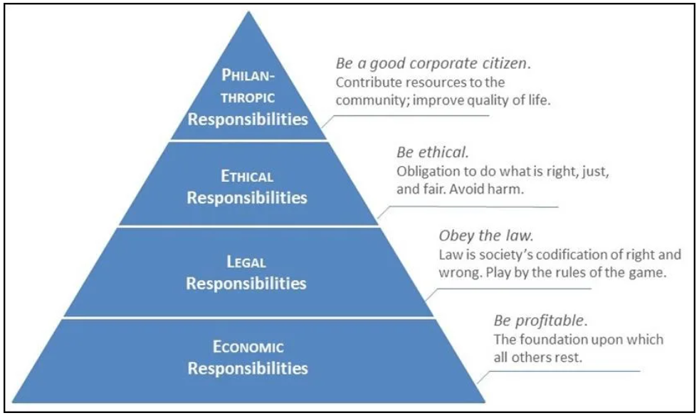
Figure: Carroll’s CSR Model
Source: (Nadeem, et al., 2021)
AMASK Energy Drink has the economic responsibility to make profits and satisfy the need of the investors and the other stakeholders. Then, the legal responsibility of AMASK Energy Drink is to follow all the rules and regulations imposed by the UK government for developing products and using appropriate ingredients (Johnson, et al., 2022). Then, as a part of ethical responsibility, AMASK Energy Drink will operate its business by using sustainable practices such as using recyclable packaging and no harmful ingredients. Lastly, as a long tropic responsibility, AMASK Energy Drink will improve the social lifestyle of the people by offering good quality products at the same time maintaining positive public relations.

Development, Milestone, and exit plan
AMASK Energy Drink is expected to start its project in January 2023. The initial milestone of the project of AMASK Energy Drink is to make at least £20,000 profit. Also, as a part of the exit plan, the exit of the business is going to be done by selling all the assets of the business in the market to pay the liabilities of the debtors.

Financial plan
Here, a few assumption-based financial data have been displayed which show the overall profit margin and the potential financial returns from the project named AMASK Energy Drink.
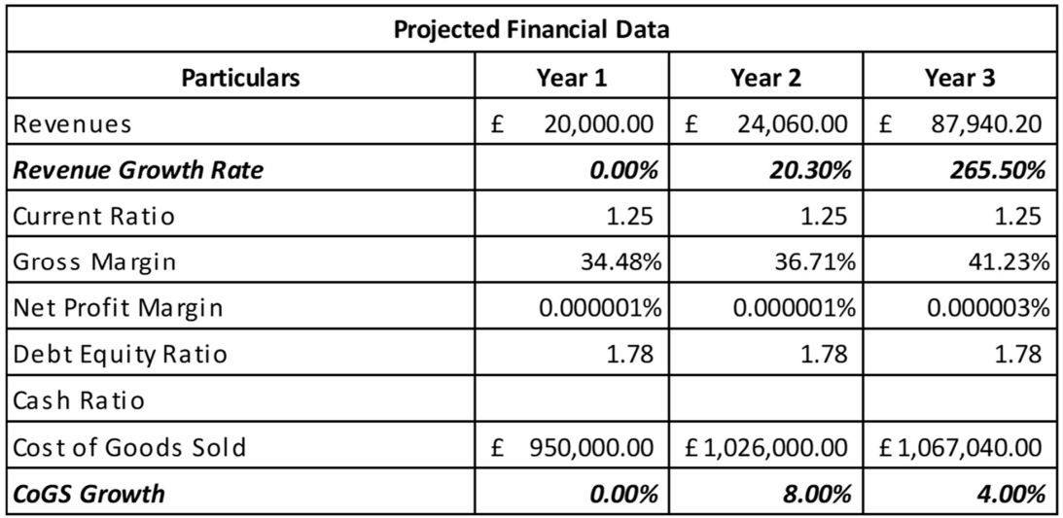

Projected profit and loss accounts
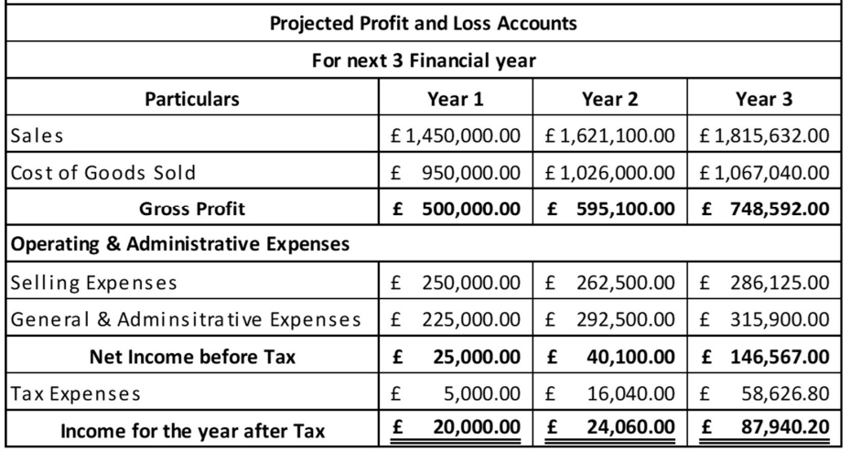

Projected Cash flow statement
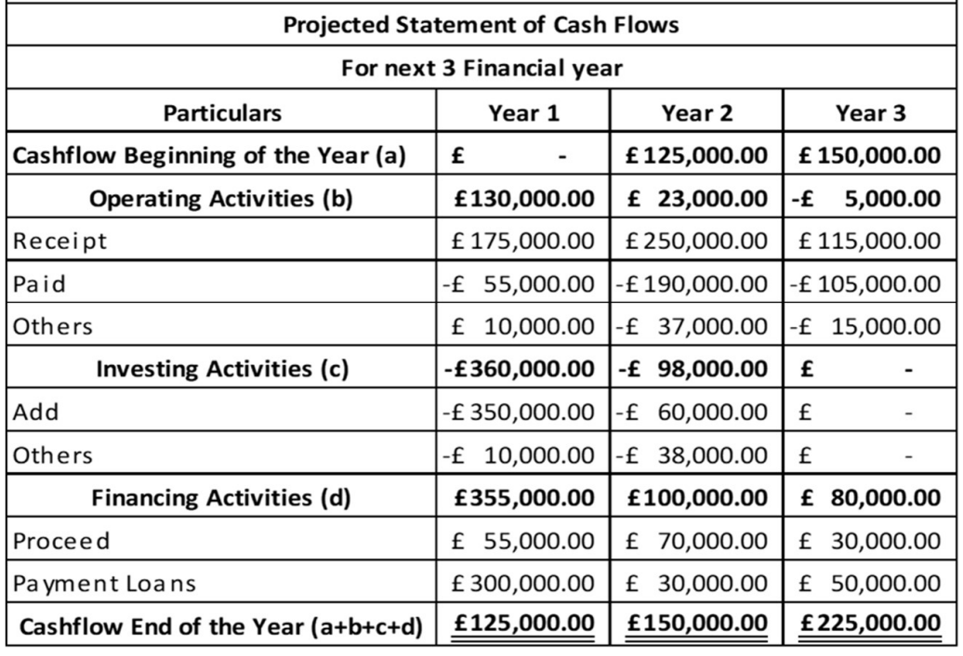

Projected Balance Sheet
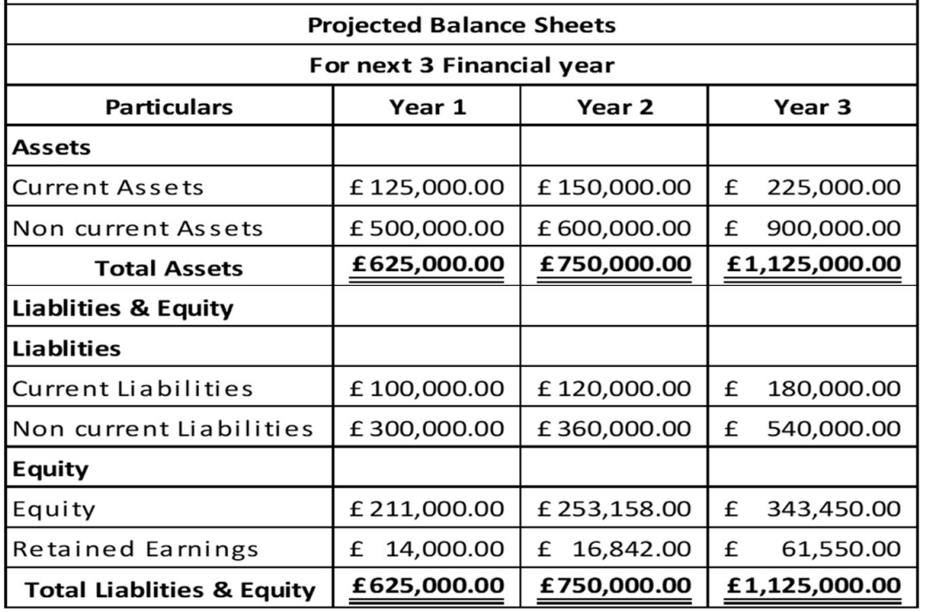

Conclusion
So, at last, it can be said that the business idea of bringing a new energy drink to the UK market can be profitable as there is less number of producers available related to similar products. Also, the internal and external market analysis shows that AMASK Energy Drink can get an appropriate profit margin and a good position in the market because of that unique eco-friendly feature. Also, the financial analysis suggested that AMASK Energy Drink can have a good option to get an appropriate profit margin with their plan in the UK market after two or three years of their business operations.

References
Ariffin, H., Chong, X.Q., Chong, P.N. and Okechukwu, P.N., 2022. Is the consumption of energy drinks beneficial or detrimental to health: a comprehensive review? Bulletin of the National Research Centre, 46(1), pp.1-28.
Ballinger, J., 2022. Celsius Energy Drink Review.
Benson, S., Johnson, S.J., Alford, C., Scholey, A. and Verster, J.C., 2021. A cross-cultural comparison of the effects of alcohol mixed with energy drink (AMED) consumption on overall alcohol consumption and related consequences. International Journal of Environmental Research and Public Health, 18(14), p.7579.
Clapp, O., Morgan, M.Z. and Fairchild, R.M., 2019. The top five selling UK energy drinks: implications for dental and general health. British Dental Journal, 226(7), pp.493-497.
Devi, J., Director, R.S. and Upadhyay, P.K., 2022. ENERGY DRINK TABLET: A REVIEW.
Dickson, A., Gehrsitz, M. and Kemp, J., 2021. Does a spoonful of sugar levy help the calories go down? An analysis of the UK soft drinks industry levy.
Fisk, G., Hammond-Haley, M., and D'Silva, A., 2021. Energy drink-induced cardiomyopathy. BMJ Case Reports CP, 14(4), p.e239370.
Johnson, S.J., Verster, J.C. and Alford, C., 2022. A comparison between ecological momentary assessment and the adapted-quick drinking screen: alcohol mixed with energy drinks. Alcohol and alcoholism.
Marinoni, M., Parpinel, M., Gasparini, A., Ferraroni, M. and Edefonti, V., 2021. Psychological and socio-educational correlates of energy drink consumption in children and adolescents: a systematic review. European Journal of Pediatrics, pp.1-13.
Nadeem, I.M., Shanmugaraj, A., Sakha, S., Horner, N.S., Ayeni, O.R. and Khan, M., 2021. Energy drinks and their adverse health effects: a systematic review and meta-analysis. Sports Health, 13(3), pp.265-277.
Satti, H., 2015. Knowledge of risk factor of energy drinks among student of the university of science & technology who drinks energy drinks 2015.
Skis, D.S., Dillon, P.M., Meredith, S.E., Thacker, L.R., Polak, K., Edwards, A.C., Pomm, D., Dick, D. and Kendler, K., 2022. Coffee and energy drink use patterns in college freshmen: associations with adverse health behaviors and risk factors. BMC public health, 22(1), pp.1-10.
Thomson, B.M., Campbell, D.M., Cressey, P., Egan, U. and Horn, B., 2014. Energy drink consumption and impact on caffeine risk. Food Additives & Contaminants: Part A, 31(9), pp.1476-1488.
Wee, J.H., Min, C., Park, M.W., Park, I.S., Park, B. and Choi, H.G., 2021. Energy-drink consumption is associated with asthma, allergic rhinitis, and atopic dermatitis in Korean adolescents. European Journal of Clinical Nutrition, 75(7), pp.1077-1087.

